27-01-2021
Thursday, January 27, 2022
7:47 PM

Programming Language

- High Language
- Low Language
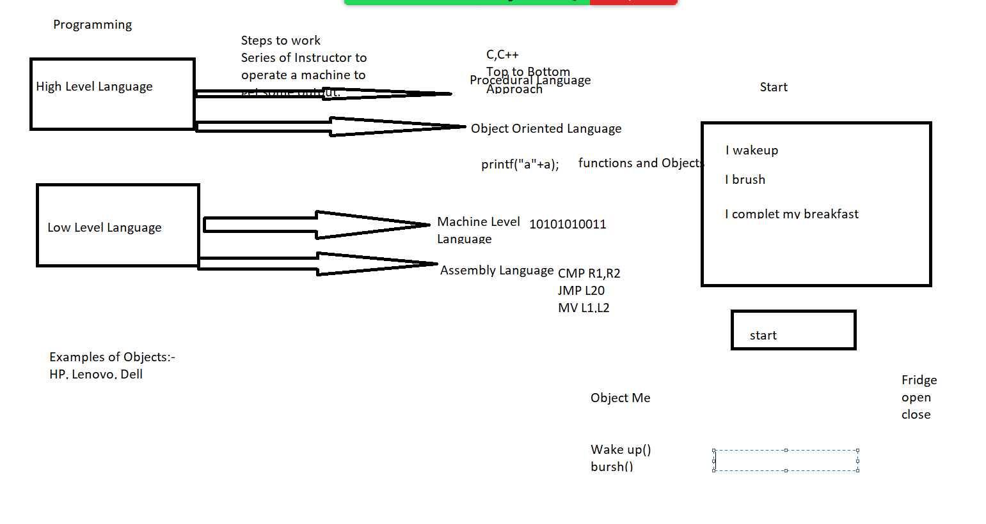

JAVA:- 1991
1995 1.0

- Desktop Applications:- Single user Applications Standalone Applications, Static Applications
- Enterprise Applications:- Web Applications, Dynamic behavior , Client-Server
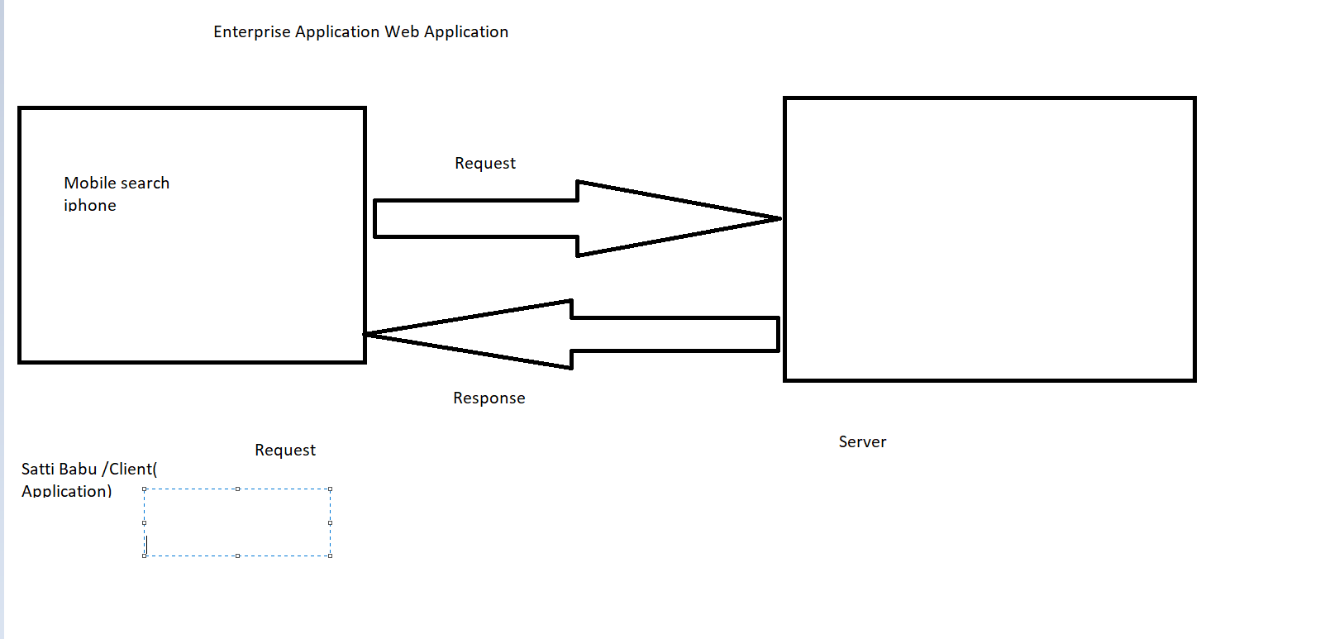
- Distributed Applications:- Webservices, Communication between two Services. Sharing Data.
- Games, AI
- Mobile Applications
Applications:-
- Java SE --- Standard Edition ------ Core Java
- Java EE -- Enterprise Edition ---- J2EE, Jsp, Servlets, Frameworks, JDBC, Service
- Java ME-- Mobile Edition

