Infosys Springboard Virtual Internship 7.0
Completion Report
Batch 1 [Team D]
Smart-HVAC-Energy-Optimization-and-AI-Based-
Industrial-Maintenance-and-Process Optimization-System

Team-Based Project

Internship Program | Infosys Springboard Virtual Internship 7.0
Batch | Batch 1 [Team D]
Project Type | Team-Based
Project Domain | AI Powered Industrial Maintenance and Process Optimization System
Mentor / Dates | Mentor: Sangeetha Mahalingam | Start Date: 29 June 2026 | Duration: 8 Weeks

Team Details
This project was developed as a collaborative team project during the Infosys Springboard Virtual Internship 7.0. The team worked across data understanding, preprocessing, exploratory analysis, feature engineering, machine learning, backend API development, frontend dashboard development, simulation, testing and documentation.
Team Member
Shristi Sharma
Satvik Pandey
Shashank M M
Snehith Reddy Anuka
Sahil Manoj Shah
Sai Charan

1. Project Title
Smart-HVAC-Energy-Optimization-and-AI-Based-Industrial-Maintenance-and-Process Optimization-System

2. Project Objective
The project aims to develop an AI-driven HVAC management platform that combines HVAC fault detection, building energy consumption prediction, live monitoring simulation and predictive maintenance support in a single dashboard. The system demonstrates how machine learning can be integrated with Building Management System (BMS)-style workflows to improve equipment monitoring, identify abnormal operating conditions and support data-driven maintenance decisions.
- Detect HVAC operating conditions as Healthy or Fault Detected using a Random Forest classification model.
- Predict building electricity consumption using Building Genome data and a Random Forest regression model.
- Simulate a live stream of HVAC sensor readings for demonstrating continuous monitoring.
- Display model confidence, sensor readings, energy prediction and system status through an interactive dashboard.
- Generate maintenance-ticket information and recommendations when a fault condition is detected.
- Integrate the machine-learning models with a FastAPI backend and a Next.js frontend.
- Demonstrate an end-to-end pipeline from raw datasets and preprocessing to model inference and user-facing visualization.

3. Project Description in Detail
The Smart HVAC system is an AI-powered monitoring and analytics platform designed for HVAC equipment and building-energy management. It combines two major machine-learning capabilities. The first is binary HVAC fault detection based on sensor measurements from the LBNL RTU Fault Detection dataset. The second is building energy-consumption prediction using the Building Genome dataset, which combines electricity measurements with building metadata and weather information.
The fault-detection pipeline begins with dataset understanding and quality assessment, followed by preprocessing, exploratory data analysis, feature engineering and model training. A Random Forest Classifier is trained on 23 engineered sensor features. The model produces a Healthy/Fault prediction and probability-based confidence information.
For energy analytics, electricity consumption data is transformed into a long format and merged with building metadata and weather records. Time-related variables such as hour, day, month, day of week, week of year and weekend status are engineered. Building age is also derived from the year-built attribute. A Random Forest Regressor is then used to estimate electricity consumption.
The backend is implemented using FastAPI. Separate API routes are provided for fault prediction, energy prediction and the simulated next sensor reading. The frontend is implemented using Next.js, React, TypeScript and TailwindCSS. The dashboard presents HVAC status, predicted energy, AI confidence, sensor updates and maintenance status. Additional modules provide live monitoring, energy analytics and maintenance-ticket views.

4. Datasets Used
Dataset | Purpose | Important Data | Use in Project
LBNL RTU Fault Detection Dataset | HVAC fault detection | RTU sensor measurements, health status, fault type and severity | Binary classification of Healthy vs Fault
Building Genome Dataset | Building energy prediction | Electricity consumption, building metadata and weather | Regression-based energy prediction

5. Data Processing and Machine Learning Pipeline
- Dataset understanding: inspect files, columns, data types, missing values, duplicates, relationships and target variables.
- Preprocessing: prepare the LBNL RTU simulation data and remove or handle unusable information.
- Exploratory Data Analysis: examine dataset structure, class distribution, numerical statistics, correlations and important sensor behaviour.
- Feature engineering: prepare the model-ready feature set for fault detection and derive temporal/building/weather features for energy prediction.
- Model development: train Random Forest models for classification and regression.
- Evaluation: measure classification using accuracy, precision, recall, F1-score and ROC-AUC.
- Model integration: expose predictions through FastAPI endpoints.
- Frontend integration: consume backend APIs and visualize results through the Next.js dashboard.
- Monitoring simulation: stream sequential HVAC records to demonstrate real-time behaviour.
- Maintenance workflow: connect fault status with maintenance-ticket and recommendation views.

6. Fault Detection Model
The fault detection model uses a Random Forest Classifier trained on the prepared LBNL RTU simulation dataset. The model uses 23 sensor features representing HVAC operating conditions. The classification target distinguishes healthy operation from fault operation.
Metric | Baseline Random Forest Result
Training samples | 230,305
Testing samples | 57,577
Number of features | 23
Accuracy | 93.27%
Precision | 97.42%
Recall | 88.89%
F1 Score | 92.96%
ROC-AUC | 97.33%
The notebook also performs an overfitting check by comparing training and testing accuracy. The baseline model achieved 100% training accuracy and 93.27% testing accuracy, indicating a performance gap that should be considered when interpreting the model.
Hyperparameter tuning was performed with RandomizedSearchCV using F1-score as the optimization metric. The tuned model was compared with the baseline model before production-model selection.

7. Energy Prediction Model
The energy prediction pipeline uses the Building Genome dataset. Electricity data is cleaned, sparse building columns are filtered, and the wide electricity table is transformed into long format. The resulting records are joined with building metadata and weather data using building/site and timestamp relationships.
- Timestamp-derived features: hour, day, month, day_of_week, week_of_year and is_weekend.
- Building age feature derived from the year-built value.
- Numerical missing values are handled using median imputation.
- Categorical missing values are filled using an Unknown category.
- A Random Forest Regressor is used for energy-consumption prediction.
Regression Metric | Observed Result
MAE | 5.24
MSE | 1135.52
RMSE | 33.70
Testing R² | 0.9813
Training R² | 0.9908
The reported evaluation values are taken from the energy-model notebook contained in the final project files. The testing R² of approximately 0.9813 indicates a strong fit on the evaluated test data.

8. System Architecture
The implemented architecture follows a frontend–backend–machine-learning pattern. The datasets and trained models form the analytics layer; FastAPI provides inference services; and the Next.js application presents the results to users.
- LBNL RTU Dataset → preprocessing / feature engineering → Random Forest Fault Classifier → FastAPI → Next.js Dashboard
- Building Genome Dataset → electricity + metadata + weather merge → feature engineering → Random Forest Energy Regressor → FastAPI → Energy Analytics
- Demo sensor stream → simulation service → fault inference → live monitoring interface → maintenance status

9. Frontend and Dashboard
The frontend is a Next.js application using React, TypeScript, TailwindCSS, Axios, Recharts and Lucide React. The dashboard is organized into multiple user-facing modules.
- Dashboard: overall HVAC status, predicted energy, AI confidence, last update, live sensor information and maintenance status.
- Live Monitoring: simulated real-time IoT sensor instrumentation and system-status visualization.
- Energy Analytics: building-energy information and environmental/context indicators.
- Maintenance Tickets: ticket status, priority, assigned service team and maintenance protocols.
- About / supporting pages: project-oriented information and navigation.
The dashboard status logic distinguishes Healthy, Fault Detected and Not Monitoring states. Fault status is visually connected to the maintenance workflow so that abnormal operation can trigger attention from the maintenance module.

10. Weekly Activities – Planned vs Completed
Week | Planned Activity | Completed Activity
Week 1 | Requirement study, problem definition and project planning | Project scope, objectives, workflow and responsibilities finalized
Week 2 | Dataset understanding and technology study | LBNL RTU and Building Genome datasets reviewed; technology stack finalized
Week 3 | Data preprocessing and exploratory data analysis | Data quality checks, preprocessing, statistics, distributions and correlations completed
Week 4 | Feature engineering and fault-detection preparation | Model-ready sensor features and target preparation completed
Week 5 | Machine learning model development | Random Forest fault-classification and energy-regression models trained and evaluated
Week 6 | Model tuning and validation | Model comparison, evaluation metrics and validation completed
Week 7 | Backend, frontend and dashboard integration | FastAPI services, Next.js dashboard, live monitoring and maintenance modules integrated
Week 8 | Testing, documentation and final submission | End-to-end testing, documentation, presentation preparation and final project completion

11. Key Milestones
Milestone | Description | Date
Milestone 1 – Project & Dataset Foundation | Project requirements, scope, datasets and technology stack finalized. | Weeks 1–2
Milestone 2 – Data & ML Development | Preprocessing, EDA, feature engineering, fault detection and energy prediction models completed. | Weeks 3–5
Milestone 3 – System Integration | FastAPI backend, model inference, frontend dashboard, live monitoring and maintenance workflow integrated. | Weeks 6–7
Milestone 4 – Testing & Finalization | End-to-end testing, documentation, presentation preparation and final project completed. | Week 8

12. Project Execution Details
The project followed a phased development process. Phase 1 focused on understanding the datasets and defining the data relationships. Phase 2 prepared the datasets through preprocessing. Phase 3 performed exploratory analysis of the HVAC simulation data. Phase 4 focused on feature engineering. Phase 5 trained and evaluated the fault detection model. The energy model was developed from Building Genome data using a separate regression workflow.
After the ML workflows were established, the trained models were connected to backend services. FastAPI routes provide structured inference interfaces, while the frontend consumes these services and presents results in a dashboard. The final integration includes live monitoring simulation and a maintenance-ticket workflow, creating an end-to-end demonstration from sensor data to operational decision support.

13. Challenges Faced
Large and heterogeneous datasets: The project combines HVAC sensor data, building metadata, weather information and electricity measurements. Preparing these sources for consistent downstream processing required careful inspection and merging.
Missing and sparse data: The energy pipeline required removal of completely empty columns, filtering sparse building columns and handling remaining missing numerical and categorical values.
High-volume HVAC data: The processed simulation dataset contains more than 1.8 million records, requiring memory-aware exploration and model preparation.
Model generalization: The fault classifier showed a training accuracy of 1.00 versus a test accuracy of 0.9327, making overfitting assessment important.
Model selection and tuning: RandomizedSearchCV was used to compare alternative Random Forest configurations rather than assuming that tuning would automatically improve the baseline.
End-to-end integration: Connecting ML inference with FastAPI services and a Next.js interface required consistent feature schemas and request formats.
Real-time demonstration: Because the project uses datasets rather than physical HVAC sensors, a sequential simulation stream was created to demonstrate live monitoring.

14. Suggested Screenshots / Evidence
1. Project repository / folder structure showing backend, frontend, notebooks, datasets, models and source directories.
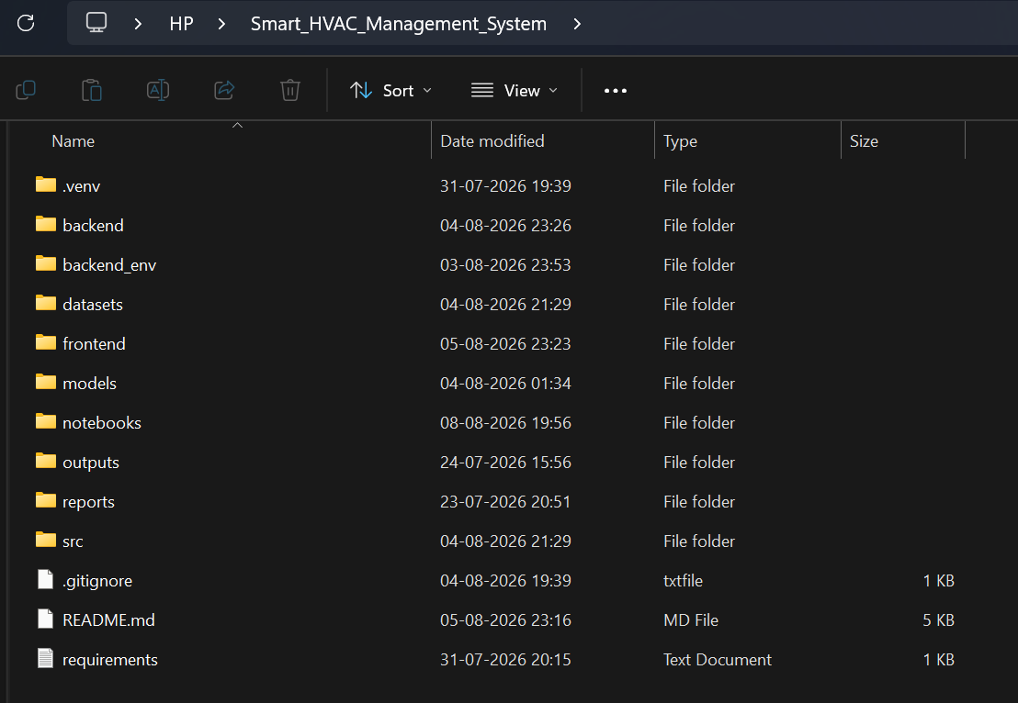

2. Dataset analysis notebook showing LBNL RTU and Building Genome dataset exploration.
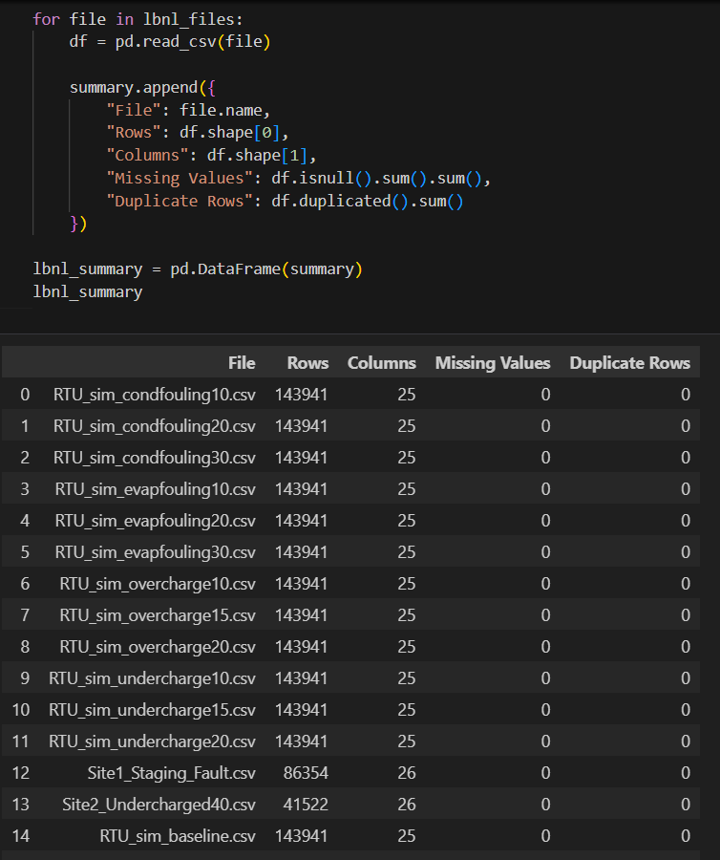

3. EDA output showing HVAC sensor statistics, class distribution or correlation analysis.
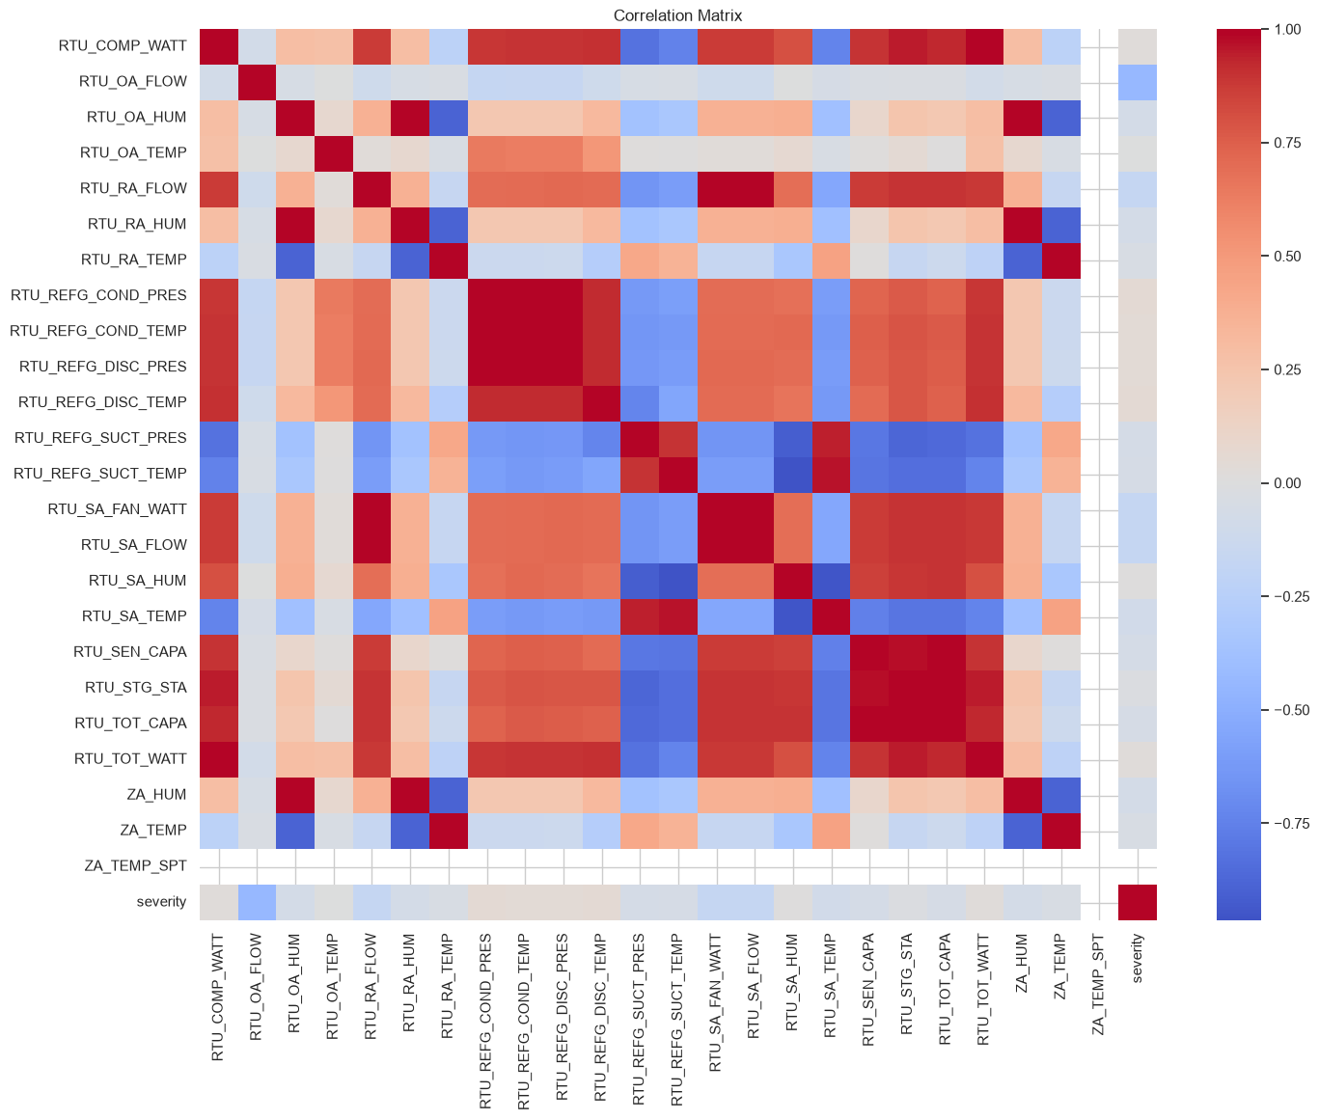

4. Fault model evaluation showing accuracy, precision, recall, F1-score and ROC-AUC.
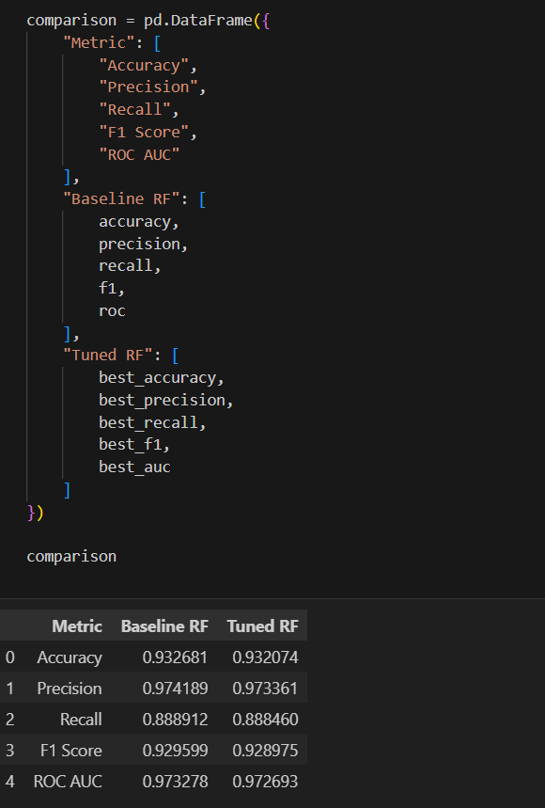

5. FastAPI/Swagger interface showing /predict/fault and /predict/energy requests.
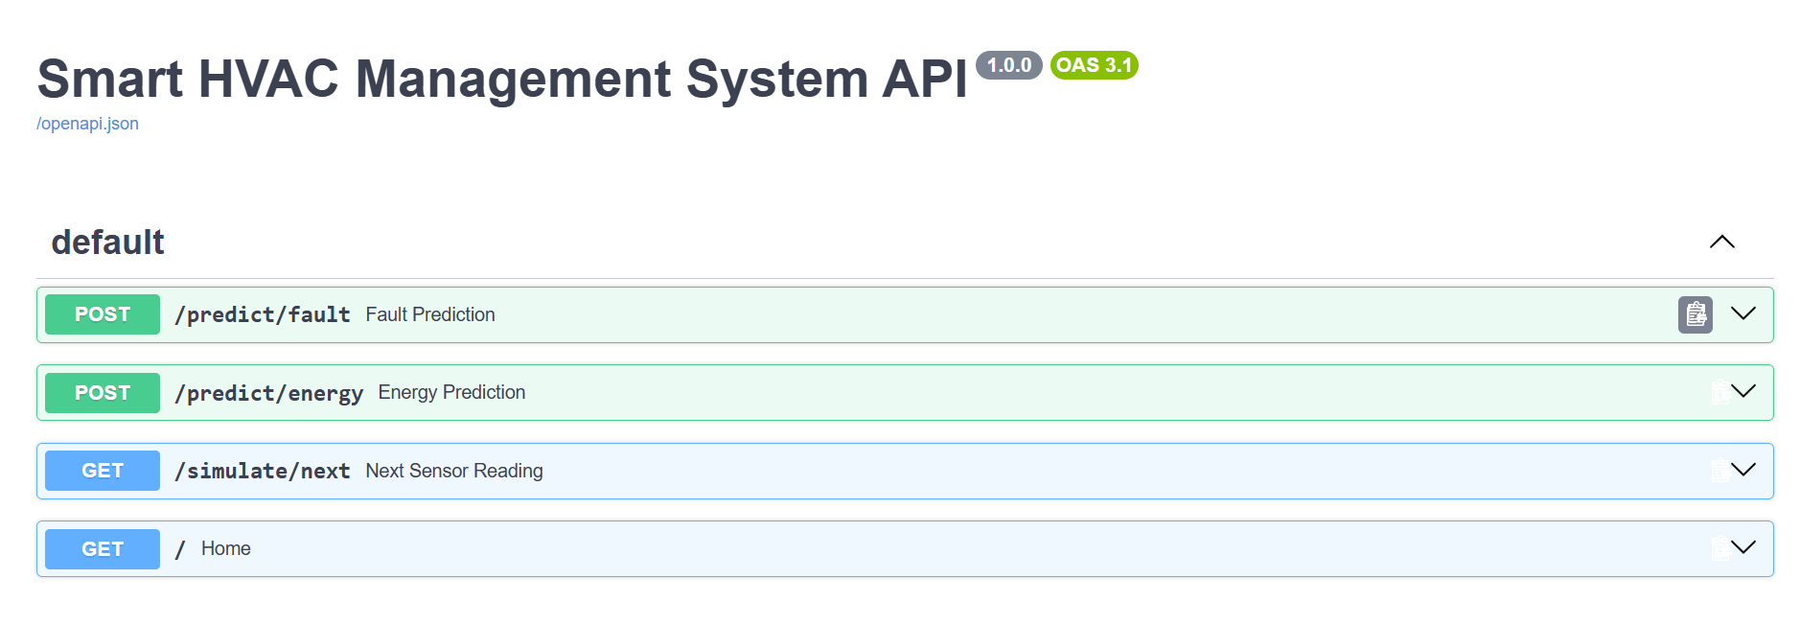
6. Main Smart HVAC dashboard.
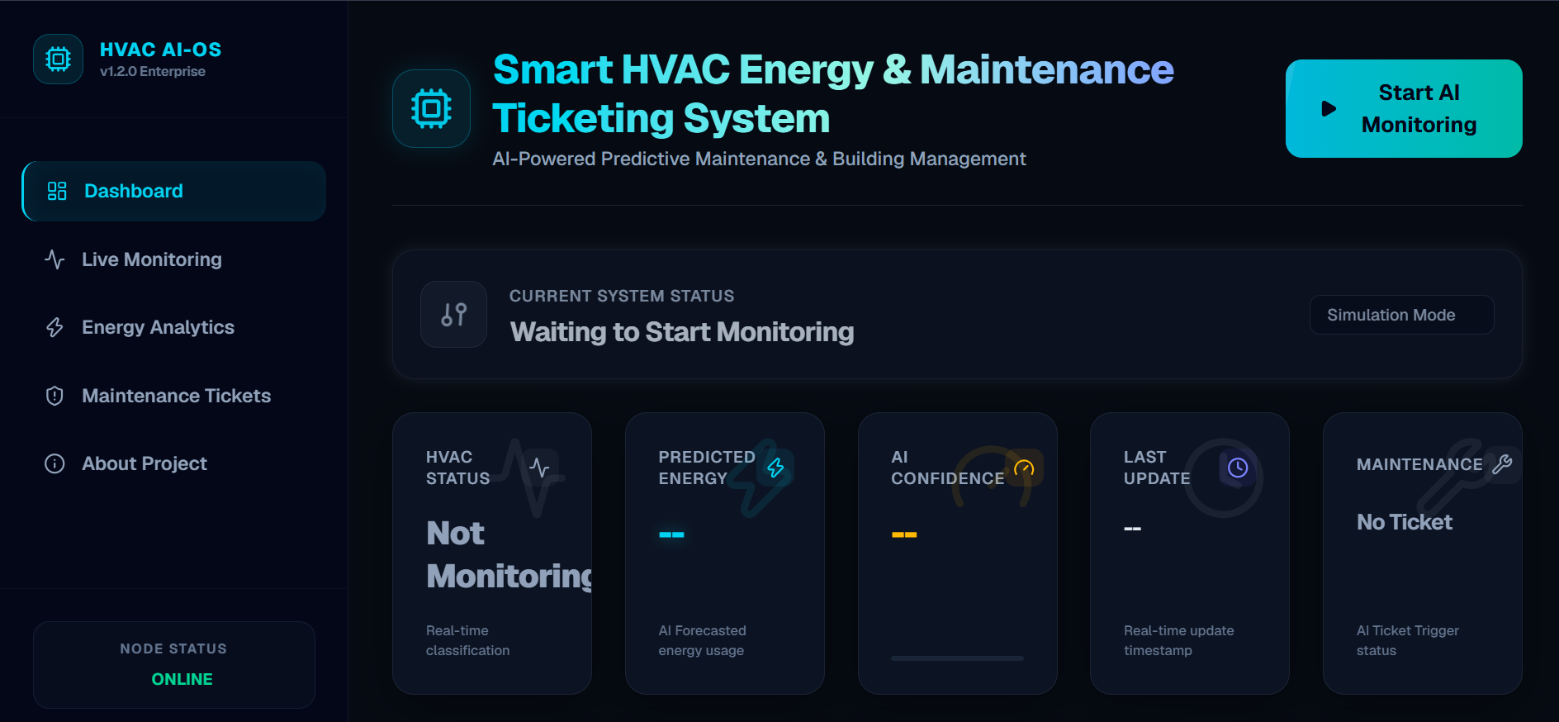

7. Live Monitoring page showing simulated sensor readings and system status.
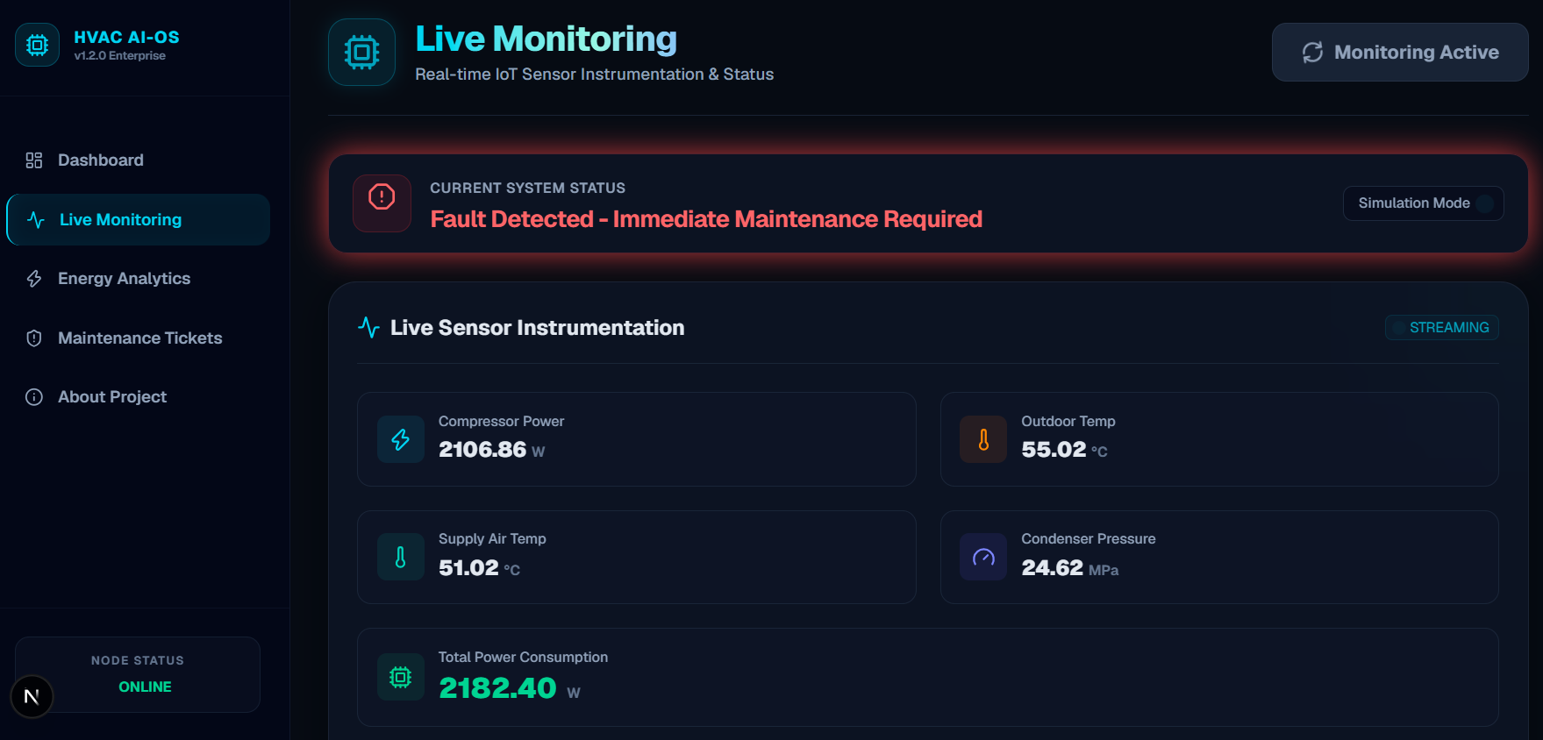
8. Energy Analytics page.
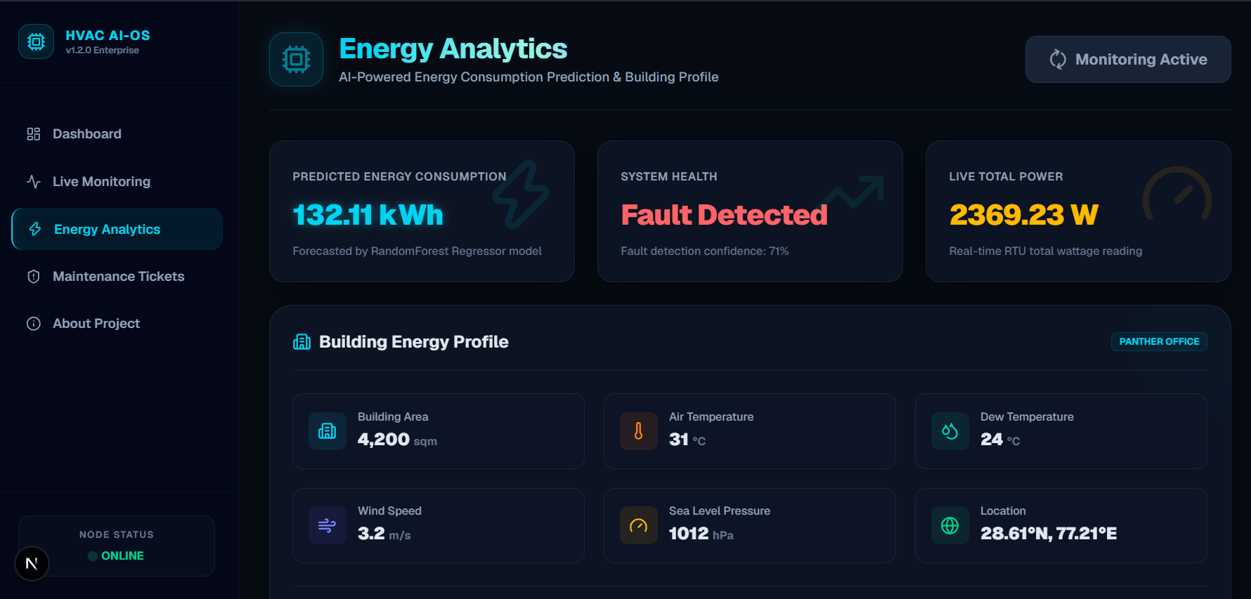

9. Maintenance Tickets page showing ticket status and maintenance protocols.
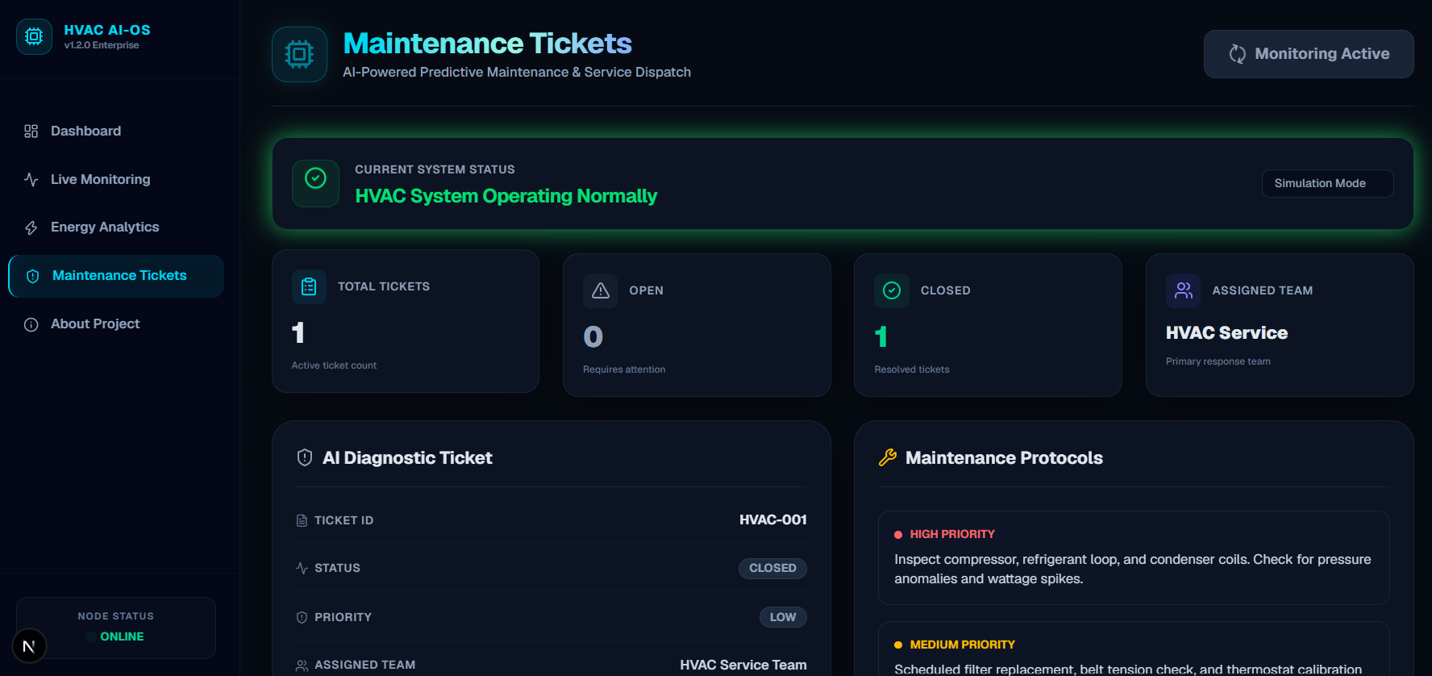

15. Testimonials from Team Members
Team Member 1: “This project strengthened my understanding of HVAC data analysis and showed how machine learning can be applied to real-world equipment monitoring.”
Team Member 2: “Working on the fault detection pipeline gave me practical experience in preprocessing, feature engineering, Random Forest classification and model evaluation.”
Team Member 3: “The energy prediction workflow helped me understand how electricity, building metadata and weather information can be combined for building analytics.”
Team Member 4: “Integrating FastAPI with the machine-learning models improved my understanding of how AI models are converted into application-ready services.”
Team Member 5: “Developing the dashboard and maintenance workflow helped me understand the importance of presenting AI predictions in a useful operational form.”
Team Member 6: “The team project improved my collaboration, debugging, documentation and end-to-end software development skills.”

16. Conclusion
The Smart-HVAC-Energy-Optimization-and-AI-Based-Industrial-Maintenance-and-Process Optimization-System demonstrates an end-to-end application of Artificial Intelligence and Machine Learning to HVAC monitoring and building energy analytics. The system combines Random Forest-based fault detection with energy-consumption prediction and connects both capabilities to a modern web application.
The project successfully brings together dataset analysis, preprocessing, exploratory analysis, feature engineering, machine-learning development, model evaluation, backend API integration and frontend visualization. The fault classifier achieved 93.27% test accuracy, 97.42% precision, 88.89% recall, 92.96% F1-score and 97.33% ROC-AUC in the documented baseline evaluation. The energy regression workflow reported a testing R² of approximately 0.9813 with MAE of 5.24 and RMSE of 33.70.
The final application further demonstrates how model predictions can be connected to live-monitoring simulation and maintenance-ticket workflows. Future development can extend the project toward real IoT sensor integration, continuous model monitoring, richer energy optimization strategies, explainable AI, automated work-order systems and deployment in a production Building Management System.

17. Acknowledgements
We express our sincere gratitude to Infosys Springboard for providing the learning environment, technical resources and internship framework that enabled us to work on this project.
We are thankful to our Project Mentor, Ms. Sangeetha Mahalingam, faculty members, peers and team members for their guidance, feedback, collaboration and continuous support throughout the project lifecycle.
We also acknowledge the open datasets and software libraries that supported the academic and technical development of the Smart HVAC system.

Appendix A – Technology Stack
Layer | Technologies
Frontend | Next.js, React, TypeScript, TailwindCSS, Axios, Recharts, Lucide React
Backend | FastAPI, Python, Pydantic
Machine Learning | Scikit-learn, Random Forest Classifier, Random Forest Regressor
Data Processing | Pandas, NumPy
Model Persistence | Joblib
Development / Analysis | Jupyter Notebooks, Python

End of Completion Report

