Dataset Approach

Dataset Description
This project uses a small-scale dataset derived from the DAQA (Audio Question Answering) dataset introduced by Fayek and Johnson for temporal reasoning over audio. The original DAQA dataset was designed to evaluate question answering systems that must reason over events occurring in audio narratives.
For this project, a reproducible local subset was constructed from the publicly available DAQA audio resources. The purpose of creating this subset was to provide a manageable dataset for developing and evaluating the proposed Audio Context Layer while maintaining separate training, validation, and test splits.
Dataset Composition
The project dataset contains 60 audio samples and 714 question-answer pairs distributed across the three splits:
Split Audio Samples QA Pairs
Train 40 475
Validation 10 123
Test 10 116
Total 60 714
The dataset contains four categories of questions:
- What questions – identify the event or sound present in the audio.
- Counting questions – determine how many times a particular event occurs.
- Temporal questions – reason about the order or temporal relationship between events.
- Causal questions – identify the environmental or contextual condition associated with an event.
The final answer vocabulary contains 20 answer classes, including numerical answers and event/environment categories such as crowd events, door sounds, phone ringing, and human whistling.
Data Organization
The released dataset is organized into separate training, validation, and test directories. Each split contains:
- audio/ – audio files used as model inputs.
- narratives/ – corresponding narrative descriptions.
- QA annotations are provided separately as JSON files for each split.
The QA annotation files contain the question, corresponding audio/narrative identifier, question type, and ground-truth answer. This format allows the dataset to be directly used for training and evaluation.
Dataset Generation and Reproducibility
The subset was generated using project-provided Python scripts with fixed random seeds. The train, validation, and test splits are generated independently and are kept consistent across audio, narrative, and question-answer annotations.
The dataset generation process and annotation format are documented in the accompanying README, and the scripts required to reproduce the dataset are included in the project repository.
Relationship to the Original DAQA Dataset
This dataset should not be considered a replacement for the full official DAQA benchmark. Instead, it is a small, reproducible DAQA-style subset created for this research prototype. The reduced size makes experimentation feasible while retaining the key question types and reasoning structure required by the project.
The original DAQA dataset and its associated resources are credited to the original authors. This project uses the publicly available resources as the basis for constructing its experimental subset.

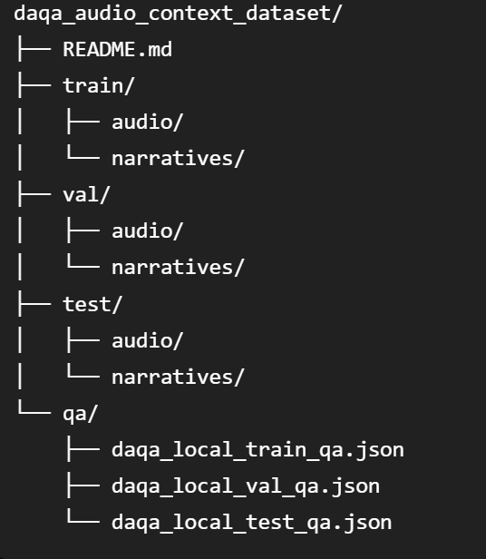

train/val/test splits + documentation on data format
Important
Your dataset is relatively small:
- 60 generated WAV files
- 714 QA pairs
- 40 train audio
- 10 validation audio
- 10 test audio

