**ASSIGNMENT-1**

**GIT_Assignment**

**Section-0**

***GIT installed and added to the path in local system.***

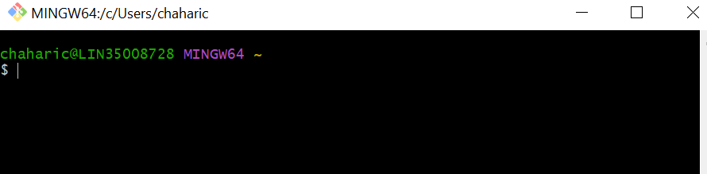

***1.created a directory ‘project_ dir ’ & cd to ‘project _dir ’.***

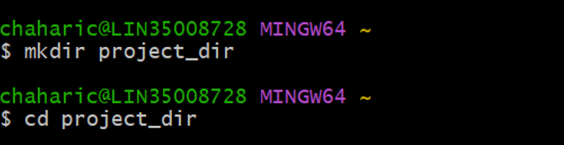

***2.Initialized git version database.***

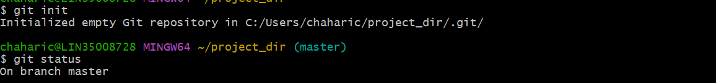

***3.Created a new file index.html.***

***Path : This pc – users – chaharic - project_dir - index.html.***

***4.Checked the git status and found that html file is listed as a untracked file.***

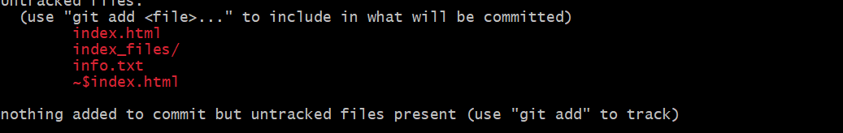

***5.Staged the index.html file.***

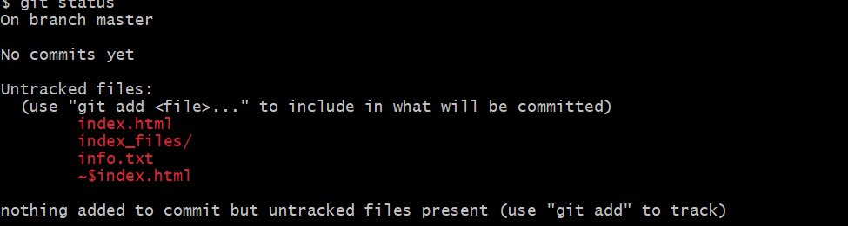

***6.Commit index.html.***

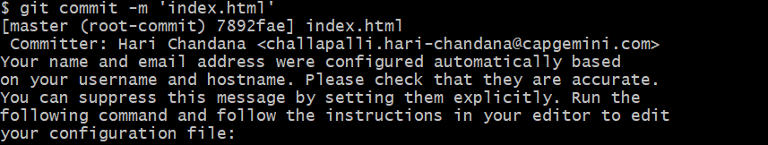

***7.Make a few changes in index.html file &create a new file info.txt file.***

***Path: This pc_users_chaharic_project-dir_info.txt.***

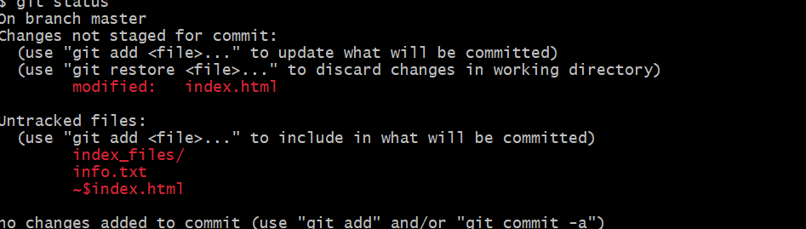

***8.Check git status you should find index.html and info.txt as untracked files.***



***9.Configured git to ignore all files.***

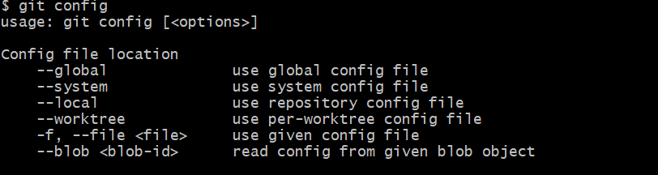

***10.Again check git status you should find only index.html as untracked file.***

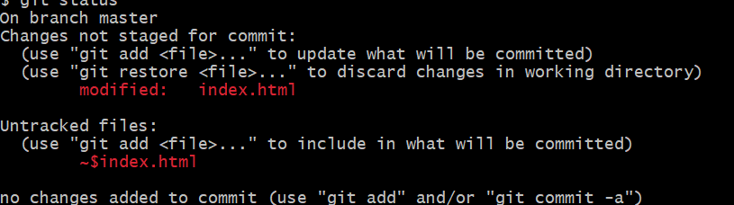

***11.State & commit index.html.***

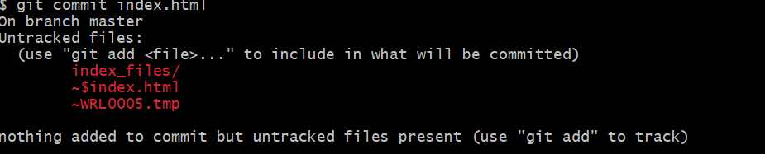

***12.Rename add command to my add.***

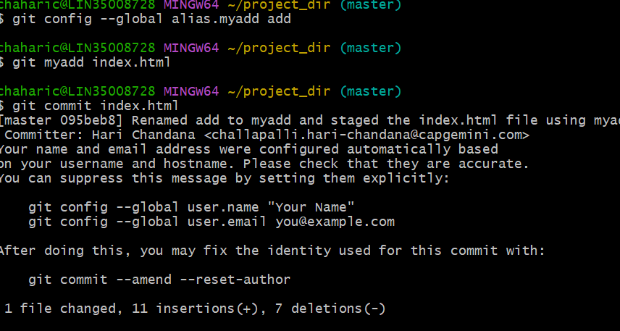

c

***Git Branching***

***Section-1(Html Assignments)***

***21.First take a backup of your assignments & projects.this is required because incorrect git operation you may loose your files.***

***22.Create an empty directory assignments & cd to assignments.***

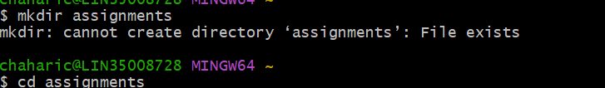

***23.Create a file Readme.txt inside Assignments and write few lines about the contents of Assignments folder.***

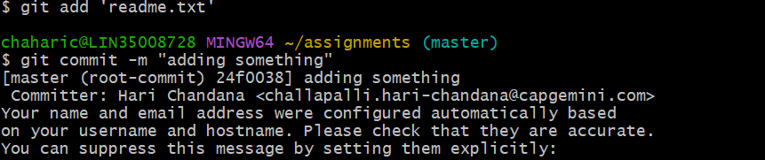

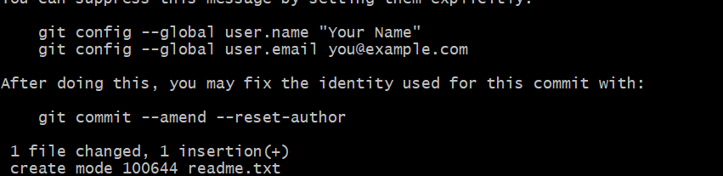

***24.Commit Readme.txt file.***

***$ git commit -m ‘Some new lines are added’.***

***25.Now create a new branch ‘html-assignments’.***



***26.Switch to html-assignments branch.***



***27.Copy all html-assignments inside Assignments folder.***

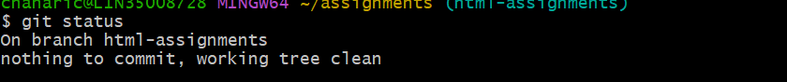

***28.Commit Html-assignments into html assignments branch.***

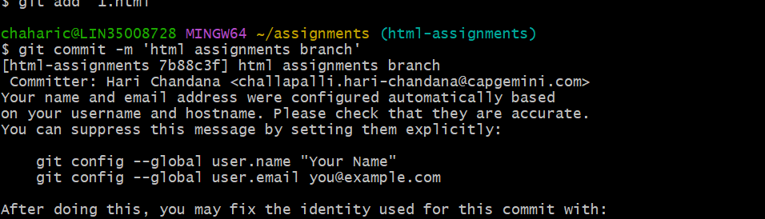

***29.Make minor changes into few files belonging to ‘html-assignments’ branch.***

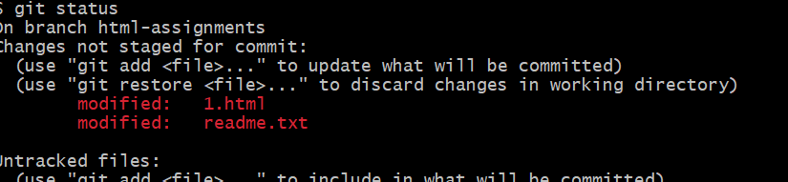

***30.Commit those changes.***

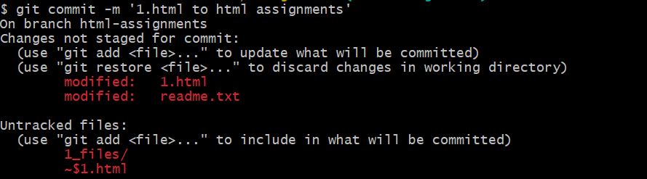

***31.Switch to master branch.***

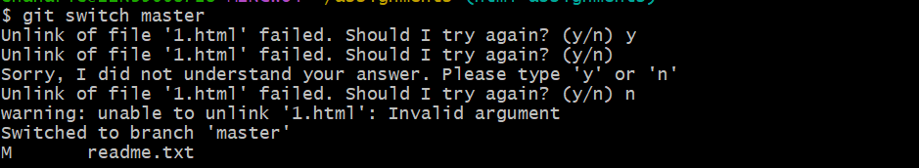

***32.Make minor changes in readme.txt file and &commit those changes.***

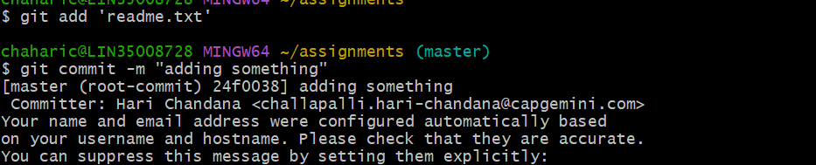

***33.Again switch to ‘html-assignments’ branch.***



***34.Make minor changes in few files belonging to ‘html-assignments’ branch. commit those changes.***

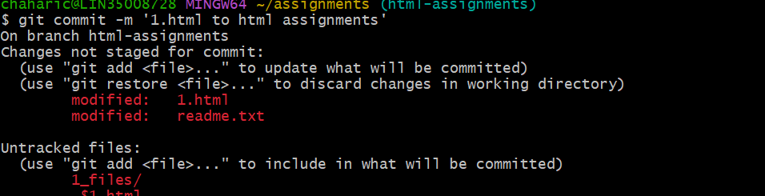

***35.Switch to master.***



***36.Finally delete the html-assignments branch.***

***$ git branch -d ‘html-assignments’.***

***Section-2(CSS-Assignments)***

***1.Create a new branch ‘ css – assignments ’.***



***2.Switch to css – assignments branch.***



***3.copy all css – assignments into assignments folder and commit the changes.***

***Copid into assignments folder.***

***4.Make minor changes into readme.txt file and commit those changes.***

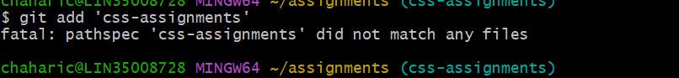

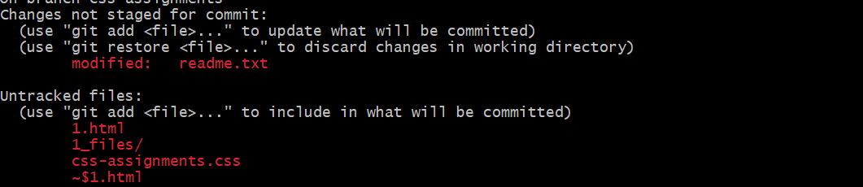

***5.Commit those changes.***

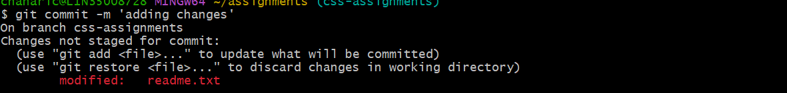

***6.Switch to master branch.***



***7.Make a few changes on Readme.txt and commit those changes to master.***

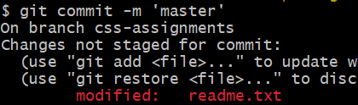

***8.Again switch to css - assignments branch.***



***9.Make minor changes in few files belonging to css – assignments branch and commit those changes.***

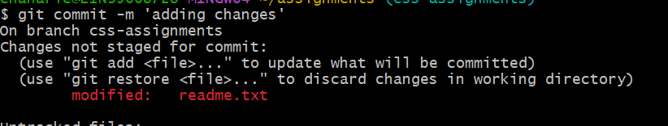

***10.Switch to master.***

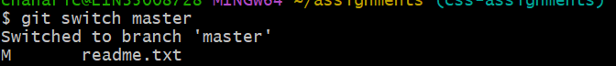

***11.Merge css-assignments into master .***

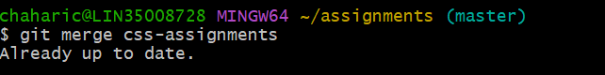

***12.Finally delete the css – assignments branch.***



***Section-3(Javascript-assignments)***

***1.Create a new branch ‘js - assignments’.***



***2.Switch to js - assignments branch.***

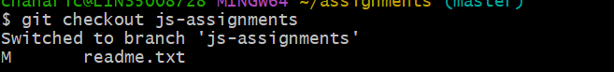

***3.Copy all javascipt assignments inside assignments folder and commit the changes made.***

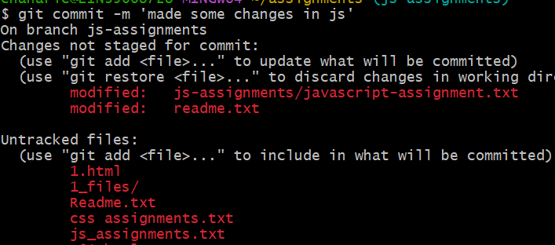

***4.Switch to master branch.***



***5.Make some changes in readme.txt file and commit those changes.***

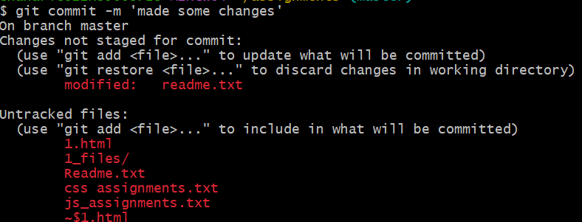

***6.Again switch to js-assignments branch.***

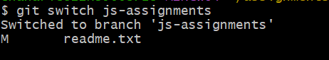

***7.Make minor changes in few files belonging to js – assignments branch and commit those changes.***

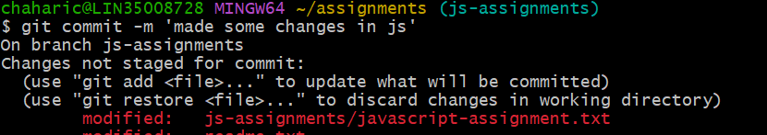

***8.Switch to master.***

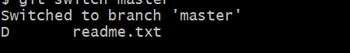

***9.Merge all js – assignments and finally delete the js – assignments branch.***



***GIT REMOTING***

***Section-3(Pushing assignments to remote repository)***

***39.Created a Git hub account.***



***40.login on into git hub account. Created a new public Repository ‘freshersbatch’.***

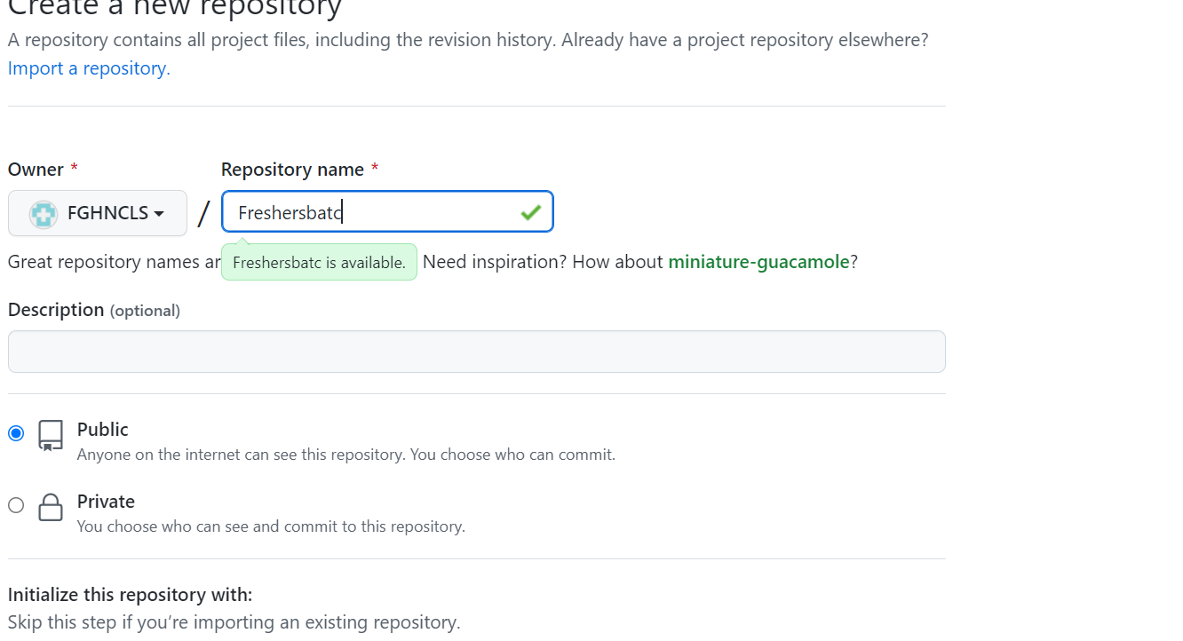

***41.Commited& pushed 1.html file under Assignments directory.***

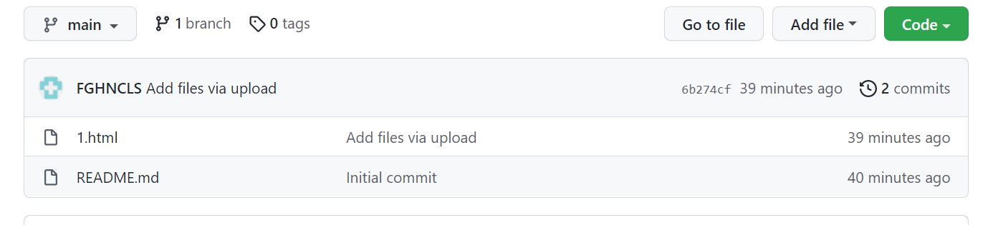

***s***