BRAIN TUMOR CLASSIFICATION
A Project Report submitted in partial fulfillment of the requirements
for the award of the degree of


BACHELOR OF TECHNOLOGY
in
COMPUTER SCIENCE AND ENGINEERING
(Specialization in Artificial Intelligence & Machine Learning)

Submitted by
AKSHAT VASHISTH (VU22CSEN0300234)
MANIKONDA SATYA VARDHAN (VU22CSEN0300205)
MUPPASANI SHRUTHIKKA (VU22CSEN0300300)

Under the esteemed guidance of
Dr. Milan Kumar Dholey
Assistant Professor



Department of Artificial Intelligence and Data Science
GITAM School of Computer Science and Engineering
GITAM (Deemed to be University)
Visakhapatnam
2026

Department of Artificial Intelligence and Data Science
YEAR
GITAM School of Computer Science and Engineering
GITAM (Deemed to be University)
Visakhapatnam


DECLARATION

We, hereby declare that the project report entitled BRAIN TUMOR CLASSIFICATION is an original work done in the Department of Artificial Intelligence and Data Science, GITAM School of CSE, GITAM (Deemed to be University) submitted in partial fulfillment of the requirements for the award of B.Tech Degree in Computer Science and Engineering (Specialization in Artificial Intelligence and Machine Learning).

The work has not been submitted to any other college or University for the award of any degree or diploma.

Date: 06-04-2026
Registration Nos Names Signature
VU22CSEN0300234 AKSHAT VASHIST
VU22CSEN0300205 MANIKONDA SATYA VARDHAN
VU22CSEN0300300 MUPPASANI SHRUTHIKKA
Department of Artificial Intelligence and Data Science
GITAM School of Computer Science and Engineering
GITAM (Deemed to be University)
Visakhapatnam


CERTIFICATE

This is to certify that the project report entitled “BRAIN TUMOR CLASSIFICATION” is a bonafide record of work carried out by Akshat Vashisth (VU22CSEN0300234), Manikonda Satya Vardhan (VU22CSEN0300205), Muppasani Shruthikka (VU22CSEN0300300), students of this department submitted in partial fulfillment of requirements for the award of B.Tech Degree in Computer Science and Engineering (Specialization in Artificial Intelligence and Machine Learning).

Date: 06-04-2026

Project Guide Head of the Department
Dr. Milan Kumar Dholey Kuppili Naveen Kumar
(Assistant Professor) Associate Professor, HOD
Department of Artificial Intelligence and Data science
ACKNOWLEDGEMENT
We express our sincere gratitude to Dr. Milan Kumar Dholey, Assistant Professor, Department of Computer Science Engineering, for his valuable guidance, continuous support, and encouragement throughout the development of our capstone project titled “Brain Tumor Classification”. His insightful suggestions, motivation, and constant supervision greatly contributed to the successful completion of this work.
We extend our heartfelt thanks to our reviewers, Dr. Kollati Vijaya Kumar, Associate Professor, Department of Computer Science Engineering, and Dr. Surada Amarnadh, Assistant Professor, Department of Computer Science Engineering, for their constructive feedback, evaluation, and valuable recommendations during the review process. Their inputs helped us refine and strengthen our project.
We are grateful to the Department of Artificial Intelligence and Data Science, GITAM School of CSE, GITAM (Deemed to be University), for providing the resources, academic environment, and facilities required for carrying out this project. We also thank the faculty members and friends who have supported us throughout this work.

TABLE OF CONTENTS

S. No. | Description | Page No.
1. | Abstract | 1
2. | Introduction | 2
3. | Literature Review | 3
4. | Problem Identification & Objectives | 6
5. | Existing System | 7
6. | Proposed System | 9
7. | System Architecture | 10
8. | Tools/Technologies Used | 12
9. | Implementation & Results | 13
10. | Conclusion | 16
11. | References | 17

ABSTRACT
Brain tumors are among the most critical neurological disorders, where early and accurate diagnosis is essential for effective treatment. This project presents a deep learning-based system for automated brain tumor classification and localization using MRI images. Advanced convolutional neural networks, including EfficientNetB0 and DenseNet121, are utilized to perform both binary and multiclass classification of brain tumors. Additionally, a prototype-based neural network (ProtoPNet) is incorporated to enhance interpretability by providing visual explanations for model predictions. To improve overall reliability, a voting-based approach combines outputs from multiple models and selects the most confident prediction as the final result. Alongside classification, a tumor highlighting mechanism is implemented using classical image processing techniques such as grayscale conversion, Gaussian blurring, binary thresholding, and contour detection to identify and visualize tumor regions within MRI scans. The proposed system achieves strong performance in accurately classifying tumor types while offering visual insights into affected areas. By integrating deep learning with traditional image processing methods, this approach provides a practical and effective tool for assisting medical professionals in brain tumor diagnosis, with future scope for incorporating advanced segmentation techniques for improved localization.

INTRODUCTION
Brain tumors represent one of the most serious and life-threatening neurological conditions, requiring timely and accurate diagnosis to improve patient outcomes. Magnetic Resonance Imaging (MRI) is widely used for detecting brain abnormalities due to its high-resolution imaging capability and non-invasive nature. Traditionally, tumor detection and classification rely heavily on the expertise of radiologists, which can be time-consuming, subjective, and prone to inter-observer variability, especially when dealing with large volumes of medical data. With the rapid advancement of artificial intelligence, several automated systems have been developed to assist in tumor diagnosis. Early approaches primarily used traditional machine learning techniques with handcrafted features; however, these methods often lacked robustness and generalization. More recently, deep learning models, particularly Convolutional Neural Networks (CNNs), have demonstrated significant improvements in image classification tasks, including medical imaging.
Various existing systems utilize architectures such as VGG, ResNet, and U-Net for tumor detection and segmentation. While these models achieve high accuracy, many of them function as “black boxes,” offering limited interpretability, which is a critical requirement in the medical domain. Furthermore, most systems focus either on classification or segmentation independently, lacking an integrated approach that combines accuracy with explainability and practical visualization. This creates a need for a comprehensive system that not only classifies brain tumors accurately but also provides insights into the decision-making process and highlights the affected regions.
The proposed project, titled “Brain Tumor Classification,” aims to address these challenges by developing a robust and interpretable framework that integrates multiple deep learning models with traditional image processing techniques. By leveraging advanced architectures such as EfficientNetB0 and DenseNet121 for classification, along with a prototype-based model (ProtoPNet) for explainability, the system enhances both performance and transparency. Additionally, a tumor highlighting mechanism using classical image processing methods is incorporated to visually identify tumor regions in MRI images. This integrated approach justifies the need for the proposed system, as it combines accuracy, interpretability, and practical usability, ultimately supporting medical professionals in making faster and more reliable diagnostic decisions.
LITERATURE REVIEW
Tan et al. [1] introduced EfficientNet, a family of convolutional neural networks (CNNs) that achieve state-of-the-art performance through a compound scaling method. This method uniformly scales network depth, width, and resolution to optimize accuracy and computational efficiency. EfficientNetB0, the base model, demonstrated superior performance on benchmark datasets like ImageNet while requiring fewer parameters compared to traditional architectures. The study highlighted the importance of balanced scaling in improving model efficiency, making EfficientNetB0 particularly suitable for resource-constrained applications, including medical imaging. However, the fixed scaling factors may limit adaptability to datasets with unique characteristics, such as varying MRI image resolutions.
Huang et al. [2] proposed DenseNet, an architecture that introduces dense connectivity between layers to mitigate the vanishing gradient problem and improve feature reuse. DenseNet121, a variant of this architecture, achieved high accuracy on image classification tasks by concatenating feature maps from all preceding layers. This design reduced parameter redundancy and enhanced gradient flow, leading to more efficient training. The study demonstrated DenseNet121’s effectiveness in capturing fine-grained features, making it well-suited for medical imaging tasks like brain tumor classification. However, the increased memory consumption due to dense connections may pose challenges in deployment on low-resource devices.
Chen et al. [3] developed ProtoPNet, a prototype-based neural network that enhances interpretability by comparing input images to learned prototypes. Unlike traditional CNNs, ProtoPNet provides visual explanations for predictions, making it highly suitable for medical applications where transparency is critical. The model achieved competitive accuracy on benchmark datasets while offering clear insights into decision-making processes. However, ProtoPNet’s reliance on prototype similarity may limit its performance in scenarios with high intra-class variability, such as diverse brain tumor appearances in MRI scans.
Islam et al. [4] evaluated EfficientNetB0 for brain tumor classification using transfer learning. By leveraging pre-trained weights from ImageNet, the model achieved high accuracy on MRI datasets with limited labeled data. The study demonstrated that fine-tuning EfficientNetB0 significantly outperformed traditional CNNs, highlighting its potential for medical imaging applications. However, the model’s performance was sensitive to dataset size and quality, and further optimization was required to handle class imbalances in brain tumor datasets.
Pereira et al. [5] conducted a comparative analysis of DenseNet121 and ResNet for brain tumor segmentation. DenseNet121 outperformed ResNet due to its dense connectivity, which preserved spatial information and improved feature propagation. The study emphasized DenseNet121’s ability to capture intricate tumor boundaries, making it ideal for segmentation tasks. However, the computational overhead of dense connections remained a challenge, particularly for real-time applications in clinical settings.
Naseer et al. [6] presented an optimized EfficientNet-B0 framework for multi-class brain tumour detection and classification from MRI images. They fine-tuned the EfficientNet-B0 architecture to accurately classify three major tumor types — glioma, meningioma, and pituitary tumors. The model leveraged the compound scaling benefits of EfficientNet for efficient feature extraction while maintaining low computational cost. The study reported robust classification performance on publicly available MRI datasets. Nevertheless, the optimization process was mostly manual, and the model lacked built-in interpretability mechanisms, making it difficult for clinicians to understand the basis of its predictions.
Onah et al. [7] introduced Deep Brain Net, an optimized deep learning model for brain tumor detection in MRI images using EfficientNetB0 and ResNet50 with transfer learning. Their hybrid architecture combined the parameter efficiency of EfficientNetB0 with the residual learning capability of ResNet50 to improve generalization and reduce training time. The model showed promising results in binary and multi-class tumor detection tasks. However, the increased complexity of the hybrid design raised computational demands during inference, and the study did not deeply explore the model’s robustness against noisy or low-quality MRI scans.
Jiven and Rumini [8] developed an MRI classification system for brain tumors by using EfficientNetB0 for feature extraction followed by traditional machine learning classifiers. This hybrid approach extracted deep features from EfficientNetB0 and fed them into conventional algorithms for final classification. The method achieved competitive accuracy with reduced training complexity compared to end-to-end deep models. A limitation of their work was the dependency on the quality of extracted features; any degradation in the pre-trained EfficientNetB0 backbone significantly affected downstream classifier performance.
Rasheed et al. [9] proposed an improved brain tumor classification approach through DenseNet121-based transfer learning. They utilized the dense connectivity pattern of DenseNet121 to extract rich hierarchical features from MRI scans and classify tumors into glioma, meningioma, pituitary, and healthy categories. The model achieved strong performance metrics across accuracy, precision, recall, and F1-score on the Kaggle brain tumor dataset. One drawback was the relatively high number of parameters in DenseNet121, which increased memory usage and made real-time inference more challenging in clinical settings.
Mao et al. [10] introduced a dilated SE-DenseNet architecture based on DenseNet121 for brain tumor MRI classification. They enhanced the base DenseNet121 by integrating dilated convolutions for larger receptive fields and Squeeze-and-Excitation attention modules to focus on important feature channels. The modified model effectively classified glioma, meningioma, pituitary tumors, and no-tumor cases from T1-weighted MRI images. While the additions improved feature representation, they also increased model complexity and training time compared to the standard DenseNet121.
Wei et al. [11] proposed MProtoNet, a case-based interpretable model extending ProtoPNet for brain tumor classification with 3D multi-parametric MRI. Unlike traditional black-box CNNs, MProtoNet learns prototypes during training and classifies by comparing input patches to these learned prototypes, providing inherent explainability. The model demonstrated competitive accuracy along with improved localization coherence on 3D mpMRI data. The main limitation was the higher computational cost associated with prototype learning and the challenge of scaling the approach to very large 3D volumes.
Wei et al. [12] further refined their work on MProtoNet as a case-based interpretable model for brain tumor classification using 3D multi-parametric magnetic resonance imaging. They introduced attention modules with soft masking and an online clustering loss to enhance prototype quality and interpretability. The prototype-based reasoning allowed clinicians to visualize which learned tumor patterns most influenced the prediction. Although the model offered superior transparency compared to standard CNNs, it required careful tuning of prototype-related hyperparameters and showed slightly lower raw accuracy than some non-interpretable deep models on certain datasets.

PROBLEM IDENTIFICATION & OBJECTIVE
Problem Identification
The clinical diagnosis of brain tumors—specifically distinguishing between Gliomas, Meningiomas, and Pituitary tumors—presents a significant challenge due to the high morphological variability and subtle intensity overlaps inherent in MRI scans. While MRI is the gold standard for neuro-oncology, manual interpretation by radiologists is frequently hindered by high diagnostic volumes, subjective qualitative assessment, and significant inter-observer variability. Although modern Deep Learning architectures have achieved high classification accuracy, they predominantly function as "black boxes," offering a predictive label without providing the spatial reasoning or quantitative evidence required for surgical planning. Most existing automated systems focus strictly on categorical output, neglecting the critical need for precise tumor localization and physical measurement. This creates a dangerous diagnostic gap where a model may correctly identify a tumor type but fail to provide the major axis, minor axis, or total surface area necessary for assessing tumor progression or radiotherapy boundaries. Consequently, there is an urgent need for an integrated diagnostic framework that combines high-performance neural networks with transparent, prototype-based explainability and classical image processing for objective, real-world physical quantification.
Objectives of the Project
- To develop a deep learning-based model for accurate multi-class brain tumor classification (Glioma, Meningioma, Pituitary).
- To apply and compare advanced models such as EfficientNetB0, DenseNet121, and ProtoPNet to improve performance and reliability.
- To implement tumor localization using OpenCV techniques like contour detection and bounding box estimation.
- To provide interpretability and visual insights to support faster and more reliable medical diagnosis
- Implementation of voting-based ensemble learning to improve generalization and reduce variance

EXISTING SYSTEM
A study of Iqbal et al. (2024) proposed paper showed an advanced deep learning-based system for brain tumor classification using the EfficientNet-B0 architecture. The system utilizes MRI images as input and applies transfer learning to improve classification performance across four categories: glioma, meningioma, pituitary tumor, and no tumor. The model consists of approximately 241 layers and incorporates key components such as Mobile Inverted Bottleneck Convolution (MBConv) blocks and squeeze-and-excitation mechanisms to enhance feature extraction efficiency. To adapt the pretrained network to the medical domain, the final layers were modified by adding global average pooling, dropout regularization, and a softmax classification layer.
The system follows a structured pipeline that includes preprocessing, feature extraction, classification, and evaluation. MRI images are first resized and normalized before being passed through the EfficientNet model for deep feature extraction. The extracted features are then used for classification using fully connected layers. Performance evaluation is carried out using metrics such as accuracy, precision, recall, F1-score, and confusion matrix analysis. The proposed system achieved an impressive classification accuracy of around 99%, outperforming several traditional CNN models such as ResNet and basic EfficientNet variants.
Similarly, other studies have utilized DenseNet121 with transfer learning to improve feature propagation and classification performance. DenseNet-based systems leverage dense connectivity between layers, allowing better gradient flow and feature reuse, which results in improved diagnostic accuracy and faster convergence.
Drawbacks of the Existing System
Firstly, one of the major limitations of existing systems is the absence of tumor localization, as most models primarily focus on classification and fail to provide information about the tumor’s exact location, size, or shape within the MRI image. While classification helps in identifying the type of tumor, it does not offer spatial insights that are essential for diagnosis, treatment planning, and surgical procedures. Without clear visualization of the tumor region, medical professionals cannot fully rely on these systems for practical clinical use, reducing their overall effectiveness.
Secondly, these deep learning models often involve high computational complexity, as architectures like EfficientNet and DenseNet require significant processing power, memory, and training time. They typically depend on high-end GPUs or specialized hardware to achieve optimal performance, which may not be available in smaller hospitals or resource-constrained environments. This limits their accessibility and scalability, making it challenging to deploy such systems in real-world healthcare systems
Thirdly, limited generalization remains a critical issue in many existing approaches, as models are often trained on specific datasets that may not represent the variability found in real-world MRI scans. Differences in imaging protocols, scanner types, noise levels, and patient demographics can significantly affect model performance. As a result, a model that performs well on one dataset may produce inconsistent or inaccurate results when applied to data from different sources, thereby reducing its reliability and robustness.
Finally, there is a lack of integrated systems in current research, as most existing approaches focus solely on classification and do not combine multiple functionalities such as explainability, tumor localization, and decision support into a single framework. This fragmented approach limits their practical usability, as clinicians require systems that not only provide accurate predictions but also offer visual explanations and actionable insights. The absence of such integrated solutions highlights the need for more comprehensive and clinically oriented systems in brain tumor diagnosis.

PROPOSED SYSTEM
The proposed system presents a comprehensive and integrated framework for brain tumor classification and localization using MRI images, combining the strengths of deep learning and traditional image processing techniques. The system is designed to accurately classify brain tumors into multiple categories, including glioma, meningioma, and pituitary tumors, while also providing visual insights into tumor regions to support clinical decision-making. The overall architecture consists of several key stages: data preprocessing, feature extraction, classification using multiple deep learning models, model fusion through a voting mechanism, and tumor localization using classical computer vision techniques.
In the preprocessing stage, MRI images are resized, normalized, and enhanced to ensure consistency and improve model performance. The processed images are then fed into multiple deep learning models, including EfficientNetB0 and DenseNet121, which are used for feature extraction and classification. These models leverage transfer learning, allowing them to utilize pretrained weights and adapt effectively to the medical imaging domain.
To enhance interpretability, the system incorporates a prototype-based neural network (ProtoPNet), which provides visual explanations by comparing input image regions with learned prototypes. Furthermore, a voting-based mechanism is implemented to combine the predictions from multiple models, selecting the most confident output as the final classification result. This ensemble approach improves overall robustness and reduces the likelihood of incorrect predictions.
In addition to classification, the proposed system includes a tumor localization module implemented using traditional image processing techniques in OpenCV. This module performs grayscale conversion, Gaussian blurring, and binary thresholding to segment potential tumor regions. Contour detection is then applied to identify the tumor boundaries, followed by bounding box extraction and ellipse fitting to estimate the tumor’s size, shape, and position within the MRI image. This provides valuable spatial information that can assist in diagnosis and treatment planning. Overall, the proposed system addresses the limitations of existing approaches by integrating accurate classification, interpretability, and tumor localization into a single unified framework.

SYSTEM ARCHITECTURE
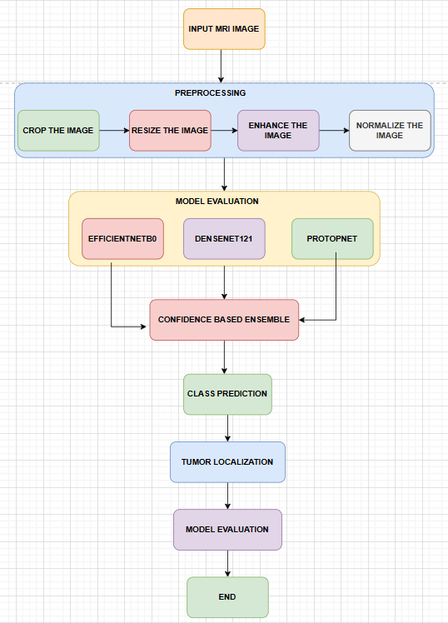
The Brain Tumor Classification and Localization Project begins with the merging and preprocessing of diverse MRI datasets to create a comprehensive and balanced collection of brain tumor images, encompassing glioma, meningioma, pituitary tumors, and non-tumor cases. This step is crucial for ensuring the system’s robustness and generalizability, as it addresses the common issue of dataset imbalance and variability in imaging protocols across different sources. The merged dataset undergoes rigorous preprocessing, including resizing, normalization, to enhance image quality and prepare the data for deep learning model training. Techniques such as contrast enhancement and noise reduction are applied to improve feature extraction and ensure consistency across the dataset.
Following preprocessing, the project employs a multi model deep learning framework that integrates EfficientNetB0, DenseNet121, and ProtoPNet for multi-class tumor classification. EfficientNetB0, with its compound scaling method and Mobile Inverted Bottleneck Convolution (MBConv) blocks, is fine-tuned using transfer learning to adapt the pre-trained ImageNet weights to the specific characteristics of brain tumor MRI images. This model excels in feature extraction efficiency and computational performance, making it ideal for handling high-resolution medical images. DenseNet121, on the other hand, leverages dense connectivity between layers to improve gradient flow and feature reuse, resulting in faster convergence and higher classification accuracy. The inclusion of ProtoPNet further enhances the system’s interpretability by providing visual explanations for model predictions, allowing clinicians to understand the basis of the classification decisions. To improve overall performance and reliability, a voting-based ensemble approach is implemented, where predictions from all models are combined, and the final output is selected based on the highest confidence score.
To complement the classification pipeline, the project incorporates traditional computer vision techniques using OpenCV for tumor localization and visualization. After the deep learning models classify the tumor type, OpenCV-based algorithms are applied to segment and highlight tumor regions within the MRI scans. This involves contour detection, bounding box calculation, and ellipse fitting to estimate the tumor’s size, shape, and precise location. The localization module generates visual outputs that clearly demarcate tumor boundaries, providing clinicians with actionable spatial insights critical for treatment planning, surgical guidance, and patient prognosis.
The final output of the system includes both the predicted tumor class and a visually highlighted tumor region, providing comprehensive diagnostic information. The integration of classification and localization into a single framework addresses a major gap in existing systems, which often focus solely on classification without offering spatial context. By combining high classification accuracy, precise localization, and model interpretability, the project delivers a comprehensive, clinically practical solution that supports faster and more reliable brain tumor diagnosis. Ultimately, this system aims to enhance diagnostic confidence, improve treatment outcomes, and streamline clinical workflows in neuro-oncology.

TOOLS & TECHNOLOGIES USED
- Google Colab / Jupyter Notebook
Google Colab and Jupyter Notebook were used as the primary development and execution environments for building, training, and testing the deep learning models.
- Programming Language: Python
Python is the primary programming language used because of its strong ecosystem supporting machine learning, deep learning, and scientific computation.
- Deep Learning Frameworks: TensorFlow and PyTorch
TensorFlow (with Keras) is used to implement and train models such as EfficientNetB0 and DenseNet121, while PyTorch is used for implementing the ProtoPNet model, enabling both high-performance training and flexibility in model development.
- Computer Vision Library: OpenCV
OpenCV is used for tumor localization and image processing tasks, including grayscale conversion, Gaussian blurring, thresholding, contour detection, bounding box extraction, and ellipse fitting to identify tumor regions.
- Machine Learning Libraries: Scikit-learn
Scikit-learn is utilized for data preprocessing, performance evaluation, and generating metrics such as confusion matrix, accuracy, precision, and recall.
- Data Handling Libraries: Pandas and NumPy
Pandas and NumPy are used for handling datasets, managing image labels, performing numerical computations, and supporting efficient array operations
- Visualization Tools: Matplotlib and Seaborn
Matplotlib and Seaborn are used to visualize training results such as accuracy and loss curves, confusion matrices, and sample predictions, helping in better understanding and evaluation of model performance.
- Image Processing Libraries: PIL (Python Imaging Library)
PIL is used for image loading, resizing, and preprocessing tasks before feeding images into deep learning models.
- Version Control: GitHub
GitHub is used for version control, code management, and collaboration. It ensures proper tracking of changes and provides a centralized repository for the project.

IMPLEMENTATION & RESULTS
EfficientNetB0 Model Multiclass Classification
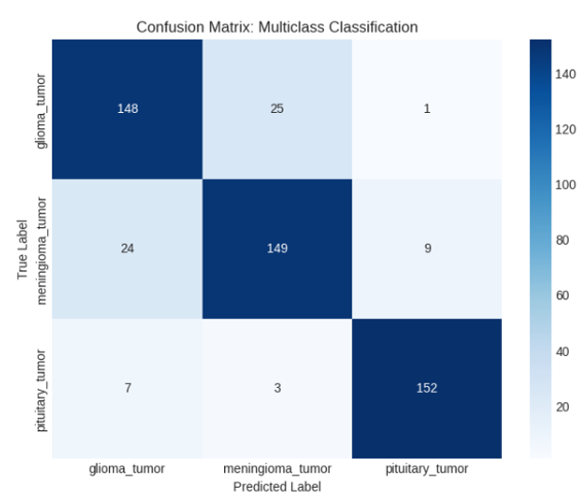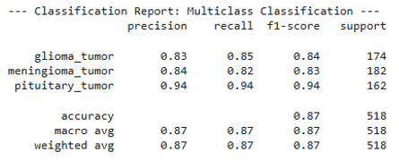
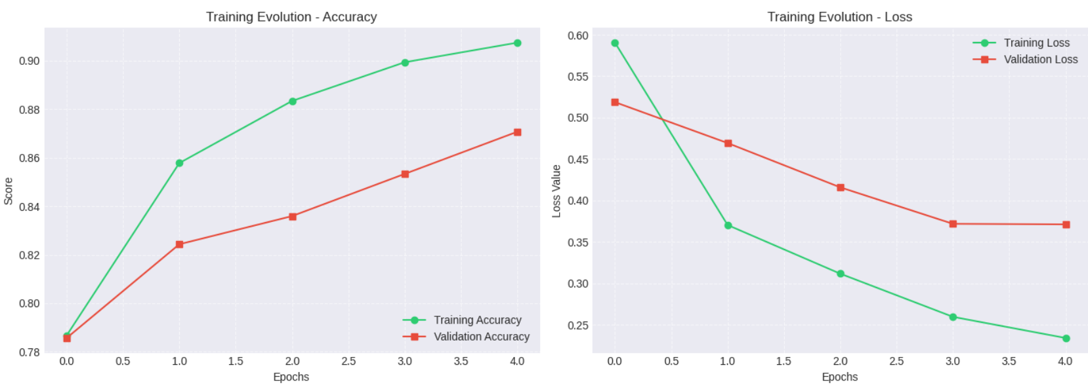
DenseNet121 Model Multiclass Classification
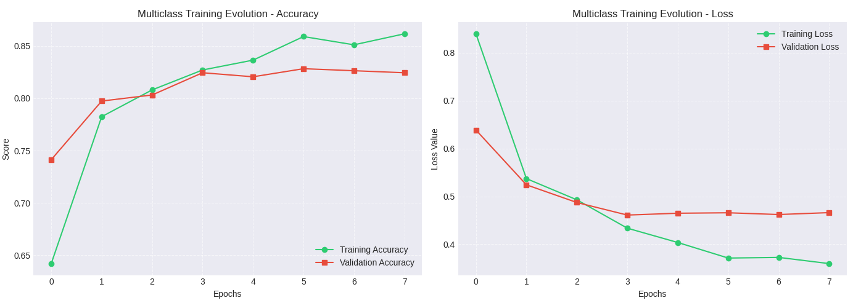
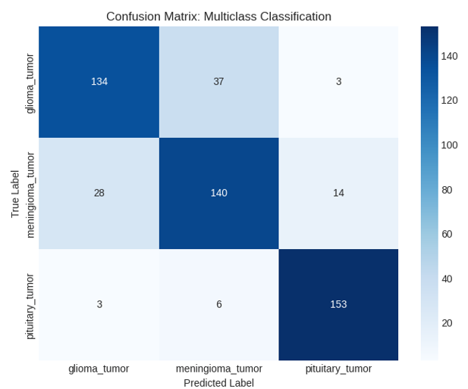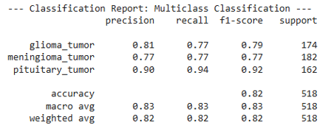
ProtoPnet Model Multiclass Classification
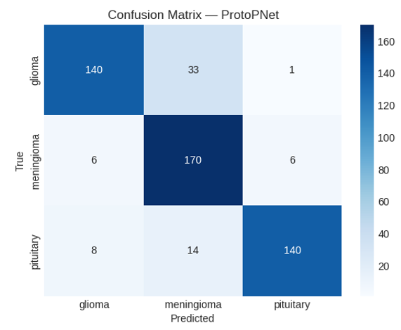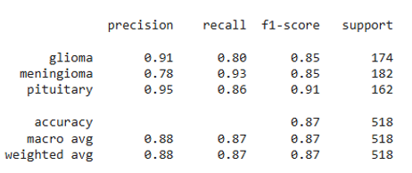
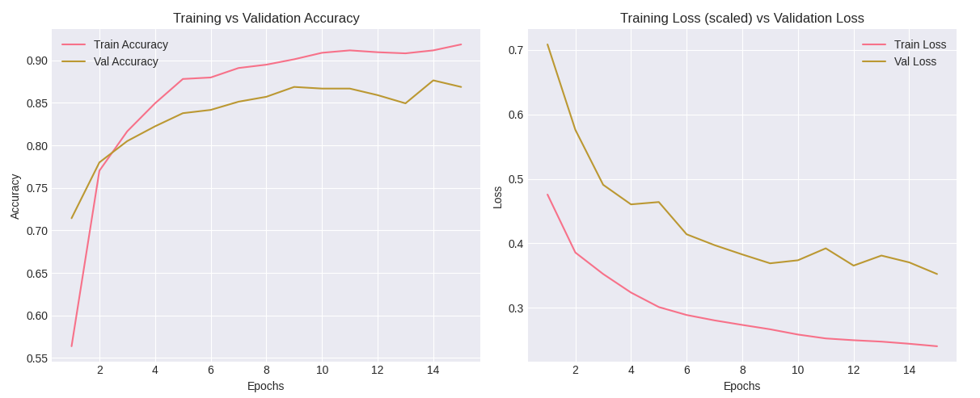

Testing accuracy and Tumor Localization
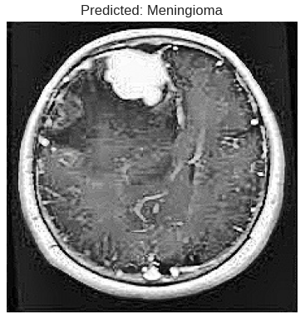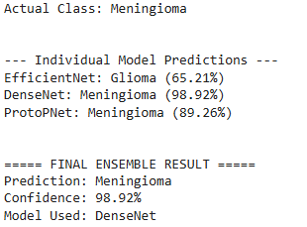
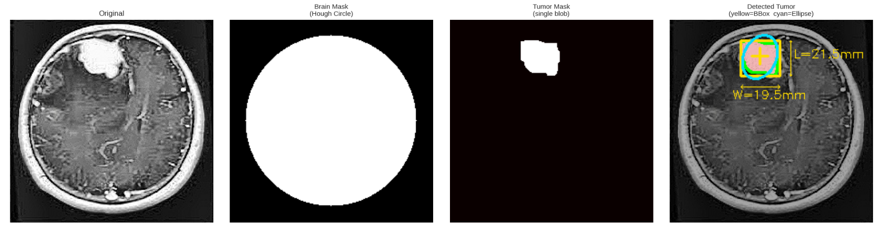
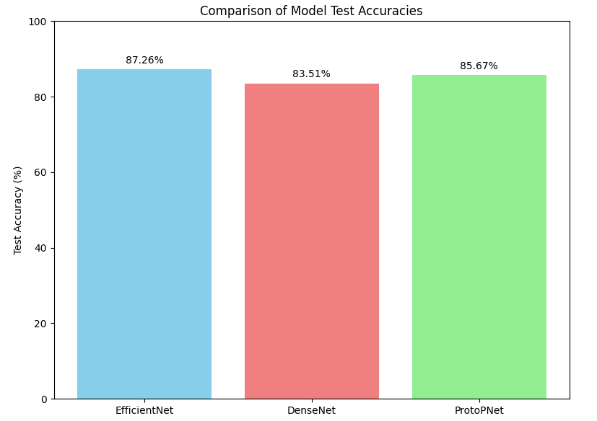

CONCLUSION
In conclusion, the developed project successfully demonstrates an integrated approach for brain tumor classification and localization using MRI images by combining advanced deep learning models with traditional image processing techniques. The system effectively utilizes architectures such as EfficientNetB0 and DenseNet121 for accurate multiclass classification, while ProtoPNet enhances interpretability by providing visual explanations for predictions. The implementation of a voting-based ensemble further improves reliability and overall performance. In addition to classification, the incorporation of OpenCV-based tumor localization enables the identification and visualization of tumor regions, offering valuable spatial insights for clinical use. By addressing key limitations of existing systems, such as lack of interpretability and absence of localization, the proposed solution provides a more practical and comprehensive diagnostic tool. Overall, the project highlights the potential of combining deep learning with classical computer vision methods to support medical professionals in making faster, more accurate, and informed decisions, with future scope for further improvements using advanced segmentation techniques and real-time deployment.

REFERENCES
[1] T. R. Mahesh et al., “An XAI-enhanced EfficientNetB0 framework for precision brain tumor detection in MRI imaging,” J. Neurosci. Methods, vol. 410, p. 110227, 2024.
[2] M. M. Naseer et al., “An optimized EfficientNet-B0 framework for multi-class brain tumour detection and classification from MRI images,” Biomed. Pharmacol. J., vol. 18, no. Special Edition, Oct. 2025.
[3] D. Onah et al., “Deep Brain Net: An optimized deep learning model for brain tumor detection in MRI images using EfficientNetB0 and ResNet50 with transfer learning,” arXiv preprint arXiv:2507.07011, 2025.
[4] F. F. Jiven and R. Rumini, “MRI classification of brain tumors using EfficientNetB0 feature extraction and machine learning methods,” J. Appl. Inform. Comput., vol. 9, no. 6, pp. 3394–3404, Dec. 2025.
[5] K. Gencer, “A comparative analysis of EfficientNetB0 and EfficientNetV2 variants for brain tumor classification using MRI images,” Int. J. Innov. Eng. Appl., vol. 9, no. 1, pp. 1–7, 2025.
[6] A. Iqbal et al., “Enhancing brain tumour multi-classification using Efficient-Net B0-based intelligent diagnosis for Internet of Medical Things (IoMT) applications,” Information, vol. 15, no. 8, p. 489, 2024.
[7] M. Rasheed et al., “Improved brain tumor classification through DenseNet121 based transfer learning,” Discov. Oncol., vol. 16, p. 1645, Aug. 2025.
[8] Y. Mao et al., “Dilated SE-DenseNet for brain tumor MRI classification,” Sci. Rep., vol. 15, Art. no. 86752, 2025.
[9] S. S. Sabila et al., “The multiple brain tumor with modified DenseNet121 architecture using brain MRI images: Classification multiclass brain tumor,” Kursor, vol. 12, no. 2, pp. 123–134, 2024.
[10] R. B. Sumona et al., “An integrated deep learning approach for enhancing brain tumor classification using RDXNet,” Healthcare Analytics, vol. 8, p. 100421, Dec. 2025.
[11] R. Disci et al., “Advanced brain tumor classification in MR images using pre-trained deep learning models,” Cancers, vol. 17, no. 1, p. 121, 2025.
[12] Y. Wei, R. Tam, and X. Tang, “MProtoNet: A case-based interpretable model for brain tumor classification with 3D multi-parametric magnetic resonance imaging,” in Proc. Medical Imaging with Deep Learning (MIDL), 2023, pp. 1–15.
[13] Y. Wei, R. Tam, and X. Tang, “MProtoNet: A case-based interpretable model for brain tumor classification with 3D multi-parametric magnetic resonance imaging,” in Proc. 6th Conf. Medical Imaging with Deep Learning, 2024.
[14] Y. Wei et al., “MAProtoNet: A multi-scale attentive interpretable prototypical part network for 3D magnetic resonance imaging brain tumor classification,” arXiv preprint arXiv:2404.08917, 2024.
[15] M. Rasheed et al., “Advanced deep learning-based brain tumor classification using DenseNet121 transfer learning on MRI images,” PLoS One, 2025.


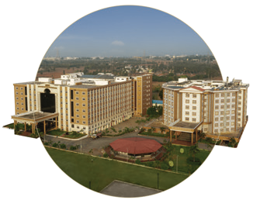
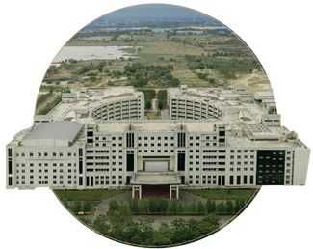

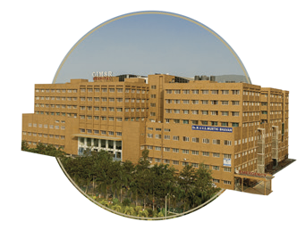

Bengaluru
NH 207, Nagadenehali, Doddaballapur Taluk, Bengaluru - 561203, Karnataka, India
Hyderabad
Rudraram, Patancheru mandal, Hyderabad - 502329, Telengana, India
Visakhapatnam
Gandhi Nagar, Rushikonda, Visakhapatnam- 530045, Andhra Pradesh, India
Bengaluru
Visakhapatnam
GIMSR Bengaluru City Office Hyderabad City Office GITAM Medical College Rd, No 5/1, First Floor, Prestige 6th floor, TP House, Cyber Gandhi Nagar, Rushikonda, Terraces, Union Street, Hills Colony, VIP Hills,
Visakhapatnam - 530045 Infantry Road, Bengaluru - Jaihind Enclave, Madhapur, Andhra Pradesh, India 560003 Karnataka, India Hyderabad - 500081,
Telangana, India
Hyderabad
GIMSR
Visakhapatnam

