BTAI: Proposed Multimodel Explainable AI Techniques for Brain Tumor Classification
A Project Report submitted in partial fulfillment of the requirements
for the award of the degree of


BACHELOR OF TECHNOLOGY
in
COMPUTER SCIENCE AND ENGINEERING
(Specialization in Artificial Intelligence & Machine Learning)

Submitted by
AKSHAT VASHISTH (VU22CSEN0300234)
MANIKONDA SATYA VARDHAN (VU22CSEN0300205)
MUPPASANI SHRUTHIKKA (VU22CSEN0300300)

Under the esteemed guidance of
Dr. Milan Kumar Dholey
Assistant Professor
GSCSE Dept. of CSSE



Department of Artificial Intelligence and Data Science
GITAM School of Computer Science and Engineering
GITAM (Deemed to be University)
Visakhapatnam
2026

Department of Artificial Intelligence and Data Science
YEAR
GITAM School of Computer Science and Engineering
GITAM (Deemed to be University)
Visakhapatnam


DECLARATION

We, hereby declare that the project report entitled “Proposed Multimodel Explainable AI Techniques for Brain Tumor Classification” is an original work done in the Department of Artificial Intelligence and Data Science, GITAM School of CSE, GITAM (Deemed to be University) submitted in partial fulfillment of the requirements for the award of B.Tech Degree in Computer Science and Engineering (Specialization in Artificial Intelligence and Machine Learning).

The work has not been submitted to any other college or University for the award of any degree or diploma.

Date: 06-04-2026
Registration Nos Names Signature
VU22CSEN0300234 AKSHAT VASHIST
VU22CSEN0300205 MANIKONDA SATYA VARDHAN
VU22CSEN0300300 MUPPASANI SHRUTHIKKA
Department of Artificial Intelligence and Data Science
GITAM School of Computer Science and Engineering
GITAM (Deemed to be University)
Visakhapatnam


CERTIFICATE

This is to certify that the project report entitled “BTAI: Proposed Multimodel Explainable AI Techniques for Brain Tumor Classification” is a bonafide record of work carried out by Akshat Vashisth (VU22CSEN0300234), Manikonda Satya Vardhan (VU22CSEN0300205), Muppasani Shruthikka (VU22CSEN0300300), students of this department submitted in partial fulfillment of requirements for the award of B.Tech Degree in Computer Science and Engineering (Specialization in Artificial Intelligence and Machine Learning).

Date: 10-04-2026

Project Guide Head of the Department
Dr. Milan Kumar Dholey Dr. Kuppili Naveen Kumar
(Assistant Professor,CSSE) Associate Professor, HOD
Department of Artificial Intelligence and Data science

ACKNOWLEDGEMENT
Everyone who helped get this research effort across the finish line has our deepest, most sincere appreciation.
Dr. Milan Kumar Dholey Sir, our project advisor, has been an incredible resource for us; we are very grateful to him for all of the time, energy, and wisdom he has shared with us. Our study was greatly influenced by his competence, patience, and helpful criticism. Under his guidance, we were encouraged to think outside the box and improve our approach at every turn.
The staff and professors of GITAM University have also our deepest gratitude for creating a space that is conducive to study and discovery. We were able to solidify our thoughts and raise the project's quality with their helpful criticisms. Additionally, we would want to express our deepest gratitude to everyone at GITAM University who has offered us encouragement, support, and insightful criticism.
We are very grateful to our families, who were our rock-solid supporters and sources of unfaltering encouragement. We remained committed and focused throughout because of their understanding and encouragement.
Additionally, we would like to express our gratitude to the writers and researchers whose earlier work served as a basis for our investigation. The institution's resources and assistance were vital in making this study a success, and for that we are eternally thankful. Without the cooperation of these organizations and people, this initiative would never have been able to happen. Each and every one of them has our deepest gratitude.

TABLE OF CONTENTS

S. No. | Description | Page No.
1. | Abstract | 1
2. | Introduction | 2
3. | Literature Review | 6
4. | Problem Identification & Objectives | 10
5. | Existing System | 12
6. | Proposed System | 16
7. | System Architecture and Flow Diagram of the Proposal | 20
8. | Tools/Technologies Used | 28
9. | Implementation & Results | 32
10. | Conclusion | 49
11. | References | 50
12. | Programme Outcomes (POs) and Programme Specific Outcomes (PSOs) | 52

ABSTRACT
Every day, we confront the most deadly problem: brain tumors. The importance of early and precise tumor diagnosis cannot be overstated, as it has the potential to significantly enhance treatment results and save many lives. Our "BTAI" deep learning system can detect and categorize brain cancers in magnetic resonance imaging (MRI) scans without human intervention. Here, we used state-of-the-art convolutional neural networks such as EfficientNetB0 and DenseNet121 to carry out multiclass classification (glioma, meningioma, and pituitary cancers) in addition to binary classification (tumor or no tumor). We also used ProtoPNet, an ante-hoc neural network model based on prototypes that provides a clear visual explanation for a specific prediction made by the model, to make our model more accurate and precise for clinicians. We used a confidence-based voting mechanism to aggregate the findings of all three models and choose the most confident prediction as the final output, resulting in a superior output categorization. After the categorization, we used several basic classical image processing methods to bring the tumor-affected area of the MRI scan to light. These techniques included grayscale conversion, Gaussian blurring, binary thresholding, and contour detection. In addition to providing physicians with a clear visual picture of the tumor-affected region in the brain, our method not only achieves a strong categorization but also achieves excellent accuracy. We are developing a very practical and helpful tool that will aid clinicians in the faster and more accurate detection of brain tumors by integrating state-of-the-art deep learning models with conventional computer vision techniques.

INTRODUCTION
When it comes to neurological disorders, brain tumors are among the most dangerous and deadly. They pose a tremendous risk to patients, their families, and healthcare systems throughout the globe. When an aberrant proliferation of brain cells is observed, they are among the most serious and potentially fatal. The existence of these tumors may significantly impact vital brain processes including speech, vision, memory, and motor abilities; on the other hand, brain tumors can be benign, meaning they are not cancerous and pose less of a threat, or malignant, meaning they are very dangerous. Because the brain is one of the most mysterious and complicated organs in the body, it is crucial to identify brain tumors early and correctly classify them so that patients may get the best therapy possible and have a better chance of survival. It is crucial to make the appropriate choice at the right time for a patient's health since a delayed or incorrect diagnosis might worsen the brain tumor, leading to diseases including brain strokes or even death. According to a well-respected organization's analysis, there are approximately 3.5 cases of primary malignant brain tumors for every 100,000 cancer patients. Brain tumors are a leading cause of cancer-related deaths in children and adolescents under the age of 20, and they continue to be a significant factor in the mortality rate among adults under the age of 40. It is the tumor type that determines the survival rates of brain tumors. Aggressive malignancies, including glioblastoma multiforme (GBM), are very deadly and often manifest in adults between the ages of 30 and 35; in contrast, many meningiomas are benign and have a good chance of survival. Based on these findings, we want reliable techniques that can detect tumor types at an early stage.
Now let's go into the classification of brain tumors. These tumors are categorized according to their origin, behavior, and aggressiveness. The most frequent forms in humans are pituitary, glioma, and meningioma tumors. The meninges are the protective membranes that encase the brain and spinal cord; tumors of the meningiomas type develop in this area. These tumors account for 30–35% of all brain tumors globally, and they are characterized by their moderate growth rate and benign nature, making them less dangerous and more quickly curable with medication and chemotherapy. The most common age group for this type of meningioma tumor is middle-aged women (between 30 and 35 years old), though it can also develop in older adults (male and female). The most crucial point to remember is that these tumors are often found unintentionally during imaging tests for other medical issues. Although medication and mild chemotherapy may heal most meningioma tumors, the location of the tumor can lead to serious side effects such seizures and headaches. Even though they take a long time to heal and need a lot of medical assistance, these tumors may be curable since they often have clear borders and do not invade brain tissue. Thankfully, they are frequently very treatable with treatment.
Gliomas are the most frequent and deadly kind of brain tumor, and we will talk about them next. Glial cells are known as brain supporting cells, and tumors of this sort develop straight from these cells. These tumors are incredibly diverse and can range from very small to very large in size. The severity of each tumor type determines its ranking from one to four. The most dangerous and potentially life-threatening tumor type in this family is glioblastoma, which is ranked four. These tumors have a tendency to metastasize, or spread to other parts of the brain. This makes them very hazardous, makes tumor removal a difficult procedure, and increases the likelihood that the patient may die while under anesthesia. The most common age group for these tumors to manifest is adults, and the major reasons for this include stress, pressure, and even heredity in rare instances. Seizures, cognitive impairments, muscular weakness, and chronic headaches are signs of this kind of tumor in women. In most cases, gliomas need a combination of three different types of treatment—surgery, radiation therapy, and chemotherapy—because of their aggressive activity. Curing the tumor with this method takes time.
Thirdly, there are tumors that grow in the pituitary gland in the brain. These tumors, which are also called pituitary adenomas, are about the size of a kidney bean and sit near the brain's base. The pituitary gland is crucial because it controls the body's essential hormone functions. These tumors are often considered benign and develop at a relatively slow rate, according to the research. While most tumors of this kind do not secrete hormones, those that do are frequently categorized as functional tumors. Additionally, there are pituitary functioning tumors that can cause severe kidney disorders like the well-known Cushing's disease. These tumors tend to be quite large, and one of their major side effects is complete vision loss caused by compressing the optic nerves of the eyes. If these tumors are not cured, they can affect the entire body. Because of their strategic placement, these pituitary tumors may have far-reaching consequences for a person's health. If not treated appropriately, this kind of tumor poses a significant risk to the patient's life and might potentially cause death within a few days. Medications, nasal surgeries, and radiation therapy are the main components of treatment, while the specifics might vary according to tumor size, tumor location, and hormone fluctuations.
There are three main types of tumors: pituitary, meningioma, and glioma. These tumors can cause a wide range of behavioral changes in humans, from harmless and treatable benign tumors to less treatable, extremely aggressive, and potentially fatal malignant tumors. Although accurate diagnosis of brain tumors is challenging, proper classification of tumors is crucial for developing effective treatment strategies.
Through the years, magnetic resonance imaging (MRI) scanning has been a go-to imaging method for diagnosing brain cancers because to its high level of accuracy, reliability, and usage. It allows for a comprehensive view of the brain's structure without exposing the patient to dangerous radiation, unlike an X-ray scan, and it produces very high-resolution pictures of the brain's tissues. By capturing several parts of the brain, such as the T1, T2, and FLAIR sections, it facilitates easy and comprehensive analysis of tumor size, location, and texture. Understanding the MRI images is heavily reliant on the physicians, despite the numerous benefits. Everyone knows that manually analyzing these tumors through scans isn't always easy or quick. When doctors have to look at a lot of scans in a day, it can be exhausting, and sometimes there's room for human error due to the sheer volume of patients' scans. Another issue to think about is that several physicians may interpret the same MRI scan in different ways, which may lead to conflicting choices and, in some cases, even patient confusion when it comes to tumor analysis and treatment planning.
Conventional wisdom on brain tumor diagnosis has long been plagued by several drawbacks. Particularly in areas with a high reported incidence of brain tumors and where physicians are required to review several scans daily, the previous method was notoriously laborious. Artificial intelligence (AI) has the upper hand in certain situations when it comes to recognizing tumors and their types, but doctor analysis is superior in other circumstances, according to several research. We already established that AI can outperform humans in some situations; this is because human error, heavy workloads, and low-resolution imaging characteristics caused by outdated MRI equipment all play a role in the prevalence of these potentially fatal diagnostic mistakes. Additionally, there is a risk of missing treatable tiny or early stage cancers while doing manual analysis; postponing treatment worsens the patient's condition. All of these problems are exacerbated in underdeveloped areas, where healthcare facilities and specialists are harder to reach than in more established cities.
Thanks to advancements in AI and CNN, tumor identification has become a breeze. Once upon a time, most people used antiquated machine learning methods that included manually extracting features like form, texture, and other attributes from MRI images. Because of their low accuracy, lack of generalizability, and inability to converge across many scanners and protocols, these approaches necessitated the development of more effective feature extraction and classification algorithms. A number of deep learning models, including perceptrons and others, have recently made strides, completely changing the face of image processing, analysis, and prediction. Convolutional neural networks (CNNs) were among the first to emerge, and their ability to directly convert images into raw pixels without requiring complicated mathematical operations was revolutionary. A plethora of other architectures have also developed over the years; some, like VGG, ResNet, U-Net, GoogleNet, and AlexNet, have their advantages and disadvantages. All of these models engage in a parameter game, but some, like EfficientNet and DenseNet, have improved their accuracy while using fewer parameters, and they have produced results that surpass those of average humans in detection tasks such as tumor detection, classification, and segmentation.
Despite the fact that several advancements are being made in these areas of CNN, there are still numerous shortcomings in the existing systems. Many of these deep learning models operate as so-called "black boxes" models; this implies that they may be made to justify their output, but they don't explain why they make predictions, which leaves room for skepticism. Decisions made by a blackbox model cannot have any positive impact on healthcare, as we all know that healthcare is crucial to a country's progress. Furthermore, putting all our faith in these models can have disastrous consequences, including harm to human lives and distrust among doctors who use them. An very significant and unique concept in healthcare, "explainability" plays a pivotal role in our brain tumor study endeavor. Not to mention that the majority of systems only ever address one aspect, such categorization or localization, and very seldom both. This results in the employment of several systems and, sometimes, annoyance among physicians. When both speed and accuracy are crucial, this missing-pieces method is a huge letdown for the system.
We have created a thorough, resilient, and interpretable system that incorporates some outstanding state-of-the-art deep learning architectures, namely EfficientNetB0 and DenseNet121, to produce an accurate multi-class classification output of the specific brain tumors in a patient, whether it be a glioma, meningioma, pituitary, or no tumor at all. This project, "Proposed Multimodel Explainable AI Techniques for Brain Tumor Classification," addresses all the issues mentioned above. We opted for this kind of model because it can effectively capture both the hierarchical and fine-grained information seen in MRI images, and it also has great performance and efficiency in prediction. Finally, in order to back up the term "Explainability" in the proposed framework, we added an ante-hoc model called ProtoPNet, which is a prototype-based neural network. This model learns prototypical parts of tumor appearances and lets doctors see which visual concepts drive the predictions.
Additionally, a conventional image processing module is now included in our suggested project for the purpose of tumor localization. An important way to identify tumors is by using an understandable visual overlay that highlights tumor borders and size measurements (in pixels and estimated millimeters). Techniques including contour detection, elliptical fitting, thresholding, and morphological procedures all contribute to this goal. A linked pipeline that enables automated classification and tumor identification is produced by this hybrid multi-model method, which integrates all the deep learning models for excellent classification with a classical computer vision technique for good tumor location.
Our project's goals include lowering the time it takes to discover and localize tumors, reducing human error, and increasing physicians' confidence in AI system diagnoses—all while addressing critical features of tumor detection like interpretability and explainability. In addition to tumor classification, the system can detect tumors in images and determine quantitative tumor metrics. The ultimate goal is to provide physicians with trustworthy decision support tools that are easy to understand and use, so they can make better diagnoses more quickly.
LITERATURE REVIEW
A group of convolutional neural networks (CNNs) called EfficientNetB0 models were suggested by Tan et al. [1]. These CNNs outperform their competitors due to a special quality they possess: they can automatically grow its depth and width. His work on this design includes automating the scaling of the network's depth, breadth, and resolution in an effort to boost speed and efficiency. The basic model, EfficientNetB0, demonstrated superior performance on ImageNet data sets compared to its predecessors due to the reduced number of parameters. Because it may be used in medical settings with less resources, EfficientNetB0 is both efficient and adaptable. When dealing with data sets that include diverse types of MRI scans, for example, fixed scaling factors may not be helpful.
In their work on the DenseNet model, Huang et al. [2] discovered that feature reuse is economical and that dense connections between layers may be the only output for the vanishing gradient problem. DenseNet121 is well-known for using this design, which has recently achieved mainstream success in image recognition and related fields by integrating feature maps obtained from all preceding layers. Additionally, this design enhances the model's gradient flow process and reduces parameter redundancy, making the model more effective during training.
One of the best pre-trained models we looked at was ProtoPNet, suggested by Chen et al. [3]. It's also called a prototype-based neural network, and the reason it enhances explainability is because it compares the input pictures' similarities to prototypes. Because this ProtoPNet, unlike other CNNs, lets you see the results, the model is great for healthcare applications. Its strong performance on benchmark datasets provides us with important insights on the tumor's decision-making process.
Islam et al. [4] developed the model EfficientNetB0, which was employed for transfer learning-based brain tumor classification. Using the pre-trained parameters he had retrieved from ImageNet, he was able to train a model that performed well with a sparse dataset. Results obtained by fine-tuning EfficientNetB0, such as freezing the layers, outperformed those from traditional CNN models, suggesting promising future use in medical imaging.
Pereira et al. [5] compared DenseNet121 and ResNet with regard to their applicability in segmenting brain tumors. According to the paper's details, the DenseNet121 model's superior performance over ResNet was a result of its dense connection, which in turn encouraged the usage of concept names feature propagation. Based on what we learned from this work, DenseNet121 is better suited for segmentation tasks because to its capacity to detect the fine features of tumor boundaries.
The paper's authors, Naseer et al. [6], suggested utilizing the EfficientNet-B0 model, which was developed for the purpose of multi-class classification of brain tumors using MRI images. Improved accuracy in classifying pituitary tumors, gliomas, and meningiomas were the results of fine-tuning the EfficientNet-B0 model by Naseer et al. [6]. In order to effectively extract features while guaranteeing the model's lowest computing cost, the researcher took use of EfficientNet's unique approach, which automatically increases the depth and breadth. The EfficientNet-B0 model demonstrated excellent accuracy on publicly available MRI image datasets, according to this research. Unfortunately, this model's optimization was heavily dependent on human intervention and lacked built-in interpretability features.
In order to identify cancers in magnetic resonance imaging (MRI) scans, Onah et al. [7] presented a deep learning model approach called Deep Brain Network. This Deep Brain Network system was built using the EfficientNetB0 and ResNet50 models. The goal of this project is to optimize the network parameters and residual learning via the use of transfer learning. Whether running in binary or multi-class mode, this Deep Brain Network handled the brain tumor detection tasks well. The significant computational expenses of running the model on this hybrid architecture and its extremely low picture quality were not fully investigated, which is a major drawback.
For the purpose of MRI brain tumor categorization, Jiven and Rumini's [8] suggested technique used a novel two-stage framework approach. Using EfficientNetB0 for deep feature extraction and the usual machine learning methods for classification were both part of this system. It was shown that the suggested technique achieved high brain tumor classification accuracy with much less computing effort compared to a conventional deep learning-based approach. Nevertheless, the suggested method relied entirely on the efficacy of the acquired traits, which was a big drawback.
An improved brain tumor classification with DenseNet121 as its foundation was introduced by Rasheed et al. [9]. Rasheed et al. [9] discovered that MRI scans may be utilized to classify various brain cancers, such as meningiomas, gliomas, pituitary, and others, by using DenseNet121's hierarchical feature information. On the Kaggle brain tumor dataset, our model performed well in terms of recall, accuracy, precision, and F1-score. The large number of parameters in DenseNet121 is one of its drawbacks, however.
In their presentation of the Dilated SE-DenseNet model architecture, Mao et al. [10] made use of DenseNet121 to classify brain tumors from MRI data. A refinement of the original DenseNet121 model, this work employs dilated convolutions and novel squeeze-and-excitation techniques to boost the classifier's efficiency across a wider receptive field, with a particular emphasis on feature extraction via key channels. Using T2-weighted MRIs, their method successfully classified four different kinds of brain cancers: meningioma, glioma, pituitary tumors, and non-tumors.
Wei et al. [11] developed the MProtoNet model, an interpretable case-based model that improves upon ProtoPNet for the purpose of detecting brain tumors using novel 3D multi-parametric MRI. According to the suggested model, MProtoNet is a conventional black-box CNN. It can learn prototypes and identify tumor kinds by comparing the input patch to prototypes. This method achieves high localization performance on 3D mpMRI datasets while also ensuring the model's interpretability. Prototype learning increases the computational overhead, which is the main downside.
Wei et al. [12] investigated MProtoNet, a novel interpretable model that used a case-based method to forecast brain malignancies using 3D multi-parametric MRI data. To further enhance the quality and interpretability of the prototypes, attention modules were used in conjunction with soft masking and online clustering losses. Practitioners were also able to get insight into which learnt tumor patterns had the most impact on the prediction because to this prototype reasoning. The suggested technique outperformed traditional CNNs, although it required tweaking of prototype hyperparameters and had somewhat worse accuracy when applied to non-interpretable deep architectures.

PROBLEM IDENTIFICATION & OBJECTIVE
Problem Identification
Brain tumor detection and classification is challenging because brain tumors may be located deep inside the brain and because MRI image intensities can change. This makes clinical diagnosis of brain tumors, especially differentiating between meningiomas, gliomas, and pituitary tumors, a very complex and difficult task. Despite the fact that MRI scans brain tissues at a high resolution and in many sections, the accuracy of the interpretation of these pictures is still heavily dependent on the physicians' knowledge and experience. It is challenging to correctly distinguish between tumor types in the real world due to factors such as the high volume of scans needed to treat patients, the high likelihood of human error and exhaustion, and the fact that tumors have irregular shapes, diffuse borders, and overlapping intensity distributions. Since many experts may come to different findings for the same scan, this causes a huge discrepancy when two or more physicians analyze brain tumors. The majority of current systems still use what are known as "black box" models; these models simply provide the final predictions without explaining the reasoning behind them, even though several deep learning based models have shown promising results in predicting the kind of tumor. The findings of these models for a tumor are not widely accepted in the medical field, where trust and transparency are highly valued, due to their lack of interpretability and explainability.
Now, interpretability and explainability are big problems in a lot of current systems. Another big problem is that these detection methods can't provide tumor diagnostic information beyond categorization, which is a huge drawback. When it comes to tumor identification, most models just tell you which categories tumors fall into, ignoring crucial details like tumor placement and quantitative measurement. According to most clinicians, accurate measurements of the tumor's size, shape, and geographic extent—including crucial characteristics like major axis length, minor axis length, and total tumor area—are crucial for optimal treatment planning, particularly in the fields of surgery and radiation. There is a huge discrepancy between the model predictions and the doctor's interpretation of a brain tumor due to the lack of measurements. Not only that, but the majority of existing systems on the market still don't integrate the several pipelined activities involved in tumor detection, such as classification, segmentation, and explainability, into a single framework. This method, which is based on pipelines, is inefficient, slows down analysis, and restricts its practical use for medical professionals. Thus, bridging the gap between the various models currently in use and the decisions made by individual doctors requires a thorough interconnected system that not only achieves high classification accuracy but also offers some explainable insights into the model's decision-making process.
Objectives of the Project
- To utilize the proper deep learning models for an accurate multiclass brain tumor classification (Pituitary, Glioma, Meningioma).
- To apply and compare the confidence scores of some advanced models such as EfficientNetB0, DenseNet121, and ProtoPNet to improve performance and reliability.
- To implement a voting-based ensemble learning module for a better generalization and to reduce the overall variance.
- To implement a tumor localization module using some popular OpenCV techniques like contour detection and bounding box estimation that help in perfectly detecting the tumor in the MRI scan.
- To provide interpretability and explainability through visual insights to support faster and more reliable medical diagnosis by leveraging Ante-Hoc models.

EXISTING SYSTEM
Our team was able to modify a well-known research by Iqbal et al. that dealt with brain tumor multi-classification. This study presents a transfer-learning-powered intelligent diagnostic system based on the EfficientNet-B0 model, which is compatible with the Internet of Medical Things (IoMT). The model was developed with the express purpose of classifying three tumor types—glioma, meningioma, and pituitary—using the BraTs dataset and MRI images obtained from Kaggle and other sources. This is where the author goes on to say that EfficientNet-B0 is a super efficient convolutional neural network. It uses a technique where the depth and width just keep getting bigger and better on their own, which helps keep the resolution, width, and depth all in check while keeping the network relatively lightweight (with about 5.3 million parameters at the very least). Compared to the original convolution layer, this network's feature extraction process is more efficient thanks to its multiple layers of Mobile Inverted Bottleneck Convolution (MBConv) blocks integrated with a unique squeeze-and-excitation (SE) attention mechanism. Additionally, this model makes use of channel-wise feature recalibration. To accommodate the medical domain's pre-trained ImageNet weights, the authors reportedly swapped out the final layer's classification head with custom layers such as global average pooling—used to lower spatial dimensions—, a dropout regularization technique—used to avoid overfitting—and a softmax layer—used to generate three-class probability outputs. Typically, the full MRI image is resized to 224×224 and normalized so that each pixel falls within the range of [0,-1] in the small data preprocessing phase of the pipeline. Then, using the EfficientNet-B0 backbone, deep feature extraction is carried out, and finally, fully connected layers are used for classification. Following this, the system is assessed using familiar measures like as precision, accuracy, and the F1-score in conjunction with confusion matrix analysis. Outperforming several baseline CNN models, including ResNet, VGGNET variations, and the original EfficientNet with basic setups, the author achieved an astounding classification accuracy of over 99%, as described in the research.
Along with EfficientNet-based methods, several well-known works have investigated DenseNet121, a model for brain tumor classification that makes use of a transfer learning mechanism; these studies all cite the same original work. The key difference between DenseNet121 and other CNN models is how their interconnected layers share all the detected features. This reduces the need to extract base features for each layer, which is how DenseNet121 models work. This architecture has many unique points as compared to other CNN models such as feature reuse, strengthens gradient flow during backpropagation, and mitigates the vanishing gradient problem all these lead to a faster convergence and improved generalization even with a very limited medical datasets. The pre-trained DenseNet121 model has been fine-tuned by several researchers by retraining the latter dense blocks and a new classification head, which generally increases the classification accuracy. This model was initially trained on ImageNet. With a 97–98.5% accuracy rate across the same three-class problem, this state-of-the-art method captures both low- and high-level compound details in dull MRI images, as well as high-level structural features in MRI scans (glioma, meningioma, pituitary tumor). With its dense connection approach, DenseNet121 excels at managing glioma and meningioma tumor types, as well as other forms of tumors with deep, undifferentiated intensity changes in dull pictures and overlapping morphological features.
There are certain shared restrictions between the two usecases, despite the fact that they both have achieved outstanding categorization performance. Without spatial reasoning, visual explanations, or quantitative tumor measurements, the majority of these systems mostly operate as black-box classification models that only provide very accurate predictions. They seldom include physical quantification like major/minor axis length for tumor size measurement, border delineation, or prototype-based interpretability for tumor localization and traditional image processing. This leaves a huge hole in terms of practical use, as clinicians primarily need proper decision support with certain objective criteria for treatment planning, surgery, and radiation border determination in addition to tumor type categorization. An integrated framework that combines excellent accuracy with explainability and practical clinical application is precisely what is needed to address these limitations.
Drawbacks of the Existing System
To begin, the current systems have a very limited knowledge of the tumor kind and do not have a tumor localization module, which is a big constraint. Classification tasks are the mainstay of deep learning models like ResNet, Alexnet, and VGGNET, but their output is limited to recognizing the kind of tumor without pinpointing its exact position in the MRI scan. But knowing the type of tumor isn't enough in the actual world of hospitals and doctors. In order to treat a brain tumor, doctors need specific details regarding it, including its location inside the brain, any anomalies in its shape, and its limits. Due to the AI system's lack of localization and explainability, many clinicians are unable to use it to successfully determine radiation treatment margins, schedule surgeries, or evaluate tumor development. Also, most models don't earn physicians' confidence since they don't back up their predictions with data, which is especially problematic in this case because just disclosing the tumor kind doesn't make sense. This severely limits the usefulness and flexibility of such systems as there is a mismatch between their output and what doctors need.
Second, real-world deployment is complicated since many CNN models, such VGNET, ResNet, etc., are memory and computationally heavy. Models of this kind handle a plethora of mathematical operations, including convolution, pooling, batch normalization, and a large number of layers and parameters. They are resource intensive since training them takes a lot of time, additional RAM, and high-performance GPUs. It is very undesirable and, in some time-sensitive medical situations, entirely pointless, for computing expense to cause delays even during picture interpretation. There is often a severe lack of access to modern hardware infrastructure in healthcare facilities, especially in more remote or underserved areas. Because of this, the systems can't be scaled up or used by many people. Smaller hospitals also have a harder time implementing and making good use of these technologies due to the high computing needs, which raise operating and maintenance expenses.
Thirdly, one of the key issues with the current methods is their low generalizability. The majority of these deep learning models undergo thorough training and validation on narrow datasets, which could lead to inaccurate results when applied to actual patient tumor types. There isn't a single, universally applicable method for producing MRI pictures; instead, variations in scanners, imaging procedures, resolution, noise levels, and patient demographics cause the images to seem quite different. Therefore, our trained models may do very well on the training datasets yet completely bomb when presented with a picture of data they have never seen before. The scarcity of labeled medical datasets on the market and online, together with the existing class imbalance in datasets, exacerbates this problem. Because of this, these systems are not well-suited for deployment across several institutions or hospitals due to their low flexibility, which in turn lowers their dependability. One of the biggest problems with medical AI has been maintaining consistent performance across different datasets for a long time.
The absence of integrated systems in present research is a major drawback, despite the fact that most of the critical aspects have been addressed. Since most of the previous research our team reviewed only addressed one part of our proposed system—classification, segmentation, or explainability—we feel that the system would be completely useless in a real-world healthcare setting unless it combines all of these features into a single framework. These flawed methods restrict the practical use of such systems in actual healthcare facilities, where simultaneous analysis of many tumor kinds and recommendations need the use of several types of information. In order to make educated decisions regarding the type of tumor and any future decisions regarding the tumor, many doctors around the world believe that accurate tumor predictions are necessary, but they also need localization of the tumor, quantitative measurements, and a clear visual explanation of the analysis. The real usefulness of these systems for doctors is further diminished by the lack of decision-supporting features that we identified. Furthermore, many models are not trustworthy because to their lack of explainability, which is particularly problematic in important medical and eternal situations. Integrating accuracy, interpretability, localization, explainability, and quantitative analysis into one system is therefore very necessary.

PROPOSED SYSTEM
To accurately classify and localize brain tumors using only MRI images, our proposed system incorporates a highly pipelined and integrated framework that draws on the strengths of three deep learning models, as well as our traditional image processing methods from the OpenCV model. Our main goal in developing this system was to make it easier for doctors to diagnose and treat brain tumors by visually pinpointing their exact location and then classifying them into different types, such as pituitary, glioma, and meningioma. In contrast to the majority of these traditional methods, which tend to concentrate on just one function, our suggested system is a one-of-a-kind multi-functional pipeline that bridges the gap between model-based requirements and those dictated by actual medical professionals through the simultaneous integration of classification, explainability, and localization.
In summary, our proposed system's architecture consists of multiple stages: data preprocessing, feature extraction, classification using multiple deep learning models, an ensemble-based decision making module, and lastly, our tumor localization module that utilizes classical computer vision methods. The explainability through prototype learning is an important part of this architecture. In the first stage of the system's preprocessing, we combine all the datasets we obtained from various sources into one large dataset, which we call merged_dataset. Then, to make sure the MRI images are uniform and to improve the dull, blurry ones, we subject this merged dataset to multiple transformations. First, we standardize the pixel intensities to stabilize the model training, which is common in most papers. Then, we pass the images to an enhancement technique, such as a contrast adjustment or the CLAHE image enhancement method, which works well. The collected images are resized to a fixed resolution that is compatible with our deep learning models. Importantly, this pretreatment step guarantees that the models can learn features efficiently regardless of picture quality inconsistencies or dullness and increases the uniqueness across all photos in the combined dataset.
The photos undergo a thorough preprocessing step before being fed into a cluster of deep learning models, with EfficientNetB0, DenseNet121, and ProtoPNet serving as the project's backbone for feature extraction and classification, respectively. The models used for this purpose have a track record of success when it comes to analyzing tumor images. The EfficientNetB0 model, as mentioned earlier, employs a novel technique that allows the depth and width to increase on their own. This method strikes a balance between the network's depth, width, and resolution, resulting in the most efficient feature extraction with fewer parameters compared to other models. The next step is to pass the picture through smart DenseNet121. As we've already established, this network makes full use of its dense connectivity between layers to improve gradient flow and, more crucially, feature reuse. This is especially helpful when trying to capture the intricate features of tumors in MRI images. Using the principle of transfer learning, these two models are second to none. They are able to swiftly adapt to the learned medical domain despite having very little training data because they make clever use of the pretrained weights from big datasets like ImageNet. In the last step, the models are optimized for brain tumor classification tasks by fine-tuning their performance on the last layers.
Using a prototype-based neural network called ProtoPNet, we include the explainable AI ante-hoc model notion, which is a crucial part of our proposed system. During training, ProtoPNet learns the unique representative prototype pictures for each class, increasing transparency compared to most typical deep learning models, which function as opaque and untrustworthy black boxes. The model takes in new MRI images and uses them to compare various regions with the learned prototype images. It then finds similarities and can give visual explanations by highlighting the specific regions that were involved in the classification decision. Because it aids physicians in comprehending and verifying the proper rationale behind model predictions, this kind of interpretability is crucial in the medical arena, and it ultimately boosts the confidence and adoption of AI systems.
A key differentiator from other systems in the market is the incorporation of a confidence-based ensemble learning strategy. This allows us to pick the best outcomes from the accuracy results of all the models, improving the system and its predictions. We now know that we can trust any machine learning or deep learning model. We no longer use a single model for all forecasts; instead, we take into account a number of models before settling on the optimal one. The ultimate choice on the classification is based on either confidence-based selection or majority vote after each model independently predicts the tumor class of the MRI picture. In order to lessen the likelihood of inaccurate predictions, our clever method lessens the effect of individual model bias towards a tumor kind. Our proposed approach is more dependable when used to varied unseen datasets since these ensemble techniques are well-known to promote model generalization and entire system convergence.
A tumor localization module using old classic image processing methods built in OpenCV is also part of our proposed system, along with our classification and explainability idea. This module's purpose is to extract useful information from MRI images by locating and highlighting the tumor location. First, the image is grayscaled to make tumor detection easier. Then, it undergoes Gaussian blurring to smooth out the image and reduce noise. Finally, binary thresholding is applied to the image to separate regions that could be tumors based on intensity differences. To find the tumor's borders, contour detection happens after segmentation. Following the detection of tumor locations, our method uses elliptical fitting to estimate the tumor's form and extracts bounding boxes around those regions. Major axis length, minor axis length, total area, and tumor size may all be estimated using this method. In the medical field, these numerical measures have many uses, such as tracking tumor progression and preparing for radiation or surgery.
Last but not least, our suggested system provides a comprehensive answer to the problems with the current system that we discussed before. Our approach strikes an excellent compromise between accuracy, explainability, and practical use by mixing high performance deep learning models with explainable AI methodologies and conventional image processing methods. The localization module adds crucial information that is lacking in many conventional classification systems, and the incorporation of ensemble learning improves accuracy. Better patient outcomes are a direct result of our unified framework's ability to increase diagnostic efficiency while simultaneously assisting several providers in making accurate, trustworthy data-driven judgments. For your convenience, we have included a comparison study (Table 1) comparing the current system with the new suggested system. As mentioned below, the following modules make up the proposed BTAI system.
- Input MRI images
- Preprocessing Stage
- Model Evaluation (Feature Extraction & Classification)
- Confidence-Based Ensemble
- Class Prediction
- Tumor Localization
- Model Evaluation
- Final Output
Existing System | Proposed System
These systems use only a single efficient deep learning models for classification | Our system uses multiple models (EfficientNetB0, DenseNet121, ProtoPNet)
These systems relies on single-model learning | Our system uses ensemble learning with confidence-based voting
These systems does not provide any tumor localization | Our system provides tumor localization using OpenCV image processing techniques
These systems operates as a black-box with no explainability | Our system incorporates Explainable AI using ProtoPNet which is an ante-hoc model
These systems offers a low decision transparency | Our system provides high transparency with prototype-based reasoning
These systems extracts features using a single architecture | Our system combines multiple architectures for better feature extraction
These systems model performance depends on a single model | Our system improves reliability through ensemble approach
These systems does not provide quantitative tumor analysis | Our system provides tumor size, shape, and area estimation
These systems has a very moderate generalization capability | Our systems has an improved generalization performance
These systems has a very lower computational complexity | Slightly higher computational complexity due to multiple models
These systems have a very poor interpretability | Our system have a strong interpretability with visual explanations
These systems provides good accuracy but limited functionality | Our system provides high accuracy with integrated and comprehensive features
Table 1: Comparison between Existing System and Proposed System

Therefore, our proposed system is beneficial for all doctors who use it, and they begin to trust AI systems. What's more, by using an ante-hoc model, we help doctors trust our system by explaining why the model produced a certain result. What's more, we assist doctors in detecting tumors in MRI images, which reduces their workload. Eventually, this leads to a system where doctors can see more patients with brain tumors because treatment is faster and more accurate.

System Architecture and Flowchart Diagram of the Proposal
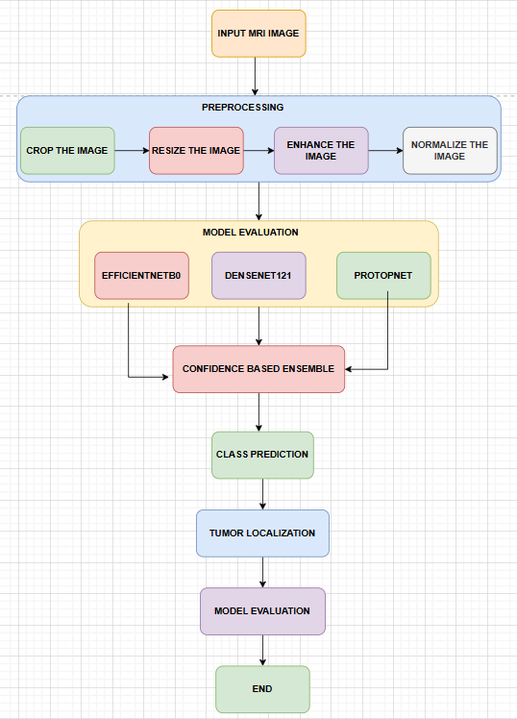
In order to analyze, classify, and localize brain tumors, our proposed system (figure 1) follows a structured pipeline flow that methodically processes MRI images through various stages, beginning with preprocessing and ending with tumor localization. These stages are based on deep learning. When it comes to accuracy, robustness, and proper detection, every step is crucial.

Figure 1: Proposed System Architecture and Flowchart diagram of BTAI
a) Input MRI Images: The system begins by receiving a batch of MRI images as input; they will form the backbone of the model's data set. Images with vastly varied levels of noise, contrast, and resolution originate from a variety of sources, including scanners and imaging methods, as well as databases like Kaggle and BraTs. We all know that raw MRI scans aren't always consistent and might include unwanted regions like the skull or background. These don't belong in the training model, so they go through an initial preprocessing stage to standardize and improve the scans before they're fed into the deep learning models.
b) Preprocessing Stage: As mentioned before, a specific PREPROCESSING block is used to get the data ready for deep learning models by making sure it's consistent, reducing noise, and improving model performance. There are four successive operations that make up this stage:
i) Crop the Image: At this stage, any extraneous parts of the scan, including the black borders, parts of the skull, or noise in the backdrop, are eliminated. In order to improve feature learning and reduce mathematical complexity, cropping is utilized to ensure that the model is fully focused on the appropriate brain area in the scan. To avoid confusing the model during training, it is crucial to delete any extraneous parts of the scan, and this step helps with that.
ii) Resize the Image: The size of magnetic resonance imaging (MRI) pictures might vary greatly from one dataset to another. In our case, the input requirements of most deep learning models such as EfficientNetB0, DenseNet121, ResNet, VGGNET, etc. are 224×224 pixels, so all the cropped images from the previous stage are resized to this fixed resolution. For quicker batch training and more consistent processing, it's best to use a standard picture size.
iii) Enhance the Image: Our enhancing procedure makes use of a method called contrast stretching and sharpening filters, which are applied to the scaled images. The most important part of accurate feature extraction, classification, and localization is improved visibility of dull pictures and tumor borders in MRI scans, and this step helps with that. In instances when the tumor borders are dull or indistinct, these enhancements assist us emphasize the tumor areas and strengthen the specific deep learning model to extract significant patterns from the photos.
iv) Normalize the Image: Normalizing these improved pictures to a certain scale of pixel intensity values—usually between 0 and 1—is the next crucial step in ensuring consistent and successful training. This aids the model in training for quicker convergence and lessens the impact of intensity changes in the scans. At this point in the preprocessing process, the picture is clean, well-structured, and prepared to be entered into the model.
c) Model Evaluation (Feature Extraction & Classification): Once the extensive preprocessing is complete, the pictures are fed into a cluster of deep learning models to extract features and classify brain tumors. At this crucial step, which we have already covered, three deep learning models are used:
i) EfficientNetB0: First, there's our EfficientNetB0 model, which is typically hailed as a cutting-edge neural network design that aims for extreme precision and accuracy with little computational overhead. This model is superior to others that increase computation and mathematical ability by randomly increasing one dimension at a time because it is based on a unique concept where the depth and width automatically increase, as mentioned earlier. This properly balances the scales of the three important aspects of a network, namely its depth, width, and input resolution. In comparison to more conventional models like VGG or ResNet, EfficientNetB0 is able to extract more relevant features with fewer parameters because to its balanced scaling. An innovative set of convolutional layers called Mobile Inverted Bottleneck Convolution (MBConv) blocks is used to construct the architecture. These blocks employ a depthwise separable convolutions mechanism and, on top of that, a squeeze-and-excitation mechanism, which allows for the effective capture of both partial and channel-wise feature relationships. Applications like brain tumor classification benefit greatly from EfficientNetB0's ability to swiftly and readily detect subtle hidden patterns in magnetic resonance imaging (MRI) data; these patterns may accompany subtle changes in texture, intensity, or tumor anatomy. With the use of transfer learning, this model can use pretrained weights from big datasets like ImageNet to increase its performance and speed up convergence, even while working with sparse medical data. With a minimal amount of parameters, this model effectively extracts high-level properties. The model is now precise and efficient in terms of computing power because of this. With its strong handling of accuracy, efficiency, and scalability—the three pillars of a successful model—EfficientNetB0 is highly applicable to real-world healthcare applications.
ii) DenseNet121: Our second convolutional neural network model was DenseNet121. We used it in our project as well. Within each block of this architecture, there is a direct connection between every layer. One interesting aspect of this model is that it reduces the vanishing gradient problem, which is seen in most models. This is because the feature maps collected by one layer can be reused by the next layer and eventually throughout the network, improving the feature reuse concept and increasing the gradient flow and information flow. In contrast to most conventional designs, DenseNet121 integrates data from earlier layers; this intriguing feature allows the model to efficiently assess and store both the low-level characteristics from earlier levels and the high-level features from present. As a consequence, it is computationally faster than other models with fewer parameters discovered by a given layer while keeping high performance in accuracy. Because it can pick up on minute changes in MRI scan texture, intensity, and form, the DenseNet121 model is ideal for tasks like brain tumor categorization. Utilizing the pretrained weights to get quicker convergence and greater generalization, even with limited datasets, this intriguing model outperforms EfficientNetB0 when coupled with strong transfer learning. A solid model option for the age-old picture classification challenge, DenseNet121 strikes a nice balance between accuracy, efficiency, and feature reuse. It works wonders in picture analysis, where even little variations in form or texture may have a significant impact on categorization.
iii) ProtoPNet (Prototype-Based Model): The fourth model we use is ProtoPNet, which stands for "Prototype Propagation Network." It is an ante-hoc model that aims to provide predictions that are both clear and explicable by incorporating decision-making reasoning into neural networks. We are all aware that the majority of conventional convolutional neural networks are just prediction engines without any explanation for their predictions. However, this ProtoPNet model learns a set of representative prototypes for each class while training, which is something that most other models don't do. These models are based on significant features or patterns seen in the training pictures. The model finds the most comparable parts of the prototype picture it learnt from and compares them to the new input image; this allows us to rationalize the model's decision-making process. Just as said earlier, the model is able to rationalize its prediction for a human to reason out by basing its final classification judgment on the similarity between the provided picture and class-specific prototypes it received during training. The reasoning capability of our ProtoPNet is very important in brain tumor categorization. It impacts decisions when an MRI image is provided, which improves confidence and helps us justify the term explainability. Our suggested model's strength is in its visual explanations, which make it ideal for tumor classification. However, there is a little drawback: compared to so-called black-box models, it may somewhat reduce raw accuracy. Additionally, the method becomes more reliable for a doctor to use since all these stages provide an impression of monitoring what's occurring.
d) Confidence-Based Ensemble: Our project's central idea, the Confidence-Based Ensemble, cleverly integrates the predictions from three deep learning-based models—EfficientNetB0, DenseNet121, and ProtoPNet—to provide a more precise final classification. In contrast to more conventional models, an ensemble based on majority vote gives more weight to the model with the greatest confidence in its forecast. Every one of the four models—glioma, meningioma, pituitary tumor, and no tumor—generates a confidence score for each input MRI scan. The ensemble module then takes a look at all of the scores and chooses the most confident class, along with the model that produced that result.
We believe this method significantly reduces the number of inaccurate predictions produced by any one model. It takes full use of each architecture's strengths while minimizing their weaknesses; for example, EfficientNetB0's high task efficiency, DenseNet121's clever dense layer feature learning method, and ProtoPNet's prototype-based confident reasoning. With this ensemble method, doctors are more likely to trust the system, which makes it more suited for real-world use cases, and the three major pillars of any model—accuracy, generalization, and covergenance—are all enhanced across a set of specific MRI scans.
e) Class Prediction: Finally, the system reaches the end output stage, which is the ultimate tumor categorization, after this enormous ensemble step. Glioma, pituitary, meningioma, or no tumor at all might be the expected class. So far, the classification has helped identify the kind of brain tumor a patient may be suffering from by producing a classification result.
f) Tumor Localization: The tumor localization module in the proposed system is the most important part of the project. Most papers only cover the model's classification phase, but we went above and beyond by designing the system to pinpoint the exact location of the tumor in an MRI scan. This information is crucial for doctors' decision-making. This module uses conventional image processing approaches to identify tumor locations using scan intensity and structural variations by appropriately using white and black in the picture. This is in contrast to all the typical models that mostly concentrate on categorization. Converting to grayscale, reducing noise, segmenting, detecting contours, and performing geometric analysis are all lengthy processes in this localization process. Together, these procedures identify the tumor region in the image, delineate its borders, and determine its size and form. Time and money are of the essence for physicians, and this method is both computationally excellent and simple to grasp, so it may be valuable for them.
Steps involved:
i) Grayscale Imaging: Starting with the raw anticipated MRI scan in RGB or sometimes multi-channel format and converting it to grayscale picture format with just one channel is the first stage in this tumor localization procedure. This is a crucial step since it simplifies the next ones by reducing the picture to a single intensity channel. This grayscale conversion helps concentrate on one significant characteristic because the tumor has already been discovered and its identification is mostly dependent on the model. Tumor localization is then determined by balancing the fluctuations in intensity of the black and white picture, rather than the color information. In order to analyze the picture more accurately and quickly, the system may do away with extraneous colors.
ii) Gaussian Blurring: Once the picture was grayscaled, we employed a method called Gaussian blurring to smoothen the MRI scan and remove noise. Note that most magnetic resonance imaging (MRI) scans include subtle changes in intensity that can obstruct the identification of tumors. In order to effectively eliminate high-frequency noise while keeping the majority of the critical structures intact, a technique known as gaussian filtering takes an average of the pixel values with all of their neighbours using a kernel. In order to avoid false positives and improve segmentation accuracy, this step is crucial.
iii) Thresholding: Thresholding is the next stage in tumor localization. It utilizes pixel intensity values to divide the picture, isolating probable tumor patches from the backdrop. We begin by choosing a threshold value; then, any pixels whose intensity values are higher than that threshold are labelled as foreground, indicating the possibility of a tumor, and all other pixels are labelled as background, meaning they are black. To facilitate the identification of locations of interest, this transforms the grayscale picture into a null binary image. Given that our tumors tend to seem brighter as a result of the CLAHE enhancement we performed during preprocessing, we are able to quickly achieve thresholding, which aids in efficiently separating the areas.
iv) Contour Detection: Now that we have our binary picture from the previous step, we can use the contour detection procedure to find the edges of the sections that were segmented before. We are well aware that these contours encapsulate places, like tumor regions in our example, since they are continuous curves. This process aids in pinpointing the tumor's precise location and contours within the picture. Our algorithm is able to identify the tumor site in a scan from among many other regions by examining these contours.
v) Bounding Box Extraction: Following accurate tumor contour detection, a bounding box is drawn around the identified area. The tumor's location may be easily seen on the MRI scan thanks to the bounding box, a rectangular area that encircles the tumor. This is a crucial stage since it provides the clinician with a concise outline of the tumor region. The bounding box also gives the physicians some basic data, including location and approximate size, that they may utilize for further study.
vi) Ellipse Fitting: Now we built some code for an ellipse construction to fit around the identified contour so the tumor shape could be more accurately represented in the scan. Along with the rectangular bounding box, this elliptical fitting gives the tumors a more realistic appearance, despite their irregular forms. At this stage, the system is also able to determine critical factors including the tumor's orientation, main and minor axis lengths, and more. When it comes to evaluating tumor development, tracking progression, and formulating treatment plans, all of these metrics are invaluable.
g) Model Evaluation: Finally, we reach the model evaluation stage, which is the last assessment phase of our proposed system. At this stage, we take the test dataset that we collected earlier and feed it into the model to determine its accuracy and loss. Up until now, we have completed tumor image classification and tumor localization. At this point, the accuracy of the categorization and the location of the tumor may be tested. The Confidence-Based Ensemble, which consisted of EfficientNetB0, DenseNet121, and ProtoPNet, was evaluated using metrics such as Accuracy, Precision, Recall, F1-Score, and Confusion Matrix. These metrics were used to determine the ensemble's performance across four classes: glioma, pituitary tumor, meningioma, and no tumor.
Metrics such as the Intersection over Union (IoU), Dice Coefficient, and bounding box accuracy are used to assess the quality of tumor segmentation and measurement; these are the most essential considerations now, beyond categorization. Additionally, the system compares the explanations provided by ProtoPNet based on prototypes with real doctor decisions in order to assess their credibility. This comprehensive review guarantees that the suggested framework is reliable, accurate, and prepared for implementation in the actual world. A thorough performance report is generated from the final assessment findings, which are then analyzed by a doctor and used for future improvements.
h) Final Output: This is the last product of the suggested system's last step; it provides a combined set of outputs that include a graph, all of the projected values, and classification accuracy. After determining that the MRI picture is consistent with a glioma, meningioma, or pituitary tumor using a confidence-based ensemble of several deep learning models, the system gives the final tumor classification. Along with this, we receive a categorical prediction; also, the method produces an exceptionally accurate tumor localization; this allows the physicians to readily examine the afflicted portion of the brain since the identified tumor site is prominently shown using bounding boxes and ellipse fitting. In addition, several quantitative tumor metrics are computed by the system. These include characteristics like tumor area, main axis length, minor axis length, and orientation. With these specific metrics in hand, a clinician may more easily evaluate the tumor's size, track its development over time, and prepare for surgical or radiation treatments, among other things.

TOOLS & TECHNOLOGIES USED
- Google Colab / Jupyter Notebook
Throughout the project, Google Colab and Jupyter Notebook were the main settings for developing and executing our work. With its free access to the powerful GPUs Tesla T4 and TPUs, Colab became the go-to platform for constructing, training, and assessing deep learning models. This was especially helpful for computationally expensive models like EfficientNetB0 and DenseNet121, since their training was greatly expedited. In addition, it gave us access to a free, collaborative cloud environment that did away with the need for on-premises infrastructure and made it simple to integrate Google Drive for streamlined data storage and administration. In contrast, we used Jupyter Notebook for all of our preliminary experiments, exploratory data analysis (EDA), and module documentation needs. Notebooks' interactive nature allowed for better organization of the whole workflow model, from data preprocessing to model development to final evaluation and finally result presentation, as well as efficient debugging and real-time visualization of results. Collectively, they allowed us more leeway, reduced duplication, and facilitated collaboration, all of which are necessary for a capstone project in the academic world.
- Programming Language: Python
Python is a popular choice among machine learning, deep learning, and scientific computing developers because of its abundance of open-source resources, ease of use, and simplicity. Our whole system, from data handling to processing MRI scans to model building, was able to be implemented in a single language because to its extensive collection of specialized libraries and frameworks. Developing complicated modules like the Confidence-Based Ensemble and Tumor Localization need quick prototyping and experimentation, which Python's dynamic nature and concise syntax made possible. Additionally, Python's great documentation and robust community support make it easy to incorporate technologies like Scikit-learn, Matplotlib, OpenCV, TensorFlow, and PyTorch. Its ability to work with cloud services, such as Google Colab, allowed us to be even more productive. Overall, Python was the best option for creating a stable, scalable, and maintainable system for classifying brain tumors because of its adaptability, strong library support, and extensive use in the field of artificial intelligence research.
- Deep Learning Frameworks: TensorFlow and PyTorch
For this project, we primarily used the deep learning frameworks TensorFlow and PyTorch, with each library being hand-picked to serve a unique aspect of the overall system. We trained and implemented the EfficientNetB0 and DenseNet121 models using this tensorflow. Models could be quickly built, transferred easily, and deployed efficiently because to its high-level Keras interface. The combination of TensorFlow's built-in callbacks, smooth connection with Google Colab, and outstanding model optimization features makes it the perfect tool for large-scale training and performance monitoring. Alternatively, the ProtoPNet (Prototype-based Neural Network) was built using PyTorch because of its easy modification and unique reasoning style in producing the output. PyTorch is a good choice for developers because of its straightforward debugging features and robust support for research-oriented models. Thanks to this two-framework strategy, the project was able to leverage the excellent TensorFlow's production ready module while taking advantage of PyTorch's adaptability.
- Computer Vision Library: OpenCV
The Tumor Localization module in our project heavily relies on OpenCV, which is an Open Source Computer Vision Library. It was a vital library for us to run the traditional image processing operations that were required to locate and measure the tumor in MRI scans. To be more precise, OpenCV was used for a number of computationally intensive tasks, including grayscale conversion, noise reduction through Gaussian blurring, tumor segmentation using adaptive and binary thresholding, contour detection for boundary identification, bounding box extraction, and ellipse fitting for axis estimation. Its real-time processing capabilities, large array of optimized algorithms, and outstanding speed make it an ideal option for modules like these.
- Machine Learning Libraries: Scikit-learn
Various assessment tasks across the project make use of Scikit-learn, the core library. It was an integral part of the preprocessing module that merged datasets and split them up into testing, validation, and training sets. When it came to evaluating models and analyzing performance, Scikit-learn was our savior. Important data including Accuracy, Precision, Recall, F1-Score, and more were reported. In order to provide comprehensive performance reports for the multi-class classification assignment, we used the confusion matrix and classification report functions from the library. Implementing cross-validation procedures and examining model performance across multiple distributions were also made easier using the tools provided by Scikit-learn.
- Data Handling Libraries: Pandas and NumPy
This project relied heavily on Pandas and NumPy for its numerical calculations and data handling needs. We relied on NumPy for efficient array operations, complicated mathematical calculations, and quick numerical processing—essential for data pretreatment and model input preparation—in our project. Additionally, it allowed us to easily convert photos into arrays, which greatly improved our batch processing efficiency. Structured datasets were managed using Pandas, and DataFrames' labels, metadata, and picture file URLs were organized. Pandas and NumPy worked hand in hand to improve the project's workflow and data handling efficiency by facilitating fast preprocessing pipelines, structured management of massive amounts of MRI images and labels, and seamless data loading.
- Visualization Tools: Matplotlib and Seaborn
To produce visualizations of the model's performance, we mostly utilized Matplotlib and Seaborn, two visualization frameworks. Accuracy curves for training and validation, loss curves, confusion matrices, and other visualizations were created using the extremely customisable Matplotlib. Furthermore, we were able to see granular control over the presentation of plots, annotations, and multi-view visualizations. Class distribution bar plots, heatmaps of confusion matrices, and pair plots for exploratory data analysis were some of the most aesthetically pleasing graphs that were created using Seaborn, which is built on top of Matplotlib. We were able to track the training progress of the model, detect overfitting or underfitting problems, and convey the findings more clearly with the aid of these libraries.
- Image Processing Libraries: Pillow
Pillow is a fast and lightweight toolkit for common image processing operations including loading, modifying, and preprocessing. As a whole, PIL was the go-to tool for reading and converting MRI images from the dataset into common formats, resizing them to a uniform size, changing their image mode from RGB to grayscale, and applying basic transformations before feeding them into the deep learning models. Both batch image processing and initial data preparation development benefit greatly from its ease of use. We learned that PIL and NumPy collaborated on our project to transform photos into the array format needed for TensorFlow and PyTorch models. For both the training and testing stages, it was effective for processing huge amounts of medical photos due to its simplicity of use and low memory usage.
- Version Control: GitHub
Our capstone project was developed using GitHub as the platform for version control and project management. It offered a consolidated location to keep track of and manage all project files, including documentation, datasets, trained models (in the form of.h5 files), Python scripts, and.ipynb Notebooks. Because our team used GitHub to keep track of code versions, we can easily roll back to older stable versions if necessary. By allowing users to create new branches and test out features like various ensemble approaches or translation methods, this platform made it easier for users to work together without having to modify the main source. Project documentation, outcome visualizations, and a portfolio repo were the primary uses of GitHub.

IMPLEMENTATION & RESULTS
Image Distribution analysis
The binary classification dataset is balanced and well-structured throughout all the training, validation, and testing folders, according to our class distribution study (Figure 2). The number of photographs in the training folder is 510 for both the tumor and no tumor classes. The validation folder also contains 90 photos for each class. This MRI picture distribution, as shown in the graph below, provides approximately balanced images, which is appropriate for model assessment. In the testing folder, there is a minor difference, with 105 photos without tumors and 115 images with tumors. Assuring equal representation of both categories, this balanced distribution bar chart provides a useful analysis that helps with steady training, proper generalization, and improved classification performance.
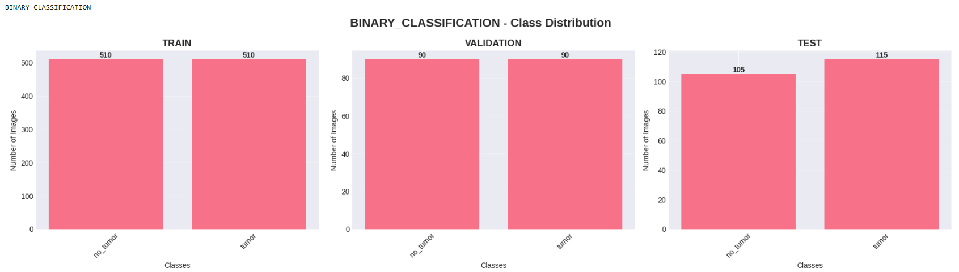
Figure 2: Binary classification Dataset Class distribution analysis
Figure 3 displays the results of the class distribution analysis for the multiclass classification dataset. The distribution of tumor classes meningioma, glioma, and pituitary is well-structured and almost balanced throughout all three folders, including the training, validation, and testing folders. With almost identical photos for the three classes (1520 meningioma, 1528 glioma, and 1529 pituitary) in the training folder, we may conclude that the model accurately and unbiasedly extracts the characteristics from each class. With 182 meningioma photos, 174 glioma images, and 162 pituitary images in the validation folder, we can ensure accurate performance and proper monitoring during the model's training phase. This data is used just for evaluating the model's generalizability to new datasets; the test folder likewise has a decent distribution with 172 meningiomas, 150 gliomas, and 111 pituitary. An excellent study that guarantees equal representation of all tumor types, contributes to steady training, proper generalization, and accurate classification performance, is provided by this balanced distribution bar chart.
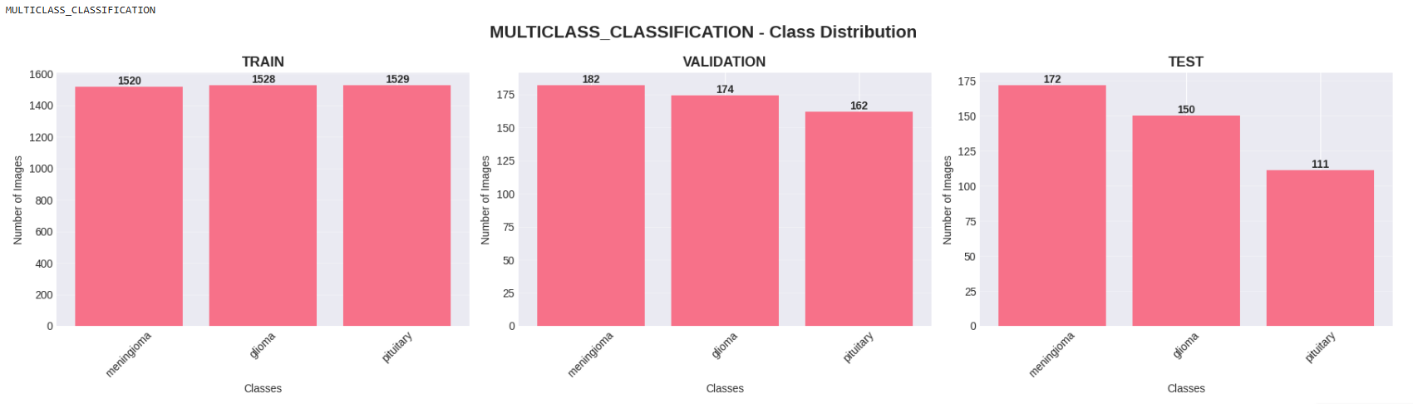
Figure 3: Multiclass classification Dataset Class distribution analysis
Preprocessing Pipeline
Figure 4 demonstrates the preprocessing pipeline, which transforms an input MRI picture step-by-step to ensure correct model training results. To start, the original picture has a lot of dark variations and unneeded background areas, which might impact the model's performance. down the cropping step, the model is able to zero down on the brain area by eliminating distractions like black borders. After that, we adjust the image's dimensions to 244 x 244. This makes sure the input images are of the same size, and it's worth noting that this size works with all deep learning models, including DenseNet121 and EfficientNetB0. The next step is to apply contrast and intensity modifications to the picture using the CLAHE approach. This will make significant characteristics, such tumor patches, seem brighter. Finally, in the normalization step, we scale all the pixel values to a range usually between 0 and 1. This improves convergence and speeds up training. Our project benefits from this preprocessing pipeline because it ensures that the input data is consistent and clean, which in turn helps the models learn relevant features and improves their classification performance.
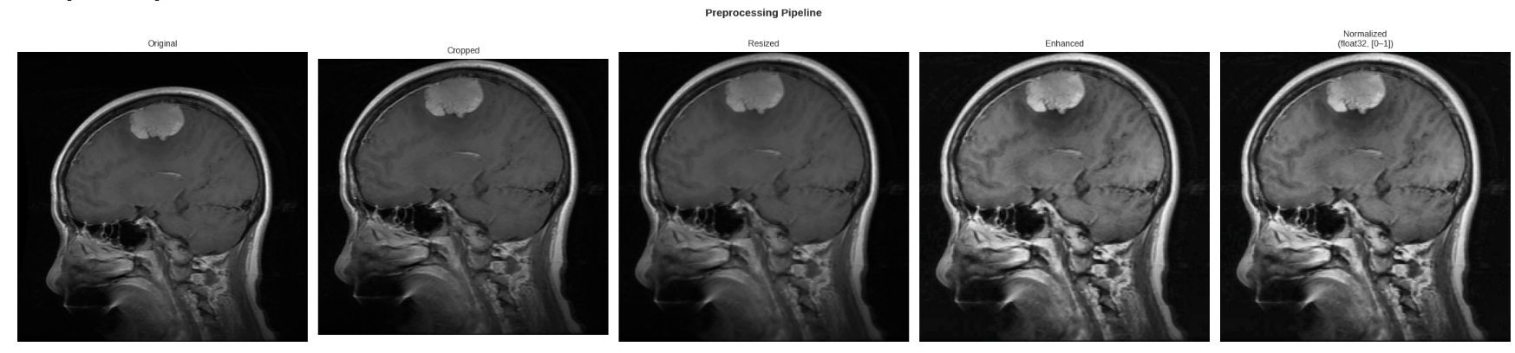
Figure 4: Preprocessing Pipeline Steps
EfficientNetB0 Model Binary Classification
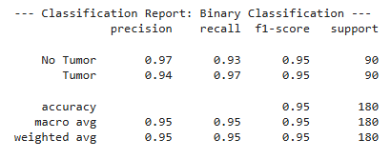
In the binary classification test of tumor prediction, the EfficientNetB0 model (Figure 5) performed very well, distinguishing between cases where there is a tumor and those where there is no tumor. Figure 5's function matrix informs us that our overall accuracy was 95%, and we can observe that the model exhibited remarkable parity between the two classes. Even in the "No Tumor" and "Tumor" groups, our F1-score was 0.95, which is quite good. On top of that, the model's excellent performance is shown by its high accuracy of 0.97 for the No Tumor class. With weighted and macro averages of 0.95, we can see that the model holds true for both groups.
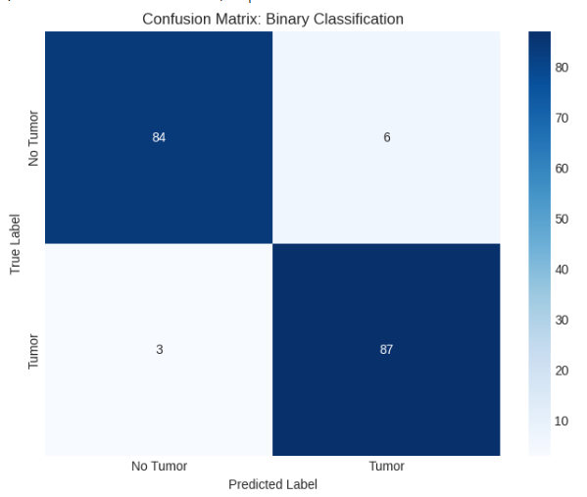

Figure 5: Confusion Matrix of EfficientNetB0 binary classification model
Figure 6, which displays the EfficientNetB0 training and validation graphs, reveals a learning curve that remains constant throughout the training phase. This indicates that the model performs well on binary classification tasks. It is clear that the model is extracting useful information from the MRI dataset as the accuracy curve shows a steady increase in training and validation accuracy across all epochs. When the training accuracy reaches 99% and the validation accuracy reaches 95% to 96%, it indicates that the model is generalizing. This phenomenon occurs as the training period progresses and both accuracies become apparent at high numbers. Both the training and validation loss curves show a consistent drop, indicating that the model is converging. The picture shows that the loss decrease is monotonic and downwards, indicating that the model is learning steadily and predictably. Based on these graphs, it is clear that the EfficientNetB0 model has identified the dataset's underlying patterns, leading to dependable performance, minimal loss, and excellent accuracy.
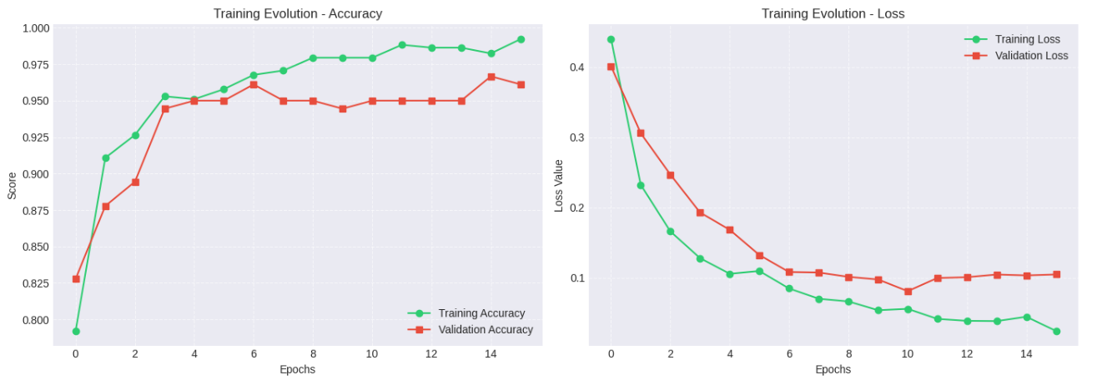
Figure 6: Accuracy and Loss curves of EfficientNetB0 binary classification model
EfficientNetB0 Model Multiclass Classification
Figure 7 shows the correct outcome of the EfficientNetB0 model in the multiclass classification task of differentiating pituitary tumors, gliomas, and meningiomas. According to the confusion matrix, the model successfully distinguishes between tumor types over a significant number of samples across all three categories. The model's balanced performance across all three classes is highlighted in the classification report by strong precision, recall, and F1-scores. Precision, recall, and F1-score are all best achieved by the pituitary tumor class. These findings demonstrate that EfficientNetB0 can successfully learn challenging patterns in MRI images, which allows it to perform admirably in multiclass tumor classification tasks.
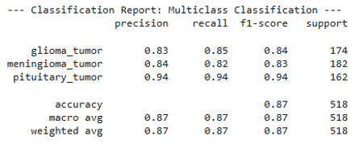
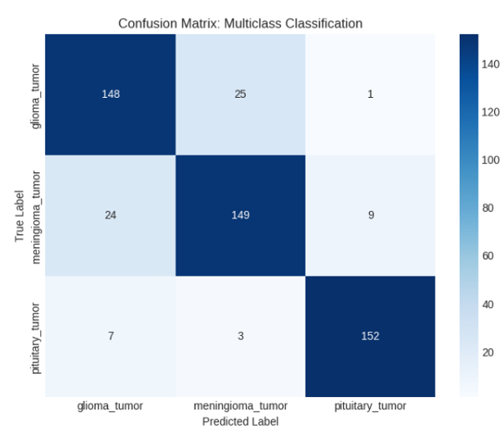

Figure 7: Confusion Matrix of EfficientNetB0 multiclass classification model
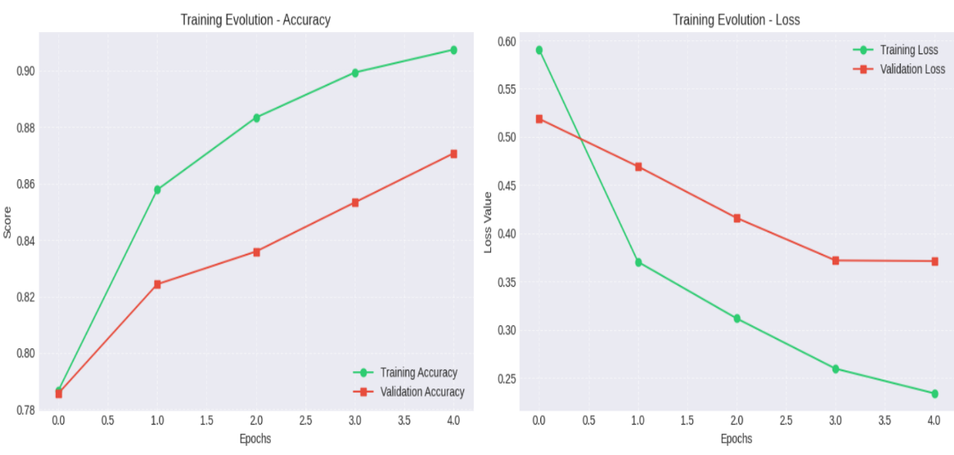
As shown in Figure 8, the training and validation graph for EfficientNetB0 in the multiclass classification problem demonstrates a consistent learning trajectory, indicating that the model is successfully undergoing training. A rising accuracy curve for training and validation throughout all epochs indicates that the model has learned the features and can generalize well to the MRI dataset.
Figure 8: Accuracy and Loss curves of EfficientNetB0 multiclass classification model
The loss curve in the above image shows a continuous decrease for both training and validation loss this tells us that the model is slowly minimizing errors during training. This steady decline in loss values tells us that the model is going to a stable convergence state

EfficientNetB0 Model Testing
This MRI picture (figure 9) was correctly identified as a meningioma tumor by our EfficientNetB0 model, demonstrating the model's excellent predictive power. With a high tumor probability of 0.9972 and a final classification output that shows it is meningioma with a confidence score of 87%, the model is accurately giving us the correct tumor types. Additionally, the model correctly identified the true class.
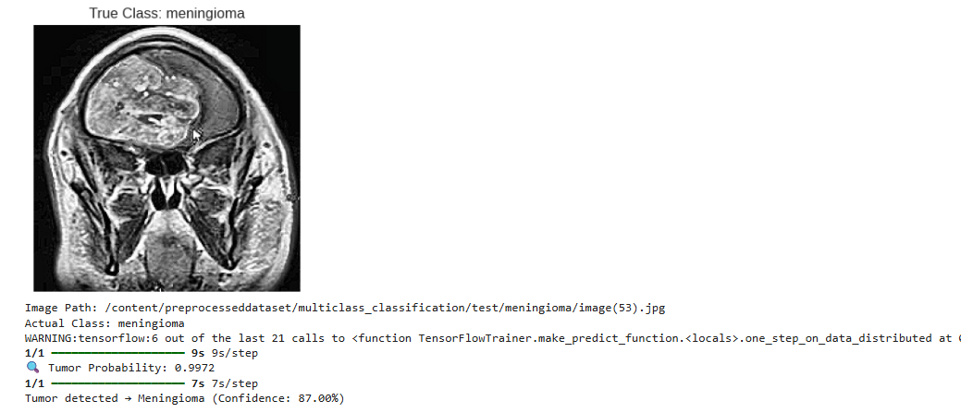
Figure 9: EfficientNetB0 Model Testing
DenseNet121 Model Binary Classification
The DenseNet121 binary classification model (Figure 10) as show demonstrated a very good performance in the binary classification task of prediction of the tumor between a Tumor and No Tumor case. The confunction matrix shown in the figure 10 tell us that we got an overall accuracy of 94%, we can find that the model showed an excellent balance on both the classes. We got an strong F1-score of 0.94 for both "No Tumor" and "Tumor" categories. More than this the model achieved a high precision of 0.93 for the No Tumor class this tells us that the model is performing good.
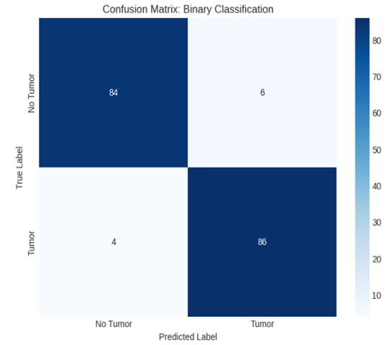
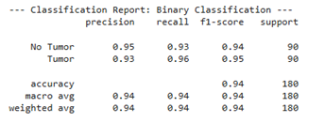

Figure 10: Confusion Matrix of DenseNet121 binary classification model
The training and validation graphs for DenseNet121 (figure 11) shows us a stable learning curve throughout the training process this says that the model is effective and good in binary classification task. The accuracy curve also shows a consistent growth in both training and validation accuracy during the all epochs, this indicates that the model is only learning meaningful features from the MRI dataset. After some time the training epoch increase both the accuracies become plain at high values this thing happens when the training accuracy is at 96% and validation accuracy is at 94–95% this tells the model is generalizing. The loss curves shows us a steady decline in both the training and validation loss this tells us the model is converging. The image tells us that the reduction in loss is continuously downwards only which means that the model is learning in a controlled and stable manner without any ups and downs. These graphs tell us that EfficientNetB0 model has successfully detected the underlying patterns in the dataset which results in high accuracy, low loss, and reliable performance.
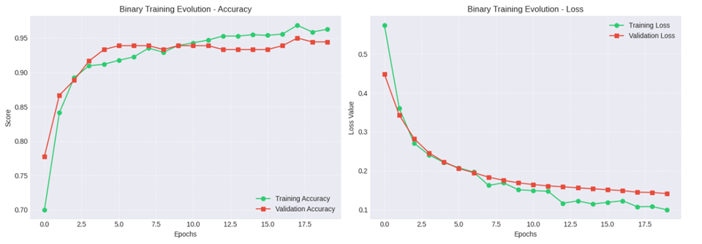
Figure 11: Accuracy and Loss curves of DenseNet121 binary classification model
DenseNet121 Model Multiclass Classification
The DenseNet121 model (Figure 12) showed an accurate result in the multiclass classification task of distinguishing between glioma, meningioma, and pituitary tumors. The confusion matrix tells us that the model classifies correctly for a large number of samples on the three categories this indicates that it can correctly differentiate between tumor types. The classification report tells us that the performance of the model is very well balanced with good precision, recall, and F1-scores across all three classes. The pituitary tumor class achieves the highest performance with precision, recall, and F1-score. These results tells us that DenseNet121 is capable of learning difficult patterns in MRI images and these can perform effectively in multiclass tumor classification with good accuracy.
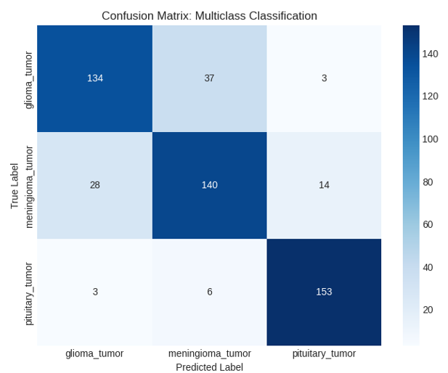
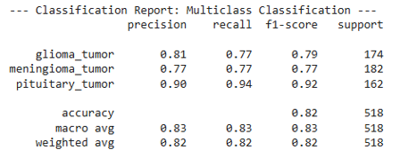

Figure 12: Confusion Matrix of DenseNet121 multiclass classification model
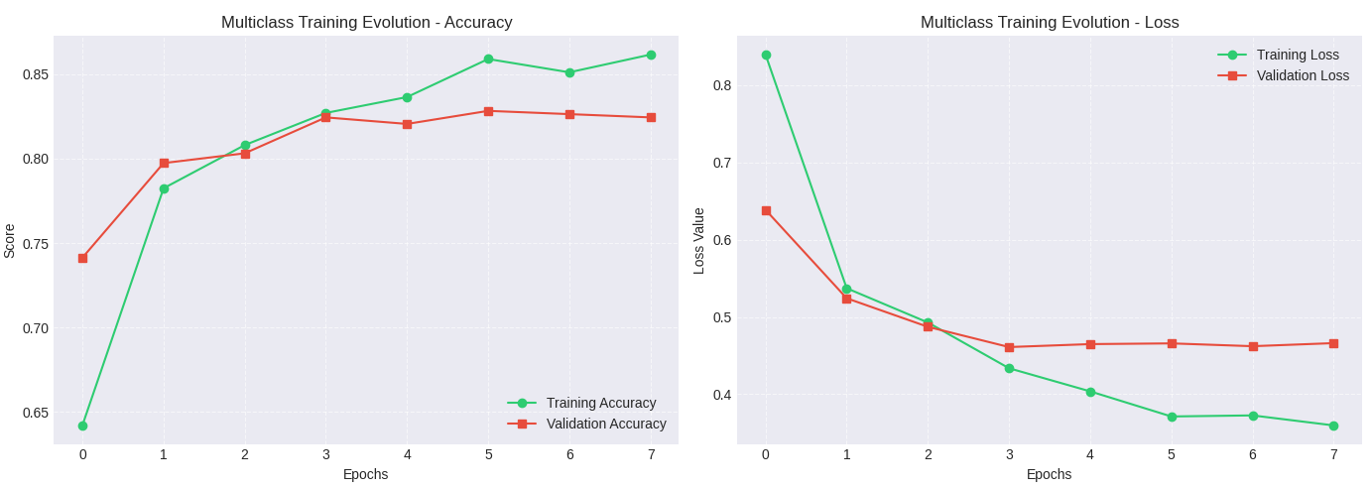
The training and validation graph (figure 13) for DenseNet121 in the multiclass classification task show a very steady learning progression this tells us that that the model is effective getting training. The accuracy curve gives an increase in both training and validation accuracy across all the epochs this tells us that the model is able to learn the features and can also generalize well for the MRI dataset. The loss curve in the above image shows a continuous decrease for both training and validation loss this tells us that the model is slowly minimizing errors during training. This steady decline in loss values tells us that the model is going to a stable convergence state
Figure 13: Accuracy and Loss curves of DenseNet121 multiclass classification model

DenseNet121 Model Testing
The DenseNet121 model (figure 14) successfully classifies the given MRI image as a pituitary tumor this shows that the model has properly got trained with all the required features for the multiclass classification. This model also correctly identifies the true class and provides a tumor probability of 0.6427 and with a confident final prediction of pituitary tumor with 83.91% confidence. This indicates that the model correctly recognized the tumor type by getting trained with the features for the pituitary tumors type from MRI images.
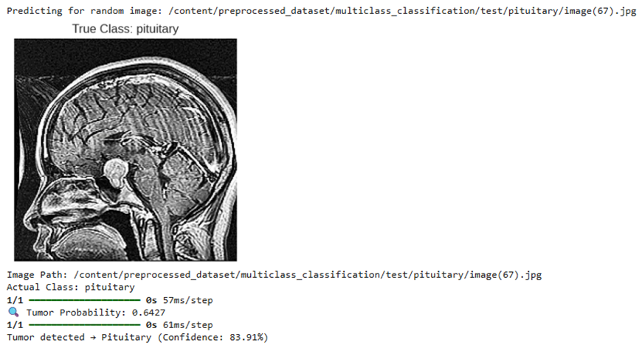
Figure 14: DenseNet121 Model Testing
ProtoPnet Model Multiclass Classification
The ProtoPNet model (figure 15) gives a good performance of the classification of brain tumors this clearly tells us that the models is good at distinguishing between glioma, meningioma, and pituitary tumor classes. The confusion matrix speaks that the model correctly classifies a large number of samples, with 140 glioma, 170 meningioma, and 140 pituitary tumor cases this tells us that the model is learning the features and not just remembering the values. The pituitary tumor in this also achieves good results with a precision of 0.95, recall of 0.86, and an F1-score of 0.91 this tells us that the model is good at prediction of pituitary king tumors. Also this glioma and meningioma classes show good performance and the model accuracy is 87%, along with macro and weighted averages around 0.87–0.88 for brain tumor classification.

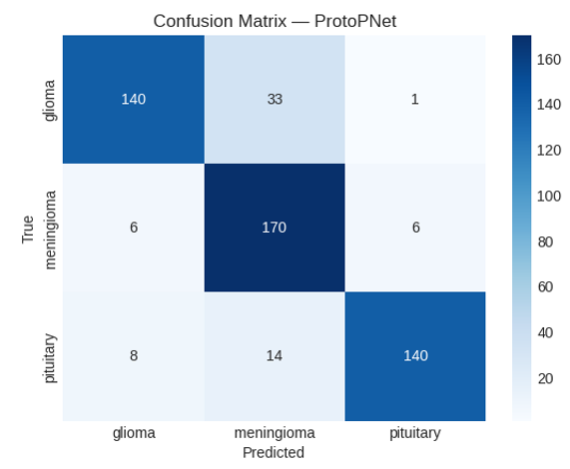
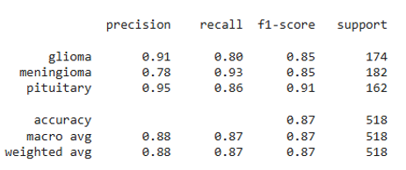

Figure 15: Confusion Matrix of ProtoPNet classification model
The training and validation graphs (figure 16) of ProtoPNet also a stable learning behavior throughout the training process. The accuracy and loss curve shows a continuous increase and decrease in both training and validation accuracy this tells us that the model is successful in learning meaningful features from the MRI dataset. Training accuracy increases to above 91%, and this validation accuracy also increases reaching around 87–88% this is telling us that the model is generalizing. Similarly, the loss curves shows a continuous decrease for both training and validation loss telling us that the model is in convergence mode. All these results shows that the ProtoPNet model is effectively capturing important patterns in the data.
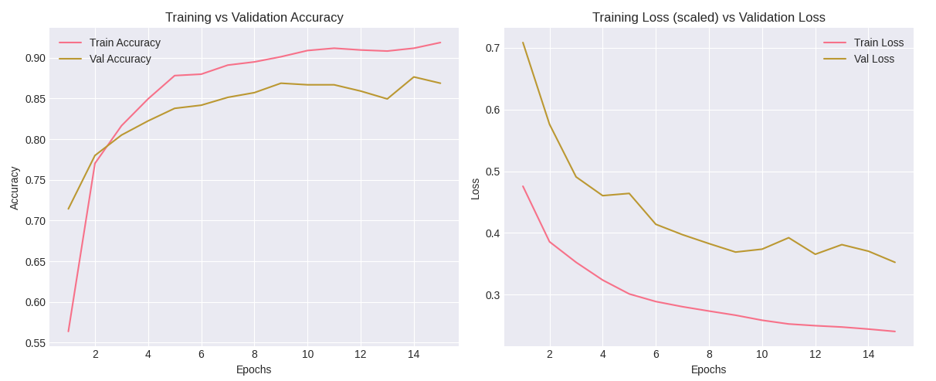
Figure 16: Accuracy and Loss curves of ProtoPNet classification model
This displayed images (figure 17) is very important part of this model it represent the model picked prototypes of the ProtoPNet, that act as a comparision representative patterns for each tumor class glioma, meningioma, and pituitary. Each of these prototype gives an important and unique visual features from MRI scans images for a specific class. During the prediction process this ProtoPNet compares the regions of a new input image with these stored prototypes images and identifies similarities to make the classification decision. accordingly These prototypes highlight only meaningful structures such as tumor shape, location, and texture, allowing the model to provide the correct reason for its predictions.
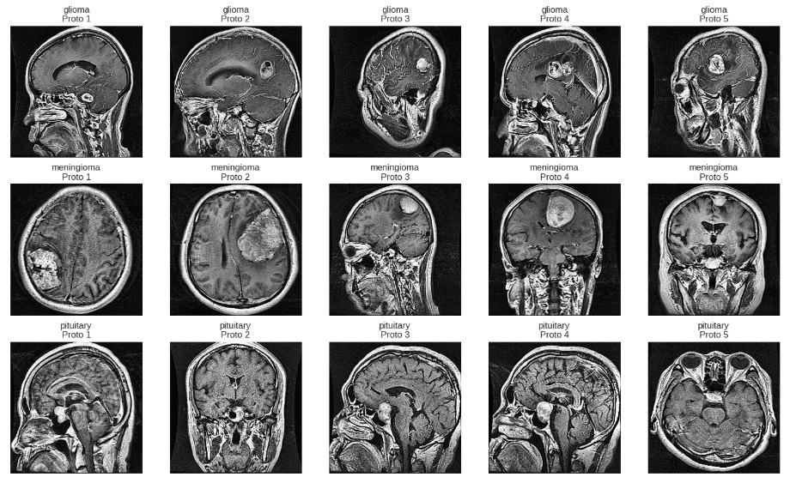
Figure 17: ProtoPNet prototypes
ProtoPnet Model Classification
The ProtoPNet model (figure 18) has successfully classified the given MRI image as a glioma tumor with a confidence of 93.06% this tells us that the model is predicting correctly. To prove this result as correct our team showed the contribution analysis of each prototype as we can see in this multiple glioma related prototypes show high scores telling us that the predicted result of the model is correct from the input image. Also to prove the other classes are wrong the other class prototype contributions are also show. This prototype based reasoning tells us the actual reason why the model predicted a particular result for the MRI scan this provides not only the classification but also an interpretable resoning for decision made.
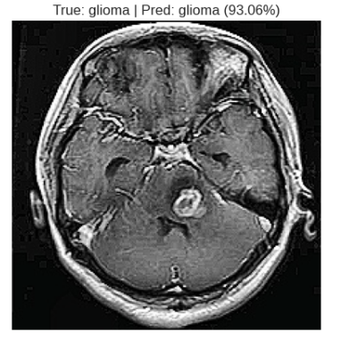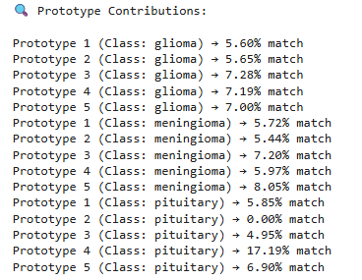
Figure 18: ProtoPnet Model Testing
Training Accuracies
The training results (figure 19) shows strong learning performance across all models this tells us that all the model system effectively captures correct features from the MRI dataset. For EfficientNetB0 binary classification performance is very good with an accuracy score of 99.22%, precision score of 99.41%, and recall score of 99.02% this model worked very good in comparing which is tumor image and which is no tumor image. In the multiclass EfficientNetB0 it also perform well with an accuracy score of 90.74%, this also is good at classification tasks. Next coming to DenseNet121 this model shows good performance in binary classification with an accuracy of 96.27% score, precision score of 95.38% score, and recall of 97.25% score. In multiclass classification also DenseNet121 gives us a good results with a good precision score and recall score this is also good in identifying the tumor types. The ProtoPNet model also gives a performance in multiclass classification with an accuracy score of 93.55% and both precision and recall are correctly in par with each other giving us a strong classification capability.
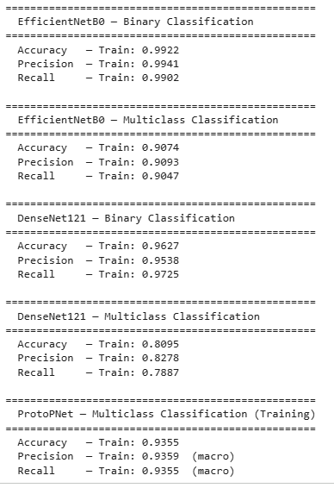
Figure 19: Training Accuracies of all the models
Testing accuracy and Tumor Localization
The ensemble model (figure 20) showed a good performance in classifying the given MRI image as a meningioma tumor type. We can also see that the individual models produced very different predictions EfficientNet predicted glioma with a confidence of about 65.21% and both DenseNet and ProtoPNet correctly identified the image as meningioma with high confidence score of about 98.92% and 89.26% this ensemble mechanism combined these outputs to select the one with highest confidence. The final result correctly classifies the image as meningioma with a high confidence of 98.92%, this is given by DenseNet’s model.
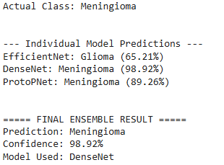
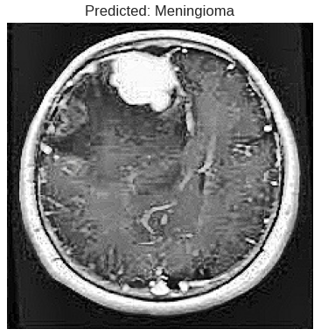

Figure 20: Confidence based Ensemble Final result
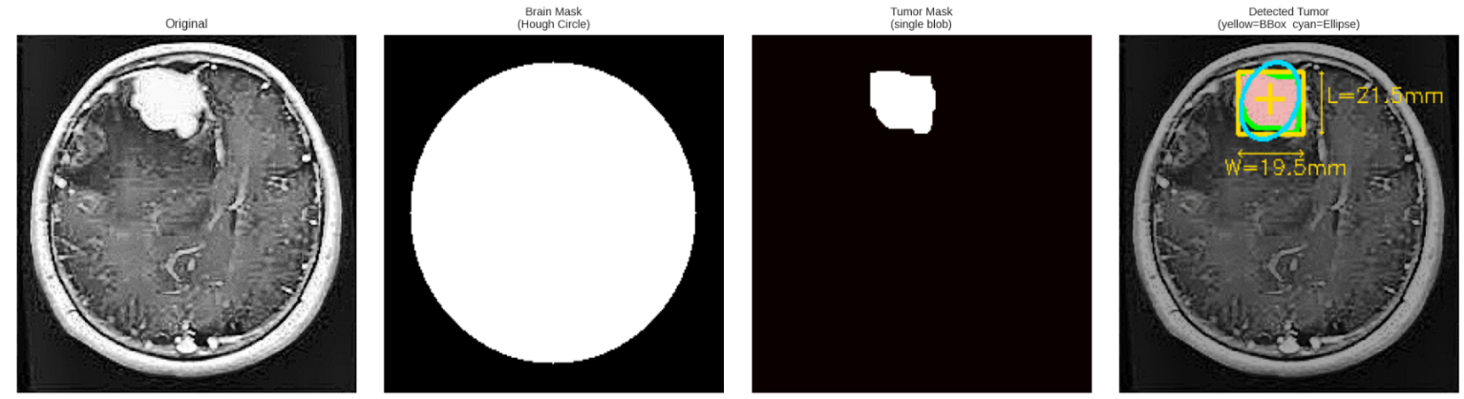
The tumor localization output (figure 21) clearly shows the correct application of our image processing pipeline in detecting and highlighting the tumor region for a MRI scan image. We start from the from the predicted original image then the system isolates the brain part region using a circular mask and then it ensures that only the required region is considered for further analysis. The tumor mask then successfully segments the suspicious region giving us the accurate separation of the tumor from surrounding brain tissues. In the final output of the image we can see that the detected tumor is clearly highlighted using a bounding box and ellipse. The system also calculates some important measurements such as the approximate dimensions of the tumor etc. This results also confirms that the localization module is good in identifing the tumor region.
Figure 21: Tumor Identification
This compares the test accuracies (figure 22) of all the three models that we used this in this system this also demonstrates how good the model is in brain tumor classification process. Among all the models the EfficientNetB0 achieves the highest accuracy of 87.26% showing that it has captured and generalized all important features from MRI images. ProtoPNet model is the next good model with an accuracy of 85.67% then next is DenseNet121 with an accuracy of 83.51%, this also gives a good result and it also showed that it has learnt some good and meaningful features. All these models have a very close performance and it also tells us that consistency and accurate prediction are very important in giving the output for a model. These results also validate our project idea of using multiple models in the system and it also tells us that each model contributes a very important action in the improved accuracy and improved predictions.
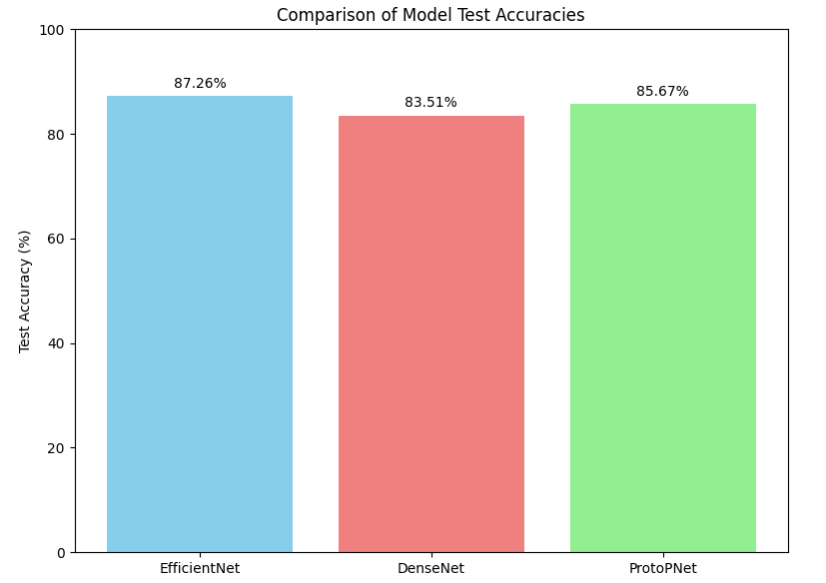
Figure 22: Testing Accuracies of all 3 Models

CONCLUSION
To conclude, our proposed project has been successful in demonstrating how a classification and localization of brain tumor can be achieved using MRI Images through the integration of modern deep learning architectures and traditional approaches of image processing. The project makes the efficient use of architectures like EfficientNetB0 and DenseNet121, which facilitate multiclass classification of tumors accurately. The project also uses a ProtoPNet to improve interpretability of models, which also provides a visual explanation for the predicted classes and also by using a voting-based ensemble the system achieve a better performance is another positive aspect of the system. Along with classification our proposed system also performs the tumor localization through OpenCV this facilitates the identification of tumor regions from images. Through my proposed system all of the shortcomings of the traditional and conventional systems which lack interpretability, localization, explainability of tumors have been overcomed through this project. Our project has successfully highlighted the real usefulness of combining the deep learning models with the traditional and old classical computer vision techniques in assisting doctors to make faster and more accurate decision-making processes.

REFERENCES
- T. R. Mahesh et al., “An XAI-enhanced EfficientNetB0 framework for precision brain tumor detection in MRI imaging,” J. Neurosci. Methods, vol. 410, p. 110227, 2024.
- M. M. Naseer et al., “An optimized EfficientNet-B0 framework for multi-class brain tumour detection and classification from MRI images,” Biomed. Pharmacol. J., vol. 18, no. Special Edition, Oct. 2025.
- D. Onah et al., “Deep Brain Net: An optimized deep learning model for brain tumor detection in MRI images using EfficientNetB0 and ResNet50 with transfer learning,” arXiv preprint arXiv:2507.07011, 2025.
- F. F. Jiven and R. Rumini, “MRI classification of brain tumors using EfficientNetB0 feature extraction and machine learning methods,” J. Appl. Inform. Comput., vol. 9, no. 6, pp. 3394–3404, Dec. 2025.
- K. Gencer, “A comparative analysis of EfficientNetB0 and EfficientNetV2 variants for brain tumor classification using MRI images,” Int. J. Innov. Eng. Appl., vol. 9, no. 1, pp. 1–7, 2025.
- A. Iqbal et al., “Enhancing brain tumour multi-classification using Efficient-Net B0-based intelligent diagnosis for Internet of Medica
- l Things (IoMT) applications,” Information, vol. 15, no. 8, p. 489, 2024.
- M. Rasheed et al., “Improved brain tumor classification through DenseNet121 based transfer learning,” Discov. Oncol., vol. 16, p. 1645, Aug. 2025.
- Y. Mao et al., “Dilated SE-DenseNet for brain tumor MRI classification,” Sci. Rep., vol. 15, Art. no. 86752, 2025.
- S. S. Sabila et al., “The multiple brain tumor with modified DenseNet121 architecture using brain MRI images: Classification multiclass brain tumor,” Kursor, vol. 12, no. 2, pp. 123–134, 2024.
- R. B. Sumona et al., “An integrated deep learning approach for enhancing brain tumor classification using RDXNet,” Healthcare Analytics, vol. 8, p. 100421, Dec. 2025.
- R. Disci et al., “Advanced brain tumor classification in MR images using pre-trained deep learning models,” Cancers, vol. 17, no. 1, p. 121, 2025.
- Y. Wei, R. Tam, and X. Tang, “MProtoNet: A case-based interpretable model for brain tumor classification with 3D multi-parametric magnetic resonance imaging,” in Proc. Medical Imaging with Deep Learning (MIDL), 2023, pp. 1–15.
- Y. Wei, R. Tam, and X. Tang, “MProtoNet: A case-based interpretable model for brain tumor classification with 3D multi-parametric magnetic resonance imaging,” in Proc. 6th Conf. Medical Imaging with Deep Learning, 2024.
- Y. Wei et al., “MAProtoNet: A multi-scale attentive interpretable prototypical part network for 3D magnetic resonance imaging brain tumor classification,” arXiv preprint arXiv:2404.08917, 2024.
- M. Rasheed et al., “Advanced deep learning-based brain tumor classification using DenseNet121 transfer learning on MRI images,” PLoS One, 2025.

Programme Outcomes (POs) and Programme Specific Outcomes (PSOs)
At the end of the Programme the students would be able to:
PO1 Engineering knowledge: Apply the knowledge of mathematics, science, engineering fundamentals, and an engineering specialization to the solution of complex engineering problems.
PO2 Problem analysis: Identify, formulate, research literature, and analyze complex engineering problems reaching substantiated conclusions using first principles of mathematics, natural sciences, and engineering sciences.
PO3 Design/development of solutions: Design solutions for complex engineering problems and design system components or processes that meet the specified needs with appropriate consideration for the public health and safety, and the cultural, societal, and environmental considerations.
PO4 Conduct investigations of complex problems: Use research-based knowledge and research methods including design of experiments, analysis and interpretation of data, and synthesis of the information to provide valid conclusions.
PO5 Modern tool usage: Create, select, and apply appropriate techniques, resources, and modern engineering and IT tools including prediction and modeling to complex engineering activities with an understanding of the limitations.
PO6 The engineer and society: Apply reasoning informed by the contextual knowledge to assess societal, health, safety, legal and cultural issues and the consequent responsibilities relevant to the professional engineering practice.
PO7 Environment and sustainability: Understand the impact of the professional engineering solutions in societal and environmental contexts, and demonstrate the knowledge of, and need for sustainable development.
PO8 Ethics: Apply ethical principles and commit to professional ethics and responsibilities and norms of the engineering practice.
PO9 Individual and teamwork: Function effectively as an individual, and as a member or leader in diverse teams, and in multidisciplinary settings.
PO10 Communication: Communicate effectively on complex engineering activities with the engineering community and with society at large, such as, being able to comprehend and write effective reports and design documentation, make effective presentations, and give and receive clear instructions.
PO11 Project management and finance: Demonstrate knowledge and understanding of the engineering and management principles and apply these to one’s own work, as a member and leader in a team, to manage projects and in multidisciplinary environments.
PO12 Life-long learning: Recognize the need for and have the preparation and ability to engage in independent and life-long learning in the broadest context of technological change.
PSO1 Apply algorithmic thinking and utilize programming languages such as C, Python and Java to develop and maintain efficient and robust computing systems.
PSO2 Design and develop computer-based applications of varying complexities using emerging topics of Computer Science and Engineering such as cloud computing, artificial intelligence, data processing etc.
PSO3 Possess the subject knowledge and scientific temper necessary to pursue successful careers in Computer Science and Engineering with ethical responsibility towards societal needs.

17 UN Sustainable Development Goals (UN-SDG)
No. | Description
SDG 1 | Goal-1: No Poverty
SDG 2 | Goal-2: Zero Hunger
SDG 3 | Goal-3: Good Health and Well-being
SDG 4 | Goal-4: Quality Education
SDG 5 | Goal-5: Gender Equality
SDG 6 | Goal-6: Clean Water and Sanitation
SDG 7 | Goal-7: Affordable and Clean Energy
SDG 8 | Goal-8: Decent Work and Economic Growth
SDG 9 | Goal-9: Industrial Innovation and Infrastructure
SDG 10 | Goal-10: Reduced Inequalities
SDG 11 | Goal-11: Sustainable Cities and Communities
SDG 12 | Goal-12: Responsible Consumption and Production
SDG 13 | Goal-13: Climate Action
SDG 14 | Goal-14: Life Below Water
SDG 15 | Goal-15: Life on Land
SDG 16 | Goal-16: Peace, Justice and Strong Institution
SDG 17 | Goal-17: Partnerships for the Goals

PROJECT PROFORMA
Classification of the Project | Application | Product | Research | Review
 |  |  | ✔

Project Course Outcomes
Outcome 1 | Formulate specific problem statements for well-defined real-life problems with reasonable assumptions and constraints.
Outcome 2 | Perform literature search and / or patent search in the area of interest.
Outcome 3 | Conduct experiments / Design and Analysis / solution iterations and document the results.
Outcome 4 | Perform error analysis / benchmarking / costing, Synthesis the results and arrive at scientific conclusions / products / solution
Outcome 5 | Document the results in the form of technical report / presentation

CO – PO Mapping
Project Outcomes | Programme Outcomes (POs) |  |  |  |  |  |  |  |  |  |  |  |  | PSOs
 | PO1 | PO2 | PO3 | PO4 | PO5 | PO6 | PO7 | PO8 | PO9 | PO10 | PO11 | PO12 | PSO1 |  | PSO2 | PSO3
CO1 | 3 | 3 | 3 | 3 | 3 |  |  |  | 3 | 3 | 3 | 3 | 3 |  | 3 | 3
CO2 | 3 | 3 | 3 | 3 | 3 |  |  |  | 3 | 3 | 3 | 3 | 3 |  | 3 | 3
CO3 | 3 | 3 | 3 | 3 | 3 |  |  |  | 3 | 3 | 3 | 3 | 3 |  | 3 | 3
CO4 | 3 | 3 | 3 | 3 | 3 |  |  |  | 3 | 3 | 3 | 3 | 3 |  | 3 | 3
CO5 | 2 | 3 | 3 | 3 | 3 |  |  |  | 3 | 3 | 3 | 3 | 3 |  | 3 | 3

UN Sustainable Development Goals (UN-SDG) Mapping
Project Title | Project Type | SDG Target | Justification
Proposed Explainable AI Techniques for Brain Tumor Classification | Capstone Project | Goal-3: Good Health and Well-being | System enables early and accurate brain tumor diagnosis using AI, improving treatment outcomes and reducing mortality.


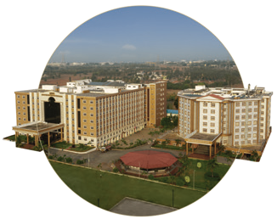
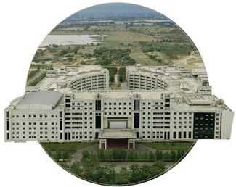

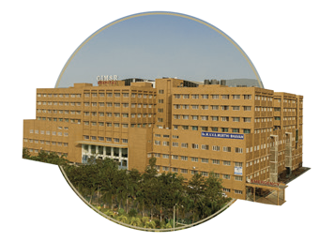

Bengaluru
NH 207, Nagadenehali, Doddaballapur Taluk, Bengaluru - 561203, Karnataka, India
Hyderabad
Rudraram, Patancheru mandal, Hyderabad - 502329, Telengana, India
Visakhapatnam
Gandhi Nagar, Rushikonda, Visakhapatnam- 530045, Andhra Pradesh, India
Bengaluru
Visakhapatnam
GIMSR Bengaluru City Office Hyderabad City Office GITAM Medical College Rd, No 5/1, First Floor, Prestige 6th floor, TP House, Cyber Gandhi Nagar, Rushikonda, Terraces, Union Street, Hills Colony, VIP Hills,
Visakhapatnam - 530045 Infantry Road, Bengaluru - Jaihind Enclave, Madhapur, Andhra Pradesh, India 560003 Karnataka, India Hyderabad - 500081,
Telangana, India
Hyderabad
GIMSR
Visakhapatnam

