BTAI: Proposed Multimodel Explainable AI Techniques for Brain Tumor Classification
A Project Report submitted in partial fulfillment of the requirements
for the award of the degree of


BACHELOR OF TECHNOLOGY
in
COMPUTER SCIENCE AND ENGINEERING
(Specialization in Artificial Intelligence & Machine Learning)

Submitted by
AKSHAT VASHISTH (VU22CSEN0300234)
MANIKONDA SATYA VARDHAN (VU22CSEN0300205)
MUPPASANI SHRUTHIKKA (VU22CSEN0300300)

Under the esteemed guidance of
Dr. Milan Kumar Dholey
Assistant Professor
GSCSE Dept. of CSSE



Department of Artificial Intelligence and Data Science
GITAM School of Computer Science and Engineering
GITAM (Deemed to be University)
Visakhapatnam
2026

Department of Artificial Intelligence and Data Science
YEAR
GITAM School of Computer Science and Engineering
GITAM (Deemed to be University)
Visakhapatnam


DECLARATION

We, hereby declare that the project report entitled “Proposed Multimodel Explainable AI Techniques for Brain Tumor Classification” is an original work done in the Department of Artificial Intelligence and Data Science, GITAM School of CSE, GITAM (Deemed to be University) submitted in partial fulfillment of the requirements for the award of B.Tech Degree in Computer Science and Engineering (Specialization in Artificial Intelligence and Machine Learning).

The work has not been submitted to any other college or University for the award of any degree or diploma.

Date: 06-04-2026
Registration Nos Names Signature
VU22CSEN0300234 AKSHAT VASHIST
VU22CSEN0300205 MANIKONDA SATYA VARDHAN
VU22CSEN0300300 MUPPASANI SHRUTHIKKA
Department of Artificial Intelligence and Data Science
GITAM School of Computer Science and Engineering
GITAM (Deemed to be University)
Visakhapatnam


CERTIFICATE

This is to certify that the project report entitled “BTAI: Proposed Multimodel Explainable AI Techniques for Brain Tumor Classification” is a bonafide record of work carried out by Akshat Vashisth (VU22CSEN0300234), Manikonda Satya Vardhan (VU22CSEN0300205), Muppasani Shruthikka (VU22CSEN0300300), students of this department submitted in partial fulfillment of requirements for the award of B.Tech Degree in Computer Science and Engineering (Specialization in Artificial Intelligence and Machine Learning).

Date: 10-04-2026

Project Guide Head of the Department
Dr. Milan Kumar Dholey Dr. Kuppili Naveen Kumar
(Assistant Professor,CSSE) Associate Professor, HOD
Department of Artificial Intelligence and Data science

ACKNOWLEDGEMENT
We owe to all of you, our utmost and most heartfelt gratitude, who contributed to seeing this research effort through to the finish line.
Our project advisor, Dr. Milan Kumar Dholey Sir, has been a tremendous asset to us, and we are very thankful to him having given us all the time, energy and wisdom. This power and complete wiseness and smartest criticism were the of the great helped in our study. Through him, we was able to think outside the box and enhance our approach at every opportunity.
This is also the highest raise that can give afford to the staff professors of GITAM and that have made the a place conducive to study. Their constructive criticism is helpful since the soliding our thoughts and just the improve the quality of our project. We would also like to offer our most sincere thanks to all of the people in GITAM college have provided us with encouragement staff and helpful manner.
Our families very thankful to us as the were us rocks solid support and the backing of our rare failing encouragement. The knowledge also support helped us be dedicated and stay focused.
We wish this acknowledge the authors and guides the previous researches were very used as the main rocks to the our research. This resources and supports of the institution played a part in making that this study became a success and we make a promise to them all this time. This initiative would not have never been able to happens without this cooperation of this organizations and beautiful people. Our mostly hearty thanks to each and every one of them.

TABLE OF CONTENTS

S. No. | Description | Page No.
1. | Abstract | 1
2. | Introduction | 2
3. | Literature Review | 7
4. | Problem Identification & Objectives | 10
5. | Existing System | 12
6. | Proposed System | 16
7. | System Architecture and Flow Diagram of the Proposal | 20
8. | Tools/Technologies Used | 27
9. | Implementation & Results | 31
10. | Conclusion | 47
11. | References | 48
12. | Programme Outcomes (POs) and Programme Specific Outcomes (PSOs) | 50

ABSTRACT
Every day we start our own confrontation work this the most deadlist problem: brain tumors. The importance of early and precise tumor diagnosis cannot be overstated, as it has the potential to significantly enhance treatment results and save many lives. Our "BTAI" deep learning system can detect and categorize brain cancers in magnetic resonance imaging (MRI) scans without human intervention. Here, we used state-of-the-art convolutional neural networks such as EfficientNetB0 and DenseNet121 to carry out multiclass classification (glioma, meningioma, and pituitary cancers) in addition to binary classification (tumor or no tumor). We also used ProtoPNet, an ante-hoc neural network model based on prototypes that provides a clear visual explanation for a specific prediction made by the model, to make our model more accurate and precise for clinicians. We used a confidence-based voting mechanism to aggregate the findings of all three models and choose the most confident prediction as the final output, resulting in a superior output categorization. After the categorization, we used several basic classical image processing methods to bring the tumor-affected area of the MRI scan to light. These techniques included grayscale conversion, Gaussian blurring, binary thresholding, and contour detection. In addition to providing physicians with a clear visual picture of the tumor-affected region in the brain, our method not only achieves a strong categorization but also achieves excellent accuracy. We are developing a very practical and helpful tool that will aid clinicians in the faster and more accurate detection of brain tumors by integrating state-of-the-art deep learning models with conventional computer vision techniques.

INTRODUCTION
When it comes to have neurological disorders, brains tumors are among the mosts dangerous and deadly. These pose a tremendous risks to all patients, their families, and healthcares systems throughout the globes. When an aberrants proliferation of brain cells is observed, they are among the most serious and potentially fatal. The existence of these tumors may significantly impact vital brain processes including speech, visions, memory, and motor abilities; on the other hands, brain tumors can be benigns, meaning they are nots cancerous and pose less of a threat, or malignant, meaning they are very dangerous. Because this ours brain is one of the most mysterious and complicated organs in the body, it is crucial to identify brain tumors early and correctly classify them so that patients may get the best therapyies possible and have a better chance of survivals. It is crucial to make the appropriate choice at the right time for a patient's health since a delayed or incorrect diagnosis might worsen the brain tumor, leading to diseases including brain strokes or even or death. According my a well respected sir organization mike analysis they are approximately 3.5 cases of primary malignant brain tumors for every 100,000 cancer patients. Brain tumors is a leading cause of cancer-related deaths in children and adolescents under the age of 20, and these continues to be a significant factors in the mortalities of the rate among adults under the ages of like 40 maybe. It is this kind a tumor type which sort of determines the survivals rates of brains tumors. Some of my these worst are the bad losed aggressived forms of worst malignancy such as the glioblastoma multiforme (GBM) is extremely lethall and are very casually occured systems in most bad adults grouped aged max at 30-35 years below that the however the most malignant meningiomas are mostly harmless and the have high probability they of survival mode. Our findings based on this claim would becoming to have reliable this sort methods can switch identify the type of tumors at an earlier stage of life of the man.
We shall now enter into my own world where a classification of brain tumors. These highlight this kind a tumors are classified according to their birthplace behavior and aggressiveness. The most frequent forms in humans are pituitarys, gliomas, and meningioma tumors. The meninges are the moistest but is protective membranes that oncase the brain and the spinal cord sometimes tumors of this meningiomas type also very develop in this area. These kind of tumors account for 30–35% of all brain tumors globally and they are characterized by their moderate growths rate and benigns nature also show the making them less dangerous as you also knows and then the more quickly curable with medication and the chremotherapy. The most common age group for this type of meningioma tumor is the middle-aged locking women (between 30 and 35 years old), though it can also develop in can say that older adults (male and female). The most past crucial point to thinking remembering is that these tumors are often found as a very bad unintentionally during imaging also tests for other say medical issues. Although some medication and few mild chemotherapy may heal sould and most the meningioma tumors this location of the tumor can say lead to some serious side effects such seizures and headaches. Even though they say not much take a long time to heal and need a lot of medical assistance these kind tumors may also be curable since they often have a clear borders and do not invade brain tissue. Thankfully, they are frequently very treatable with treatment.
Gliomas are the most some frequent and deadly kind of brain tumor, and we should will talk about them nexts. Glial cells are known as brain supporting cells and but some tumors of this sort of develop straight from these cells. This kind of tumors are incredibly diverse in ranges and also can ranges from very little smallest to a very largest in sizes. The kind of severity of each these tumor type are also determines its ranking from one to four. This most dangerous and the most potentially life-threatening tumors type in this family of humans are glioblastoma, with is ranked four. These tumors have a very cute tendency to meta molsize, or most spread to other sort parts of the brain. This makes them hinge very more hazardous, and some makes tumor removal a worst hard time taking made difficult procedure, and this might chances the increases their likelihood that the patients will die due to this also while under the anesthesia injection. The most related common age group for any tumors to come to the body like the stage we can talk is like adults, and the major reasons for this bad healthy nature that includes stress, pressure, and even heredity in sort of rare instances. Seizure, cognitives impairment, muscles weakness, and chronic headaches are most likely bad signs of this kind of tumors in pacific kind of women. In most of these cases, these gliomas need some combination of three different types of treatment surgeries, radiation therapy, and chemotherapies because of this kind of aggressive activity. Curing is the tumor with this method takes time.
Thirdly, there are tumors that grow in the pituitary gland in the brain. These tumors are which are also called the pituitary adenomas are about the size of a house kidney bean and nasty sit near the brain's base. The pituitary gland is kinda very important study as it regulates the vital functions of the body in the form of hormones. The research assumes that these tumors are benign and grow at a rather slow pace. Although most of such tumors do not secrete hormones, those that do, are often classified as functional tumors. Also, pituitary functioning tumors, which may result in severe kidney disorders, such as the well-known Cushing disease, can be found. Such tumors are usually very large and one of the most significant side effects is that they cause total loss of vision because they squeeze the optic nerves of the eyes. In case these tumors are not treated, they might spread to the whole body. These pituitary tumors could have far reaching effects on the health of a person due to their strategic location. Unless treated properly, such a tumor can be a great threat to the life of the patient, and can even lead to death within several days. The predominant parts of treatment are medications, nasal surgery, and radiation therapy, although the details may worstly depend like the weights and calculated heights the tumor are the position was the tumor and between changes in hormones.
Pituitarys, meningiomas, and gliomas have these three principal types of tumours. These kind of tumors might have a very major cause a wide range of these behavioral changes in most of the humans, from the harmless brats and the most treatable benign tumors have the least treatable form, and since most extremely aggressive and this potentially might fatal malignant be the tumors. Although these accurate diagnosis of brain tumors is challenging, proper classification of tumors is very important crucial for developing effective treatment strategies.
Through many of these years passed the magnetic resonance imaging (MRI) scanning has still been a go a very be the imaging method for most of diagnosing brain cancers because no other is that high level of accuracy it produces, and the reliability is good and usage is super. It also allows for most comprehensive view of the brain's structure without any exposing the patient to most of dangerous radiation, unlike an X-ray body scan finds a good way and it may produce small very high-resolution pictures of our brain's tissues. By capturing most of several parts of this kind of brain, such as the some say T1, some T2, and some FLAIR sections, this facilitates easy and comprehensively good analysis of only the tumor left, the location, and texture. Understanding some this the MRI images is heavily depends on the most physicians and this might despite the numerous benefits. Everyone got to knows that some manually analyzing these tumors through a scan always isn't that always easy or quick. When our doctors have to look at a lot of scans in one day some of these kind it can be exhausting of them and sometimes the room for human error is always there in that region due to the sheer volume of patients data scans that are more in number. Another issue to this is like think of about is that several physicians may interpret the some of the same MRI scan may come different ways, which may lead to conflicting choices and, in some cases, even patient confusion when it comes to tumor analysis and treatment planning.
Conventional some wisdom on this brain tumor diagnosis that has been some long been plagued by a several drawbacks. Particularly in some areas with a highly reported coincidences of the brain tumors and where physicians less are required to review huge several scans daily, the previous method was notorious worst laborious. Artificial intelligence (AI) has the upper hand in the task but cases in certain situations when some of them it comes to recognizing tumors and their types good but doctor analysis is also very superior in other circumstances, according to many such several research. We have already established that an AI can outperform humans in some rare dimension situations; this is because of that human errors, heavy workloads, and some low resolution imaging characteristics caused by an outdated MRI equipment all which play a big role in this prevalence of these potentially most fatal diagnostic mistakes. Additionally, when there is a big risk of these missing and very small treatable tine or early stage cancers while doing a manual analysis; postponing such treatments worsens the patient's condition. All of these problems are very high in underdeveloped areas, where healthcare facilities and specialists are harder to reach than in more established cities.
Thanks to advancements in AI and CNN, tumor identification has become a breeze. Once upon a time, most people used antiquated machine learning methods that included manually extracting features like form, texture, and other attributes from MRI images. Because of their low accuracy, lack of generalizability, and inability to converge across many scanners and protocols, these approaches necessitated the development of more effective feature extraction and classification algorithms. A number of deep learning models, including perceptrons and others, have recently made strides, completely changing the face of image processing, analysis, and prediction. Most were among the first to come as we know from their ability to directly convert images into pixel format without requiring hard mathematical operations was revolutionary. A plethora of other architectures have also developed over the years; some, like VGG, ResNet, U-Net, GoogleNet, and AlexNet, have their advantages and disadvantages. All of these models engage in a parameter game, but some, like EfficientNet and DenseNet, have improved their accuracy while using fewer parameters, and they have produced results that surpass those of average humans in detection tasks such as tumor detection, classification, and segmentation.
Despite the fact that several advancements are being made in these areas of CNN, there are still numerous shortcomings in the existing systems. Many of these deep learning models operate as so-called "black boxes" models; this implies that they may be made to justify their output, but they don't explain why they make predictions, which leaves room for skepticism. Decisions made by a blackbox model cannot have any positive impact on healthcare, as we all know that healthcare is crucial to a country's progress. Furthermore, putting all our faith in these models can have disastrous consequences, including harm to human lives and distrust among doctors who use them. An very significant and unique concept in healthcare, "explainability" plays a pivotal role in our brain tumor study endeavor. Not to mention that the majority of systems only ever address one aspect, such categorization or localization, and very seldom both. This results in the employment of several systems and, sometimes, annoyance among physicians. When both speed and accuracy are crucial, this missing-pieces method is a huge letdown for the system.
We have created a thorough, resilient, and interpretable system that incorporates some outstanding state-of-the-art deep learning architectures, namely EfficientNetB0 and DenseNet121, to produce an accurate multi-class classification output of the specific brain tumors in a patient, whether it be a glioma, meningioma, pituitary, or no tumor at all. This project, "Proposed Multimodel Explainable AI Techniques for Brain Tumor Classification," addresses all the issues mentioned above. We opted for this kind of model because it can effectively capture both the hierarchical and fine-grained information seen in MRI images, and it also has great performance and efficiency in prediction. Finally, in order to back up the term "Explainability" in the proposed framework, we added an ante-hoc model called ProtoPNet, which is a prototype-based neural network. This model hell thing learns not only by these bad typical components that sort the appearance kind of tumors and allows the worst physicians to visualize which visual concepts are behind the predictions.
Moreover that small traditional image processing kind of the block is added to our proposed project to be as a very unused as a tumor localization is considered. A significant sort of method to maximize the locate tumors is through a very easy and a follow up overlay that starts to the indicating boundaries and for the size of many of these tumors in pixels format and sometimes in the estimations of very small millimeters kind. Such unique techniques like the contour detection, fitting, methods thresholding some sort of the procedures can also help these in achieving the main objectives. This main hybrid multi-model approach is a very big kind a combination of all the highlight deep learning models to achieve high classification system and a classical computer vision system method which mainly achieves a good tumor localization, results in a linked pipeline that can perform automatic classification and tumor localization.
The objectives of this our project are also to decrease the time needing to the main diagnose and point out tumors, decreases human error, and boost the highlight trust that most physicians place in the diagnosis of the AI system as well all this without sacrificing key attributes of tumor detection such as interpretability and explainability. The system can be also identify tumors in images in addition to classifying tumors, and calculating the main quantitative tumor measurements. The final aim is to equip the main physicians with the most reliable decision support tools which are simple to comprehend and operate, in order to make improved diagnoses faster.

LITERATURE REVIEW
A group of convolutional neural networks (CNNs) called EfficientNetB0 models were suggested by Tan et al. [1]. These CNNs outperform their competitors due to a special quality they possess: they can automatically grow its depth and width. His work on this design includes automating the scaling of the network's depth, breadth, and resolution in an effort to boost speed and efficiency. The basic model, EfficientNetB0, demonstrated superior performance on ImageNet data sets compared to its predecessors due to the reduced number of parameters. Because it may be used in medical settings with less resources, EfficientNetB0 is both efficient and adaptable. When dealing with data sets that include diverse types of MRI scans, for example, fixed scaling factors may not be helpful.
In their work on the DenseNet model, Huang et al. [2] discovered that feature reuse is economical and that dense connections between layers may be the only output for the vanishing gradient problem. DenseNet121 is well-known for using this design, which has recently achieved mainstream success in image recognition and related fields by integrating feature maps obtained from all preceding layers. Additionally, this design enhances the model's gradient flow process and reduces parameter redundancy, making the model more effective during training.
One of the best pre-trained models we looked at was ProtoPNet, suggested by Chen et al. [3]. It's also called a prototype-based neural network, and the reason it enhances explainability is because it compares the input pictures' similarities to prototypes. Because this ProtoPNet, unlike other CNNs, lets you see the results, the model is great for healthcare applications. Its strong performance on benchmark datasets provides us with important insights on the tumor's decision-making process.
Islam et al. [4] developed the model EfficientNetB0, which was employed for transfer learning-based brain tumor classification. Using the pre-trained parameters he had retrieved from ImageNet, he was able to train a model that performed well with a sparse dataset. Results obtained by fine-tuning EfficientNetB0, such as freezing the layers, outperformed those from traditional CNN models, suggesting promising future use in medical imaging.
Pereira et al. [5] compared DenseNet121 and ResNet with regard to their applicability in segmenting brain tumors. According to the paper's details, the DenseNet121 model's superior performance over ResNet was a result of its dense connection, which in turn encouraged the usage of concept names feature propagation. According to what he said we can also have to have a acquired during this work we do DenseNet121 model is the more appropriate to be used in a task that has the main capable of recognizing the smallest details of the boundaries of a tumor of any type in present humans.
In order to identify these bad cancers cell in magnetic resonance imaging (MRI) scans, Onah et al. [7] presented a deep learning model approach called Deep Brain Network. This Deep Brain Network system has been constructed with the help of EfficientNetB0 and ResNet50 models. This project aims at optimization of the network parameters and residual learning through transfer learning. Running in binary or multi-class mode, this Deep Brain Network was able to cope with the tasks of the brain tumor detection.The significant computational expenses of running the model on this hybrid architecture and its extremely low picture quality were not fully investigated, which is a major drawback.
For the purpose of MRI brain tumor categorization, Jiven and Rumini's [8] suggested technique used a novel two-stage framework approach. Using EfficientNetB0 for deep feature extraction and the usual machine learning methods for classification were both part of this system. It was shown that the suggested technique achieved high brain tumor classification accuracy with much less computing effort compared to a conventional deep learning-based approach. Nevertheless, the suggested method relied entirely on the efficacy of the acquired traits, which was a big drawback.
An improved brain tumor classification with DenseNet121 as its foundation was introduced by Rasheed et al. [9]. Rasheed et al. [9] discovered that MRI scans may be utilized to classify various brain cancers, such as meningiomas, gliomas, pituitary, and others, by using DenseNet121's hierarchical feature information. On the Kaggle brain tumor dataset, our model performed well in terms of recall, accuracy, precision, and F1-score. The large number of parameters in DenseNet121 is one of its drawbacks, however.
In their presentation of the Dilated SE-DenseNet model architecture, Mao et al. [10] made use of DenseNet121 to classify brain tumors from MRI data. A refinement of the original DenseNet121 model, this work employs dilated convolutions and novel squeeze-and-excitation techniques to boost the classifier's efficiency across a wider receptive field, with a particular emphasis on feature extraction via key channels. Using T2-weighted MRIs, their method successfully classified four different kinds of brain cancers: meningioma, glioma, pituitary tumors, and non-tumors.
Wei et al. [11] developed the MProtoNet model, an interpretable case-based model that improves upon ProtoPNet for the purpose of detecting brain tumors using novel 3D multi-parametric MRI. According to the suggested model, MProtoNet is a conventional black-box CNN. It can learn prototypes and identify tumor kinds by comparing the input patch to prototypes. This method achieves high localization performance on 3D mpMRI datasets while also ensuring the model's interpretability. Prototype learning increases the computational overhead, which is the main downside.
Wei et al. [12] investigated MProtoNet, a novel interpretable model that used a case-based method to forecast brain malignancies using 3D multi-parametric MRI data. To further enhance the quality and interpretability of the prototypes, attention modules were used in conjunction with soft masking and online clustering losses. Practitioners were also able to get insight into which learnt tumor patterns had the most impact on the prediction because to this prototype reasoning. The suggested technique outperformed traditional CNNs, although it required tweaking of prototype hyperparameters and had somewhat worse accuracy when applied to non-interpretable deep architectures.

PROBLEM IDENTIFICATION & OBJECTIVE
Problem Identification
Brain tumor detection and classification is challenging because brain tumors may be located deep inside the brain and because MRI image intensities can change. This makes clinical diagnosis of brain tumors, especially differentiating between meningiomas, gliomas, and pituitary tumors, a very complex and difficult task. Despite the fact that MRI scans brain tissues at a high resolution and in many sections, the accuracy of the interpretation of these pictures is still heavily dependent on the physicians' knowledge and experience. It is challenging to correctly distinguish between tumor types in the real world due to factors such as the high volume of scans needed to treat patients, the high likelihood of human error and exhaustion, and the fact that tumors have irregular shapes, diffuse borders, and overlapping intensity distributions. Since many experts may come to different findings for the same scan, this causes a huge discrepancy when two or more physicians analyze brain tumors. The majority of current systems still use what are known as "black box" models; these models simply provide the final predictions without explaining the reasoning behind them, even though several deep learning based models have shown promising results in predicting the kind of tumor. These are not the good results of these models on a tumor and also these are not popular with any of the the medical community we have where the trust and the transparency are much greatly developed since they lack interpretability and explainability.
Interpretability and explainability these lockets are now worst big issues in the much of the existing systems. The second major issue we could find is that these detection techniques can also have not a major giving of the diagnostic information of the tumor type other than its classification but that is a big fat disadvantage. Most models will simply kind of inform you on the type of tumors that they belong to which but they will not consider the important information such as tumor location and size. Proper measurements of the size, shape, and geographic location of the tumor, including important variables such as major axis length, minor axis length and total tumor area are essential to optimal treatment planning, especially in surgery and radiation. There is a huge drawback between the model predictions and the doctor's interpretation of a brain tumor due to the lack of measurements. Not only that, but the majority of existing systems on the market still don't integrate the several pipelined activities involved in tumor detection, such as classification, segmentation, and explainability, into a single framework. This method, which is based on pipelines, is inefficient, slows down analysis, and restricts its practical use for medical professionals. Thus, bridging the gap between the various models currently in use and the decisions made by individual doctors requires a thorough interconnected system that not only achieves high classification accuracy but also offers some explainable insights into the model's decision-making process.
Objectives of the Project
- To utilize the proper deep learning models for an accurate multiclass brain tumor classification (Pituitary, Glioma, Meningioma).
- To apply and compare the confidence scores of some advanced models such as EfficientNetB0, DenseNet121, and ProtoPNet to improve performance and reliability.
- To implement a voting-based ensemble learning module for a better generalization and to reduce the overall variance.
- To implement a tumor localization module using some popular OpenCV techniques like contour detection and bounding box estimation that help in perfectly detecting the tumor in the MRI scan.
- To provide interpretability and explainability through visual insights to support faster and more reliable medical diagnosis by leveraging Ante-Hoc models.

EXISTING SYSTEM
Our team was able to modify a well-known research by Iqbal et al. that dealt with brain tumor multi-classification. This study presents a transfer-learning-powered intelligent diagnostic system based on the EfficientNet-B0 model, which is compatible with the Internet of Medical Things (IoMT). The model was developed with the express purpose of classifying three tumor types—glioma, meningioma, and pituitary—using the BraTs dataset and MRI images obtained from Kaggle and other sources. This is where the author goes on to say that EfficientNet-B0 is a super efficient convolutional neural network. It uses a technique where the depth and width just keep getting bigger and better on their own, which helps keep the resolution, width, and depth all in check while keeping the network relatively lightweight (with about 5.3 million parameters at the very least). Compared to the original convolution layer, this network's feature extraction process is more efficient thanks to its multiple layers of Mobile Inverted Bottleneck Convolution (MBConv) blocks integrated with a unique squeeze-and-excitation (SE) attention mechanism. Additionally, this model makes use of channel-wise feature recalibration. To accommodate the medical domain's pre-trained ImageNet weights, the authors reportedly swapped out the final layer's classification head with custom layers such as global average pooling—used to lower spatial dimensions—, a dropout regularization technique—used to avoid overfitting—and a softmax layer—used to generate three-class probability outputs. Typically, the full MRI image is resized to 224×224 and normalized so that each pixel falls within the range of [0,-1] in the small data preprocessing phase of the pipeline. Then, using the EfficientNet-B0 backbone, deep feature extraction is carried out, and finally, fully connected layers are used for classification. Following this, the system is assessed using familiar measures like as precision, accuracy, and the F1-score in conjunction with confusion matrix analysis. That authors surpassed a rondust number of benchmark CNN models, such as ResNet, VGGNET variations, and the original EfficientNet with simple architectures and obtained a staggering classification accuracy of more than 99% as detailed in the study.
Along with EfficientNet-based methods, several well-known works have investigated DenseNet121, a model for brain tumor classification that makes use of a transfer learning mechanism; these studies all cite the same original work. The key difference between DenseNet121 and other CNN models is how their interconnected layers share all the detected features. This reduces the need to extract base features for each layer, which is how DenseNet121 models work. This architecture has many unique points as compared to other CNN models such as feature reuse, strengthens gradient flow during backpropagation, and mitigates the vanishing gradient problem all these lead to a faster convergence and improved generalization even with a very limited medical datasets. The pre-trained DenseNet121 model has been fine-tuned by several researchers by retraining the latter dense blocks and a new classification head, which generally increases the classification accuracy. This model was initially trained on ImageNet. With a 97–98.5% accuracy rate across the same three-class problem, this state-of-the-art method captures both low- and high-level compound details in dull MRI images, as well as high-level structural features in MRI scans (glioma, meningioma, pituitary tumor). With its dense connection approach, DenseNet121 excels at managing glioma and meningioma tumor types, as well as other forms of tumors with deep, undifferentiated intensity changes in dull pictures and overlapping morphological features.
There are certain shared restrictions between the two usecases, despite the fact that they both have achieved outstanding categorization performance. Without spatial reasoning, visual explanations, or quantitative tumor measurements, the majority of these systems mostly operate as black-box classification models that only provide very accurate predictions. They seldom include physical quantification like major/minor axis length for tumor size measurement, border delineation, or prototype-based interpretability for tumor localization and traditional image processing. This leaves a huge hole in terms of practical use, as clinicians primarily need proper decision support with certain objective criteria for treatment planning, surgery, and radiation border determination in addition to tumor type categorization. A combined system, which incorporates good accuracy explanation nature as well as a real clinical usage, is exactly what has to be done to overcome these limitations.
Drawbacks of the Existing System
Firstly, these bad existing systems dont know anything as much as we know and also much about the tumor type, and these you know you know these badly lack a tumor localization module, which is a large limitation. The dirty primary type of deep learning models such as ResNet, Alexnet, and VGGNET is are according to me as worst and worst done as classification, which only allows identifying the type of tumor and not its location in the MRI scan. Yet knowing what kind of tumor it is, is not sufficient in the real world of hospitals and doctors. To cure a brain tumor, a physician requires certain information about the tumor such as the location of the tumor in the brain, any irregularities in its shape and boundaries. Due to the AI system's lack of localization and explainability, many clinicians are unable to use it to successfully determine radiation treatment margins, schedule surgeries, or evaluate tumor development. Also, most models don't earn physicians' confidence since they don't back up their predictions with data, which is especially problematic in this case because just disclosing the tumor kind doesn't make sense. This severely limits the usefulness and flexibility of such systems as there is a mismatch between their output and what doctors need.
Second, real-world deployment is complicated since many CNN models, such VGNET, ResNet, etc., are memory and computationally heavy. Models of this kind handle a plethora of mathematical operations, including convolution, pooling, batch normalization, and a large number of layers and parameters. They are resource intensive since training them takes a lot of time, additional RAM, and high-performance GPUs. It is very undesirable and, in some time-sensitive medical situations, entirely pointless, for computing expense to cause delays even during picture interpretation. There is often a severe lack of access to modern hardware infrastructure in healthcare facilities, especially in more remote or underserved areas. Because of this, the systems can't be scaled up or used by many people. Smaller hospitals also have a harder time implementing and making good use of these technologies due to the high computing needs, which raise operating and maintenance expenses.
Thirdly, one of the key issues with the current methods is their low generalizability. The majority of these deep learning models undergo thorough training and validation on narrow datasets, which could lead to inaccurate results when applied to actual patient tumor types. There isn't a single, universally applicable method for producing MRI pictures; instead, variations in scanners, imaging procedures, resolution, noise levels, and patient demographics cause the images to seem quite different. Therefore, our trained models may do very well on the training datasets yet completely bomb when presented with a picture of data they have never seen before. The scarcity of labeled medical datasets on the market and online, together with the existing class imbalance in datasets, exacerbates this problem. Because of this, these systems are not well-suited for deployment across several institutions or hospitals due to their low flexibility, which in turn lowers their dependability. Biggest problems with medical AI has been in the maintaining consistent performance across different datasets labels for a long time.
The absence of integrated systems in present research is a major drawback, despite the fact that most of the critical aspects have been addressed. Since most of the previous research our team reviewed only addressed one part of our proposed system—classification, segmentation, or explainability—we feel that the system would be completely useless in a real-world healthcare setting unless it combines all of these features into a single framework. These flawed methods restrict the practical use of such systems in actual healthcare facilities, where simultaneous analysis of many tumor kinds and recommendations need the use of several types of information. In order to make educated decisions regarding the type of tumor and any future decisions regarding the tumor, many doctors around the world believe that accurate tumor predictions are necessary, but they also need localization of the tumor, quantitative measurements, and a clear visual explanation of the analysis. The real usefulness of these systems for doctors is further diminished by the lack of decision-supporting features that we identified. Furthermore, many models are not trustworthy because to their lack of explainability, which is particularly problematic in important medical and eternal situations. Integrating accuracy, interpretability, localization, explainability, and quantitative analysis into one system is therefore very necessary.

PROPOSED SYSTEM
To accurately classify and localize brain tumors using only MRI images, our proposed system incorporates a highly pipelined and integrated framework that draws on the strengths of three deep learning models, as well as our traditional image processing methods from the OpenCV model. Our main goal in developing this system was to make it easier for doctors to diagnose and treat brain tumors by visually pinpointing their exact location and then classifying them into different types, such as pituitary, glioma, and meningioma. In contrast to the majority of these traditional methods, which tend to concentrate on just one function, our suggested system is a one-of-a-kind multi-functional pipeline that bridges the gap between model-based requirements and those dictated by actual medical professionals through the simultaneous integration of classification, explainability, and localization.
In summary, our proposed system's architecture consists of multiple stages: data preprocessing, feature extraction, classification using multiple deep learning models, an ensemble-based decision making module, and lastly, our tumor localization module that utilizes classical computer vision methods. The explainability through prototype learning is an important part of this architecture. In the first stage of the system's preprocessing, we combine all the datasets we obtained from various sources into one large dataset, which we call merged_dataset. Then, to make sure the MRI images are uniform and to improve the dull, blurry ones, we subject this merged dataset to multiple transformations. First, we standardize the pixel intensities to stabilize the model training, which is common in most papers. Then, we pass the images to an enhancement technique, such as a contrast adjustment or the CLAHE image enhancement method, which works well. The collected images are resized to a fixed resolution that is compatible with our deep learning models. Make note on me and my project one day these type of processing will dirtily ensure that all these dirty models are not able to learn features effectively despite the inconsistencies in picture quality or dullness and enhances its uniqueness in the entire data set of photos.
The photos are then preprocessed and then fed into a set of deep learning models, which in the case of the project are EfficientNetB0, DenseNet121 and ProtoPNet, which are used to extract features and classify them respectively. The models applied to this effect have been successful in the past in their analysis of tumor images. The EfficientNetB0 model, which has been discussed above, uses a new method whereby the depth and width are automatically increased. Such an approach balances depth, width and resolution of the network, leading to the most efficient feature extraction with a reduced number of parameters than other models. The second step involves processing the picture with smart DenseNet121. As we have already determined, this network fully utilizes the dense connectivity between layers in order to enhance gradient flow but, more importantly, has reuse. This is particularly useful when attempting to image the complex characteristics of tumors in the MRI images. Using the principle of transfer learning, these two models are second to none. They are able to swiftly adapt to the learned medical domain despite having very little training data because they make clever use of the pretrained weights from big datasets like ImageNet. In the last step, the models are optimized for brain tumor classification tasks by fine-tuning their performance on the last layers.
Using a prototype-based neural network called ProtoPNet, we include the explainable AI ante-hoc model notion, which is a crucial part of our proposed system. During training, ProtoPNet learns the unique representative prototype pictures for each class, increasing transparency compared to most typical deep learning models, which function as opaque and untrustworthy black boxes. The model takes in new MRI images and uses them to compare various regions with the learned prototype images. It then finds similarities and can give visual explanations by highlighting the specific regions that were involved in the classification decision. Because it aids physicians in comprehending and verifying the proper rationale behind model predictions, this kind of interpretability is crucial in the medical arena, and it ultimately boosts the confidence and adoption of AI systems.
A factor from others systems in the market places is the inclusion of the confidence-based ensemble learning strategy. This allows us to pick the best outcomes from the accuracy results of all the models, improving the system and its predictions. We now know that we can trust any machine learning or deep learning model. We no longer use a single model for all forecasts; instead, we take into account a number of models before settling on the optimal one. The ultimate choice on the classification is based on either confidence-based selection or majority vote after each model independently predicts the tumor class of the MRI picture. In order to lessen the likelihood of inaccurate predictions, our clever method lessens the effect of individual model bias towards a tumor kind. Our proposed approach is more dependable when used to varied unseen datasets since these ensemble techniques are well-known to promote model generalization and entire system convergence.
A tumor localization module using old classic image processing methods built in OpenCV is also part of our proposed system, along with our classification and explainability idea. This module's purpose is to extract useful information from MRI images by locating and highlighting the tumor location. First, the image is grayscaled to make tumor detection easier. Then, it undergoes Gaussian blurring to smooth out the image and reduce noise. Lastly this kind of binary thresholding is not only applied to the images to separate regions but also that could be a tumors in future based on the most intensity differences. To find the tumor's borders, contour detection happens after segmentation. Following the detection of tumor locations, our method uses elliptical fitting to estimate the tumor's form and extracts bounding boxes around those regions. Major axis length, minor axis length, total area, and tumor size may all be estimated using this method. Such numerical values found numerous applications in the medical profession, e.g., in monitoring tumor development and preoperative planning of radiation or surgery.
And, of course, the last, but not the least, our proposed system is the complete solution to the issues with the current system that we have touched upon above. We find a fantastic balance between accuracy, explainability and practical use by combining high performance deep learning models with explainable AI methods and traditional image processing methods. The localization module incorporates essential information where much of the traditional classification systems do not have such information and the addition of ensemble learning enhances accuracy. Better patient outcomes are a direct result of our unified framework's ability to increase diagnostic efficiency while simultaneously assisting several providers in making accurate, trustworthy data-driven judgments. For your convenience, we have included a comparison study (Table 1) comparing the current system with the new suggested system. As mentioned below, the following modules make up the proposed BTAI system.
- Input MRI images
- Preprocessing Stage
- Model Evaluation (Feature Extraction & Classification)
- Confidence-Based Ensemble
- Class Prediction
- Tumor Localization
- Model Evaluation
- Final Output

Existing System | Proposed System
These systems use only a single efficient deep learning models for classification | Our system uses multiple models (EfficientNetB0, DenseNet121, ProtoPNet)
These systems relies on single-model learning | Our system uses ensemble learning with confidence-based voting
These systems does not provide any tumor localization | Our system provides tumor localization using OpenCV image processing techniques
These systems operates as a black-box with no explainability | Our system incorporates Explainable AI using ProtoPNet which is an ante-hoc model
These systems offers a low decision transparency | Our system provides high transparency with prototype-based reasoning
These systems extracts features using a single architecture | Our system combines multiple architectures for better feature extraction
These systems model performance depends on a single model | Our system improves reliability through ensemble approach
These systems does not provide quantitative tumor analysis | Our system provides tumor size, shape, and area estimation
These systems has a very moderate generalization capability | Our systems has an improved generalization performance
These systems has a very lower computational complexity | Slightly higher computational complexity due to multiple models
Table 1: Comparison between Existing System and Proposed System
Therefore, our proposed system is beneficial for all doctors who use it, and they begin to trust AI systems. What's more, by using an ante-hoc model, we help doctors trust our system by explaining why the model produced a certain result. What's more, we assist doctors in detecting tumors in MRI images, which reduces their workload.
System Architecture and Flowchart Diagram of the Proposal
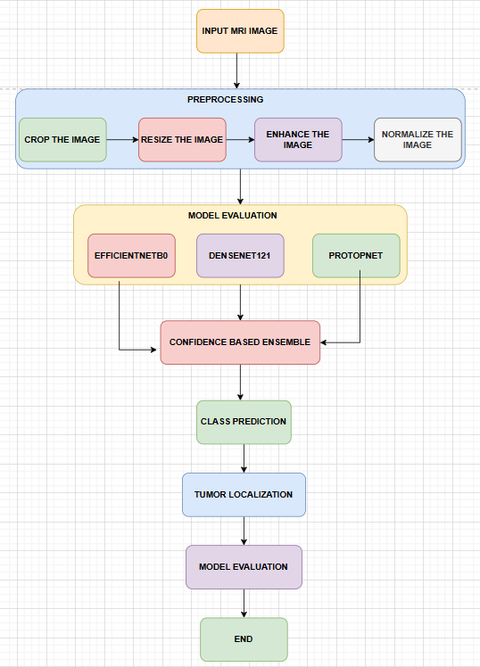
In order to analyze, classify, and localize brain tumors, our proposed system (figure 1) follows a structured pipeline flow that methodically processes MRI images through various stages, beginning with preprocessing and ending with tumor localization. These stages are based on deep learning. All the steps are greatest important terms when it comes to robustness, accuracy and appropriate detection.

Figure 1: Proposed System Architecture and Flowchart diagram of BTAI
a) Input MRI Images: The system as you received the MRI as input this will form the bones of the model's data set. Images with vastly varied levels of noise, contrast, and resolution originate from a variety of sources, including scanners and imaging methods, as well as databases like Kaggle and BraTs. We all know that raw MRI scans aren't always consistent and might include unwanted regions like the skull or background. These don't belong in the training model, so they go through an initial preprocessing stage to standardize and improve the scans before they're fed into the deep learning models.
b) Preprocessing Stage: As mentioned before, a specific PREPROCESSING block is used to get the data ready for deep learning models by making sure it's consistent, reducing noise, and improving model performance. There are four successive operations that make up this stage:
i) Crop the Image: At this stage, any extraneous parts of the scan, including the black borders, parts of the skull, or noise in the backdrop, are eliminated. In order to improve feature learning and reduce mathematical complexity, cropping is utilized to ensure that the model is fully focused on the appropriate brain area in the scan. To avoid confusing the model during training, it is crucial to delete any extraneous parts of the scan, and this step helps with that.
ii) Resize the Image: The size of magnetic resonance imaging (MRI) pictures might vary greatly from one dataset to another. In our case, the input requirements of most deep learning models such as EfficientNetB0, DenseNet121, ResNet, VGGNET, etc. are 224×224 pixels, so all the cropped images from the previous stage are resized to this fixed resolution. For quicker batch training and more consistent processing, it's best to use a standard picture size.
iii) Improve Image: Our Image improvement process utilizes a technique known as contrast stretching and sharpening filters which are then implemented on the images that have been scaled. This step is useful in the most crucial aspect of proper feature extraction, classification and localization of tumors in the MRI scans which is; it raises the dull pictures and tumor boundaries in the scans. We can use these improvements in cases when the tumor boundaries are either dull or indistinct to highlight the tumor regions and to reinforce the particular deep learning model to isolate meaningful patterns in the photos.
iv) Normalize the Image: The next important step in making sure that the training is always successful is to normalize these enhanced pictures to some degree of pixel intensity values, typically in the range 0-1. This helps the model to train to converge faster and reduces the effects of changes in intensity of the scans. At this stage of the preprocessing, the image is clear, well organized and ready to be inputted into the model.
c) Model Evaluation (Feature Extraction & Classification): Once the extensive preprocessing is complete, the pictures are fed into a cluster of deep learning models to extract features and classify brain tumors. At this crucial step, which we have already covered, three deep learning models are used:
i) EfficientNetB0: Our EfficientNetB0 model is the first one, and is generally touted as a state-of-the-art neural network design that strives to achieve the highest degree of precision and accuracy at minimal computational cost. This model is better than other models that enhance computation and mathematical capacity by randomly enhancing one dimension at a time since it is founded on a distinct idea in which the depth and width are automatically enhanced as indicated earlier. This is to balance the scales of the three noteworthy aspects of a network, i.e. its depth, width and resolution of input. In comparison to more conventional models like VGG or ResNet, EfficientNetB0 is able to extract more relevant features with fewer parameters because to its balanced scaling. An innovative set of convolutional layers called Mobile Inverted Bottleneck Convolution (MBConv) blocks is used to construct the architecture. They use depthwise separable convolutions mechanism, on top of that, a squeeze-and-excitation mechanism, which enables the successful extraction of feature relationships, both partial and channel-wise. Such applications as brain tumor classification make good use of the EfficientNetB0 capability to identify hidden patterns in magnetic resonance images (MRI) data rapidly and easily; these patterns can be accompanied by subtle changes in texture, intensity or tumor morphology. This model is capable of making use of pretrained weights of large datasets such as ImageNet with the aid of transfer learning to enhance its performance and accelerate the rate of convergence, despite using sparse medical data. This model has few parameters and is able to extract high-level properties. This makes this model accurate and efficient with regards to computing power. Having a robust management of accuracy, efficiency, and scalability, the three foundations of an effective model, EfficientNetB0 can find numerous applications in healthcare real-world scenarios.
ii) DenseNet121: The second model of our convolutional neural network was that of DenseNet121. We used it in our project as well. Each block of this architecture is connected directly with all the layers. An interesting feature of this model is that it decreases the vanishing gradient problem which is observed in most models. The reason is that the feature maps that are produced by one layer can be used by the other layer and ultimately across the entire network enhancing the concept of feature reuse and enhancing the gradient flow and information flow. Unlike the majority of more traditional designs, DenseNet121 combines the information of the previous layers; this interesting aspect enables the model to effectively evaluate as well as store the low-level features of the previous stages and high-level features of the current one. Consequently, it is also computationally cheaper than other models with fewer parameters that were learned by a particular layer whilst maintaining high performance in accuracy. DenseNet121 is best suited to such tasks as brain tumor classification since it is able to detect even slight variations in MRI scan texture, intensity, and form. This interesting model harners the benefit of using the pretrained weights to achieve faster convergence, more generalization, yet with limited datasets, it surpasses EfficientNetB0 with good transfer learning. Because of its nice balance between its accuracy, efficiency and feature reuse, DenseNet121 is a solid model choice to tackle the age-old problem of picture classification. It performs miracles in picture analysis, in which an incidence of small changes in form or texture can greatly influence categorization.
iii) ProtoPNet (Prototype-Based Model): The fourth model we use is ProtoPNet, which stands for "Prototype Propagation Network." It is an ante-hoc model that aims to provide predictions that are both clear and explicable by incorporating decision-making reasoning into neural networks. We are all aware that the majority of conventional convolutional neural networks are just prediction engines without any explanation for their predictions. However, this ProtoPNet model learns a set of representative prototypes for each class while training, which is something that most other models don't do. These models are based on significant features or patterns seen in the training pictures. The model finds the most comparable parts of the prototype picture it learnt from and compares them to the new input image; this allows us to rationalize the model's decision-making process. Just as said earlier, the model is able to rationalize its prediction for a human to reason out by basing its final classification judgment on the similarity between the provided picture and class-specific prototypes it received during training. The reasoning capability of our ProtoPNet is very important in brain tumor categorization. It impacts decisions when an MRI image is provided, which improves confidence and helps us justify the term explainability. Our suggested model's strength is in its visual explanations, which make it ideal for tumor classification. However, there is a little drawback: compared to so-called black-box models, it may somewhat reduce raw accuracy. Additionally, the method becomes more reliable for a doctor to use since all these stages provide an impression of monitoring what's occurring.
d) Confidence-Based Ensemble: Our project's central idea, the Confidence-Based Ensemble, cleverly integrates the predictions from three deep learning-based models—EfficientNetB0, DenseNet121, and ProtoPNet—to provide a more precise final classification. In contrast to more conventional models, an ensemble based on majority vote gives more weight to the model with the greatest confidence in its forecast. Every one of the four models—glioma, meningioma, pituitary tumor, and no tumor—generates a confidence score for each input MRI scan. The ensemble module then takes a look at all of the scores and chooses the most confident class, along with the model that produced that result.
We believe this method significantly reduces the number of inaccurate predictions produced by any one model. It takes full use of each architecture's strengths while minimizing their weaknesses; for example, EfficientNetB0's high task efficiency, DenseNet121's clever dense layer feature learning method, and ProtoPNet's prototype-based confident reasoning. With this ensemble method, doctors are more likely to trust the system, which makes it more suited for real-world use cases, and the three major pillars of any model—accuracy, generalization, and covergenance—are all enhanced across a set of specific MRI scans.
e) Class Prediction: Finally, the system reaches the end output stage, which is the ultimate tumor categorization, after this enormous ensemble step. Glioma, pituitary, meningioma, or no tumor at all might be the expected class. So far, the classification has helped identify the kind of brain tumor a patient may be suffering from by producing a classification result.
f) Tumor Localization: The tumor localization module in the proposed system is the most important part of the project. Most papers only cover the model's classification phase, but we went above and beyond by designing the system to pinpoint the exact location of the tumor in an MRI scan. This information is crucial for doctors' decision-making. This module uses conventional image processing approaches to identify tumor locations using scan intensity and structural variations by appropriately using white and black in the picture. This is in contrast to all the typical models that mostly concentrate on categorization. Converting to grayscale, reducing noise, segmenting, detecting contours, and performing geometric analysis are all lengthy processes in this localization process. Together, these procedures identify the tumor region in the image, delineate its borders, and determine its size and form. Time and money are of the essence for physicians, and this method is both computationally excellent and simple to grasp, so it may be valuable for them.
Steps involved:
i) Grayscale Imaging: Starting with the raw anticipated MRI scan in RGB or sometimes multi-channel format and converting it to grayscale picture format with just one channel is the first stage in this tumor localization procedure. This is a crucial step since it simplifies the next ones by reducing the picture to a single intensity channel. This grayscale conversion helps concentrate on one significant characteristic because the tumor has already been discovered and its identification is mostly dependent on the model. Tumor localization is then determined by balancing the fluctuations in intensity of the black and white picture, rather than the color information. In order to analyze the picture more accurately and quickly, the system may do away with extraneous colors.
ii) Gaussian Blurring: Once the picture was grayscaled, we employed a method called Gaussian blurring to smoothen the MRI scan and remove noise. Note that most magnetic resonance imaging (MRI) scans include subtle changes in intensity that can obstruct the identification of tumors. In order to effectively eliminate high-frequency noise while keeping the majority of the critical structures intact, a technique known as gaussian filtering takes an average of the pixel values with all of their neighbours using a kernel.
iii) Thresholding: The next step in localization of tumors is thresholding. It uses pixel intensity values to separate the image, isolating likely tumor areas to the background. We start with a set point, which is the threshold value, and then, all pixels that have intensity values greater than that threshold value are considered foreground meaning that they may have a tumor and we consider all other pixels as background meaning that they are black. To enhance easy detection of areas of interest, this converts the grayscale image to a null binary image. Since our tumors will appear brighter by default due to the CLAHE boost we did in the preprocessing stage, we can easily produce thresholding which can help to effectively divide the regions.
iv) Contour Detection: Now that we have our binary picture from the previous step, we can use the contour detection procedure to find the edges of the sections that were segmented before. We are well aware that these contours encapsulate places, like tumor regions in our example, since they are continuous curves. This process aids in pinpointing the tumor's precise location and contours within the picture. Our algorithm is able to identify the tumor site in a scan from among many other regions by examining these contours.
v) Bounding Box Extraction: Once the precise tumor contours have been detected, a bounding box is outlined around the region detected. The tumor's location may be easily seen on the MRI scan thanks to the bounding box, a rectangular area that encircles the tumor. This is an important step as it will give the clinician a rough map of the tumor area. The bounding box also provides the physicians with certain basic information, such as location and approximate size which they could use in their further research.
vi) Ellipse Fitting: Our next step was to write some code to construct an ellipse and wrap around the contour that we had identified to allow the shape of the tumor to be better mapped onto the scan. This elliptical fitting, together with the rectangular bounding box produces a more realistic look of the tumors, even though they have irregular shapes. The system can also be used at this stage to identify some of the crucial parameters such as the orientation of the tumor, the length of the main and minor axis among others. All of these metrics are priceless when it comes to assessing tumor progression, monitoring it, and coming up with an effective treatment strategy.
g) Model Evaluation: Finally, we reach the model evaluation stage, which is the last assessment phase of our proposed system. At this stage, we take the test dataset that we collected earlier and feed it into the model to determine its accuracy and loss. Up until now, we have completed tumor image classification and tumor localization. At this point, the accuracy of the categorization and the location of the tumor may be tested. The Confidence-Based Ensemble, which consisted of EfficientNetB0, DenseNet121, and ProtoPNet, was evaluated using metrics such as Accuracy, Precision, Recall, F1-Score, and Confusion Matrix. These metrics were used to determine the ensemble's performance across four classes: glioma, pituitary tumor, meningioma, and no tumor.
Metrics such as the Intersection over Union (IoU), Dice Coefficient, and bounding box accuracy are used to assess the quality of tumor segmentation and measurement; these are the most essential considerations now, beyond categorization. Additionally, the system compares the explanations provided by ProtoPNet based on prototypes with real doctor decisions in order to assess their credibility. The extensive review would ensure that the proposed framework is dependable, precise and ready to be applied in the real world. Final assessment results are analyzed by a doctor and create a thorough performance report which is used in future improvements.
h) Final Output: This is the last product of the suggested system's last step; it provides a combined set of outputs that include a graph, all of the projected values, and classification accuracy. After determining that the MRI picture is consistent with a glioma, meningioma, or pituitary tumor using a confidence-based ensemble of several deep learning models, the system gives the final tumor classification. Along with this, we receive a categorical prediction; also, the method produces an exceptionally accurate tumor localization; this allows the physicians to readily examine the afflicted portion of the brain since the identified tumor site is prominently shown using bounding boxes and ellipse fitting.
TOOLS & TECHNOLOGIES USED
- Google Colab / Jupyter Notebook
- During the work, Google Colab and Jupyter Notebook were the primary environments to work and execute our work. Colab was the platform of choice in building, training, and evaluating deep learning models with its free access to the powerful GPUs Tesla T4 and TPUs. This was particularly useful on models that are computationally intensive such as EfficientNetB0 and DenseNet121, as their training was significantly faster. It also provided us with the opportunity to have a free, collaborative, cloud-based space that eliminated the necessity of on-premises infrastructure and it was easy to add Google Drive so that we could have a smooth data storage and administration system. However, we ran all of our initial experiments, exploratory data analysis (EDA) and module documentation requirements in Jupyter Notebook. The interactive nature of notebooks enabled it to be better organized to handle the entire model of the workflow, including data preprocessing, model creation, and eventual evaluation and the eventual presentation of results, as well as easy debugging and real-time visualization of results. All of these enabled us to have more flexibility, less duplication and helped us to work together, which are essential to a capstone project within the academic world.
- Programming Language: Python
Python is used by many developers of machine learning, deep learning, and scientific computing due to its high volume of open-source resources, ease of use and simplicity. The entire data processing system, including the data handling, processing of MRI scans, and model building, could be written in one language due to its large number of special purpose libraries and structures. Developing complicated modules like the Confidence-Based Ensemble and Tumor Localization need quick prototyping and experimentation, which Python's dynamic nature and concise syntax made possible. Moreover, Python has extensive documentation and a well-developed community presence that allows it to be used to easily integrate other technologies such as Scikit-learn, Matplotlib, OpenCV, TensorFlow, and PyTorch. The possibility to interact with cloud services, including Google Colab, enabled us to be even more productive. All in all, Python was the most suitable to develop a stable, scalable and maintainable system to classify brain tumors due to its flexibility, great support of libraries, and wide application in the area of artificial intelligence research.
- Deep Learning Frameworks: TensorFlow and PyTorch
In this project, we have mostly been utilizing the deep learning frameworks of TensorFlow and PyTorch, with each being a hand-selected framework to address a specific facet of the entire system. We trained and deployed the EfficientNetB0 and DenseNet121 models with this tensorflow. The ability to transfer and deploy models quickly, easily, and efficiently due to high-level Keras interface. TensorFlow has a combination of its native set of callback, a seamless integration with Google Colab and excellent features of model optimization, it is the best choice to use when training on large scale and monitoring performance. Another option is the ProtoPNet (Prototype-based Neural Network) as it is constructed with the help of PyTorch due to its straightforward adjustment and distinctive logic in the formation of the result. PyTorch can be used by developers due to its easy debugging support and rich support of research-oriented models. This two-framework approach enabled the project to make use of the production ready module of the excellent TensorFlow and also capitalize on the flexibility of PyTorch.
- Computer Vision Library: OpenCV
OpenCV, an Open Source Computer Vision Library, is a significant part of our project, the Tumor Localization module. It was an essential library to us to perform the conventional image processing tasks that were necessary to find and quantify the tumor in MRI scans. To be more specific, a series of computationally intensive functions were performed using OpenCV, such as conversion to grayscale, noise reduction with the help of Gaussian blurring, tumor segmentation with the help of adaptive and binary thresholding, finding contours and identifying a boundary, extracting bounding boxes, and finding ellipses to estimate their axis. Its real time processing functions, wide range of optimized algorithms and excellent speed make it to be a perfect choice in modules such as these.
- Machine Learning Libraries: Scikit-learn
- Scikit-learn, the core library is used in various assessment tasks throughout the project. It was an integral part of the preprocessing module that merged datasets and split them up into testing, validation, and training sets. Scikit-learn saved us when it came to the models analysis and performance evaluation. Critical information such as Accuracy, Precision, Recall, F1-Score and others were reported. To be able to give a complete report on performance of the multi-class classification assignment, we had to resort to the confusion matrix and classification report functions provided by the library. The tools offered by Scikit-learn.hese also made it easier to implement cross-validation procedures and analyze model performance on a variety of distributions.
- Data Handling Libraries: Pandas and NumPy
In this project, Pandas and NumPy were essential in the calculations that had to be done numerically and in the handling of data. In our project we used NumPy to efficiently perform array operations, complex mathematical computations and rapid numerical processing- necessary to perform data pretreatment and model input preparation. It also enabled us to convert photos easily into arrays, which significantly enhanced our efficiency of batch processing. Pandas was used to handle structured datasets and label, metadata, and picture file URLs of DataFrames were sorted. Pandas and NumPy collaborated to enhance the workflow of the project, make it more efficient in data processing, and manage large volumes of MRI images and labels with structured data management and data loading.
- Visualization Tools: Matplotlib and Seaborn
Accuracy curves for training and validation, loss curves, confusion matrices, and other visualizations were created using the extremely customisable Matplotlib. Furthermore, we were able to see granular control over the presentation of plots, annotations, and multi-view visualizations. Class distribution bar plots, heatmaps of confusion matrices, and pair plots for exploratory data analysis were some of the most aesthetically pleasing graphs that were created using Seaborn, which is built on top of Matplotlib. We were able to track the training progress of the model, detect overfitting or underfitting problems, and convey the findings more clearly with the aid of these libraries.
- Image Processing Libraries: Pillow
Pillow is a fast and lightweight toolkit for common image processing operations including loading, modifying, and preprocessing. As a whole, PIL was the go-to tool for reading and converting MRI images from the dataset into common formats, resizing them to a uniform size, changing their image mode from RGB to grayscale, and applying basic transformations before feeding them into the deep learning models. Both batch image processing and initial data preparation development benefit greatly from its ease of use. We learned that PIL and NumPy collaborated on our project to transform photos into the array format needed for TensorFlow and PyTorch models. For both the training and testing stages, it was effective for processing huge amounts of medical photos due to its simplicity of use and low memory usage.

IMPLEMENTATION & RESULTS
Image Distribution analysis
The binary classification dataset is balanced and well-structured throughout all the training, validation, and testing folders, according to our class distribution study (Figure 2). The number of photographs in the training folder is 510 for both the tumor and no tumor classes. The validation folder also contains 90 photos for each class. This MRI picture distribution, as shown in the graph below, provides approximately balanced images, which is appropriate for model assessment. In the testing folder, there is a minor difference, with 105 photos without tumors and 115 images with tumors. Assuring equal representation of both categories, this balanced distribution bar chart provides a useful analysis that helps with steady training, proper generalization, and improved classification performance.
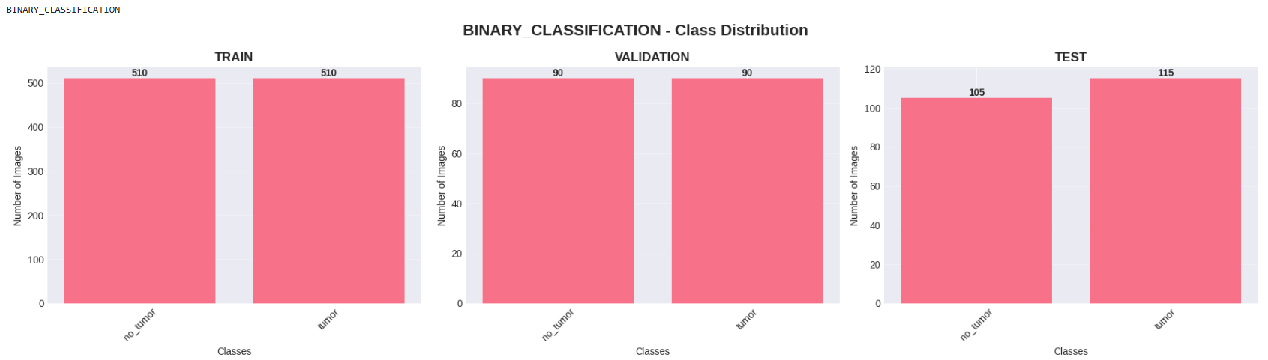
Figure 2: Binary classification Dataset Class distribution analysis
Figure 3 displays the results of the class distribution analysis for the multiclass classification dataset. The distribution of tumor classes meningioma, glioma, and pituitary is well-structured and almost balanced throughout all three folders, including the training, validation, and testing folders. With almost identical photos for the three classes (1520 meningioma, 1528 glioma, and 1529 pituitary) in the training folder, we may conclude that the model accurately and unbiasedly extracts the characteristics from each class. With 182 meningioma photos, 174 glioma images, and 162 pituitary images in the validation folder, we can ensure accurate performance and proper monitoring during the model's training phase. This data is used just for evaluating the model's generalizability to new datasets; the test folder likewise has a decent distribution with 172 meningiomas, 150 gliomas, and 111 pituitary. An excellent study that guarantees equal representation of all tumor types, contributes to steady training, proper generalization, and accurate classification performance, is provided by this balanced distribution bar chart.
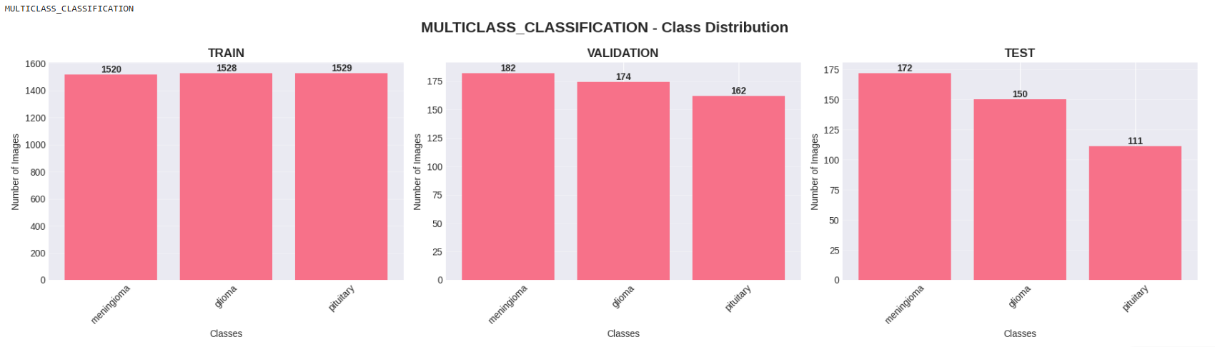
Figure 3: Multiclass classification Dataset Class distribution analysis
Preprocessing Pipeline
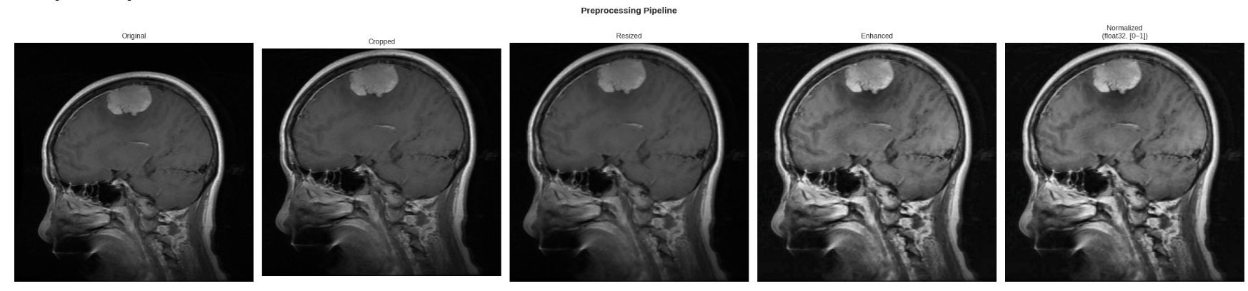
The preprocessing pipeline (figure 4) shows a detailed step-by-step transformation process of an input MRI image that prepare it for an accurate model training results. Firstly original image contains unnecessary many background regions and many dark variations that may affect model performance. The cropping stage cuts the irrelevant areas such as black borders this allows the model to focus only on the brain region. Then next the image is resized to a fixed dimension of 244x244 this ensures a uniform image size across all inputs note that all this image size is suitable with all deep learning models like EfficientNetB0 and DenseNet121. Following this, the image goes enhancement and in more specific we have use CLAHE technique where the contrast and intensity adjustments are applied to make important features, such as tumor regions look more brighter. Finally in our normalization stage all the pixel values are scaled to a range typically between 0 and 1 which makes training faster and this also improves convergence. This preprocessing pipeline help our project that the input data is clean, consistent this enables the models to learn only the meaningful features effectively and to achieve better classification performance.Figure 4: Preprocessing Pipeline Steps
EfficientNetB0 Model Binary Classification
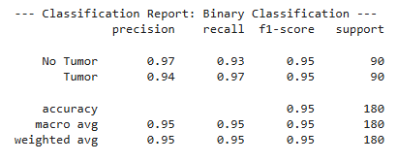
The EfficientNetB0 binary classification model (Figure 5) as show demonstrated an a very good performance in the binary classification task of prediction of the tumor between a Tumor and No Tumor case. Figure 5's function matrix informs us that our overall accuracy was 95%, and we can observe that the model exhibited remarkable parity between the two classes. Even in the "No Tumor" and "Tumor" groups, our F1-score was 0.95, which is quite good. On top of that, the model's excellent performance is shown by its high accuracy of 0.97 for the No Tumor class. With weighted and macro averages of 0.95, we can see that the model holds true for both groups.
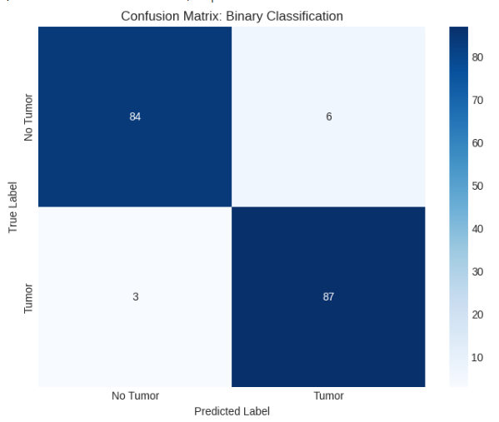

Figure 5: Confusion Matrix of EfficientNetB0 binary classification model
Figure 6, which displays the EfficientNetB0 training and validation graphs, reveals a learning curve that remains constant throughout the training phase. This indicates that the model performs well on binary classification tasks. It is clear that the model is extracting useful information from the MRI dataset as the accuracy curve shows a steady increase in training and validation accuracy across all epochs. When the training accuracy reaches 99% and the validation accuracy reaches 95% to 96%, it indicates that the model is generalizing. This phenomenon occurs as the training period progresses and both accuracies become apparent at high numbers. Both the training and validation loss curves show a consistent drop, indicating that the model is converging. The picture shows that the loss decrease is monotonic and downwards, indicating that the model is learning steadily and predictably.
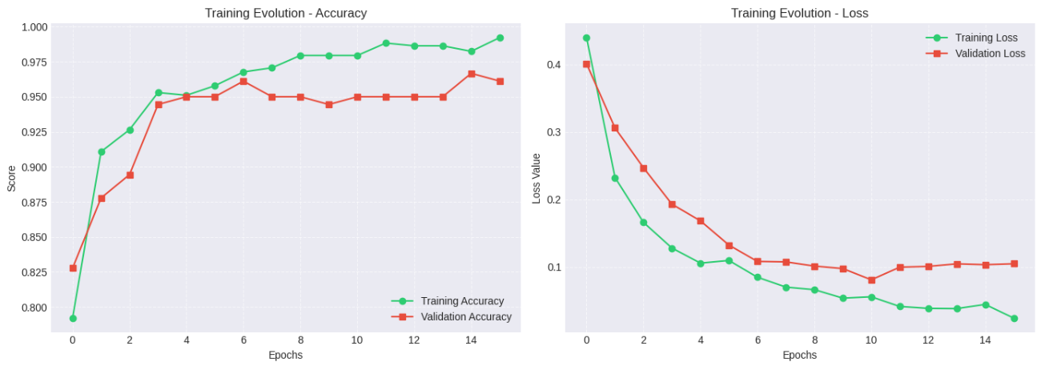
Figure 6: Curves of mode binary model classification model
EfficientNetB0 Model Multiclass Classification
The EfficientNetB0 model (Figure 7) showed an very accurate an result in the multiclass classification task of distinguishing between , meningioma, glioma, and pituitary tumors. The confusion matrix tells us that the model classifies correctly for a large number of samples on the three categories this indicates that it can correctly differentiate between tumor types. The classification report also tells us that the performance of the model is very well balanced with a good precision, recall, and F1-scores across all three classes. The pituitary tumor class achieves the highest performance with precision, recall, and F1-score. These results tells us that EfficientNetB0 is capable of learning difficult patterns in MRI images and these can perform effectively in multiclass tumor classification with good accuracy.
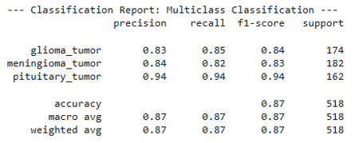
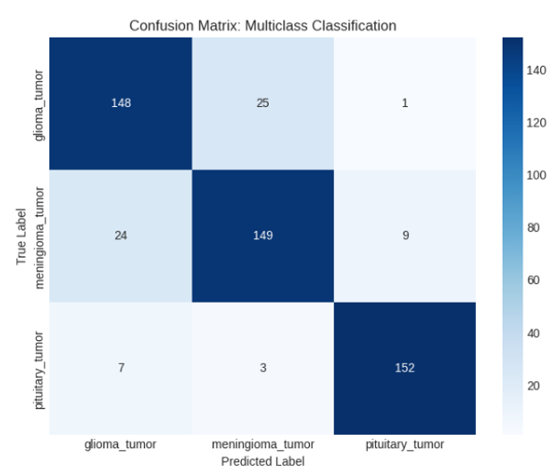

Figure 7: Confusion Matrix of EfficientNetB0 multiclass classification model
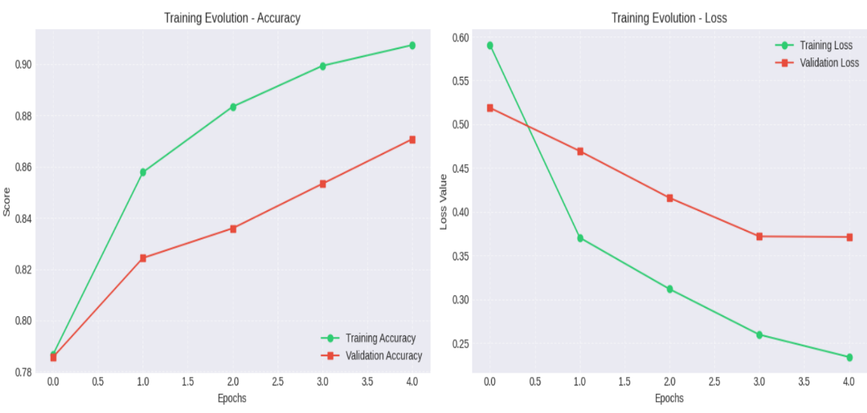
The training and validation graph (figure 8) for EfficientNetB0 bad the only the multiclass classification task show a very steady learning progression this tells us that that the model is effective getting training. A rising accuracy curve for training and validation throughout all epochs indicates that the model has learned the features and can generalize well to the MRI dataset.
Figure 8: Accuracy and Loss curves of EfficientNetB0 multiclass classification model
The loss curve in the above image shows a continuous decrease for both training and validation loss this tells us that the model is slowly minimizing errors during training. This steady decline in loss values tells us that the model is going to a stable convergence state

EfficientNetB0 Model Testing
This MRI picture (figure 9) was correctly identified as a meningioma tumor by our EfficientNetB0 model, demonstrating the model's excellent predictive power. With a high tumor probability of 0.9972 and a final classification output that shows it is meningioma with a confidence score of 87%, the model is accurately giving us the correct tumor types. Additionally, the model correctly identified the true class.
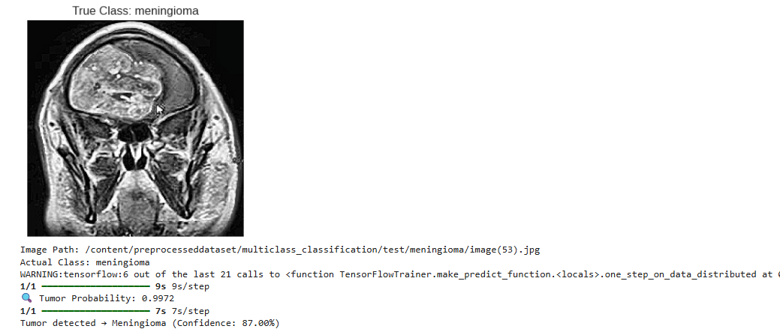
Figure 9: EfficientNetB0 Model Testing
DenseNet121 Model Binary Classification
The DenseNet121 binary classification model (Figure 10) as show demonstrated a very good performance in the binary classification task of prediction of the tumor between a Tumor and No Tumor case. The confunction matrix shown in the figure 10 tell us that we got an overall accuracy of 94%, we can find that the model showed an excellent balance on both the classes. We got an strong F1-score of 0.94 for both "No Tumor" and "Tumor" categories. More than this the model achieved a high precision of 0.93 for the No Tumor class this tells us that the model is performing good.
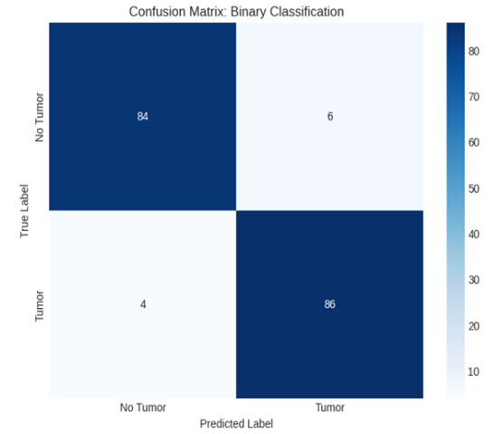
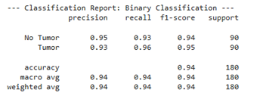

Figure 10: Confusion Matrix of DenseNet121 binary classification model
The training and validation graphs for DenseNet121 (figure 11) shows us a stable learning curve throughout the training process this says that the model is effective and good in binary classification task. The accuracy curve also shows a consistent growth in both training and validation accuracy during the all epochs, this indicates that the model is only learning meaningful features from the MRI dataset. After some time the training epoch increase both the accuracies become plain at high values this thing happens when the training accuracy is at 96% and validation accuracy is at 94–95% this tells the model is generalizing. The loss curves shows us a steady decline in both the training and validation loss this tells us the model is converging. The image tells us that the reduction in loss is continuously downwards only which means that the model is learning in a controlled and stable manner without any ups and downs. These graphs tell us that EfficientNetB0 model has successfully detected the underlying patterns in the dataset which results in high accuracy, low loss, and reliable performance.
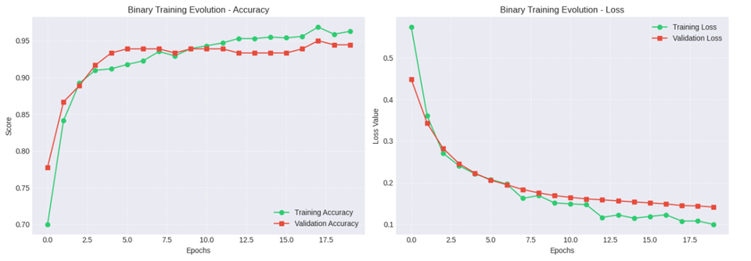
Figure 11: Accuracy and Loss curves of DenseNet121 binary classification model
DenseNet121 Model Multiclass Classification
The DenseNet121 model (Figure 12) showed an accurate result in the multiclass classification task of distinguishing between glioma, meningioma, and pituitary tumors. The confusion matrix tells us that the model classifies correctly for a large number of samples on the three categories this indicates that it can correctly differentiate between tumor types. The classification report tells us that the performance of the model is very well balanced with good precision, recall, and F1-scores across all three classes. The pituitary tumor class achieves the highest performance with precision, recall, and F1-score. These results tells us that DenseNet121 is capable of learning difficult patterns in MRI images and these can perform effectively in multiclass tumor classification with good accuracy.
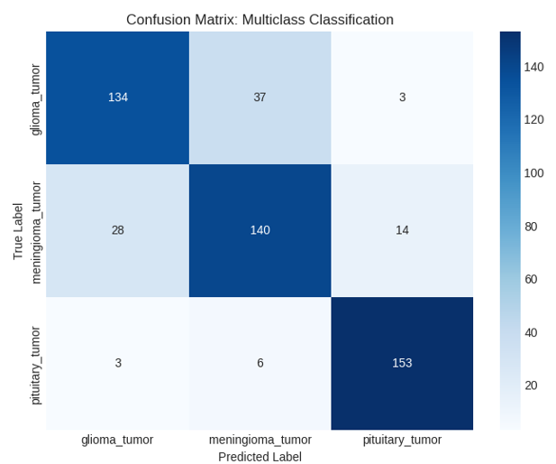
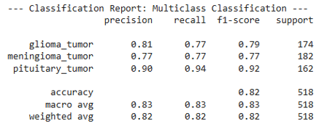

Figure 12: Confusion Matrix of DenseNet121 multiclass classification model
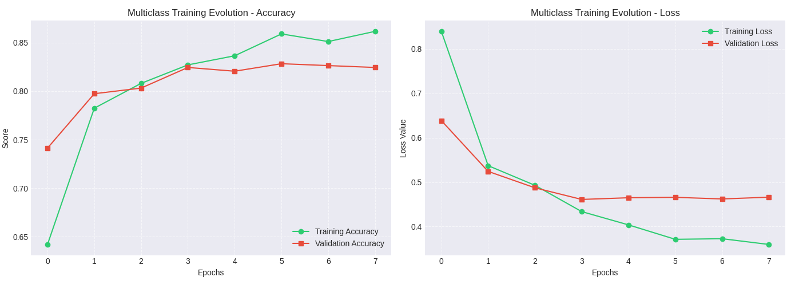
The training and validation graph (figure 13) for DenseNet121 in the multiclass classification task show a very steady learning progression this tells us that that the model is effective getting training. The accuracy curve gives an increase in both training and validation accuracy across all the epochs this tells us that the model is able to learn the features and can also generalize well for the MRI dataset. The loss curve in the above image shows a continuous decrease for both training and validation loss this tells us that the model is slowly minimizing errors during training. This steady decline in loss values tells us that the model is going to a stable convergence state
Figure 13: Accuracy and Loss curves of DenseNet121 multiclass classification model

DenseNet121 Model Testing
The DenseNet121 model (figure 14) successfully classifies the given MRI image as a pituitary tumor this shows that the model has properly got trained with all the required features for the multiclass classification. This model also correctly identifies the true class and provides a tumor probability of 0.6427 and with a confident final prediction of pituitary tumor with 83.91% confidence. This indicates that the model correctly recognized the tumor type by getting trained with the features for the pituitary tumors type from MRI images.
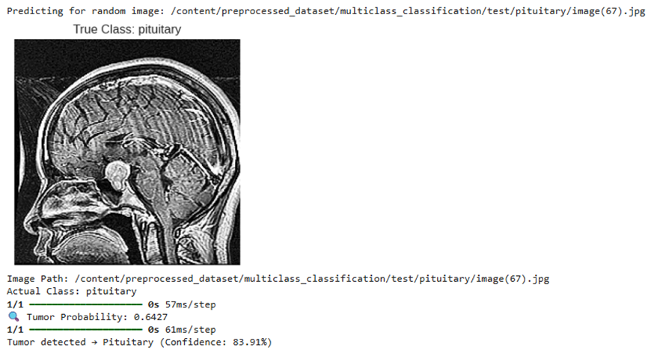
Figure 14: DenseNet121 Model Testing
ProtoPnet Model Multiclass Classification
The ProtoPNet model (figure 15) gives a good performance of the classification of brain tumors this clearly tells us that the models is good at distinguishing between glioma, meningioma, and pituitary tumor classes. The confusion matrix speaks that the model correctly classifies a large number of samples, with 140 glioma, 170 meningioma, and 140 pituitary tumor cases this tells us that the model is learning the features and not just remembering the values. The pituitary tumor in this also achieves good results with a precision of 0.95, recall of 0.86, and an F1-score of 0.91 this tells us that the model is good at prediction of pituitary king tumors. Also this glioma and meningioma classes show good performance and the model accuracy is 87%, along with macro and weighted averages around 0.87–0.88 for brain tumor classification.

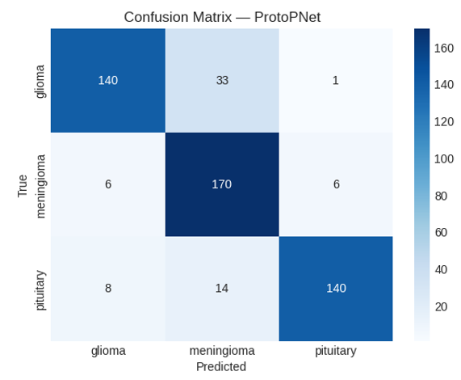
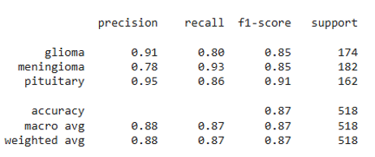

Figure 15: Confusion Matrix of ProtoPNet classification model
The training and validation graphs (figure 16) of ProtoPNet also a stable learning behavior throughout the training process. The accuracy and loss curve shows a continuous increase and decrease in both training and validation accuracy this tells us that the model is successful in learning meaningful features from the MRI dataset. Training accuracy increases to above 91%, and this validation accuracy also increases reaching around 87–88% this is telling us that the model is generalizing. Similarly, the loss curves shows a continuous decrease for both training and validation loss telling us that the model is in convergence mode. All these results shows that the ProtoPNet model is effectively capturing important patterns in the data.
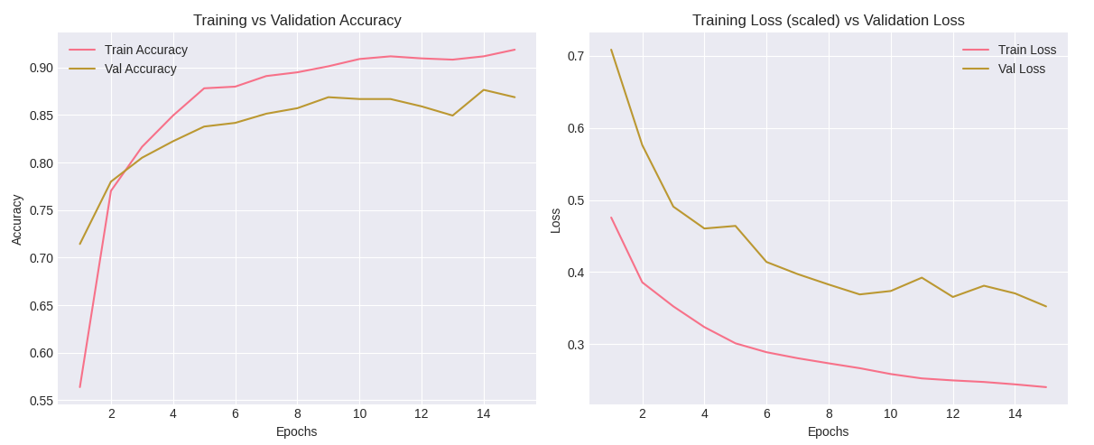
Figure 16: Accuracy and Loss curves of ProtoPNet classification model
This displayed images (figure 17) is very important part of this model it represent the model picked prototypes of the ProtoPNet, that act as a comparision representative patterns for each tumor class glioma, meningioma, and pituitary. Each of these prototype gives an important and unique visual features from MRI scans images for a specific class. During the prediction process this ProtoPNet compares the regions of a new input image with these stored prototypes images and identifies similarities to make the classification decision. accordingly These prototypes highlight only meaningful structures such as tumor shape, location, and texture, allowing the model to provide the correct reason for its predictions.
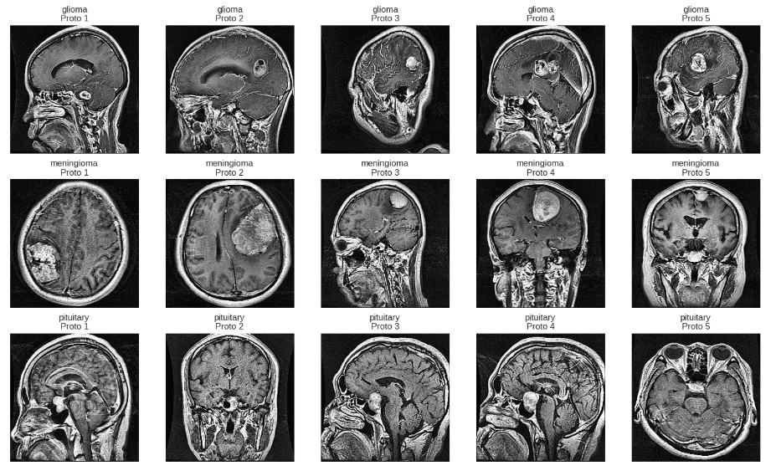
Figure 17: ProtoPNet prototypes
ProtoPnet Model Classification
The ProtoPNet model (figure 18) has successfully classified the given MRI image as a glioma tumor with a confidence of 93.06% this tells us that the model is predicting correctly. To prove this result as correct our team showed the contribution analysis of each prototype as we can see in this multiple glioma related prototypes show high scores telling us that the predicted result of the model is correct from the input image. Also to prove the other classes are wrong the other class prototype contributions are also show. This prototype based reasoning tells us the actual reason why the model predicted a particular result for the MRI scan this provides not only the classification but also an interpretable resoning for decision made.
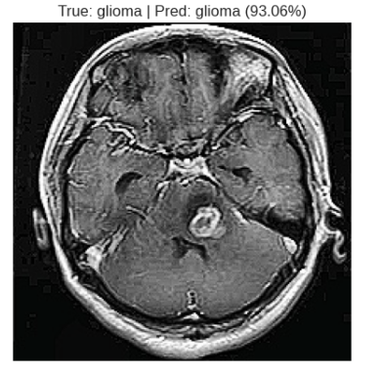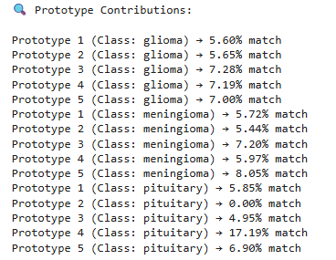
Figure 18: ProtoPnet Model Testing
Training Accuracies
The training results (figure 19) shows strong learning performance across all models this tells us that all the model system effectively captures correct features from the MRI dataset. For EfficientNetB0 binary classification performance is very good with an accuracy score of 99.22%, precision score of 99.41%, and recall score of 99.02% this model worked very good in comparing which is tumor image and which is no tumor image. In the multiclass EfficientNetB0 it also perform well with an accuracy score of 90.74%, this also is good at classification tasks. Next coming to DenseNet121 this model shows good performance in binary classification with an accuracy of 96.27% score, precision score of 95.38% score, and recall of 97.25% score. In multiclass classification also DenseNet121 gives us a good results with a good precision score and recall score this is also good in identifying the tumor types. The ProtoPNet model also gives a performance in multiclass classification with an accuracy score of 93.55% and both precision and recall are correctly in par with each other giving us a strong classification capability.
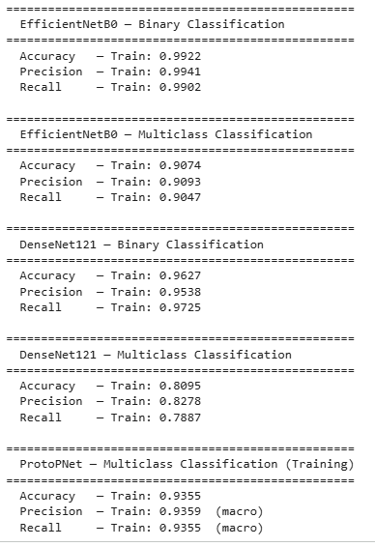
Figure 19: Training Accuracies of all the models
Testing accuracy and Tumor Localization
The ensemble model (figure 20) showed a good performance in classifying the given MRI image as a meningioma tumor type. We can also see that the individual models produced very different predictions EfficientNet predicted glioma with a confidence of about 65.21% and both DenseNet and ProtoPNet correctly identified the image as meningioma with high confidence score of about 98.92% and 89.26% this ensemble mechanism combined these outputs to select the one with highest confidence. The final result correctly classifies the image as meningioma with a high confidence of 98.92%, this is given by DenseNet’s model.
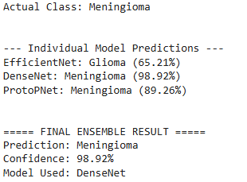
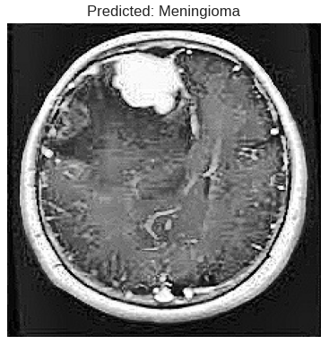

Figure 20: Confidence based Ensemble Final result
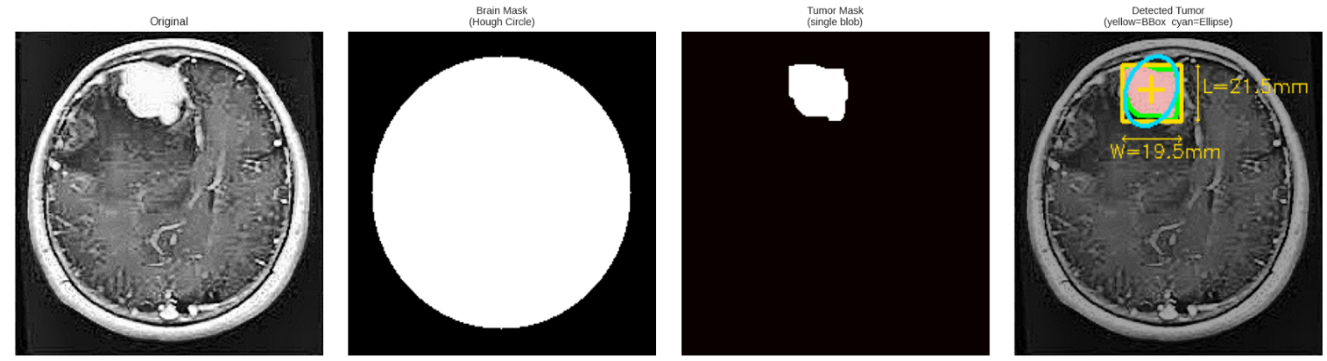
The tumor localization output (figure 21) clearly shows the correct application of our image processing pipeline in detecting and highlighting the tumor region for a MRI scan image. We start from the from the predicted original image then the system isolates the brain part region using a circular mask and then it ensures that only the required region is considered for further analysis. The tumor mask then successfully segments the suspicious region giving us the accurate separation of the tumor from surrounding brain tissues. In the final output of the image we can see that the detected tumor is clearly highlighted using a bounding box and ellipse. The system also calculates some important measurements such as the approximate dimensions of the tumor etc. This results also confirms that the localization module is good in identifing the tumor region.
Figure 21: Tumor Identification
This compares the test accuracies (figure 22) of all the three models that we used this in this system this also demonstrates how good the model is in brain tumor classification process. Among all the models the EfficientNetB0 achieves the highest accuracy of 87.26% showing that it has captured and generalized all important features from MRI images. ProtoPNet model is the next good model with an accuracy of 85.67% then next is DenseNet121 with an accuracy of 83.51%, this also gives a good result and it also showed that it has learnt some good and meaningful features. All these models have a very close performance and it also tells us that consistency and accurate prediction are very important in giving the output for a model. These results also validate our project idea of using multiple models in the system and it also tells us that each model contributes a very important action in the improved accuracy and improved predictions.
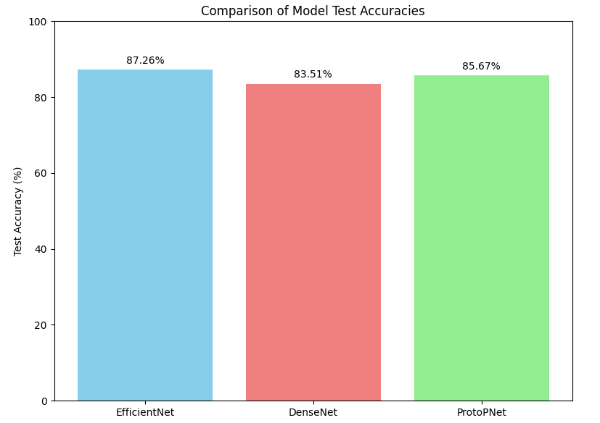
Figure 22: Testing Accuracies of all 3 Models

CONCLUSION
To conclude, our proposed project has been successful in demonstrating how a classification and localization of brain tumor can be achieved using MRI Images through the integration of modern deep learning architectures and traditional approaches of image processing. The project makes the efficient use of architectures like EfficientNetB0 and DenseNet121, which facilitate multiclass classification of tumors accurately. The project also uses a ProtoPNet to improve interpretability of models, which also provides a visual explanation for the predicted classes and also by using a voting-based ensemble the system achieve a better performance is another positive aspect of the system. Along with classification our proposed system also performs the tumor localization through OpenCV this facilitates the identification of tumor regions from images. Through my proposed system all of the shortcomings of the traditional and conventional systems which lack interpretability, localization, explainability of tumors have been overcomed through this project. Our project has successfully highlighted the real usefulness of combining the deep learning models with the traditional and old classical computer vision techniques in assisting doctors to make faster and more accurate decision-making processes.

REFERENCES
- T. R. Mahesh et al., “An XAI-enhanced EfficientNetB0 framework for precision brain tumor detection in MRI imaging,” J. Neurosci. Methods, vol. 410, p. 110227, 2024.
- M. M. Naseer et al., “An optimized EfficientNet-B0 framework for multi-class brain tumour detection and classification from MRI images,” Biomed. Pharmacol. J., vol. 18, no. Special Edition, Oct. 2025.
- D. Onah et al., “Deep Brain Net: An optimized deep learning model for brain tumor detection in MRI images using EfficientNetB0 and ResNet50 with transfer learning,” arXiv preprint arXiv:2507.07011, 2025.
- F. F. Jiven and R. Rumini, “MRI classification of brain tumors using EfficientNetB0 feature extraction and machine learning methods,” J. Appl. Inform. Comput., vol. 9, no. 6, pp. 3394–3404, Dec. 2025.
- K. Gencer, “A comparative analysis of EfficientNetB0 and EfficientNetV2 variants for brain tumor classification using MRI images,” Int. J. Innov. Eng. Appl., vol. 9, no. 1, pp. 1–7, 2025.
- A. Iqbal et al., “Enhancing brain tumour multi-classification using Efficient-Net B0-based intelligent diagnosis for Internet of Medica
- l Things (IoMT) applications,” Information, vol. 15, no. 8, p. 489, 2024.
- M. Rasheed et al., “Improved brain tumor classification through DenseNet121 based transfer learning,” Discov. Oncol., vol. 16, p. 1645, Aug. 2025.
- Y. Mao et al., “Dilated SE-DenseNet for brain tumor MRI classification,” Sci. Rep., vol. 15, Art. no. 86752, 2025.
- S. S. Sabila et al., “The multiple brain tumor with modified DenseNet121 architecture using brain MRI images: Classification multiclass brain tumor,” Kursor, vol. 12, no. 2, pp. 123–134, 2024.
- R. B. Sumona et al., “An integrated deep learning approach for enhancing brain tumor classification using RDXNet,” Healthcare Analytics, vol. 8, p. 100421, Dec. 2025.
- R. Disci et al., “Advanced brain tumor classification in MR images using pre-trained deep learning models,” Cancers, vol. 17, no. 1, p. 121, 2025.
- Y. Wei, R. Tam, and X. Tang, “MProtoNet: A case-based interpretable model for brain tumor classification with 3D multi-parametric magnetic resonance imaging,” in Proc. Medical Imaging with Deep Learning (MIDL), 2023, pp. 1–15.
- Y. Wei, R. Tam, and X. Tang, “MProtoNet: A case-based interpretable model for brain tumor classification with 3D multi-parametric magnetic resonance imaging,” in Proc. 6th Conf. Medical Imaging with Deep Learning, 2024.
- Y. Wei et al., “MAProtoNet: A multi-scale attentive interpretable prototypical part network for 3D magnetic resonance imaging brain tumor classification,” arXiv preprint arXiv:2404.08917, 2024.
- M. Rasheed et al., “Advanced deep learning-based brain tumor classification using DenseNet121 transfer learning on MRI images,” PLoS One, 2025.

Programme Outcomes (POs) and Programme Specific Outcomes (PSOs)
At the end of the Programme the students would be able to:
PO1 Engineering knowledge: Apply the knowledge of mathematics, science, engineering fundamentals, and an engineering specialization to the solution of complex engineering problems.
PO2 Problem analysis: Identify, formulate, research literature, and analyze complex engineering problems reaching substantiated conclusions using first principles of mathematics, natural sciences, and engineering sciences.
PO3 Design/development of solutions: Design solutions for complex engineering problems and design system components or processes that meet the specified needs with appropriate consideration for the public health and safety, and the cultural, societal, and environmental considerations.
PO4 Conduct investigations of complex problems: Use research-based knowledge and research methods including design of experiments, analysis and interpretation of data, and synthesis of the information to provide valid conclusions.
PO5 Modern tool usage: Create, select, and apply appropriate techniques, resources, and modern engineering and IT tools including prediction and modeling to complex engineering activities with an understanding of the limitations.
PO6 The engineer and society: Apply reasoning informed by the contextual knowledge to assess societal, health, safety, legal and cultural issues and the consequent responsibilities relevant to the professional engineering practice.
PO7 Environment and sustainability: Understand the impact of the professional engineering solutions in societal and environmental contexts, and demonstrate the knowledge of, and need for sustainable development.
PO8 Ethics: Apply ethical principles and commit to professional ethics and responsibilities and norms of the engineering practice.
PO9 Individual and teamwork: Function effectively as an individual, and as a member or leader in diverse teams, and in multidisciplinary settings.
PO10 Communication: Communicate effectively on complex engineering activities with the engineering community and with society at large, such as, being able to comprehend and write effective reports and design documentation, make effective presentations, and give and receive clear instructions.
PO11 Project management and finance: Demonstrate knowledge and understanding of the engineering and management principles and apply these to one’s own work, as a member and leader in a team, to manage projects and in multidisciplinary environments.
PO12 Life-long learning: Recognize the need for and have the preparation and ability to engage in independent and life-long learning in the broadest context of technological change.
PSO1 Apply algorithmic thinking and utilize programming languages such as C, Python and Java to develop and maintain efficient and robust computing systems.
PSO2 Design and develop computer-based applications of varying complexities using emerging topics of Computer Science and Engineering such as cloud computing, artificial intelligence, data processing etc.
PSO3 Possess the subject knowledge and scientific temper necessary to pursue successful careers in Computer Science and Engineering with ethical responsibility towards societal needs.

17 UN Sustainable Development Goals (UN-SDG)
No. | Description
SDG 1 | Goal-1: No Poverty
SDG 2 | Goal-2: Zero Hunger
SDG 3 | Goal-3: Good Health and Well-being
SDG 4 | Goal-4: Quality Education
SDG 5 | Goal-5: Gender Equality
SDG 6 | Goal-6: Clean Water and Sanitation
SDG 7 | Goal-7: Affordable and Clean Energy
SDG 8 | Goal-8: Decent Work and Economic Growth
SDG 9 | Goal-9: Industrial Innovation and Infrastructure
SDG 10 | Goal-10: Reduced Inequalities
SDG 11 | Goal-11: Sustainable Cities and Communities
SDG 12 | Goal-12: Responsible Consumption and Production
SDG 13 | Goal-13: Climate Action
SDG 14 | Goal-14: Life Below Water
SDG 15 | Goal-15: Life on Land
SDG 16 | Goal-16: Peace, Justice and Strong Institution
SDG 17 | Goal-17: Partnerships for the Goals

PROJECT PROFORMA
Classification of the Project | Application | Product | Research | Review
 |  |  | ✔

Project Course Outcomes
Outcome 1 | Formulate specific problem statements for well-defined real-life problems with reasonable assumptions and constraints.
Outcome 2 | Perform literature search and / or patent search in the area of interest.
Outcome 3 | Conduct experiments / Design and Analysis / solution iterations and document the results.
Outcome 4 | Perform error analysis / benchmarking / costing, Synthesis the results and arrive at scientific conclusions / products / solution
Outcome 5 | Document the results in the form of technical report / presentation

CO – PO Mapping
Project Outcomes | Programme Outcomes (POs) |  |  |  |  |  |  |  |  |  |  |  |  | PSOs
 | PO1 | PO2 | PO3 | PO4 | PO5 | PO6 | PO7 | PO8 | PO9 | PO10 | PO11 | PO12 | PSO1 |  | PSO2 | PSO3
CO1 | 3 | 3 | 3 | 3 | 3 |  |  |  | 3 | 3 | 3 | 3 | 3 |  | 3 | 3
CO2 | 3 | 3 | 3 | 3 | 3 |  |  |  | 3 | 3 | 3 | 3 | 3 |  | 3 | 3
CO3 | 3 | 3 | 3 | 3 | 3 |  |  |  | 3 | 3 | 3 | 3 | 3 |  | 3 | 3
CO4 | 3 | 3 | 3 | 3 | 3 |  |  |  | 3 | 3 | 3 | 3 | 3 |  | 3 | 3
CO5 | 2 | 3 | 3 | 3 | 3 |  |  |  | 3 | 3 | 3 | 3 | 3 |  | 3 | 3

UN Sustainable Development Goals (UN-SDG) Mapping
Project Title | Project Type | SDG Target | Justification
Proposed Explainable AI Techniques for Brain Tumor Classification | Capstone Project | Goal-3: Good Health and Well-being | System enables early and accurate brain tumor diagnosis using AI, improving treatment outcomes and reducing mortality.


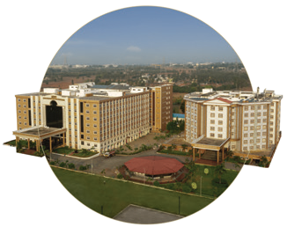
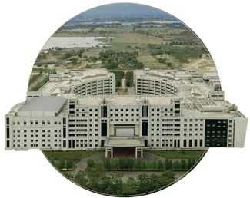

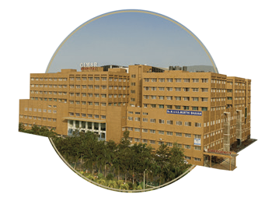

Bengaluru
NH 207, Nagadenehali, Doddaballapur Taluk, Bengaluru - 561203, Karnataka, India
Hyderabad
Rudraram, Patancheru mandal, Hyderabad - 502329, Telengana, India
Visakhapatnam
Gandhi Nagar, Rushikonda, Visakhapatnam- 530045, Andhra Pradesh, India
Bengaluru
Visakhapatnam
GIMSR Bengaluru City Office Hyderabad City Office GITAM Medical College Rd, No 5/1, First Floor, Prestige 6th floor, TP House, Cyber Gandhi Nagar, Rushikonda, Terraces, Union Street, Hills Colony, VIP Hills,
Visakhapatnam - 530045 Infantry Road, Bengaluru - Jaihind Enclave, Madhapur, Andhra Pradesh, India 560003 Karnataka, India Hyderabad - 500081,
Telangana, India
Hyderabad
GIMSR
Visakhapatnam

