DATA VISUALIZATION SOFTWARE

**LOGIN PAGE**

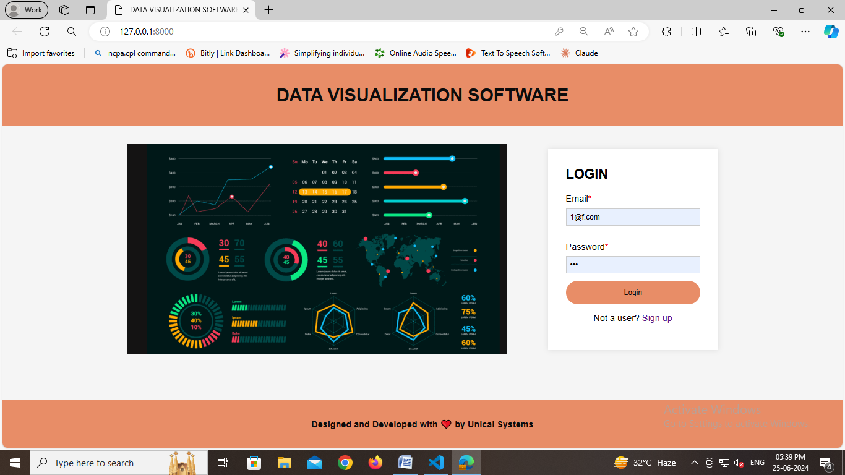

**SIGN UP PAGE**

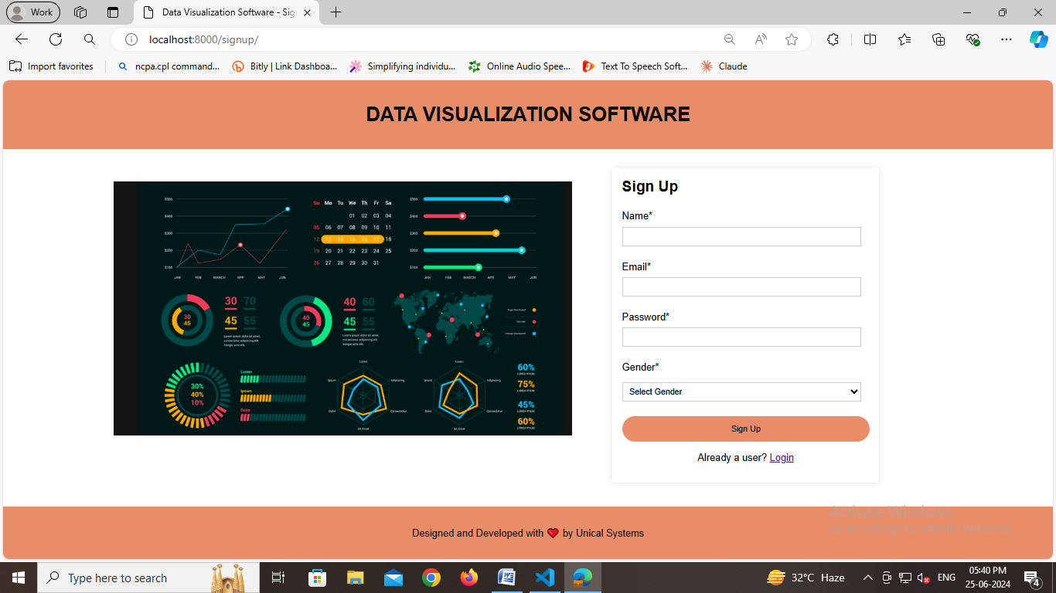

**CREATING A NEW PROJECT**

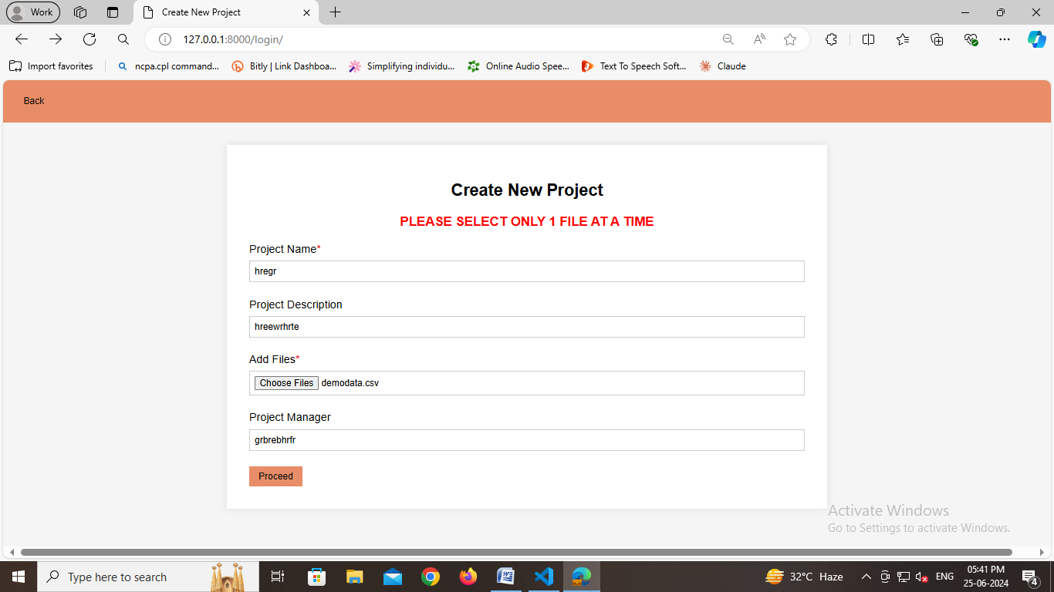

**MAPPING PARAMTERS**

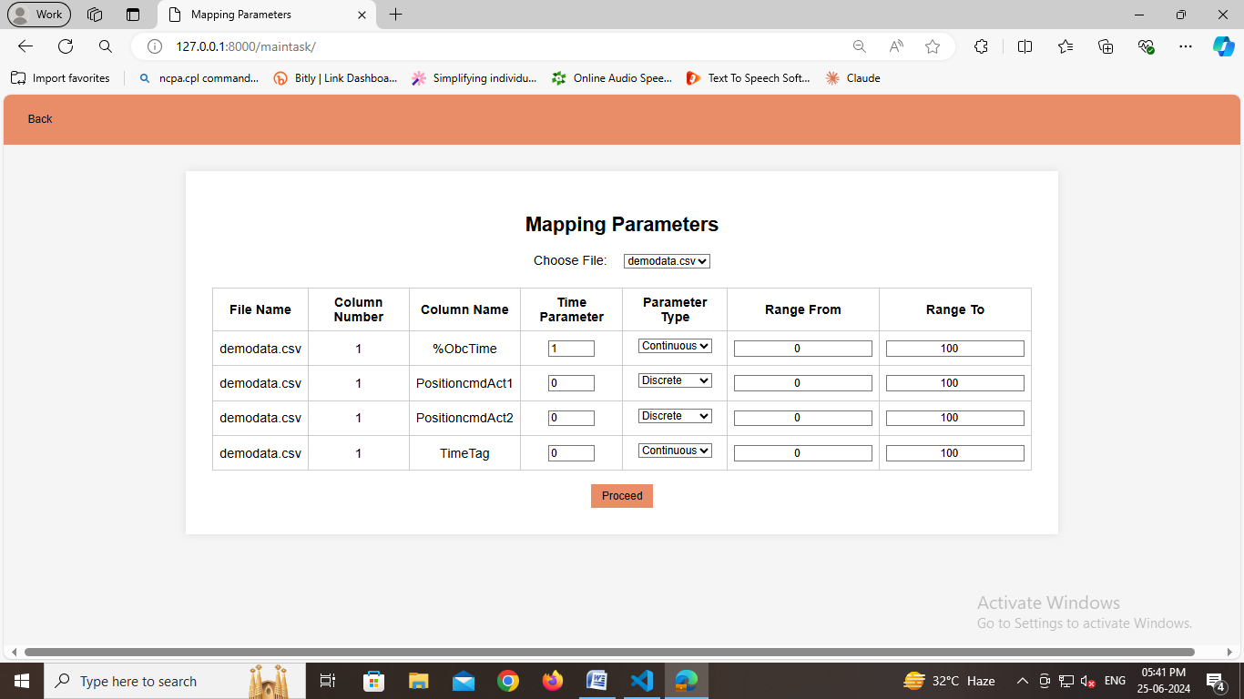

**SELECTION TABLE**

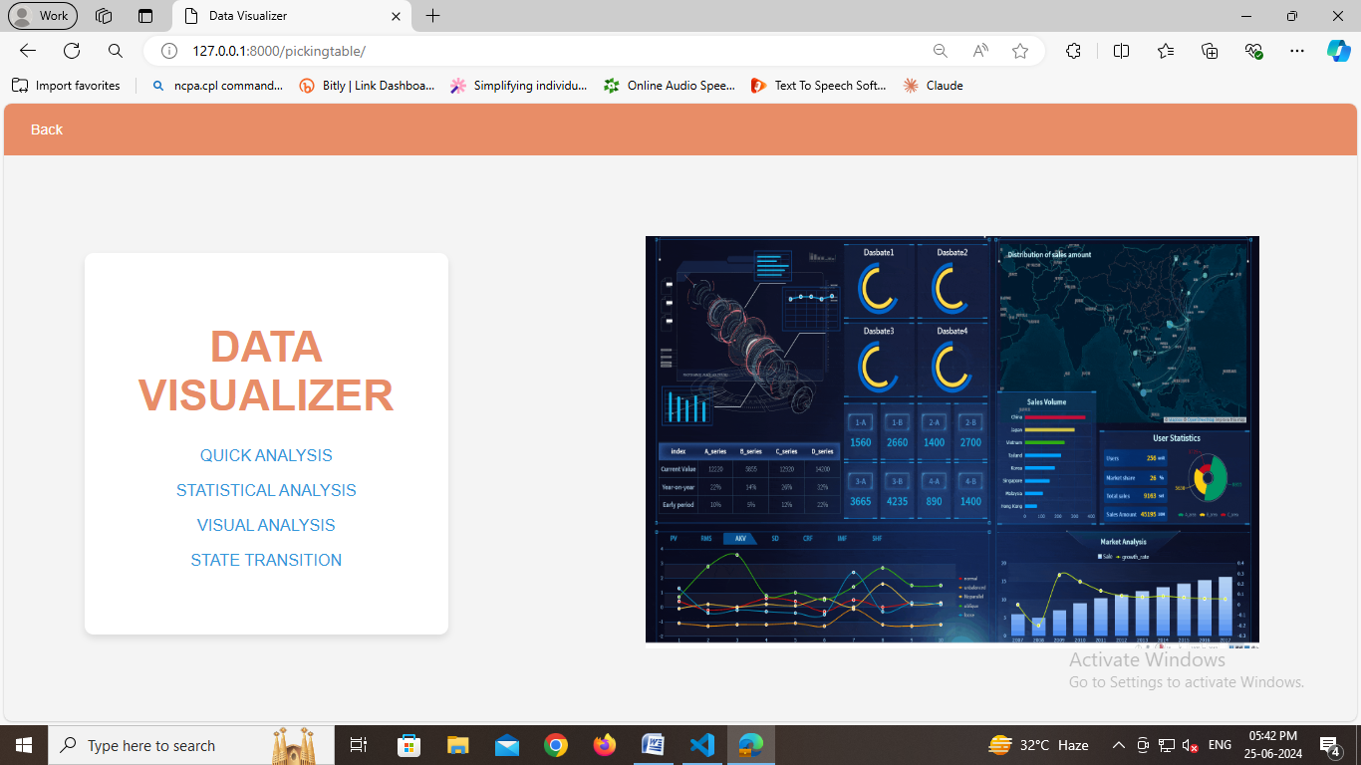

**QUICK ANALYSIS**

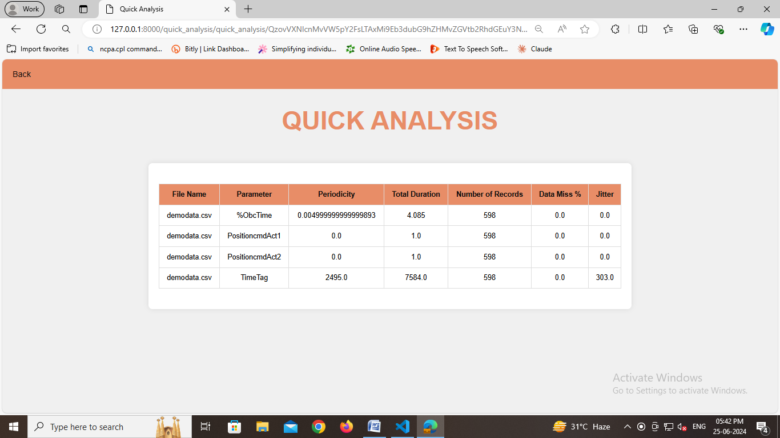

**STATISTICAL ANALYSIS**

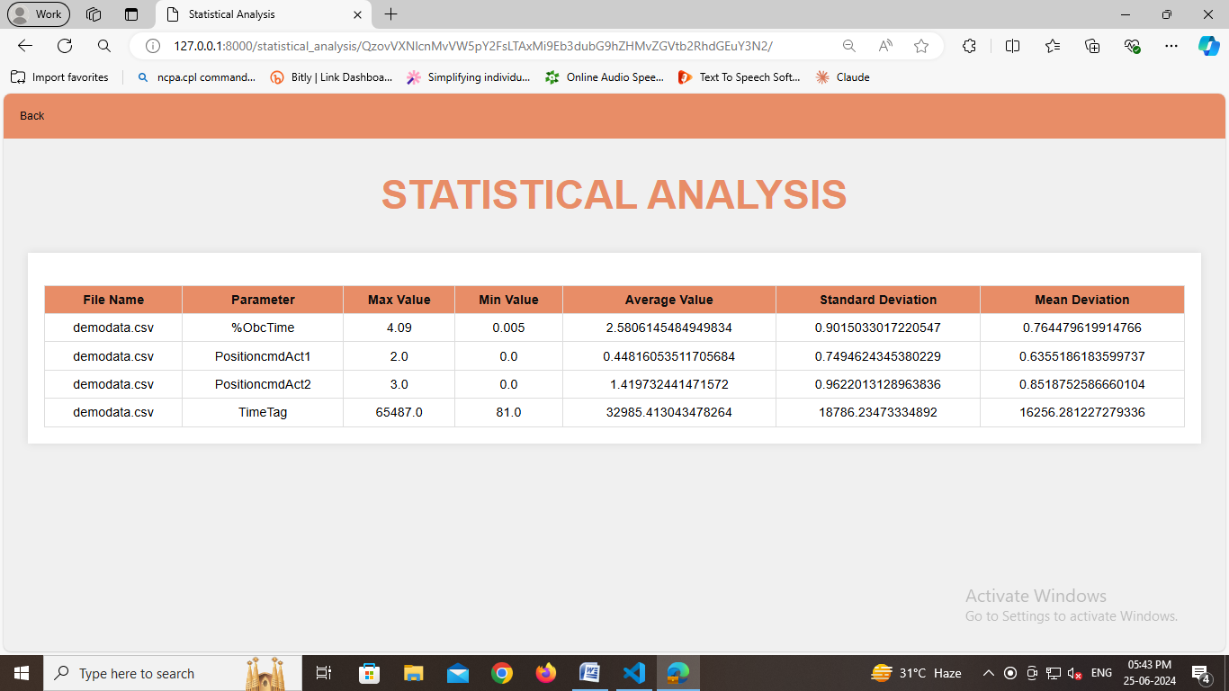

**VISUAL ANALYSIS**

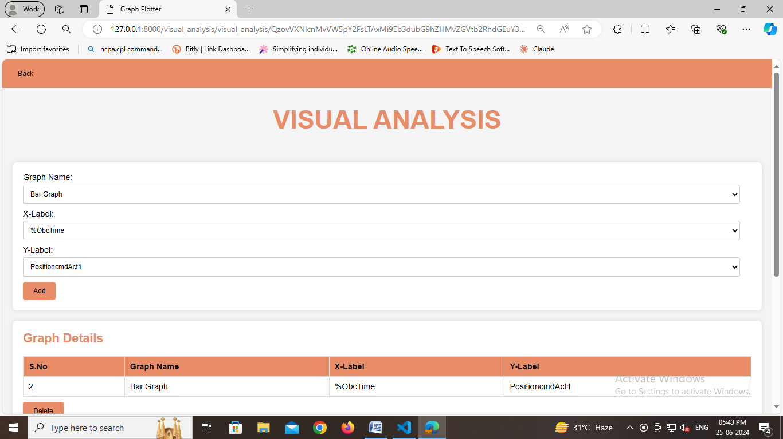

**STATE TRANSITION ANALYSIS**

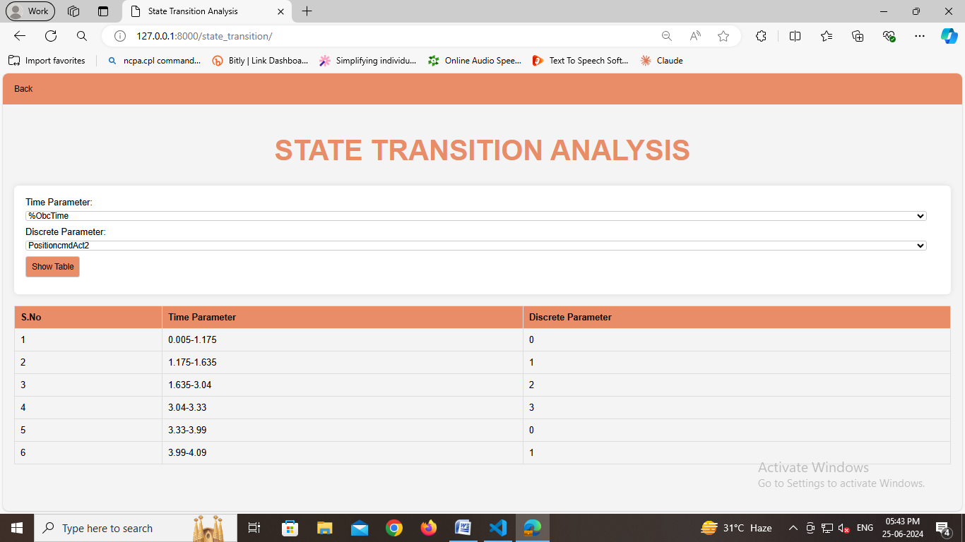

**LIMITATIONS**

* **ONLY ACCEPTS AND MAKES CALCULATIONS FOR 1 FILE AT A TIME.**
* **MAKES CALCULATIONS ONLY FOR A .csv FILE SO THE DATA SHOULD BE IN THE .csv FILE FORMAT.**
* **THE .csv file MUST AND SHOULD CONTAIN THE REQUIRED PARAMETERS LIKE %ObcTime,PositioncmdAct1,PositioncmdAct2 ,TimeTag.**

**DATABASE STRUCTURE**

**1.login.user**

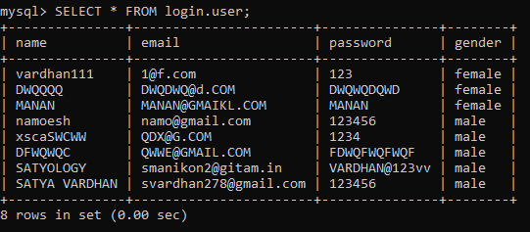

**2.login.info2**

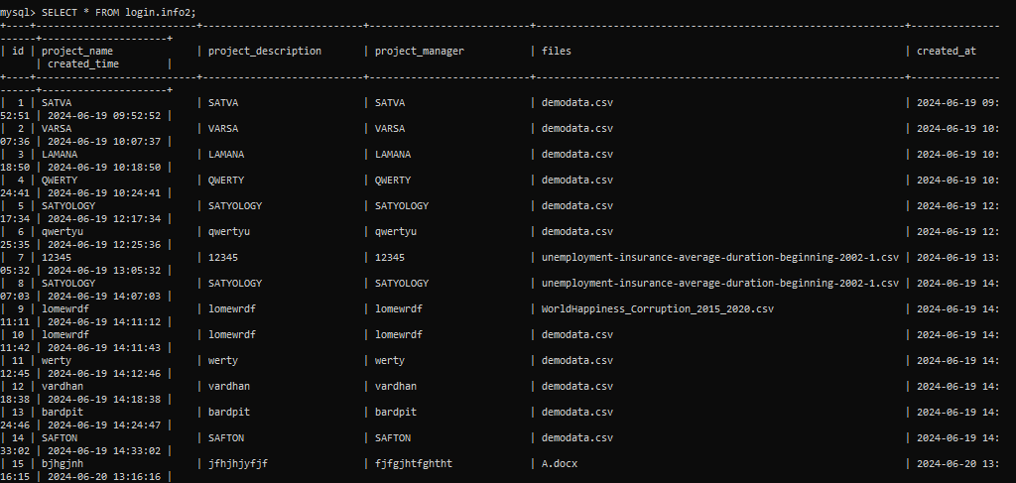

**3.login.info3**

