Vocational school for computer programming and innovation



Game Shop

|  |
| --- |
| Stanislav Todorov  SATodorov18@codingburgas.bg |
| Stoyan Kolev  SNKolev18@codingburgas.bg |
| Borislav Ferdinandov  BBFerdinandov18@codingburga  s.bg |
| Kaloyan Dinev  KDDinev18@codingburgas.bg |

|  |  |
| --- | --- |
| Mentor - Petar Georgiev |  |

Contents

1. Description of the project 3

2. Diagram 3

3. Table with the functions 4

Table 1 4

Figure 1 3

# Description of the project

**Idea and goal of the project.**

Our project is a computer program written on c++.

The idea of our project is to make the job of the shop assistants easier.

**Problems that can solve.**

The shop assistants can find a game faster by entering criteria that they want to search by.

**How to use it?**

You just start it and then you are granted a menu with options. For example if you type 1, you select the first option which will allow you to enter a game by many critcerias.

# Diagram

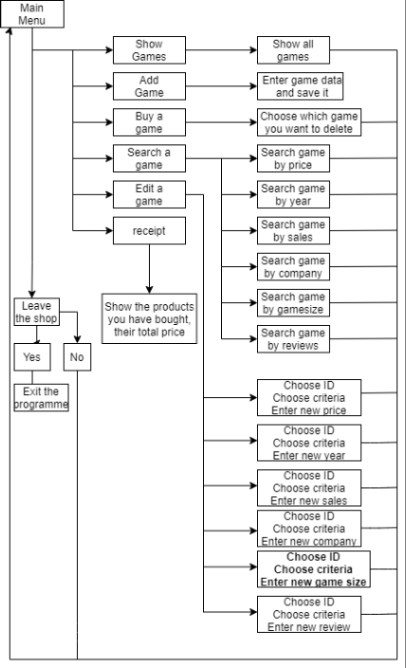

Figure 1

# Table with the functions

|  |  |  |  |
| --- | --- | --- | --- |
| showGames | The function is from type void. It contains two parameters | GAMESHOP* game, int& gameCount | We used a for loop that cycles till the number of games(int& gameCount) to print every game. |
| searchMenu | The function is from type void. It contains two parameters | GAMESHOP* game, int& gameCount | We used multiple IF statements so the user could choose the criteria to find a game. |
| editMenu | The function is from type void. It contains two parameters | GAMESHOP* game, int& gameCount | We used multiple IF statements so the user could choose the criteria to find a game. |
| mainMenu | The function is from type void. It contains two parameters | GAMESHOP* game, int& gameCount | We used switch case so that the user could choose between six options : add a game, show all games, buy a game, search game, edit game, leave the shop. |
| addGame | The function is from type void. Function with two parameters | GAMESHOP game[], int& gameCount | We used couts so that we can show the user what information to enter using cin. It returns nothing |
| buyGame, chooseInd | here are functions that have three parameters | GAMESHOP* game, int& gameCount, int ind | moves the game that the user bought to the very last index from the array and the number of games decreases by one.; finds the index of the game that the user wants to clear and returns it. |
| searchGameby(year, review, price, sales, company, size) | The function is from type int. It has three parameters | GAMESHOP* game, int& gameCount, int criteria(year, review, price, sales, company, size | It prints all games that have matched the criteria. |
| searchBy (year, review, price, sales, company, size)Menu | he function is from type void. It has two parameters | GAMESHOP* game, int& gameCount | This function wants the user to enter criteria that he wants to search and when that criteria finds the matches and calls the function searchGameby(year, review, price, sales, company, size) |
| edit(year, review, price, sales, company, size) | Functions from type void with two parameters | GAMESHOP* game, int& gameCount | Two variables are declared in it(int ID; year, review, price, sales, company, size). The user has to enter the ID of the game that he wants to edit and to enter the new info. |

Table 1