### COMP3782 Information Technology Project

Insert Date Here

Brain Computer Interface

Final Project Report

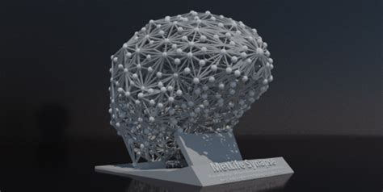

Author: FAN:

Timothy Finn Finn0066

Josh Francis

Michael Douglas

Yeqing Liu

George Proios

Contents

Table of Figures 2

Executive Summary 2

1 – Introduction and Background 3

2 – Project Objectives/Hypotheses 3

3 – Project Value 4

3.1 – Who/What benefited from the project 4

3.2 How did the results generated by the project assist the organisation? 4

4 – Principal Target Groups 4

5 – Changes to the Project 5

6 – Document Executing Tasks 6

6.1 – Actual/Planned Data Comparison 6

6.2 – Earned Value Management (EVM) 8

6.3 – Change of Request Records 9

7 – Document Controlling Tasks 11

7.1 Problem solving Record 11

8 - Main Outputs 13

8.1 - Python Simulation 13

8.2 – EPOC + Software 14

8.3 – Physical Miniature Pinball Machine 15

8.4 – Pinball Graphics 16

9 - Recommendations and Conclusions 17

10 - Final Reflections 18

References 19

Appendix 20

Appendix A – 3D pinball machine 20

Appendix B – Pinball Machine Decal 20

Appendix C – User Guide 21

Appendix D – Meeting Minutes 23

# Table of Figures

Figure 1: Revised Cost Estimate. 7

Figure 2: Planned vs Actual labour (costs) 7

Figure 3: Planned vs Actual total cost 7

Figure 4: Planned vs Actual Non-Labour costs 7

Figure 5: Planned vs Actual labour (hours) 7

Figure 6: EVM Table 8

Figure 7: Fishbone diagram 11

Figure 8: Issue Log 12

Figure 9: Basic Python simulation of pinball game 13

Figure 10: EMOTIV EPOC+ EEG headset 14

Figure 11: Output raw EEG data 14

Figure 12: EEG sensor locations 15

Figure 13: 3D pinball model 15

Figure 14: Flipper actuator, RaspberryPi and LED strip 16

Figure 15: Pinball decals 16

Figure 16: Final system overview 17

# Executive Summary

This document covers the final stages of the project undertaken by the Brain Computer Interface (BCI) team. The project undertaken was to develop a system that utilises brain signals to control one or more external devices. The specific focus was on developing a system that can be utilised by young children. This is to assist in cultivating a passion for STEM (Science Technology Engineering and Mathematics) in young children. A range of systems were considered, finally deciding on implementing a brain-controlled LED light setup in a hallowed out 3d printed brain.

Key outcomes of the project include a hallowed out 3d printed brain with a RGB LED strip placed inside, with associated software that can provide an interface for an EPOCH+ device to connect to the LED strips and simulate brain activity.

Key beneficiaries/stakeholders to the project include the Brain Signals Lab, Trent Lewis, The Department of Education, and primary school students. Both the Brain Signals Lab and Trent Lewis obtained a working prototype that verifies the research of the BSL. It provided them with a device that can be used to present the research of the BSL to external parties. The Department of Education benefit from the project, as they gain an educational tool that can be used in classrooms to help engage young children. The school children also benefit from this technology as it enables them to learn and helps cultivate an interest in STEM.

# 1 – Introduction and Background

Recent years have seen advancements in the field of electroencephalography (EEG) technology. EEG technology enables brainwaves to be read by the user. Achieved by detecting electrical pulses between brain cells (Blocka, 2017). Currently this technology is used by doctors to help diagnose conditions such as; seizure disorders, head injuries, encephalitis, brain tumours, and memory problems (Blocka, 2017). Advances in the field of EEG technology are indispensable to the scientific community, as it enables further studies to be conducted into neurological diseases and broadens the uses of EEG technology.

Research is crucial for those who are affected by these diseases as they in some cases are unable to rely on their own physical abilities and must constantly use the help of others to complete even the simplest of everyday tasks. Continuation of research is therefore essential and the more people who can attribute to this the better the technology will become. Unfortunately, the process involved to read, interpret and act upon these brain signals is extremely complex and requires years of dedication and study to fully understand. Due to this, many young students are unable to see the benefits brain computer interfaces can provide for those in need as they unfortunately lose interest in its complexity.

This project sets out change this, the aim was to develop an interactive and fun Brain Computer Interface which could be taken into a school environment in the hope that it entices the students of tomorrow. Although the design may not contribute to the study of neurological diseases by creating something easy to display to young students attending schools, it may spark an interest in them at an early stage in the hope that they continue to develop knowledge in computer science to contribute to the study of neurological diseases soon.

# 

# 2 – Project Objectives

The *BCI* project aims to generate a greater interest in STEM and raise awareness of neurological diseases through the development of a child friendly and interactive brain computer interface (BCI). By simplifying existing technology and making it appealing to a younger audience the Brain Signals Lab desired to engage students from a young age and capture their interest, allowing for BCI technology to gain greater public exposure.

Team members working on this project discussed with the primary stakeholder Trent that showing LED’s on a brain simulating activity will give a great way for children to increase their interest in the field of EEG. By allowing the system to be more interactive for children this will increase the retainability of learning and increase their desire to learn. Side objectives are to give children an increase desire to learn programming languages and interact with high-tech technology.

The BCIproject has been aligned with the expectations of the Brain Signals Lab and Flinders University’s strategic goals to clarify what can be considered successful outcome. For this project to be considered successful it must deliver a working prototype and user guide. The working prototype will function as a proof of concept and with the user guide to correctly demonstrate how to implement the technology in a safe and constructive manner around children the BCI project will prove that this technology can be used to achieve the projects goals.

# 3 – Project Value

## 3.1 – Who/What benefited from the project

The Brain Computer Interface (BCI) project was designed to be a non-for-profit organisation. This means that all financials assets gained are reinvested into developing the research into EEG technology. The purpose of development was to create something exciting and relatively easy to use such that it could be presented to young students attending schools, and hopefully engage them enough to continue their studies in STEM.

A major external stakeholder, the Department of Education, will gain significant value by introducing this product into schools across the state. This is because it creates a fun and enjoyable school experience which has the potential to create a brighter generation of younger students who are willing to push the boundaries of neuroscience.

## 3.2 How did the results generated by the project assist the organisation?

The easy to use pinball machine controlled by a Brain Computer Interface was exactly what the team set out to create, and in doing so it has enabled the Department of Education to introduce students to electroencephalography technology in a significantly simpler way.

# 4 – Principal Target Groups

The principal target groups for the Brain Computer Interface project are:

* The Brain Signals Lab (BSL)
* Trent Lewis
* The Department of Education (SA)
* Primary school students

The Brain Signals Lab (BSL) is a key target group. From the project they obtain a prototype which uses the technology that they have been developing. As a result, it helps validate their research and provides the BSL with information they can use to make further advancements in the field.

Professor Trent Lewis directly benefits as he has presented the team with the project. He provided the team with the requirements and details of the project. He also provided us with an EEG headset to assist in prototyping. Through completing the project, it provides Trent with a prototype that he can further develop as part of the BSL team. This prototype also provides Trent with a prototype he can use immediately to assist in engaging people in research conducted by the BSL lab, in a manor he deems fit.

The Department of Education is also a key target group. They benefit as they obtain an educational tool that can be implemented in classrooms across the state. This will help keep school aged children engaged in learning and instil this attitude from an early age.

Primary school students are a key target group, they directly benefit through using the prototype. Students will gain a hands-on practical experience with BCI technology, which not only educates them in that field, but will hopefully inspire them to peruse the area further.

# 5 – Changes to the Project

A few changes were made throughout the duration of the project. The largest of which was the implementation of the Python simulation of the pinball game. This was deemed beneficial to the project for a few reasons;

1. The implementation of the simulation allowed for most of the software debugging to occur independently of the hardware, reducing the amount of time spent in the hardware development stage.
2. It also produced an additional aspect of the project that would further help achieve the goals of the project. The production of the simulation will help to inspire interest in the fields of STEM and BCI technology by allowing students and children delve into software side of basic game development and programming.

The result of this change meant that an additional week was allotted to the software development stage whilst simultaneously reducing a week from the hardware development stage.

The second change that occurred within the project was the requirement of a laptop in the final implementation. As mentioned in the challenges faced section, the laptop was deemed necessary as reading the raw data directly from the EEG headset via the RaspberryPi proved difficult. The solution to this challenge was to broadcast the data, from the laptop, over an LSL stream and hook into the LSL stream via the RaspberryPi. Although this change did not affect the project in a major way, additional hardware is now required to run the physical pinball game via the EEG headset.

# 6 – Document Executing Tasks

|  |  |  |  |  |  |  |  |  |  |
| --- | --- | --- | --- | --- | --- | --- | --- | --- | --- |
| WBS Categories | Internal Labour | |  | Labour Total | | Non Labour | | Total Cost | |
| Planned | Actual | **$/Hr** | Planned | Actual | Planned | Actual | Planned | Actual |
| 1. Concept |  |  |  |  |  |  |  |  |  |
| 1.1 Requirements |  |  |  |  |  |  |  |  |  |
| 1.1.1 System | 40 | 40 | $50 | $2,000 | $2,000 |  |  | $2,000 | $2,000 |
| 1.1.2 User | 30 | 30 | $50 | $1,500 | $1,500 |  |  | $1,500 | $1,500 |
| 1.1.3 Clearance | 10 | 10 | $50 | $500 | $500 |  |  | $500 | $500 |
| 2. Designing |  |  |  |  |  |  |  | $0 | $0 |
| 2.1 Software | 20 | 40 | $60 | $1,200 | $2,400 |  |  | $1,200 | $2,400 |
| 2.1.1 Laptop |  |  |  |  |  | $1,000 | $1,000 | $1,000 | $1,000 |
| 2.2 Hardware |  |  |  |  |  |  |  |  | $0 |
| 2.2.1 Conceptual | 50 | 50 | $70 | $3,500 | $3,500 |  |  | $3,500 | $3,500 |
| 2.2.2 Logical | 70 | 70 | $70 | $4,900 | $4,900 |  |  | $4,900 | $4,900 |
| 2.2.3 Physical | 80 | 60 | $70 | $5,600 | $4,200 |  |  | $5,600 | $4,200 |
| 2.2.3.1 RaspberryPi |  |  |  |  |  | $50 | $50 | $50 | $50 |
| 2.2.3.2 EEG Helmet |  |  |  |  |  | $10,000 | $500 | $10,000 | $500 |
| 2.2.3.3 Monitor |  |  |  |  |  | $200 | $200 | $200 | $200 |
| 2.2.3.4 Speakers |  |  |  |  |  | $50 | $60 | $50 | $60 |
| 2.2.3.5 Other |  |  |  |  |  | $100 | $0 | $100 | $0 |
| 3. Development |  |  |  |  |  |  |  |  | $0 |
| 3.1 Construct Physical System | 30 | 30 | $70 | $2,100 | $2,100 |  |  | $2,100 | $2,100 |
| 3.2 Construct System Software | 30 | 30 | $70 | $2,100 | $2,100 |  |  | $2,100 | $2,100 |
| 3.3 Development | 30 | 30 | $70 | $2,100 | $2,100 |  |  | $2,100 | $2,100 |
| 4. Testing |  |  |  |  |  |  |  |  | $0 |
| 4.1 Component Test | 10 | 10 | $60 | $600 | $600 |  |  | $600 | $600 |
| 4.2 System Test | 15 | 15 | $60 | $900 | $900 |  |  | $900 | $900 |
| 5. Implementation |  |  |  |  |  |  |  |  | $0 |
| 5.1 Deploy Project | 5 | 5 | $50 | $250 | $250 |  |  | $250 | $250 |
| 5.2 Training | 10 | 10 | $50 | $500 | $500 |  |  | $500 | $500 |
| 6. Project Evaluation |  |  |  |  |  |  |  |  | $0 |
| 6.1 Conduct Review Survey | 10 | 20 | $40 | $400 | $800 |  |  | $400 | $800 |
| 6.2 Make Suggested Changes | 10 | 10 | $40 | $400 | $400 |  |  | $400 | $400 |
| 7. Maintenance | 50 | 40 | $65 | $3,250 | $2,600 |  |  | $3,250 | $2,600 |
|  |  |  |  |  |  |  |  |  |  |
| Total | 500 | 500 |  | $31,800 | $31,350 | $11,400 | $1,810 | $43,200 | $33,160 |

## 6.1 – Actual/Planned Data Comparison

Figure 1: Revised Cost Estimate.

The prototype was delivered in the specified time frame. As such a revised cost estimate was produced, detailing the breakdown of the actual and planned data of the project. The cost estimate details all the associated costs and labour it took to complete the project. Columns with blue text indicate the planned time and labour, and columns with read text indicate the actual time and labour associated with the project. The revised cost estimate can be seen in *Figure 1* below.

*Figures 2* demonstrates the difference between actual labour costs and planned labours costs. The actual cost came in at $450 under budget. *Figure 5* shows the difference between the actual and planned hours dedicated to labour. The number of hours required were deemed to be the same for both planned and actual. However, in *Figure 1* it can be observed that 20 hours were moved from hardware to software design. *Figure 4* details the difference between the planned and actual non-labour costs. There is a significant discrepancy of $9,590, due to a reduction in EEG helmet costs. The original estimate budgeted for an expensive EEG helmet, and after research a significantly cheaper option was deemed necessary. *Figure 3* demonstrates the actual vs planned total cost of the project, the project came in under budget.

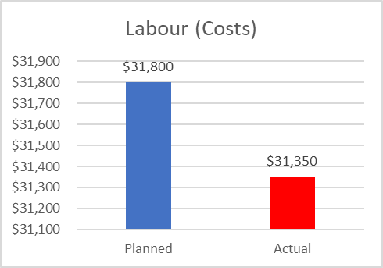

Figure 2: Planned vs Actual labour (costs)

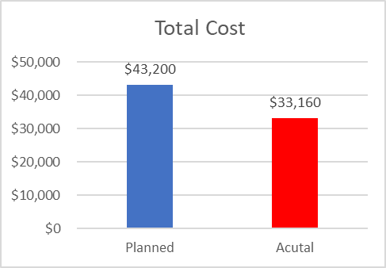

Figure 3: Planned vs Actual total cost

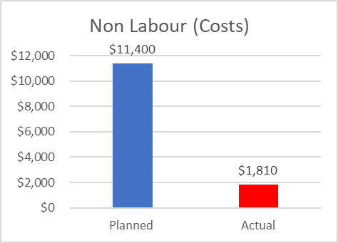

Figure 4: Planned vs Actual Non-Labour costs

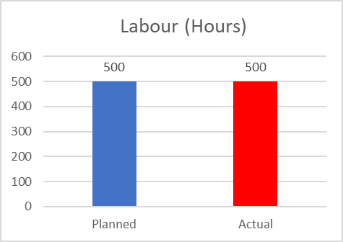

Figure 5: Planned vs Actual labour (hours)

## 6.2 – Earned Value Management (EVM)

Based on the data in section 6.1, the values shown in *Figure 6* below could be developed. The SPI and SV indicates the project was delivered on schedule. The cost variance indicates that the project was delivered under budget by $10,040.

|  |  |  |
| --- | --- | --- |
| Function | Formula | Amount |
| Planned Value (PV) |  | $43,200 |
| Actual Cost (AC) |  | $33,160 |
| Rate of Performance (RP) |  | 100% |
| Earned Value (EV) | PV*RP | $43,200 |
| Cost Variance (CV) | EV-AC | $10,040 |
| Schedule Variance (SV) | EV - PC | $0 |
| Cost Performance Index (CPI) | EV/AC | 1.30 |
| Schedule Performance Index (SPI) | EV/PV | 1 |

Figure 6: EVM Table

## 6.3 – Change of Request Records

**BCI Project Change Request 1**

**Project Name:** Brain Computer Interface

**Date Request Submitted:** 9th August 2018

**Title of Change Request:** Construct Python Simulation

**Submitted by:** Josh Francis

Change Category:  Scope  Schedule  Cost  Technology  Other

**Description of change requested:**

It was decided that implementing a Python simulation of the pinball game would benefit the project as it facilitates increased isolation of the software components from the hardware components. This will allow for easier troubleshooting regarding software as it would then become hardware independent. Additionally, it will assist in further inspiring an interest in STEM and BCI technology as it would allow students and children to delve into the software aspect of game development. To complete this task, an additional week will be required within the software development stage of the project.

**Events that made this change necessary or desirable:**

Due to the inherent complexity of the software required for this project, increased assistance regarding troubleshooting and debugging is required. Also, by providing another aspect of the game for students and children to explore further contributes towards the goal of this project.

**Justification for the change/why it is needed/desired to continue/complete the project:**

This change is required to minimise time spent debugging and troubleshooting the software responsible for obtaining the data from the EEG headset and streaming it over the LSL.

**Impact of the proposed change on:**

**Scope:** Increases the chances of achieving the project goals.

**Schedule:** Requires an additional week to be allocated to the software development stage.

**Cost:** No changes to cost will occur.

**Risk:** No risk involved.

**Suggested implementation if the change request is approved:**

A Python simulation of the pinball game will be produced and documented.

**Required approvals:**

|  |  |  |
| --- | --- | --- |
| **Name/Title** | **Date** | **Approve/Reject** |
| Project Leader / Trent Lewis | August 2018 | **Approved** |

**BCI Project Change Request 2**

**Project Name:** Brain Computer Interface

**Date Request Submitted:** 11th August 2018

**Title of Change Request:** Modify System Design

**Submitted by:** Josh Francis

Change Category:  Scope  Schedule  Cost  Technology  Other

**Description of change requested:**

It was discovered that a laptop was necessary for the final implementation of the physical pinball game. Reading the raw data directly from the EEG headset via the RaspberryPi proved to be quite difficult. It was evident that the ability to access the raw data stream was not possible. The solution to this is to broadcast the data from the wireless EEG headset, via the laptop, over an LSL stream and hook into the LSL stream via the RaspberryPi. This, therefore, means that a laptop is required to run the system in the final implementation.

**Events that made this change necessary or desirable:**

Due to the nature of directly accessing the raw data stream from the wireless EEG headset, it was deemed necessary to stream the data over an LSL stream and hook into the LSL stream via the RaspberryPi.

**Justification for the change/why it is needed/desired to continue/complete the project:**

This change is required in order to gain access to the data from the EEG headset such that the game can be controlled.

**Impact of the proposed change on:**

**Scope:** Involves development of an additional piece of software, adding additional complexity.

**Schedule:** No effect on overall project schedule.

**Cost:** Additional costs will be added to the project as a laptop is now required.

**Risk:** No risk involved.

**Suggested implementation if the change request is approved:**

An additional piece of software will be developed to act as the conduit between the EEG headset and the RaspberryPi.

**Required approvals:**

|  |  |  |
| --- | --- | --- |
| **Name/Title** | **Date** | **Approve/Reject** |
| Project Leader / Trent Lewis | August 2018 | **Approved** |

# 7 – Document Controlling Tasks

## 7.1 Problem solving Record

There are 7 Basic Tools of Quality, these are basic techniques used to develop and perform quality control. They are:

* Cause-and-effect diagram (also called Ishikawa or fishbone chart): Identifies many possible causes for an effect or problem and sorts ideas into useful categories.
* Check sheet: A structured, prepared form for collecting and analysing data; a generic tool that can be adapted for a wide variety of purposes.
* Control charts: Graphs used to study how a process changes over time.
* Histogram: The most commonly used graph for showing frequency distributions, or how often each different value in a set of data occurs.
* Pareto chart: Shows on a bar graph which factors are more significant.
* Scatter diagram: Graphs pairs of numerical data, one variable on each axis, to look for a relationship.
* Stratification: A technique that separates data gathered from a variety of sources so that patterns can be seen (some lists replace “stratification” with “flowchart” or “run chart”).

(ASQ.org, 2018)

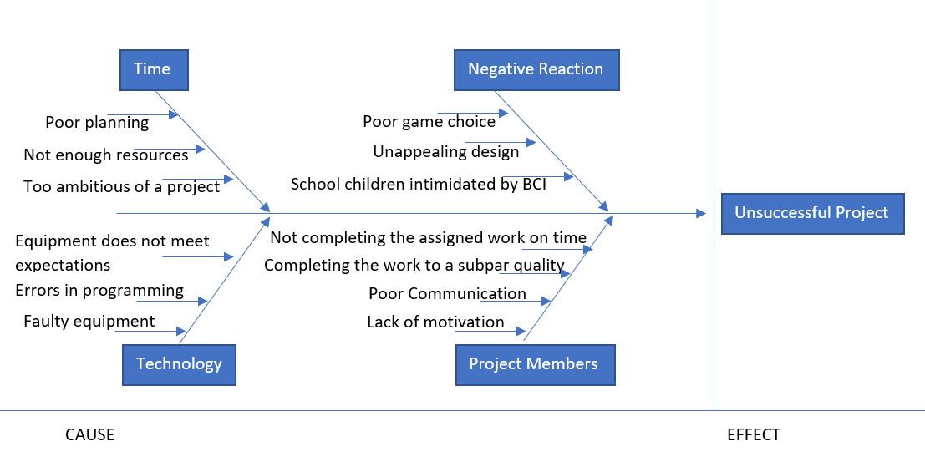The projected team opted to use a cause and effect diagram, also known as a fishbone diagram, for this project as it allowed for easy tracking of the root cause of the major issues that were expected. The diagram is shown in *Figure 7*.

Figure 7: Fishbone diagram

|  |  |  |  |  |  |  |  |  |
| --- | --- | --- | --- | --- | --- | --- | --- | --- |
| ISSUE # | DESCRIPTION | IMPACT | DATE | REPOPORTED BY | PRIORITY | DEADLINE | STATUS | COMMENTS |
| 1 | Change in project deliverable | Josh and Adam had to work together to create a Python simulation of the pinball game instead of the physical machine we originally intended to build. | 12/7/18 | Josh Francis | Very High | 29/8/18 | Closed | The decision to change the deliverable prototype came about because we realised we did not have the necessary resources to develop a physical version. |
| 2 | Unable to secure permission for use of graphics. | The team was unable to secure the proper permissions for the graphic used in the design of the pinball simulation. Because of this, only images labelled for re-use were used. | 18/7/18 | Adam Schwarz | Medium | 20/7/18 | Closed | We were unable to use the graphics we originally wanted, but we still were able to find comparable designs that still achieved our goal. |
| 3 | Delay in delivery of materials | Because of a lack of supplies, development ground to a halt for a short time. Overall it did not have an enormous impact because we were still on schedule. | 29/7/18 | Kamy Kianoush | Medium | 30/7/18 | Closed | The team was able to make up for the lost time by working efficiently. That is why it did not affect the overall timeframe of the project. |
| 4 | Problems in the BCI laboratory | The BCI lab experienced some difficulties as the team was unable to access the BCI for the purposes of testing the prototype. | 15/8/18 | Mitch Heath | High | 22/8/18 | Closed | The BCI lab had problems with the BCI itself and it ended with one of the sensors having to be replaced. |
| 5 | Issues securing funding | For a brief time, development was without funding. This meant that development could not commence until that funding was secured. | 1/7/18 | Tarkis Cooper | Very High | 8/7/18 | Closed | Unfortunately, the ones funding the project were unable to see the progress we were making and cut off our funding. This was resolved by demonstrating to them what we had achieved. |
| 6 | Confusion with BCI capabilities | As none of the team has worked with BCI technology before, it was necessary to learn the ins and outs of its software and gain knowledge of the technology before development could start. | 25/6/18 | Tyler Sheehan | Very High | 1/7/18 | Closed | Prior to this, we had ensured the feasibility of our project with the lab, but we realised we would need in-depth knowledge of the technology in order to properly develop our prototype. So, we approached the lab and they were happy to help us. |

Figure 8: Issue Log

# 8 - Main Outputs

The main goal of this project was to inspire interest in the fields of STEM and BCI technology within young children and students across Australia. It was decided that the best way to achieve this goal was via the implementation of a simple pinball game that utilises a wireless EEG headset, such that the game could be driven via various signals generated from the players’ brain. This would allow children to interactively use BCI technology in an interesting way, in the hopes of achieving the aforementioned goals. As a result, the main outputs of this project are as follows:

## 8.1 - Python Simulation

A minor change within the project involved development of a Python simulation of the game before implementing the physical pinball machine. The simulation was first developed such that the software component of the pinball game could be developed independently of the hardware, in the hopes of minimising potential issues and simplifying the debugging process. To achieve this, a simple Python program was written to display the basic geometry of the game.

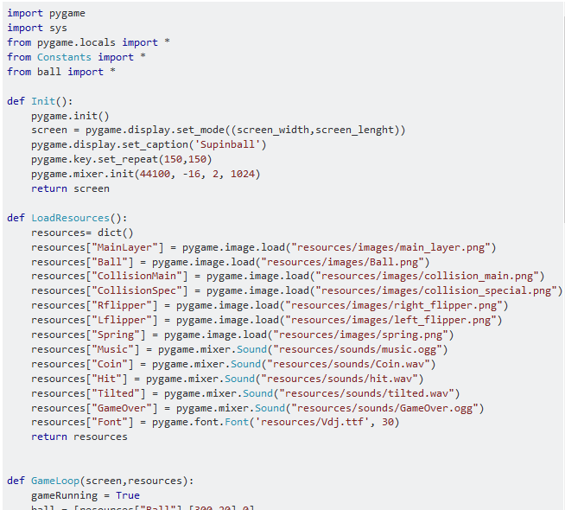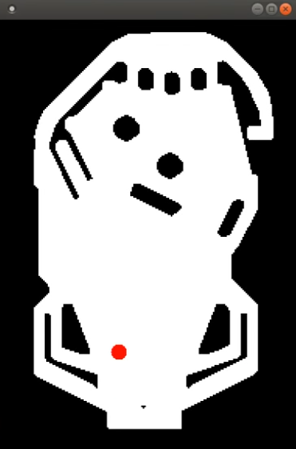

Figure 9: Basic Python simulation of pinball game

Having constructed a simulation of the layout and the basic game mechanics, software development focus was then shifted to the wireless EEG headset.

## 8.2 – EPOC + Software

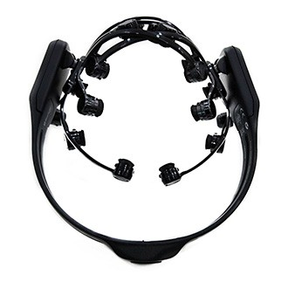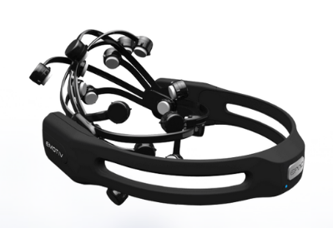

Figure 10: EMOTIV EPOC+ EEG headset

The EEG headset that was decided upon was the EPOC+ from EMOTIV, as shown in Figure 10. Extensive research into existing libraries and application programming interfaces (API’s) that could be used to access brain signal data from the EEG headset was then conducted. Various libraries and API’s were found including non-free software such as Cortex UI. Although these API’s and software development kits (SDK’s) were enticing, it was predetermined that any software used should be free and open source, such that children and students can access it freely and make changes as they desire. The result of this research was the discovery of the EMOTIV community SDK, freely available on GitHub (Github, 2018). After obtaining the repo, additional software was written to extract data from the EEG headset and broadcast it over a lab streaming layer (LSL) via a laptop (Github, 2018). Upon running this code, it was evident that data was being extracted from the EEG headset and broadcast over the LSL as shown by the output below.

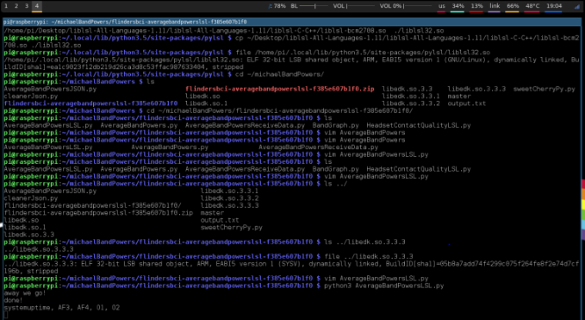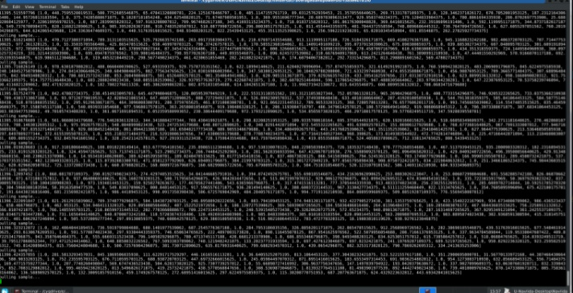

Figure 11: Output raw EEG data

EEG headsets can have a wide variety of sensors. The EPOC+ EEG headset has 14 sensors, each with 5 readable frequencies. The locations of which approximated using a dummy head, shown in *Figure 12*.

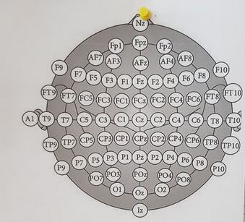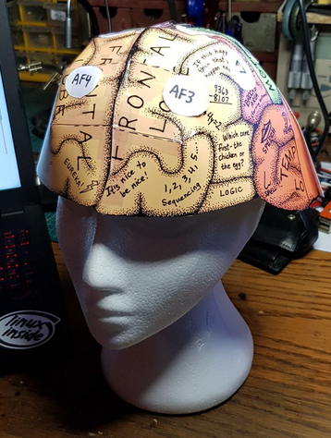

Figure 12: EEG sensor locations

The sensors chosen to drive the pinball game were AF4 and AF3 as they are available on the EPOC+ and they are located on the frontal lobe. This will serve to be beneficial as students and children can not only attempt to use signals generated from the part of their brain responsible for logic and problem solving but can also use the muscles responsible for blinking to drive the game should they be unable to generate the appropriate signals. Having determined which sensors, the data was to be obtained from, the data was then used to drive the Python pinball simulation. This was achieved with more Python code. The result of running this code was basic operation of the pinball simulation via the EEG headset, as intended. Having completed much of the software development, construction of the physical pinball machine could begin.

## 8.3 – Physical Miniature Pinball Machine

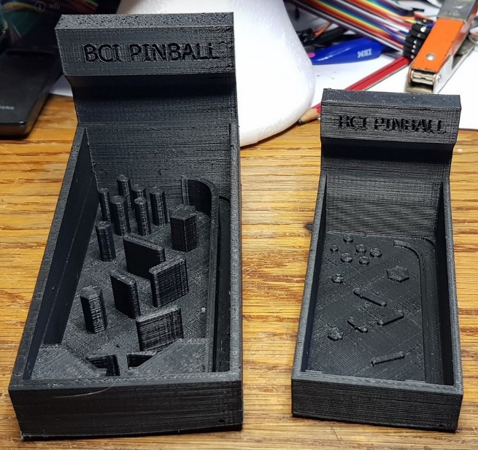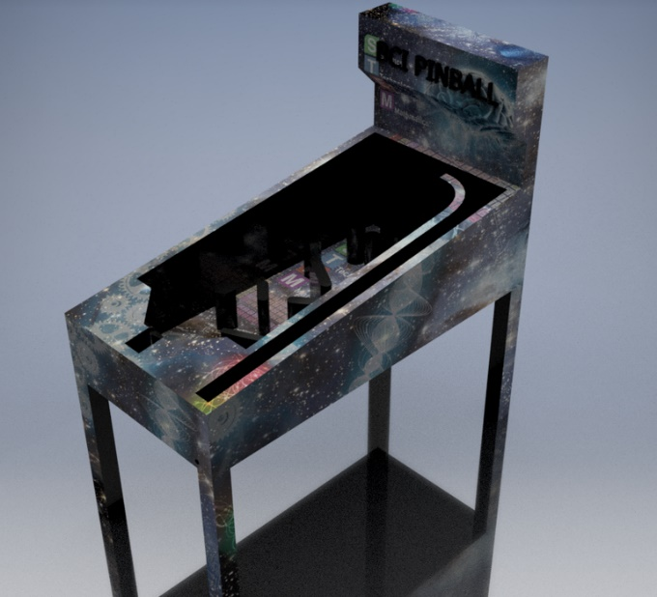The physical pinball machine was first designed in Autodesk Inventor to develop plans to work from. The result of which was the following 3D models.

Figure 13: 3D pinball model

The model was then 3D printed such that the development team had a basic structure to base other aspects of the design off of, such as the visual graphics and lighting placement etc. With a basic design to work from, research into the various components used to drive the pinball machine could then begin. This research involved looking into linear actuators to drive the flippers and LED strips for the interactive pinball displays. Additionally, research into driving these components via a RaspberryPi was also conducted. The results of which are as follows:

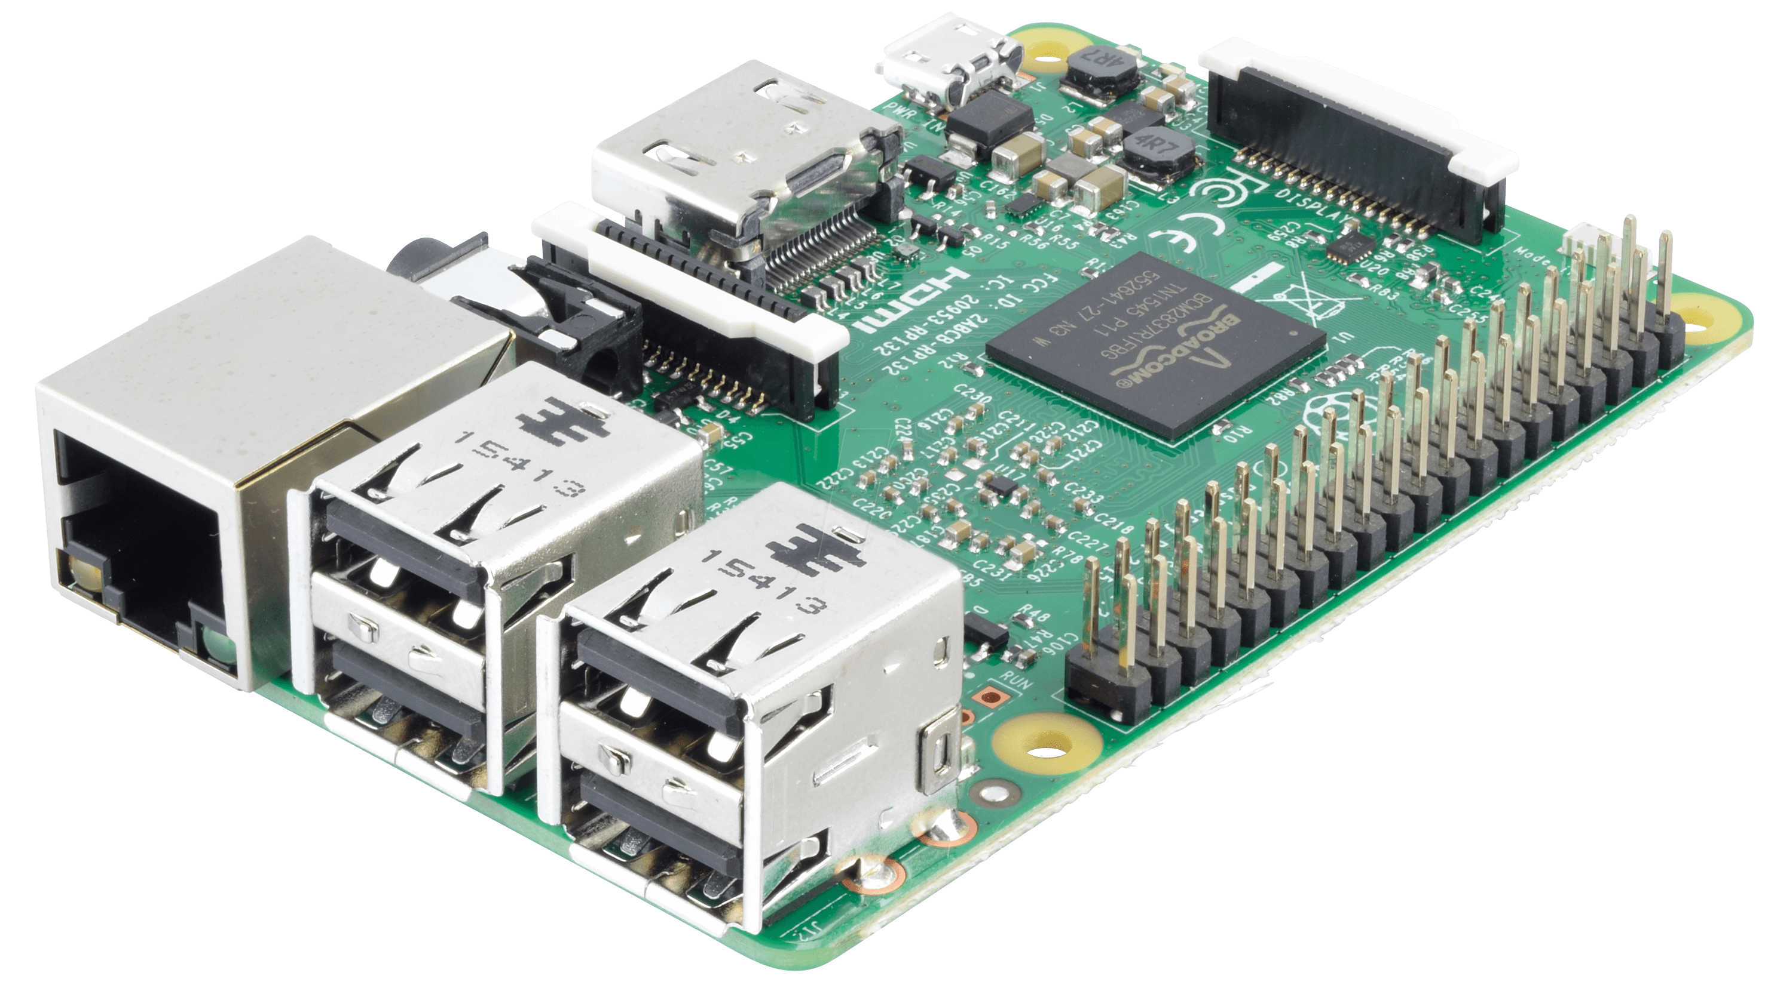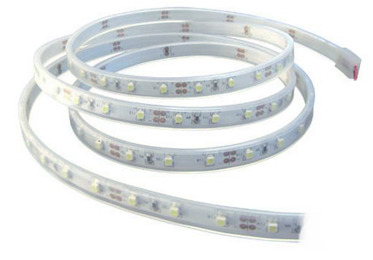

As shown above, the RaspberryPi chosen was the RaspberryPi 3 Model B. 2 generic pinball actuators and a simple digital RGB LED strip were also decided upon. Python code was written for the RaspberryPi to read the EEG data broadcast over the LSL stream and drive the 2 linear actuators and LED strips accordingly. After assembling the basic system components, the result was a functioning miniature pinball machine that could be driven via the wireless EEG headset. All written code was then documented and heavily commented such that future modification by children and students could be conducted easily.

# 8- Recommendations and Conclusions

Brain Computer Interface (BCI) project revealed hidden complexities in the way of interpreting brain signals as well as isolating them to act as triggers for any specific action. This brings about the importance of investigations in the field of signal processing and possible enhancements regarding the acquisition of brain signals (Electroencephalography techniques). Considering feedback, noticeable enthusiasm was observed among older age groups, too, that emphasises the viability of investments in mass production of such devices that can be accessible by everyone in the community and operated safely with no professional supervision. Huge benefits of a BCI must be evaluated in the long run where it would contribute to the formation of a social trend towards ground-breaking inventions in technology. Separate modules were developed in the process of implementation of the ideas throughout this project which added to the complexity and bulkiness of the final product. So, it sounds logical to move towards more light weight, compact and portable systems that can be carried around and taken to any environments the user wishes. The latter recommendation would significantly contribute to the role of BCI in neurology, the study of neurological disorders and understanding contributing factors as well as the nature of the diseases themselves, where constant data acquisition and monitoring is made possible under user consent and will. Moreover, as this device evolves, issues and concerns around ethics and how this invention is going to affect standards would arise. It is estimated that a crew consisting of IT, computer science, and Biomedical engineering professionals as well as experts in finance and accounting are required to make progress for future attempts.

In Conclusion, this endeavour was aimed to shed some light on the complexity of modern neurology to make it more appealing and understandable for the young generation who have the potential of becoming next masterminds of our digital future. The goal of sparking the interest in technology in the school aged children was achieved despite the changes in execution that had to be made along the way. Out of all imperfections that such an avantgarde approach may have, the necessity of the presence of a professional oversight as well as complicated apparatus were regarded as drawbacks which with the help of future advancements is hoped to be resolved.

# 10 - Final Reflections

# References