Group A Contract

This document outlines the expectations for the conduct of individuals within the group over the course of the project. All participating group members are expected to read this document, understand the expectations detailed within and sign the end as an acknowledgement of their commitment to act as a productive group member and abiding by the outlined expectations.

A three-strike formal warning system will be used in cases where individuals are not adhering to the standards of conduct as defined within this document. A formal warning will be issued to a group member should they fail to abide by the set standards. An example of this would be a group member being disrespectful to other members of the group. Further specifics on what can lead to a formal warning are outlined within each section. Should an individual receive three formal warnings they will be removed from the group.

# Behavioural expectations

All group members are expected to act in a professional and respectful manner towards other group members. The aim is to have productive environment where group members can work together towards the goals of the project without feeling threatened or unwelcome. If a group member is acting in a disrespectful manner towards another group member they will be issued a formal warning.

All members are expected to adhere to the academic standards as set by the university regarding submission of work and plagiarism. All members are also expected to respect the work conducted by other members of the group. A group member should not change the work done by another member without their permission and in the case that you are working on someone else’s section, do so in a copy so that you are not overriding any work that they have done.

# Methods of communication

The primary method of communication that will be used for this project is the VoIP service Discord which offers both text-based communication and VoIP as well as a variety of other functions. Group members are expected to check the server for updates so that they do not miss out on important information or questions involving them.

In the case that an individual is unreachable via Discord alternate communication methods may be used to contact the group member. These include but are not limited to university email and social media messaging services like Facebook.

Individuals who are excessively inactive on Discord for group communication may be issued with a formal warning.

# Expected work commitment

A member of the group working on this project is expected to spend an average of 9 hours per week working towards the projects goals. These 9 hours includes meeting and collaborative time outside of the 1 hour per week session on Fridays from 3pm-4pm which contribute towards the project.

It is understood that there are going to be weeks where individuals may not be able to dedicate as much time due to a number of reasons such as other subject’s assessment pieces and personal issues such as ill health. In these instances, it is expected that appropriate time is allocated either in weeks preceding or following to help ensure that the time spent working on the project remains at around 9 hours per week.

The hours that are worked should be documented within the Timesheet document within the Google Drive within the Minutes folder. Each person has their own tab within to document their hours worked along with a date, start and end time, and a description of the activity / work conducted during that time.

Members who neglect updating their timesheet page for extended periods of time will be issued a formal warning.

A Google Drive is being used as a central location for the uploading of files for the project as of the writing of this document. Further along the development timeline other methods of collaborative storage and version control for code may be utilized. The specifics of these services will be decided by the group during meeting times. Group members are expected to utilize these services to the best of their ability to allow for an easy to use development environment that all members can access.

# Expectations on meetings

Group members are expected to meet outside of the scheduled 1 hour per week session on Fridays from 3pm-4pm once per week. As of the creation of this document a meeting time of 1pm-3pm on Thursday has been allocated as a weekly meeting time. This time was chosen with all the group members schedules in mind, aiming to provide a common time that was suitable for all members. It is expected that all members are to attend this meeting time to help progress the project.

In the case that an individual is not able to physically attend the meeting they can use the VoIP service offered by Discord to call into the meeting to participate. Physical attendance to the scheduled meetings is preferable and excessive physical absence from meetings without appropriate reason discussed with the group may be met with a formal warning.

In the case that an individual is not able to attend the meeting due to other commitments or unexpected circumstances they should inform the group beforehand to the best of their ability. In the situation that the scheduled time no longer works for group members an internal discussion will be held to decide the best course of action.

Absence from a meeting without notice will be met with a formal warning, except in cases where an appropriate reason can be provided after the fact. This reason needs to be deemed acceptable by a majority of the group.

# Expectations on meetings

Sign on the provided spaces below once you have read and agreed to the expectations that have been outlined within this group work contract.

Date: 1/9/2018

Name: Timothy Finn Signature: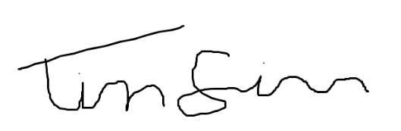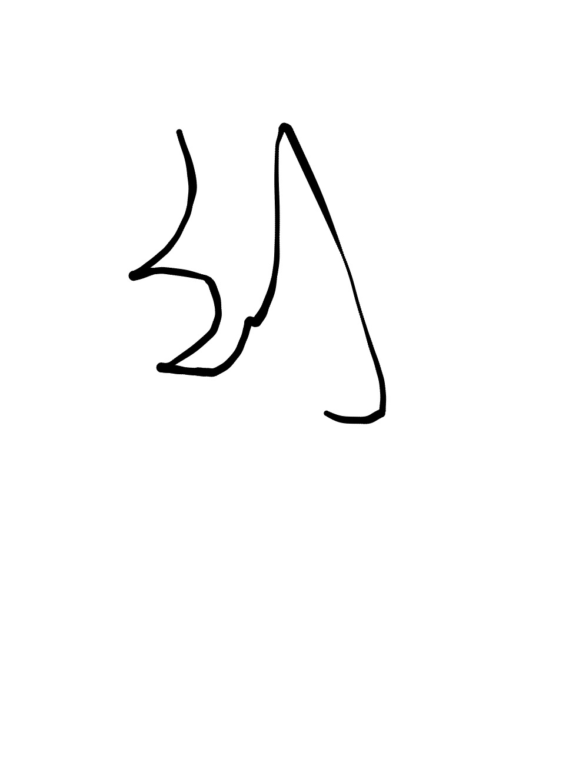

Name: Yeqing Liu Signature: 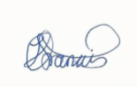

Name: Joshua Francis Signature:

Name: George Proios Signature: 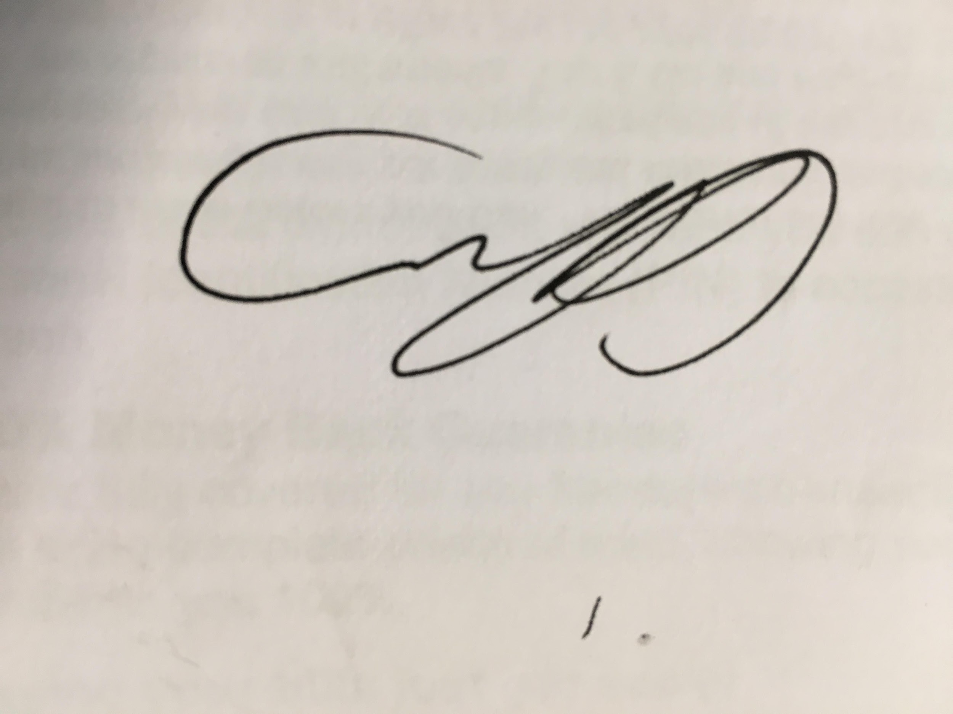

Name: Michael Douglas Signature: 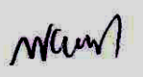

Name: ____________________________ Signature: ____________________________