ENGR3704 Project Management for Engineering and Science

1/08/2018

Brain Computer Interface

Project Specification

Author: FAN:

Joshua Francis Fran0464

Synopsis

The aim of this project is to develop a simple brain computer interface (BCI), that can be used to drive LED’s within a 3D printed brain. The key milestones produced in this project specification report are documentation of user requirements, system design and prototyping, testing, and prototype deployment. The main stakeholders in the project are the BCI Team Members, The Brain Signal’s Lab, and Trent Lewis. This project significantly contributes toward making the work of the Brain Signal Lab more accessible to the wider community, specifically school aged children. By doing so it will help make STEM engaging and fun to school aged children.

Contents

Table of Figures 2

1 - Executive Summary 3

2 – Introduction 4

3 - Project Overview 4

3.1 - Project Title 4

3.2 - Vision 4

3.3 - Organisation Objectives 4

3.4 - Scope 5

3.4.1 – Project Justification 5

3.4.2 – Product Characteristics and Requirements 5

3.4.3 – User Acceptance Criteria 5

3.4.4 – Summary of Project Deliverables 5

4 - Project Purpose and Problem Statement 6

5 - Assumptions and Constraints 6

5.1 - Assumptions 6

5.2 - Constraints 6

6 - Analysis of Options 7

6.1 - Option 1: Do Nothing 7

6.2 - Option 2: Pinball Machine 7

6.3 - Option 3: Maze 7

6.4 – Selection Criteria and Weightings 7

6.5 – Weighted Decision Matrix 8

6.6 - Preferred Option 8

7 - Work Plan 9

7.1 - Work Breakdown Structure (WBS) 9

8 - Outputs 11

8.1 - Milestone List 11

9 - Cost Estimate 11

10 - Implementation Strategy 13

10.1 - Gantt Chart 13

10.2 - Network Diagram 13

11 - Stakeholders Analysis 14

11.1 – Internal Stakeholders 14

11.2 – External Stakeholders 15

12 - Project Management Framework 16

12.1 - RACI Chart 16

12.2 - Quality Checklist 17

12.3 - Impact Matrix 17

12.4 – Communication Management Plan 17

12.4.1 – Communications Summary 18

12.4.2 – Communications Guidelines 18

References 19

Appendix 19

Meeting Minutes 19

# Table of Figures

Figure 1. Weighted Decision Matrix 8

Figure 2. WBS Hierarchy 9

Figure 3. WBS Diagram 10

Figure 4. Milestone List 11

Figure 5. Cost Estimates table 12

Figure 6. Gantt Chart 13

Figure 7. Network Diagram 13

Figure 8. Network Diagram key 13

Figure 9. Internal Stakeholders 14

Figure 10. External Stakeholders 15

Figure 11. RACI Chart 16

Figure 12. Impact Matrix 17

Figure 13. Communications Summary 18

# 1 - Executive Summary

In 2003, as a part of the Centre for Neuroscience and Medical Device Research Institute, a variety of specialists in the Neuroscience, Medicine, Computer Science, Engineering and Psychology fields came together to form the Brain Signal Lab (BSL). The primary objective for the BSL team is to investigate the behaviour of neurological diseases by using technology and machinery to analyse various signals generated from the brain. This process however involves an excessive amount of MATLAB coding and complex algorithms which, in most cases, can be very hard to explain to audiences with little knowledge in Computer Science.

The BSL team aims to create a simple yet interactive Brain Computer Interface (BCI) that utilizes electroencephalography technology to create an interesting model that will appeal to young childrem. In developing this program, the BSL team hopes to apply to a broader audience, mostly focussed on school aged children, to both engage students in neurological research and show the importance of this innovative technology.

In this project specification document, the selection and overview of an interactive, user friendly model will be explained in detail using a variety of project management techniques. These techniques are used to justify why the preferred option is chosen as well as the team management process and costs it would take to complete the project. Such techniques include conducting cost estimates, doing a stakeholder analysis and writing milestone lists which present information to be analysed about the proposed project in factual and numerical data.

# 2 – Introduction

This Specifications Report has been prepared to outline the details of the project we are undertaking for this topic. The project is in conjunction with Trent Lewis, the Brain Signal Lab (BSL) and the work they have been doing to develop ways to creatively display brain activity through Brain-Computer Interfaces (BCI’s) and the visualisation of them. One such way that is in development is using the changes in the brain’s Alpha rhythm to switch a Belkin WeMo light on or off. (Lewis, 2018)

The purpose of this is to demonstrate some fun and engaging BCI technologies to spark the interest of school age audiences into the area of brain and computer sciences as well as STEM as a whole.

This document goes into detail on the project itself and how we aim to achieve this goal. Through the gamification of the BCI technology into a pinball simulation, the target audience will find this approach more interactive and engaging.

# 3 - Project Overview

## 3.1 - Project Title

*Brain Computer Interface (BCI)*

## 3.2 - Vision

The *BCI* project aims to deliver a prototype and user manual of a Brain Computer Interface that will be tested amongst school aged children. Using an EEG helmet, signals of the brain will be interpreted through use of an opensource electronics development platform. Using software, those signals will be interpreted and used to display brain activity via LED’s within a 3D printed brain. The hope is that by using an interactive model, the children will be actively engaged and interested in the technology and STEM as a whole.

## 3.3 - Organisation Objectives

The *BCI* project aims to simplify existing technology developed by the Brain Signals Lab. To do so the *BCI,* project has been aligned as much as possible with the expectations of the Brain Signals Lab to be considered successful.

A successful project would dictate the completion of the *BCI’s* objectives of a working prototype and user guide. A working prototype and user guide would in turn, allow for that prototype to be introduced as an educational tool into schools. Thereby making the Brain Signals Labs research more accessible to a wider audience and achieving both organisations objectives.

## 3.4 - Scope

### 3.4.1 – Project Justification

The Brain Signal Lab at Flinders University has been endeavouring to create a Brain Computer Interface (BCI) to investigate the “neurological mechanisms of various neurological diseases using analytical and machine learning techniques” (Lewis, 2018). This project aims to design and test the functionality and plausibility of a head mounted BCI that allows for the technology to be demonstrated in a fun manner that could be presented to school children.

### 3.4.2 – Product Characteristics and Requirements

Experimentation and research is required into the different methods of BCI including the software that is required to the accommodate the simple interfacing of the BCI headset with external devices. The existing system consists of turning on and off a Belkin WeMo light via the detection of the subjects blinking eyes, using the EEG headset.  This could be expanded to other practical and common household appliances as well as making the technology appealing to youth.

The project’s aim is to produce a prototype that displays the communication between the EEG (Electroencephalography) headset and other desired appliances or peripherals in a manner that would be more accessible to a younger audience. In particular, a simple model will be created such that a younger audience can view their brain activity via the EEG headset at school science shows and fairs to assist in spreading interest in STEM fields throughout the younger community.

This prototype will require an EEG headset wirelessly connected to a computer (Laptop, RaspberryPi etc) and compatible peripherals (keyboard, mouse, monitor) that can be used to provide an alternative method of input. The model itself will consist of the 3D printed brain and a matrix of RGB LED’s.

### 3.4.3 – User Acceptance Criteria

The product will be considered successful if the prototype is delivered and shown to be an accurate representation of design and concept by the deadline (4/11/18).

### 3.4.4 – Summary of Project Deliverables

#### 3.4.4.1 – Product Related Deliverables

* “Prototype end-to-end BCI for demonstration purposes. A User Guide for the system such that it could be used to train those unfamiliar with BCIs to demonstrate the prototype.” (Lewis, 2018).
* Prototype system
* Prototype design
* Prototype software
* User manual

#### 3.4.4.2 – Project Management Related Deliverables

Scope Statement, Stakeholder Analysis, Gantt Chart, Team Meeting Minutes, Work Breakdown Structure, Milestone List, Network Chart, Project Cost Estimate, RACI, Quality Checklist, Probability Impact Matrix.

# 4 - Project Purpose and Problem Statement

The purpose of the *BCI* project is to make the research of the Brain Signals Lab more accessible to a wider community, with a focus on school aged children. Thereby making the STEM more engaging and fun to a younger audience.

Currently projects have been developed that allow a LED to be turned on and off through changes in the brains Alpha rhythm (Lewis, 2018). Due to the simple nature of turning a LED on and off, more engaging outputs are required to fully engage school students in the STEM area. This project will address this issue by looking at creative way of display brain activity.

With the sponsorship of Trent Lewis and the BSL team, we are going to attempt to develop a more engaging way to interact with BCI technology in the hopes of garnering more interest in STEM among school-aged children. The majority of our work will be done at the Flinders University Tonsley campus with the end product being deployed into schools to reach our target audience. Our timeframe is the duration of the Project Management topic, which is 5 weeks finishing on the 20th of August 2018.

# 5 - Assumptions and Constraints

## 5.1 - Assumptions

* The project team has the knowledge and capability to develop the solution internally.
* The solution is achievable using open-source software and platforms.
* All communications are well established between stakeholders.
* Different signal waveforms are distinguishable based on locality and intensity.
* There is no technical difficulty using current brain-computer interface hardware.
* No extra costs will be added.

## 5.2 - Constraints

* Open-source software is at the mercy of the developers and the community.
* Highly ranked stakeholders are heavily committed, so they might be hard to communicate with on time.
* Instructions might be hard for children to follow.
* Limited current signal processing capabilities.
* Signals might not be precisely repeatable.

# 6 - Analysis of Options

## 6.1 - Option 1: Do Nothing

Under the assumption that there is no market for the product or the current systems don’t require improvement. No changes necessary.

## 6.2 - Option 2: Pinball Machine

System setup includes an EEG helmet connected to a RaspberryPi. The RaspberryPi is then connected to an external computer monitor, a pushbutton will also be connected to the RaspberryPi.

An EEG helmet is placed on the subject’s head and connected to a RaspberryPi. Brain activity is then recorded via the RaspberryPi and is used to control a simulated pinball game displayed on an external monitor. The alterations in brainwave activity will be used to control the left and right flippers. The flippers are used to keep the ball in the game for as long as possible, the pushbutton is used to release the ball to start the game. This option can be further developed into a physical system using solenoids to control the flippers and a spring-loaded actuator to start the game.

This option is relatively simple to implement as it only requires the filtering of two distinct brainwave patterns to operate the game, further simplified by having the pushbutton to start the game.

## 6.3 - Option 3: Maze

System setup includes an EEG helmet connected to a RaspberryPi. The RaspberryPi is then connected to an external computer monitor.

An EEG helmet is placed on the user’s head and connected to the RaspberryPi. The RaspberryPi is then connected to an external monitor. The changing brainwave activity is used to control a simple character to navigate a maze. Four brainwave signals are required to control the user’s direction (forwards, backwards, left, and right).

This option is slightly more complex to implement as it requires the filtering of four distinct brainwave patterns to operate the game, it however does eliminate the need for a pushbutton.

## 6.4 – Option 4: Brain Activity Model

System setup includes an EEG helmet wirelessly connected to a RaspberryPi. The RaspberryPi is then connected to an RGB LED matrix installed within the brain model.

The EEG helmet will then be placed on the subject’s head. The changes in brainwave activity will then be displayed via the LED’s in various ways including heat maps displaying localised activity and intensity displaying the most active parts of the brain.

## 6.5 – Selection Criteria and Weightings

To assist in choosing the best option, a weighted decision matrix will be utilised. The following criteria will be assigned weights as percentages based on their importance regarding the implementation of the BCI system. The criteria and associated weights are as follows.

* **Functionality**: How well the system will perform. 25%
* **Cost**: How much the components will cost. 20%
* **Simplicity**: How simple the choice will be to implement. 20%.
* **Interest Factor:** How interesting the children will find the product. 35%

## 6.6 – Weighted Decision Matrix

Figure 1 shows the decision matrix used to choose the most appropriate project based on the criteria and associated weights derived in section 6.4.

|  |  |  |  |  |  |
| --- | --- | --- | --- | --- | --- |
| Criteria | Weight | Nothing | Pinball Machine | Maze | Brain |
| Functionality | 25% | 0 | 90 | 60 | 95 |
| Cost | 20% | 0 | 50 | 60 | 50 |
| Simplicity | 20% | 0 | 80 | 50 | 85 |
| Interest Factor | 35% | 0 | 70 | 90 | 90 |
| Total | | **0** | **73** | **68.5** | **82.25** |

Figure 1. Weighted Decision Matrix

## 6.7 - Preferred Option

The preferred option is option 4, the brain model, as it’s the simplest to implement, relatively cheap and will result in the most functional system.

# 7 - Work Plan

## 7.1 - Work Breakdown Structure (WBS)

*Figures 2* and *3* demonstrate the projects Work Breakdown Structure (WBS). The WBS shows distinct modules that are then broken down into individual tasks. A summary of the individual modules can be seen as follows.

1. *Concept*
   1. Requirements
      1. System
      2. User
      3. Project Clearance
2. *Design*
   1. Software
   2. Hardware
      1. Conceptual
      2. Logical
      3. Physical
3. *Development*
   1. Construct Physical System
   2. Construct System Software
4. *Testing*
   1. Component Test
   2. System Test
5. *Implementation*
   1. Deploy Project
   2. Training
6. *Project Evaluation*
   1. Conduct Review Surveys
   2. Make Suggested Changes
7. *Project Maintenance/Support*

Figure 2. WBS Hierarchy

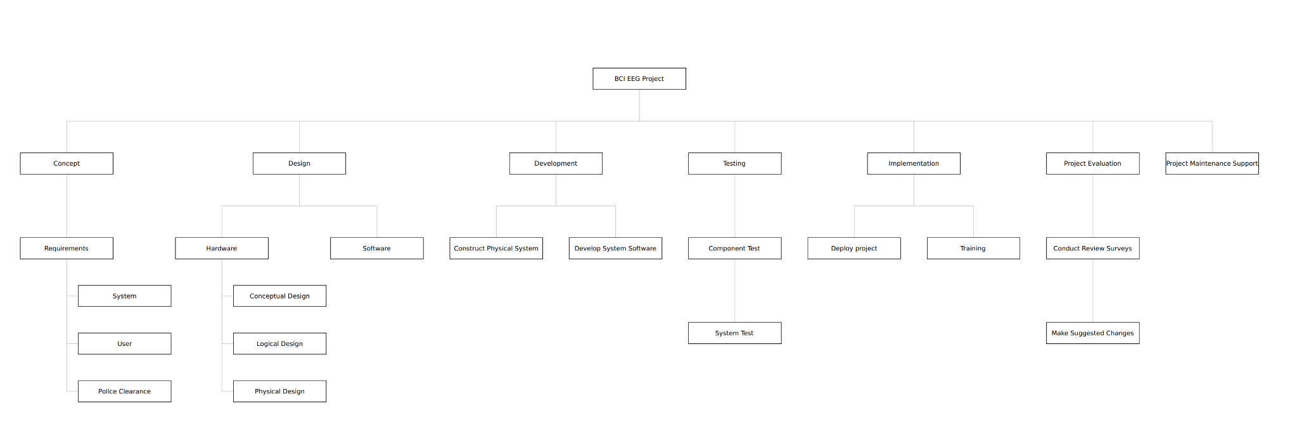Figure 3. WBS Diagram

# 8 - Outputs

## 8.1 - Milestone List

In *Figure 4* a list of milestones corresponding to the WBS list for the BCI project is displayed in chronological order. Each of the given milestones has been provided with an estimated date of completion.

|  |  |
| --- | --- |
| Milestone | Estimated Completion |
| Completion of Conceptualisation Stream | 30/07/2018 |
| Completion of System Design | 06/08/2018 |
| Physical System Construction | 13/08/2018 |
| Completion of Software Development | 24/09/2018 |
| Completion of Testing Phase | 08/10/2018 |
| Project Deployment | 15/10/2018 |
| Project Evaluation | 22/10/2018 |

## 

Figure 4. Milestone List

# 9 - Implementation Strategy

## 9.1 - Gantt Chart

*Figure 6* shows a Gantt Chart that outlines the estimated duration of each stage in the development and the predicted start and finish dates of each individual task as well as the predicted completion date of the entire project.

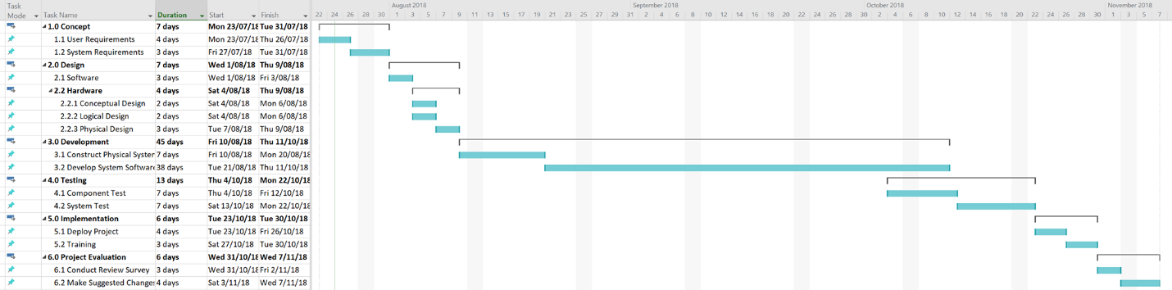

Figure 6. Gantt Chart

## 9.2 - Network Diagram

The network diagram is depicted in *Figure 7.* Tasks are pinned on arrows with expected number of days to carry out and nodes define the start and end for each task. Tasks are defined by a key shown in *Figure 8*.

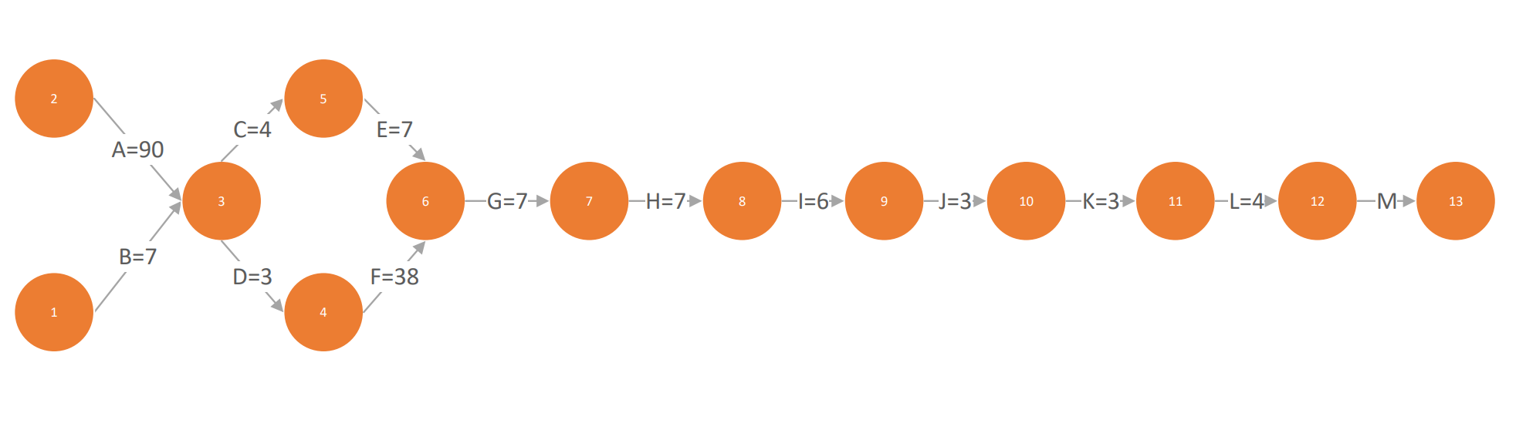

Figure 7. Network Diagram

|  |  |  |  |
| --- | --- | --- | --- |
| Network Diagram Key | | | |
| A | Clearance | **H** | System Testing |
| B | Concept | **I** | Implementation |
| C | Hardware design | **J** | Training |
| D | Software design | **K** | Feedback |
| E | Hardware development | **L** | Modification |
| F | Software development | **M** | Deliverance |
| G | Component Testing |  |  |

Figure 8. Network Diagram key

# 10 - Stakeholders Analysis

The Stakeholder Analysis, shown in *Figures 9* and 10, is divided into 2 sections (Internal Stakeholders and External Stakeholders). The Internal Stakeholders figure outlines all entities directly involved in any stage of the development of the project. Conversely, the External Stakeholders figure outlines all entities involved with the project from an external point of view, i.e. end users, government etc.

## 10.1 – Internal Stakeholders

|  |  |  |  |  |  |
| --- | --- | --- | --- | --- | --- |
| Stakeholder Name | Role on project | Impact | Organisation | Level of Influence | Suggestions |
| BSL | Research Group | Very High | Centre of Neuroscience and Medical Device Research Institute | Very High | Consult regarding equipment acquisition and project specifications |
| Trent Lewis | Head of project | Very High | Flinders University, Tonsley 3.26, (08) 8201 3867 | Very High | Keep up to date with current project status |

Figure 9. Internal Stakeholders

## 10.2 – External Stakeholders

|  |  |  |  |  |  |
| --- | --- | --- | --- | --- | --- |
| Stakeholder Name | Organisation(s) | Description | Level of Interest | Level of Influence | Suggestions |
| Suppliers | Flinders University, Element 14, Redarc, Sage Automation, FED EX, NeuroScan, Brain Products | Provide materials and resources for project | Medium | Medium | Spend time researching various suppliers to obtain lowest potential costs. |
| Government | Hospitals,  Education Sector |  | High | High | Communicate with variety of Government departments to determine project applicability and steps required for implementation |
| End Users | Children, Students. |  |  | High | Discuss and communicate with end users to determine the applicability, ease of use and all other aspects of the project design |

Figure 10. External Stakeholders

# 11 - Project Management Framework

## 11.1 - RACI Chart

*Figure 11* depicts the Responsible, Accountable, Consulted and Informed (RACI) chart. This chart details which of the internal stakeholders are responsible/accountable or should be informed/consulted regarding any of the tasks needed to complete the project.

|  |  |  |  |
| --- | --- | --- | --- |
| Task | Brain Signal Lab | | Trent Lewis |
| Project Maintenance Support | | I | I |
| Project Evaluation | | R A | R A |
| Conduct Review Surveys | | I | I |
| Make Suggested Changes | | I | I |
| Implementation | | C | C |
| Deploy project | | I | I |
| Training | | I | I |
| Testing | | I | C |
| Component Test | | I | I |
| System Test | | I C | I |
| Development | | C | C |
| Construct Physical System | | C | I |
| Develop System Software | | C | I |
| Design | | C | I |
| Hardware | | C | I |
| Conceptual Design | | I | I |
| Logical Design | | I | I |
| Physical Design | | C | I |
| Software | | C | I |
| Concept | | R A | I |
| Requirements | | R A | I |
| System | | R A | I |
| User | | C | C |
| Police Clearance | | I | I |

Figure 11. RACI Chart

## 11.2 - Quality Checklist

Below is the Quality Checklist to be completed upon the final development of the product. The checklist ensures the product meets the appropriate quality standards before being deployed into an environment where children will interact with the product.

* Test and tag power supplies and relevant power cables for RaspberryPi.
* Test nominal operating voltages of RaspberryPi.
* Test nominal operating temperatures of RaspberryPi.
* Test connectivity between RaspberryPi, LED matrix and EEG headset.
* Test model to ensure inputs from EEG headset are read correctly.
* Test LED’s to ensure correct functionality.
* Train relevant operators to set up the equipment and diagnose simple operational problems.
* Acquire feedback from operators regarding equipment operation and implement suggested changes if possible or feasible.

## 11.3 - Impact Matrix

*Figure 12* shows the Impact Matrix for the BCI project. The Impact Matrix outlines the various risks present throughout the development of the BCI system and their associated probability and impact. This information is then used to construct the matrix such that the severity of various risks and their associated impacts can be easily visualized.

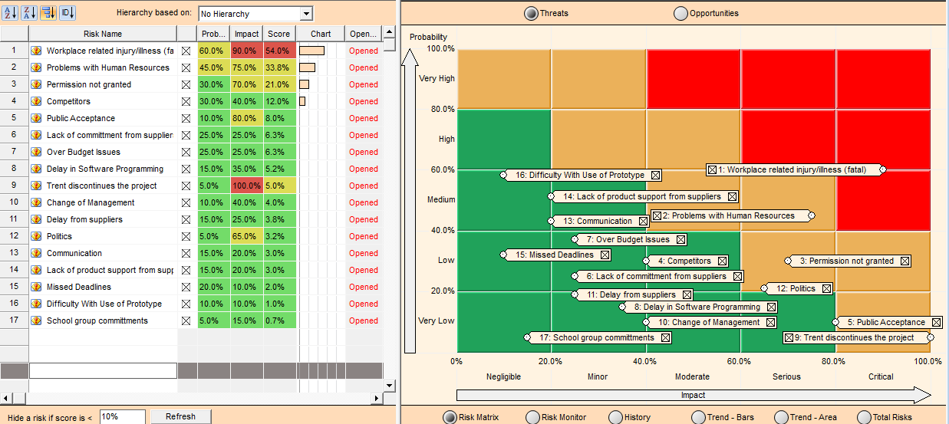

Figure 12. Impact Matrix

## 11.4 – Communication Management Plan

The communication plan outlines the communication methods to be used between the various project stakeholders, both internal and external. *Figure 13,* shown below, details the frequency and types of communication to occur between the various stakeholders.

### 11.4.1 – Communications Summary

|  |  |  |  |
| --- | --- | --- | --- |
| Stakeholder | Type of Communication | Producer | Frequency |
| Project Team Members | Physical Meetings | Project Team Manager | Weekly |
| Sponsor | Email | Project Team Manager | Weekly |
| Trent Lewis | Physical Meetings | Project Team Manager | Weekly |
| Suppliers | Email | Suppliers | Weekly |
| End Users | Physical Meetings | End Users | Weekly |
| System Operators | Email | System Operators | Weekly |

Figure 13. Communications Summary

### 11.4.2 – Communications Guidelines

The communication guidelines detail the communication hierarchy that should be adhered to regarding project issues and communication with the various project stakeholders.

* Any issues within the project development team regarding project design and development should be brought to the attention of the project team manager as soon as possible. This information should be conveyed in person.
* All project relevant documents should be hosted on the relevant google drive directory as provided by the project team manager.
* Any necessary communication with external stakeholders should be directed either through the project team manager or Trent Lewis.

# References

Lewis, T., 2018. *Information Technology Projects,* Adelaide: Flinders Uninversity.