SAUMITRA TIWARI
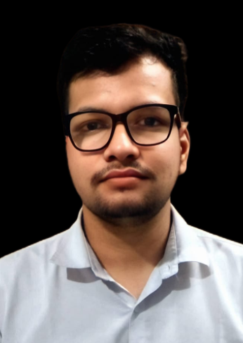
MCA – FULL STACK WEBDEVELOPER INDORE (M.P) | +91 9685332030
saumitratiwari138@gmail.com
PORTFOLIO - http://saumitra.unaux.com/#portfolio

OBJECTIVE

• Aspiring Full Stack Web Developer seeking an opportunity to leverage my passion for coding and problem-solving skills to contribute to dynamic and innovative web development projects. Eager to apply my solid foundation in front-end and back-end technologies, along with my enthusiasm for creating responsive and user-friendly applications, to drive seamless user experiences and contribute to the growth of a forward-thinking team

• Proficient in HTML5, CSS3, and JavaScript, with a focus on building modern, interactive, and visually appealing user interfaces.
• Familiarity with front-end frameworks like React enabling the creation of dynamic and efficient single-page applications.
• Hands-on experience with server-side technologies such as Node.js allowing for the development of robust and scalable back-end systems.
• Knowledge of database management using SQL and experience working with databases like MySQL to ensure data integrity and efficient retrieval.
• Skilled in version control and collaborative development using Git and GitHub, facilitating seamless teamwork and efficient code management.
• Strong problem-solving abilities demonstrated through successful troubleshooting and debugging of code to enhance application functionality.
• Adept at responsive web design principles, ensuring applications function seamlessly across various devices and screen sizes.
• Enthusiastic about staying updated on industry trends and emerging technologies to continuously enhance skills and contribute innovative ideas.

SKILLS

• HTML5
• CSS
• JAVASCRIPT
• REACT
• GIT AND GITHUB
• DATABASE ( MYSQL)
• BACK-END – (NODE.JS)

EDUCATION

PARUL UNIVERSITY | VADODARA, GUJARAT
MCA | 05/2024 CGPA – 7.5 / 10
PURSUING MY DREAM TO BE A FULL STACK WEB DEVELOPER

DHSGSU (CENTAL UNIVERSITY M.P) | SAGAR, MP
BCA | 05/2021 CGPA - 7.6 /10
TOOK 1 YEAR DROP FOR PREPARATION OF NIMCET

KIDS ACADMEY HIGHER SC SCHOOL | SAGAR, MP
12TH CLASS | 2018 CGPA - 6.75 / 10

PARAS VIDYA VIHAR | SAGAR, MP
10TH CLASS | 2016 CGPA - 6.00 / 10

INTERNSHIP

STEPS SOFTWARE SOLUTION & COMPUTER EDUCATION STUDY CENTRE CODE – 6217
KEY SKILLS – HTML, CSS, JAVASCRIPT, MACHINE LEARNING
• WORKED ON RELEVANT PRACTICAL PROJECTS ON EMERGING TECHNOLOGIES LIKE JAVASCRIPT, CSS AND HTML TECHNOLOGY UNDER STEPS SOFTWARE SOLUTION
• COMPLETED THE PROJECT UNDER MENTORING FROM EXPERTS OF STEPS SOLUTION
• SUBMITTED THE PROJECT SYNOPSIS AND DETAILED REPORT WITHIN THE STIPULATED TIMELINE.
• I HAVE DONE "GOVERNMENT CERTIFICATE PORTAL" PROJECT UNDER THE GUIDANCE OF MENTOR

PROJECTS

- GOVERNMENT CERTIFICATE PORTAL
MENTOR: PRASHANT TOMAR | TEAM SIZE:1
KEY SKILLS - HTML, CSS, JAVASCRIPT, MACHINE LEARNING
THIS IS A PORTAL THAT PROVIDE ALL GOVERNMENT CERTIFICATIONS AT A SINGLE PLATFORM
SO THAT THE ACESS OF DIFFRENT CERTIFICATIONS CAN BE PROVIDED EASLY

- HOSPITAL CONNECTING WEBSITE
KEY SKILLS – HTML, CSS, JAVASCRIPT
A HOSPITAL CONNECTING WEBSITE IS A WEB PLATFORM DESIGNED TO FACILITATE COMMUNICATION, COORDINATION, AND INFORMATION SHARING BETWEEN VARIOUS STAKEHOLDERS WITHIN THE HEALTHCARE ECOSYSTEM, INCLUDING PATIENTS, HEALTHCARE PROVIDERS, HOSPITALS, CLINICS, AND OTHER HEALTHCARE ORGANIZATIONS. THE MAIN GOAL OF SUCH A WEBSITE IS TO IMPROVE THE OVERALL HEALTHCARE EXPERIENCE AND PATIENT OUTCOMES BY STREAMLINING COMMUNICATION AND ACCESS TO MEDICAL RESOURCES.

WEBLINKS

Saumitratiwari138@gmail.com
2205112110142@paruluniversity.ac.in

PERSONAL INFORMATION

GENDER: MALE
DATE OF BIRTH: 30 MAY 2000
MARITIAL STATUS: SINGLE
KNOWN LANGUAGE: ENGLISH, HINDI.
CURRENT ADDRESS: AT SNEH NAGAR COLONY,
MADHUKAR SHAH WARD, SAGAR (MP)
PIN CODE: 470002

