**CA3 CAP 807**

**SAUMYA GUPTA**

**REGISTRAION NUMBER**

**12113761**

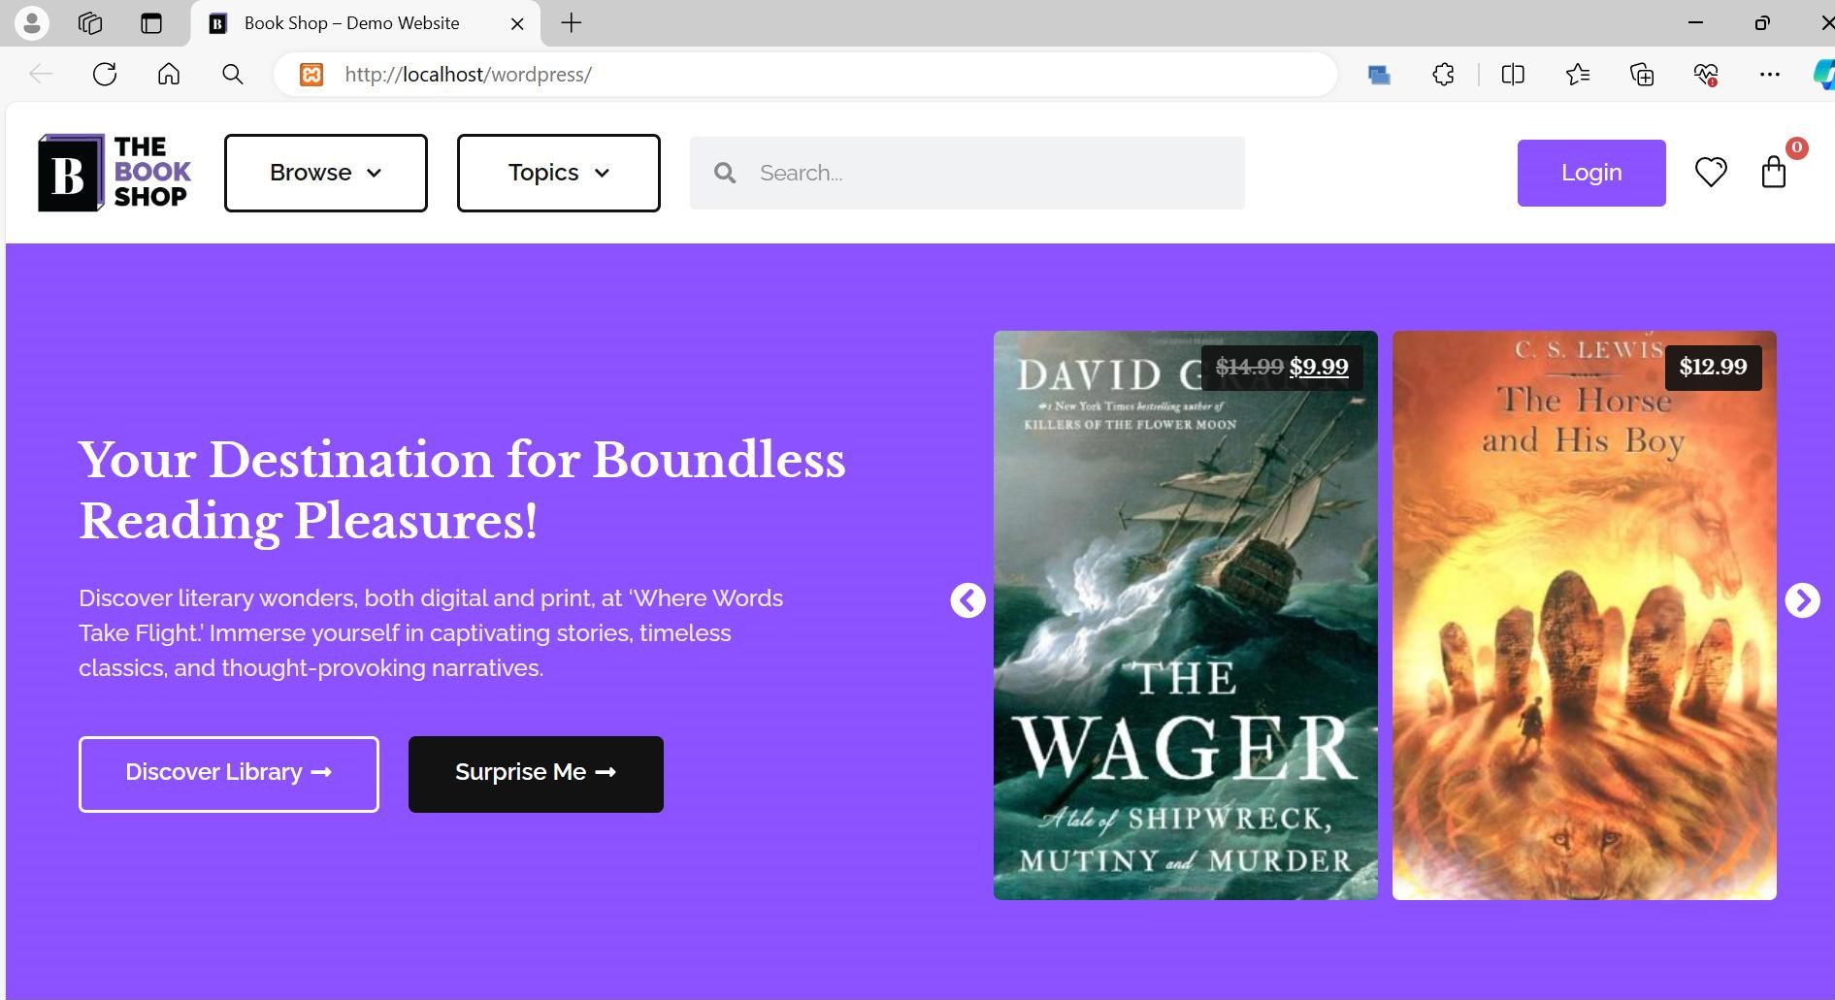



x

|  |  |  |
| --- | --- | --- |
| Explore Categories  Explore our library of books by category to find the books you are looking for. |  |  |
| Biography Business Children | Comics | Education |
| Historical Novels Politics | Religion | Technology |

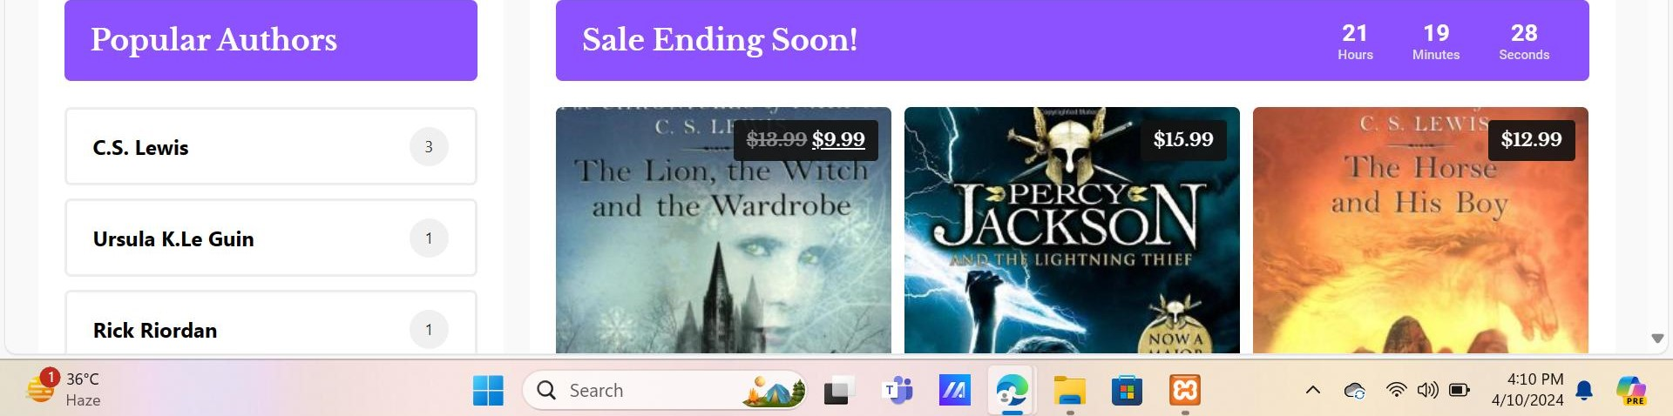

x



|  |  |  |  |  |  |
| --- | --- | --- | --- | --- | --- |
| |  |  | | --- | --- | |  | Novels |     The Wager  by David Grann | O SciFi & Fantasy    Our Missing Hearts  by Celeste Ng | Education Biographies    Horse a Novel  by Geraldine Brooks | Business    AWizard of Earthsea  by Ursula K.Le Guin |





and thoughtful critiques, and embark on a journey of captivating stories waiting to be explored.

John Doe

Traveler

Read Our Publications!

We write regular articles for book readers. Guides, Lists, Tips, and Information. You can read more of them on the blog page.



Time Travel Through Pages: Exploring Tech Tales: Exploring the Intersection of Unleashing Imagination: The Magical

History's Rich Tapestry in Books Books and Technology World of Books for Kids



June 27. 2023 / No Comments

Lorem ipsum dolor sit amet, consectetur adipiscing elit.

Nunc feugiat a risus eu euismod. Ut

Read Article »

June 27. 2023 / No Comments

Lorem ipsum dolor sit amet, consectetur adipiscing elit.

Nunc feugiat a risus eu euismod. Cit

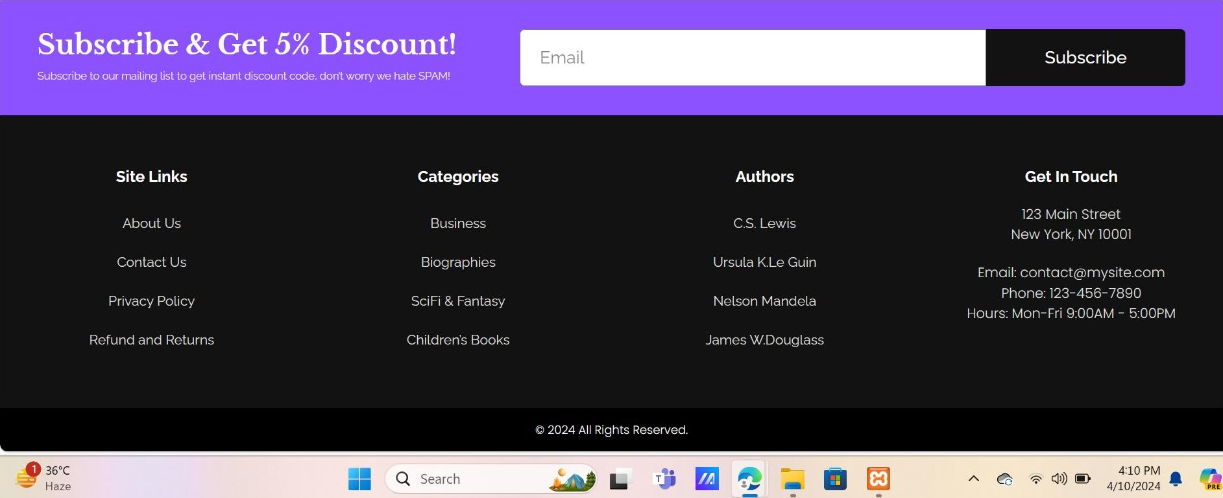Read Article »

June 27. 2023 / No Comments

Lorem ipsum dolor sit amet, consectetur adipiscing elit.

Nunc feugiat a risus eu euismod. Ut

Read Article »