CAPSTONE PROJECT REPORT
Best Buy Automation | Selenium Testing Report

Name | Saumy Singh
Superset ID | 4959462
Project Type | Capstone Project
Project Name | Best Buy Automation Testing using Selenium PyTest and Behave BDD Framework
Domain | E-Commerce
Module Title | Deal of the Day

PROJECT DESCRIPTION

This project automates the Best Buy web application using Selenium WebDriver with Python. The automation framework covers the Deal of the Day module on the Best Buy e-commerce platform, validating deal navigation, product selection, cart operations, checkout flows, and email validation using both Selenium PyTest and Behave BDD frameworks.
The framework is designed using the Page Object Model (POM) architecture to improve maintainability and reusability. Screenshots, logs, Allure reports, and reusable utilities are integrated to support execution tracking and debugging. The project includes both positive and negative testing scenarios using industry-standard automation testing practices.

PART 1 — SELENIUM PYTEST FRAMEWORK

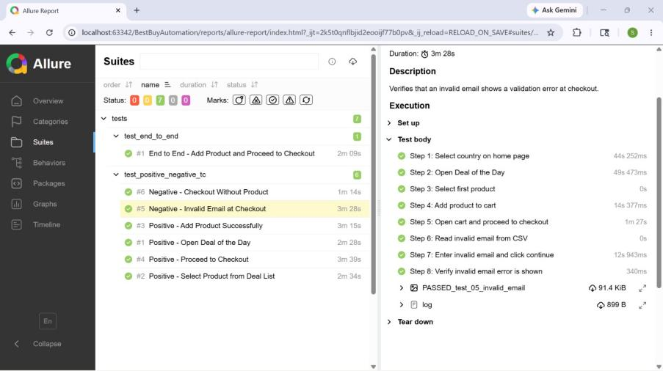
Fig-1: Selenium PyTest Framework

1.1 Test Strategy
The Selenium PyTest framework automates the Best Buy Deal of the Day module using Selenium WebDriver with Python PyTest. The framework validates deal page navigation, product selection, cart operations, checkout flow, and email validation including negative cases for invalid email input and empty cart checkout. It supports End-to-End, Positive, and Negative testing with CSV-based data-driven test data.
Allure Reports are integrated for professional execution reporting with screenshot evidence and detailed execution logs.

Tools Used:
- Selenium WebDriver
- PyTest
- Allure Reports
- Python Logging Module
- Screenshot Utility

1.2 Test Environment
Operating System | Windows 11
IDE | PyCharm
Browser | Google Chrome
Framework | Selenium + PyTest
Design Pattern | Page Object Model (POM)
Reporting Tool | Allure Reports
Language | Python 3.12.2

1.3 Framework Architecture
BestBuyAutomation/
├── conftest.py
├── requirements.txt
├── pytest.ini
├── config/
│ └── config.properties
├── data/
│ └── test_data.csv
├── pages/
│ ├── base_page.py
│ ├── home_page.py
│ ├── deal_of_day_page.py
│ ├── cart_page.py
│ ├── checkout_page.py
│ └── product_page.py
├── tests/
│ ├── test_positive_negative_tc.py
│ └── test_end_to_end.py
├── utils/
│ ├── logger.py
│ ├── screenshot_util.py
│ ├── csv_reader.py
│ └── config_reader.py
├── logs/
│ └── automation.log
└── reports/
├── screenshots/
├── allure-results/
└── allure-report/

1.4 Test Execution

End-to-End Test
The End-to-End test validates the complete Best Buy Deal of the Day workflow. Starting from the home page, the test selects the user's country, navigates to the Deal of the Day page, selects the first product, adds it to the cart, navigates to the cart, proceeds to checkout, reads a valid email from the CSV data file, enters the email, and asserts that the checkout or sign-in page is reached successfully.

Positive and Negative Tests
The positive test cases validate: opening the Deal of the Day page, selecting a product from the deal list, adding a product to the cart, and proceeding to checkout. The negative test cases validate: invalid email input at checkout displaying a validation error message, and navigating to the cart without adding any product detecting an empty cart state.

1.5 Test Case Summary — Selenium PyTest
S.No | Test Type | Test Scenario | Expected Result | Status
1 | End-to-End | End to End - Add Product and Proceed to Checkout (Deal of Day → Cart → Checkout → Email) | Checkout/sign-in page reached after email entry | Passed
2 | Positive | Open Deal of the Day | Deal of the Day page displayed successfully | Passed
3 | Positive | Select Product from Deal List | Product details page displayed after selection | Passed
4 | Positive | Add Product Successfully to Cart | Cart is not empty after adding product | Passed
5 | Positive | Proceed to Checkout | Checkout page opens after cart navigation | Passed
6 | Negative | Invalid Email at Checkout (from CSV) | Validation error displayed for invalid email | Passed
7 | Negative | Checkout Without Product (Empty Cart) | Empty cart detected and confirmed | Passed

1.6 Test Outputs & Screenshots

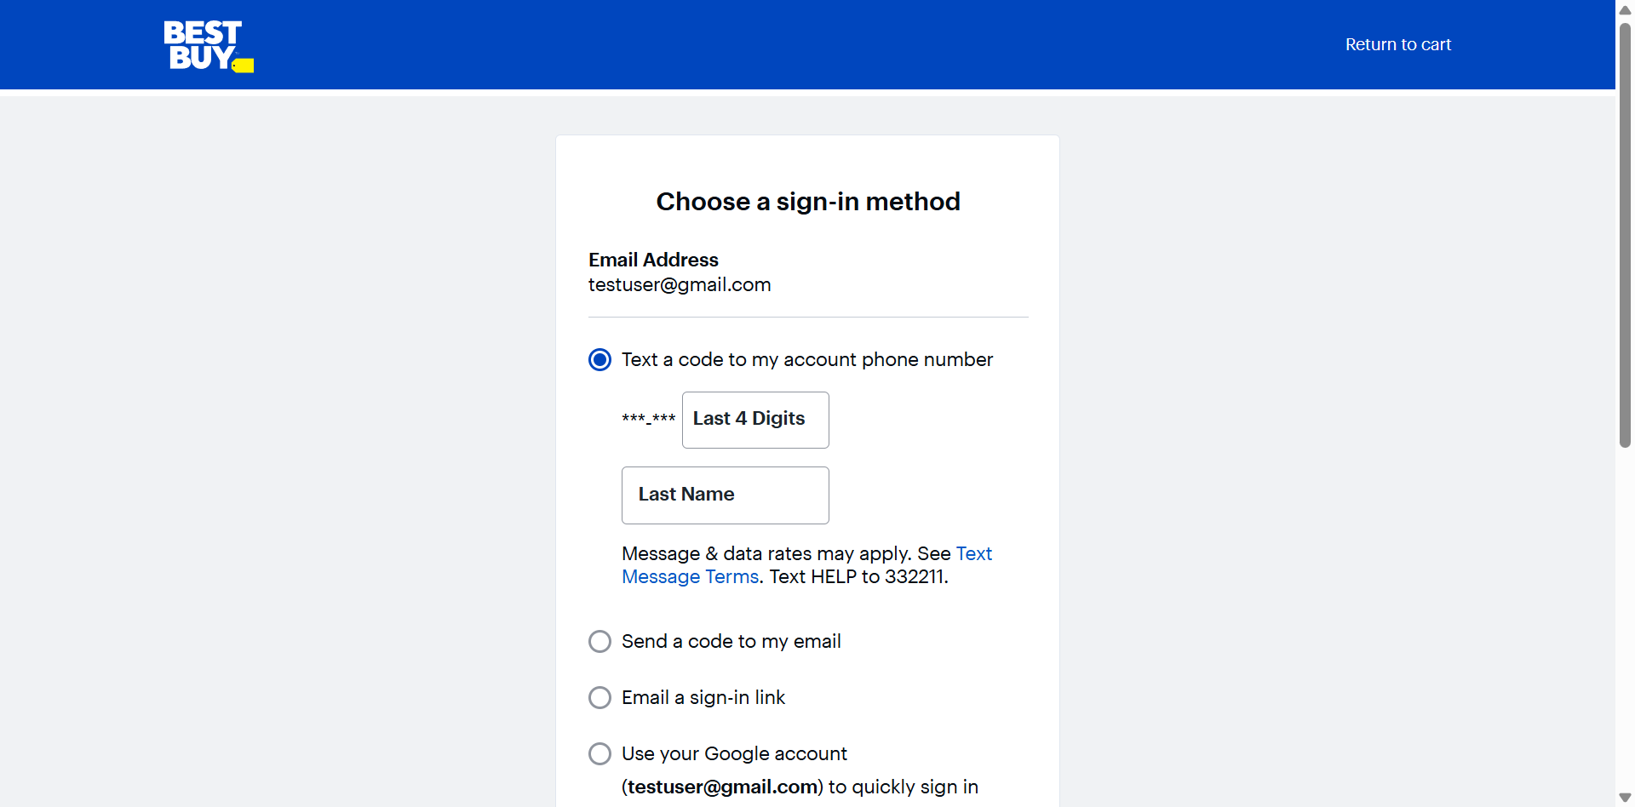
Fig-2 [PyTest] End-to-End Test — Checkout Page Reached

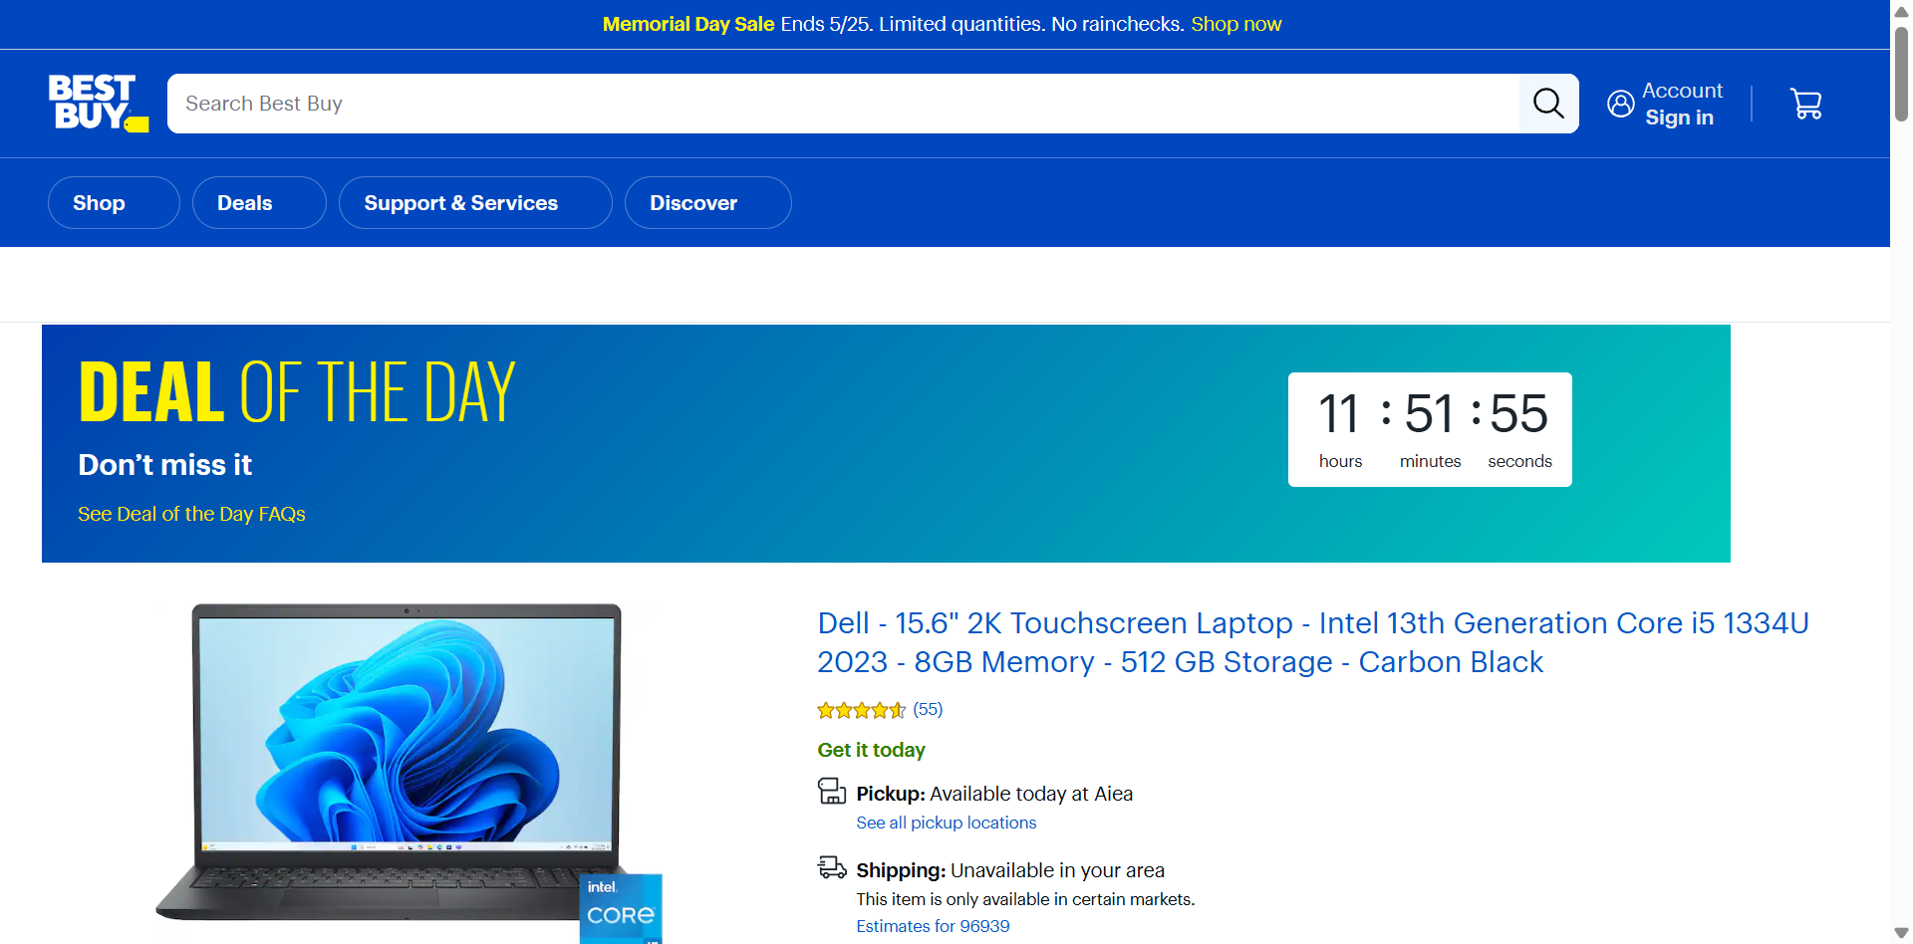
Fig-3 [PyTest] TC01 — Deal of the Day Page Opened

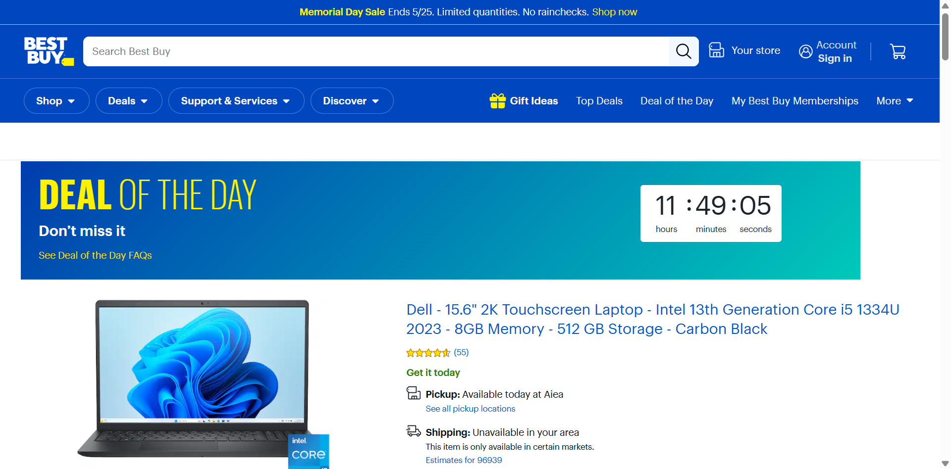
Fig-4 [PyTest] TC02 — Product Selected from Deal List

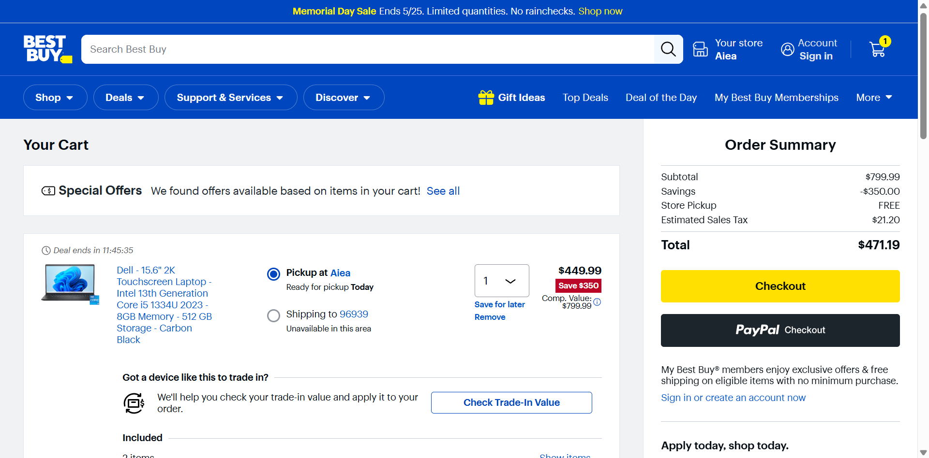
Fig-5 [PyTest] TC03 — Product Added to Cart

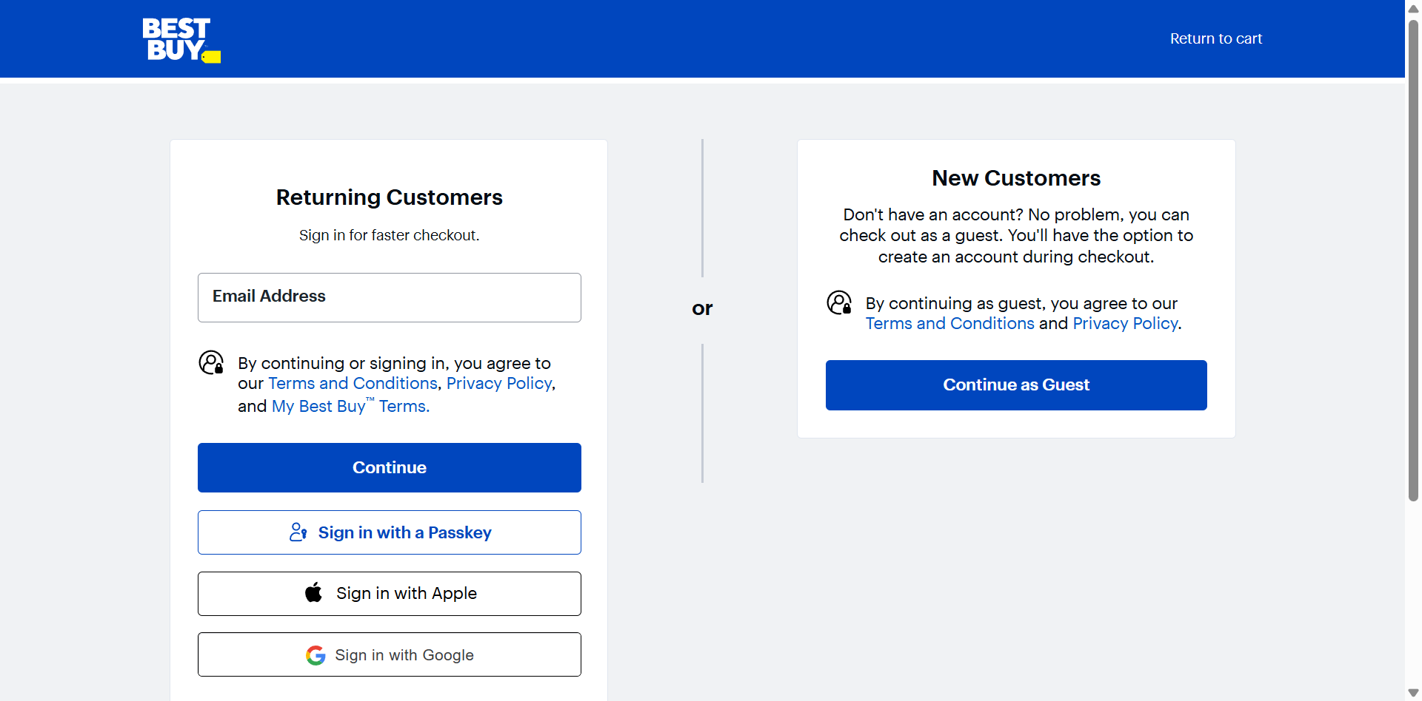
Fig-6 [PyTest] TC04 — Checkout Page Displayed

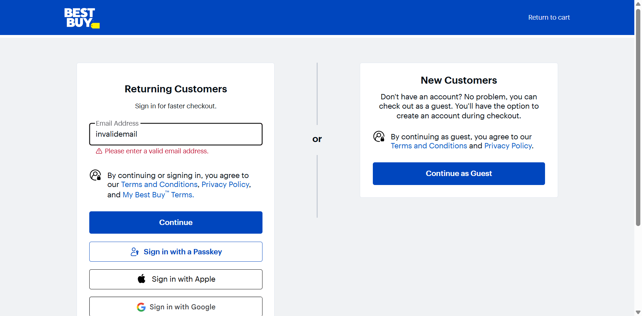
Fig-7 [PyTest] TC05 — Invalid Email Validation Error

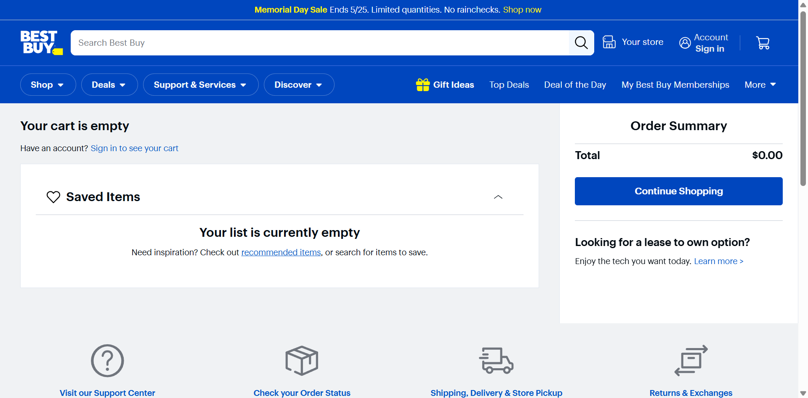
Fig-8 [PyTest] TC06 — Empty Cart Detected

1.7 Allure Report — Selenium PyTest
Allure Reports are integrated with the Selenium PyTest framework to generate professional execution reports. The reports display passed status, capture screenshots at key execution stages, and attach per-test logs for debugging.


Fig-9 [PyTest Allure] TC01 — Open Deal of the Day


Fig-10 [PyTest Allure] TC02 — Select Product from Deal List


Fig-11 [PyTest Allure] TC03 — Add Product to Cart


Fig-12 [PyTest Allure] TC04 — Proceed to Checkout


Fig-13 [PyTest Allure] TC05 — Invalid Email at Checkout


Fig-14 [PyTest Allure] TC06 — Checkout Without Product


Fig-15 [PyTest Allure] End-to-End Test Passed

1.8 Test Report Summary — Selenium PyTest
Total Tests Executed | 7
Tests Passed | 7
Tests Failed | 0
Automation Accuracy | 100%

1.9 Conclusion — Selenium PyTest
The Selenium PyTest automation framework successfully validates the Best Buy Deal of the Day module using End-to-End, Positive, and Negative testing approaches. The framework leverages Selenium WebDriver, PyTest, Page Object Model, Allure Reporting, Logging Framework, and Data-Driven Testing with CSV. All 7 test cases executed successfully with professional reporting, screenshot capture, and detailed execution logs demonstrating automation accuracy of 100%.

PART 2 — SELENIUM BDD BEHAVE FRAMEWORK

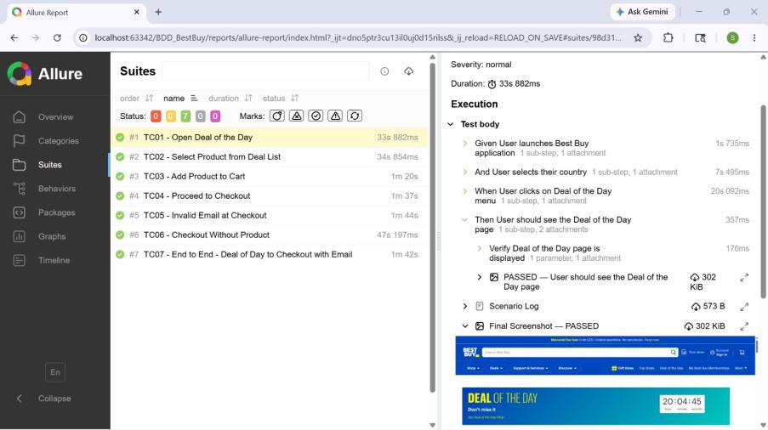
Fig-16: Selenium BDD Behave Framework

2.1 Test Strategy
The Selenium Behave BDD framework automates the Best Buy Deal of the Day module using Behavior Driven Development methodology. Test scenarios are written in Gherkin syntax using Given-When-Then structure, making them readable by both technical and non-technical stakeholders. The framework validates the full deal-to-checkout flow expressed as business-readable feature files.
Allure Reports are integrated with the Behave formatter to generate professional execution reports with per-scenario screenshot evidence and isolated log attachments.

Tools Used:
- Selenium WebDriver
- Behave BDD Framework
- Allure Reports (allure-behave)
- Python Logging Module

2.2 Test Environment
Operating System | Windows 11
IDE | PyCharm / VS Code
Browser | Google Chrome
Framework | Selenium + Behave BDD
Design Pattern | Page Object Model (POM)
Reporting Tool | Allure Reports
Test Approach | Behavior Driven Development (BDD)
Language | Python 3.12.2

2.3 Framework Architecture
BDD_BestBuy/
├── behave.ini
├── requirements.txt
├── runtests.py
├── config/
│ └── config.ini
├── data/
│ └── test_data.csv
├── features/
│ ├── deal_of_day.feature
│ ├── end_to_end.feature
│ ├── environment.py
│ └── steps/
│ └── deal_of_day_steps.py
├── locators/
│ └── bestbuy_locators.py
├── pages/
│ ├── base_page.py
│ ├── home_page.py
│ ├── deal_of_day_page.py
│ ├── cart_page.py
│ ├── checkout_page.py
│ └── product_page.py
├── utils/
│ ├── logger.py
│ ├── screenshot_util.py
│ ├── csv_reader.py
│ ├── waits.py
│ └── config_reader.py
├── logs/
│ └── automation.log
└── reports/
├── screenshots/
├── allure-results/
└── allure-report/

2.4 BDD Implementation — Feature Files
The framework follows Behavior Driven Development using Feature Files, Step Definition Files, Gherkin Syntax, and Given-When-Then structure. A Background step initialises the browser and navigates to Best Buy before each scenario. Tags (@positive, @negative, @e2e, @smoke) are used to categorise and selectively run scenarios.

Feature: deal_of_day.feature (TC01–TC06)
Feature: Best Buy Deal of the Day - Functional Tests (Positive & Negative)
Background:
Given User launches Best Buy application
And User selects their country
@positive @smoke
Scenario: TC01 - Open Deal of the Day
When User clicks on Deal of the Day menu
Then User should see the Deal of the Day page
@positive
Scenario: TC02 - Select Product from Deal List
When User clicks on Deal of the Day menu
And User selects the first product from the deal list
Then User should see the product details page
@positive
Scenario: TC03 - Add Product to Cart
When User clicks on Deal of the Day menu
And User selects the first product from the deal list
And User clicks on Add to Cart button
And User clicks on Cart icon
Then User should see the cart is not empty
@positive
Scenario: TC04 - Proceed to Checkout
When User clicks on Deal of the Day menu
...
And User clicks on Checkout button
Then User should see the checkout page
@negative
Scenario: TC05 - Invalid Email at Checkout
...
When User enters an invalid email "invalidemail@@@.com"
And User clicks on Continue button
Then User should see an invalid email error message
@negative
Scenario: TC06 - Checkout Without Product
When User opens the cart directly without adding a product
Then User should see the cart is empty

Feature: end_to_end.feature (TC07)
Feature: Best Buy Deal of the Day - End to End Tests
Background:
Given User launches Best Buy application
And User selects their country
@e2e
Scenario: TC07 - End to End - Deal of Day to Checkout with Email
When User clicks on Deal of the Day menu
And User selects the first product from the deal list
And User clicks on Add to Cart button
And User clicks on Cart icon
And User clicks on Checkout button
Then User should see the checkout page
When User enters email address "testuser@example.com"
And User clicks on Continue button
Then User should proceed to the next checkout step

2.5 Test Execution

End-to-End Scenario (TC07)
The End-to-End scenario validates the complete Best Buy Deal of the Day to checkout flow using BDD methodology. The Background step launches the browser and navigates to Best Buy. The scenario then clicks on Deal of the Day, selects the first product, adds it to the cart, proceeds to checkout, enters a valid email address, and asserts that the next checkout step is reached successfully.

Positive Scenarios (TC01–TC04)
TC01 verifies that the Deal of the Day page loads successfully after clicking the menu. TC02 verifies that a product can be selected from the deal list and the product details page opens. TC03 adds the selected product to the cart and confirms the cart is not empty. TC04 continues through to checkout and verifies the checkout page is displayed.

Negative Scenarios (TC05–TC06)
TC05 enters an invalid email "invalidemail@@@.com" at checkout and verifies that a validation error message is displayed. TC06 opens the cart directly without adding any product and asserts that the cart is empty.

2.6 Test Case Summary — Selenium BDD Behave
S.No | Test Type | Test Scenario | Expected Result | Status
1 | Positive / Smoke | TC01 - Open Deal of the Day | Deal of the Day page displayed successfully | Passed
2 | Positive | TC02 - Select Product from Deal List | Product details page displayed after selection | Passed
3 | Positive | TC03 - Add Product to Cart | Cart is not empty after product added | Passed
4 | Positive | TC04 - Proceed to Checkout | Checkout page opens successfully | Passed
5 | Negative | TC05 - Invalid Email at Checkout ("invalidemail@@@.com") | Invalid email error message displayed | Passed
6 | Negative | TC06 - Checkout Without Product | Cart is empty as expected | Passed
7 | End-to-End | TC07 - End to End - Deal of Day to Checkout with Email | Next checkout step reached after email entry | Passed

2.7 Test Outputs & Screenshots

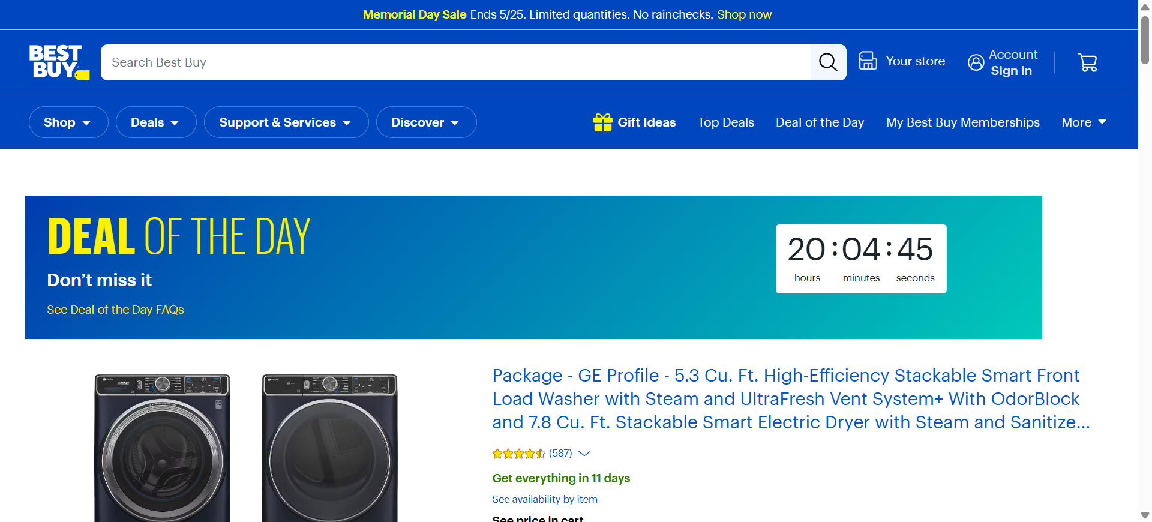
Fig-17 [BDD] TC01 — Deal of the Day Page Opened

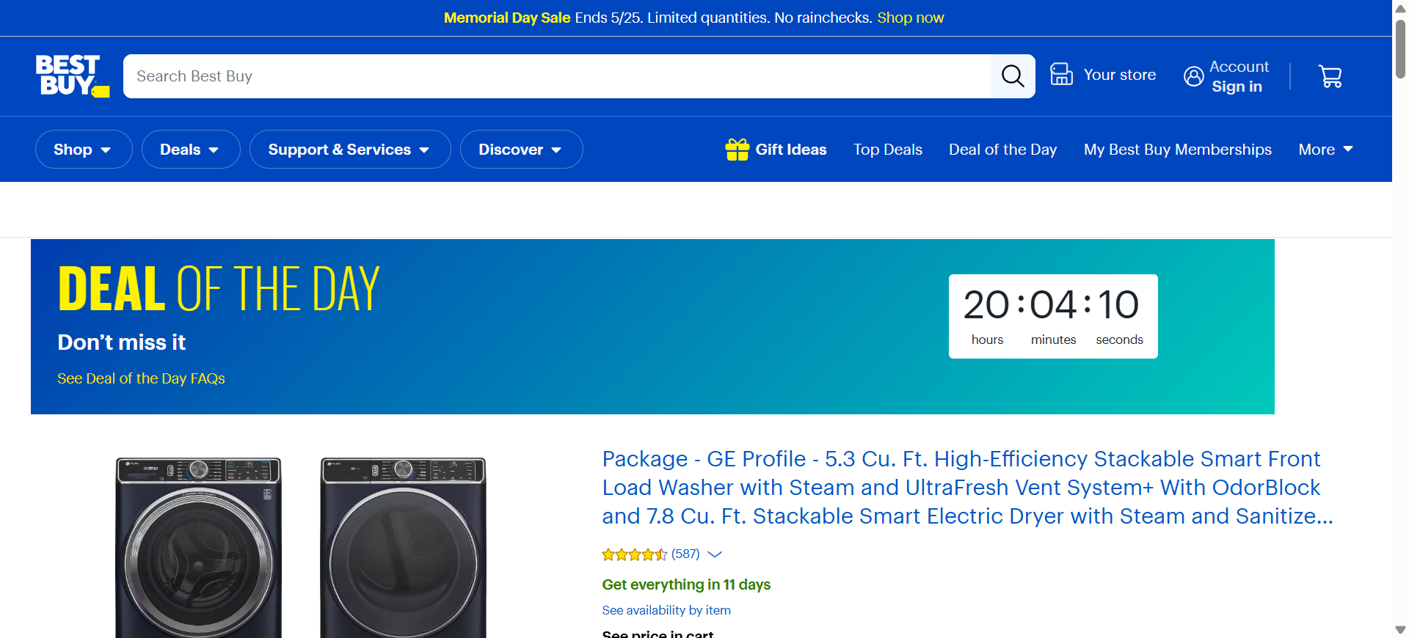
Fig-18 [BDD] TC02 — Product Selected from Deal List

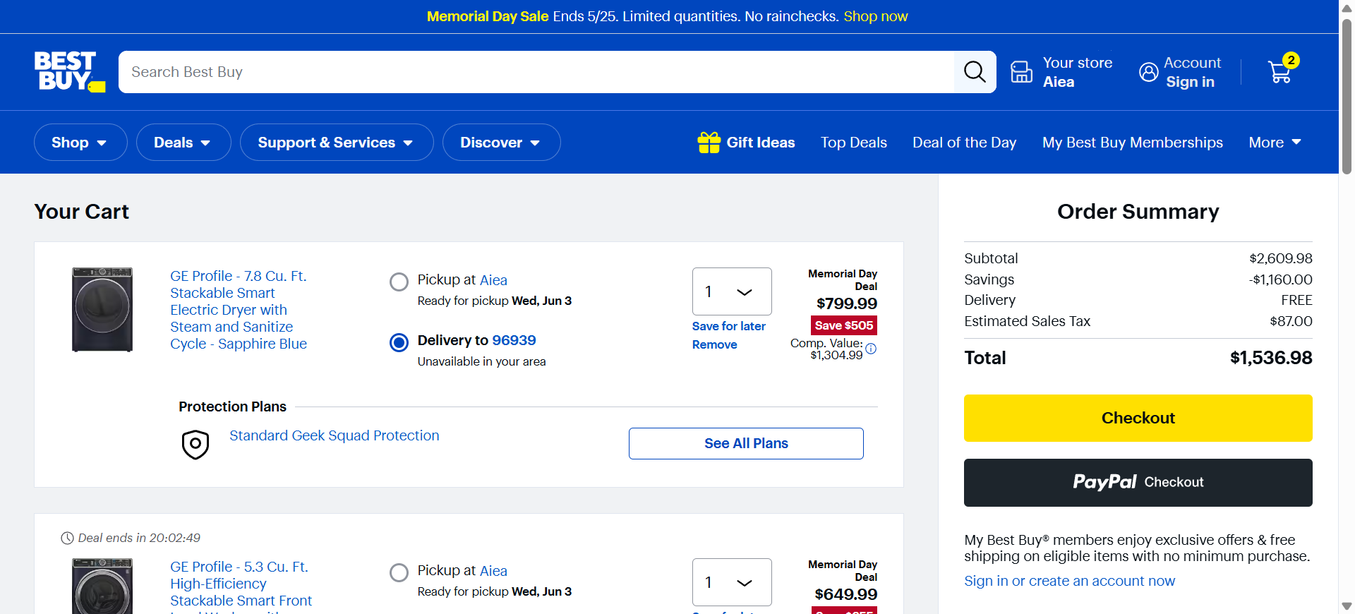
Fig-19 [BDD] TC03 — Product Added to Cart

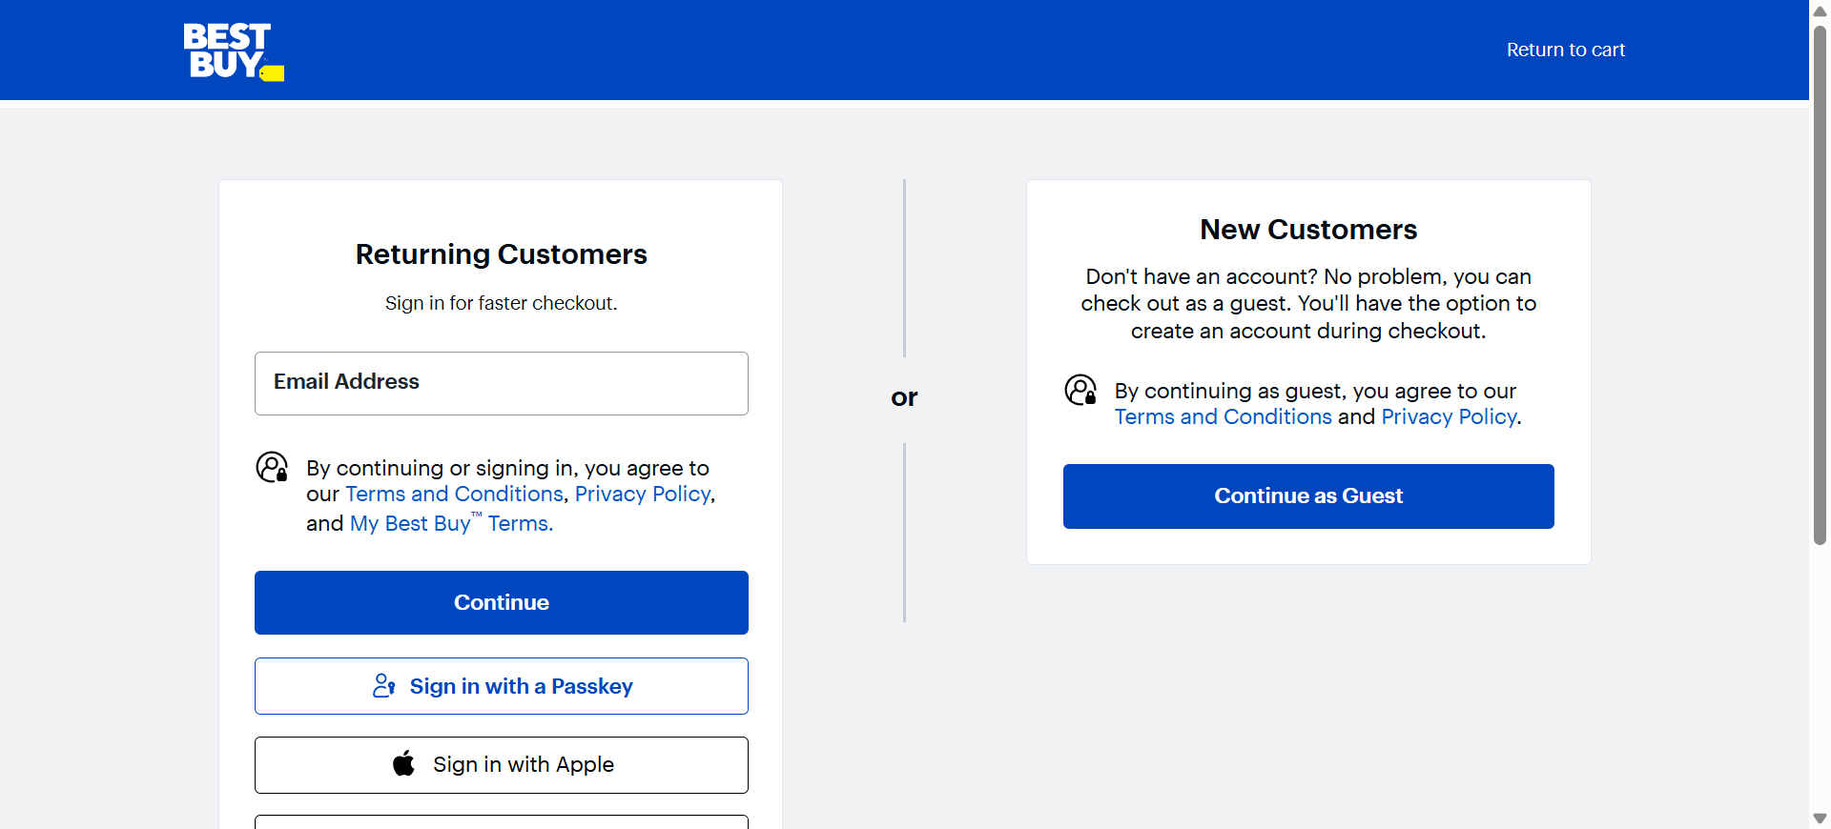
Fig-20 [BDD] TC04 — Checkout Page Displayed

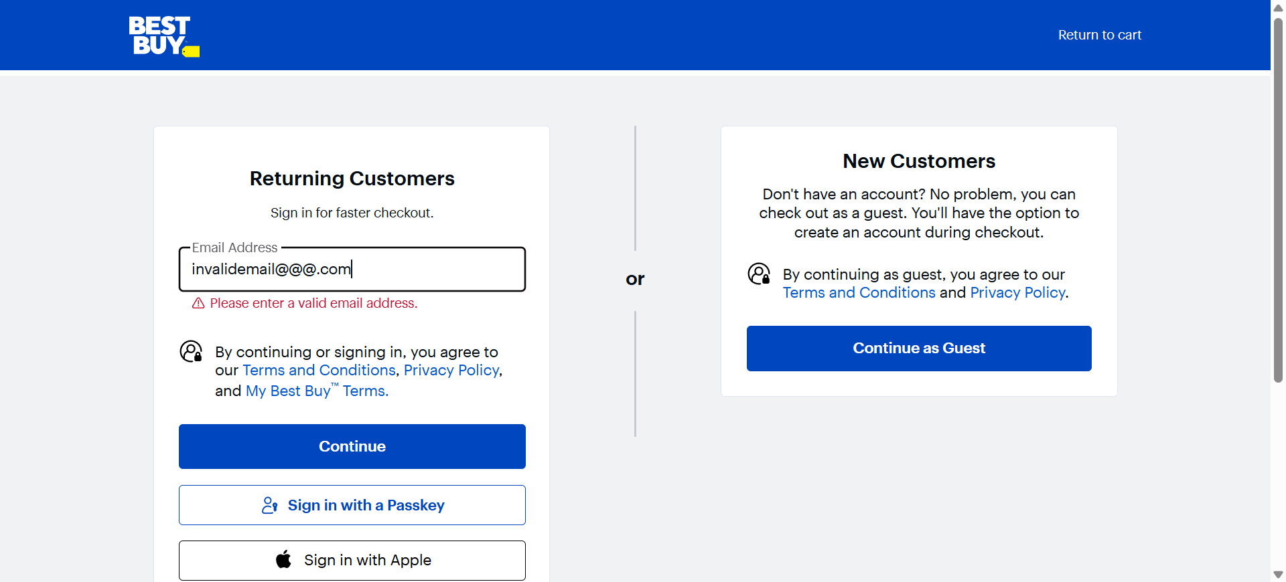
Fig-21 [BDD] TC05 — Invalid Email Validation Error

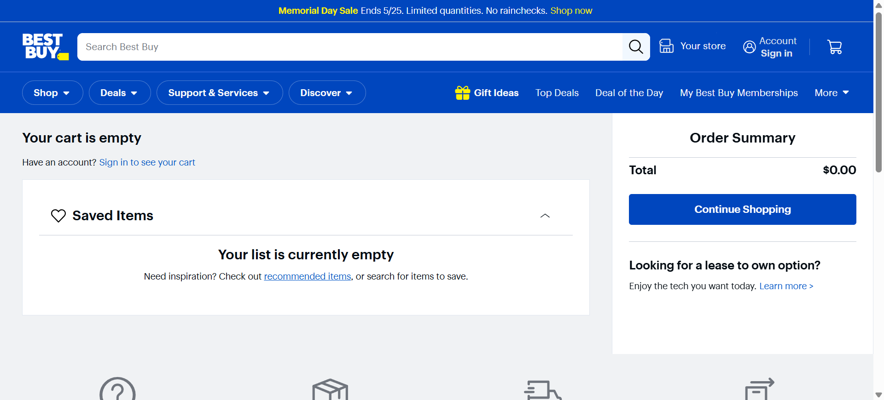
Fig-22 [BDD] TC06 — Empty Cart Detected

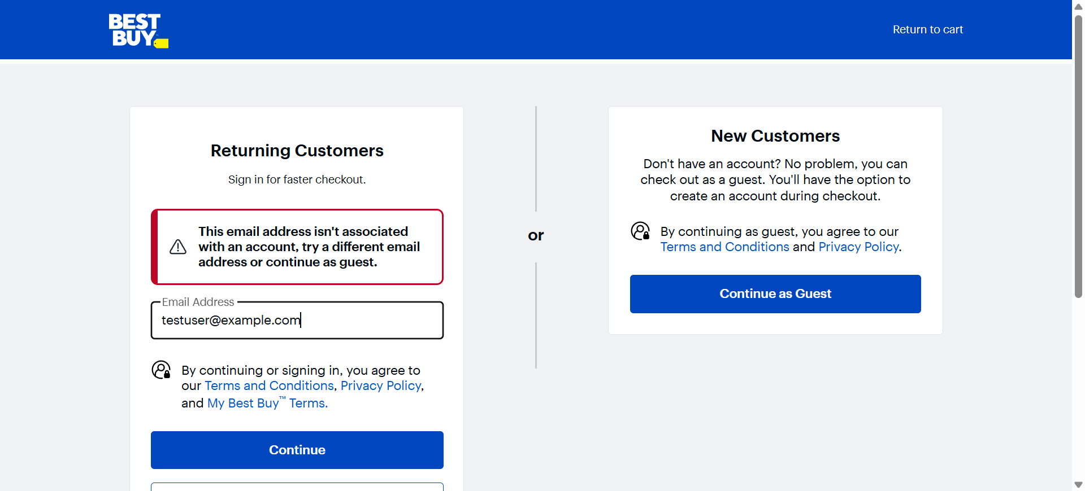
Fig-23 [BDD] TC07 — End-to-End: Next Checkout Step Reached

2.8 Allure Report — BDD Behave
Allure Reports are integrated with the Behave BDD framework. Screenshots are attached after every step, and a final screenshot is attached at the end of each scenario along with the full scenario log for debugging.


Fig-24 [BDD Allure] TC01 — Open Deal of the Day


Fig-25 [BDD Allure] TC02 — Select Product from Deal List (Final Screenshot)


Fig-26 [BDD Allure] TC03 — Add Product to Cart (Final Screenshot)


Fig-27 [BDD Allure] TC04 — Proceed to Checkout (Final Screenshot)


Fig-28 [BDD Allure] TC05 — Invalid Email at Checkout (Final Screenshot)


Fig-29 [BDD Allure] TC06 — Checkout Without Product (Final Screenshot)


Fig-30 [BDD Allure] TC07 — End-to-End (Final Screenshot)

2.9 Test Report Summary — BDD Behave
Total Scenarios Executed | 7
Scenarios Passed | 7
Scenarios Failed | 0
Automation Accuracy | 100%

2.10 Conclusion — BDD Behave
The Selenium Behave BDD automation framework successfully validates the Best Buy Deal of the Day module using Behavior Driven Development methodology. The framework uses Gherkin Feature Files and Given-When-Then structure which improves readability, maintainability, and collaboration between technical and non-technical stakeholders. All 7 scenarios executed successfully with 100% pass rate, with professional Allure Reports, per-step and per-scenario screenshot evidence, and detailed execution logs.

PART 3 — FRAMEWORK COMPARISON

Both frameworks automate the Best Buy Deal of the Day module and achieve 100% pass rates. The table below highlights key differences:

Aspect | Selenium PyTest | Selenium BDD Behave
Test Language | Python + PyTest decorators | Gherkin (Given/When/Then)
Test File Format | .py test files with @allure annotations | .feature files + step definitions
Data-Driven | CSV via CSVReader utility | CSV via CSVReader utility
Screenshot Strategy | End-of-test via pytest hook | After every step + end of scenario
Reporting | Allure Reports with per-test logs | Allure Reports with per-scenario logs
Module Under Test | Deal of the Day — Deal of Day flow | Deal of the Day — Deal of Day flow
Total Test Cases | 7 (1 E2E + 4 Positive + 2 Negative) | 7 (1 E2E + 4 Positive + 2 Negative)
Pass Rate | 100% (7/7) | 100% (7/7)
Stakeholder Readability | Technical (Python) | Business-readable (Gherkin)
Architecture | Page Object Model | Page Object Model

Overall Conclusion
Both the Selenium PyTest and Selenium BDD Behave automation frameworks successfully validate the Best Buy Deal of the Day module with 100% automation accuracy across all 14 combined test cases. The PyTest framework excels in technical flexibility and rapid test development, while the BDD Behave framework provides superior readability through Gherkin syntax enabling collaboration with non-technical stakeholders.
Both frameworks implement the Page Object Model design pattern ensuring maintainability and reusability, integrate Allure reporting for professional test evidence, employ CSV-based data-driven testing, and capture screenshots at key execution stages. Together they represent a comprehensive, industry-standard automation testing solution for the Best Buy e-commerce platform.

