**NAME OF THE PROJECT**

**Statistics  
Submitted by:**

**SAUNAK MUKHERJEE**



1. **Which of the following is the correct formula for total variation?**

b) Total Variation = Residual Variation + Regression Variation

2. Collection of exchangeable binary outcomes for the same covariate data are called___outcomes

c) binomial

**3. How many outcomes are possible with Bernoulli trial?**

a) 2

**4. If Ho is true and we reject it is called?**

a) Type-I error

**5. Level of significance is also called:**

**6. The chance of rejecting a true hypothesis decreases when sample size is:**

b) Increase

**7. Which of the following testing is concerned with making decisions using data?**

b) Hypothesis

**8. What is the purpose of multiple testing in statistical inference?**

d) All of the mentioned

**9. Normalized data are centred at and have units equal to standard deviations of the original data**

a) 0

1**0. What Is Bayes' Theorem?**

Bayes' Theorem which is the states that conditional probability of an event, based on the occurrence of another event, is equal to the likelihood of the second event given the first event multiplied by the probability of the first event.

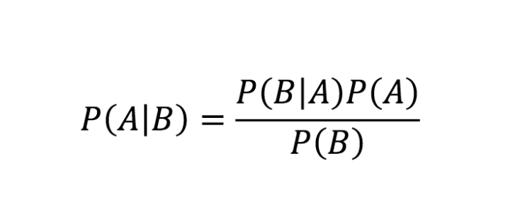

**11. What is z-score?**

It is a numerical measurement that describes a value's relationship to the mean of a group of values.

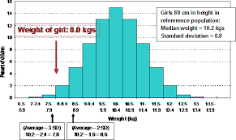

**12. What is t-test?**

It is compare means of 2 groups in a statistical way. Sometimes It’s also use in a hyphothisis testing

**13. What is percentile?**

The percent of the people took the quant section scored lower than you.

Like 50th percentile means that 50% of the scores were below your score, and 50% were above your score.

**14. What is ANOVA?**

 It is a type of statistical test used to determine if there is a statistically significant difference between two or more categorical groups by testing for differences of means using variance

a linear modeling method for evaluating the relationship among fields.

**15. How can ANOVA help?**

ANOVA helps us to find out whether the differences between groups of data are statistically to significant. It works by analyzing to the levels of variance within to the groups through samples taken from each of them.