DentaMind AI: An Uncertainty-Aware Pipeline for Tooth Detection, FDI Numbering, Segmentation and Finding Classification on Panoramic Dental Radiographs
Nilesh Sonawane, Saurabh Mali, Sadhyoj Hanwate, and Sachet Lothe
Guide: Dr. Pradnya Narkhede
Department of Computer Engineering, Pimpri Chinchwad College of Engineering (PCCOE), Pune, Maharashtra, India
Abstract—Reading a panoramic radiograph means locating every tooth, numbering it and checking it for findings, yet published dental AI results are often hard to trace back to the data behind them. This paper presents DentaMind AI, a research prototype built on the public DENTEX dataset that detects teeth, assigns FDI numbers, segments tooth instances and names the closest of four finding classes (Caries, Deep Caries, Impacted, Periapical Lesion) for each detected tooth, while routing uncertain regions to a human reviewer. On a held-out internal test split of 63 radiographs, the detector reached AP50 0.966, the segmenter mask AP50 0.974 (mean matched Dice 0.873), and 96.8 % of matched teeth received the correct FDI number. On ground-truth crops from 73 test radiographs, the finding classifier reached accuracy 0.785 and macro-F1 0.646, but recall for Periapical Lesion was only 0.308. Replacing ground-truth boxes with detector boxes lowered validation macro-F1 from 0.718 to 0.634. An entropy rule flagged 54.2 % of test crops, which contained 86.8 % of the classifier’s errors; temperature scaling reduced test ECE from 0.048 to 0.036 but was not adopted. Four classifier-improvement attempts with acceptance criteria fixed in advance, and an uncertainty-based active-learning study, were all negative. Splits are grouped by pixel hash and every use of the test split is logged, but DENTEX has no patient identifiers, so patient-level leakage cannot be ruled out. The system has not been clinically validated and is not a diagnostic device.
Index Terms—Dental panoramic radiography, DENTEX, tooth detection, FDI tooth numbering, instance segmentation, finding classification, uncertainty estimation, calibration, selective prediction, human review, data leakage, reproducibility.

I. Introduction
A panoramic radiograph records both dental arches, the alveolar bone and the temporomandibular region in a single exposure, which is why it is so often the first image taken in a dental examination. The same breadth makes it demanding to read: every tooth has to be located and numbered, and each one checked for findings such as caries, impaction or periapical lesions. Deep learning now addresses each of these steps, from tooth detection, numbering and segmentation [1]–[5] to the detection of specific findings [6]–[8], and the DENTEX benchmark made it possible to study enumeration and diagnosis on the same public panoramic images [9], [10].
Two practical questions receive less attention than they deserve. The first is how the stages behave together. Classifiers are usually scored on hand-drawn tooth boxes, whereas a deployed system crops whatever the detector returns, so errors propagate from one stage to the next. The second is whether the evaluation itself can be trusted: how the data were split, whether duplicate radiographs crossed splits, and how often the test set was consulted. Leakage of this kind inflates reported performance across machine-learning research [11], and near-duplicate contamination has been shown to raise benchmark scores in medical imaging [12].
DentaMind AI was built to answer these questions on DENTEX. It chains a tooth detector, an FDI numbering model, an instance segmenter and a finding classifier, links their outputs region by region, attaches uncertainty signals to every region and sends uncertain regions to human review. We report every evaluation recorded in the project, including negative and unfavorable results, and each number in the paper can be traced to a named evaluation report. The system is a research prototype: it has not been clinically validated and does not make diagnoses.
Fig. 1 gives an overview of the system and Fig. 2 its processing workflow. Figs. 3, 4 and 5 detail the numbering, classification and review stages, Fig. 6 the data protocol and Fig. 7 the evaluation framework. Section II reviews related work and Section III states the contributions. Sections IV–VII describe the data, architecture, methods and training, and Section VIII defines the evaluation. Sections IX–XI report the results, the error analysis and the uncertainty study, Section XII covers active learning, inference cost and software checks, and Sections XIII–XV address data integrity, limitations and future work.

II. Related Work
Table I summarizes the studies closest to this work. Tooth detection and numbering on panoramic radiographs have been approached with two-stage detectors and, more recently, single-stage YOLO models. Putra et al. [1] detect and number permanent teeth, and Peker and Kurtoglu [2] apply YOLOv10 to 200 pediatric patients in the mixed dentition. Tang et al. [3] show that missing teeth degrade deep-learning numbering, a failure mode that also appears in our per-tooth results. Zhang et al. [4] couple instance segmentation with FDI-compliant numbering in a multi-stage system that treats supernumerary and missing teeth explicitly. For segmentation, Brahmi et al. [5] review convolutional networks in dental radiography, and Yalım et al. [13] relate the accuracy of U-Net variants to their computational cost. Ayhan et al. [14] combine numbering with caries detection, but on bitewing rather than panoramic radiographs.
For findings, Szabó et al. [6] evaluate a commercial system for periapical lesion detection on 616 teeth from 357 panoramic radiographs, and Raeisi et al. [7] study multi-label diagnosis of dental conditions on panoramic X-rays with attention-enhanced networks. Bittar et al. [8] summarize the evidence on AI for caries detection in an umbrella review. Hamamci et al. introduced the DENTEX benchmark [9] together with a diffusion-based hierarchical detector for its enumeration-and-diagnosis task [10].
Reliability has a literature of its own. Recent reviews survey uncertainty quantification for medical image analysis, covering both probabilistic and non-probabilistic methods [15], [16]. Selective classification lets a model withhold a prediction when it is uncertain [17], and uncertainty-aware abstention has recently been examined for medical diagnosis [18]. Test-time augmentation gives an inexpensive uncertainty estimate from a single network [19]. Temperature scaling [20] remains the standard post-hoc calibration method, adaptive variants have been proposed to make it more robust [21], and the expected calibration error (ECE) [22] is the usual summary measure. Active learning aims to reduce labeling effort in medical imaging [23].
On the data side, Kapoor and Narayanan [11] identify leakage as a common cause of irreproducible machine-learning results, Truong et al. [24] benchmark pretrained embeddings for finding exact and near duplicates in medical images, and Huang et al. [12] measure how near-duplicate contamination inflates performance on a brain-MRI benchmark. On the human side, it has been argued that radiology workflows should assign distinct roles to AI and human readers instead of treating AI as a generic assistant [25]. DentaMind AI takes a narrower, measurable position: the models draft, a person decides, and we report how often review is triggered. Throughout, we use these ideas as tools and measure how much they help on DENTEX; we do not propose new methods for them.
TABLE I
Recent Studies Related to This Work
Study | Task and data | Relation to this work
Putra et al. [1] | Permanent-tooth detection and numbering, panoramic | Same tasks; we add end-to-end and uncertainty evaluation
Peker, Kurtoglu [2] | YOLOv10 detection and numbering, mixed dentition (200 patients) | Numbering task; our data are adult DENTEX films
Tang et al. [3] | Effect of missing teeth on numbering, panoramic | Explains a failure mode seen in our per-tooth results
Zhang et al. [4] | Multi-stage instance segmentation and FDI numbering, panoramic | Same task pair; we link stages by IoU and add review routing
Brahmi et al. [5] | Systematic review, CNN segmentation in dental radiography | Context for our Mask R-CNN choice
Ayhan et al. [14] | Tooth numbering and caries detection, bitewing | Combined numbering and finding task, different modality
Szabó et al. [6] | Commercial system, periapical lesions, 357 panoramics | Our weakest class is Periapical Lesion
Raeisi et al. [7] | Multi-label dental conditions, panoramic | Our classifier is single-label (Section X)
Yalım et al. [13] | U-Net tooth segmentation, accuracy vs. cost | We use Mask R-CNN instances and report latency
Bittar et al. [8] | Umbrella review, AI caries detection | Context for caries results
Hamamci et al. [9], [10] | DENTEX benchmark; hierarchical diffusion detector | Source of our data and finding taxonomy

III. Research Gap and Contributions
The models we use—Faster R-CNN [26], Mask R-CNN [27] with a ResNet-50 [28] feature pyramid [29], and a ResNet-50 classifier—are standard, and we do not claim any architectural novelty. The gap we address is evidence: what a complete panoramic-radiograph pipeline achieves when every stage is measured on the same held-out data, how the stages interact, and whether common uncertainty and data-efficiency techniques actually help. Our contributions are:
- an integrated, open pipeline that links detection, FDI numbering, segmentation and finding classification region by region through IoU matching, never by list position;
- an end-to-end validation study that measures how detector boxes, rather than ground-truth boxes, change finding classification, with the sources of the gap broken down;
- an evaluation of uncertainty-based review routing, calibration and abstention rules with thresholds fixed on a separate calibration split, including the rules that failed;
- four controlled attempts to improve the finding classifier (class-imbalance methods, crop jitter, a training-recipe comparison and a cloud re-run) with acceptance criteria fixed before the results were known, plus an active-learning study; all were negative; and
- an auditable data protocol: pixel-hash grouped splits, leakage checks, and a hash-chained test-set ledger that records every use of the test split.

IV. Dataset and Data Preparation

A. DENTEX Sub-Sets
We use the DENTEX panoramic radiographs [9], which come from three institutions and several scanners. Table II lists the sub-sets found on disk, as measured by the project’s dataset audit. The quadrant sub-set labels quadrants. The quadrant-enumeration sub-set labels every tooth with its quadrant and tooth index, which together give the two-digit FDI code [30]. The quadrant-enumeration-disease sub-set labels only teeth that carry one of four findings. All annotations include both boxes and polygon masks.
TABLE II
DENTEX Sub-Sets Present in the Project (Dataset Audit, 2026-10-14)
Sub-set | Images | Annotations | Use
quadrant | 693 | 2,772 | not used by the current models
quadrant-enumeration | 634 | 18,095 | detection, numbering, segmentation
quadrant-enumeration-disease | 705 | 3,529 | finding classification
unlabelled | 1,571 | — | active-learning pool
validation_data (unlabeled) | 50 | — | inference demonstration only
All files on disk | 3,653 |  | 2,716 distinct radiographs by pixels
Source: Data/reports/dataset_audit.md. Annotated entries total 2,005 but contain only 1,133 distinct radiographs, because the sub-sets reuse the same films under different file names. In the disease sub-set, 27 images have no annotation.
The sub-sets overlap heavily. The 3,653 files contain only 2,716 distinct radiographs, and the 2,005 annotated entries only 1,133. For example, 235 radiographs appear in all three annotated sub-sets, sometimes under different file names. Image counts quoted for DENTEX therefore count entries, not independent patients.

B. Finding Taxonomy and Excluded Data
The disease sub-set contains 2,189 Caries, 578 Deep Caries, 604 Impacted and 158 Periapical Lesion annotations. There is no “healthy” label: a tooth without a finding is simply not annotated. The official DENTEX test release uses a Turkish, treatment-oriented label set (for example “1-çürük” and “3-kanal”). The project found no verified equivalence between those labels and the four English finding classes. On the one radiograph shared between the two releases, the English labels contradicted the mapping. The official test set is therefore excluded from every evaluation in this paper. The project also found that 95 of the 250 official test images are byte-identical to radiographs in DENTEX’s own training sub-sets. The 50 unlabeled validation_data images are used only to demonstrate inference; 20 of them duplicate labeled radiographs.

C. Splitting Procedure
Each radiograph is identified by the SHA-256 hash of its pixels, so identical copies across sub-sets form one group and always share a split. Groups are assigned with seed 42 to train, validation, calibration and test splits in proportions 0.70/0.10/0.10/0.10. The split file is append-only: images that already have a split never move. Fig. 6 summarizes the procedure, and Table III gives the resulting counts per task. Each split has a fixed role. Train is used to fit weights. Validation selects the training epoch and provides the reported validation metrics. Calibration fits thresholds and the temperature. Test is reserved for final metrics.
TABLE III
Split Statistics per Task
Task (sub-set) | Train | Val. | Cal. | Test
Detection, numbering, segmentation: radiographs | 440 | 69 | 62 | 63
Detection: tooth boxes | — | 2,000 | — | 1,790
Findings: radiographs | 476 | 65 | 64 | 73
Findings: Caries | 1,550 | 205 | 206 | 228
Findings: Deep Caries | 438 | 45 | 47 | 48
Findings: Impacted | 412 | 72 | 55 | 65
Findings: Periapical Lesion | 120 | 9 | 16 | 13
Sources: dataset_audit.md, eval_*.json and reports/training_summary.md. Finding counts are ground-truth finding boxes (crops). The training imbalance between Caries and Periapical Lesion is 12.9 : 1. Calibration finding count: 324 crops.

V. System Architecture
Fig. 1 shows the implemented system. A FastAPI back end runs the full-analysis pipeline. A SQLite store keeps images, analyses, reviews and reports, and a React front end displays them. The original upload is never modified. Models receive the RGB image as floating-point values in [0, 1] at full resolution, and torchvision’s internal transform resizes it (shorter side 800 px, longer side at most 1,333 px). Grayscale contrast statistics are computed only to raise image-quality flags and never change the model input.
Fig. 2 lists the ten pipeline steps in execution order. Each step is timed and records its status. A step whose model is missing is reported as “unavailable” and a crashed step as “failed”. Later steps that do not depend on it still run, and a missing signal is reported as unavailable rather than as zero. Regions carry a content-derived identifier (image, rounded box and model version), so a review stays attached to the region the reviewer actually saw.

VI. Methodology

A. Tooth Detection and Instance Segmentation
Tooth detection uses Faster R-CNN [26] with a ResNet-50 feature pyramid [28], [29] and a single foreground class, “tooth”. Detections with score ≥ 0.3 are kept. The detector does not number teeth. Instance segmentation uses Mask R-CNN [27] trained on DENTEX’s polygon masks; boxes are never converted into masks. A mask instance and a detector box are linked by one-to-one greedy matching at intersection over union (IoU) ≥ 0.5:
$IoU\left(A,B\right)=\frac{|A∩B|}{|A∪B|}$ (1)
where A and B are boxes or binary masks. Mask quality is also summarized by the Dice coefficient,
$Dice\left(A,B\right)=\frac{2|A∩B|}{|A|+|B|}$ (2)
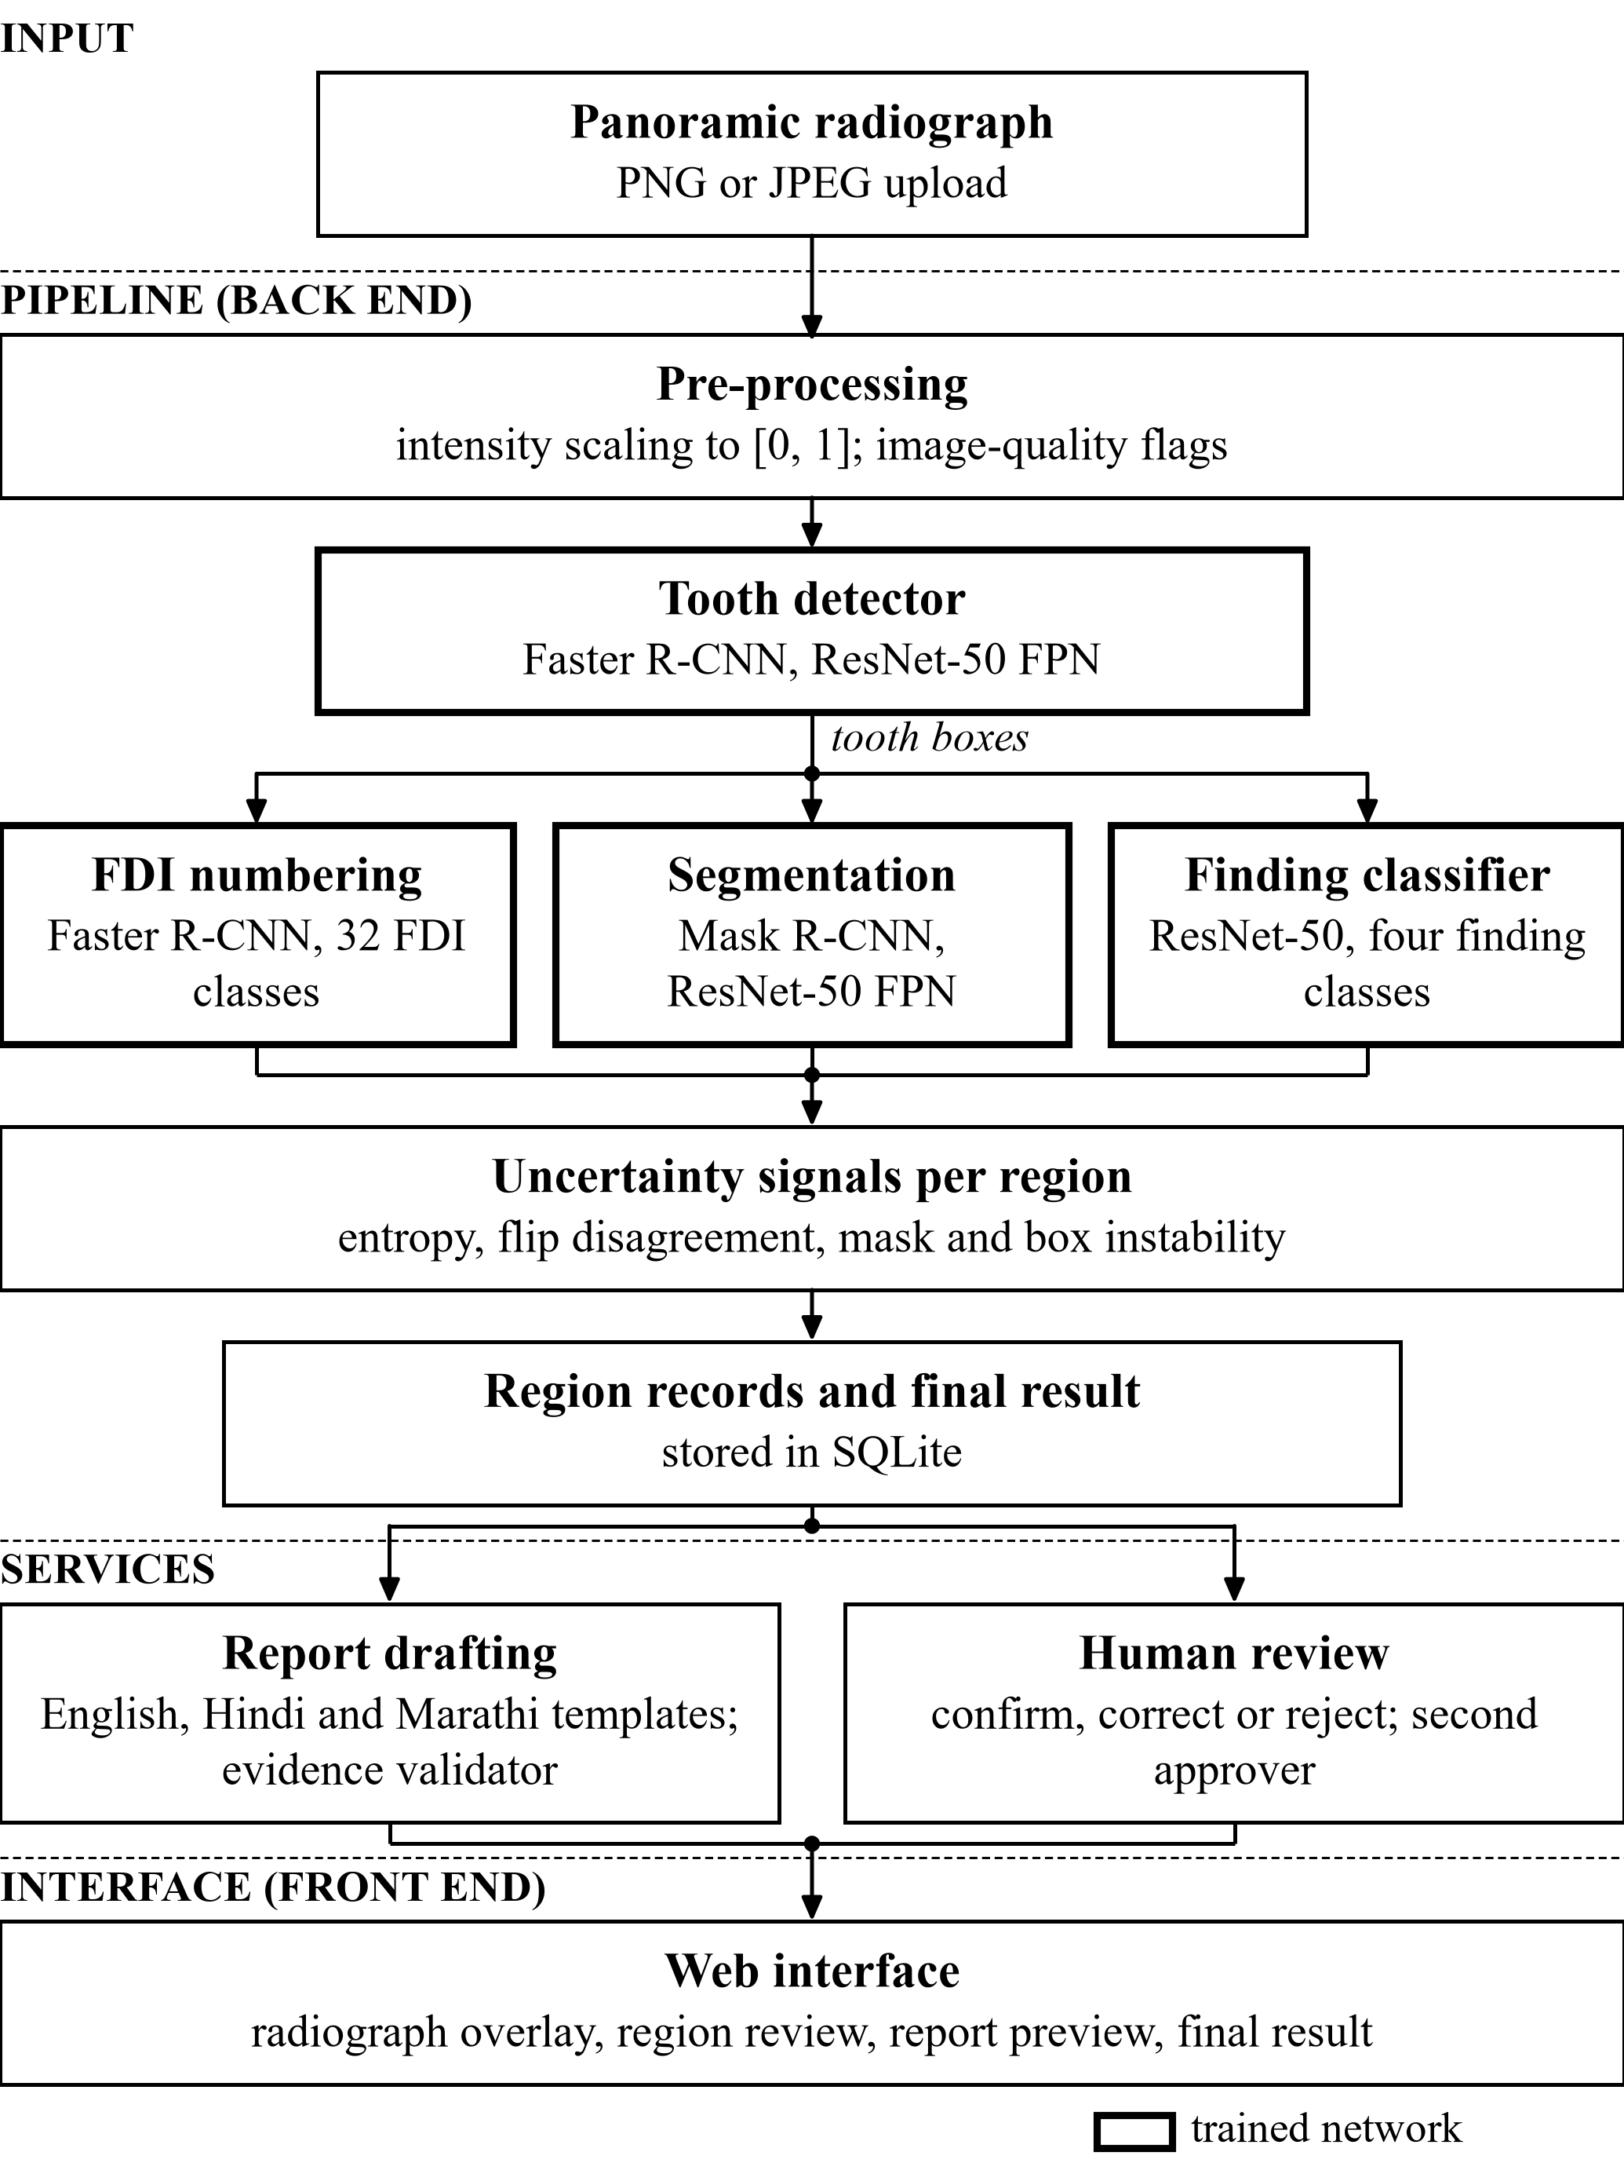
Fig. 1. System architecture of DentaMind AI as implemented. The tooth detector feeds number assignment, mask matching and finding classification; per-region uncertainty signals become review flags before the final result, report drafting and human review. Bold outlines mark trained networks.

B. FDI Tooth Numbering
Numbering uses a second Faster R-CNN with 32 foreground classes, one per permanent FDI code [30]. Faster R-CNN suppresses overlapping boxes only within a class, so one tooth can come back with several numbers. The raw output is therefore resolved: boxes below score 0.3 are dropped, class-agnostic non-maximum suppression at IoU 0.5 is applied, and the best box per FDI code is kept. Detector boxes are then visited in descending score order, and each takes the unused numbering box with the highest IoU if that IoU is at least 0.5 (Fig. 3a). A tooth without such a box stays “unassigned”: the system never guesses a number. A rule-based check then marks a number for review when it is duplicated, when its confidence is below 0.5, or when the box lies on the wrong side or arch for its quadrant. The panoramic convention used is that image-left is patient-right.
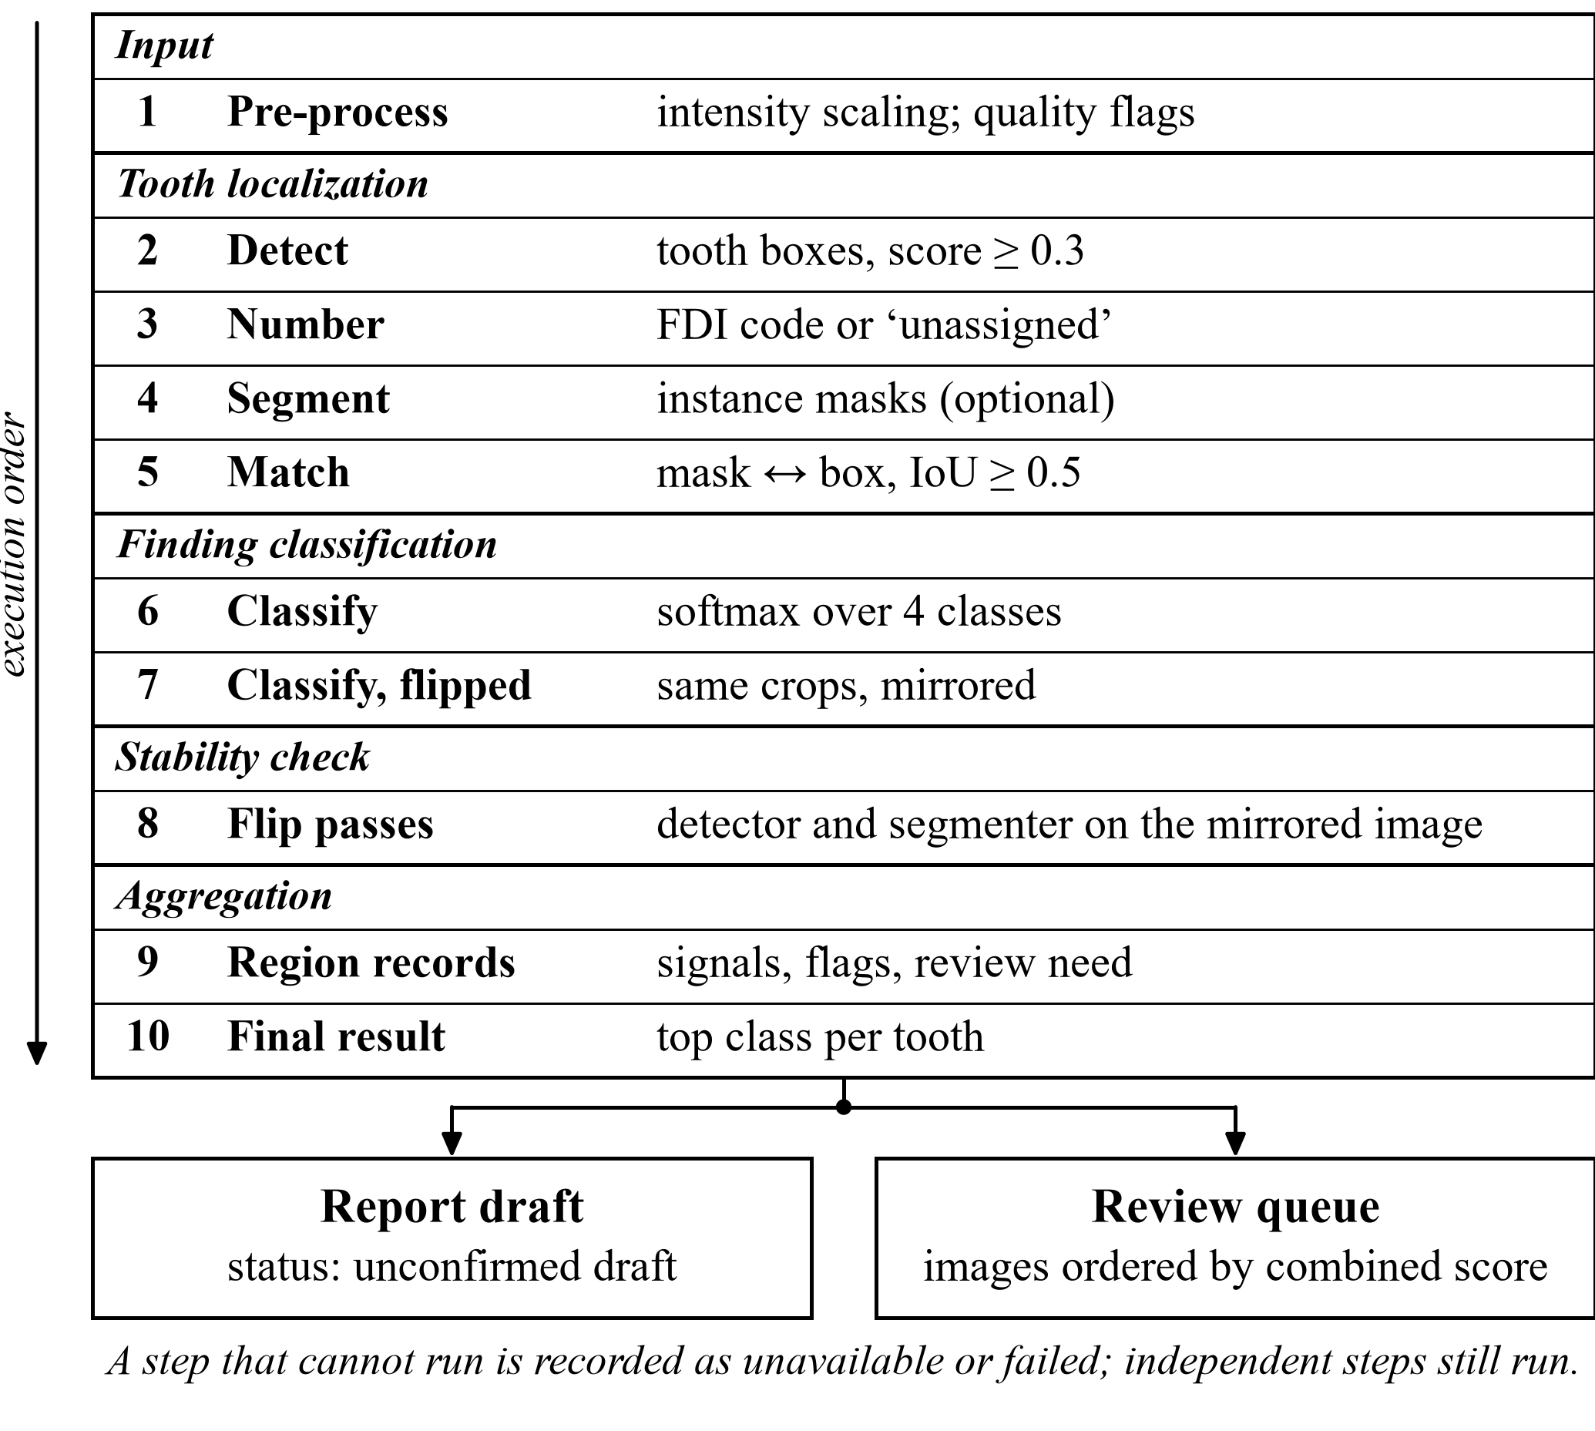
Fig. 2. End-to-end processing workflow. The ten pipeline steps run in order and are grouped by purpose; a step whose model is missing or that fails is recorded as unavailable or failed, and steps that do not depend on it still run.

C. Finding Classification
Each tooth box is cropped with 10 % padding, resized to 224 × 224 pixels, normalized with ImageNet statistics [31] and classified by a ResNet-50 with a new four-way output layer (Fig. 4). The application crops detector boxes. The classifier evaluation crops ground-truth finding boxes, and Section X measures the difference. The softmax over Caries, Deep Caries, Impacted and Periapical Lesion is an answer to “which of these four does this crop most resemble”, not to “is this tooth diseased”, because the training data contain no healthy class. Training uses inverse-frequency class weights,
$w_{c}=\frac{N}{Kn_{c}}$ (3)
where N = 2,520 training crops, K = 4 and n_{c} is the class count. This gives weights 0.41, 1.44, 1.53 and 5.25 (Fig. 4).
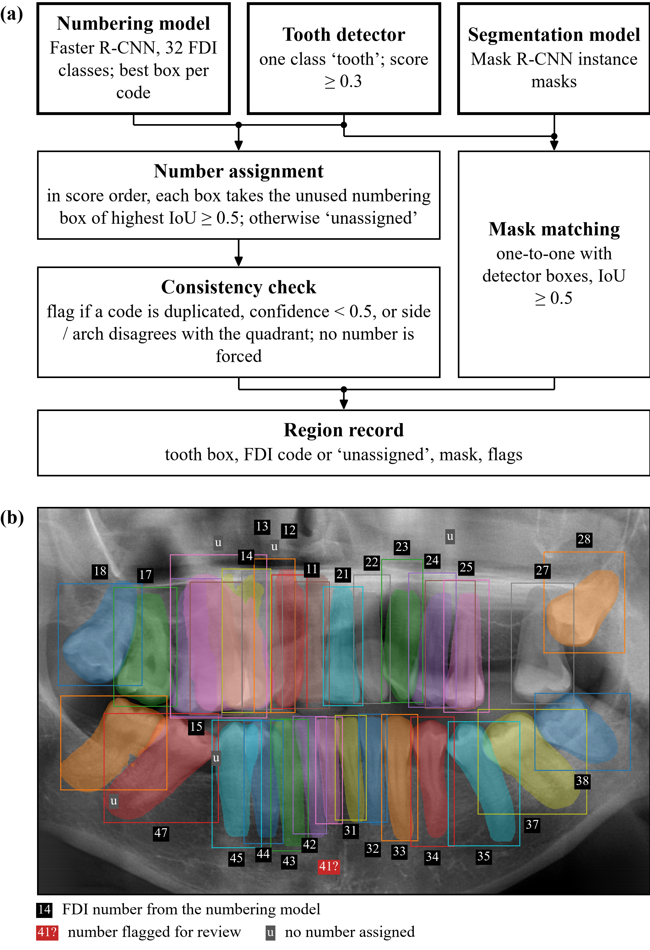
Fig. 3. (a) How detector boxes, the numbering model and the segmentation model are combined into a region record. (b) Genuine output of the four deployed checkpoints on val_12.png, an unlabeled DENTEX validation radiograph without ground truth: Mask R-CNN masks, detector boxes and assigned FDI numbers. Of 32 regions, 27 received a number (one flagged for review, “41?”) and 30 a matched mask. Labels are model outputs, not verified annotations. Image: DENTEX, CC BY-NC-SA 4.0.

D. Uncertainty Signals
All signals come from a single network; none is an ensemble or a Bayesian estimate. For a softmax vector p over K = 4 classes, the normalized entropy is
$H\left(p\right)=−\frac{\sum_{k}{p_{k} ln p_{k}}}{ln K}$ (4)
and the flip disagreement is the Jensen–Shannon divergence [32] between the prediction p on a crop and the prediction q on its horizontal flip, a two-pass form of test-time augmentation [19]:
$JS\left(p,q\right)=\frac{H′\left(\frac{p+q}{2}\right)−\frac{H′\left(p\right)+H′\left(q\right)}{2}}{ln 2}$ (5)
where H′ is the unnormalized entropy. Mask instability and detection instability are both 1 − IoU between an instance and its best match on the horizontally flipped image (flipped back); an instance with no counterpart counts as 1:
$u_{mask}=1−IoU\left(m,{m̃}_{flip}\right)$ (6)
The image-level combined score used to order the review queue is the weighted mean of the available signals,
$S=\frac{\sum_{j∈avail}{α_{j}s_{j}}}{\sum_{j∈avail}{α_{j}}}$ (7)
with weights 0.4 (entropy), 0.4 (flip disagreement) and 0.2 (mask instability); the weights are renormalized over the signals that are available. Detection instability is shown but excluded from S.
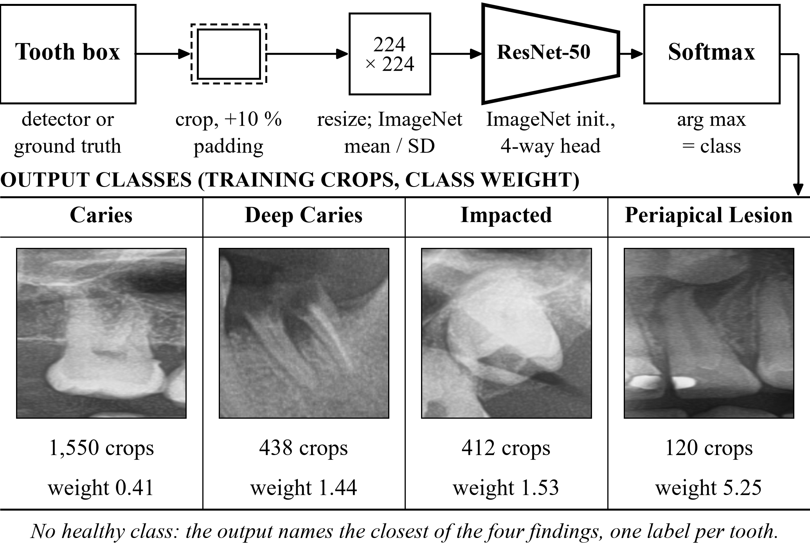
Fig. 4. Finding-classification workflow. Bottom: one genuine ground-truth training crop per class, cut with the classifier’s own crop rule (10 % padding, 224 × 224 px; the training box closest to the class-median area), with the training-crop count and class weight recorded in the checkpoint sidecar. Images: DENTEX, CC BY-NC-SA 4.0.

E. Review Routing and Final Result
Fig. 5 shows which thresholds are deployed. The entropy threshold 0.397 maximizes Youden’s index [33],
$J=TPR−FPR$ (8)
where a “positive” is a classifier error on calibration crops. The flip-disagreement threshold 0.076 is the 90th percentile on calibration crops. Both values were fixed once, on one seed and one dataset, and are provisional. A region at or above the entropy threshold gets status “abstained” and is sent for review. Since a project decision on 2026-10-16, its highest-scoring class is still shown, marked “Needs human review — high classifier uncertainty”, and an abstained tooth is never reported as healthy. Mask instability ≥ 0.30, detection score < 0.50 and numbering problems also trigger review. Scores shown to users are raw softmax values; they are not calibrated probabilities.
Algorithm 1 summarizes how one radiograph is analyzed and routed. It follows the production pipeline step by step.
Algorithm 1: Per-image analysis and review routing (as implemented)
Input: radiograph I (RGB, values in [0, 1]); thresholds τ_{H} = 0.397, τ_{JS} = 0.076, τ_{M} = 0.30, τ_{D} = 0.50
1: D ← tooth detector(I), keeping boxes with score ≥ 0.3
2: assign FDI codes to D from the numbering model (score order, IoU ≥ 0.5); run the consistency check
3: M ← segmenter(I); match M to D one-to-one at IoU ≥ 0.5
4: repeat detection and segmentation on the flipped image (instability signals)
5: for each box d ∈ D do
6: p ← classifier(crop(d)); q ← classifier(flip(crop(d)))
7: compute H(p), JS(p, q), u_{mask} and detection instability
8: flags ← {H ≥ τ_{H}, JS ≥ τ_{JS}, u_{mask} ≥ τ_{M}, score < τ_{D}, no matched mask, number needs review, not found on flipped image}
9: status ← “abstained” if H ≥ τ_{H} (top class still shown); review ← flags ≠ ∅ or number unassigned
10: S ← weighted mean of the available image-level signals (7); store region records
11: draft the report as an unconfirmed draft; place the image in the review queue ordered by S

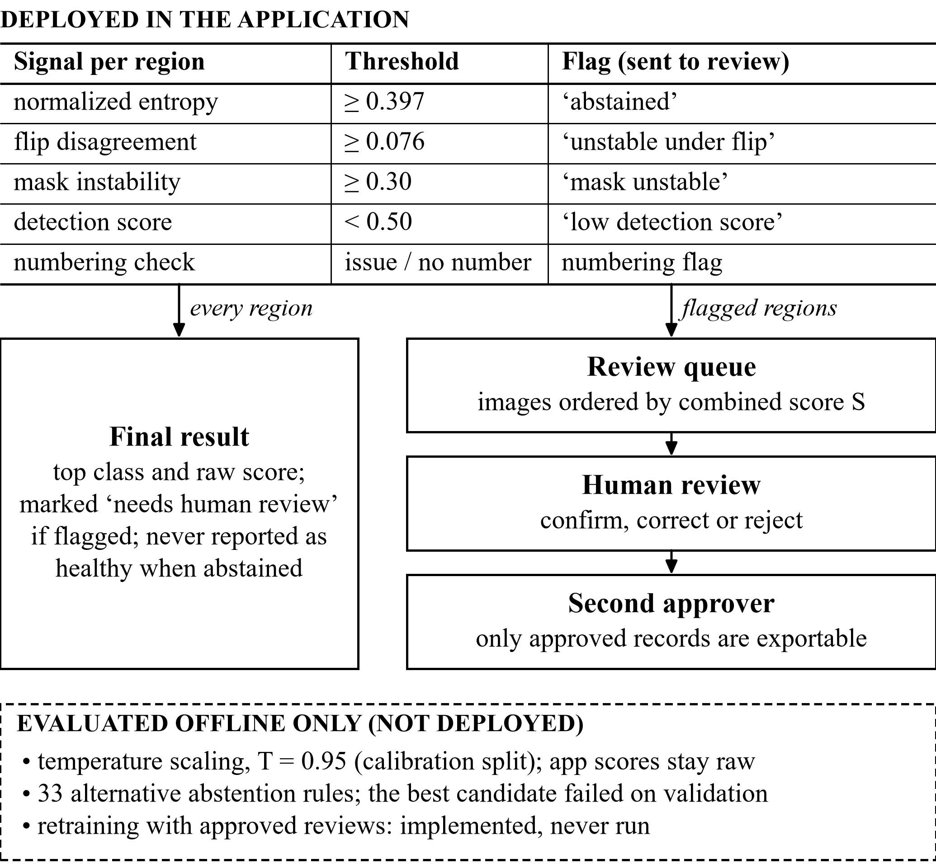
Fig. 5. Uncertainty-aware review routing. Upper part: thresholds and routing deployed in the application. Lower dashed panel: methods evaluated offline only, which are not active in the application.

F. Human Review and Reports
A reviewer can confirm, correct or reject a region’s class, set or clear its tooth number, or mark the image for specialist review or as unusable. Each record stores the model output the reviewer saw. A changed decision creates a new revision, and an identical resubmission is refused. Approval requires a second named person. Reviewer names are self-declared and stored as such, and nothing is labeled expert-verified. Only approved records on unlabeled-pool or uploaded images can be exported for training. Reports are drafted from structured findings with fixed templates in English, Hindi and Marathi. A validator rejects text that cites teeth, labels or numbers absent from the findings, and every report remains an unconfirmed research draft until a named reviewer signs it. The Hindi and Marathi wording has not been reviewed by a native-speaking dental professional.

VII. Model Architectures and Training Configuration
Table IV lists the training configuration recorded in each checkpoint’s sidecar file. All models are torchvision implementations. Detectors start from COCO weights [34] and the classifier from ImageNet weights [31]; these are general-domain, not dental, starting points. All models use AdamW with weight decay 10⁻⁴, a cosine learning-rate schedule and seed 42, and each keeps the epoch that scores best on validation. Horizontal flipping is used for the one-class detector and segmenter but not for the numbering model, because a flip would swap left and right FDI codes. Training ran on an NVIDIA RTX 3050 Laptop GPU (4 GB) with PyTorch 2.6 and CUDA 12.4.
TABLE IV
Training Configuration of the Four Deployed Checkpoints
Model | Architecture (init.) | Epochs / batch / lr | Selection on val.
Tooth detector | Faster R-CNN R50-FPN, 1 class (COCO) | 12 / 2 / 1e-4 | box mAP@[.5:.95]
FDI numbering | Faster R-CNN R50-FPN, 32 classes (COCO) | 16 / 2 / 1e-4 | box mAP@[.5:.95]
Segmenter | Mask R-CNN R50-FPN, 1 class (COCO) | 8 / 1 / 1e-4 | box mAP@[.5:.95]
Finding classifier | ResNet-50, 4 classes (ImageNet V2) | 15 / 32 / 3e-4 | macro-F1 (epoch 5)
Sources: Data/checkpoints/*.json sidecars. Classifier augmentation: horizontal flip p = 0.5 and multiplicative contrast jitter of ±5 %. The detector, numbering and segmentation models used 440 training and 69 validation radiographs. The checkpoints are legacy: image-level training membership was not recorded (Section XIII).

VIII. Experimental Setup and Evaluation Metrics
Fig. 7 maps each task and study to its metrics and splits. Detection and segmentation use COCO-style average precision (AP). For one class, AP is the area under the precision envelope with all-point interpolation,
$AP=\sum_{k}{\left(r_{k}−r_{k−1}\right) maxp_{r≥rₖ}}$ (9)
where r_{k} are recall levels and p precision. AP50 uses an IoU match threshold of 0.5, and mAP averages AP over IoU 0.50:0.05:0.95. Precision P and recall R are also reported at the operating point (score ≥ 0.3, IoU ≥ 0.5) from true positives (TP), false positives (FP) and false negatives (FN):
$P=\frac{TP}{TP+FP}, R=\frac{TP}{TP+FN}, F1=\frac{2PR}{P+R}$ (10)
For classification, macro-F1 (F1_{macro}) is the unweighted mean of the per-class F1 values,
${F1}_{macro}=\frac{1}{K}\sum_{k=1}^{K}{{F1}_{k}}$ (11)
Per-class sensitivity, specificity and one-vs-rest ROC AUC are reported for the test split. Mask IoU is computed on a grid subsampled by a factor of four. Numbering is scored on ground-truth teeth: coverage is the fraction matched by a numbered prediction at IoU ≥ 0.5, exact accuracy is the fraction of matched teeth with the correct FDI code, and strict accuracy counts correct codes over all ground-truth teeth, so that missed teeth count as errors.
Calibration uses the expected calibration error with 15 equal-width confidence bins B_{m} [22],
$ECE=\sum_{m=1}^{15}{\frac{|Bₘ|}{n}|acc\left(Bₘ\right)−conf\left(Bₘ\right)|}$ (12)
and the multi-class Brier score [35],
$BS=\frac{1}{n}\sum_{i}{\sum_{k}{{\left(p_{ik}−y_{ik}\right)}^{2}}}$ (13)
where y_{ik} is the one-hot label. Temperature scaling [20] divides the logits z by a scalar T fitted by negative log-likelihood on the calibration split (grid 0.5–5.0, step 0.05):
$p_{k}=\frac{exp\left(z_{k}/T\right)}{\sum_{j}{exp\left(z_{j}/T\right)}}$ (14)
For abstention rules [17], coverage is the fraction of crops that receive a class and risk is the error rate among them:
$cov=\frac{|acc.|}{n}, risk=\frac{|wrong∩acc.|}{|acc.|}$ (15)
The ability of a signal to rank errors is summarized by the AUROC: the probability that a randomly chosen misclassified crop scores higher than a correctly classified one, with ties counted as one half.
The data protocol behind all splits is summarized in Fig. 6; the roles of the splits are those of Section IV-C.
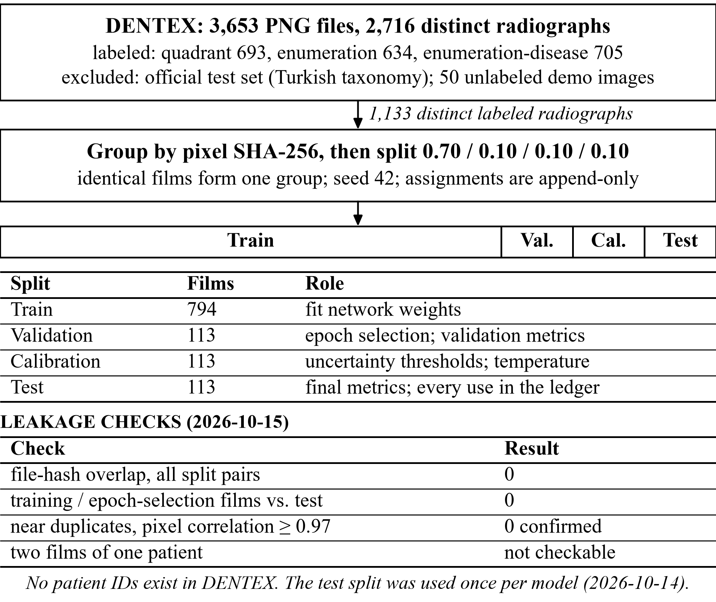
Fig. 6. Dataset, splitting and leakage-check protocol as implemented. The split bar is drawn to the configured proportions; film counts are distinct labeled radiographs.
Three conditions apply to every result below. First, validation also selected each model’s training epoch, so validation numbers are optimistic. Second, the internal test split was evaluated once for each of the four checkpoints on 2026-10-14, after model selection. Third, all models were trained with one seed on one dataset, so no confidence intervals over seeds exist for the deployed models.

IX. Quantitative Results

A. Tooth Detection and Segmentation
Table V reports detection and segmentation. On the 63 test radiographs (1,790 teeth), the detector reaches AP50 0.966 and recall 0.974 at the operating point. The segmenter’s mask AP50 is 0.974, and matched instances have mean mask IoU 0.780 and mean Dice 0.873. The much lower mAP@[.5:.95] (0.515 for detection) shows that boxes are close to the annotation but not tight, which Section X confirms.
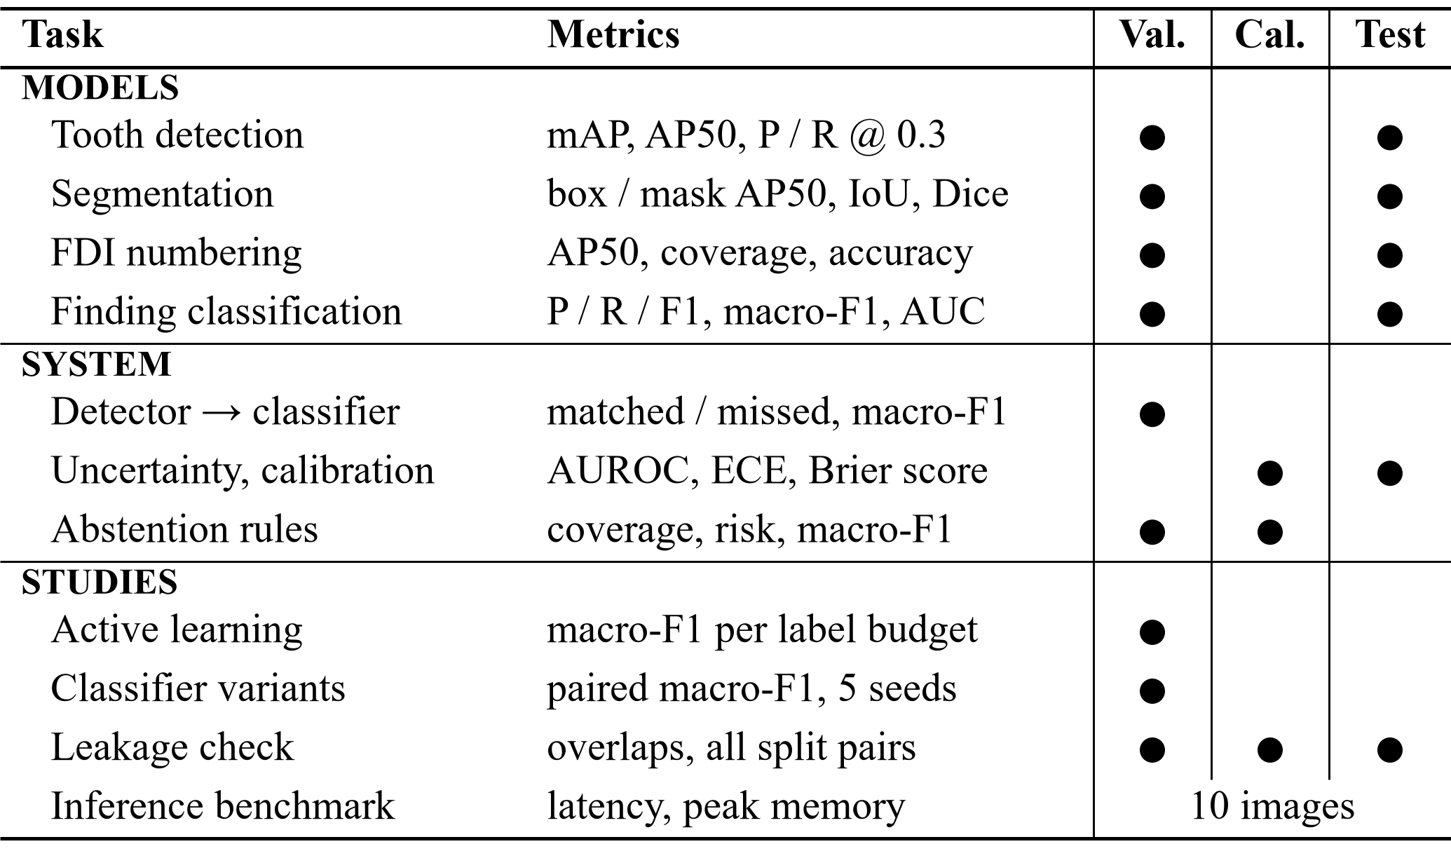
Fig. 7. Experimental evaluation framework: each task or study, its metrics and the splits on which it was evaluated.
TABLE V
Tooth Detection and Instance Segmentation
Metric | Det. val | Det. test | Seg. val | Seg. test
Radiographs / GT teeth | 69 / 2,000 | 63 / 1,790 | 69 / 2,000 | 63 / 1,790
Box mAP@[.5:.95] | 0.560 | 0.515 | 0.569 | 0.530
Box AP50 | 0.978 | 0.966 | 0.981 | 0.974
Mask AP50 | — | — | 0.980 | 0.974
Mean mask IoU / Dice (matched) | — | — | n.r. | 0.780 / 0.873
TP / FP / FN @ 0.3 | 1968/78/32 | 1743/73/47 | 1972/70/28 | 1754/69/36
Precision @ 0.3 | 0.962 | 0.960 | 0.966 | 0.962
Recall @ 0.3 | 0.984 | 0.974 | 0.986 | 0.980
Sources: eval_dentex_teeth_detection_v1_{val,test}.json and eval_dentex_teeth_segmentation_v1_{val,test}.json, rounded to three decimals. n.r. = not recorded in the validation report. Mask IoU is computed on a 4× subsampled grid; 1,753 matched test instances.

B. FDI Tooth Numbering
Table VI reports numbering. On test, 96.9 % of ground-truth teeth are matched by a numbered prediction, and 96.8 % of those receive the exact FDI code. Counting missed teeth as errors gives a strict accuracy of 93.8 %. Quadrant accuracy is almost perfect (0.999), so most errors put the wrong index within the correct quadrant. The test result is higher than the validation result (exact accuracy 0.968 vs. 0.936). With 63 and 69 radiographs this difference is within the range expected from small samples, and we do not interpret it.
TABLE VI
FDI Tooth Numbering
Metric | Validation | Test
Radiographs / GT teeth | 69 / 2,000 | 63 / 1,790
Box mAP@[.5:.95] / AP50 (32 classes) | 0.524 / 0.928 | 0.507 / 0.952
Precision / recall @ 0.3 (any class) | 0.872 / 0.992 | 0.882 / 0.983
Coverage (matched / GT) | 0.979 (1,957) | 0.969 (1,734)
Exact accuracy among matched | 0.936 | 0.968
Quadrant accuracy among matched | 0.997 | 0.999
Strict accuracy over all GT teeth | 0.916 | 0.938
Lowest per-tooth exact accuracy | 36: 0.825; 47: 0.862 | 47: 0.912; 27: 0.917
Source: eval_dentex_fdi_numbering_v1_{val,test}.json. Third molars (18, 28, 38, 48) have the fewest ground-truth teeth (34–50 per split), so their per-tooth accuracies are the least stable.

C. Finding Classification
Table VII reports the classifier on ground-truth finding crops. Test accuracy is 0.785 and macro-F1 0.646. Impacted teeth are recognized reliably (F1 0.926, AUC 0.990), and Caries reasonably well (F1 0.842). Deep Caries (F1 0.453) and Periapical Lesion (F1 0.364, recall 0.308) are poor. The confusion matrices in Table VIII show the main error: Caries and Deep Caries are confused in both directions (30 and 22 test crops), and 9 of the 13 test Periapical Lesions are labeled as some form of caries. Macro ROC AUC is 0.910, so the scores rank classes better than the argmax decisions suggest.
TABLE VII
Finding Classification on Ground-Truth Crops
Class | Split | P | R | F1 | n | Spec. | AUC
Caries | val | 0.885 | 0.863 | 0.874 | 205
 | test | 0.866 | 0.820 | 0.842 | 228 | 0.770 | 0.895
Deep Caries | val | 0.500 | 0.467 | 0.483 | 45
 | test | 0.414 | 0.500 | 0.453 | 48 | 0.889 | 0.834
Impacted | val | 0.919 | 0.944 | 0.932 | 72
 | test | 0.887 | 0.969 | 0.926 | 65 | 0.972 | 0.990
Periapical Lesion | val | 0.467 | 0.778 | 0.583 | 9
 | test | 0.444 | 0.308 | 0.364 | 13 | 0.985 | 0.921
Macro / accuracy | val | 0.693 | 0.763 | 0.718 | 331 | acc. 0.825
 | test | 0.653 | 0.649 | 0.646 | 354 | acc. 0.785 | 0.910
Source: eval_dentex_findings_classification_v1_{val,test}.json (65 and 73 radiographs). Specificity and AUC (one-vs-rest) were computed for the test split only. The validation macro-F1 was also the epoch-selection criterion.
TABLE VIII
Confusion Matrices of the Finding Classifier (Rows: True Class)
True \ predicted | Caries | Deep C. | Impacted | Periap.
Caries (val / test) | 177 / 187 | 18 / 30 | 5 / 6 | 5 / 5
Deep Caries | 20 / 22 | 21 / 24 | 1 / 2 | 3 / 0
Impacted | 2 / 1 | 2 / 1 | 68 / 63 | 0 / 0
Periapical Lesion | 1 / 6 | 1 / 3 | 0 / 0 | 7 / 4
Each cell gives validation / test counts of ground-truth crops. Source: same reports as Table VII.

X. Detailed Results and Error Analysis

A. End-to-End Validation: Detector Boxes Instead of Ground Truth
The classifier numbers above assume perfect boxes. A dedicated study ran the production path—detector, then crop, then classifier—on the 65 validation radiographs of the findings sub-set (331 findings) without touching calibration or test data (Table IX). It first confirmed that production and evaluation pre-processing give byte-identical pixels and identical predictions on all 331 crops, which rules out a train/inference pre-processing mismatch.
Detection precision could be scored only on the 24 radiographs that also have a complete tooth annotation. On those, the detector found 716 of 719 teeth at IoU 0.5, but only 582 at IoU 0.75. On the 65 finding radiographs, detector boxes matched 323 of the 331 findings. Of the 8 unmatched findings, 4 were genuine detector misses. The other 4 were teeth carrying two findings, where one detector box can match only one annotation.
TABLE IX
End-to-End Validation (65 Radiographs, 331 Findings)
Measure | GT boxes | Detector boxes
Detection on 24 fully annotated films: P / R / F1 @ IoU 0.5 | — | 0.977 / 0.996 / 0.986
Same at IoU 0.75 | — | 0.794 / 0.809 / 0.802
Same 323 matched teeth: accuracy | 0.830 | 0.811
Same 323 teeth: macro-F1 | 0.717 | 0.649
Same 323 teeth: macro recall | 0.777 | 0.688
All 331 findings (miss = wrong): accuracy | 0.825 | 0.792
All 331: macro-F1 | 0.718 | 0.634
All 331: Deep Caries recall (n = 45) | 0.467 | 0.333
All 331: Periapical Lesion recall (n = 9) | 0.778 | 0.444
Unlabeled detector boxes given a finding class | — | 1,580 of 1,903
Source: Data/reports/end_to_end_validation_evaluation.md/.json (2026-10-15). Validation also selected the epochs, so all numbers are optimistic.
The accuracy loss from 0.825 to 0.792 (11 findings) breaks down into 20 findings that became wrong with detector boxes, 14 that became right, and 5 correct findings lost to non-matching. Predictions changed for about 10 % of teeth even when the detector box overlapped the annotation with IoU 0.8–1.0. The classifier is therefore sensitive to small crop shifts, not only to badly placed boxes. The loss is concentrated in the two rare classes: Periapical Lesion recall fell from 7/9 to 4/9 and its precision on matched teeth from 0.46 to 0.29. Eight of the 331 findings (2.4 %) sit on teeth with a second finding, including 4 of the 9 validation Periapical Lesions, and a single-label classifier cannot be right for both.
The largest practical limitation is outside these metrics. Of 1,903 detector boxes on the 65 radiographs, 1,580 match no annotated finding. Because the classifier has no “no finding” class, the application shows a closest finding class for each of them. On the 24 fully annotated films, 584 such boxes cover real teeth without a finding label, and the classifier called them Caries 475, Periapical Lesion 71, Deep Caries 23 and Impacted 15 times. DENTEX does not certify that unlabeled teeth are healthy, so these outputs cannot be scored as false positives, but the user sees them. This is a design limitation, not a threshold problem.

B. Attempts to Improve the Classifier (Ablations)
Table X summarizes the controlled experiments run to improve the finding classifier. All were evaluated on validation only, with acceptance criteria fixed before the results were known. The criteria were a detector-box macro-F1 gain larger than 0.027 in at least four of five paired seeds, no loss of Deep Caries or Periapical Lesion recall, and limits on per-class losses. None of the experiments met them.
TABLE X
Classifier-Improvement Experiments (Validation, 5 Seeds)
Study | Variant | Macro-F1 | Verdict
Class imbalance, GT boxes | inverse-freq. weights, cap 5 (C0) | 0.764 ± 0.027 | baseline
 | weighted sampler | 0.766 ± 0.009 | not accepted
 | oversampling | 0.774 ± 0.016 | not accepted
 | focal loss (γ = 2) | 0.750 ± 0.022 | not accepted
 | square-root weights | 0.742 ± 0.024 | not accepted
 | no rebalancing | 0.751 ± 0.017 | reference
 | minority geometric aug. | 0.751 ± 0.020 | not accepted
Crop jitter, det. boxes | C0r (baseline) | 0.723 ± 0.016 | baseline
 | jittered training boxes | 0.720 ± 0.038 | rejected
Training recipe, det. boxes | production recipe P | 0.722 ± 0.045 | baseline
 | experimental recipe E | 0.724 ± 0.015 | rejected
Kaggle re-run, det. boxes | BASE | 0.726 ± 0.026 | baseline
 | 6 variants (best mean gain +0.004) | 0.712–0.730 | none accepted
Sources: docs/audit_evidence/ml_improvement/imbalance/report.md, Data/reports/crop_robustness_experiment.md, training_recipe_comparison_results.md, checkpoints/kaggle_candidates/dc9c505b/README.md. GT-box and detector-box rows are not comparable with each other. Every alternative imbalance method lowered Deep Caries recall relative to C0.
Two findings from these studies matter for interpreting Table VII. First, re-running the production trainer with seed 42 reproduced the deployed classifier bit for bit. Five seeds of the same recipe gave detector-box macro-F1 between 0.651 (the deployed seed) and 0.776. The deployed checkpoint is therefore the weakest of five draws of its recipe, not evidence that the recipe is worse. Choosing the best seed by validation score would, however, be selection on validation, so no replacement was promoted. Second, crop jitter shifted the operating point toward the minority classes (Deep Caries recall +0.117) at the cost of precision, instead of making predictions more stable.

XI. Uncertainty Estimation, Calibration and Human Review

A. Error Capture and Calibration
Table XI reports the classifier’s uncertainty on ground-truth crops, with thresholds and the temperature fitted on the calibration split and then applied once to the test split. On test, the entropy flag marks 54.2 % of crops. Their error rate is 34.4 %, against 6.2 % for unflagged crops, and they contain 86.8 % of all errors (66 of 76). The flag therefore catches most errors, but it misses 13.2 % of them and sends more than half of all regions to review. The signals carry real information about errors (AUROC 0.768 for entropy and 0.745 for flip disagreement). On test, the simpler 1 − max-probability score ranked errors slightly better (0.790).
TABLE XI
Uncertainty and Calibration of the Finding Classifier
Measure | Calibration | Test
Crops / accuracy | 324 / 0.830 | 354 / 0.785
ECE (15 bins) / Brier, raw scores | 0.071 / 0.277 | 0.048 / 0.291
ECE / Brier after temperature T = 0.95 | 0.076 / 0.276 | 0.036 / 0.291
AUROC for errors: entropy | 0.721 | 0.768
AUROC: flip disagreement | 0.709 | 0.745
AUROC: 1 − max probability | 0.713 | 0.790
Flagged by entropy ≥ 0.397 | threshold fitted | 54.2 %
Error rate flagged / unflagged | — | 0.344 / 0.062
Errors inside flagged set | — | 0.868
Flip-unstable (≥ 0.076): share; error rate vs. stable | 90th pct. | 9.3 %; 0.485 vs. 0.187
Source: Data/reports/uncertainty_evaluation.json (2026-10-14; test-ledger entry 5). Temperature scaling is not applied in the application.
Temperature scaling gives a mixed result. The fitted temperature (0.95) is close to 1. It lowered test ECE from 0.048 to 0.036 but raised calibration ECE from 0.071 to 0.076, on the very split it was fitted on, and left the Brier score almost unchanged. Because the effect is small and inconsistent between splits, the application keeps raw scores and labels them as uncalibrated.

B. Flip-Instability Signals of the Detector and Segmenter
A separate check on 30 validation radiographs, run through the live API with the real models, tested whether flip instability flags poor masks or false detections (Table XII). Mask instability ranked masks with IoU below 0.8 only weakly (AUROC 0.593), and detection instability ranked false positives with AUROC 0.644. With only 27 false positives among 878 detections, this second estimate rests on few events. Neither signal should be presented as a validated error detector.
TABLE XII
Flip-Instability Validation (30 Validation Radiographs)
Signal | Regions | Target event | AUROC
Mask instability | 851 | mask IoU vs. GT < 0.8 (51.8 %) | 0.593
Detection instability | 878 | false-positive box (27; 3.1 %) | 0.644
Source: Data/reports/instability_validation.json (2026-10-14). Error rate above vs. at or below the median mask signal: 0.598 vs. 0.439.

C. Abstention Rules
An offline experiment compared 33 abstention rules—entropy, maximum-probability and top-2-margin thresholds—on detector crops (Table XIII). Rules were selected on calibration and confirmed on validation, and the test split was never read. Only “abstain if max p < 0.75” passed the calibration criteria. It raised validation coverage from 0.520 to 0.638 at almost the same risk (bootstrap 95 % CI of the risk difference −0.018 to +0.026). It failed the minority-class criterion, however: Periapical Lesion precision fell from 0.50 to 0.43. The production entropy rule was therefore kept. The candidate would also have named a class for 345 instead of 250 of the 584 unlabeled tooth boxes, whose correctness cannot be measured.
TABLE XIII
Abstention Rules on Detector Crops
Rule / split | Coverage | Risk | Macro-F1 (all) | PL P / R
Entropy ≥ 0.397, cal. | 0.506 | 0.093 | 0.570 | 0.80 / 0.50
max p < 0.75, cal. | 0.623 | 0.096 | 0.620 | 0.75 / 0.56
Entropy ≥ 0.397, val. | 0.520 | 0.119 | 0.518 | 0.50 / 0.43
max p < 0.75, val. | 0.638 | 0.121 | 0.571 | 0.43 / 0.43
Source: docs/audit_evidence/ml_improvement/abstention/report.md (2026-10-15). Calibration 318 and validation 323 matched findings. “All” counts abstained and missing crops as not recalled. PL = Periapical Lesion; precision is over accepted crops.

D. Human Review in Practice
The review mechanism is implemented and unit-tested, but its clinical value is unmeasured. No study with qualified dental reviewers has been run, reviewer identities are not verified, and retraining with approved reviews is implemented but has never been executed. In the archived UI audit (2026-10-14) on an unlabeled DENTEX validation radiograph, the application reported 32 regions, 27 with a number and 30 with a mask, and recommended 26 of the 32 for review. Fig. 3b shows the same radiograph re-analyzed with the deployed checkpoints, which reproduce the 32 regions, 27 numbers and 30 masks exactly. The review rate matches the high flag rate of Table XI: with the present thresholds, a large share of the work moves to the reviewer.

XII. Active Learning, Inference Cost and Software Verification

A. Active Learning
The application can rank unlabeled pool radiographs by uncertainty for annotation. A simulated study measured whether this saves labels (Table XIV). Labels already present in the training split were revealed on selection, and a ResNet-18 was retrained at each budget (160 px, 8 epochs, three seeds). Entropy and combined selection did not beat random selection. Paired differences against random over budgets 120–300 averaged −0.005 (entropy, better in 7 of 12) and −0.011 (combined, better in 4 of 12), well within seed variation [23]. The study measures label efficiency, not annotator effort, and the Label Studio loop was not exercised against a live server.
TABLE XIV
Active Learning: Validation Macro-F1 (Mean ± SD, 3 Seeds)
Labeled films | Random | Entropy | Combined
60 | 0.553 ± 0.053 | 0.553 ± 0.053 | 0.553 ± 0.053
120 | 0.626 ± 0.014 | 0.639 ± 0.011 | 0.618 ± 0.013
180 | 0.680 ± 0.019 | 0.665 ± 0.035 | 0.640 ± 0.013
240 | 0.712 ± 0.029 | 0.695 ± 0.010 | 0.702 ± 0.026
300 | 0.706 ± 0.014 | 0.706 ± 0.029 | 0.720 ± 0.027
Source: Data/reports/active_learning_experiment.md/.json (pool 476 radiographs; evaluation 331 validation crops). Paired differences: docs/UNCERTAINTY_AND_ACTIVE_LEARNING.md.

B. Inference Cost
Table XV gives inference times on the RTX 3050 Laptop GPU for 10 panoramic images of up to 3,076 × 1,536 pixels, after two warm-up runs. Detection takes about 0.1 s per image and segmentation about 0.3 s, with peak GPU memory up to 1.65 GB. The detection-plus-numbering harness runs the detector twice, so it overstates the application’s cost. In the same UI audit, the application reported 1.92 s for the full analysis of one image, including the flipped passes.
TABLE XV
Inference Benchmark (RTX 3050 Laptop GPU, 10 Images)
Stage | Mean s | Median s | p95 s | Img/s | Peak MB
Detection | 0.110 | 0.099 | 0.153 | 9.08 | 613
Segmentation | 0.285 | 0.298 | 0.339 | 3.51 | 1,653
Detection + numbering | 0.334 | 0.332 | 0.367 | 2.99 | 985
Detection + classification | 0.252 | 0.246 | 0.291 | 3.96 | 1,039
Source: Data/reports/benchmark_inference.json (2026-10-14), 0 failures. The report lists 11 image sizes for 10 images; this inconsistency is unresolved.

C. Software Verification
The project test suite reported 309 passing tests and no failures after the last training run (reports/training_summary.md). The tests cover label mapping, split isolation, abstention rules, the final-result rule and resumed-training determinism. These tests verify software behavior, not clinical performance.

XIII. Data Integrity and Reproducibility
Table XVI summarizes the leakage check of 2026-10-15: 17 of 18 checks passed and one gave a warning. No radiograph, identified by file-byte hash, appears in two splits. No image used for training or epoch selection of any model is in the test split. Near-duplicate candidates found by perceptual hashing were all rejected by a pixel-correlation test (r ≥ 0.97); embedding-based detectors [24] are a more sensitive alternative that we have not applied. The warning concerns three unlabeled validation_data images that duplicate test radiographs; they are not used in any metric. These checks prove only the absence of identical or near-identical films across splits. DENTEX has no patient identifiers, so two different radiographs of the same patient could fall into different splits. Patient-level leakage therefore cannot be excluded [11].
TABLE XVI
Leakage Checks (Held-Out Test Split)
Check (unit: SHA-256 of file bytes) | Overlap | Result
All six split pairs (train/val/cal/test) | 0 | pass
Per task: training images vs. all test films (4 tasks) | 0 | pass
Per task: epoch-selection images vs. all test films | 0 | pass
Unlabeled pool (after duplicate exclusion) vs. test | 0 | pass
Approved-review training items vs. val/cal/test | 0 | pass
Near duplicates across splits (r ≥ 0.97) | 0 | pass
validation_data (unlabeled) vs. test | 3 | warning
Source: Data/reports/leakage_check.md. Distinct annotated radiographs: train 794, validation 113, calibration 113, test 113.
Use of the test split is gated in code. A test evaluation needs an explicit flag, a named authorizer, a written reason and a prior validation report for the same checkpoint hash. Partial test runs and repeated test runs for the same purpose are refused, and every run is appended to a hash-chained ledger. Table XVII lists all recorded uses. The four deployed checkpoints were test-evaluated on 2026-10-14, before the authorization fields existed, so their entries have no authorizer. We also found one use outside the ledger: the Kaggle re-run evaluated its BASE recipe once on the test split on 2026-10-16 (ground-truth-box macro-F1 0.693 ± 0.030 over five seeds). A disclosure record was prepared, but the entry has not been appended to the ledger.
TABLE XVII
Recorded Uses of the Internal Test Split
# | Checkpoint / run | Task | Date | Films
1 | dentex_fdi_numbering_v1 | numbering | 2026-10-14 | 63
2 | dentex_findings_classification_v1 | classification | 2026-10-14 | 73
3 | dentex_teeth_detection_v1 | detection | 2026-10-14 | 63
4 | dentex_teeth_segmentation_v1 | segmentation | 2026-10-14 | 63
5 | classifier uncertainty evaluation | calibration | 2026-10-14 | crops
(6) | Kaggle BASE, seeds 42–46 | classification | 2026-10-16 | 73
Entries 1–5: Data/reports/test_set_ledger.json. Entry (6) is not in the ledger; source: reports/p5_disclosure_entry.json.
Reproducibility is supported but limited. Every evaluation report records the dataset fingerprint, manifest and split hashes, and the software versions. Checkpoint SHA-256 values match the prefixes recorded at training time. The four deployed checkpoints are, however, legacy: they were trained before image-level training manifests existed. Their recorded image counts match the current split, which is consistent with, but does not prove, training on exactly these images. Checkpoints trained later carry a manifest that the model registry verifies.

XIV. Limitations and Ethical Considerations
The evidence has clear boundaries. All models were trained and tested on one dataset, from three institutions, with one seed and a single hold-out split, so performance on other scanners, pediatric patients or unusual images is unknown. The validation and test splits are small (65–73 radiographs per task), and Periapical Lesion has only 9 validation and 13 test findings, so its metrics move by large steps when a single crop changes. Validation numbers are optimistic because validation chose the epochs. The internal test split has now been used, so later results on it are not untouched estimates, and an external test set would be needed for an unbiased estimate. Patient-level leakage cannot be excluded.
The classifier’s design limits what the system can say. It has no healthy class, returns one label per tooth, names a closest finding for every detected tooth, and its scores are not calibrated probabilities. The entropy flag sends more than half of the regions to review and still misses 13 % of errors. The thresholds are provisional, and no study has measured whether review by qualified clinicians improves accuracy or safety. Reviewer identities are self-declared, and the Hindi and Marathi report wording has not been reviewed by native-speaking dental professionals.
Ethically, DentaMind AI is a research prototype. It does not diagnose, and its reports are marked as unconfirmed drafts that require a qualified professional’s review. We make no claim of clinical validation, autonomous diagnosis or improved patient outcomes. DENTEX images are de-identified public research data released under the CC BY-NC-SA 4.0 license [9]; the radiograph content in Figs. 3b and 4 is reproduced from DENTEX with attribution for non-commercial academic use.

XV. Conclusion and Future Work
On DENTEX, standard detectors localize and number teeth well: test AP50 is 0.966 for detection and mask AP50 0.974 for segmentation, and 96.8 % of matched teeth receive the exact FDI number. Finding classification is the weak link. Macro-F1 is 0.646 on ground-truth test crops, and on validation it drops from 0.718 to 0.634 once the classifier receives detector boxes; Deep Caries and Periapical Lesion are recognized poorly in both settings. Uncertainty flags capture most classifier errors, but only by routing more than half of all regions to review. None of the four controlled attempts to improve the classifier met its pre-set criteria, and active learning did not outperform random selection. We report these negative results because they mark the limits of what the system can currently claim, and because they show where effort is most needed: better labels for the rare classes, a “no finding” class, and external data.
Future work follows directly from these limits: a separately sourced external test set evaluated once under the documented protocol; patient identifiers that allow patient-grouped splits; labels for teeth without findings, so that a “no finding” class and real false-positive rates become measurable; a multi-label formulation for teeth with several findings; and a reader study with qualified dentists to measure whether uncertainty-guided review improves accuracy. After the evaluation reported here, a radiograph-grouped five-fold cross-validation of the baseline ResNet-50 classifier recipe was run on the DENTEX training and validation pool (541 radiographs, 2,851 findings, five seeds). Its out-of-fold macro-F1 was 0.677 ± 0.008 on detector boxes and 0.698 ± 0.007 on ground-truth boxes (mean ± SD over seeds). It is reported separately, was not used to select any model in this paper, and does not change the results above.

Acknowledgment
The authors thank their guide, Dr. Pradnya Narkhede, Department of Computer Engineering, PCCOE, for guidance and supervision. The manuscript text was drafted with the assistance of an AI writing tool (Claude, Anthropic) from the project’s own code and evaluation reports, and every reported number was reconciled against those reports. The authors are responsible for the content of this paper.

References
[1] R. H. Putra, E. R. Astuti, D. K. Putri, M. Widiasri, P. A. M. Laksanti, H. Majidah, and N. Yoda, “Automated permanent tooth detection and numbering on panoramic radiograph using a deep learning approach,” Oral Surg. Oral Med. Oral Pathol. Oral Radiol., vol. 137, no. 5, pp. 537–544, May 2024, doi: 10.1016/j.oooo.2023.06.003.
[2] R. B. Peker and C. O. Kurtoglu, “Evaluation of the performance of a YOLOv10-based deep learning model for tooth detection and numbering on panoramic radiographs of patients in the mixed dentition period,” Diagnostics, vol. 15, no. 4, Art. no. 405, Feb. 2025, doi: 10.3390/diagnostics15040405.
[3] Z. Tang, T. Mameno, T. Hayami, C. Lee, S. Date, K. Ikebe, and K. Nozaki, “Assessment of the impact of missing teeth on deep learning-based tooth numbering method from panoramic X-rays,” IEEE Access, vol. 13, pp. 50274–50281, 2025, doi: 10.1109/ACCESS.2025.3552203.
[4] Y. Zhang, Y. Yu, Q. Li, H. Chen, Y. Liang, J. Chen, and J. Yin, “A reliable multi-stage system for tooth instance segmentation and numbering in panoramic radiographs,” IEEE J. Biomed. Health Inform., early access, pp. 1–13, 2025, doi: 10.1109/JBHI.2025.3643805.
[5] W. Brahmi, I. Jdey, and F. Drira, “Exploring the role of convolutional neural networks (CNN) in dental radiography segmentation: A comprehensive systematic literature review,” Eng. Appl. Artif. Intell., vol. 133, Art. no. 108510, Jul. 2024, doi: 10.1016/j.engappai.2024.108510.
[6] V. Szabó, K. Orhan, C. Dobó-Nagy, D. S. Veres, D. Manulis, M. Ezhov, A. Sanders, and B. T. Szabó, “Deep learning-based periapical lesion detection on panoramic radiographs,” Diagnostics, vol. 15, no. 4, Art. no. 510, Feb. 2025, doi: 10.3390/diagnostics15040510.
[7] Z. Raeisi, S. Rokhva, F. Rahmani, A. Goodarzi, and H. Najafzadeh, “Multi-label diagnosis of dental conditions from panoramic x-rays using attention-enhanced deep learning,” Oral Maxillofac. Surg., vol. 29, no. 1, Art. no. 166, Oct. 2025, doi: 10.1007/s10006-025-01463-y.
[8] A. Bittar, R. Dascanio, and M. Özcan, “Artificial intelligence for dental caries detection: An umbrella review,” J. Dent., vol. 175, Art. no. 106944, Dec. 2026, doi: 10.1016/j.jdent.2026.106944.
[9] I. E. Hamamci, S. Er, O. F. Durugol, G. R. Cakmak, E. de la Rosa, E. Simsar, et al., “DENTEX: Dental enumeration and tooth pathosis detection benchmark for panoramic X-ray,” arXiv preprint arXiv:2305.19112, 2023, doi: 10.48550/arXiv.2305.19112.
[10] I. E. Hamamci, S. Er, E. Simsar, A. Sekuboyina, M. Gundogar, B. Stadlinger, A. Mehl, and B. Menze, “Diffusion-based hierarchical multi-label object detection to analyze panoramic dental X-rays,” in Medical Image Computing and Computer Assisted Intervention (MICCAI 2023), Lecture Notes in Computer Science. Cham, Switzerland: Springer, 2023, pp. 389–399, doi: 10.1007/978-3-031-43987-2_38.
[11] S. Kapoor and A. Narayanan, “Leakage and the reproducibility crisis in machine-learning-based science,” Patterns, vol. 4, no. 9, Art. no. 100804, Sep. 2023, doi: 10.1016/j.patter.2023.100804.
[12] Y. Huang, Z. Sun, J. Chen, T. Yang, L. Xie, and X. Lin, “Near-duplicate contamination inflates brain MRI benchmark performance: A size-matched, multi-seed MedNeXt-B study,” Front. Med., vol. 13, Art. no. 1955863, Oct. 2026, doi: 10.3389/fmed.2026.1955863.
[13] A. Yalım, E. Aytugar, F. Kalabalık, and İ. Akdağ, “Comparative analysis of deep learning architectures for automatic tooth segmentation in panoramic dental radiographs: Balancing accuracy and computational efficiency,” Diagnostics, vol. 16, no. 2, Art. no. 336, Jan. 2026, doi: 10.3390/diagnostics16020336.
[14] B. Ayhan, E. Ayan, and Y. Bayraktar, “A novel deep learning-based perspective for tooth numbering and caries detection,” Clin. Oral Investig., vol. 28, no. 3, Art. no. 178, Feb. 2024, doi: 10.1007/s00784-024-05566-w.
[15] L. Huang, S. Ruan, Y. Xing, and M. Feng, “A review of uncertainty quantification in medical image analysis: Probabilistic and non-probabilistic methods,” Med. Image Anal., vol. 97, Art. no. 103223, Oct. 2024, doi: 10.1016/j.media.2024.103223.
[16] B. Lambert, F. Forbes, S. Doyle, H. Dehaene, and M. Dojat, “Trustworthy clinical AI solutions: A unified review of uncertainty quantification in deep learning models for medical image analysis,” Artif. Intell. Med., vol. 150, Art. no. 102830, Apr. 2024, doi: 10.1016/j.artmed.2024.102830.
[17] Y. Geifman and R. El-Yaniv, “Selective classification for deep neural networks,” in Proc. Adv. Neural Inf. Process. Syst. (NIPS), vol. 30, 2017, pp. 4878–4887.
[18] A. Vazhentsev, I. Sviridov, A. Barseghyan, G. Kuzmin, A. Panchenko, A. Nesterov, A. Shelmanov, and M. Panov, “Uncertainty-aware abstention in medical diagnosis based on medical texts,” npj Artif. Intell., 2026, doi: 10.1038/s44387-026-00097-z.
[19] G. Wang, W. Li, M. Aertsen, J. Deprest, S. Ourselin, and T. Vercauteren, “Aleatoric uncertainty estimation with test-time augmentation for medical image segmentation with convolutional neural networks,” Neurocomputing, vol. 338, pp. 34–45, Apr. 2019, doi: 10.1016/j.neucom.2019.01.103.
[20] C. Guo, G. Pleiss, Y. Sun, and K. Q. Weinberger, “On calibration of modern neural networks,” in Proc. 34th Int. Conf. Mach. Learn. (ICML), PMLR, vol. 70, 2017, pp. 1321–1330.
[21] S. A. Balanya, J. Maroñas, and D. Ramos, “Adaptive temperature scaling for robust calibration of deep neural networks,” Neural Comput. Appl., vol. 36, no. 14, pp. 8073–8095, May 2024, doi: 10.1007/s00521-024-09505-4.
[22] M. P. Naeini, G. Cooper, and M. Hauskrecht, “Obtaining well calibrated probabilities using Bayesian binning,” in Proc. AAAI Conf. Artif. Intell., vol. 29, no. 1, 2015, doi: 10.1609/aaai.v29i1.9602.
[23] H. Wang, Q. Jin, S. Li, S. Liu, M. Wang, and Z. Song, “A comprehensive survey on deep active learning in medical image analysis,” Med. Image Anal., vol. 95, Art. no. 103201, Jul. 2024, doi: 10.1016/j.media.2024.103201.
[24] T. Truong, F. Khun Jush, and M. Lenga, “Benchmarking pretrained vision embeddings for near- and duplicate detection in medical images,” in Proc. IEEE Int. Symp. Biomed. Imaging (ISBI), 2024, pp. 1–5, doi: 10.1109/ISBI56570.2024.10635550.
[25] P. Rajpurkar and E. J. Topol, “Beyond assistance: The case for role separation in AI-human radiology workflows,” Radiology, vol. 316, no. 1, Art. no. e250477, Jul. 2025, doi: 10.1148/radiol.250477.
[26] S. Ren, K. He, R. Girshick, and J. Sun, “Faster R-CNN: Towards real-time object detection with region proposal networks,” IEEE Trans. Pattern Anal. Mach. Intell., vol. 39, no. 6, pp. 1137–1149, Jun. 2017, doi: 10.1109/TPAMI.2016.2577031.
[27] K. He, G. Gkioxari, P. Dollár, and R. Girshick, “Mask R-CNN,” in Proc. IEEE Int. Conf. Comput. Vis. (ICCV), 2017, pp. 2980–2988, doi: 10.1109/ICCV.2017.322.
[28] K. He, X. Zhang, S. Ren, and J. Sun, “Deep residual learning for image recognition,” in Proc. IEEE Conf. Comput. Vis. Pattern Recognit. (CVPR), 2016, pp. 770–778, doi: 10.1109/CVPR.2016.90.
[29] T.-Y. Lin, P. Dollár, R. Girshick, K. He, B. Hariharan, and S. Belongie, “Feature pyramid networks for object detection,” in Proc. IEEE Conf. Comput. Vis. Pattern Recognit. (CVPR), 2017, pp. 936–944, doi: 10.1109/CVPR.2017.106.
[30] Dentistry — Designation System for Teeth and Areas of the Oral Cavity, ISO Standard 3950:2016, International Organization for Standardization, Geneva, Switzerland, 2016.
[31] J. Deng, W. Dong, R. Socher, L.-J. Li, K. Li, and L. Fei-Fei, “ImageNet: A large-scale hierarchical image database,” in Proc. IEEE Conf. Comput. Vis. Pattern Recognit. (CVPR), 2009, pp. 248–255, doi: 10.1109/CVPR.2009.5206848.
[32] J. Lin, “Divergence measures based on the Shannon entropy,” IEEE Trans. Inf. Theory, vol. 37, no. 1, pp. 145–151, Jan. 1991, doi: 10.1109/18.61115.
[33] W. J. Youden, “Index for rating diagnostic tests,” Cancer, vol. 3, no. 1, pp. 32–35, 1950, doi: 10.1002/1097-0142(1950)3:1<32::AID-CNCR2820030106>3.0.CO;2-3.
[34] T.-Y. Lin, M. Maire, S. Belongie, J. Hays, P. Perona, D. Ramanan, P. Dollár, and C. L. Zitnick, “Microsoft COCO: Common objects in context,” in Computer Vision – ECCV 2014, Lecture Notes in Computer Science. Cham, Switzerland: Springer, 2014, pp. 740–755, doi: 10.1007/978-3-319-10602-1_48.
[35] G. W. Brier, “Verification of forecasts expressed in terms of probability,” Mon. Weather Rev., vol. 78, no. 1, pp. 1–3, Jan. 1950, doi: 10.1175/1520-0493(1950)078<0001:VOFEIT>2.0.CO;2.

