GROUP ID: __________

A PROJECT REPORT ON
DENTAMIND AI: AN UNCERTAINTY-AWARE PIPELINE FOR TOOTH DETECTION, FDI NUMBERING, SEGMENTATION AND FINDING CLASSIFICATION ON PANORAMIC DENTAL RADIOGRAPHS

SUBMITTED TO THE PIMPRI CHINCHWAD COLLEGE OF ENGINEERING
AN AUTONOMOUS INSTITUTE, PUNE

IN THE FULFILLMENT OF THE REQUIREMENTS
FOR THE AWARD OF THE DEGREE

OF
B. TECH. IN COMPUTER ENGINEERING
FOR THE SUBJECT

GENERATIVE AI MDM CAPSTONE PROJECT
UNDER THE DEPARTMENT OF COMPUTER SCIENCE AND ENGINEERING (AI & ML)

SUBMITTED BY

NILESH SONAWANE | PRN: __________
SAURABH MALI | PRN: __________
SADHYOJ HANWATE | PRN: __________
SACHET LOTHE | PRN: __________

UNDER THE GUIDANCE OF

DR. PRADNYA NARKHEDE



DEPARTMENT OF COMPUTER ENGINEERING

PCET’S PIMPRI CHINCHWAD COLLEGE OF ENGINEERING

Sector No. 26, Pradhikaran, Nigdi, Pimpri-Chinchwad, PUNE – 411044

2026-2027

PCET’S PIMPRI CHINCHWAD COLLEGE OF ENGINEERING
Sector No. 26, Pradhikaran, Nigdi, Pimpri-Chinchwad, PUNE 411044

2026-2027
CERTIFICATE
This is to certify that the project report entitled
“DENTAMIND AI: AN UNCERTAINTY-AWARE PIPELINE FOR TOOTH DETECTION, FDI NUMBERING, SEGMENTATION AND FINDING CLASSIFICATION ON PANORAMIC DENTAL RADIOGRAPHS”
Submitted by
NILESH SONAWANE | PRN: __________
SAURABH MALI | PRN: __________
SADHYOJ HANWATE | PRN: __________
SACHET LOTHE | PRN: __________

are bonafide students of this institute and the work has been carried out by them under the supervision of Dr. Pradnya Narkhede and it is approved for the partial fulfillment of the requirement of Pimpri Chinchwad College of Engineering, an autonomous institute, for the award of the B. Tech. degree in Computer Engineering.

(Dr. Pradnya Narkhede)  Guide  Department of CSE (AI & ML) | (Prof. Dr. Anuradha Thakare)  Head,  Department of CSE (AI & ML)

Place: Pune
Date:

ACKNOWLEDGEMENT
We are grateful to our guide, Dr. Pradnya Narkhede, for steady guidance throughout the project and for the hard questions raised during every review. The insistence that each result should be traceable to the evidence behind it shaped how this project was evaluated and how this report was written.
We thank Prof. Dr. Anuradha Thakare, Head of the Department of Computer Science and Engineering (AI & ML), and the faculty and staff of Pimpri Chinchwad College of Engineering for the academic environment and support that made this capstone project possible.
We acknowledge the organisers of the DENTEX challenge for releasing a public, hierarchically annotated set of panoramic radiographs, the authors of the CCB computer vision repository on which our code base was started, and the developers of PyTorch, torchvision, FastAPI and React, whose open-source software the system is built on.
Parts of this report, including the drafting of text and the drawing of the schematic diagrams, were prepared with the assistance of an AI system (Claude, Anthropic), working from the project’s own source code, test records and evaluation reports. The team checked the content against those sources and takes responsibility for the report.
Finally, we thank our families and friends for their patience during the long training runs and evaluations.
Nilesh Sonawane
Saurabh Mali
Sadhyoj Hanwate
Sachet Lothe

ABSTRACT
Reading a panoramic dental radiograph means locating every tooth, giving it its FDI number and checking it for findings such as caries, impaction or periapical lesions. DentaMind AI is a research prototype that performs these steps with trained models and then uses a generative step to turn the structured model output into a readable draft report. It was built and evaluated on the public DENTEX dataset.
The system chains a Faster R-CNN tooth detector, a second Faster R-CNN for FDI numbering, a Mask R-CNN instance segmenter and a ResNet-50 classifier that names the closest of four finding classes (Caries, Deep Caries, Impacted, Periapical Lesion) for each detected tooth. Regions are linked by intersection over union rather than by list position. Normalized entropy and horizontal-flip disagreement estimate uncertainty, and thresholds fitted on a separate calibration split route uncertain regions to a human reviewer. The generative component drafts English, Hindi and Marathi reports from the structured findings only. A deterministic template is used by default, an optional language-model path is guarded by the same evidence validator, and every draft stays an unconfirmed research draft until a named reviewer signs it.
On an internal test split of 63 radiographs, the detector reached AP50 0.966, the segmenter mask AP50 0.974 (mean matched Dice 0.873), and 96.8 % of matched teeth received the correct FDI number. On ground-truth crops from 73 test radiographs, the classifier reached accuracy 0.785 and macro-F1 0.646, but Periapical Lesion recall was only 0.308; with detector crops in place of ground-truth crops, validation macro-F1 fell from 0.718 to 0.634. The entropy flag marked 54.2 % of test crops, which held 86.8 % of the errors. Four controlled attempts to improve the classifier and an active-learning study were all negative. All 61 report-output checks passed, the 20 acceptance tests gave 19 passes and one partial result, and the project test suite passed 590 tests on 2026-10-26.
The splits are grouped by pixel hash and every use of the test split is logged, but DENTEX has no patient identifiers, so patient-level leakage cannot be excluded. The classifier has no healthy class, and the language-model path has never been run against a live model. DentaMind AI has not been clinically validated and is not a diagnostic device.
Keywords: panoramic radiograph, DENTEX, tooth detection, FDI numbering, instance segmentation, uncertainty estimation, human review, evidence-grounded report generation, generative AI, data leakage.

TABLE OF CONTENTS

Sr. No. | Title of Chapter | Page No.
01 | Introduction | 1
 | 1.1 Overview of Generative AI | 1
 | 1.2 Project Background | 2
 | 1.3 Motivation | 2
 | 1.4 Problem Statement | 3
 | 1.5 Objectives | 3
 | 1.6 Scope of the Work | 4
02 | Literature Survey | 5
 | 2.1 Review of Recent Literature | 5
 | 2.2 Generative AI: Existing Approaches | 6
 | 2.3 Review of Related Generative AI Systems | 6
 | 2.4 Existing Solutions and State-of-the-Art Methods | 7
 | 2.5 Gap Identification | 8
 | 2.6 Common Findings from Literature | 8
03 | Requirements Specification | 10
 | 3.1 Hardware Requirements | 10
 | 3.2 Software Requirements | 10
 | 3.3 Functional Requirements | 11
 | 3.4 Non-Functional Requirements | 12
 | 3.5 Generative AI Model Requirements | 13
 | 3.6 Dataset and Knowledge-Base Requirements | 14
04 | System Design | 17
 | 4.1 Proposed System Architecture | 17
 | 4.2 System Block Diagram | 18
 | 4.3 System Workflow | 20
 | 4.4 Mathematical Model | 24
05 | Project Implementation | 28
 | 5.1 Overview of Project Modules | 28
 | 5.2 Data Collection and Preprocessing | 29
 | 5.3 Generative AI Model Selection | 31
 | 5.4 Model Configuration and Fine-Tuning | 32
 | 5.5 Project Modules | 33
 | 5.6 Tools and Technologies Used | 35
 | 5.7 Algorithm Details | 35
06 | Software Testing | 38
 | 6.1 Test Cases | 38
 | 6.2 Generative AI Output Testing | 40
 | 6.3 Performance Evaluation | 41
07 | Results and Discussion | 43
 | 7.1 Project Outcomes | 43
 | 7.2 Result Analysis | 44
 | 7.3 Generated Output Analysis | 46
 | 7.4 Performance Metrics | 48
 | 7.5 Accuracy, Relevance and Quality Evaluation | 50
 | 7.6 Validation of Results | 52
 | 7.7 Comparison with Existing Approaches | 55
 | 7.8 Screenshots of the Implemented System | 56
08 | Conclusion and Future Work | 60
 | 8.1 Conclusion | 60
 | 8.2 Limitations of the Proposed System | 60
 | 8.3 Future Work | 61
 | 8.4 Applications | 62
 | References | 63
 | Appendix A: Publication details (paper, reviewer comments, certificates) | 67
 | Appendix B: Plagiarism report of the project report | 78

LIST OF ABBREVIATIONS

ABBREVIATION | ILLUSTRATION
AI | Artificial Intelligence
API | Application Programming Interface
AP | Average Precision
AP50 | Average Precision at an IoU match threshold of 0.5
AUC | Area Under the (ROC) Curve
AUROC | Area Under the Receiver Operating Characteristic curve
CNN | Convolutional Neural Network
COCO | Common Objects in Context (dataset)
CSV | Comma-Separated Values
CUDA | Compute Unified Device Architecture
DENTEX | Dental Enumeration and Tooth Pathosis Detection Benchmark
ECE | Expected Calibration Error
FDI | Fédération Dentaire Internationale (two-digit tooth notation, ISO 3950)
FN | False Negative
FP | False Positive
FPN | Feature Pyramid Network
GAN | Generative Adversarial Network
GPU | Graphics Processing Unit
Grad-CAM | Gradient-weighted Class Activation Mapping
GT | Ground Truth
HTML | HyperText Markup Language
HTTP | HyperText Transfer Protocol
IoU | Intersection over Union
JS | Jensen-Shannon (divergence)
JSON | JavaScript Object Notation
LLM | Large Language Model
mAP | mean Average Precision
MDM | Multidisciplinary Minor
NLG | Natural Language Generation
NMS | Non-Maximum Suppression
PCCOE | Pimpri Chinchwad College of Engineering
PNG | Portable Network Graphics
R-CNN | Region-based Convolutional Neural Network
RAG | Retrieval-Augmented Generation
ResNet | Residual Network
RGB | Red, Green, Blue (colour channels)
ROC | Receiver Operating Characteristic
SD | Standard Deviation
SHA-256 | Secure Hash Algorithm, 256-bit
SQL | Structured Query Language
TP | True Positive
TPR / FPR | True Positive Rate / False Positive Rate
TTA | Test-Time Augmentation
TXT | Plain-text file
UI | User Interface

NOMENCLATURE

SYMBOL | MEANING
A, B | Two boxes or binary masks being compared
IoU(A, B) | Intersection over union of A and B
Dice(A, B) | Dice coefficient of A and B
K | Number of finding classes (K = 4)
N | Number of training crops (N = 2,520)
n_{c} | Number of training crops of class c
w_{c} | Loss weight of class c
z_{k} | Logit (pre-softmax score) of class k
p_{k} | Softmax probability of class k
p, q | Softmax vectors of a crop and of its horizontally flipped copy
H(p) | Normalized predictive entropy
H′ | Unnormalized (Shannon) entropy
JS(p, q) | Jensen-Shannon divergence between p and q, normalized by ln 2
u_{mask} | Mask instability of a region under horizontal flipping
S | Image-level combined uncertainty score
α_{j}, s_{j} | Weight and value of uncertainty signal j
τ_{H}, τ_{JS}, τ_{M}, τ_{D} | Review thresholds: entropy, flip disagreement, mask instability, detection score
J | Youden's index, J = TPR − FPR
T | Temperature used in temperature scaling
B_{m} | m-th confidence bin used by the ECE
acc(B_{m}), conf(B_{m}) | Accuracy and mean confidence of bin m
y_{ik} | One-hot ground-truth label of sample i for class k
BS | Multi-class Brier score
P, R, F1 | Precision, recall and their harmonic mean
cov, risk | Coverage and error rate of an abstention rule

LIST OF FIGURES

FIGURE | ILLUSTRATION | PAGE NO.
4.1 | System architecture | 18
4.2 | System block diagram | 19
4.3 | End-to-end processing workflow | 20
4.4 | Detection, FDI numbering and segmentation | 21
4.5 | Finding-classification workflow | 22
4.6 | Uncertainty and review routing | 23
4.7 | Evidence-grounded report generation | 24
5.1 | Dataset splitting and integrity protocol | 30
7.1 | Experimental evaluation framework | 44
7.2 | X-ray Analysis page before analysis | 57
7.3 | Analysis result with numbered regions | 57
7.4 | English research-draft report | 57
7.5 | Marathi view of a report | 58
7.6 | Region review with second approver | 58
7.7 | Uncertainty page | 59

LIST OF TABLES

TABLE | ILLUSTRATION | PAGE NO.
2.1 | Comparison of Related Studies with DentaMind AI | 5
2.2 | Generative Approaches and Their Suitability for Evidence-Grounded Dental Reports | 6
2.3 | Gaps in Existing Work and the Response in This Project | 8
3.1 | Hardware Used for Development, Training and Testing | 10
3.2 | Software Stack (Installed Versions) | 11
3.3 | Functional Requirements and Their Status | 11
3.4 | Non-Functional Requirements | 13
3.5 | Requirements for the Report-Generation Component | 14
3.6 | DENTEX Sub-Sets Present in the Project (Dataset Audit, 2026-10-14) | 15
3.7 | Split Statistics per Task | 15
4.1 | Review Thresholds Deployed in the Application | 23
5.1 | Main Modules and Their Location in the Code | 28
5.2 | Options Considered for the Generative Component | 31
5.3 | Training Configuration of the Four Deployed Checkpoints | 32
5.4 | Tools and Technologies Used | 35
6.1 | Acceptance Test Cases and Observed Outcomes (2026-10-14) | 38
6.2 | Summary of Software Test Results | 39
6.3 | Selected Report-Generation Test Cases (2026-10-14) | 40
6.4 | Inference Benchmark (RTX 3050 Laptop GPU, 10 Images) | 41
7.1 | Tooth Detection and Instance Segmentation | 45
7.2 | FDI Tooth Numbering | 45
7.3 | Finding Classification on Ground-Truth Crops | 46
7.4 | Confusion Matrices of the Finding Classifier (Rows: True Class; Validation / Test) | 46
7.5 | Excerpt of a Generated English Report (Exported 2026-10-14) | 47
7.6 | Summary of Test Metrics | 48
7.7 | Uncertainty and Calibration of the Finding Classifier | 49
7.8 | Flip-Instability Validation (30 Validation Radiographs) | 49
7.9 | Abstention Rules on Detector Crops | 50
7.10 | End-to-End Validation on Detector Crops (65 Radiographs, 331 Findings) | 51
7.11 | Leakage Checks (Held-Out Test Split) | 52
7.12 | Recorded Uses of the Internal Test Split | 53
7.13 | Classifier-Improvement Experiments (Validation, 5 Seeds) | 54
7.14 | Active Learning: Validation Macro-F1 (Mean ± SD, 3 Seeds) | 55
7.15 | Comparison of Evaluation Settings with Existing Approaches | 56
A.1 | Status of Publication-Related Documents | 67

CHAPTER 1

INTRODUCTION

1.1 OVERVIEW OF GENERATIVE AI
Generative artificial intelligence refers to models that learn the structure of a body of data well enough to produce new data of the same kind: images, text, audio or structured records. Three families dominate current practice. Generative adversarial networks train a generator against a discriminator until the generated samples become hard to tell apart from real ones [1]. Diffusion models learn to reverse a gradual noising process and produce samples by denoising step by step [2]. Transformer language models, built on self-attention [3], generate text one token at a time, and at large scale they can follow instructions and solve new tasks from a few examples [4].
Large language models have already been tested on medical questions. Singhal et al. showed that such models encode a substantial amount of clinical knowledge [5], and Thirunavukarasu et al. reviewed both the opportunities and the risks of using them in medicine [6]. The main risk for this project is hallucination: fluent text that is not supported by the input [7]. Retrieval-augmented generation reduces the problem by conditioning the generator on retrieved documents [8], but it does not remove it. In a clinical setting, a sentence that names the wrong tooth or invents a finding is worse than no sentence at all.
DentaMind AI uses generative AI in one clearly bounded place. The perception models that locate, number, segment and classify teeth are discriminative networks; they are not generative and the report does not describe them as such. The generative component is the reporting layer, which turns the structured output of those models into readable draft reports in English, Hindi and Marathi. It is built so that it can only restate what the models produced: every draft is checked against the structured evidence, and text that adds a tooth, a number, a finding name or a diagnostic phrase is rejected. Section 3.5 lists the requirements this places on the generator, and Section 5.3 explains why this conservative design was chosen.

1.2 PROJECT BACKGROUND
A panoramic radiograph shows both dental arches, the supporting bone and the temporomandibular region in a single exposure, which makes it one of the most common images in a dental examination. Reading it takes time. The reader has to find every tooth, assign it a two-digit FDI number (ISO 3950 [9]) and look at each tooth for findings such as caries, impaction or a periapical lesion. Convolutional neural networks have been studied for many of these tasks [10], from early tooth detection and numbering [11] to recent multi-stage systems that combine segmentation and numbering [12], [13].
The public DENTEX dataset made it possible to study enumeration and diagnosis on the same panoramic images. Its annotations are hierarchical: quadrants, then teeth with their quadrant and index, then teeth that carry one of four findings [14]. The DENTEX authors also published a diffusion-based hierarchical detector for the combined task [15], which is itself an example of a generative model used for perception.
The DentaMind code base started from the open-source CCB computer vision repository, which provides template notebooks for classification, detection, instance segmentation and Grad-CAM on the DENTEX data [16]. Those research notebooks were kept unchanged. The team added everything that makes up the system described in this report: the core library, the FastAPI back end, the React front end, the configuration, the training and evaluation scripts, the report generator and the test suite.

1.3 MOTIVATION
Three observations motivated the project. The first is that published results for dental AI are often reported per task, while a usable tool has to run the tasks in sequence. A finding classifier is usually scored on hand-drawn tooth boxes, but in a real system it receives whatever the detector returns, so detection errors propagate. We wanted to measure that effect rather than assume it away.
The second is that a model which is wrong without warning is hard to use safely. A tool that marks the regions it is unsure about, and hands them to a person, can still be useful even when its accuracy is modest, provided the uncertainty signals actually separate correct from incorrect outputs. This had to be tested, not claimed.
The third concerns the written output. Clinicians and patients read reports, not tables of scores, and in Maharashtra a report in Hindi or Marathi can be easier to follow than one in English. Generative AI makes fluent drafting cheap, but it also makes confident errors cheap. The project therefore needed a way to produce readable multilingual drafts that cannot say more than the models found.

1.4 PROBLEM STATEMENT
To design, implement and evaluate a research system that takes a panoramic dental radiograph and (i) detects, numbers and segments the teeth, (ii) names the closest of the four DENTEX finding classes for each detected tooth, (iii) estimates the uncertainty of each region and routes uncertain regions to a human reviewer, and (iv) generates evidence-grounded draft reports in English, Hindi and Marathi that cannot introduce content absent from the model output. The system has to be evaluated on held-out data with a documented protocol that prevents duplicate radiographs from leaking across splits, and its limitations have to be reported as clearly as its results.

1.5 OBJECTIVES
- To audit the DENTEX data, remove the effect of duplicated radiographs, and build train, validation, calibration and test splits grouped by pixel content.
- To train and evaluate a tooth detector, an FDI numbering model, a tooth instance segmenter and a four-class finding classifier, and to link their outputs region by region through IoU matching.
- To measure how finding classification changes when the classifier receives detector crops instead of ground-truth crops.
- To compute per-region uncertainty signals, fix review thresholds on a separate calibration split, and test whether the signals capture the classifier’s errors.
- To build an evidence-grounded report generator with English, Hindi and Marathi output, an automatic validator and named-reviewer sign-off.
- To deliver a working local application (FastAPI back end and React front end) with human review, and to verify it with automated and acceptance tests.
- To report negative results, unfavourable metrics and data-integrity limitations alongside the positive findings.

1.6 SCOPE OF THE WORK
The work covers adult panoramic radiographs from the DENTEX dataset, the four finding classes that DENTEX annotates, and a locally deployed prototype that runs on a single workstation. Within that scope it includes data auditing, model training and evaluation, uncertainty estimation and review routing, evidence-grounded report drafting in three languages, a human-review workflow with a second approver, an active-learning study and a full software test campaign.
Several things are deliberately outside the scope. The system is not a diagnostic device and makes no clinical claim; no clinical study has been carried out. The classifier has no healthy class, so it cannot declare a tooth healthy. Pediatric and mixed-dentition images, other imaging modalities and other datasets were not studied. The optional language-model path for rewording reports is implemented but was never connected to a live model, and the Hindi and Marathi wording has not been reviewed by a native-speaking dental professional. These limits are restated in Chapter 8.
CHAPTER 2

LITERATURE SURVEY

2.1 REVIEW OF RECENT LITERATURE
Deep learning for dental radiographs has moved from single tasks to multi-stage pipelines. Schwendicke et al. mapped the early use of convolutional networks for dental image diagnostics in a scoping review [10]. Tuzoff et al. detected and numbered teeth on panoramic radiographs with a Faster R-CNN detector followed by a classification network [11]. More recently, Putra et al. detected and numbered permanent teeth with a deep detector [12], and Zhang et al. built a multi-stage system that couples instance segmentation with FDI-compliant numbering and treats missing and supernumerary teeth explicitly [13].
For findings, Szabó et al. evaluated a commercial system for periapical lesions on 616 teeth from 357 panoramic radiographs [17], and Bittar et al. summarized the evidence on AI for caries detection in an umbrella review [18]. Hamamci et al. released DENTEX [14] together with a diffusion-based hierarchical detector for its enumeration-and-diagnosis task [15]. Two lessons from this literature shaped the project: results depend strongly on how the data were split, and rare findings such as periapical lesions are much harder than common ones. Table 2.1 places these studies next to DentaMind AI.
Table 2.1: Comparison of Related Studies with DentaMind AI
Study | Task and data | Relation to this project
Schwendicke et al. [10] | Scoping review of CNNs for dental image diagnostics | Background on early CNN work in dental imaging
Tuzoff et al. [11] | Tooth detection and numbering, panoramic radiographs | Same tasks; we add segmentation, findings and uncertainty
Putra et al. [12] | Permanent-tooth detection and numbering, panoramic | Same tasks; we add end-to-end evaluation
Zhang et al. [13] | Multi-stage instance segmentation and FDI numbering | Same task pair; we link stages by IoU and add review routing
Szabó et al. [17] | Commercial periapical-lesion detection, 357 panoramic radiographs | Periapical Lesion is our weakest class
Bittar et al. [18] | Umbrella review of AI caries detection | Context for the Caries and Deep Caries results
Hamamci et al. [14], [15] | DENTEX benchmark; diffusion-based hierarchical detector | Source of our data and finding taxonomy

2.2 GENERATIVE AI: EXISTING APPROACHES
Generative models differ in what they generate and in how much control the user has over the output. Adversarial networks [1] and diffusion models [2] generate images and have been used in medical imaging for synthesis and, in the DENTEX baseline, for detection [15]. Transformer language models [3], [4] generate text and can describe structured data in natural language. Retrieval-augmented generation adds documents retrieved at run time to the model’s input, so that the text can be grounded in a knowledge source [8]. Older data-to-text systems generate text from structured records with explicit document plans and sentence templates; they are less fluent but fully predictable [19].
Table 2.2 compares these approaches for the specific job DentaMind needs done: turning a list of model findings into a short, faithful report. The deciding factor was not fluency but control. A report generator in this setting must never add a tooth, a number or a diagnosis that the models did not produce.
Table 2.2: Generative Approaches and Their Suitability for Evidence-Grounded Dental Reports
Approach | What it generates | Main risk for reports | Use in DentaMind AI
GAN [1] | Images | Not designed for text; synthetic images could be mistaken for data | Not used
Diffusion model [2] | Images; also used for detection [15] | Heavy computation for a 4 GB GPU | Not used
Large language model [3], [4] | Fluent free text | Hallucinated teeth, numbers or diagnoses [7] | Optional rewording only, behind the validator; never run live
Retrieval-augmented generation [8] | Text grounded in retrieved documents | Retrieved text can still be misused; needs a curated corpus | Not used (no curated dental corpus)
Template-based data-to-text [19] | Text from structured records | Less fluent; wording must be written by hand | Default generator in English, Hindi and Marathi

2.3 REVIEW OF RELATED GENERATIVE AI SYSTEMS
Automatic report generation for medical images has its own line of work. Jing et al. generated medical imaging reports, including chest X-ray reports, with a co-attention model that first predicts tags and then writes the text [20]. Chen et al. introduced R2Gen, a memory-driven Transformer that writes complete radiology reports directly from images [21]. These systems learn from large collections of paired images and reports. DENTEX contains no reports at all, so this approach was not available to us even in principle.
General-purpose biomedical models point in the same direction. Singhal et al. reported strong results for the Med-PaLM models on medical question-answering benchmarks, while their human evaluation still found gaps relative to clinicians [5], and Tu et al. extended the idea to a single model that handles images, text and genomics [22]. Both papers are careful to note failure modes, and the survey by Ji et al. shows that hallucination is a property of neural text generation in general rather than of any one model [7]. For a student project without clinical reviewers, these results argue for keeping the generator on a short leash: let it rephrase, never let it decide.

2.4 EXISTING SOLUTIONS AND STATE-OF-THE-ART METHODS

2.4.1 Detection, Segmentation and Classification
Faster R-CNN proposes candidate regions with a region-proposal network and classifies them in a second stage [23]. A feature pyramid network gives the detector features at several scales [24], which suits panoramic images, where incisors and molars differ greatly in size. Mask R-CNN adds a mask branch to Faster R-CNN and produces one binary mask per instance [25]. Residual networks make very deep classifiers trainable through identity shortcuts [26]. In practice all of these are initialized from weights pre-trained on large general-purpose datasets, COCO for detection [27] and ImageNet for classification [28], and then fine-tuned on the target data.

2.4.2 Uncertainty, Calibration and Selective Prediction
Huang et al. review uncertainty quantification for medical image analysis and distinguish probabilistic from non-probabilistic methods [29]. Test-time augmentation gives an inexpensive estimate from a single network by comparing predictions on transformed copies of the input [30]. Selective classification lets a model abstain when it is unsure, trading coverage for lower risk [31]. Modern networks tend to be over-confident; temperature scaling is the standard post-hoc correction [32], and the expected calibration error [33] and the Brier score [34] are the usual measures. Youden’s index [35] is a common way to pick a decision threshold, and the Jensen-Shannon divergence [36] measures how far two probability vectors differ.

2.4.3 Explainability, Active Learning and Data Integrity
Grad-CAM produces a coarse heat map of the image regions that drive a classifier’s decision [37]. Active learning tries to reduce labeling effort by choosing which images to annotate next, and Wang et al. survey its use in medical imaging [38]. On the data side, Kapoor and Narayanan show that leakage between training and test data is a common cause of irreproducible machine-learning results [39], and Huang et al. measured how near-duplicate images inflate a brain-MRI benchmark [40]. These two papers explain why so much of this project’s effort went into the data protocol of Section 5.2.

2.5 GAP IDENTIFICATION
Reading the literature against the needs of a usable tool shows five gaps. Table 2.3 lists them with the way the project responds. The responses are evaluations and safeguards rather than new network architectures; the contribution of this project is evidence about how a complete pipeline behaves, not a new model.
Table 2.3: Gaps in Existing Work and the Response in This Project
Gap | Response in DentaMind AI
Stages are evaluated separately; classifiers are scored on ground-truth boxes | An end-to-end study on detector crops (Section 7.5)
Uncertainty is rarely tied to an operational review decision | Thresholds fixed on a calibration split, then tested once on held-out data (Section 7.4)
Generated reports can hallucinate content | Template generation by default, an evidence validator for every draft, LLM output rejected on any violation (Section 6.2)
Duplicate radiographs and repeated test use inflate results | Pixel-hash grouped splits, leakage checks and a hash-chained test-set ledger (Section 7.6)
Negative results are seldom reported | Four improvement attempts and an active-learning study reported with their failed criteria (Section 7.6)

2.6 COMMON FINDINGS FROM LITERATURE
- Detecting and numbering teeth on panoramic radiographs is now reliable on curated data, while recognizing findings, especially rare ones, remains much harder.
- Most models are fine-tuned from general-purpose pre-trained weights, and results depend heavily on dataset composition and splitting.
- Uncertainty estimates are useful only if they are checked against actual errors on data that were not used to tune them.
- Neural text generators are fluent but can produce unsupported statements, so medical text generation needs grounding and checking.
- Leakage and duplicate images are a recognized source of inflated performance, and patient-level grouping requires identifiers that public datasets often lack.

CHAPTER 3

REQUIREMENTS SPECIFICATION
This chapter lists what the system needs and what it must do. Every requirement marked as implemented was checked against the code and the project’s test records; items that are optional or were not exercised are marked as such, so that the reader can separate the delivered system from possible extensions.

3.1 HARDWARE REQUIREMENTS
All training, evaluation and testing were done on one laptop, whose configuration is given in Table 3.1. The values were read from the machine itself and agree with the hardware named in the training records. A CUDA-capable GPU is needed for practical training. Inference also runs on the CPU, at a cost measured during the acceptance tests.
Table 3.1: Hardware Used for Development, Training and Testing
Component | Configuration used | Notes
Processor | Intel Core i5-12450H (12th generation), 8 cores, 12 threads | CPU-only inference took about 7 to 23 s per prediction and 11 to 53 s per full analysis
GPU | NVIDIA GeForce RTX 3050 Laptop GPU, 4 GB | Training both detectors at full resolution needs about 3 GB of GPU memory; one training job at a time
Memory | 15.7 GB RAM | Configuration used; no minimum was measured
Storage | DENTEX training data: 3,606 files, 14.7 GB; unlabeled validation data: 51 files, 0.2 GB | Additional space for checkpoints, the SQLite database and reports
Operating system | Windows 11 Home (64-bit) | Windows scripts provided; the Docker files were not tested
Sources: the development machine (queried 2026-10-26), docs/FINAL_ACCEPTANCE_REPORT.md (CPU timings, data sizes) and docs/KNOWN_LIMITATIONS.md (GPU memory).

3.2 SOFTWARE REQUIREMENTS
Table 3.2 gives the software stack with the versions installed in the project environment. The back end and the models are written in Python; the user interface is a single-page React application built with Vite. Components that are supported by the code but were not installed or configured are listed separately, because the report must not imply that they were used.
Table 3.2: Software Stack (Installed Versions)
Layer | Software | Version
Language | Python | 3.13.0
Deep learning | PyTorch (CUDA 12.4 build); torchvision | 2.6.0; 0.21.0
Numerics and images | NumPy; Pillow | 2.5.4; 12.3.0
Web API | FastAPI; Uvicorn; Pydantic | 0.143.0; 0.54.0; 2.14.1
Database | SQLite (Python sqlite3 module) | 3.45.3
Front end | React; React Router; Recharts; lucide-react | 18.3.1; 6.30.6; 2.15.4; 0.460.0
Build and styling | Vite; Tailwind CSS | 5.4.21; 3.4.19
Testing | pytest (also runs the unittest suites) | 9.1.1
Optional, not configured | OpenAI-compatible LLM endpoint; Label Studio; TensorBoard; Docker | not installed or not run
Versions read from the project’s .venv and frontend/node_modules on 2026-10-26.

3.3 FUNCTIONAL REQUIREMENTS
The functional requirements follow the path of one radiograph through the system, from upload to a signed-off report, and add the research functions used to evaluate the models. Table 3.3 gives each requirement with the evidence that it is met; acceptance test identifiers (AT) refer to Table 6.1 in Chapter 6.
Table 3.3: Functional Requirements and Their Status
ID | Requirement | Status and evidence
FR-01 | Accept PNG or JPEG radiographs up to 25 MB; check extension and file signature; reject anything else without storing it | Implemented; AT-04, AT-05
FR-02 | Detect every tooth and return its box and score | Implemented; AT-06
FR-03 | Assign an FDI number to each detected tooth, or leave it unassigned; never invent a number when the model is missing | Implemented; AT-10
FR-04 | Segment tooth instances and link each mask to one detected tooth | Implemented; AT-08
FR-05 | Name the closest of the four finding classes for each tooth and show the raw score | Implemented; AT-07
FR-06 | Compute uncertainty signals per region; report a missing signal as unavailable, never as zero | Implemented; AT-11
FR-07 | Flag uncertain or problematic regions for review and order images by a combined score | Implemented; AT-11, review tests
FR-08 | Show a Grad-CAM heat map for a selected region | Implemented; verified through the API, not clicked in the browser
FR-09 | Let a reviewer confirm, correct or reject a region, keep a revision history, and require a second named approver | Implemented; review workflow tests (27 of 27)
FR-10 | Generate a draft report from the structured findings and validate it | Implemented; AT-12
FR-11 | Show the same report in Hindi and Marathi without changing any structured value | Implemented; AT-13
FR-12 | Export reports as HTML, TXT or JSON and reopen saved reports | Implemented; AT-14, AT-15
FR-13 | Register checkpoints with SHA-256 checks and link them to their evaluation reports | Implemented; AT-16
FR-14 | Score the unlabeled pool and select images for annotation by random, entropy or combined strategies, never from the test split | Implemented; unit and API tests
FR-15 | Start training and validation-split evaluation jobs from the API | Partly verified: smoke runs only

3.4 NON-FUNCTIONAL REQUIREMENTS
The non-functional requirements matter as much as the functional ones, because the main risk of a medical prototype is not a crash but a confident wrong answer. Table 3.4 lists them.
Table 3.4: Non-Functional Requirements
Quality | Requirement | How it is met
Honesty of output | No invented predictions, numbers or signals | Missing model gives HTTP 503; unavailable signals are labelled; validator rejects unsupported report text
Integrity | Models and test data cannot be swapped or reused silently | SHA-256 check of every checkpoint against its sidecar; test split locked and every use logged
Privacy | Radiographs stay on the machine | Local processing; stored names derived from content hashes; the optional LLM would receive only de-identified findings
Security | Only the local user can call the API | API token, loopback-only access, per-client rate limits (23 live checks passed)
Performance | Interactive analysis on a laptop GPU | Full analysis of one image in 1.92 s in the UI audit; server ready 4.1 s after start
Reliability | A failing step must not hide the others | Each of the ten steps reports ok, unavailable or failed; no HTTP 500 in the audited access log
Usability | Clear, multilingual output with visible limitations | English, Hindi and Marathi views; disabled controls state the reason
Maintainability | Changes are covered by automated tests | 590 tests passed on 2026-10-26
Reproducibility | Results can be traced to data and code | Seed 42, dataset fingerprint, split hashes and software versions stored in every evaluation report
Portability | Runs without a GPU | Automatic CPU fallback, at the cost shown in Table 3.1

3.5 GENERATIVE AI MODEL REQUIREMENTS
The report generator is the only generative component, and its requirements are written to limit what it can say. They follow from the hallucination risk discussed in Chapter 2 [7] and from the fact that no clinician was available to review the generated text. Table 3.5 lists them together with the status of each.
Table 3.5: Requirements for the Report-Generation Component
Requirement | Implementation | Status
Use only structured model output as input | Evidence bundle with finding id, FDI code, class label, raw score, uncertainty and review status per region | Implemented and tested
Deterministic default | Template generator; regenerating a report gives identical findings | Implemented; RPT-A03
Never add unsupported content | Validator checks fields, FDI validity, scores, and scans the text for teeth, numbers, finding names and clinical phrases not in the evidence | Implemented; RPT-E01 to E07
No diagnostic or treatment language | Forbidden phrases include diagnosis, prescription, recommendation, treatment plan, extraction, root canal, antibiotic, “confirmed” and “patient has” | Implemented; RPT-C07, C08
Optional LLM rewording | OpenAI-compatible chat-completions call, temperature 0, JSON output, restrictive system prompt | Implemented; stub-tested only; never run live
De-identification | Only finding fields and a hashed image alias leave the machine; no image, path or original id | Implemented; unit test
Safe fallback | Invalid or non-JSON LLM output is discarded and the template draft is used, with the reasons recorded | Implemented; unit test
Three languages, identical values | Hindi and Marathi from fixed sentence templates; export refused if any value differs from English | Implemented; RPT-C01 to C06
Human sign-off | Every report is an unconfirmed research draft until a named reviewer signs it | Implemented; RPT-F01 to F04
Not required, not implemented | Fine-tuning of a language model; retrieval from a knowledge base; editing of drafts; PDF export | Out of scope
RPT identifiers refer to the report test campaign in docs/MULTILINGUAL_REPORT_TEST_REPORT.md (Section 6.2).

3.6 DATASET AND KNOWLEDGE-BASE REQUIREMENTS

3.6.1 Image Dataset
The models need panoramic radiographs with tooth boxes, polygon masks, FDI labels and finding labels. DENTEX provides all four [14]. Its radiographs come from three institutions and several scanners. Table 3.6 lists the sub-sets present in the project as measured by the dataset audit. The sub-sets overlap heavily: the 3,653 files contain only 2,716 distinct radiographs, and the 2,005 annotated entries only 1,133. As many as 235 radiographs appear in all three annotated sub-sets, sometimes under different file names, so DENTEX image counts are counts of entries, not of radiographs and certainly not of patients.
Table 3.6: DENTEX Sub-Sets Present in the Project (Dataset Audit, 2026-10-14)
Sub-set | Images | Annotations | Use in this project
quadrant | 693 | 2,772 | not used by the current models
quadrant-enumeration | 634 | 18,095 | detection, numbering, segmentation
quadrant-enumeration-disease | 705 | 3,529 | finding classification
unlabelled | 1,571 | n/a | active-learning pool
validation_data (unlabeled) | 50 | n/a | inference demonstration only
All files on disk | 3,653 |  | 2,716 distinct radiographs by pixels
Source: Data/reports/dataset_audit.md. In the disease sub-set, 27 images have no annotation.
The disease sub-set contains 2,189 Caries, 578 Deep Caries, 604 Impacted and 158 Periapical Lesion annotations. There is no healthy label: a tooth without a finding is simply not annotated. Two parts of DENTEX are excluded from evaluation. The official test release uses a different, Turkish and treatment-oriented label set, no verified mapping to the four English classes was found, and 95 of its 250 images are byte-identical to radiographs in the training sub-sets. The 50 unlabeled validation_data images are used only to demonstrate inference; 20 of them duplicate labeled radiographs.

3.6.2 Split Requirements
Each split has a single purpose. Train fits the weights, validation selects the training epoch and gives validation metrics, calibration fixes the review thresholds and the temperature, and test is reserved for final metrics. Table 3.7 gives the resulting counts per task; the procedure is described in Section 5.2.
Table 3.7: Split Statistics per Task
Task (sub-set) | Train | Val. | Cal. | Test
Detection, numbering, segmentation: radiographs | 440 | 69 | 62 | 63
Detection: ground-truth tooth boxes | n/a | 2,000 | n/a | 1,790
Findings: radiographs | 476 | 65 | 64 | 73
Findings: Caries crops | 1,550 | 205 | 206 | 228
Findings: Deep Caries crops | 438 | 45 | 47 | 48
Findings: Impacted crops | 412 | 72 | 55 | 65
Findings: Periapical Lesion crops | 120 | 9 | 16 | 13
Sources: dataset_audit.md, eval_*.json and reports/training_summary.md. The calibration split holds 324 finding crops; in training, Caries outnumber Periapical Lesion 12.9 to 1.

3.6.3 Knowledge Base for Report Generation
The report generator does not use a retrieval corpus or any external knowledge base. Its “knowledge” is a small controlled vocabulary kept in the code: the four class names the classifier can output, the 32 valid FDI codes [9], the sentence templates for English, Hindi and Marathi, the standard disclaimer and limitation statements, and the list of forbidden clinical phrases used by the validator. Keeping this vocabulary closed is what allows the validator to reject any statement the models did not support.
CHAPTER 4

SYSTEM DESIGN

4.1 PROPOSED SYSTEM ARCHITECTURE
Figure 4.1 shows the architecture as implemented. A radiograph enters through the web interface and is passed unchanged to the back end. The tooth detector is the central model: its boxes are the regions that every later stage refers to. The numbering model, the segmenter and the finding classifier each attach information to those regions, and the uncertainty stage adds signals that decide whether a region needs review. Region records and the final result are stored in SQLite, from where the report service and the human-review service read them.
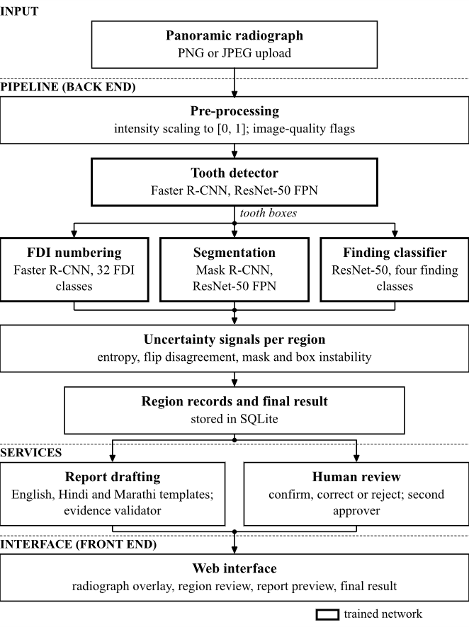
Figure 4.1: System architecture of DentaMind AI as implemented. Bold outlines mark trained networks.
Two design decisions shape this architecture. First, regions are linked between models by overlap (intersection over union), never by their position in a list, because the models return their outputs in different orders and some regions have no counterpart in another model. Second, the original upload is never modified; preprocessing works on a copy, so that a reviewer can always see the image the models analyzed.

4.2 SYSTEM BLOCK DIAGRAM
Figure 4.2 shows the same system as deployed software blocks. The browser talks only to the FastAPI back end, through the Vite development proxy that adds the API token, so the token never appears in the front-end code. The back end is split into services for images, analysis, reports, reviews, active learning, models and the dataset. The model layer loads the four checkpoints through a registry that verifies each file’s SHA-256 hash against its sidecar before use. Everything is stored on the local disk.
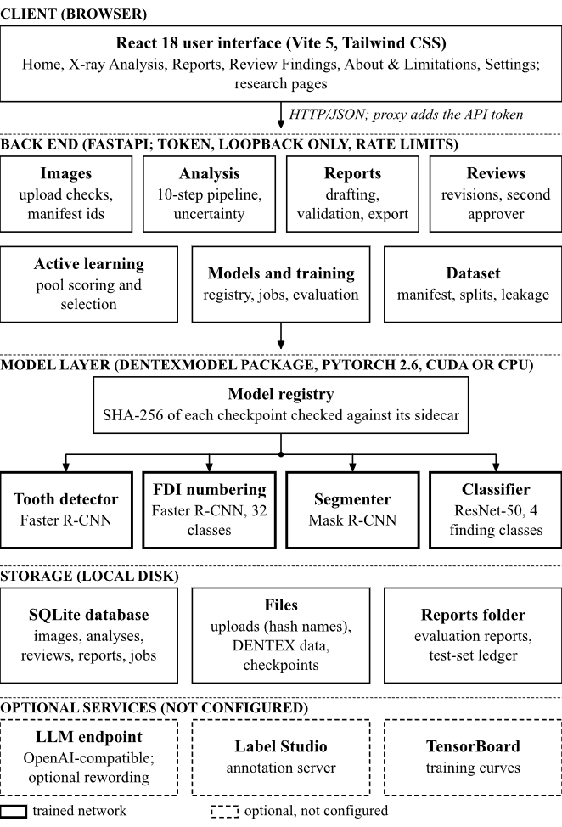
Figure 4.2: System block diagram: client, back-end services, model layer, storage and optional services (dashed, not configured).
The dashed blocks are optional services that the code supports but that were not configured in this deployment: an OpenAI-compatible language-model endpoint for rewording reports, a Label Studio annotation server and TensorBoard. With the shipped configuration nothing leaves the machine.

4.3 SYSTEM WORKFLOW

4.3.1 End-to-End Processing
Figure 4.3 lists the ten pipeline steps in the order in which the analysis service runs them. Each step is timed and records its status. If a model is missing, its step is reported as unavailable; if a step crashes, it is reported as failed. Later steps that do not depend on it still run, and a missing signal is reported as unavailable instead of being set to zero, so that a reviewer can tell “no problem found” from “not measured”.
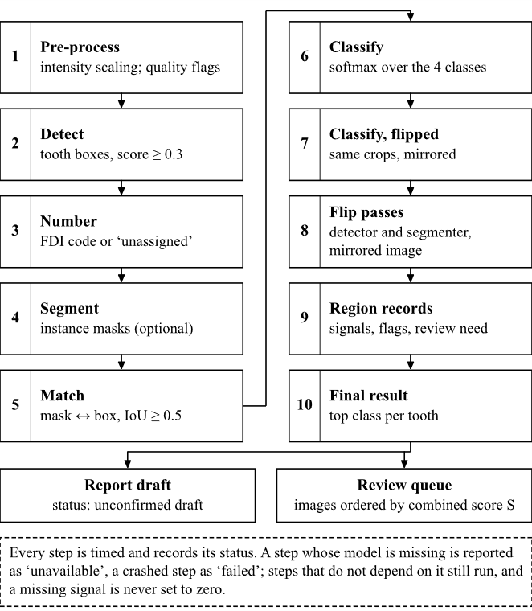
Figure 4.3: End-to-end processing workflow: the ten implemented pipeline steps, the two outputs, and (dashed) the behaviour when a step is unavailable or fails.

4.3.2 Detection, Numbering and Segmentation
Figure 4.4 shows how the three localization models are combined. The detector proposes tooth boxes with score at least 0.3. The numbering model is a second detector with one class per FDI code. Each detector box takes the unused numbering box with the highest overlap, provided the IoU is at least 0.5, and otherwise stays unassigned. Instance masks from the segmenter are matched one to one to detector boxes at the same threshold. A consistency check flags duplicated codes, low-confidence codes and codes on the wrong side or arch for their quadrant.
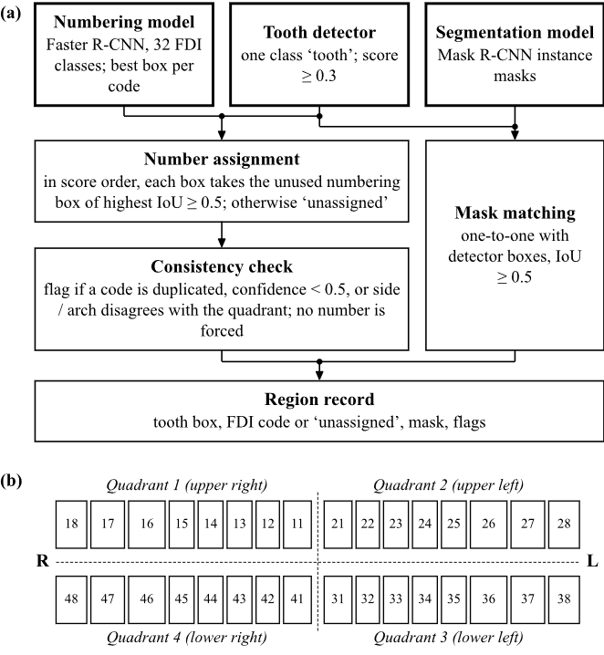
Figure 4.4: (a) Combination of detector boxes, numbering model and segmentation model into a region record. (b) FDI two-digit notation used for the 32 numbering classes, as the teeth appear on a panoramic radiograph.

4.3.3 Finding Classification
Figure 4.5 shows the classification path. Each tooth box is cropped with 10 % padding, resized to 224 × 224 pixels, normalized with ImageNet statistics and passed to a ResNet-50 with a four-way output layer. The application crops detector boxes, while the evaluation of Chapter 7 crops ground-truth boxes; the difference between the two is measured in Section 7.5. Because DENTEX labels only teeth that carry a finding, the softmax output answers “which of these four findings does this crop most resemble”, not “is this tooth diseased”.
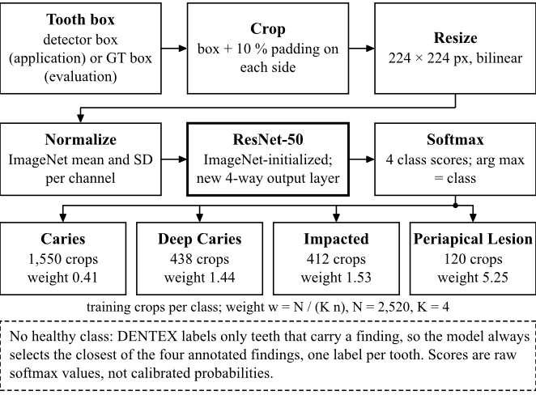
Figure 4.5: Finding-classification workflow with the training-crop count and class weight of each class; the dashed note states that there is no healthy class.

4.3.4 Uncertainty and Review Routing
Figure 4.6 separates what the application does from what was only evaluated offline. Five conditions send a region to review; their thresholds are listed in Table 4.1. The entropy and flip-disagreement thresholds were fixed once on the calibration split, using one seed and one dataset, and are therefore provisional. A region at or above the entropy threshold is marked as abstained. Since a project decision of 2026-10-16, its highest-scoring class is still shown, labelled as needing human review because of high classifier uncertainty, and an abstained tooth is never reported as healthy. Scores shown to users are raw softmax values, not calibrated probabilities.
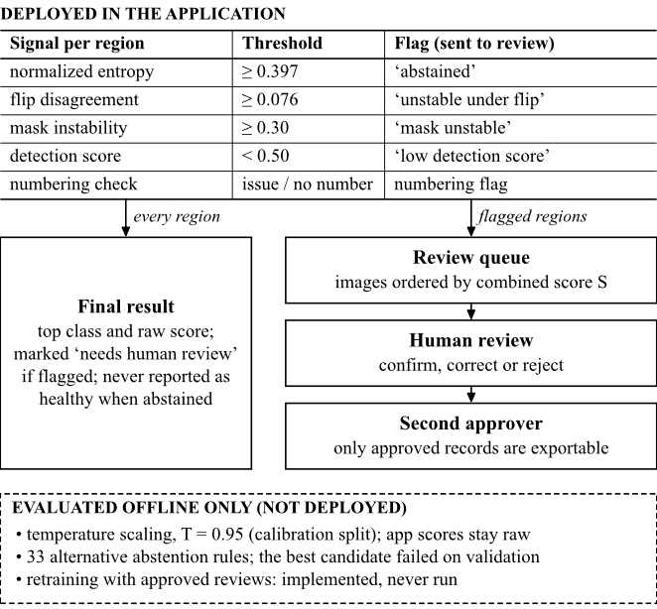
Figure 4.6: Uncertainty-aware review routing. Upper part: thresholds and routing deployed in the application. Lower dashed panel: methods evaluated offline only.
Table 4.1: Review Thresholds Deployed in the Application
Signal per region | Threshold | How it was set | Effect
Normalized entropy H | ≥ 0.397 | Maximizes Youden’s index on calibration crops | abstained; review
Flip disagreement JS | ≥ 0.076 | 90th percentile on calibration crops | review
Mask instability u_{mask} | ≥ 0.30 | Fixed design value | review
Detection score | < 0.50 | Fixed design value | review
Numbering check | issue or no number | Rule-based consistency check | review
Sources: Data/reports/uncertainty_thresholds.json (entropy 0.3966 and flip disagreement 0.0762, chosen on the calibration split on 2026-10-14) and backend/services/pipeline.py (mask and detection thresholds; the built-in fallbacks 0.40 and 0.10 apply only if the threshold file is missing). Temperature scaling and alternative abstention rules were evaluated offline only.

4.3.5 Evidence-Grounded Report Generation
Figure 4.7 shows the generative component. A stored analysis is converted into an evidence bundle with one finding per region and a stable identifier (F1, F2, and so on). By default the template generator writes the summary and one sentence per finding. If a language-model endpoint were configured, the de-identified findings could be sent for rewording instead, but the returned text passes through the same validator, and any violation makes the system discard it and fall back to the template. The English draft is the reference: the Hindi and Marathi views are produced from fixed sentence templates with all values copied verbatim, and an export is refused if any value differs. A report becomes a reviewed research draft only when a named person signs it.
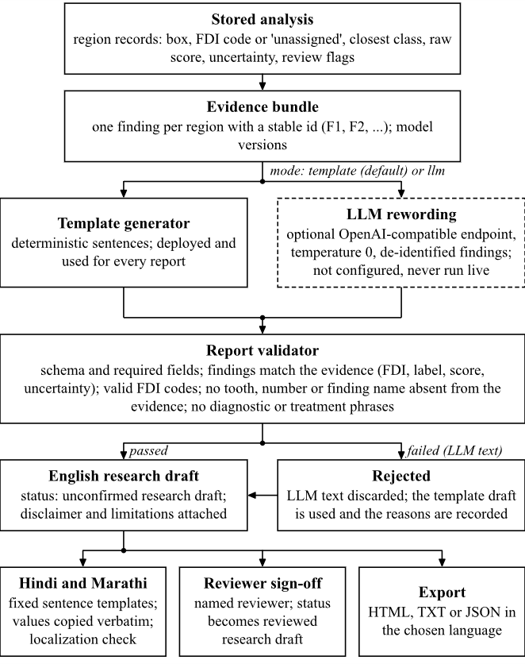
Figure 4.7: Evidence-grounded report generation as implemented; the dashed block (LLM rewording) is optional, not configured and never run against a live model.

4.4 MATHEMATICAL MODEL
This section gives the mathematical definitions used by the implemented system: the overlap measures that link regions, the class weights used in training, the uncertainty signals and the review rule. The evaluation measures follow in Subsection 4.4.5. All symbols are also listed in the Nomenclature.

4.4.1 Overlap Measures
Two regions A and B, which may be boxes or binary masks, are compared by their intersection over union and, for masks, by the Dice coefficient:
$IoU\left(A,B\right)=\frac{|A∩B|}{|A∪B|}, Dice\left(A,B\right)=\frac{2|A∩B|}{|A|+|B|}$ (4.1)
Two regions are matched when IoU ≥ 0.5. Matching is one to one and greedy: detector boxes are visited in descending score order and each takes the best unused partner.

4.4.2 Class Weights for the Finding Classifier
The training crops are strongly imbalanced, so the cross-entropy loss weights each class inversely to its frequency:
$w_{c}=\frac{N}{Kn_{c}}$ (4.2)
where N = 2,520 training crops, K = 4 classes and n_{c} is the number of training crops of class c. With 1,550, 438, 412 and 120 crops this gives weights 0.41, 1.44, 1.53 and 5.25 for Caries, Deep Caries, Impacted and Periapical Lesion.

4.4.3 Uncertainty Signals
The classifier’s logits z_{k} are turned into probabilities by the softmax. The normalized predictive entropy of a probability vector p over K classes lies between 0 and 1:
$H\left(p\right)=-\frac{\sum_{k}{p_{k} ln p_{k}}}{ln K}$ (4.3)
Flip disagreement compares the prediction p for a crop with the prediction q for its horizontally flipped copy, a two-pass form of test-time augmentation [30], using the Jensen-Shannon divergence [36] normalized by ln 2:
$JS\left(p,q\right)=\frac{H'\left(\frac{p+q}{2}\right)-\frac{H'\left(p\right)+H'\left(q\right)}{2}}{ln 2}$ (4.4)
where H′ is the unnormalized Shannon entropy. Mask instability (and, in the same way, detection instability) measures how much an instance changes when the whole image is flipped, processed and flipped back:
$u_{mask}=1-IoU\left(m,{m̃}_{flip}\right)$ (4.5)
where m is the mask and m̃_{flip} its best match on the flipped image; an instance without a counterpart counts as 1. The image-level score that orders the review queue is the weighted mean of the signals that are available:
$S=\frac{\sum_{j∈avail}{α_{j}s_{j}}}{\sum_{j∈avail}{α_{j}}}$ (4.6)
with weights α = 0.4 for entropy, 0.4 for flip disagreement and 0.2 for mask instability, renormalized over the available signals. Detection instability is displayed but not included in S. None of these signals is an ensemble or a Bayesian estimate; all come from one network.

4.4.4 Review Rule
A region r is sent for review when any of the conditions of Table 4.1 holds:
$review\left(r\right)=[H≥τ_{H}]∨[JS≥τ_{JS}]∨[u_{mask}≥τ_{M}]∨[d<τ_{D}]∨num$ (4.7)
where d is the detection score, τ_{H} = 0.397, τ_{JS} = 0.076, τ_{M} = 0.30, τ_{D} = 0.50, and “num” is true when the numbering check reports a problem or the tooth has no number. The entropy threshold maximizes Youden’s index [35] on the calibration crops,
$J=TPR-FPR$ (4.8)
where a positive is a classifier error, TPR is the fraction of errors flagged and FPR the fraction of correct crops flagged.

4.4.5 Evaluation Measures
Precision, recall and F1 are computed from true positives (TP), false positives (FP) and false negatives (FN); macro-F1 is the unweighted mean of the per-class F1 values:
$P=\frac{TP}{TP+FP}, R=\frac{TP}{TP+FN}, F1=\frac{2PR}{P+R}, {F1}_{macro}=\frac{1}{K}\sum_{k=1}^{K}{{F1}_{k}}$ (4.9)
Detection and segmentation use COCO-style average precision [27]: AP50 at an IoU threshold of 0.5, and mAP averaged over IoU thresholds from 0.50 to 0.95 in steps of 0.05. Calibration is measured with the expected calibration error over 15 equal-width confidence bins [33] and with the multi-class Brier score [34]:
$ECE=\sum_{m=1}^{15}{\frac{|Bₘ|}{n}|acc\left(Bₘ\right)-conf\left(Bₘ\right)|}, BS=\frac{1}{n}\sum_{i}{\sum_{k}{{\left(p_{ik}-y_{ik}\right)}^{2}}}$ (4.10)
Temperature scaling [32] divides the logits by a scalar T fitted by negative log-likelihood on the calibration split (grid from 0.5 to 5.0 in steps of 0.05):
$p_{k}=\frac{exp\left(z_{k}/T\right)}{\sum_{j}{exp\left(z_{j}/T\right)}}$ (4.11)
For an abstention rule [31], coverage is the fraction of crops that receive a class, and risk is the error rate among them:
$cov=\frac{|accepted|}{n}, risk=\frac{|wrong∩accepted|}{|accepted|}$ (4.12)
Finally, the ability of a signal to rank errors is summarized by the AUROC, the probability that a randomly chosen misclassified crop receives a higher score than a randomly chosen correct one, with ties counted as one half.
CHAPTER 5

PROJECT IMPLEMENTATION

5.1 OVERVIEW OF PROJECT MODULES
The implementation has four parts: a Python library (src/dentexmodel) that holds the data handling, models, uncertainty, reporting and evaluation code; a FastAPI back end (backend) that exposes this library as a local web service; a React front end (frontend); and a set of command-line scripts for data processing, training, evaluation and auditing. Table 5.1 maps the main modules to their location in the code. The library can be used without the web application, which is how the training and evaluation scripts use it.
Table 5.1: Main Modules and Their Location in the Code
Module | Location | Responsibility
Data | src/dentexmodel/data | Discovery, manifest, validation, pixel-hash splits, leakage checks, FDI codes, crop preprocessing
Training | src/dentexmodel/training; scripts/train_model.py | Training configuration, trainers, background jobs, provenance records
Inference | src/dentexmodel/inference | Model registry, torchvision models, tooth-number assignment, Grad-CAM, overlays
Uncertainty | src/dentexmodel/uncertainty | Entropy, flip disagreement, instability, abstention, temperature scaling, quality flags
Reporting | src/dentexmodel/reporting | Evidence bundle, template and LLM drafting, validator, Hindi and Marathi templates, final result
Evaluation | src/dentexmodel/evaluation; scripts/evaluate_*.py | Metrics and the hash-chained test-set ledger
Active learning | src/dentexmodel/active_learning | Random, entropy, disagreement and combined selection
Annotation and review | src/dentexmodel/annotation | Region reviews with revisions and approvals; Label Studio connector
Back end | backend (api, services, database, security.py) | REST API, ten-step pipeline service, SQLite storage, token, loopback and rate-limit checks
Front end | frontend/src (pages, components) | Home, X-ray Analysis, Reports, Review Findings, About and Limitations, Settings, research pages
Tests and audits | tests; scripts/audit_*.py | Automated test suite and live audit harnesses

5.2 DATA COLLECTION AND PREPROCESSING

5.2.1 Data Collection
No new images were collected. The project uses the public DENTEX challenge data [14], distributed through the Zenodo open-access repository and released under the CC BY-NC-SA 4.0 licence, whose terms apply to any reuse. The images are de-identified research data from three institutions; according to the dataset description they come from patients aged 12 and above. The data were stored locally in Data/training_data (3,606 files, 14.7 GB) and Data/validation_data (51 files).

5.2.2 Dataset Audit and Splitting
Before any training, an audit script identified every radiograph by the SHA-256 hash of its pixels. This revealed the overlap described in Section 3.6: identical radiographs appear in several sub-sets under different names. Splitting by file would therefore have placed copies of the same radiograph in training and test. Instead, all copies form one group, and groups are assigned with seed 42 to train, validation, calibration and test in proportions 0.70/0.10/0.10/0.10. The split file is append-only, so a radiograph never changes split once assigned. Figure 5.1 summarizes the protocol, including the leakage checks and the gate around the test split.
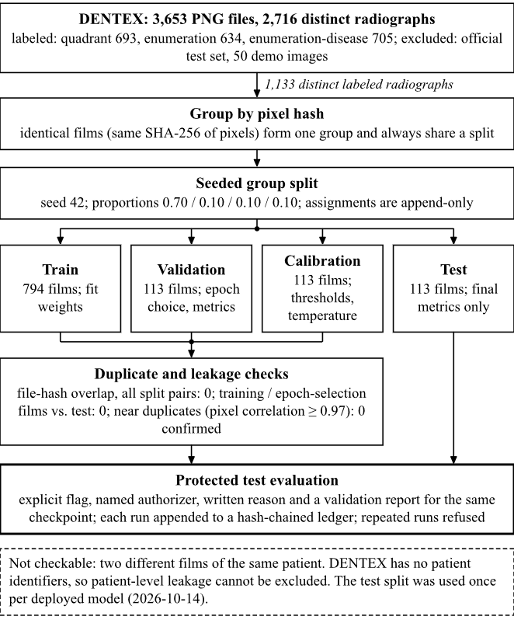
Figure 5.1: Dataset splitting and integrity protocol: pixel-hash grouping, seeded split into four splits, duplicate and leakage checks, and the gated test evaluation.

5.2.3 Image Preprocessing
The uploaded file is never changed. For the detection, numbering and segmentation models the image is converted to an RGB array with values in [0, 1] at full resolution, and torchvision’s internal transform resizes it so that the shorter side is 800 pixels and the longer side at most 1,333 pixels. Grayscale contrast statistics are computed only to raise image-quality warnings; they do not alter the model input. For the finding classifier, each tooth box is enlarged by 10 % on each side, cropped, resized to 224 × 224 pixels and normalized with the ImageNet mean and standard deviation [28]. The same crop function is used in training, evaluation and the application, and an end-to-end check confirmed that both paths give byte-identical pixels (Section 7.5).

5.2.4 Labels and Upload Validation
FDI codes are formed from the quadrant and tooth index of the enumeration labels, giving 32 permanent-tooth classes [9]. Finding labels are the four English DENTEX classes. Uploaded files must be PNG or JPEG; both the extension and the file signature are checked, the size limit is 25 MB, and the stored name is derived from the content hash rather than the client’s file name. Files that fail any check are refused and nothing is written to disk.

5.3 GENERATIVE AI MODEL SELECTION
The generative component had to turn a list of model findings into readable text in three languages without adding anything. Four options were considered, and Table 5.2 records the decision for each.
Table 5.2: Options Considered for the Generative Component
Option | Reason for the decision | Decision
Image-to-report model such as R2Gen [21] | Needs a large set of images paired with written reports; DENTEX has none | Not possible
Free-text generation by an LLM [4] | Fluent, but can invent teeth, numbers or diagnoses [7]; needs an external service or a large local model | Rejected as the default
Retrieval-augmented generation [8] | Needs a curated, reviewed dental knowledge corpus, which the project does not have | Not used
Template-based data-to-text [19] with optional LLM rewording | Deterministic, works offline, every sentence traceable to a finding; an LLM can reword but cannot bypass the validator | Selected

The selected design keeps generation subordinate to evidence. The template generator is the default and is the only generator that has been used to produce reports. The optional LLM path is implemented for completeness. It sends only de-identified findings to an OpenAI-compatible endpoint, accepts only JSON output, and passes that output through the same validator as the templates, falling back to the template on any violation. Because no endpoint was configured, this path has never been run against a live model; its behaviour is known only from unit tests with a simulated response.
For the perception models, the choice followed from the hardware and from the code base. Faster R-CNN [23], Mask R-CNN [25] and ResNet-50 [26] are available in torchvision with pre-trained weights, fit on a 4 GB laptop GPU, and were already used by the template notebooks the project started from [16]. A diffusion-based detector like the DENTEX baseline [15] would have needed far more computation.

5.4 MODEL CONFIGURATION AND FINE-TUNING
All four perception models are fine-tuned from general-domain pre-trained weights: the detectors from COCO [27] and the classifier from ImageNet [28]. Table 5.3 gives the configuration recorded in each checkpoint’s sidecar file. Every model uses AdamW with weight decay 10⁻⁴, a cosine learning-rate schedule and seed 42, and keeps the epoch with the best validation score. Horizontal flips augment the one-class detector and the segmenter, but not the numbering model, because a flip would swap left and right FDI codes. The classifier uses horizontal flips with probability 0.5, multiplicative contrast jitter of ±5 % and the class weights of (4.2).
Table 5.3: Training Configuration of the Four Deployed Checkpoints
Model | Architecture (initialization) | Epochs / batch / lr | Selection on validation
Tooth detector | Faster R-CNN R50-FPN, 1 class (COCO) | 12 / 2 / 1e-4 | box mAP@[.5:.95]
FDI numbering | Faster R-CNN R50-FPN, 32 classes (COCO) | 16 / 2 / 1e-4 | box mAP@[.5:.95]
Segmenter | Mask R-CNN R50-FPN, 1 class (COCO) | 8 / 1 / 1e-4 | box mAP@[.5:.95]
Finding classifier | ResNet-50, 4 classes (ImageNet V2) | 15 / 32 / 3e-4 | macro-F1 (epoch 5 kept)
Sources: Data/checkpoints/*.json sidecars. Training data: 440 radiographs for the three localization models and 2,520 crops from 476 radiographs for the classifier. The checkpoints are legacy: image-level training membership was not recorded (Section 7.6).
The optional language model is not fine-tuned. If configured, it is called with temperature 0, a JSON response format and a system prompt that tells it to use only the supplied findings, never to say that a finding is present, to mark high-uncertainty findings as needing human review, and never to add diagnoses, treatment advice, teeth, labels or numbers. The endpoint, key and model name are read from environment variables and are never returned by the API.

5.5 PROJECT MODULES

5.5.1 Image Management
The image service lists dataset and uploaded images under identifiers that are unique across sub-sets, serves files, thumbnails and quality summaries, and accepts uploads after the checks of Subsection 5.2.4. Identifiers are never used as file paths, so a request cannot reach files outside the manifest or the upload table.

5.5.2 Analysis Pipeline
The pipeline service runs the ten steps of Figure 4.3 for one image. It applies the detector, assigns FDI numbers (Algorithm Algorithm 2), runs the segmenter, matches masks to boxes, classifies every crop and its flipped copy, repeats detection and segmentation on the flipped image, and stores one record per region with a content-derived identifier built from the image, the model version and the box rounded to 8 pixels. Identical reruns therefore give identical region identifiers, which keeps reviews attached to the right region.

5.5.3 Uncertainty and Review Routing
The uncertainty module computes the signals of Section 4.4 and applies the review rule (4.7). Thresholds are read from the calibration report and are labelled provisional in the interface. The review queue orders images by the combined score S, so that the most uncertain images are reviewed first.

5.5.4 Explainability
For a selected region, the explain endpoint computes a Grad-CAM heat map [37] of the classifier for that crop and returns it at the size of the box. The heat map shows which pixels influenced the classifier’s score. It does not show where a finding is, and the interface says so.

5.5.5 Human Review
A reviewer can confirm, correct or reject a region’s class, set or clear its tooth number, or mark the image for specialist review or as unusable. Every record stores the model output the reviewer saw. A changed decision creates a new revision, an identical resubmission is refused, and approval requires a second person whose name differs from the reviewer’s. Reviewer names are typed in and are not verified. Only approved reviews of unlabeled-pool or uploaded images can be exported for training; validation, calibration, test and labeled images are excluded and counted.

5.5.6 Report Generation and Localization
The report service builds the evidence bundle, calls the template generator (or, if configured, the LLM path), validates the draft, stores it and renders HTML, TXT or JSON exports in English, Hindi or Marathi (Algorithm Algorithm 3). The Hindi and Marathi views come from fixed sentence templates (src/dentexmodel/reporting/i18n.py); a localization check refuses an export if any identifier, FDI code, score, version or review status differs from the English report. Every view carries the research-draft disclaimer, the limitations and, for Hindi and Marathi, a notice that the translation awaits linguistic review.

5.5.7 Active Learning
The active-learning module scores unlabeled pool images with the uncertainty pipeline and selects images for annotation by random, entropy, disagreement or combined strategies, with a recorded seed and budget. The pool excludes the locked test split and pixel duplicates of labeled images. Signals that cannot be computed, such as ensemble disagreement with a single model, are reported as unavailable rather than filled with zeros.

5.5.8 Model Registry, Training and Evaluation
The registry lists each checkpoint with its sidecar metadata and refuses a checkpoint whose file hash does not match the sidecar. Training jobs run in the background with per-epoch metrics and can be stopped. Evaluation through the API is limited to the validation and calibration splits; the test split can be evaluated only from the command line with an explicit flag, a named authorizer, a written reason and a prior validation report for the same checkpoint, and every such run is appended to a hash-chained ledger.

5.5.9 User Interface
The front end offers a simple path for a reviewer (Home, X-ray Analysis, Reports, Review Findings, About and Limitations, Settings) and separate research pages for uncertainty, models, training, experiments and active learning. The analysis page overlays boxes, tooth numbers, candidate classes and masks on the radiograph, lists every region and states how many need review. Screenshots of the implemented interface are shown in Section 7.8.

5.6 TOOLS AND TECHNOLOGIES USED
Table 5.4 lists the tools used and what each was used for. The list is limited to tools that are part of the delivered system or were used to produce its results.
Table 5.4: Tools and Technologies Used
Tool | Purpose in the project
Python 3.13 | Library, back end, training, evaluation and audit scripts
PyTorch 2.6 and torchvision 0.21 | Model definitions (Faster R-CNN, Mask R-CNN, ResNet-50), pre-trained weights, training and inference on CUDA 12.4
NumPy and Pillow | Image decoding, arrays, masks and crops
FastAPI, Uvicorn and Pydantic | REST API, request validation and error responses
SQLite | Storage of images, analyses, regions, reviews, reports and jobs
React 18, React Router, Recharts, lucide-react | Single-page user interface, charts and icons
Vite 5 and Tailwind CSS 3 | Front-end development server with API proxy, build and styling
pytest and unittest | Automated test suite (590 tests passed on 2026-10-26)
Playwright with Microsoft Edge | Browser audits of the user interface
Git | Version control of code and reports
Windows PowerShell scripts | Setup, start-up, health check and the audit suite on Windows

5.7 ALGORITHM DETAILS
Three algorithms capture the core of the implementation. Algorithm 1 is the per-image analysis and review routing; Algorithm 2 assigns FDI numbers to detector boxes; Algorithm 3 drafts and validates a report.
Algorithm 1: Per-image analysis and review routing (as implemented)
Input: radiograph I (RGB, values in [0, 1]); thresholds τ_{H} = 0.397, τ_{JS} = 0.076, τ_{M} = 0.30, τ_{D} = 0.50
1: D ← tooth detector(I), keeping boxes with score ≥ 0.3
2: assign FDI codes to D with Algorithm 2 and run the consistency check
3: M ← segmenter(I); match M to D one to one at IoU ≥ 0.5
4: repeat detection and segmentation on the flipped image to obtain instability signals
5: for each box d ∈ D do
6: p ← classifier(crop(d)); q ← classifier(flip(crop(d)))
7: compute H(p), JS(p, q), u_{mask} and detection instability
8: flags ← conditions of the review rule that hold, plus missing mask and “not found on flipped image”
9: status ← abstained if H ≥ τ_{H} (top class still shown); review ← flags not empty or number unassigned
10: S ← weighted mean of the available image-level signals; store region records
11: place the image in the review queue ordered by S

Algorithm 2: FDI number assignment
Input: detector boxes D with scores; raw numbering detections N (32 classes)
1: drop numbering boxes with score < 0.3; apply class-agnostic NMS at IoU 0.5; keep the best box per FDI code
2: for each d ∈ D in descending score order do
3: n* ← unused numbering box with the highest IoU(d, n)
4: if IoU(d, n*) ≥ 0.5 then code(d) ← code(n*); mark n* used else code(d) ← unassigned
5: flag codes that are duplicated, have confidence < 0.5, or lie on the wrong side or arch for their quadrant (image-left is patient-right)

Algorithm 3: Evidence-grounded report drafting and validation
Input: stored analysis A; mode ∈ {template, llm, auto}
1: E ← evidence bundle: one finding per region of A with id Fk, FDI code, label, raw score, uncertainty, review status
2: if mode = llm, or mode = auto and an endpoint is configured, then
3: send de-identified findings; R ← parsed JSON reply; if not valid JSON then R ← template(E) and record the rejection
4: else R ← template(E)
5: V ← validate(R, E): required fields, matching values, valid FDI codes, no unsupported teeth, numbers, finding names or clinical phrases
6: if V failed and R came from the LLM then R ← template(E) and record the reasons
7: store R with status “unconfirmed research draft”; render English, Hindi or Marathi on request
8: refuse an export whose localized values differ from R; set status “reviewed” only when a named reviewer signs

CHAPTER 6

SOFTWARE TESTING
Testing was done at four levels: an automated unit and integration suite; live harnesses that call the running API with real checkpoints; browser audits that drive the real interface; and a set of acceptance tests that follow a user through the whole workflow. This chapter reports software tests only. The accuracy of the models is a separate question and is evaluated in Chapter 7; a passing software test says nothing about clinical validity.

6.1 TEST CASES
Table 6.1 lists the 20 acceptance tests run on 2026-10-14 with the real FastAPI back end, the real Vite front end and real checkpoints on real radiographs. No mocked inference was used. Nineteen tests passed and one (AT-17) was partial, because three state-changing buttons were deliberately not clicked and were tested through the API instead.
Table 6.1: Acceptance Test Cases and Observed Outcomes (2026-10-14)
ID | Feature | Input or scenario | Expected outcome | Observed outcome | Status
AT-01 | Back end | Start FastAPI | Server starts | Healthy 4.1 s after launch | Pass
AT-02 | Front end | Start Vite | UI on port 5173 with API proxy | HTTP 200; proxy verified | Pass
AT-03 | Health | GET /api/health | Database ok, 4 checkpoints | Ok; health check script exit 0 | Pass
AT-04 | Upload | Valid PNG, JPEG, Unicode file name | Stored under hash id; bytes unchanged | Accepted; duplicate detected; download byte-identical | Pass
AT-05 | Upload | Corrupt, truncated, wrong type, empty, oversized files | 4xx; nothing stored | All refused with 422; nothing left on disk | Pass
AT-06 | Detection | Two test-split films and one upload | Real boxes, valid geometry | 31, 28 and 33 detections on GPU in about 0.4 s; identical on repeat | Pass
AT-07 | Classification | Detected regions | Softmax per crop; abstention | Four scores summing to 1; high-entropy regions abstained | Pass
AT-08 | Segmentation | Same images | Valid masks | 32, 29 and 32 instances inside their boxes | Pass
AT-09 | Overlay | Compare UI with API output | Identical | All 32 rows and boxes equal; position within 0.3 px | Pass
AT-10 | Numbering missing | Remove numbering checkpoint | No invented numbers | 0 of 32 regions numbered; all flagged; step unavailable | Pass
AT-11 | Uncertainty | Compute for an image | Real signals; unavailable ≠ 0 | Entropy 1.0 for uniform and 0.0 for one-hot input; thresholds labelled provisional | Pass
AT-12 | English report | Generate from analysis | Research-draft banner | Generated; banner shown | Pass
AT-13 | Hindi, Marathi | Switch language | Identical structured values; no new inference | 58 report checks identical; no inference request | Pass
AT-14 | Export | HTML, TXT, JSON per language | Well-formed files | 9 exports well-formed and escaped | Pass
AT-15 | Persistence | Reload; second server process | Same report | Reopened with same content and list | Pass
AT-16 | Model registry | List models | Version, hash, evaluation links | 4 models; sidecar hash equals file hash | Pass
AT-17 | UI controls | Click every control | No silent buttons | 56 controls work or state why not; 3 state-changing buttons not clicked | Partial
AT-18 | Logs | Access log and console | No unexpected errors | 1,650 log lines, no HTTP 500, no traceback | Pass
AT-19 | Unit tests | Run test suite | All pass | 180 tests OK | Pass
AT-20 | Data safety | Hash checkpoints and data | Nothing deleted or overwritten | All 8 checkpoint files and the data folders identical | Pass
Source: docs/FINAL_ACCEPTANCE_REPORT.md and docs/audit_evidence/. The abstention display described in AT-07 and AT-12 changed on 2026-10-16: abstained regions now also show their highest-scoring class with a review label.
Table 6.2 summarizes the larger test campaign. The first audit pass found one cosmetic failure (the health endpoint reported its version as unknown); it was fixed in a second pass the same day, which also added authentication, loopback restriction and rate limiting. On 2026-10-26, for this report, the automated suite was run again on the current code.
Table 6.2: Summary of Software Test Results
Test campaign | Date | Result
Acceptance tests (Table Table 6.1) | 2026-10-14 | 19 pass, 1 partial, 0 fail
All harnesses, first pass (unit, live API, per-model, reports, browser, review) | 2026-10-14 | 466 pass, 1 fail (cosmetic), 0 blocked
All harnesses, second pass | 2026-10-14 | 550 pass, 0 fail (including 205 unit tests)
Security checks (token, loopback, rate limits) | 2026-10-14 | 23 pass
Functionality audit (60 features) | 2026-10-14 | 42 pass, 1 fail, 5 blocked, 7 partial, 5 not implemented; 15 defects fixed
Full test suite after the last training run | 2026-10-16 | 309 pass, 0 fail
Full test suite (pytest), current code | 2026-10-26 | 590 pass, 0 fail (and 21 subtests) in 197 s
Sources: docs/FINAL_ACCEPTANCE_REPORT.md, docs/REMAINING_ISSUES.md, docs/FUNCTIONALITY_AUDIT.md, reports/training_summary.md; the 2026-10-26 run was executed for this report. Blocked items (live LLM, Label Studio, TensorBoard, native linguistic review) are not counted as passed.

6.2 GENERATIVE AI OUTPUT TESTING
The report generator was tested as a component that must be correct, not merely fluent. The campaign of 2026-10-14 ran 61 checks against the live API; all 61 passed. A further 21 report rows in the live-API harness and seven browser checks also passed. Table 6.3 shows a representative selection. The checks cover four questions: is the report built only from the analysis, do the three languages carry exactly the same values, does the validator reject bad evidence and unsupported text, and are failures reported truthfully.
Table 6.3: Selected Report-Generation Test Cases (2026-10-14)
ID | Check | Expected | Observed | Status
RPT-A02 | Generate English report from a real 33-region analysis | Unconfirmed draft with model versions | Created with status unconfirmed research draft | Pass
RPT-A03 | Regenerate from the same analysis | Identical findings | New id; findings identical | Pass
RPT-B02 | Unsupported language codes (xx, fr, HI, path-like) | 422, no English fallback | All refused with 422 | Pass
RPT-C01 | Hindi and Marathi values vs English | Exactly equal | 33 of 33 findings equal in each language | Pass
RPT-C03 | Every decimal of the English text in the translation | None missing | None missing | Pass
RPT-C07/C08 | Treatment wording in any language | None | None found | Pass
RPT-C09 | Sentences mentioning diagnosis or presence | All negations or limitations | 16 sentences, all negated | Pass
RPT-E04 | Evidence with invalid FDI code 99 | Report flagged invalid | Validation failed; not exportable as clean | Pass
RPT-E05 | Evidence with label “Healthy” | Report flagged invalid | Validation failed | Pass
RPT-E06 | Probability 1.7 | Report flagged invalid | Validation failed | Pass
RPT-E07 | Injected “confirmed diagnosis” text | Truthful refusal or safe, flagged output | HTTP 200; output met the harness’s safety criterion | Pass
RPT-E08 | LLM mode without configuration | Truthful refusal | 502 “LLM is not configured” with a hint | Pass
RPT-F01 | Sign-off with empty reviewer name | Refused | 422; status stays unconfirmed | Pass
RPT-I02 | Translation review flag | Shown as not reviewed | Flag false for Hindi and Marathi | Pass
REP-031 | Reviewer name containing a script tag | Escaped in HTML export | No raw script tag | Pass
Source: docs/MULTILINGUAL_REPORT_TEST_REPORT.md (scripts/audit_reports.py and scripts/audit_live_api.py).
The LLM path could not be tested against a real model, because no endpoint was configured. Its logic is covered by unit tests that replace the network call with a simulated reply. A valid JSON reply is accepted and marked as generated by the LLM, and the outgoing request is checked to contain no image identifier. A reply whose summary says “Tooth 36 needs a root canal.” is rejected and replaced by the template draft, because tooth 36 is not in the evidence and “root canal” is a forbidden phrase. A reply that is not JSON is also replaced by the template. These tests show that the guard works as designed; they do not show how often a real model would trip it.
The campaign also found and fixed three defects in the validator. Evidence with an impossible probability (1.7) or a label no model can produce (“Healthy”) had been accepted, because the validator compared the report with its evidence but did not check the evidence itself. A report about “Deep Caries” was wrongly flagged for mentioning “caries”. And the first fix for the label check broke every real report, because the configuration spells the class “DeepCaries” while the model outputs “Deep Caries”; the live run caught this before release. Each defect now has a regression test.
Two qualities could not be tested by software. The linguistic quality of the Hindi and Marathi wording needs a native-speaking dental professional, and no such review has taken place; the interface and every export say so. Whether the drafts are useful to a clinician also remains unmeasured.

6.3 PERFORMANCE EVALUATION
Table 6.4 gives the inference time of each stage on the RTX 3050 Laptop GPU for 10 panoramic images of up to 3,076 × 1,536 pixels, measured after two warm-up runs with no failures. Detection takes about 0.1 s per image and segmentation about 0.3 s, with peak GPU memory up to 1.65 GB. The detection-plus-numbering harness runs the detector twice and so overstates the cost in the application.
Table 6.4: Inference Benchmark (RTX 3050 Laptop GPU, 10 Images)
Stage | Mean (s) | Median (s) | p95 (s) | Images/s | Peak memory (MB)
Detection | 0.110 | 0.099 | 0.153 | 9.08 | 613
Segmentation | 0.285 | 0.298 | 0.339 | 3.51 | 1,653
Detection + numbering | 0.334 | 0.332 | 0.367 | 2.99 | 985
Detection + classification | 0.252 | 0.246 | 0.291 | 3.96 | 1,039
Source: Data/reports/benchmark_inference.json (2026-10-14).
In the archived interface audit, the application reported 1.92 s for the complete analysis of one image, including the flipped passes, and the server was healthy 4.1 s after a clean start. Without a GPU the same models run on the CPU, at about 7 to 23 s per prediction and 11 to 53 s per full analysis on the same laptop. These timings show that the system is interactive on modest hardware; they do not bear on its accuracy.
CHAPTER 7

RESULTS AND DISCUSSION
This chapter reports what the project produced and how well it works. Model results come from evaluation reports stored in the project and are copied without rounding beyond three decimals. Each table names its source. Validation numbers are optimistic, because validation also selected each model’s training epoch. The internal test split was evaluated once for each of the four deployed checkpoints on 2026-10-14, after model selection. All models were trained with one seed on one dataset, so there are no confidence intervals over seeds for the deployed models.

7.1 PROJECT OUTCOMES
The project delivered the following:
- an audited DENTEX data pipeline with pixel-hash grouped splits, leakage checks and a hash-chained ledger of test-split use;
- four trained and registered models (tooth detector, FDI numbering model, tooth instance segmenter and four-class finding classifier), each with a sidecar recording its configuration, data fingerprint and hash;
- a ten-step analysis pipeline that links the models region by region and attaches uncertainty signals and review flags to every region;
- an evidence-grounded report generator with English, Hindi and Marathi output, an automatic validator and named-reviewer sign-off;
- a local web application (FastAPI and React) with analysis, review, reporting, explanation, active-learning and model-management functions;
- a test campaign with 20 acceptance tests and an automated suite of 590 passing tests; and
- an evaluation that includes the unfavourable and negative results reported in this chapter, together with a 10-page IEEE-format draft paper (Appendix A).

7.2 RESULT ANALYSIS
Figure 7.1 maps each task and study to its metrics and to the splits on which it was evaluated. It separates two settings that are easily confused: classification on ground-truth tooth crops, which measures the classifier alone, and end-to-end classification on detector crops, which measures what the application actually does.
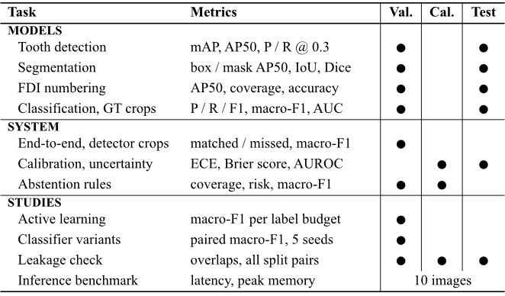
Figure 7.1: Experimental evaluation framework: each task or study, its metrics and the splits on which it was evaluated.

7.2.1 Tooth Detection and Segmentation
On the 63 test radiographs (1,790 teeth) the detector reaches AP50 0.966 and recall 0.974 at the operating point (score ≥ 0.3, IoU ≥ 0.5), as Table 7.1 shows. The segmenter’s mask AP50 is 0.974, and matched instances have a mean mask IoU of 0.780 and a mean Dice coefficient of 0.873. The much lower mAP@[.5:.95] (0.515 for detection) means that the boxes lie close to the annotations but are not tight. That difference looks harmless here, but it matters once the classifier receives detector crops (Section 7.5).
Table 7.1: Tooth Detection and Instance Segmentation
Metric | Det. val | Det. test | Seg. val | Seg. test
Radiographs / GT teeth | 69 / 2,000 | 63 / 1,790 | 69 / 2,000 | 63 / 1,790
Box mAP@[.5:.95] | 0.560 | 0.515 | 0.569 | 0.530
Box AP50 | 0.978 | 0.966 | 0.981 | 0.974
Mask AP50 | n/a | n/a | 0.980 | 0.974
Mean mask IoU / Dice (matched) | n/a | n/a | n.r. | 0.780 / 0.873
TP / FP / FN at score 0.3 | 1968/78/32 | 1743/73/47 | 1972/70/28 | 1754/69/36
Precision at score 0.3 | 0.962 | 0.960 | 0.966 | 0.962
Recall at score 0.3 | 0.984 | 0.974 | 0.986 | 0.980
Sources: Data/reports/eval_dentex_teeth_detection_v1_{val,test}.json and eval_dentex_teeth_segmentation_v1_{val,test}.json. n.r. = not recorded in the validation report. Mask IoU on a 4× subsampled grid; 1,753 matched test instances.

7.2.2 FDI Tooth Numbering
On test, 96.9 % of ground-truth teeth are matched by a numbered prediction and 96.8 % of those receive the exact FDI code (Table 7.2). Counting missed teeth as errors gives a strict accuracy of 93.8 %. Quadrant accuracy is 0.999, so almost all numbering errors put the wrong index in the right quadrant. Test accuracy is higher than validation accuracy (0.968 against 0.936); with 63 and 69 radiographs a gap of this size is within small-sample variation, and we do not read anything into it.
Table 7.2: FDI Tooth Numbering
Metric | Validation | Test
Radiographs / GT teeth | 69 / 2,000 | 63 / 1,790
Box mAP@[.5:.95] / AP50 (32 classes) | 0.524 / 0.928 | 0.507 / 0.952
Precision / recall at score 0.3 (any class) | 0.872 / 0.992 | 0.882 / 0.983
Coverage (matched / GT) | 0.979 (1,957) | 0.969 (1,734)
Exact accuracy among matched teeth | 0.936 | 0.968
Quadrant accuracy among matched teeth | 0.997 | 0.999
Strict accuracy over all GT teeth | 0.916 | 0.938
Lowest per-tooth exact accuracy | 36: 0.825; 47: 0.862 | 47: 0.912; 27: 0.917
Source: Data/reports/eval_dentex_fdi_numbering_v1_{val,test}.json. Third molars have the fewest ground-truth teeth (34 to 50 per split), so their per-tooth accuracies are the least stable.

7.2.3 Finding Classification on Ground-Truth Crops
On ground-truth test crops the classifier reaches accuracy 0.785 and macro-F1 0.646 (Table 7.3). Impacted teeth are recognized reliably (F1 0.926, AUC 0.990) and Caries reasonably well (F1 0.842). Deep Caries (F1 0.453) and Periapical Lesion (F1 0.364, recall 0.308) are poor. The confusion matrices in Table 7.4 locate the main errors. Caries and Deep Caries are confused in both directions (30 and 22 test crops), which is not surprising because the two classes differ in depth rather than in kind. Nine of the 13 test Periapical Lesions are labelled as some form of caries. The macro ROC AUC of 0.910 shows that the scores rank the classes better than the argmax decision suggests, which is what makes the uncertainty signals of Section 7.4 useful.
Table 7.3: Finding Classification on Ground-Truth Crops
Class | Split | P | R | F1 | n | Spec. | AUC
Caries | val | 0.885 | 0.863 | 0.874 | 205
 | test | 0.866 | 0.820 | 0.842 | 228 | 0.770 | 0.895
Deep Caries | val | 0.500 | 0.467 | 0.483 | 45
 | test | 0.414 | 0.500 | 0.453 | 48 | 0.889 | 0.834
Impacted | val | 0.919 | 0.944 | 0.932 | 72
 | test | 0.887 | 0.969 | 0.926 | 65 | 0.972 | 0.990
Periapical Lesion | val | 0.467 | 0.778 | 0.583 | 9
 | test | 0.444 | 0.308 | 0.364 | 13 | 0.985 | 0.921
Macro / accuracy | val | 0.693 | 0.763 | 0.718 | 331 | acc. 0.825
 | test | 0.653 | 0.649 | 0.646 | 354 | acc. 0.785 | 0.910
Source: Data/reports/eval_dentex_findings_classification_v1_{val,test}.json (65 and 73 radiographs). Specificity and one-vs-rest AUC were computed for the test split only. Validation macro-F1 was also the epoch-selection criterion.
Table 7.4: Confusion Matrices of the Finding Classifier (Rows: True Class; Validation / Test)
True \ predicted | Caries | Deep Caries | Impacted | Periapical
Caries | 177 / 187 | 18 / 30 | 5 / 6 | 5 / 5
Deep Caries | 20 / 22 | 21 / 24 | 1 / 2 | 3 / 0
Impacted | 2 / 1 | 2 / 1 | 68 / 63 | 0 / 0
Periapical Lesion | 1 / 6 | 1 / 3 | 0 / 0 | 7 / 4
Counts of ground-truth crops. Source: same reports as Table 7.3.

7.3 GENERATED OUTPUT ANALYSIS
Table 7.5 reproduces the beginning of a real report exported by the application during the audit of 2026-10-14. It was generated by the template path from a full analysis of an uploaded radiograph with 33 detected regions. The text is quoted exactly, including the British spelling used in the templates.
Table 7.5: Excerpt of a Generated English Report (Exported 2026-10-14)
Report text (verbatim)
[UNCONFIRMED RESEARCH DRAFT] Research draft generated from model outputs. Not a clinical diagnosis and not clinically validated. Requires review by a qualified professional.
Summary: The detection model (dentex_teeth_detection_v1) located 33 tooth region(s). Segmentation masks come from the segmentation model (dentex_teeth_segmentation_v1) and are matched to regions by overlap. Tooth numbers (FDI) come from the numbering model (dentex_fdi_numbering_v1); regions it did not match stay unnumbered. The classification model (dentex_findings_classification_v1) gave each region its closest class among four trained findings. It has no healthy class, so a class name here is not a statement that the finding is present. Of these, 32 have a tooth number from the numbering model, 32 have a matched segmentation mask, and 22 are flagged for manual review.
F1: tooth 48 - closest trained class 'Impacted' (score 0.98, normalised uncertainty 0.08); not evidence that the finding is present. Review status: unreviewed.
F2: tooth 18 - closest trained class 'Caries' (score 0.93, normalised uncertainty 0.19); not evidence that the finding is present. Review status: unreviewed.
F3: an unnumbered region - no reliable candidate class (normalised uncertainty 0.61); manual review required. Review status: unreviewed.
Source: docs/audit_evidence/report_en.txt (report RPT-5969557C37, generated by: template). Since 2026-10-16, an abstained region such as F3 is described with its highest-scoring class and a statement that it needs human review because of high classifier uncertainty.
Three properties of the generated text are worth pointing out. First, every number in it comes from the evidence: the region count, the counts of numbered, masked and flagged regions, and each score and uncertainty value. The validator checks this; a decimal number that is not in the evidence would make the report invalid. Second, every statement about findings is hedged in the same way. The classifier’s output is called the “closest trained class” and is followed by “not evidence that the finding is present”. The audit counted 16 sentences that mention diagnosis or presence in an English report, and all 16 were negations or limitations. Third, the report names the model version behind each part of the analysis, so that a reader can trace a statement back to the checkpoint that produced it.
The cost of this design is fluency. The text is repetitive, and a clinician reading 33 findings would probably prefer a shorter summary grouped by quadrant or by finding. That is the kind of rewording the optional language-model path was meant to provide, under the validator’s control. Because no endpoint was configured, we have no evidence on whether a real model would produce better text without being rejected, and no claim is made about it.
The Hindi and Marathi views (Figure 7.5) contain the same identifiers, FDI codes, scores and review statuses as the English report. In the audit, all 33 findings were identical in each language, every decimal value of the English text appeared verbatim, and no untranslated English prose or treatment wording was found. Their wording has not been reviewed by a native-speaking dental professional, and every Hindi and Marathi export carries a notice saying so.

7.4 PERFORMANCE METRICS

7.4.1 Summary of Model Metrics
Table 7.6 collects the headline test metrics from Section 7.2 in one place, with the weakest class for each task, so that the strengths and the weaknesses can be read side by side.
Table 7.6: Summary of Test Metrics
Task | Main test metric | Weakest point
Tooth detection | AP50 0.966; recall 0.974; precision 0.960 | boxes not tight: mAP@[.5:.95] 0.515
Instance segmentation | mask AP50 0.974; mean Dice 0.873 | mean mask IoU 0.780
FDI numbering | exact accuracy 0.968 among matched teeth; strict 0.938 | teeth 47 and 27 (0.912 and 0.917)
Finding classification (GT crops) | accuracy 0.785; macro-F1 0.646; macro AUC 0.910 | Periapical Lesion recall 0.308; Deep Caries F1 0.453
Error capture by entropy flag | 86.8 % of errors inside the flagged 54.2 % of crops | 13.2 % of errors missed; over half of all crops flagged
Test split: 63 radiographs for detection, segmentation and numbering; 73 radiographs (354 crops) for classification.

7.4.2 Uncertainty and Calibration
Thresholds and the temperature were fitted on the calibration split and then applied once to the test crops (Table 7.7). The entropy flag marks 54.2 % of test crops. Their error rate is 34.4 %, against 6.2 % for unflagged crops, and they contain 86.8 % of all errors (66 of 76). The flag therefore catches most errors, but it misses 13.2 % of them and sends more than half of the regions to review. The signals carry real information about errors (AUROC 0.768 for entropy and 0.745 for flip disagreement), although the simpler 1 − max-probability score ranked test errors slightly better (0.790).
Table 7.7: Uncertainty and Calibration of the Finding Classifier
Measure | Calibration | Test
Crops / accuracy | 324 / 0.830 | 354 / 0.785
ECE (15 bins) / Brier score, raw scores | 0.071 / 0.277 | 0.048 / 0.291
ECE / Brier after temperature T = 0.95 | 0.076 / 0.276 | 0.036 / 0.291
AUROC for errors: entropy | 0.721 | 0.768
AUROC for errors: flip disagreement | 0.709 | 0.745
AUROC for errors: 1 − max probability | 0.713 | 0.790
Crops flagged by entropy ≥ 0.397 | threshold fitted | 54.2 %
Error rate, flagged / unflagged | n/a | 0.344 / 0.062
Share of all errors inside the flagged set | n/a | 0.868
Flip-unstable (≥ 0.076): share; error rate vs. stable | 90th percentile | 9.3 %; 0.485 vs. 0.187
Source: Data/reports/uncertainty_evaluation.json (2026-10-14; test-ledger entry 5). Temperature scaling is not applied in the application.
Temperature scaling gave a mixed result. The fitted temperature (0.95) lowered test ECE from 0.048 to 0.036, but it raised calibration ECE from 0.071 to 0.076 on the very split it was fitted on and left the Brier score almost unchanged. Because the effect is small and inconsistent between splits, the application keeps raw scores and labels them as uncalibrated.

7.4.3 Flip Instability of the Detector and Segmenter
A separate check on 30 validation radiographs, run through the live API with the real models, asked whether flip instability flags poor masks or false detections (Table 7.8). Mask instability ranked masks with IoU below 0.8 only weakly, and detection instability ranked false positives with AUROC 0.644; with only 27 false positives among 878 detections, that second estimate rests on few events. Neither signal should be presented as a validated error detector, and the interface labels both as weak.
Table 7.8: Flip-Instability Validation (30 Validation Radiographs)
Signal | Regions | Target event | AUROC
Mask instability | 851 | mask IoU with ground truth < 0.8 (51.8 %) | 0.593
Detection instability | 878 | false-positive box (27; 3.1 %) | 0.644
Source: Data/reports/instability_validation.json (2026-10-14). Error rate above vs. at or below the median mask signal: 0.598 vs. 0.439.

7.4.4 Abstention Rules
An offline experiment compared 33 abstention rules (entropy, maximum-probability and top-2-margin thresholds) on detector crops (Table 7.9). Rules were selected on calibration and confirmed on validation; the test split was never read. Only “abstain if max p < 0.75” passed the calibration criteria. On validation it raised coverage from 0.520 to 0.638 at almost the same risk (bootstrap 95 % confidence interval of the risk difference from −0.018 to +0.026), but it failed the minority-class criterion, because Periapical Lesion precision fell from 0.50 to 0.43. The production entropy rule was therefore kept.
Table 7.9: Abstention Rules on Detector Crops
Rule / split | Coverage | Risk | Macro-F1 (all) | Periapical P / R
Entropy ≥ 0.397, calibration | 0.506 | 0.093 | 0.570 | 0.80 / 0.50
max p < 0.75, calibration | 0.623 | 0.096 | 0.620 | 0.75 / 0.56
Entropy ≥ 0.397, validation | 0.520 | 0.119 | 0.518 | 0.50 / 0.43
max p < 0.75, validation | 0.638 | 0.121 | 0.571 | 0.43 / 0.43
Source: docs/audit_evidence/ml_improvement/abstention/report.md (2026-10-15). Calibration 318 and validation 323 matched findings. “All” counts abstained and missing crops as not recalled.

7.5 ACCURACY, RELEVANCE AND QUALITY EVALUATION

7.5.1 End-to-End Accuracy on Detector Crops
The classifier results of Section 7.2 assume perfect boxes. A dedicated study ran the production path (detector, crop, classifier) on the 65 validation radiographs of the findings sub-set, with 331 findings, without touching calibration or test data (Table 7.10). It first confirmed that production and evaluation preprocessing give byte-identical pixels and identical predictions on all 331 crops, which rules out a preprocessing mismatch. On the 24 radiographs that also have a complete tooth annotation, the detector found 716 of 719 teeth at IoU 0.5 but only 582 at IoU 0.75. Detector boxes matched 323 of the 331 findings; of the 8 unmatched findings, 4 were genuine detector misses and 4 were second findings on a tooth that one box could match only once.
Table 7.10: End-to-End Validation on Detector Crops (65 Radiographs, 331 Findings)
Measure | GT boxes | Detector boxes
Detection on 24 fully annotated films: P / R / F1 at IoU 0.5 | n/a | 0.977 / 0.996 / 0.986
Same at IoU 0.75 | n/a | 0.794 / 0.809 / 0.802
Same 323 matched teeth: accuracy | 0.830 | 0.811
Same 323 teeth: macro-F1 | 0.717 | 0.649
Same 323 teeth: macro recall | 0.777 | 0.688
All 331 findings (miss counted as wrong): accuracy | 0.825 | 0.792
All 331 findings: macro-F1 | 0.718 | 0.634
All 331: Deep Caries recall (n = 45) | 0.467 | 0.333
All 331: Periapical Lesion recall (n = 9) | 0.778 | 0.444
Unlabeled detector boxes given a finding class | n/a | 1,580 of 1,903
Source: Data/reports/end_to_end_validation_evaluation.md and .json (2026-10-15). Validation also selected the epochs, so all numbers are optimistic.
Accuracy fell from 0.825 to 0.792, a net loss of 11 findings: 20 findings became wrong with detector boxes, 14 became right and 5 correct findings were lost to non-matching. About 10 % of predictions changed even when the detector box overlapped the annotation with IoU between 0.8 and 1.0, so the classifier is sensitive to small shifts of the crop and not only to badly placed boxes. The loss falls mostly on the rare classes: Periapical Lesion recall fell from 7 of 9 to 4 of 9, and its precision on matched teeth from 0.46 to 0.29. Eight of the 331 findings (2.4 %), including 4 of the 9 validation Periapical Lesions, sit on teeth that carry a second finding, and a single-label classifier cannot be right for both.

7.5.2 Relevance of the Output
The largest practical problem lies outside these metrics. Of the 1,903 detector boxes on the 65 radiographs, 1,580 match no annotated finding, yet without a “no finding” class the application names a closest class for each of them. On the 24 fully annotated films, 584 such boxes cover real teeth without a finding label, and the classifier called them Caries 475 times, Periapical Lesion 71 times, Deep Caries 23 times and Impacted 15 times. DENTEX does not certify that unlabeled teeth are healthy, so these outputs cannot be scored as false positives, but a user sees them. This is why every report and every screen says that a class name is not a statement that the finding is present. It is a design limitation of the training data, not a threshold problem.

7.5.3 Quality of the Generated Reports
For the generated reports, quality was defined as faithfulness rather than style: the report must contain the same findings, values and review states as the evidence, in every language, and nothing else. Measured that way, the template generator met every check in the test campaign of Section 6.2 (61 of 61 checks, plus 21 API and 7 browser checks). The validator rejected each kind of invalid evidence that was tried, and a regenerated report contained identical findings. These results describe the generator’s faithfulness to the model output; they say nothing about whether the model output itself is clinically correct.

7.6 VALIDATION OF RESULTS

7.6.1 Leakage Checks
Table 7.11 summarizes the leakage check of 2026-10-15: 17 of 18 checks passed and one gave a warning. No radiograph, identified by the hash of its file bytes, appears in two splits, and no image used to train a model or to select its epoch is in the test split. Near-duplicate candidates found by perceptual hashing were all rejected by a pixel-correlation test. The warning concerns three unlabeled validation_data images that duplicate test radiographs; they are not used in any metric. These checks rule out only identical or near-identical films across splits. DENTEX has no patient identifiers, so two different radiographs of the same patient could fall into different splits, and patient-level leakage cannot be excluded [39].
Table 7.11: Leakage Checks (Held-Out Test Split)
Check (unit: SHA-256 of file bytes) | Overlap | Result
All six split pairs (train, validation, calibration, test) | 0 | pass
Per task: training images vs. all test films (4 tasks) | 0 | pass
Per task: epoch-selection images vs. all test films | 0 | pass
Unlabeled pool (after duplicate exclusion) vs. test | 0 | pass
Approved-review training items vs. validation, calibration and test | 0 | pass
Near duplicates across splits (pixel correlation r ≥ 0.97) | 0 | pass
validation_data (unlabeled) vs. test | 3 | warning
Source: Data/reports/leakage_check.md. Distinct annotated radiographs: train 794, validation 113, calibration 113, test 113.

7.6.2 Controlled Use of the Test Split
Use of the test split is gated in code. A test evaluation needs an explicit flag, a named authorizer, a written reason and a prior validation report for the same checkpoint hash; partial and repeated runs are refused, and every run is appended to a hash-chained ledger (Table 7.12). The four deployed checkpoints were evaluated on 2026-10-14, before the authorization fields existed, so their entries have no authorizer. Two further uses happened outside the ledger: a Kaggle re-run evaluated its BASE recipe once on the test split on 2026-10-16 (ground-truth-box macro-F1 0.693 ± 0.030 over five seeds), and an external-data run evaluated its five BASE seeds on the same split on 2026-10-24 (0.705 ± 0.031). Neither run selected or changed a deployed model, and neither result is used anywhere else in this report. Disclosure records were prepared for both, but the entries have not yet been added to the ledger.
Table 7.12: Recorded Uses of the Internal Test Split
# | Checkpoint or run | Task | Date | Films
1 | dentex_fdi_numbering_v1 | numbering | 2026-10-14 | 63
2 | dentex_findings_classification_v1 | classification | 2026-10-14 | 73
3 | dentex_teeth_detection_v1 | detection | 2026-10-14 | 63
4 | dentex_teeth_segmentation_v1 | segmentation | 2026-10-14 | 63
5 | Classifier uncertainty evaluation | calibration | 2026-10-14 | crops
(6) | Kaggle BASE, seeds 42 to 46 | classification | 2026-10-16 | 73
(7) | External-data run, BASE seeds 42 to 46 | classification | 2026-10-24 | 73
Entries 1 to 5: Data/reports/test_set_ledger.json. Entries (6) and (7) are not yet in the ledger; sources: reports/p5_disclosure_entry.json and kaggle/artifacts_external_run1/ledger_disclosure_entry.json.

7.6.3 Reproducibility
Every evaluation report records the dataset fingerprint, the manifest and split hashes and the software versions, and the checkpoint hashes match those recorded at training time. Re-running the production trainer with seed 42 reproduced the deployed classifier bit for bit. Re-running the classifier’s validation evaluation on the CPU gave accuracy 0.822 and macro-F1 0.711 against the stored 0.825 and 0.718, so results are of the same size across devices but not bit-identical. The four deployed checkpoints are legacy for provenance: they were trained before image-level training manifests existed. Their recorded image counts match the current split, which is consistent with, but does not prove, training on exactly these images.

7.6.4 Attempts to Improve the Classifier
Table 7.13 lists the controlled experiments run to improve the classifier. All used validation data only, five seeds and acceptance criteria fixed before the results were known: a detector-box macro-F1 gain above 0.027 in at least four of five paired seeds, no loss of Deep Caries or Periapical Lesion recall, and limits on per-class losses. No variant met them, and every alternative imbalance method lowered Deep Caries recall relative to the baseline. Five seeds of the production recipe gave detector-box macro-F1 between 0.651 (the deployed seed) and 0.776, so the deployed checkpoint is the weakest of five draws of its recipe; promoting the best seed would have been selection on validation, and no replacement was promoted.
Table 7.13: Classifier-Improvement Experiments (Validation, 5 Seeds)
Study | Variant | Macro-F1 | Verdict
Class imbalance, GT boxes | inverse-frequency weights, cap 5 (C0) | 0.764 ± 0.027 | baseline
 | weighted sampler | 0.766 ± 0.009 | not accepted
 | oversampling | 0.774 ± 0.016 | not accepted
 | focal loss (γ = 2) | 0.750 ± 0.022 | not accepted
 | square-root weights | 0.742 ± 0.024 | not accepted
 | no rebalancing | 0.751 ± 0.017 | reference
 | minority geometric augmentation | 0.751 ± 0.020 | not accepted
Crop jitter, detector boxes | C0r (baseline) | 0.723 ± 0.016 | baseline
 | jittered training boxes | 0.720 ± 0.038 | rejected
Training recipe, detector boxes | production recipe P | 0.722 ± 0.045 | baseline
 | experimental recipe E | 0.724 ± 0.015 | rejected
Kaggle re-run, detector boxes | BASE | 0.726 ± 0.026 | baseline
 | 6 variants (best mean gain +0.004) | 0.712 to 0.730 | none accepted
Sources: docs/audit_evidence/ml_improvement/imbalance/report.md, Data/reports/crop_robustness_experiment.md, training_recipe_comparison_results.md, checkpoints/kaggle_candidates/dc9c505b/README.md. Ground-truth-box and detector-box rows are not comparable with each other.

7.6.5 Active Learning
An offline simulation measured whether uncertainty-based selection saves labels (Table 7.14). Labels already present in the training split were revealed on selection, and a ResNet-18 was retrained at each budget (160 pixels, 8 epochs, three seeds; pool of 476 radiographs; evaluation on the 331 validation crops). Neither entropy nor combined selection beat random selection: paired differences against random over budgets of 120 to 300 films averaged −0.005 for entropy (better in 7 of 12 comparisons) and −0.011 for combined selection (better in 4 of 12), well within seed variation [38]. The study measures label efficiency, not annotator effort.
Table 7.14: Active Learning: Validation Macro-F1 (Mean ± SD, 3 Seeds)
Labeled films | Random | Entropy | Combined
60 | 0.553 ± 0.053 | 0.553 ± 0.053 | 0.553 ± 0.053
120 | 0.626 ± 0.014 | 0.639 ± 0.011 | 0.618 ± 0.013
180 | 0.680 ± 0.019 | 0.665 ± 0.035 | 0.640 ± 0.013
240 | 0.712 ± 0.029 | 0.695 ± 0.010 | 0.702 ± 0.026
300 | 0.706 ± 0.014 | 0.706 ± 0.029 | 0.720 ± 0.027
Source: Data/reports/active_learning_experiment.md and .json; paired differences in docs/UNCERTAINTY_AND_ACTIVE_LEARNING.md.

7.6.6 Cross-Validation After the Main Evaluation
After the evaluation reported above, a radiograph-grouped five-fold cross-validation of the baseline ResNet-50 classifier recipe was run on the DENTEX training and validation pool (541 radiographs, 2,851 findings, five seeds). Its out-of-fold macro-F1 was 0.677 ± 0.008 on detector boxes and 0.698 ± 0.007 on ground-truth boxes (mean ± SD over seeds). The result is reported separately, was not used to select any model, and does not change the results above.

7.7 COMPARISON WITH EXISTING APPROACHES
A direct numerical comparison with published systems would be misleading. The studies of Chapter 2 use different datasets, splits, label sets and metrics, and the one shared benchmark, the official DENTEX test set, was excluded from this project because its label set could not be mapped to the four English classes and 95 of its 250 images duplicate training radiographs. Table 7.15 therefore compares evaluation settings rather than scores and states where a comparison is or is not possible.
Table 7.15: Comparison of Evaluation Settings with Existing Approaches
Approach | Usual evaluation in the literature | Evaluation in DentaMind AI | Directly comparable?
Tooth detection and numbering [11]–[13] | Per-tooth detection and numbering metrics on each study’s own data | AP50, recall, exact and strict numbering accuracy on a 63-film internal test split | No: different data and splits
Finding detection and classification [17], [18] | Detection or diagnostic accuracy on each study’s data | Classification of given crops, plus end-to-end on detector crops | No: different task definition
DENTEX baseline [15] | Official DENTEX test set | Official test set excluded (label mismatch, duplicates) | No
Image-to-report generation [20], [21] | Generated text against reference reports | Faithfulness checks of every value against the model evidence; no reference reports exist | No: different goal
Selective prediction [31] | Risk-coverage trade-off | Deployed entropy rule vs. the other rules among the 33 compared on the same crops (Table Table 7.9) | Yes, within this project
Ground-truth vs. detector crops | Usually only ground-truth crops | Both, on the same 331 findings (Table Table 7.10) | Yes, within this project

The comparisons that can be made fairly are internal: the same classifier on ground-truth and on detector crops, the deployed abstention rule against the other rules compared on the same crops, and the deployed training recipe against controlled variants. In all three, the deployed configuration was either the only one that met its criteria or no alternative was clearly better. Against the literature, the project’s distinctive features are its end-to-end evaluation, its review routing with thresholds fixed on separate data, its evidence-checked multilingual reports and its documented data protocol, not higher accuracy.

7.8 SCREENSHOTS OF THE IMPLEMENTED SYSTEM
The following screenshots are genuine captures of the running application with the real models. They were taken during the project’s own demonstration and audit sessions and are reproduced here in grayscale, as the report format requires black-and-white illustrations. The radiographs shown are DENTEX images or uploads used in those sessions. Captures from 2026-10-14 and 2026-10-15 predate the change of 2026-10-16, after which abstained regions also show their highest-scoring class with a review label.
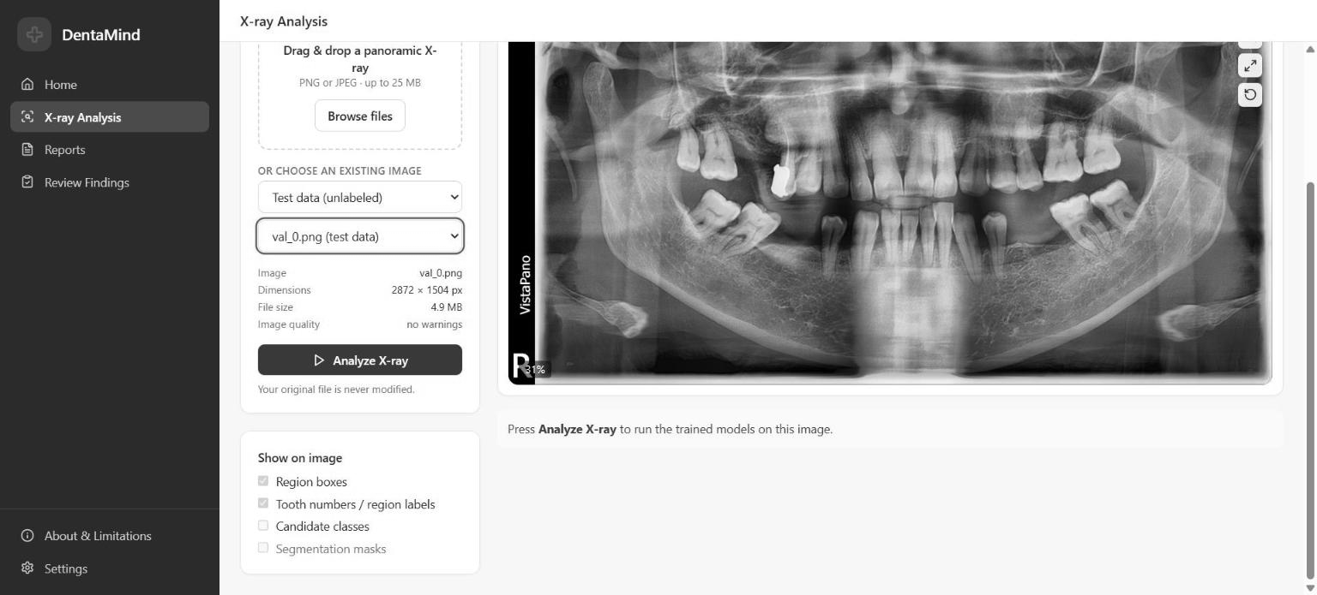
Figure 7.2: X-ray Analysis page with an unlabeled DENTEX image (val_0.png) selected before analysis (captured 2026-10-15).
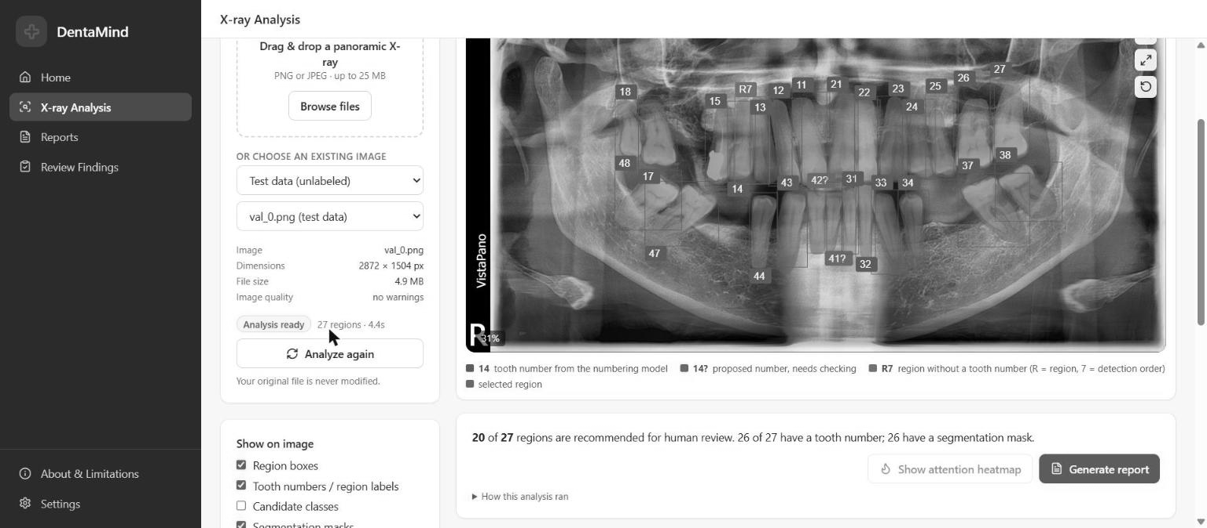
Figure 7.3: Analysis result for the same image: 27 regions, 26 with a tooth number and 26 with a mask; 20 regions recommended for human review (captured 2026-10-15).
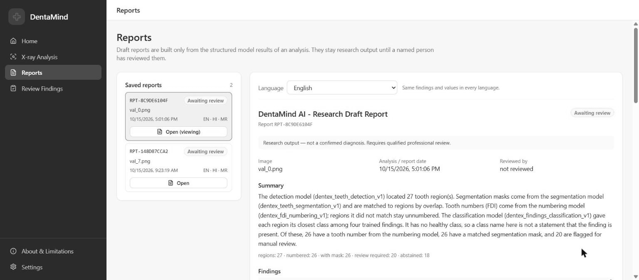
Figure 7.4: Reports page showing the English research draft generated for the same analysis, marked as awaiting review (captured 2026-10-15).
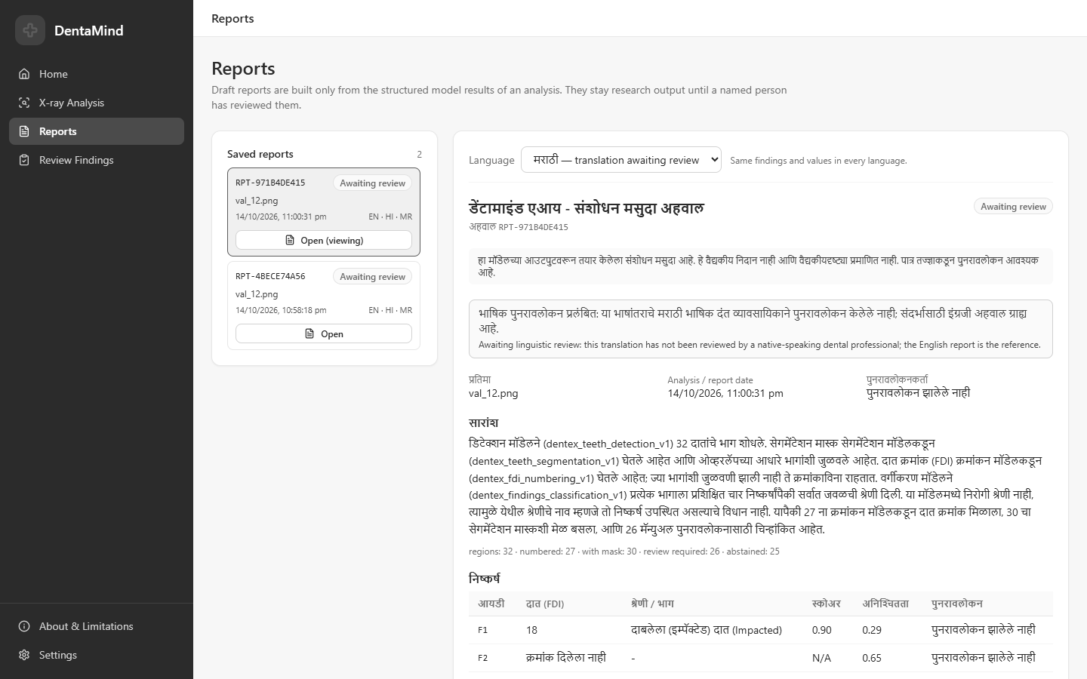
Figure 7.5: Marathi view of a generated report with the notice that the translation awaits linguistic review (audit capture, 2026-10-14).
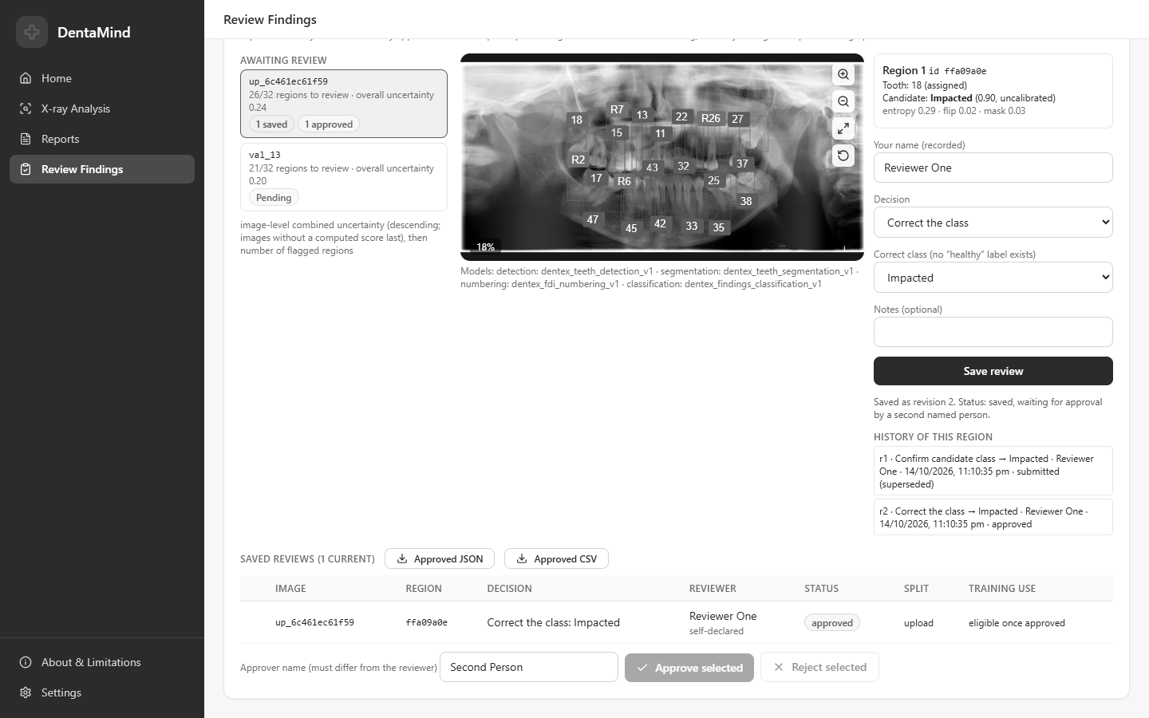
Figure 7.6: Review Findings page: a region corrected by one reviewer, its revision history, and approval by a second named person (audit capture, 2026-10-14; test reviewer names).
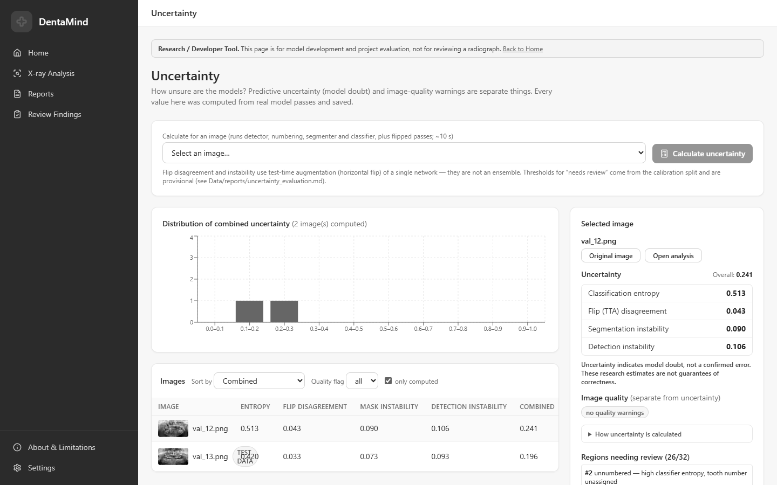
Figure 7.7: Uncertainty research page with per-image signals and the combined score (audit capture, 2026-10-14).
CHAPTER 8

CONCLUSION AND FUTURE WORK

8.1 CONCLUSION
DentaMind AI shows that a complete panoramic-radiograph pipeline can be built from standard models, evaluated honestly on held-out data and wrapped in a tool that keeps a person in charge. On DENTEX, the localization models work well: test AP50 is 0.966 for tooth detection and mask AP50 is 0.974 for segmentation, and 96.8 % of matched teeth receive the exact FDI number. Finding classification is the weak link. Macro-F1 is 0.646 on ground-truth test crops, and on validation it drops from 0.718 to 0.634 once the classifier receives detector crops; Deep Caries and Periapical Lesion are recognized poorly in both settings.
The uncertainty signals carry real information about the classifier’s errors, but with the current thresholds they capture most errors only by sending more than half of all regions to review. Four controlled attempts to improve the classifier and an active-learning study were all negative under criteria fixed in advance. These negative results are part of the contribution, because they mark the limits of what the system can claim.
The generative component did what it was designed to do. Every report is built only from the structured model output, all report-output checks passed, and the validator rejected every kind of invalid evidence that was tried. The design deliberately trades fluency for faithfulness. Whether a language model could make the reports more readable without breaking that faithfulness remains open, because the optional LLM path was never run against a live model.

8.2 LIMITATIONS OF THE PROPOSED SYSTEM
- No clinical validation. No study with qualified dentists has been carried out. The system is a research prototype, not a diagnostic device, and its reports are unconfirmed drafts.
- No healthy class. The classifier names the closest of four findings for every detected tooth, returns one label per tooth and produces uncalibrated scores.
- Data limits. One dataset from three institutions, one seed and one hold-out split; small validation and test splits (63 to 73 radiographs per task); only 9 validation and 13 test Periapical Lesions.
- Possible patient-level leakage. DENTEX has no patient identifiers, so different radiographs of one patient may fall into different splits.
- Used test split. The internal test split has been used, including two uses not yet recorded in the ledger, so an unbiased estimate needs a separate external test set.
- Heavy review load. The entropy flag sends more than half of the regions to review and still misses 13 % of errors; the thresholds are provisional.
- Generative component untested live. The LLM rewording path has only been tested with simulated replies, and the Hindi and Marathi wording has not been reviewed by native-speaking dental professionals.
- Operational limits. Reviewer names are self-declared; Label Studio, TensorBoard and Docker were not exercised; the four deployed checkpoints have no image-level training manifest.

8.3 FUTURE WORK
- Evaluate the deployed models once on a separately sourced external test set under the documented protocol.
- Obtain patient identifiers, or data that include them, so that splits can be grouped by patient.
- Label teeth without findings so that a “no finding” class can be trained and real false-positive rates can be measured.
- Move to a multi-label formulation for teeth that carry more than one finding.
- Collect more Deep Caries and Periapical Lesion examples, the two classes that limit the classifier.
- Carry out a reader study with qualified dentists to measure whether uncertainty-guided review improves accuracy or saves time.
- Connect a language model to the LLM path, measure how often its output is rejected by the validator, and compare the readability of accepted drafts with the template drafts.
- Have native-speaking dental professionals review the Hindi and Marathi templates.
- Replace self-declared reviewer names with authenticated accounts before any shared use.

8.4 APPLICATIONS
Because the system is not clinically validated, its applications are in research and education rather than in patient care. The following uses are consistent with what has been measured:
- Teaching aid. Students can see tooth detection, FDI numbering and segmentation on real panoramic radiographs, together with the uncertainty of each prediction.
- Annotation support. The detector, numbering model and review queue can speed up the preparation of new labelled data, with every label confirmed by a person.
- Research platform. The end-to-end evaluation, leakage checks and test-set ledger can be reused to evaluate other dental models under a documented protocol.
- Template for evidence-grounded reporting. The evidence bundle, validator and localization check show one way to let a generator produce readable text without adding unsupported content, which applies beyond dentistry.

REFERENCES
[1] I. Goodfellow, J. Pouget-Abadie, M. Mirza, B. Xu, D. Warde-Farley, S. Ozair, A. Courville, and Y. Bengio, “Generative adversarial networks,” Commun. ACM, vol. 63, no. 11, pp. 139–144, Nov. 2020, doi: 10.1145/3422622.
[2] J. Ho, A. Jain, and P. Abbeel, “Denoising diffusion probabilistic models,” in Proc. Adv. Neural Inf. Process. Syst. (NeurIPS), vol. 33, 2020, pp. 6840–6851.
[3] A. Vaswani, N. Shazeer, N. Parmar, J. Uszkoreit, L. Jones, A. N. Gomez, Ł. Kaiser, and I. Polosukhin, “Attention is all you need,” in Proc. Adv. Neural Inf. Process. Syst. (NIPS), vol. 30, 2017.
[4] T. Brown, B. Mann, N. Ryder, M. Subbiah, J. D. Kaplan, P. Dhariwal, A. Neelakantan, et al., “Language models are few-shot learners,” in Proc. Adv. Neural Inf. Process. Syst. (NeurIPS), vol. 33, 2020, pp. 1877–1901.
[5] K. Singhal, S. Azizi, T. Tu, S. S. Mahdavi, J. Wei, H. W. Chung, N. Scales, et al., “Large language models encode clinical knowledge,” Nature, vol. 620, no. 7972, pp. 172–180, Jul. 2023, doi: 10.1038/s41586-023-06291-2.
[6] A. J. Thirunavukarasu, D. S. J. Ting, K. Elangovan, L. Gutierrez, T. F. Tan, and D. S. W. Ting, “Large language models in medicine,” Nat. Med., vol. 29, no. 8, pp. 1930–1940, Jul. 2023, doi: 10.1038/s41591-023-02448-8.
[7] Z. Ji, N. Lee, R. Frieske, T. Yu, D. Su, Y. Xu, E. Ishii, et al., “Survey of hallucination in natural language generation,” ACM Comput. Surv., vol. 55, no. 12, pp. 1–38, 2023, doi: 10.1145/3571730.
[8] P. Lewis, E. Perez, A. Piktus, F. Petroni, V. Karpukhin, N. Goyal, H. Küttler, et al., “Retrieval-augmented generation for knowledge-intensive NLP tasks,” in Proc. Adv. Neural Inf. Process. Syst. (NeurIPS), vol. 33, 2020, pp. 9459–9474.
[9] Dentistry — Designation System for Teeth and Areas of the Oral Cavity, ISO Standard 3950:2016, International Organization for Standardization, Geneva, Switzerland, 2016.
[10] F. Schwendicke, T. Golla, M. Dreher, and J. Krois, “Convolutional neural networks for dental image diagnostics: A scoping review,” J. Dent., vol. 91, Art. no. 103226, Dec. 2019, doi: 10.1016/j.jdent.2019.103226.
[11] D. V. Tuzoff, L. N. Tuzova, M. M. Bornstein, A. S. Krasnov, M. A. Kharchenko, S. I. Nikolenko, M. M. Sveshnikov, and G. B. Bednenko, “Tooth detection and numbering in panoramic radiographs using convolutional neural networks,” Dentomaxillofac. Radiol., vol. 48, no. 4, Art. no. 20180051, May 2019, doi: 10.1259/dmfr.20180051.
[12] R. H. Putra, E. R. Astuti, D. K. Putri, M. Widiasri, P. A. M. Laksanti, H. Majidah, and N. Yoda, “Automated permanent tooth detection and numbering on panoramic radiograph using a deep learning approach,” Oral Surg. Oral Med. Oral Pathol. Oral Radiol., vol. 137, no. 5, pp. 537–544, May 2024, doi: 10.1016/j.oooo.2023.06.003.
[13] Y. Zhang, Y. Yu, Q. Li, H. Chen, Y. Liang, J. Chen, and J. Yin, “A reliable multi-stage system for tooth instance segmentation and numbering in panoramic radiographs,” IEEE J. Biomed. Health Inform., early access, Dec. 2025, pp. 1–13, doi: 10.1109/JBHI.2025.3643805.
[14] I. E. Hamamci, S. Er, O. F. Durugol, G. R. Cakmak, E. de la Rosa, E. Simsar, et al., “DENTEX: Dental enumeration and tooth pathosis detection benchmark for panoramic X-ray,” arXiv preprint arXiv:2305.19112, 2023, doi: 10.48550/arXiv.2305.19112.
[15] I. E. Hamamci, S. Er, E. Simsar, A. Sekuboyina, M. Gundogar, B. Stadlinger, A. Mehl, and B. Menze, “Diffusion-based hierarchical multi-label object detection to analyze panoramic dental X-rays,” in Medical Image Computing and Computer Assisted Intervention (MICCAI 2023), Lecture Notes in Computer Science. Cham, Switzerland: Springer, 2023, pp. 389–399, doi: 10.1007/978-3-031-43987-2_38.
[16] “The CCB computer vision repository,” GitHub repository ccb-hms/computervision (listed contributor: awerdich), licensed under CC BY 4.0. [Online]. Available: https://github.com/ccb-hms/computervision
[17] V. Szabó, K. Orhan, C. Dobó-Nagy, D. S. Veres, D. Manulis, M. Ezhov, A. Sanders, and B. T. Szabó, “Deep learning-based periapical lesion detection on panoramic radiographs,” Diagnostics, vol. 15, no. 4, Art. no. 510, Feb. 2025, doi: 10.3390/diagnostics15040510.
[18] A. Bittar, R. Dascanio, and M. Özcan, “Artificial intelligence for dental caries detection: An umbrella review,” J. Dent., vol. 175, Art. no. 106944, Dec. 2026, doi: 10.1016/j.jdent.2026.106944.
[19] E. Reiter and R. Dale, “Building applied natural language generation systems,” Nat. Lang. Eng., vol. 3, no. 1, pp. 57–87, Mar. 1997, doi: 10.1017/S1351324997001502.
[20] B. Jing, P. Xie, and E. Xing, “On the automatic generation of medical imaging reports,” in Proc. 56th Annu. Meeting Assoc. Comput. Linguistics (ACL), 2018, pp. 2577–2586, doi: 10.18653/v1/P18-1240.
[21] Z. Chen, Y. Song, T.-H. Chang, and X. Wan, “Generating radiology reports via memory-driven transformer,” in Proc. Conf. Empirical Methods Natural Lang. Process. (EMNLP), 2020, pp. 1439–1449, doi: 10.18653/v1/2020.emnlp-main.112.
[22] T. Tu, S. Azizi, D. Driess, M. Schaekermann, M. Amin, P.-C. Chang, A. Carroll, et al., “Towards generalist biomedical AI,” NEJM AI, vol. 1, no. 3, 2024, doi: 10.1056/AIoa2300138.
[23] S. Ren, K. He, R. Girshick, and J. Sun, “Faster R-CNN: Towards real-time object detection with region proposal networks,” IEEE Trans. Pattern Anal. Mach. Intell., vol. 39, no. 6, pp. 1137–1149, Jun. 2017, doi: 10.1109/TPAMI.2016.2577031.
[24] T.-Y. Lin, P. Dollár, R. Girshick, K. He, B. Hariharan, and S. Belongie, “Feature pyramid networks for object detection,” in Proc. IEEE Conf. Comput. Vis. Pattern Recognit. (CVPR), 2017, pp. 936–944, doi: 10.1109/CVPR.2017.106.
[25] K. He, G. Gkioxari, P. Dollár, and R. Girshick, “Mask R-CNN,” in Proc. IEEE Int. Conf. Comput. Vis. (ICCV), 2017, pp. 2980–2988, doi: 10.1109/ICCV.2017.322.
[26] K. He, X. Zhang, S. Ren, and J. Sun, “Deep residual learning for image recognition,” in Proc. IEEE Conf. Comput. Vis. Pattern Recognit. (CVPR), 2016, pp. 770–778, doi: 10.1109/CVPR.2016.90.
[27] T.-Y. Lin, M. Maire, S. Belongie, J. Hays, P. Perona, D. Ramanan, P. Dollár, and C. L. Zitnick, “Microsoft COCO: Common objects in context,” in Computer Vision – ECCV 2014, Lecture Notes in Computer Science. Cham, Switzerland: Springer, 2014, pp. 740–755, doi: 10.1007/978-3-319-10602-1_48.
[28] J. Deng, W. Dong, R. Socher, L.-J. Li, K. Li, and L. Fei-Fei, “ImageNet: A large-scale hierarchical image database,” in Proc. IEEE Conf. Comput. Vis. Pattern Recognit. (CVPR), 2009, pp. 248–255, doi: 10.1109/CVPR.2009.5206848.
[29] L. Huang, S. Ruan, Y. Xing, and M. Feng, “A review of uncertainty quantification in medical image analysis: Probabilistic and non-probabilistic methods,” Med. Image Anal., vol. 97, Art. no. 103223, Oct. 2024, doi: 10.1016/j.media.2024.103223.
[30] G. Wang, W. Li, M. Aertsen, J. Deprest, S. Ourselin, and T. Vercauteren, “Aleatoric uncertainty estimation with test-time augmentation for medical image segmentation with convolutional neural networks,” Neurocomputing, vol. 338, pp. 34–45, Apr. 2019, doi: 10.1016/j.neucom.2019.01.103.
[31] Y. Geifman and R. El-Yaniv, “Selective classification for deep neural networks,” in Proc. Adv. Neural Inf. Process. Syst. (NIPS), vol. 30, 2017.
[32] C. Guo, G. Pleiss, Y. Sun, and K. Q. Weinberger, “On calibration of modern neural networks,” in Proc. 34th Int. Conf. Mach. Learn. (ICML), PMLR, vol. 70, 2017, pp. 1321–1330.
[33] M. P. Naeini, G. Cooper, and M. Hauskrecht, “Obtaining well calibrated probabilities using Bayesian binning,” in Proc. AAAI Conf. Artif. Intell., vol. 29, no. 1, 2015, doi: 10.1609/aaai.v29i1.9602.
[34] G. W. Brier, “Verification of forecasts expressed in terms of probability,” Mon. Weather Rev., vol. 78, no. 1, pp. 1–3, Jan. 1950, doi: 10.1175/1520-0493(1950)078<0001:VOFEIT>2.0.CO;2.
[35] W. J. Youden, “Index for rating diagnostic tests,” Cancer, vol. 3, no. 1, pp. 32–35, 1950, doi: 10.1002/1097-0142(1950)3:1<32::AID-CNCR2820030106>3.0.CO;2-3.
[36] J. Lin, “Divergence measures based on the Shannon entropy,” IEEE Trans. Inf. Theory, vol. 37, no. 1, pp. 145–151, Jan. 1991, doi: 10.1109/18.61115.
[37] R. R. Selvaraju, M. Cogswell, A. Das, R. Vedantam, D. Parikh, and D. Batra, “Grad-CAM: Visual explanations from deep networks via gradient-based localization,” in Proc. IEEE Int. Conf. Comput. Vis. (ICCV), 2017, pp. 618–626, doi: 10.1109/ICCV.2017.74.
[38] H. Wang, Q. Jin, S. Li, S. Liu, M. Wang, and Z. Song, “A comprehensive survey on deep active learning in medical image analysis,” Med. Image Anal., vol. 95, Art. no. 103201, Jul. 2024, doi: 10.1016/j.media.2024.103201.
[39] S. Kapoor and A. Narayanan, “Leakage and the reproducibility crisis in machine-learning-based science,” Patterns, vol. 4, no. 9, Art. no. 100804, Sep. 2023, doi: 10.1016/j.patter.2023.100804.
[40] Y. Huang, Z. Sun, J. Chen, T. Yang, L. Xie, and X. Lin, “Near-duplicate contamination inflates brain MRI benchmark performance: A size-matched, multi-seed MedNeXt-B study,” Front. Med., vol. 13, Art. no. 1955863, Oct. 2026, doi: 10.3389/fmed.2026.1955863.

APPENDIX A: PUBLICATION DETAILS
The template asks for the details of a paper publication, reviewer comments, certificates and the paper itself, or a draft paper if nothing has been published. The current status of each item is listed below. Nothing in this appendix should be read as evidence of acceptance or publication.
Table A.1: Status of Publication-Related Documents
Item | Status (2026-10-26)
Paper title | DentaMind AI: An Uncertainty-Aware Pipeline for Tooth Detection, FDI Numbering, Segmentation and Finding Classification on Panoramic Dental Radiographs
Authors | Nilesh Sonawane, Saurabh Mali, Sadhyoj Hanwate and Sachet Lothe (guide: Dr. Pradnya Narkhede)
Manuscript | IEEE two-column draft, 10 pages, 24 references (DentaMind_AI_IEEE_v5.pdf); reproduced below as the draft paper
Target conference or journal | PENDING: not yet chosen; the manuscript has not been submitted
Reviewer comments | NOT AVAILABLE: no submission has been made
Acceptance letter, publication or participation certificate | NOT AVAILABLE
Patent documents | NOT APPLICABLE: no patent application has been filed
Project event participation certificates | PENDING: to be attached by the team if any exist
Open items before submission | test-set ledger entries (6) and (7) need a named authorizer; the AI-assistance disclosure needs the authors’ confirmation; an official similarity check has not been run

The draft manuscript follows, one page per report page.
Draft manuscript (not submitted), page 1 of 10
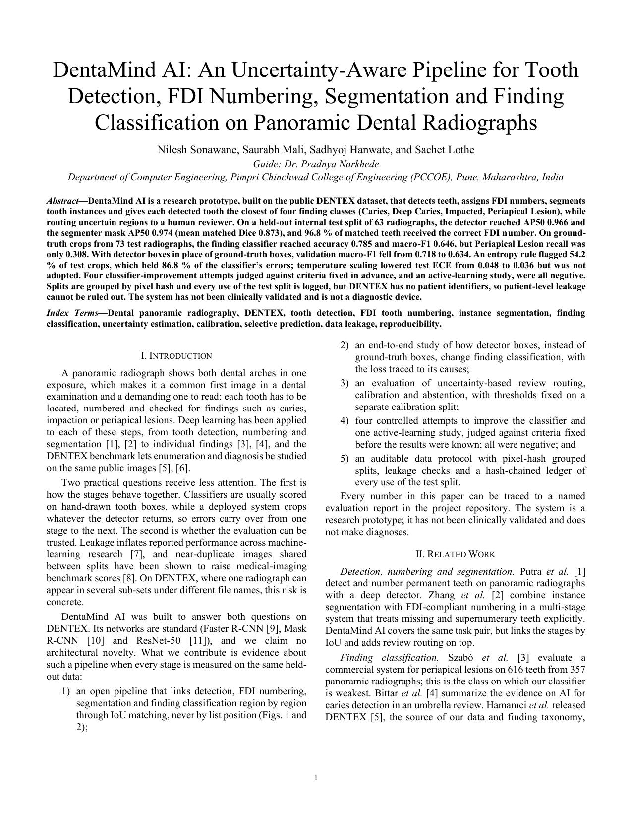
Draft manuscript (not submitted), page 2 of 10
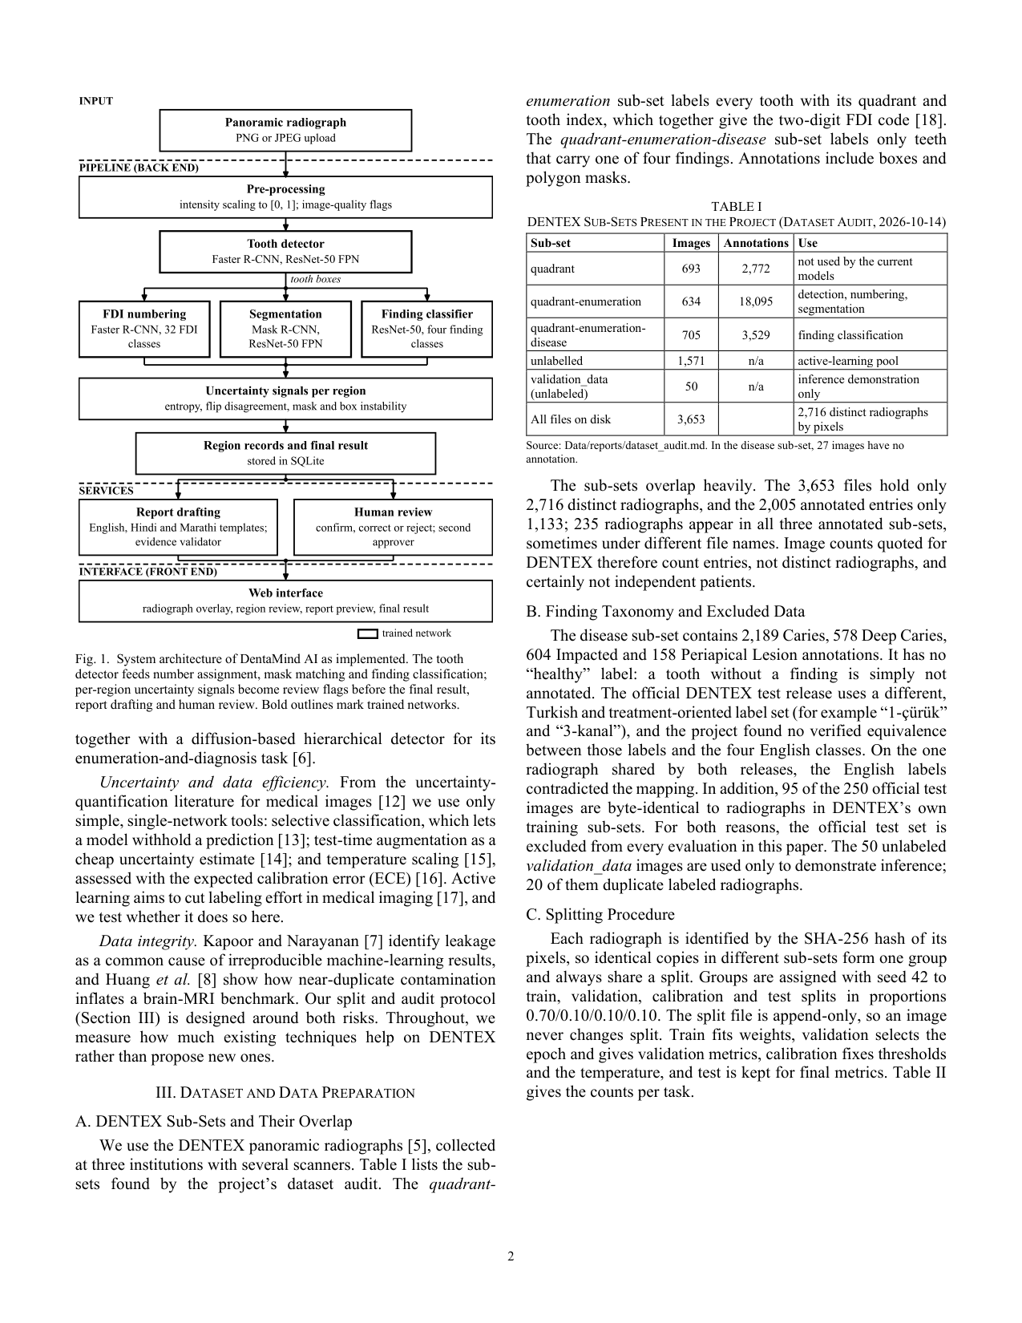
Draft manuscript (not submitted), page 3 of 10
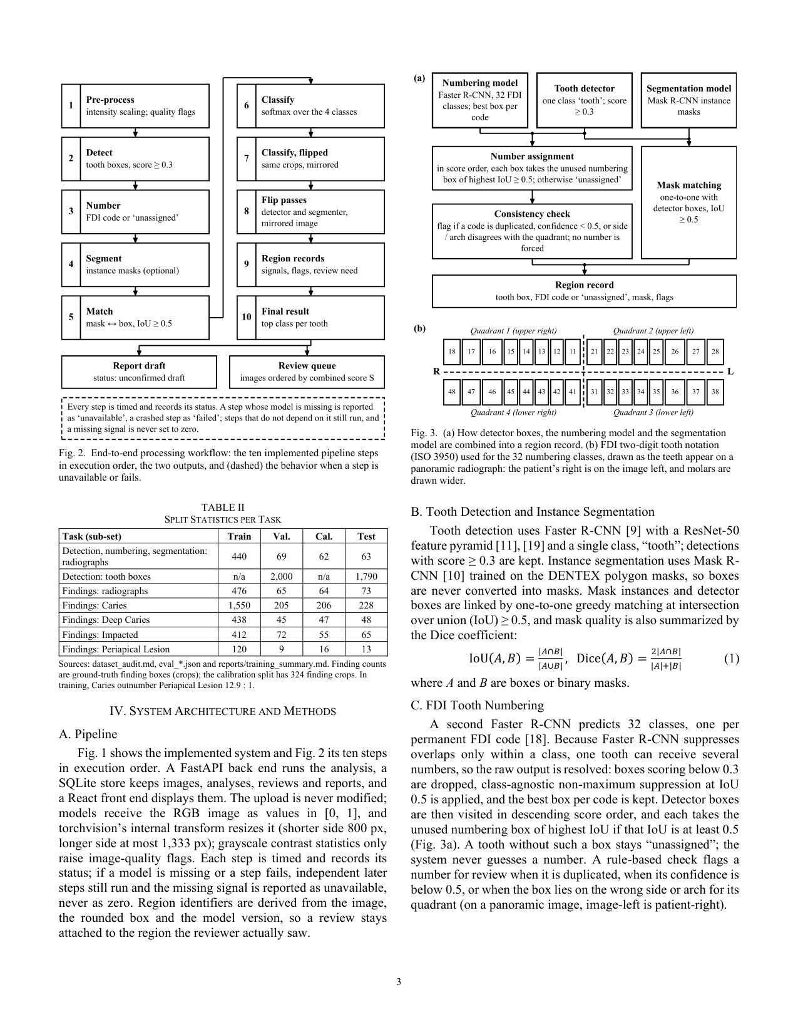
Draft manuscript (not submitted), page 4 of 10
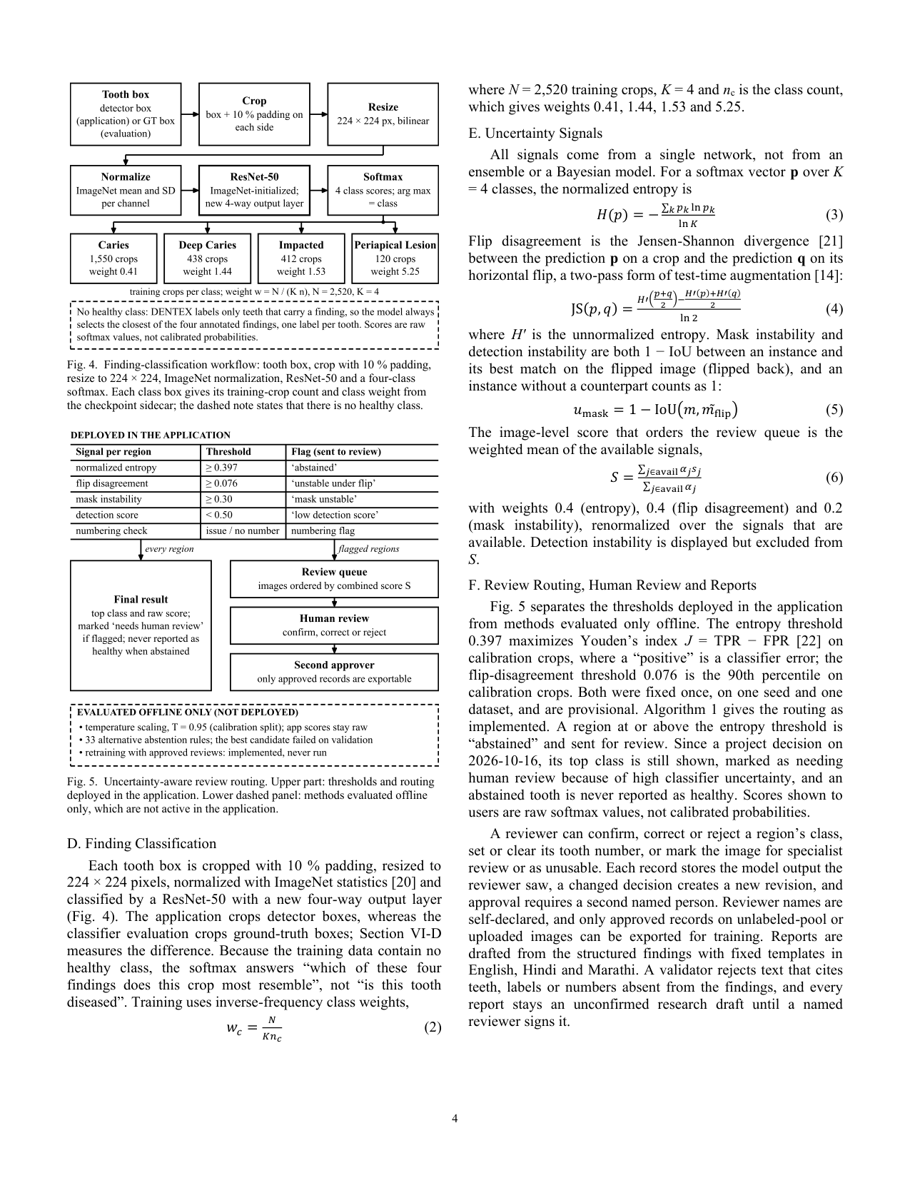
Draft manuscript (not submitted), page 5 of 10
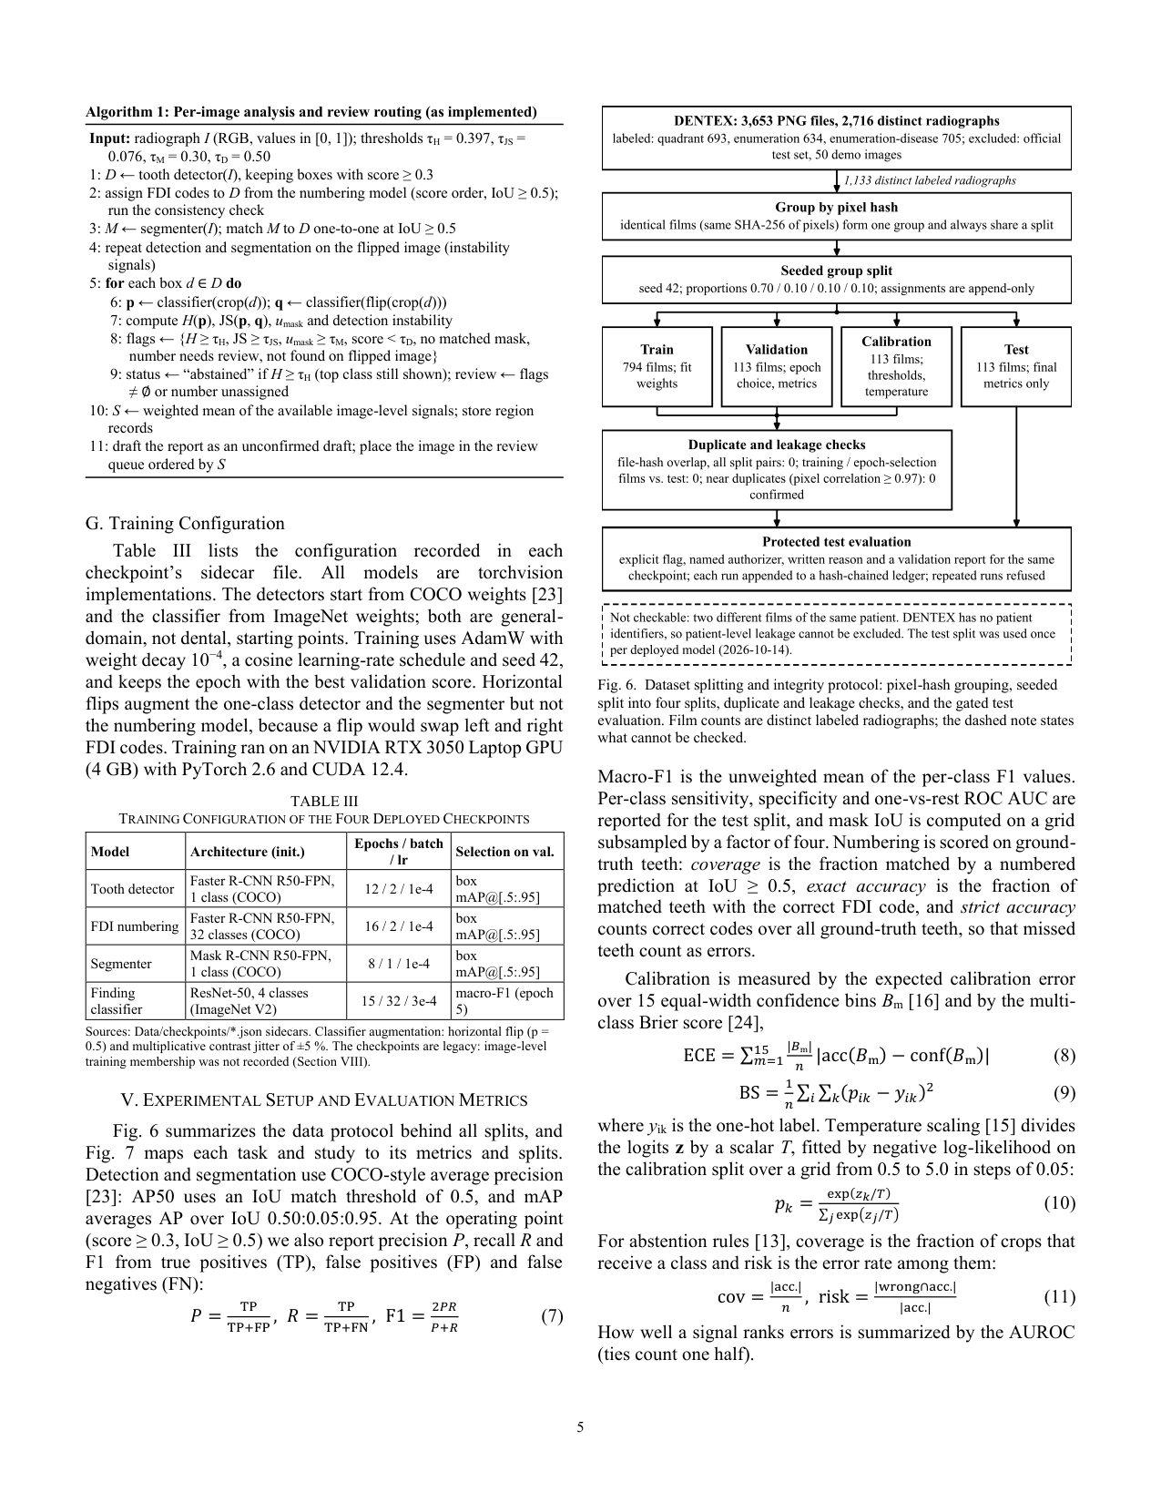
Draft manuscript (not submitted), page 6 of 10
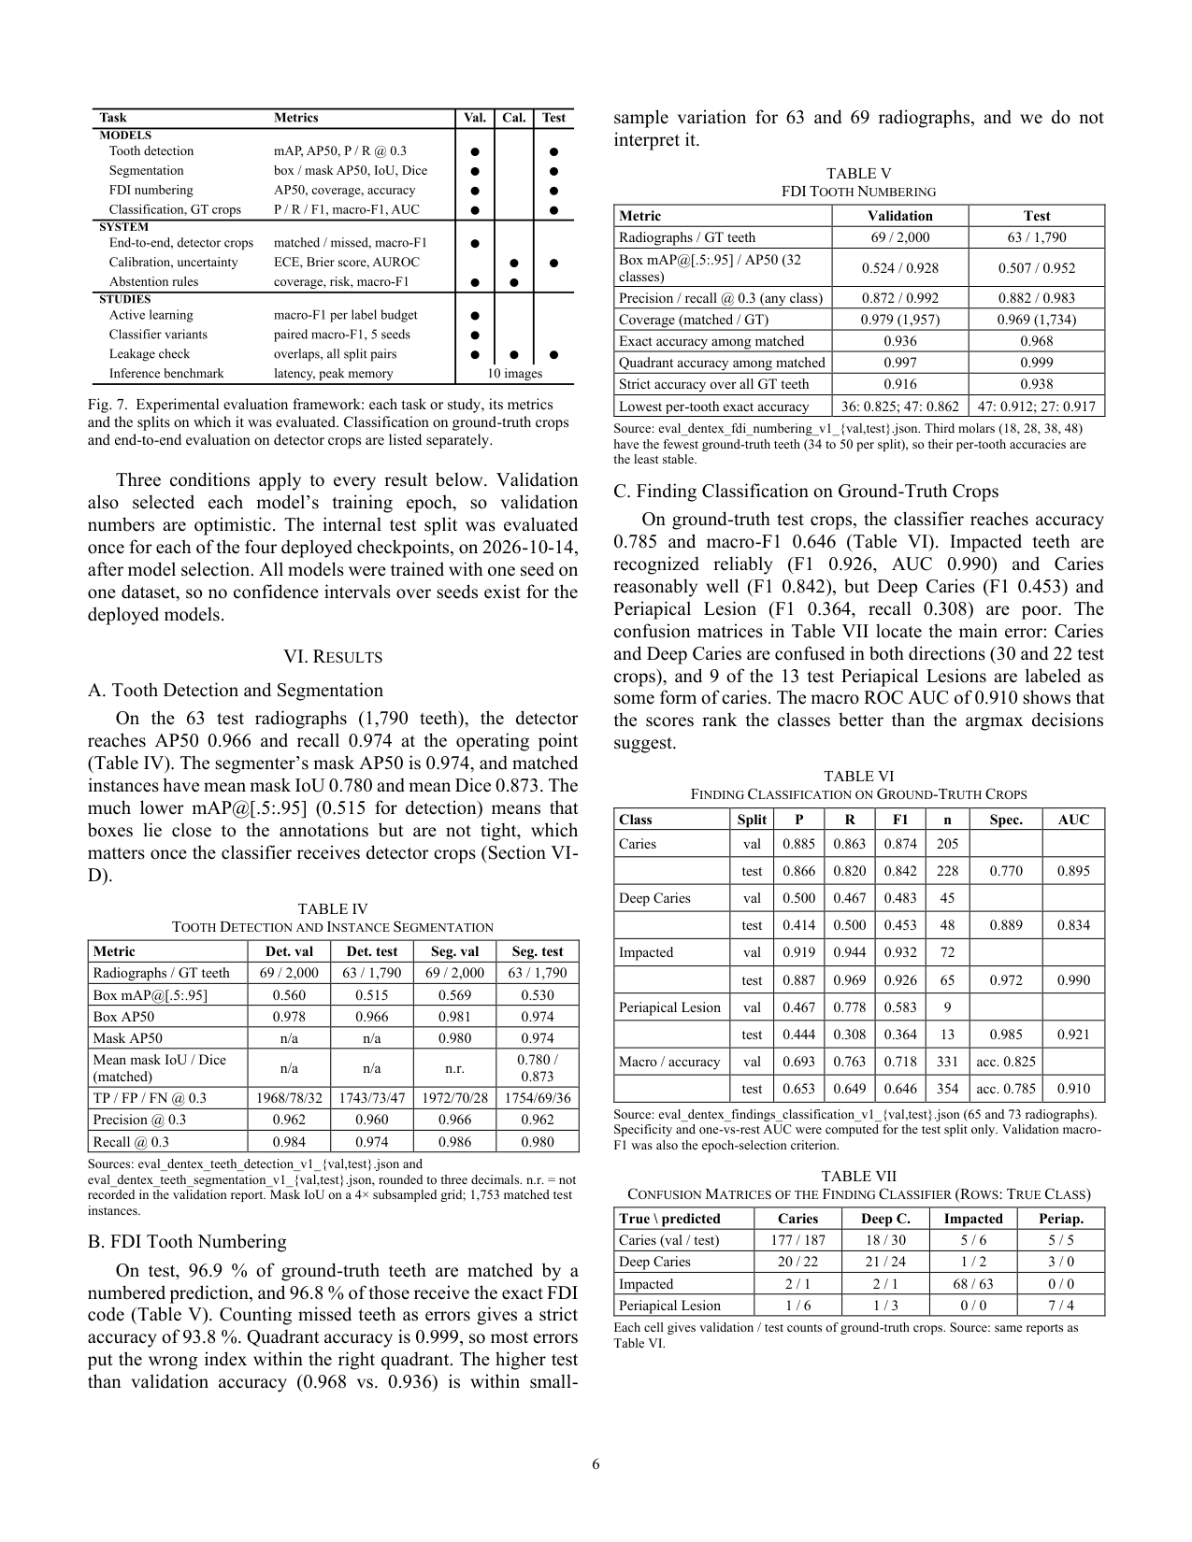
Draft manuscript (not submitted), page 7 of 10
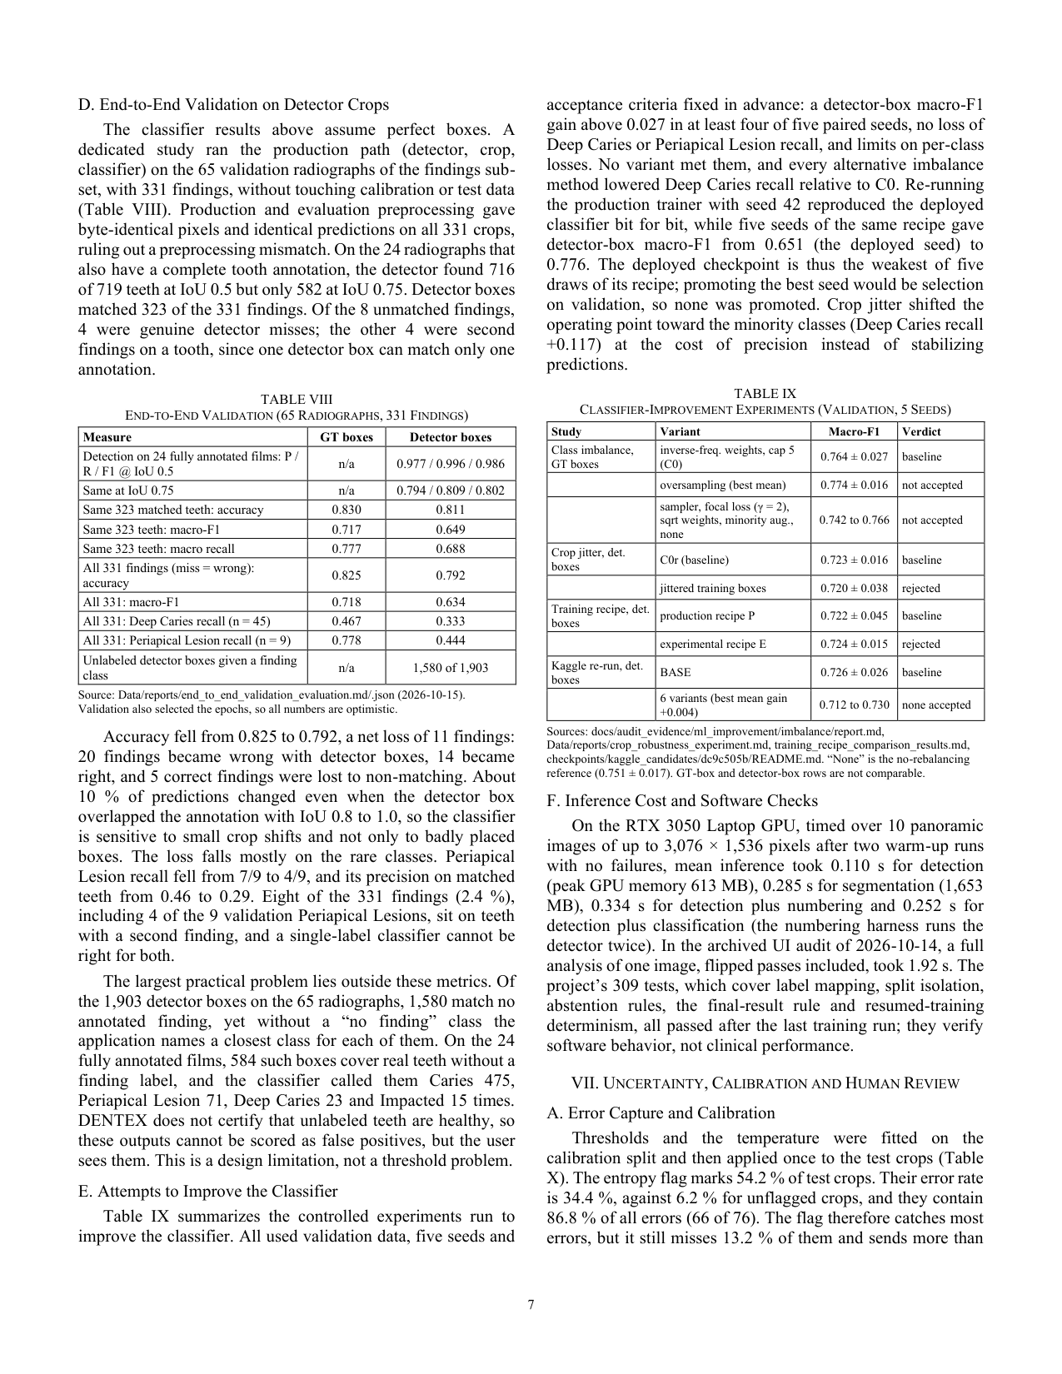
Draft manuscript (not submitted), page 8 of 10
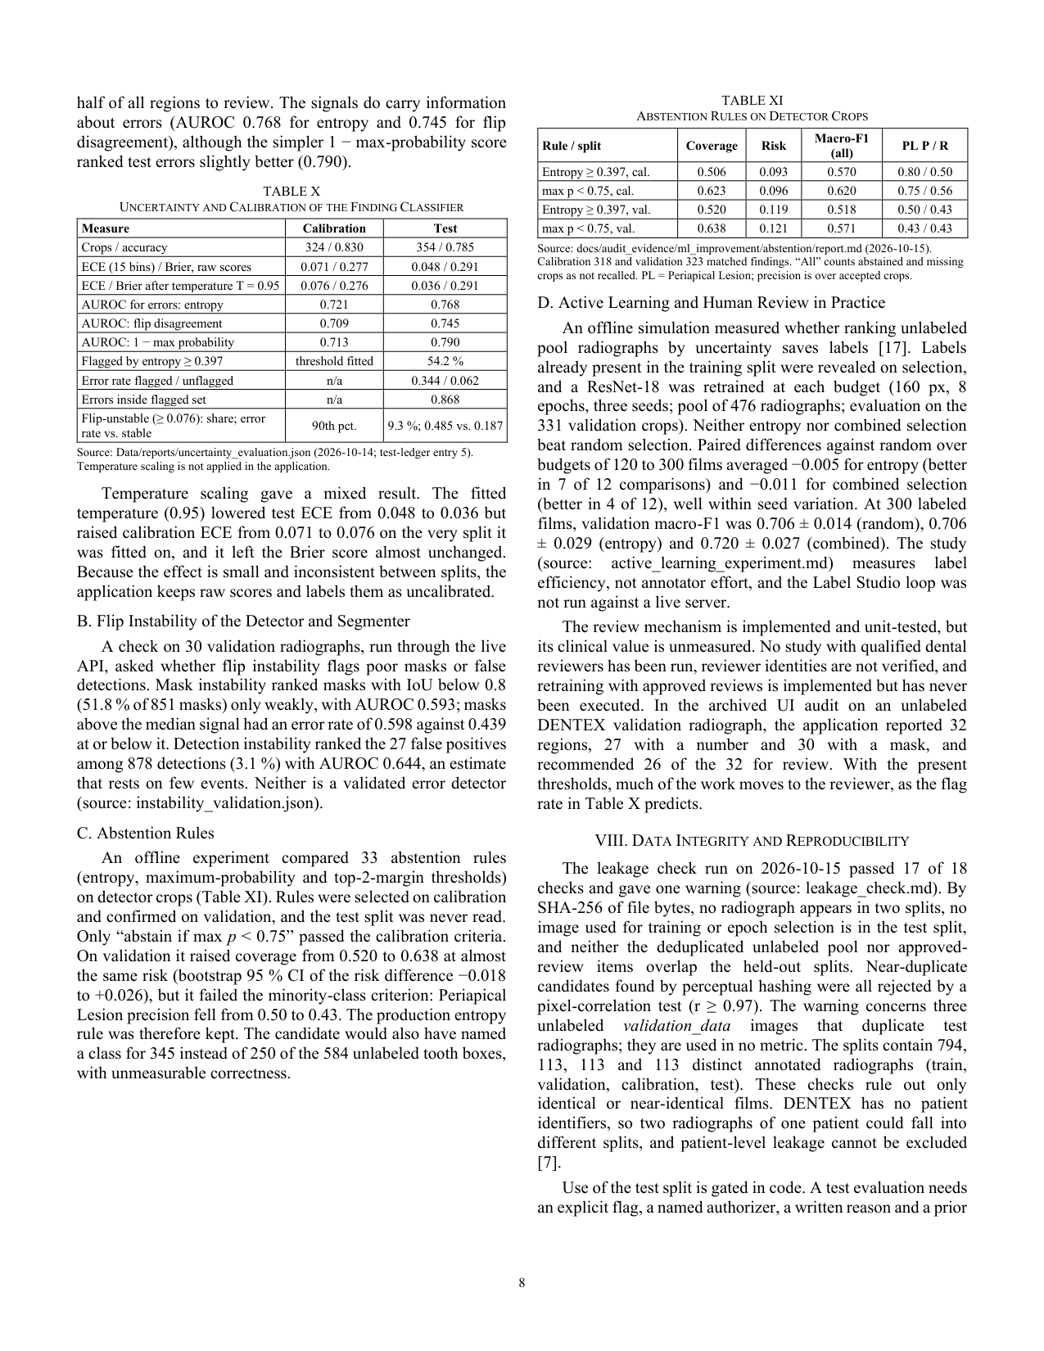
Draft manuscript (not submitted), page 9 of 10
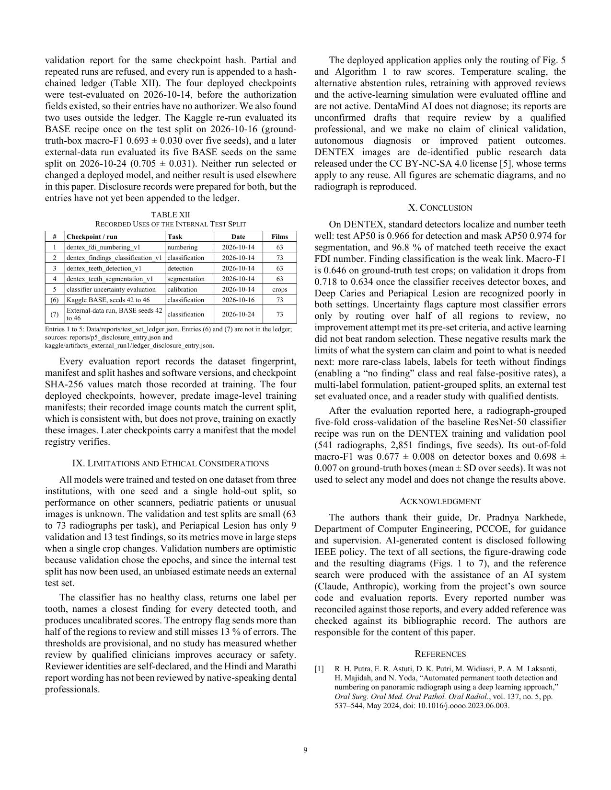
Draft manuscript (not submitted), page 10 of 10
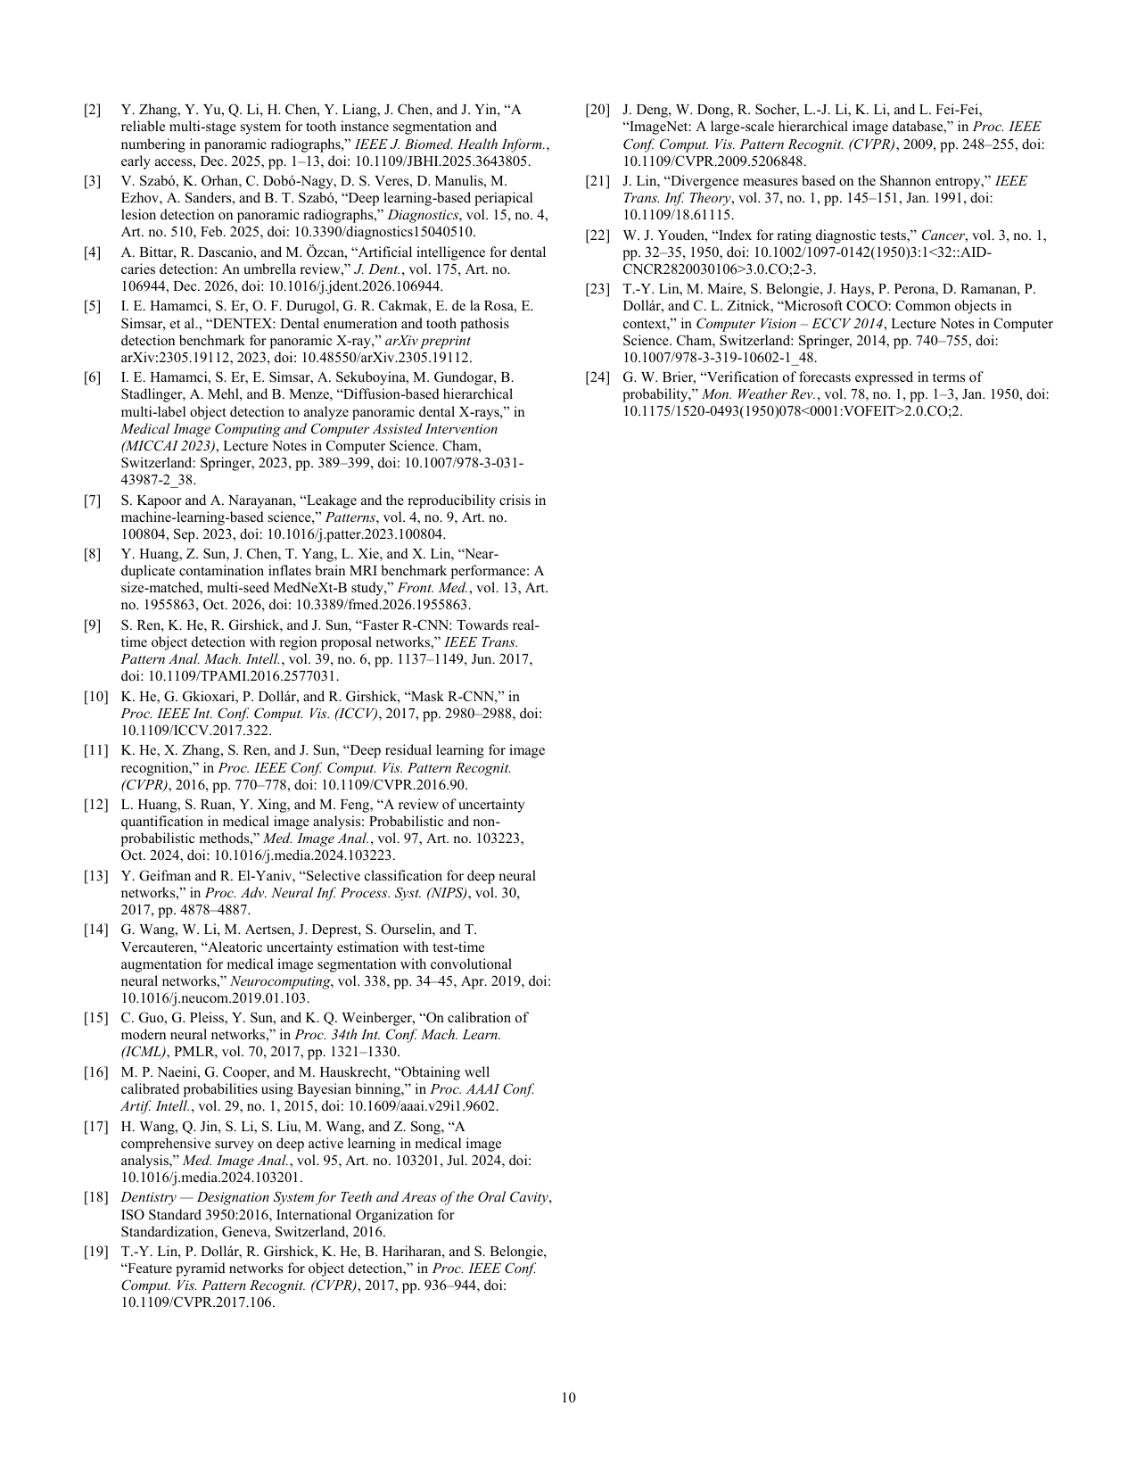

APPENDIX B: PLAGIARISM REPORT
PENDING. The official plagiarism (similarity) report is not attached because it has not been generated. The PCCOE instructions make this report mandatory: the similarity must be below 15 %, it must be produced with a good-quality similarity-checking tool, and it must be verified by the guide.
No similarity score is stated anywhere in this report, and none should be inferred. The team must run the official check on the final text of this report, have the guide verify it, and insert the report here before submission.

