GROUP ID: __________
A PROJECT REPORT ON

DENTAMIND AI: AI-ASSISTED DENTAL X-RAY ANALYSIS SYSTEM

SUBMITTED TO THE PIMPRI CHINCHWAD COLLEGE OF ENGINEERING
AN AUTONOMOUS INSTITUTE, PUNE
IN THE FULFILLMENT OF THE REQUIREMENTS
FOR THE AWARD OF THE DEGREE
OF
B. TECH. IN COMPUTER SCIENCE AND ENGINEERING (AI & ML)
FOR THE SUBJECT
GENERATIVE AI MDM CAPSTONE PROJECT
UNDER THE DEPARTMENT OF COMPUTER SCIENCE AND ENGINEERING (AI & ML)

SUBMITTED BY
STUDENT NAME ____________________ PRN: __________
STUDENT NAME ____________________ PRN: __________
STUDENT NAME ____________________ PRN: __________
STUDENT NAME ____________________ PRN: __________

UNDER THE GUIDANCE OF
PROF. ____________________ (GUIDE NAME)

DEPARTMENT OF COMPUTER SCIENCE AND ENGINEERING (AI & ML)
PCET’S PIMPRI CHINCHWAD COLLEGE OF ENGINEERING
Sector No. 26, Pradhikaran, Nigdi, Pimpri-Chinchwad, PUNE – 411044
2026-2027

PCET’S PIMPRI CHINCHWAD COLLEGE OF ENGINEERING
Sector No. 26, Pradhikaran, Nigdi, Pimpri-Chinchwad, PUNE 411044
2026-2027

CERTIFICATE
This is to certify that the project report entitled
“DENTAMIND AI: AI-ASSISTED DENTAL X-RAY ANALYSIS SYSTEM”
Submitted by
STUDENT NAME ____________________ PRN: __________
STUDENT NAME ____________________ PRN: __________
STUDENT NAME ____________________ PRN: __________
STUDENT NAME ____________________ PRN: __________

are bonafide students of this institute and the work has been carried out by them under the supervision of Prof. ____________________ and it is approved for the partial fulfillment of the requirement of Pimpri Chinchwad College of Engineering, an autonomous institute, for the award of the B. Tech. degree in Computer Science and Engineering (AI & ML).

(Prof. ____________________) (Prof. Dr. Anuradha Thakare)
Guide Head,
Department of CSE (AI & ML) Department of CSE (AI & ML)

Place: Pune
Date: ____________
ACKNOWLEDGEMENT
We express our sincere gratitude to our project guide, Prof. ____________________, for steady guidance, critical questions and patient reviews throughout this capstone project. The habit of asking “how do we know this number is true?” shaped the way the evaluation in this report was designed.
We thank Prof. Dr. Anuradha Thakare, Head of the Department of Computer Science and Engineering (AI & ML), and the faculty and staff of Pimpri Chinchwad College of Engineering for the academic environment, laboratory access and encouragement that made this work possible.
We acknowledge the organisers of the DENTEX challenge for releasing a public, hierarchically annotated panoramic X-ray dataset, and the developers of PyTorch, torchvision, FastAPI and React, whose open-source software this project is built on.
Finally, we thank our families and friends for their support and patience during the long training runs and evaluations.

Student names: ____________________
ABSTRACT
Panoramic dental radiographs are among the most frequently acquired images in dentistry, yet reading them is slow and subtle findings are easily overlooked. This project presents DentaMind AI, a locally deployed research prototype that analyses a panoramic X-ray end to end. A Faster R-CNN detector locates every tooth, a second Faster R-CNN assigns FDI tooth numbers, a Mask R-CNN outlines each tooth, and a ResNet-50 classifier suggests the closest of four findings (Caries, Deep Caries, Impacted and Periapical Lesion) for every detected tooth. Horizontal-flip test-time augmentation and normalised predictive entropy provide an uncertainty signal; regions above a threshold chosen on a held-out calibration split are shown as “no reliable class candidate” and routed to a human reviewer. The generative component converts the structured model evidence into draft reports in English, Hindi and Marathi. Every draft is checked by an automatic validator that rejects unsupported tooth numbers, numbers, finding names and clinical phrases, and the system keeps a revisioned, second-person-approved review trail.
The models were trained on the public DENTEX dataset after a pixel-hash audit reduced 3,653 files to 2,716 unique radiographs and the 1,133 annotated films were split per unique radiograph into train (794), validation (113), calibration (113) and test (113) sets. On the validation split, tooth detection reached precision 0.962 and recall 0.984 (AP50 0.978), FDI numbering was exactly correct for 93.6 % of matched teeth, and finding classification on ground-truth tooth boxes reached accuracy 0.825 and macro-F1 0.718. When the classifier receives the detector’s own crops, macro-F1 falls to 0.649 on the same 323 teeth and to 0.634 end to end, mainly because of the rare Deep Caries and Periapical Lesion classes. On the historical test split, which was used once per checkpoint and is logged in a hash-chained ledger, detection recall was 0.974, segmentation Dice 0.873 and classification macro-F1 0.646.
Five class-imbalance remedies (weighted sampling, oversampling, focal loss, square-root class weights and minority-only augmentation) were compared under a pre-registered rule across five seeds; none produced a gain beyond seed-to-seed variation without reducing minority-class recall, so none was promoted. The main limitations are the absence of a healthy-tooth class, low rare-class performance, sensitivity to crop placement and the lack of independent external validation. DentaMind AI is a research prototype and has not been clinically validated.
Keywords: panoramic radiograph, dental AI, tooth detection, FDI numbering, Mask R-CNN, uncertainty estimation, report generation, human-in-the-loop, data leakage, class imbalance.
TABLE OF CONTENTS
1. INTRODUCTION 1
1.1 OVERVIEW OF GENERATIVE AI 1
1.2 PROJECT BACKGROUND 2
1.3 MOTIVATION 2
1.4 PROBLEM STATEMENT 3
1.5 OBJECTIVES 3
1.6 SCOPE OF THE WORK 3
2. LITERATURE SURVEY 5
2.1 REVIEW OF RECENT LITERATURE 5
2.2 GENERATIVE AI: EXISTING APPROACHES 6
2.3 REVIEW OF RELATED GENERATIVE AI SYSTEMS 6
2.4 EXISTING SOLUTIONS / STATE-OF-THE-ART METHODS 7
2.5 GAP IDENTIFICATION 8
2.6 COMMON FINDINGS FROM LITERATURE 8
3. REQUIREMENTS SPECIFICATION 9
3.1 HARDWARE REQUIREMENTS 9
3.2 SOFTWARE REQUIREMENTS 9
3.3 FUNCTIONAL REQUIREMENTS 10
3.4 NON-FUNCTIONAL REQUIREMENTS 10
3.5 GENERATIVE AI MODEL REQUIREMENTS 10
3.6 DATASET / KNOWLEDGE-BASE REQUIREMENTS 11
4. SYSTEM DESIGN 13
4.1 PROPOSED SYSTEM ARCHITECTURE 13
4.2 SYSTEM BLOCK DIAGRAM 15
4.3 SYSTEM WORKFLOW 17
4.4 MATHEMATICAL MODEL 20
4.4.1 Detection and Overlap Measures 20
4.4.2 Classification and Macro-Averaged Metrics 20
4.4.3 Uncertainty Measures 20
4.4.4 Calibration 21
4.4.5 Training Objectives 21
5. PROJECT IMPLEMENTATION 22
5.1 OVERVIEW OF PROJECT MODULES 22
5.2 DATA COLLECTION AND PREPROCESSING 22
5.3 GENERATIVE AI MODEL SELECTION 23
5.4 MODEL CONFIGURATION / FINE-TUNING 24
5.5 PROJECT MODULES 25
5.5.1 Inference Pipeline Service 25
5.5.2 Report Service 25
5.5.3 Review, Registry and Integrity Services 26
5.5.4 Web Interface 26
5.6 TOOLS AND TECHNOLOGIES USED 26
5.7 ALGORITHM DETAILS 27
6. SOFTWARE TESTING 28
6.1 TEST CASES 28
6.2 GENERATIVE AI OUTPUT TESTING 29
6.3 PERFORMANCE EVALUATION 30
7. RESULTS AND DISCUSSION 31
7.1 PROJECT OUTCOMES 31
7.2 RESULT ANALYSIS 31
7.2.1 Tooth Detection and Segmentation 31
7.2.2 FDI Tooth Numbering 32
7.2.3 Finding Classification on Ground-Truth Tooth Boxes 33
7.3 GENERATED OUTPUT ANALYSIS 34
7.4 PERFORMANCE METRICS 35
7.5 ACCURACY / RELEVANCE / QUALITY EVALUATION 36
7.5.1 Ground-Truth Boxes versus Detector Boxes 36
7.5.2 Uncertainty and Abstention 37
7.6 VALIDATION OF RESULTS 38
7.6.1 Class-Imbalance Experiments 38
7.6.2 Crop-Robustness Candidate 40
7.6.3 Training-Recipe Comparison 40
7.6.4 Integrity and Reproducibility Checks 41
7.7 COMPARISON WITH EXISTING APPROACHES 42
7.8 SCREENSHOTS OF THE IMPLEMENTED SYSTEM 43
8. CONCLUSION AND FUTURE WORK 45
8.1 CONCLUSION 45
8.2 LIMITATIONS OF THE PROPOSED SYSTEM 45
8.3 FUTURE WORK 46
8.4 APPLICATIONS 47
REFERENCES 48
APPENDIX A: PAPER PUBLICATION DETAILS 51
APPENDIX B: PLAGIARISM REPORT 52

LIST OF FIGURES
Fig. 3.1 Image files per DENTEX sub-set (bars) and the effect of de-duplication (title) 12
Fig. 3.2 Finding labels in the disease sub-set and the classifier crops per split 12
Fig. 4.1 Overall system architecture of DentaMind AI 14
Fig. 4.2 Block diagram of the AI inference pipeline 16
Fig. 4.3 Training and evaluation workflow with split roles 18
Fig. 4.4 Human-review workflow for AI findings 19
Fig. 5.1 Duplicate-aware split of the 1,133 annotated radiographs 23
Fig. 7.1 Detection and segmentation on validation and historical test splits 32
Fig. 7.2 Exact FDI numbering accuracy per tooth on the validation split 33
Fig. 7.3 Per-class precision, recall and F1 of the finding classifier 34
Fig. 7.4 Confusion matrix on the validation split (ground-truth boxes) 34
Fig. 7.5 Effect of detector crops on finding classification (validation split) 37
Fig. 7.6 Error rate of flagged and unflagged crops, and calibration error 38
Fig. 7.7 Macro-F1 and minority-class recall of the imbalance variants (C0 baseline, A–E, reference) 40
Fig. 7.8 Detector-crop macro-F1 of five seeds of each training recipe (validation) 41
Fig. 7.9 Active learning versus random selection on the validation split 42
Fig. 7.10 X-ray Analysis page with a test image selected, before analysis 43
Fig. 7.11 Analysis result for val_0: 27 regions with FDI numbers, outlines and review markers 43
Fig. 7.12 Reports page with the validated draft report for val_0, awaiting review 44

LIST OF TABLES
Table 1.1 Project objectives 3
Table 2.1 Summary of related work 7
Table 3.1 Hardware used for training, evaluation and deployment 9
Table 3.2 Software stack and versions 9
Table 3.3 Functional requirements 10
Table 3.4 Non-functional requirements 10
Table 3.5 DENTEX sub-sets as found on disk 11
Table 5.1 Project modules and source locations 22
Table 5.2 Training configuration of the deployed checkpoints 24
Table 5.3 Operating thresholds of the deployed pipeline 25
Table 6.1 Automated test suite by area 28
Table 6.2 Representative functional test cases 28
Table 6.3 Inference latency per image (RTX 3050 Laptop GPU) 30
Table 7.1 Tooth detection and segmentation (score ≥ 0.3, IoU ≥ 0.5) 31
Table 7.2 FDI tooth numbering 32
Table 7.3 Finding classification with ground-truth boxes: summary 33
Table 7.4 Per-class results (validation / historical test) 33
Table 7.5 Summary of model performance 35
Table 7.6 Classification with ground-truth and detector crops (validation) 36
Table 7.7 Uncertainty evaluation of the finding classifier 38
Table 7.8 Class-imbalance experiments on the validation split (5 seeds) 39
Table 7.9 Qualitative comparison with existing approaches 42

LIST OF ABBREVIATIONS
ABBREVIATION | ILLUSTRATION
AI | Artificial Intelligence
AMP | Automatic Mixed Precision
AP / AP50 | Average Precision / AP at IoU 0.5
API | Application Programming Interface
AUROC | Area Under the ROC Curve
CNN | Convolutional Neural Network
CUDA | Compute Unified Device Architecture (NVIDIA)
DENTEX | Dental Enumeration and Diagnosis Benchmark (MICCAI 2023)
ECE | Expected Calibration Error
FDI | Fédération Dentaire Internationale (two-digit tooth notation, ISO 3950)
FN / FP / TP | False Negative / False Positive / True Positive
FPN | Feature Pyramid Network
GPU | Graphics Processing Unit
IoU | Intersection over Union
JSON | JavaScript Object Notation
LLM | Large Language Model
mAP | mean Average Precision (IoU 0.5 to 0.95)
MICCAI | Medical Image Computing and Computer-Assisted Intervention
OPG | Orthopantomogram (panoramic radiograph)
R-CNN | Region-based Convolutional Neural Network
REST | Representational State Transfer
ROC | Receiver Operating Characteristic
SD | Standard Deviation
SHA-256 | Secure Hash Algorithm, 256-bit
TTA | Test-Time Augmentation
UI | User Interface
NOMENCLATURE
SYMBOL | MEANING
TP, FP, FN | True positives, false positives and false negatives at a stated IoU threshold
P, R, F1 | Precision, recall and F1-score
K | Number of finding classes (K = 4)
p_{k} | Softmax probability of class k for a tooth crop
H_{n} | Normalised predictive entropy, 0 (certain) to 1 (uniform)
D_{JS} | Jensen–Shannon divergence between predictions on a crop and on its horizontal flip
T | Temperature used in temperature scaling
J | Youden’s index, sensitivity + specificity − 1
A, B | Predicted and ground-truth regions (boxes or masks)
n_{c}, N | Training crops of class c, and all training crops
w_{c} | Class weight of class c in the weighted cross-entropy loss
γ | Focusing parameter of the focal loss
B_{m} | Set of predictions whose confidence falls in calibration bin m

CHAPTER 1

1. INTRODUCTION

1.1 OVERVIEW OF GENERATIVE AI
Generative artificial intelligence refers to models that learn the distribution of their training data well enough to produce new samples from it: sentences, images, audio or structured records. Three families dominate the field. Generative adversarial networks pit a generator against a discriminator until the generated samples become hard to distinguish from real ones [1]. Diffusion models learn to reverse a gradual noising process and now produce some of the most realistic images available [2]. Transformer-based language models, built on the self-attention mechanism [3], are trained to predict the next token of text and, when scaled up, can follow instructions and write fluent paragraphs from only a few examples [4].
These capabilities have quickly reached medicine. Report-generation systems describe chest radiographs in sentences, and general-purpose chat models have been tried for drafting dental radiology reports [5], [6]. The same studies also show the main weakness of generated text in a clinical setting: a fluent sentence is not necessarily a supported one. A model can omit an important finding, describe something the image does not show, or word a tentative observation as a diagnosis. Grounding the generation in verified evidence, for example by retrieving facts before writing [7], is therefore as important as the fluency of the output.
Generative techniques are also used inside perception models. The strongest published system on the DENTEX panoramic X-ray benchmark used in this project treats object detection as a diffusion process that gradually turns random boxes into tooth and finding boxes [8]. This project uses generative AI in a deliberately restricted way. The image-analysis models are discriminative (detection, segmentation and classification networks), and the generative component is the report generator. It turns the structured output of those models into readable multilingual draft reports, and it is wrapped in a validator that rejects any statement not backed by the evidence.

1.2 PROJECT BACKGROUND
A panoramic radiograph, also called an orthopantomogram (OPG), captures both jaws and all teeth in a single image. It is inexpensive, fast and widely used for screening, treatment planning and follow-up. Reading it, however, requires the dentist to examine around thirty teeth, number each according to the FDI two-digit notation standardised in ISO 3950 [9], and look for findings such as caries, deep caries that approach the pulp, impacted teeth and periapical lesions at the root tip. The image superimposes structures, contrast varies between machines, and early lesions are subtle, so findings are easy to miss when a clinician is busy.
Convolutional neural networks (CNNs) have been applied to dental images for almost a decade. A scoping review of 36 studies found that most CNN applications targeted panoramic and periapical radiographs, and that CNNs often performed similarly to dentists in research settings, but that their usefulness and generalisability under realistic clinical conditions had not been shown [10]. Public data were scarce until the DENTEX challenge at MICCAI 2023 released hierarchically annotated panoramic radiographs with quadrant, tooth-number and diagnosis labels [11]. DentaMind AI builds on this dataset.

1.3 MOTIVATION
The motivation for this work came from three observations. First, research prototypes usually solve one sub-task, such as tooth numbering or caries detection, while a dentist needs all of them in one place, linked to the same tooth. Second, a classifier always produces an answer, even when it is guessing; without a visible measure of doubt, a confident-looking label can mislead the reader more than no label at all. Third, many published results are difficult to trust because the same radiograph may appear in training and test data, or the test split may have been used repeatedly while developing the model [12], [13].
We therefore set out to build a system that is useful as a whole, honest about its uncertainty, and evaluated in a way that another team could reproduce. Generative AI is attractive for the last step, turning model output into a readable report, but only if the text is constrained to what the models actually found.

1.4 PROBLEM STATEMENT
To design, implement and evaluate an AI-assisted panoramic dental X-ray analysis system that, for a given radiograph, (i) detects and outlines every tooth, (ii) assigns an FDI tooth number, (iii) suggests the closest of four trained findings (Caries, Deep Caries, Impacted, Periapical Lesion) for each tooth, (iv) quantifies the uncertainty of each suggestion and abstains when it is too uncertain, and (v) generates a structured, multilingual draft report that contains only evidence-supported statements and must be reviewed by a qualified person.
The system must be trained and evaluated on public data without leakage between training, validation, calibration and test radiographs, and any model change must be justified by validation evidence rather than by results on the test split. The work is constrained by the public DENTEX labels, which contain no healthy-tooth class and no patient identifiers, and by a single laptop GPU with 4 GB of memory.

1.5 OBJECTIVES
The objectives of the project, each of which is evaluated later in the report, are as follows.
Table 1.1 Project objectives
No. | Objective | Where evaluated
O1 | Audit and de-duplicate the DENTEX data and create leakage-free train, validation, calibration and test splits per unique radiograph. | Sections 3.6, 5.2, 6.1
O2 | Train tooth detection, FDI numbering, tooth instance segmentation and finding classification models with transfer learning. | Sections 5.4, 7.2
O3 | Combine the models in a single inference pipeline with flip test-time augmentation, uncertainty flags and abstention. | Sections 4.3, 7.5
O4 | Generate evidence-grounded draft reports in English, Hindi and Marathi and validate every draft automatically. | Sections 5.3, 6.2, 7.3
O5 | Provide a web interface for analysis, reports and human review with an auditable decision trail. | Sections 5.5, 7.8
O6 | Evaluate with precision, recall, F1, AP, Dice and calibration metrics, and test class-imbalance remedies against a pre-registered rule. | Chapter 7

1.6 SCOPE OF THE WORK
The scope covers adult panoramic radiographs from the DENTEX dataset, the four finding classes annotated in that dataset, and a single-machine deployment in which the API listens only on the loopback address. The system includes data auditing, model training and evaluation, the inference pipeline, report generation in three languages, a review workflow and research pages for experiments, active learning and model management.
The following are explicitly out of scope: clinical diagnosis or treatment advice; findings other than the four trained classes; periapical, bitewing and CBCT images; multi-user authentication for a hospital network; and integration with DICOM or PACS systems. An interface for an external large language model exists in the code but was not configured or evaluated, so every report discussed in this document was produced by the deterministic template generator. DentaMind AI is a research prototype; it has not been clinically validated and is not a medical device.
CHAPTER 2

2. LITERATURE SURVEY

2.1 REVIEW OF RECENT LITERATURE
Early deep-learning work in dentistry focused on single tasks. Lee et al. trained a GoogLeNet Inception v3 network on 3,000 periapical radiographs to detect dental caries and reported diagnostic accuracies of 89.0 %, 88.0 % and 82.0 % for the premolar, molar and combined models [14]. The study showed that transfer learning from natural images works for dental radiographs, but it handled one finding on cropped periapical films, not whole panoramic images.
Tooth detection and numbering received attention next. Tuzoff et al. combined a Faster R-CNN detector with a convolutional classifier to detect and number teeth on 1,352 panoramic radiographs [15], and Chen et al. used Faster R-CNN on periapical films, adding rule-based post-processing that removes duplicate boxes and corrects numbers that violate the tooth-numbering system [16]. Both works treat numbering as a geometric problem and show that domain rules can repair detector mistakes; neither addresses pathology.
For pathology, Ekert et al. applied deep CNNs to detect apical lesions on panoramic radiographs [17]. The scoping review by Schwendicke et al. summarised 36 studies and pointed out recurring weaknesses: small and private datasets, a wide range of incomparable metrics, and almost no evaluation of the effect on clinical decisions [10]. The DENTEX benchmark was designed to address the data problem. It provides 693 radiographs with quadrant labels, 634 with quadrant and tooth-number labels, and 705 with quadrant, tooth-number and diagnosis labels for four findings, together with a pool of unlabelled images [11]. The accompanying HierarchicalDet method exploits this hierarchy with a diffusion-based detector and was reported to outperform RetinaNet, Faster R-CNN, DETR and DiffusionDet on the task [8].

2.2 GENERATIVE AI: EXISTING APPROACHES
Generative models relevant to medical imaging fall into four groups. Adversarial networks [1] have been used for data augmentation and image translation. Diffusion models [2] produce realistic synthetic images and, as HierarchicalDet shows, can be adapted to structured prediction such as detection [8]. Transformer language models [3], [4] generate text and are the basis of current report-writing assistants. Finally, retrieval-augmented generation conditions a language model on retrieved documents so that the generated text can be traced to a source [7].
For report generation, two strategies exist. Free generation trains or prompts a model to write the whole report, which gives natural language but offers no guarantee that each sentence is supported. Structured generation first extracts facts (findings, positions, scores) with dedicated models and then verbalises them through templates or a constrained language model. DentaMind AI follows the structured strategy: the evidence is a list of findings with tooth numbers, scores and uncertainty values, and the text is generated from that list and then checked against it.

2.3 REVIEW OF RELATED GENERATIVE AI SYSTEMS
Jing et al. proposed a multi-task model that predicts tags, localises abnormal regions with co-attention and writes long paragraphs with a hierarchical LSTM; it was evaluated on two public chest X-ray datasets [5]. The approach produces coherent reports, but its sentences are learned from data and can still describe findings that are not present.
Closer to our domain, Stephan et al. asked 100 dental students to write panoramic radiograph reports either manually or with ChatGPT using a standardised prompt [6]. The ChatGPT-assisted reports were textually similar to reference reports and were judged readable and free of errors, but they frequently omitted key diagnostic details, and the authors called for better prompt design and validation before clinical use. This result supports the design choice in DentaMind AI to treat the language model, if one is used at all, as a wording layer on top of verified structured evidence, never as the source of findings.

2.4 EXISTING SOLUTIONS / STATE-OF-THE-ART METHODS
Two-stage detectors remain a strong baseline for teeth. Faster R-CNN proposes candidate regions with a region proposal network and then classifies and refines them [18]; Mask R-CNN adds a branch that predicts a pixel mask for each instance [19]. Both are usually combined with a ResNet backbone [20] and a feature pyramid network that handles objects of different sizes [21], and they are initialised from weights pre-trained on COCO [22]. Image classifiers for crops are typically ImageNet-pre-trained ResNets [23], [20].
Several techniques address problems that matter in this project. Focal loss down-weights easy examples to cope with imbalance [24], and a systematic study of class imbalance in CNNs found oversampling to be the most effective of the remedies it compared [25]. Temperature scaling is a simple and effective method to improve the calibration of modern neural networks [26], and test-time augmentation has been used to estimate the uncertainty of medical image segmentation [27]. Grad-CAM produces class-specific heat maps for visual explanation [28]. Active learning selects the most informative unlabelled samples for annotation [29]. Table 2.1 summarises the most relevant works.
Table 2.1 Summary of related work
Work | Task and data | Method | Observation relevant to this project
Lee et al. [14] | Caries, 3,000 periapical radiographs | GoogLeNet Inception v3, transfer learning | Single finding; no numbering, uncertainty or report
Tuzoff et al. [15] | Tooth detection and numbering, 1,352 panoramic radiographs | Faster R-CNN + CNN classifier | No pathology
Chen et al. [16] | Tooth detection and numbering, periapical films | Faster R-CNN + rule-based post-processing | Domain rules repair numbering; no pathology
Ekert et al. [17] | Apical lesions, panoramic radiographs | Deep CNN | Single finding; no human-review loop
DENTEX / HierarchicalDet [11], [8] | Enumeration and diagnosis, panoramic radiographs (public) | Diffusion-based hierarchical detector | Benchmark; no calibrated abstention or reporting
Jing et al. [5] | Report generation, chest X-ray | Co-attention + hierarchical LSTM | Fluent text, not verified against evidence
Stephan et al. [6] | OPG reports, 100 dental students | ChatGPT with a standard prompt | Readable but omitted key diagnostic details
This project | DENTEX, four findings + teeth | Faster/Mask R-CNN, ResNet-50, template + validator | Integrated pipeline, abstention, review trail, leakage audit

2.5 GAP IDENTIFICATION
Reading the literature against the needs of a practical assistant reveals five gaps. The first is integration: detection, numbering, segmentation and finding classification are usually reported separately, and few works show how errors of one stage affect the next. The second is uncertainty. A closed-set classifier always returns one of its classes, and DENTEX labels findings only on affected teeth, so a classifier trained on it has never seen a healthy tooth. Without abstention, such a classifier will label every healthy tooth with a finding.
The third gap is faithful generation. Free-text generation, whether learned or prompted, can omit or invent findings [6], so generated reports need an automatic check against the evidence. The fourth is evaluation hygiene. Duplicates across dataset folders, repeated use of a test split and selection on the reporting split are common sources of optimistic results in medical imaging [12], [13]. The fifth is class imbalance. Rare findings such as periapical lesions are often hidden behind accuracy figures dominated by frequent classes.

2.6 COMMON FINDINGS FROM LITERATURE
Across the surveyed work, tooth detection and numbering reach high accuracy with standard two-stage detectors and transfer learning, so the main difficulty lies in finding-level classification, especially for rare and visually subtle findings. Reported numbers are hard to compare because datasets, image types and metrics differ [10]. Generated reports read well but need explicit grounding and human review. Finally, the literature agrees that external validation on independent data is required before any clinical claim, a requirement that this project, like most academic prototypes, does not yet meet.
CHAPTER 3

3. REQUIREMENTS SPECIFICATION

3.1 HARDWARE REQUIREMENTS
All development, training and evaluation in this project was performed on a single laptop. Table 3.1 lists the configuration that was used, which is also the minimum we can vouch for.
Table 3.1 Hardware used for training, evaluation and deployment
Component | Specification used | Purpose
GPU | NVIDIA GeForce RTX 3050 Laptop GPU, 4 GB, CUDA 12.4 | Training and inference of all four models
Operating system | Windows 11 (64-bit) | Development and local deployment
Storage | Local disk (dataset, checkpoints, SQLite database, reports) | DENTEX images (3,653 PNG files) and model files
Display / browser | Any modern browser on the same machine | Web interface on localhost
With 4 GB of GPU memory only one GPU job can run at a time; the API must be stopped before training because it keeps the models loaded.

3.2 SOFTWARE REQUIREMENTS
Table 3.2 Software stack and versions
Layer | Software (version) | Role
Language | Python 3.13 | Backend, training and evaluation scripts
Deep learning | PyTorch 2.6.0 + torchvision 0.21.0 (CUDA 12.4) | Faster R-CNN, Mask R-CNN, ResNet-50 [30]
Numerics / images | NumPy 2.5.4, Pillow 12.3.0 | Image loading, hashing, crops, metrics
Web API | FastAPI 0.143.0, Uvicorn 0.54.0 | REST API with token authentication and rate limits
Database | SQLite | Analyses, reports, reviews, jobs, experiments, promotions
Frontend | React 18.3, React Router 6.26, Vite 5, Tailwind CSS, Recharts 2.12, lucide-react | Single-page web interface
Testing | pytest | 233 automated tests

3.3 FUNCTIONAL REQUIREMENTS
Table 3.3 Functional requirements
ID | Requirement
FR-1 | The user can upload a panoramic radiograph (PNG or JPEG, up to 25 MB) or choose an existing test image.
FR-2 | The system detects every tooth and shows its box, outline and FDI number on the image.
FR-3 | For every detected tooth the system shows the closest of four trained findings with its raw score, or states that no reliable class candidate exists.
FR-4 | The system flags regions for review separately by cause: weak detection, unstable outline, class unstable under flip, missing number and abstention.
FR-5 | The user can generate a draft report in English, Hindi or Marathi; every draft is validated against the evidence before it is stored.
FR-6 | A reviewer can confirm, correct or reject a finding, set or clear a tooth number, or mark the image for specialist review or as unusable; every decision is stored as a revision.
FR-7 | A second person approves or rejects review decisions; only approved decisions can be exported or used for training.
FR-8 | Research pages show dataset statistics, the leakage audit, experiments, active learning and the model registry; promotion of a model requires a validation report and a justification.

3.4 NON-FUNCTIONAL REQUIREMENTS
Table 3.4 Non-functional requirements
Category | Requirement and how it is met
Safety and honesty | Every screen and report states that the output is a research draft, not a diagnosis. Scores are labelled as raw model scores, not probabilities of disease.
Security | The API binds to 127.0.0.1, requires a token (injected by the development proxy, never sent to the browser), limits request rates and validates uploads and paths.
Reproducibility | Checkpoints carry SHA-256 hashes and JSON sidecars; new checkpoints get a training manifest with data and code hashes; evaluation reports record the software versions and the dataset fingerprint.
Research integrity | Splits are made per unique radiograph; 18 leakage checks run automatically; the test split is gated by a hash-chained ledger and is never used for selection.
Performance | A full analysis with flip test-time augmentation of a 2872 × 1504 radiograph took 4.4 s on the RTX 3050 laptop GPU.
Usability | Responsive interface, keyboard-accessible region table, separate warning chips per cause, and reports in three languages.

3.5 GENERATIVE AI MODEL REQUIREMENTS
The report generator must satisfy four requirements. It must use only the structured evidence of an analysis (findings with identifiers, FDI numbers, class names, scores and uncertainty values). It must never introduce a tooth number, a numeric value or a finding name that is not in that evidence. It must avoid clinical directives such as treatment recommendations or definitive diagnostic statements. Finally, it must produce the same content in English, Hindi and Marathi, so that only the language changes, never the findings or values.
The default generator is deterministic and template-based, which satisfies these requirements by construction. The optional language-model path must call an OpenAI-compatible endpoint with temperature 0 and a JSON response format, send only a de-identified evidence payload, and fall back to the template if the output fails validation. This optional path is implemented and unit-tested with an injected transport, but no external model was configured during this project, so no claim is made about the quality of language-model wording.

3.6 DATASET / KNOWLEDGE-BASE REQUIREMENTS
The models require panoramic radiographs with tooth-level boxes and polygons, FDI numbers and finding labels. The DENTEX release on disk contains 3,653 PNG files in five folders. A pixel-hash audit found 638 groups of files that contain the same radiograph, reducing the collection to 2,716 unique radiographs, of which 1,133 carry annotations. The same film often appears in several sub-sets, and 705 file names are reused for different images, so neither file names nor folder membership can be used to split the data. Table 3.5 summarises the sub-sets, and Fig. 3.1 and Fig. 3.2 show the file counts and the label distribution.
Table 3.5 DENTEX sub-sets as found on disk
Sub-set | Files | Annotations | Labels | Used for
training_data/quadrant | 693 | 2,772 quadrant boxes | Quadrant 1-4 | Audit only (no tooth labels)
training_data/quadrant_enumeration | 634 | 18,095 tooth polygons | Quadrant + tooth 1-8 (FDI) | Detection, numbering, segmentation
training_data/quadrant-enumeration-disease | 705 | 3,529 finding boxes | FDI + 4 findings | Finding classification
training_data/unlabelled | 1,571 | none | none | Active-learning pool
validation_data/quadrant_enumeration_disease | 50 | none (labels not released) | none | Demo images only
Counts are read from Data/reports/dataset_audit.json. The finding labels in the disease sub-set are Caries 2,189, Deep Caries 578, Impacted 604 and Periapical Lesion 158. No sub-set labels healthy teeth, and no patient identifiers are provided.
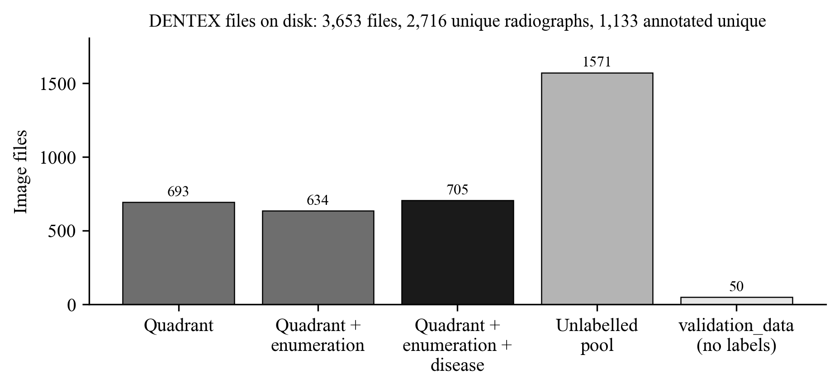
Fig. 3.1 Image files per DENTEX sub-set (bars) and the effect of de-duplication (title)
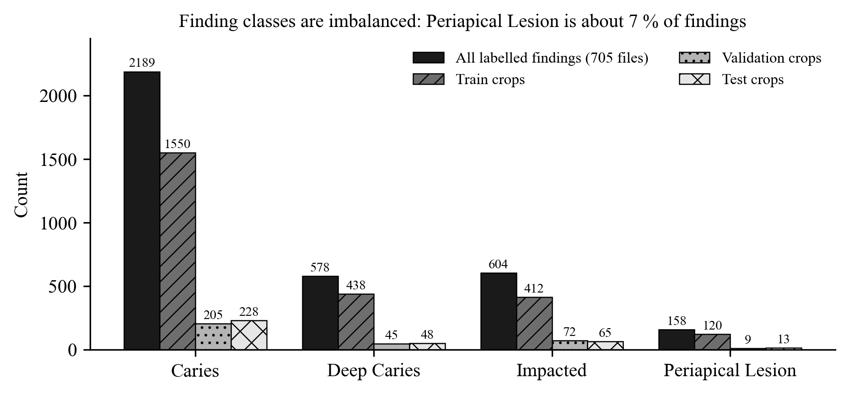
Fig. 3.2 Finding labels in the disease sub-set and the classifier crops per split
CHAPTER 4

4. SYSTEM DESIGN

4.1 PROPOSED SYSTEM ARCHITECTURE
DentaMind AI follows a three-tier architecture, shown in Fig. 4.1. The client tier is a React single-page application with pages for X-ray analysis, reports and review, plus research pages that can be switched on in the settings. Requests pass through the Vite development proxy, which adds the API token on the server side so that it never reaches the browser, to a FastAPI application that listens only on 127.0.0.1. The application tier contains the analysis pipeline service, the report service and the review and registry services. The machine-learning core is a Python package (dentexmodel) with the four networks and the uncertainty measures. All state is kept on the local disk: an SQLite database for analyses, reports and reviews, the checkpoint folder with hashes and sidecars, the DENTEX images with the split manifest, and the evaluation reports with the test-set ledger.
The design keeps three boundaries explicit. Trained networks (grey boxes in the figure) are separated from ordinary code, so the deterministic logic around them can be unit-tested. The report generator reads only stored evidence and never the image, so a report cannot contain anything the pipeline did not produce. Model promotion is a recorded human decision, not an automatic side effect of training.

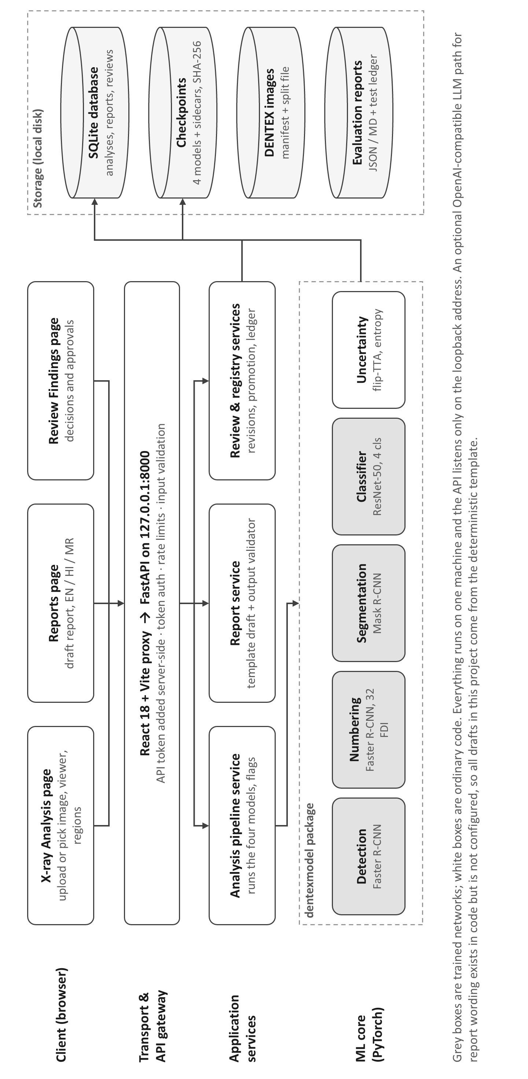
Fig. 4.1 Overall system architecture of DentaMind AI

4.2 SYSTEM BLOCK DIAGRAM
Fig. 4.2 shows the inference pipeline as a block diagram, in the order implemented in the pipeline service. The input radiograph is loaded in grayscale and replicated to three channels so that it matches the ImageNet and COCO pre-trained backbones. The detector proposes tooth boxes with a score of at least 0.3. The numbering detector, trained with 32 FDI classes, runs on the same image and its boxes are matched to the detected teeth at an IoU of at least 0.5; unmatched teeth stay unnumbered. The segmentation network predicts an outline for each tooth, again matched by overlap. Each detected box is then cropped with 10 % padding, resized to 224 × 224 pixels, normalised with ImageNet statistics and classified by the ResNet-50 into the four findings.
Uncertainty is estimated by repeating the classification, detection and segmentation on the horizontally flipped image. The normalised entropy of the classifier output and the Jensen–Shannon divergence between the original and flipped predictions are computed for each tooth, together with the outline and box instability. The flags and the abstention rule are applied, and the structured result is stored. The report generator later turns the stored evidence into a draft, which a person reviews.

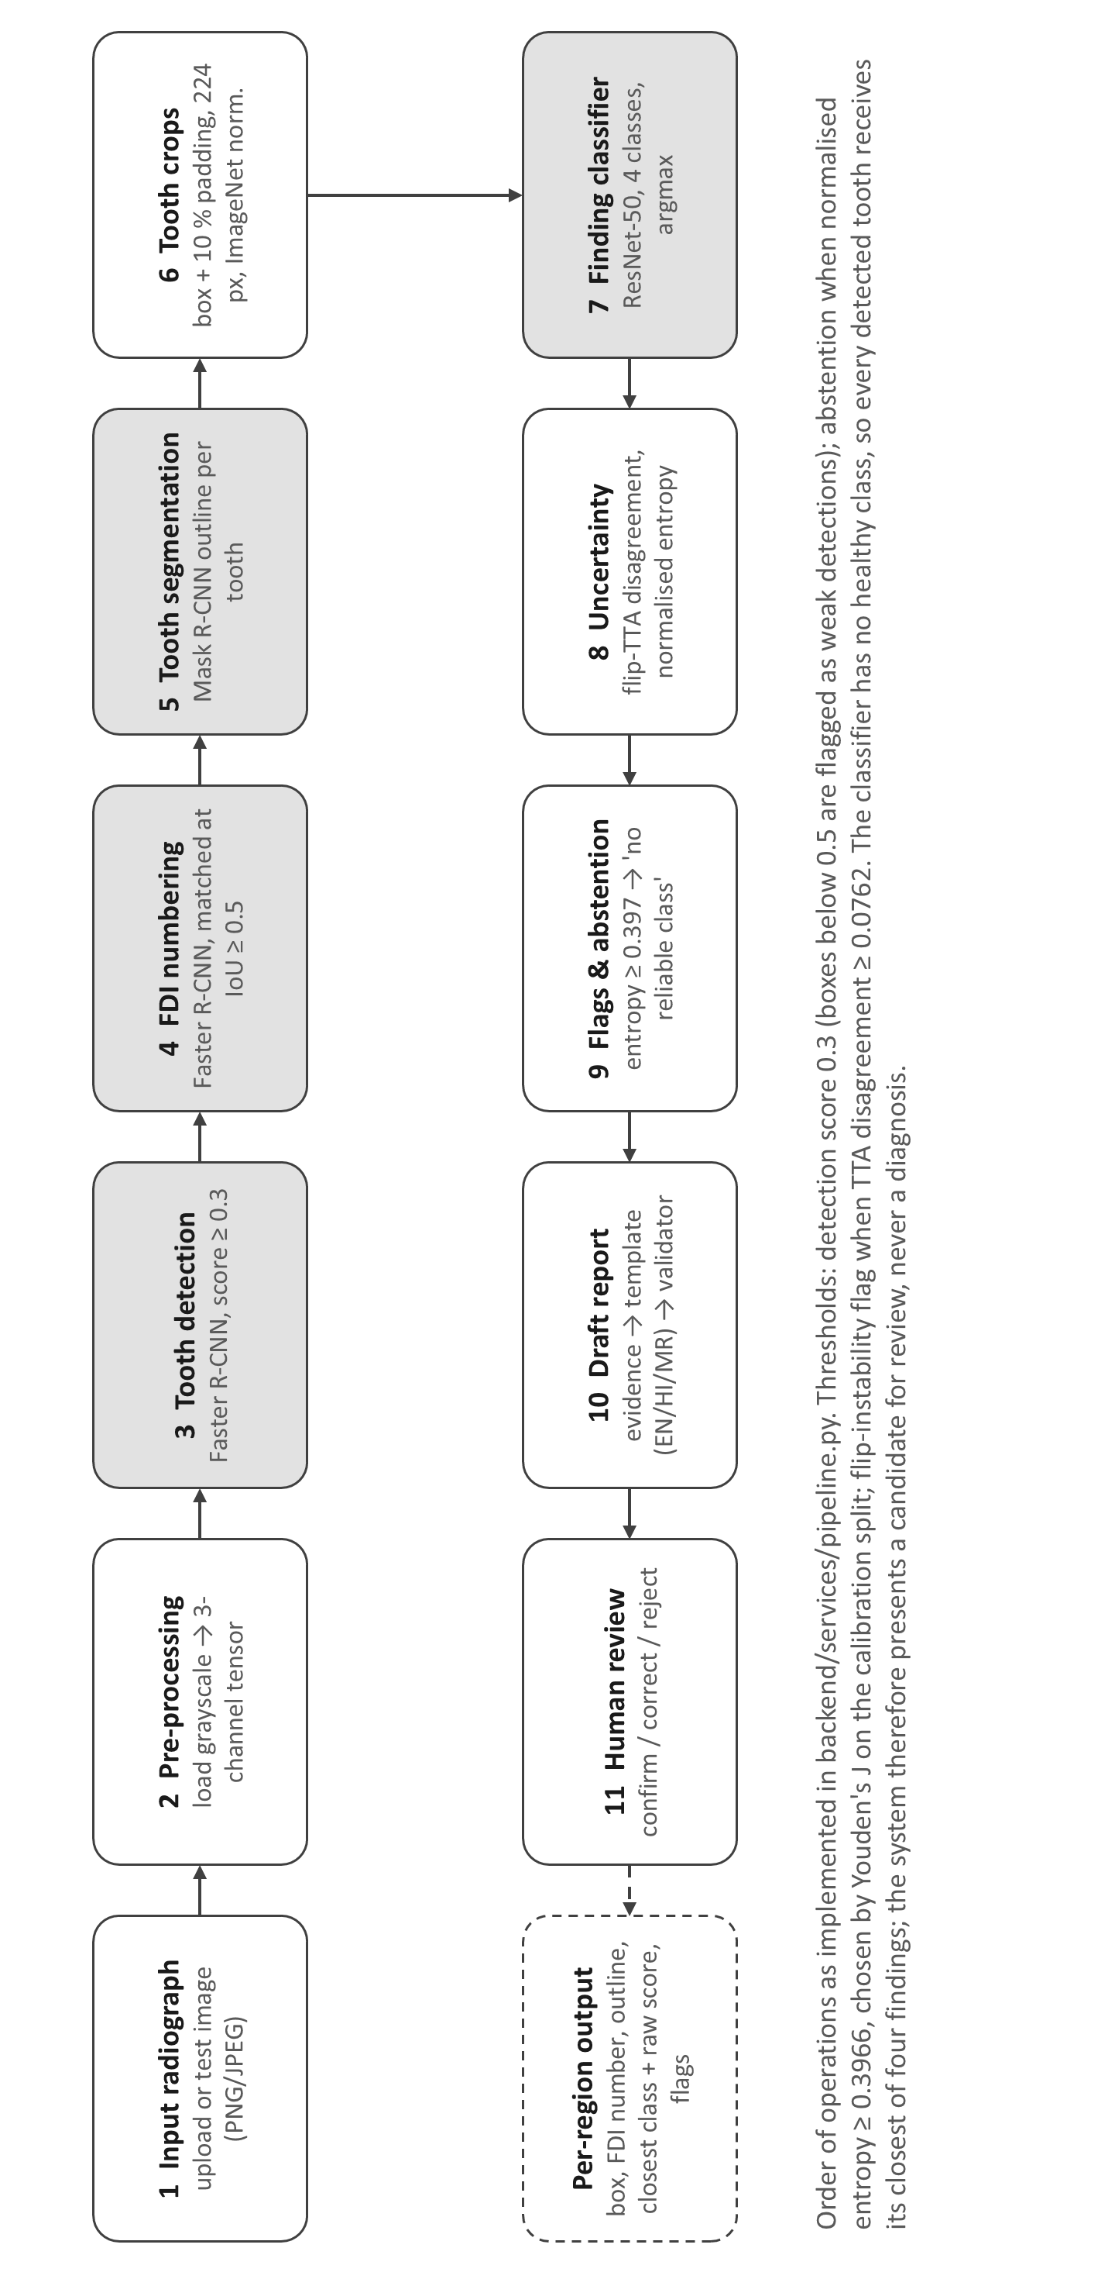
Fig. 4.2 Block diagram of the AI inference pipeline

4.3 SYSTEM WORKFLOW
Two workflows surround the inference pipeline. The training and evaluation workflow in Fig. 4.3 starts from the raw archives. The dataset audit hashes every image, groups identical films and records their sub-sets. The annotated unique radiographs are then split into train (794), validation (113), calibration (113) and test (113) sets, and the leakage checker verifies the result before any training starts. Each split has one purpose. Training uses the train split. Epoch selection and all model comparisons use the validation split. The uncertainty thresholds are chosen on the calibration split. The test split is evaluated at most once per checkpoint, every use is appended to a hash-chained ledger, and its results are never used to choose a model, a threshold or a promotion.
The human-review workflow in Fig. 4.4 starts from the per-region output. Regions with any flag go to the “needs review” group, but regions without flags remain open to review as well. A reviewer can confirm the candidate class, correct it, reject it, set or clear the tooth number, or mark the whole image for specialist review or as unusable. Each decision is stored as a new revision that keeps the previous model output, records the reviewer and a self-declared qualification, and refuses identical resubmissions. A second person approves or rejects the decision. Approved decisions mark the report as reviewed, and they can become training data only if the image is unassigned and is not a copy of any labelled radiograph, so reviewed images cannot leak into validation or test data. The clinician, not the software, remains responsible for any diagnosis.

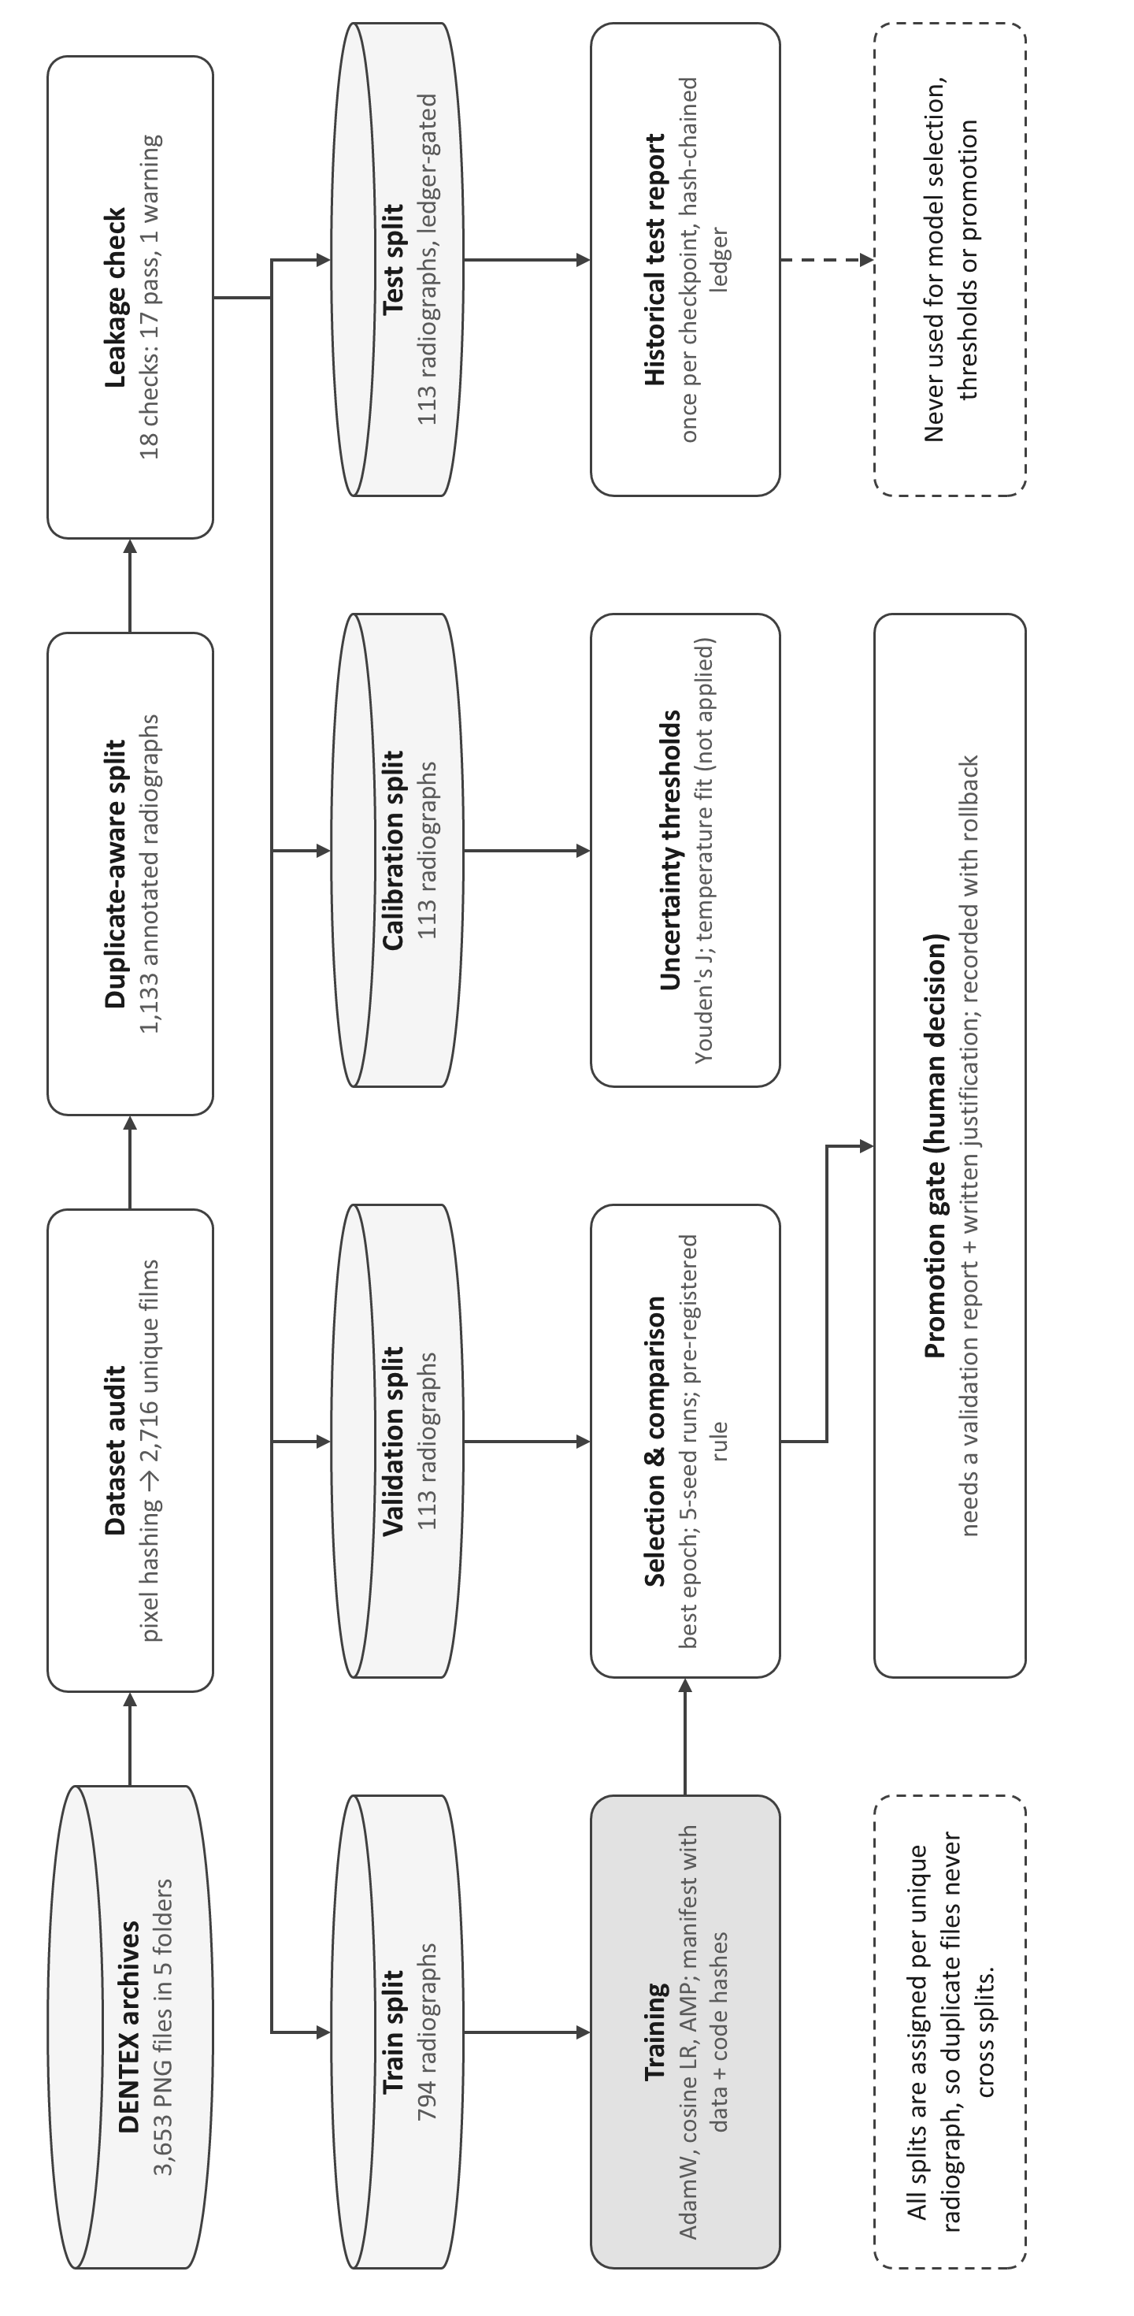
Fig. 4.3 Training and evaluation workflow with split roles

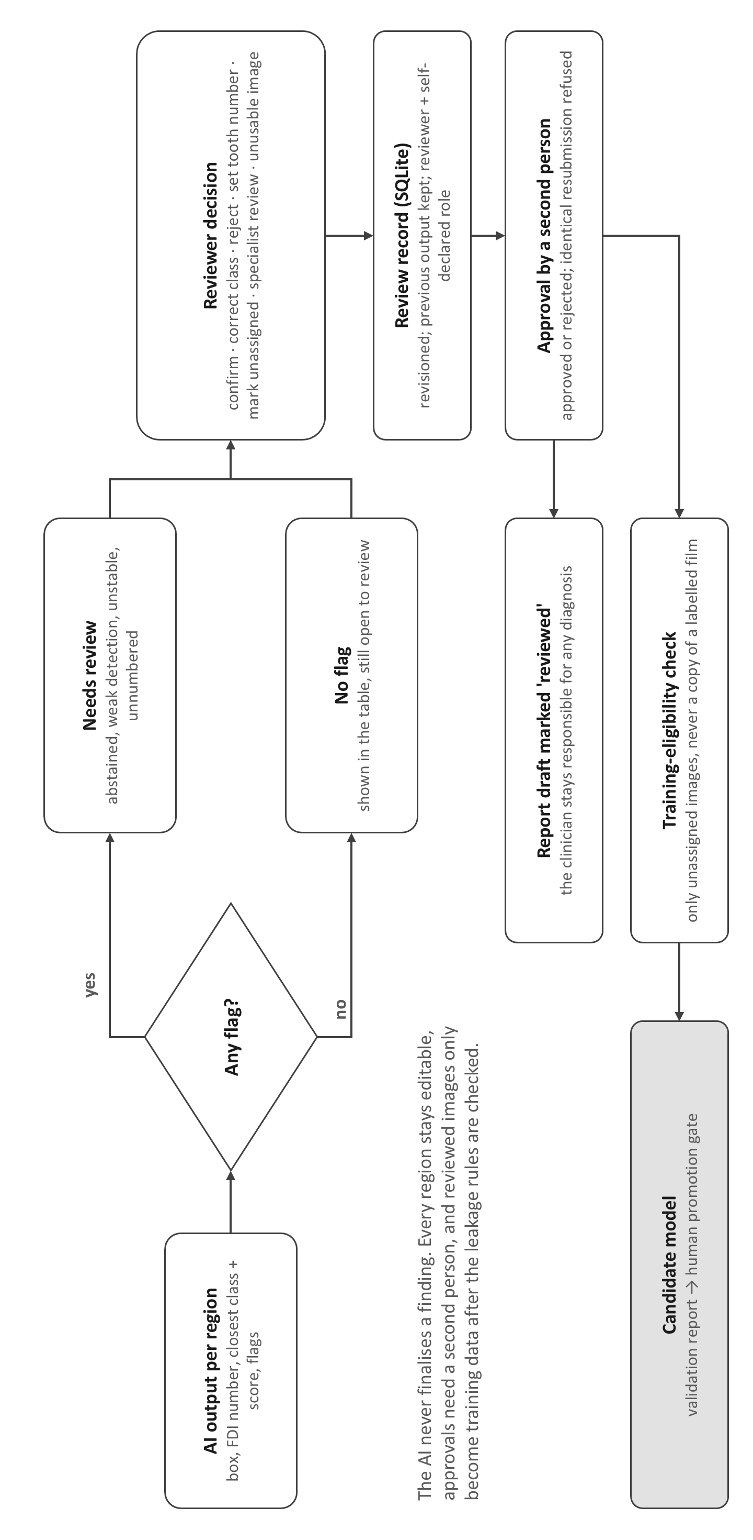
Fig. 4.4 Human-review workflow for AI findings

4.4 MATHEMATICAL MODEL
This section defines the quantities used by the system and in the evaluation; symbols are listed in the nomenclature.

4.4.1 Detection and Overlap Measures
A predicted region A and a ground-truth region B are compared with the intersection over union, and two masks are also compared with the Dice coefficient (Eq. 4.1):
$IoU=\frac{|A∩B|}{|A∪B|}, Dice=\frac{2|A∩B|}{|A|+|B|}$ (4.1)
A prediction counts as a true positive if it matches an unmatched ground-truth region with IoU ≥ 0.5 (greedy one-to-one matching by score). Precision, recall and the F1-score then follow:
$P=\frac{TP}{TP+FP}, R=\frac{TP}{TP+FN}, F1=\frac{2PR}{P+R}$ (4.2)
Average precision (AP) is the area under the precision–recall curve of one class at a fixed IoU threshold; AP50 uses IoU 0.5, and mAP averages AP over IoU thresholds from 0.5 to 0.95 in steps of 0.05, as in the COCO protocol [22].

4.4.2 Classification and Macro-Averaged Metrics
For K = 4 classes, the per-class precision, recall and F1 are computed one class against the rest, and the macro average gives every class the same weight regardless of its frequency:
${F1}_{macro}=\frac{1}{K}\sum_{k=1}^{K}{{F1}_{k}}$ (4.3)
Macro-F1 is the primary metric for the classifier because accuracy is dominated by the Caries class, which makes up 62 % of the validation crops.

4.4.3 Uncertainty Measures
Let p = (p₁, …, p_{K}) be the softmax output for a crop and q the output for its horizontally flipped copy. The normalised entropy and the flip disagreement are
$H_{n}\left(p\right)=-\frac{1}{\log{K}}\sum_{k=1}^{K}{p_{k}\log{p_{k}}}$ (4.4)
$D_{JS}\left(p,q\right)=\frac{1}{\log{2}}\left[H_{e}\left(\frac{p+q}{2}\right)-\frac{H_{e}\left(p\right)+H_{e}\left(q\right)}{2}\right]$ (4.5)
where H_{e} is the Shannon entropy in natural logarithms. A region is shown as “no reliable class candidate” when H_{n} ≥ 0.3966 and is flagged as unstable under flip when D_{JS} ≥ 0.0762. Both thresholds maximise Youden’s index [31] for detecting classifier errors on the calibration split:
$J=sensitivity+specificity-1$ (4.6)

4.4.4 Calibration
Calibration is measured by the expected calibration error over M = 10 equal-width confidence bins B_{m} [26], and temperature scaling divides the logits z by a scalar T fitted on the calibration split:
$ECE=\sum_{m=1}^{M}{\frac{|B_{m}|}{N}\left|acc\left(B_{m}\right)-conf\left(B_{m}\right)\right|}, {\hat{p}}_{k}=\frac{e^{z_{k}/T}}{\sum_{j}{e^{z_{j}/T}}}$ (4.7)

4.4.5 Training Objectives
The detection and segmentation networks minimise the standard multi-task losses of Faster R-CNN and Mask R-CNN, the sum of the region-proposal, classification, box-regression and (for Mask R-CNN) mask terms [18], [19]. The classifier minimises a class-weighted cross-entropy with inverse-frequency weights over the N training crops, and the focal loss with focusing parameter γ [24] was evaluated as an alternative:
$w_{c}=\frac{N}{Kn_{c}}, L_{FL}=-{\left(1-p_{t}\right)}^{γ}\log{p_{t}}$ (4.8)
With the 2,520 training crops described in Section 5.2, the weights are 0.41 for Caries, 1.44 for Deep Caries, 1.53 for Impacted and 5.25 for Periapical Lesion. The experiment trainer used in Section 7.6 caps the weights at 5.
CHAPTER 5

5. PROJECT IMPLEMENTATION

5.1 OVERVIEW OF PROJECT MODULES
The implementation is organised into nine modules. Table 5.1 lists them with their main source locations; each module is described in more detail in Section 5.5.
Table 5.1 Project modules and source locations
Module | Responsibility | Main location
Data audit and splitting | Discover DENTEX sub-sets, hash images, group duplicates, assign persistent splits, run leakage checks | src/dentexmodel/data/
Model training | Train detection, numbering, segmentation and classification; write sidecars and manifests | src/dentexmodel/training/
Inference pipeline | Detect, number, segment, crop, classify, flip-TTA, flags and abstention | backend/services/pipeline.py
Uncertainty and calibration | Entropy, Jensen–Shannon disagreement, mask instability, ECE, temperature scaling | src/dentexmodel/uncertainty/
Report generation | Evidence bundle, template generator, optional LLM path, validator, EN/HI/MR localisation | src/dentexmodel/reporting/
Review and annotation | Revisioned region decisions, approvals, export of approved labels | src/dentexmodel/annotation/
Active learning | Pool scoring and selection strategies (random, entropy, combined) | src/dentexmodel/active_learning/
Registry, promotion and ledger | Checkpoint registry, evidence-backed promotion with rollback, test-set ledger | src/dentexmodel/inference/, evaluation/
Web interface | Analysis, Reports, Review Findings and research pages | frontend/src/

5.2 DATA COLLECTION AND PREPROCESSING
No new data were collected; the project uses the public DENTEX release [11]. The first preprocessing step is an audit that opens every image, records its format, size and mode, and computes a hash of its pixel content. Files with identical pixels are grouped as one radiograph, and near-duplicate candidates are confirmed by pixel correlation (≥ 0.97) before they are treated as the same film. This step matters because the DENTEX folders overlap heavily: for example, 235 radiographs appear in three of the labelled sub-sets at once.
Splits are assigned per unique radiograph by a seeded, group-aware procedure. Each group is ordered by a SHA-256 hash of the seed and its key, and groups are placed into test, calibration, validation and train until the target fractions of 10 %, 10 %, 10 % and 70 % are filled. The split file is append-only: a radiograph that has been assigned never moves, so later re-processing cannot move a training film into the test split. Applied to the 1,133 annotated radiographs, this gives 794 train, 113 validation, 113 calibration and 113 test radiographs. Within each task the split is then restricted to the sub-set that carries the needed labels: the detection, numbering and segmentation models used 440 train and 69 validation radiographs of the enumeration sub-set, and the classifier used 476 train and 65 validation radiographs of the disease sub-set.
Images are read as 8-bit grayscale and replicated to three channels, because all backbones were pre-trained on RGB images. The end-to-end evaluation confirmed that the production loader and the training loader produce pixel-identical inputs (maximum absolute difference 0). For classification, each finding box is enlarged by 10 % padding, cropped, resized to 224 × 224 pixels and normalised with ImageNet mean and standard deviation. This produced 2,520 training crops (Caries 1,550, Deep Caries 438, Impacted 412, Periapical Lesion 120), 331 validation crops and 354 test crops. The classifier was trained with horizontal flips and contrast jitter. The numbering model was trained without horizontal flips, because a flip swaps left and right FDI numbers.
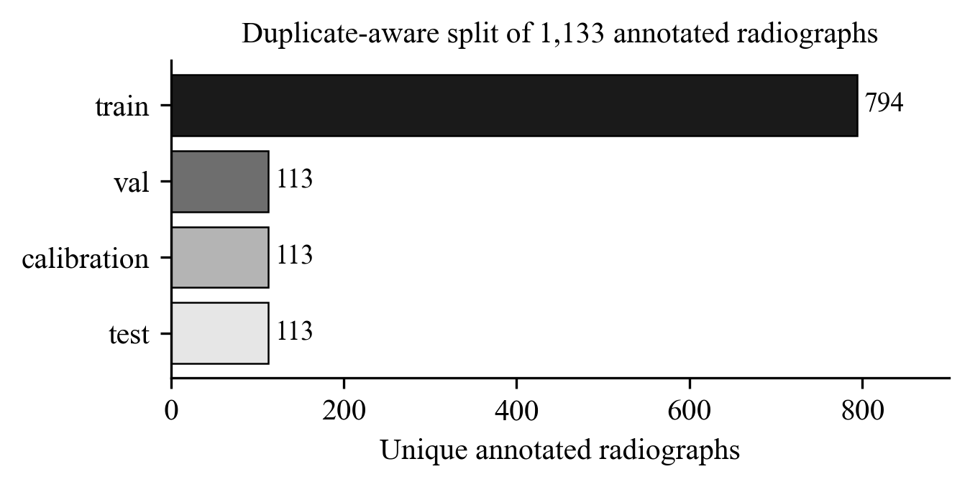
Fig. 5.1 Duplicate-aware split of the 1,133 annotated radiographs

5.3 GENERATIVE AI MODEL SELECTION
Two options were considered for the generative report component: a large language model that writes the report from the evidence, and a deterministic natural-language generator based on templates. Given the findings of Section 2.3, that LLM-written dental reports can omit key details [6], and given that the project had no dental experts to review generated wording, the deterministic generator was selected as the default. It produces a summary paragraph and one sentence per finding, uses the same wording rules for every report, and is localised into Hindi and Marathi through translation tables, so the three language versions always contain the same findings and values.
The LLM option was kept as an extension point. When it is configured, the service sends a de-identified evidence payload to an OpenAI-compatible chat-completions endpoint with temperature 0 and a JSON response format, expects a summary and one note per finding identifier, and runs the same validator on the result. Any failure, whether invalid JSON, a missing field or an unsupported claim, causes the draft to be rejected and replaced by the template output, with the rejection reasons recorded. No LLM endpoint was configured in this project, so the evaluated system is entirely template-based.

5.4 MODEL CONFIGURATION / FINE-TUNING
All four networks were fine-tuned from public pre-trained weights using transfer learning. Table 5.2 lists the configurations, which are recorded in each checkpoint’s JSON sidecar. The detectors were initialised from torchvision COCO weights [22], which are general-domain and not dental, and the classifier from ImageNet weights [23]. All models used the AdamW optimiser [32] with a cosine learning-rate schedule. The detection models used automatic mixed precision to fit into 4 GB of GPU memory, which also limited the batch size to 2 for Faster R-CNN and 1 for Mask R-CNN.
Model selection always used the validation split. The detectors were selected by validation box mAP over IoU 0.5 to 0.95, and the classifier by validation macro-F1; its best epoch was the fifth, after which the training loss kept falling while the validation macro-F1 dropped to about 0.70, a sign of over-fitting on the small minority classes. The numbering model also had to pass a registration gate (exact FDI accuracy of at least 0.80 among localised validation teeth) before the application would load it; it reached 0.936.
Table 5.2 Training configuration of the deployed checkpoints
Model | Architecture and initialisation | Training data | Schedule and selection
dentex_teeth_detection_v1 | Faster R-CNN, ResNet-50 FPN, 1 class; COCO weights [18], [21] | 440 train / 69 val radiographs (enumeration sub-set) | 12 epochs, batch 2, AdamW lr 1e-4, cosine, AMP; best epoch 9 (val box mAP)
dentex_fdi_numbering_v1 | Faster R-CNN, ResNet-50 FPN, 32 FDI classes; COCO weights | 440 / 69 radiographs; no flip augmentation | 16 epochs, batch 2, AdamW lr 1e-4; best epoch 15 (val mAP); gate ≥ 0.80 passed
dentex_teeth_segmentation_v1 | Mask R-CNN, ResNet-50 FPN, 1 class, polygon masks; COCO weights [19] | 440 / 69 radiographs | 8 epochs, batch 1, AdamW lr 1e-4, cosine, AMP; best epoch 8
dentex_findings_classification_v1 | ResNet-50, 4 classes, 224 px crops; ImageNet weights [20] | 2,520 crops from 476 radiographs / 331 val crops | 15 epochs, batch 32, AdamW lr 3e-4, cosine, inverse-frequency weights, flip + contrast jitter; best epoch 5 (val macro-F1)
Source: checkpoint sidecars in Data/checkpoints and docs/MODEL_TRAINING.md. All four checkpoints pre-date the training-manifest system and are labelled ‘legacy’; their SHA-256 hashes start with a68ce488, 83f97b2e, dd13568c and 5aa878e1.

5.5 PROJECT MODULES

5.5.1 Inference Pipeline Service
The pipeline service runs the steps of Fig. 4.2 for one image and stores the result. It records the status and duration of each step, so a failure in one optional stage (for example segmentation) still returns the other results with an explanation. Thresholds are read from the calibration report when it exists and otherwise fall back to defaults; Table 5.3 lists the values in use. Each region carries separate flags for each cause, so the interface can say why a region needs review rather than showing a single generic warning.
Table 5.3 Operating thresholds of the deployed pipeline
Parameter | Value | Origin
Detector score threshold | 0.3 | Fixed operating point used in all evaluations
Weak-detection flag | score < 0.5 | Pipeline default
Numbering match | IoU ≥ 0.5 | Same rule in evaluation and application
Abstention (no reliable class candidate) | H_{n} ≥ 0.3966 | Youden’s J on the calibration split (provisional)
Unstable under flip | D_{JS} ≥ 0.0762 | Youden’s J on the calibration split (provisional)
Unstable outline | 1 − mask IoU ≥ 0.3 | Pipeline default
Crop padding / size | 10 % / 224 px | Same as classifier training

5.5.2 Report Service
The report service builds an evidence bundle from a stored analysis. Each finding receives a stable identifier (F1, F2, …) and carries the tooth number, the class name or abstention, the raw score, the uncertainty and the review status. The template generator writes the summary, including how many regions were found, numbered, outlined and flagged, and one sentence per finding. The text states explicitly that the classifier has no healthy class, so a class name is not a statement that the finding is present. A fixed list of limitations is attached to every report. The validator described in Section 6.2 checks the draft before it is stored, and the report can be exported as HTML or text in English, Hindi or Marathi. A report changes from “awaiting review” to “reviewed” only when a named person marks it as reviewed.

5.5.3 Review, Registry and Integrity Services
The review service implements the workflow of Fig. 4.4 with seven actions: confirm candidate, correct class, reject candidate, set tooth number, mark number unassigned, specialist review and unusable image. The registry lists checkpoints with their hashes and sidecars. A new checkpoint can be promoted to the live system only with a validation report and a written justification; each promotion is recorded with the previous model so that it can be rolled back. The test-set ledger appends one hash-chained entry for every evaluation on the test split and refuses a second test evaluation of the same checkpoint. Its five entries are the historical evaluations of the four deployed models and the uncertainty evaluation.

5.5.4 Web Interface
The React interface has four main pages. Home explains the purpose and starts an analysis. X-ray Analysis combines the uploader, a zoomable viewer with boxes, numbers and outlines, and a region table that lists the tooth number, the candidate class or abstention, the raw score and the warning chips for every region. Reports shows saved drafts in the three languages, and Review Findings holds the review queue. Research pages for segmentation, uncertainty, active learning, annotations, model training, experiments and the model registry can be switched on in the settings. Screenshots are shown in Section 7.8.

5.6 TOOLS AND TECHNOLOGIES USED
Python 3.13 with PyTorch 2.6 and torchvision 0.21 [30] was used for all modelling, with CUDA 12.4 on the laptop GPU. FastAPI and Uvicorn serve the REST API, SQLite stores application data, and NumPy and Pillow handle image processing and metrics. The frontend uses React 18 with React Router, Vite 5 as the build tool and development proxy, Tailwind CSS for styling, Recharts for charts and lucide-react for icons. pytest runs the automated tests, and command-line scripts in the scripts folder perform the leakage check, the evaluations, the experiments and the ledger verification. The charts in this report were drawn with Matplotlib directly from the JSON evaluation reports, and the diagrams were drawn as editable shapes in Microsoft PowerPoint.

5.7 ALGORITHM DETAILS
The three central algorithms are given below in step form.
Algorithm 5.1 Region analysis of one radiograph
Input: radiograph I; models f_{det}, f_{num}, f_{seg}, f_{cls}; thresholds τ_{det} = 0.3, τ_{H}, τ_{JS}
1. X ← three-channel tensor of grayscale(I)
2. D ← boxes of f_{det}(X) with score ≥ τ_{det}
3. For each d in D: attach the FDI number of the f_{num}(X) box with IoU(d, ·) ≥ 0.5, else mark it unnumbered
4. Attach to each d the f_{seg}(X) mask that overlaps it best, if any
5. For each d: c ← crop(I, d, pad 10 %, 224 px); p ← f_{cls}(c); q ← f_{cls}(flip(c))
6. H ← H_{n}(p); S ← D_{JS}(p, q); label ← argmax p
7. if H ≥ τ_{H}: status ← abstained (label and score kept, shown as ‘no reliable class candidate’)
8. if S ≥ τ_{JS}: add flag ‘unstable under flip’; add detection and mask flags from the flipped image
9. Store regions with flags; mark review_required if any flag is set
Output: list of regions (box, FDI, mask, candidate class, raw score, uncertainty, flags)

Algorithm 5.2 Validation of a generated report
Input: draft report r, evidence e, vocabulary V, forbidden phrases F
1. Reject if required fields are missing or have the wrong type
2. For each finding in r: it must exist in e with the same tooth number, label, score and uncertainty
3. The number of findings in r must equal the number in e; every FDI number must be valid
4. All scores and uncertainties in e must lie in [0, 1]; labels must belong to V
5. Scan the free text: reject any phrase in F (e.g. ‘diagnos’, ‘recommend’, ‘treatment plan’, ‘confirmed’)
6. Reject any tooth number, decimal number or finding name in the text that is not in e
7. The status must be ‘research draft’ or ‘reviewed’
Output: passed / failed with the list of errors

Algorithm 5.3 Duplicate-aware, persistent split assignment
Input: annotated images with pixel hashes; seed s; fractions (train .7, val .1, calibration .1, test .1); existing split file
1. Group images by unique radiograph (identical pixel content)
2. Keep every group that already has an assignment in its split (append-only)
3. Order the remaining groups by SHA-256(s : group key)
4. Fill test, then calibration, then validation, then train up to their target counts
5. Write the split file; run the 18 leakage checks before any training
Output: split per image; all members of a group share one split

CHAPTER 6

6. SOFTWARE TESTING

6.1 TEST CASES
Testing was carried out at three levels: automated unit and integration tests, scripted checks of data integrity, and manual end-to-end checks of the running application in a browser. The automated suite contains 233 tests in 16 files, and all 233 passed in the last recorded run on 15 October 2026. Table 6.1 groups them by area.
Table 6.1 Automated test suite by area
Test file(s) | Area covered | Tests
test_dataset_pipeline, test_real_dentex_layout, test_preprocess | Dataset discovery, manifest, hashing, preprocessing | 41
test_leakage, test_research_integrity | Leakage checks, test-set ledger, provenance, promotion gate | 27
test_annotation_reporting, test_i18n_reports | Evidence bundle, template, validator, EN/HI/MR reports | 31
test_review_pipeline | Review actions, revisions, approvals, training eligibility | 12
test_backend_services, test_security_and_training_api | API services, token auth, rate limits, upload and path validation | 41
test_training_registry, test_uncertainty_eval | Trainer, registry, uncertainty measures, calibration | 34
test_geometry_fdi, test_active_learning | Box geometry, FDI validity, active-learning selection | 23
test_audit_regressions, test_skeleton | Regression tests for defects found in the functionality audit | 26
Counts are the test functions defined per file group (235 functions in total); pytest collected and passed 233 tests in the last recorded run.
Table 6.2 lists representative functional test cases with the observed result.
Table 6.2 Representative functional test cases
ID | Test case | Expected result | Observed
TC-1 | Analyse DENTEX test image val_0 from the ‘Test data’ source in the browser | Regions with boxes, numbers and outlines; flags per region | 27 regions in 4.4 s; 26 numbered, 26 with mask, 20 flagged
TC-2 | Generate a report for that analysis and switch language | Validated draft in EN, HI and MR with identical values | Report RPT-8C9DE6104F created, status ‘awaiting review’
TC-3 | Run the leakage checker on the current splits | No overlap between train, val, calibration and test | 17 checks pass, 1 informational warning
TC-4 | Verify the test-set ledger | Hash chain intact; one test use per checkpoint | 5 historical entries, chain verified
TC-5 | Submit the same review decision twice | Second submission refused | Refused as duplicate (unit test)
TC-6 | Call the API without a token | Request rejected | 401 Unauthorized (unit test)
TC-7 | Report text mentions a tooth or number absent from the evidence | Validator rejects the draft | Rejected with error list (unit test)
TC-8 | Promote a checkpoint without a validation report | Promotion refused | Refused (unit test)

The single leakage warning concerns three unlabelled demo files in validation_data (val_4, val_22 and val_29) that are byte-identical to test radiographs. They are never used for training or scoring and are listed in the interface as copies of test films; the warning was left visible on purpose.

6.2 GENERATIVE AI OUTPUT TESTING
Because generated text is the part of the system most likely to overstate results, every draft passes through the validator of Algorithm 5.2 before it is stored, and the validator itself is covered by unit tests with deliberately faulty drafts. The checks fall into four groups. Schema checks require all fields, with the correct types and a research-draft or reviewed status. Evidence checks require that every finding in the report exists in the evidence with the same tooth number, label, score and uncertainty, and that no finding is added or dropped. Claim checks scan the free text for forbidden phrases such as “diagnosis”, “recommend”, “treatment plan”, “extraction”, “definitely” and “confirmed”, and for any tooth number, decimal number or finding name not present in the evidence. Range checks require scores in [0, 1] and labels from the model vocabulary.
For the LLM path, the tests inject a fake transport that returns invalid JSON, a missing field, an invented tooth number or a forbidden phrase, and confirm that each case is rejected and replaced by the template draft with the reasons recorded. The localisation tests check that the Hindi and Marathi reports contain exactly the same findings, numbers and identifiers as the English one. The Hindi and Marathi wording has not been reviewed by a native-speaking dental professional, which is listed as a limitation.

6.3 PERFORMANCE EVALUATION
Inference speed was measured on 10 DENTEX radiographs on the RTX 3050 laptop GPU. Table 6.3 lists the mean, median and 95th-percentile time per image and the peak GPU memory of each stage; no failures occurred.
Table 6.3 Inference latency per image (RTX 3050 Laptop GPU)
Stage | Mean (s) | Median (s) | P95 (s) | Images/s | Peak GPU (MB)
Detection | 0.110 | 0.099 | 0.153 | 9.1 | 613
Segmentation | 0.285 | 0.298 | 0.339 | 3.5 | 1653
Detection + numbering | 0.334 | 0.332 | 0.367 | 3.0 | 985
Detection + classification | 0.252 | 0.246 | 0.291 | 4.0 | 1039
Source: Data/reports/benchmark_inference.json. A full analysis in the application additionally runs the flipped-image passes and stores the result; for val_0 (2872 × 1504 pixels) this took 4.4 s end to end.
CHAPTER 7

7. RESULTS AND DISCUSSION
Throughout this chapter, validation results come from the split that was also used to select epochs and compare models, so they are slightly optimistic. Historical test results come from the test split, which was evaluated once per deployed checkpoint before the test-set ledger existed. Those uses are now recorded in the ledger, and the test split was never used to choose a model or a threshold. The two kinds of result are reported side by side and are never mixed in one average.

7.1 PROJECT OUTCOMES
The project delivered a working, locally deployed system that meets the functional requirements of Section 3.3. Given a panoramic radiograph, it locates the teeth, numbers and outlines them, proposes a candidate finding or abstains, flags doubtful regions by cause, and generates a validated draft report in three languages. The review workflow keeps a revisioned, second-person-approved record of every decision.
The project also delivered an evaluation infrastructure: a dataset audit with duplicate-aware splits, 18 automated leakage checks, evaluation scripts that record dataset fingerprints and software versions, a hash-chained test-set ledger, and pre-registered experiment protocols. The infrastructure is the reason the results below can be stated with their limitations rather than as single optimistic numbers.

7.2 RESULT ANALYSIS

7.2.1 Tooth Detection and Segmentation
Table 7.1 Tooth detection and segmentation (score ≥ 0.3, IoU ≥ 0.5)
Model and split | Images | TP / FP / FN | Precision | Recall | F1 | Box AP50 | Box mAP | Mask AP50
Detection, validation | 69 | 1968 / 78 / 32 | 0.962 | 0.984 | 0.973 | 0.978 | 0.560 | –
Detection, historical test | 63 | 1743 / 73 / 47 | 0.960 | 0.974 | 0.967 | 0.966 | 0.515 | –
Segmentation, validation | 69 | 1972 / 70 / 28 | 0.966 | 0.986 | 0.976 | 0.981 | 0.569 | 0.980
Segmentation, historical test | 63 | 1754 / 69 / 36 | 0.962 | 0.980 | 0.971 | 0.974 | 0.530 | 0.974
F1 is derived from the TP/FP/FN counts. On the historical test split the segmentation masks reached mean Dice 0.873 and mean mask IoU 0.780 over 1,753 matched teeth (mask IoU on a 4× sub-sampled grid).
Tooth localisation is strong and stable between the two splits: precision stays near 0.96 and recall drops only from 0.984 to 0.974, with about one false positive per image. The gap between AP50 (0.97 to 0.98) and mAP over IoU 0.5 to 0.95 (0.52 to 0.57) shows that the boxes overlap the teeth well but are not pixel-tight. This matters later, because the classifier crops come from these boxes. The segmentation masks reach a mean Dice of 0.873 on the historical test split, enough to outline teeth in the viewer but not intended for measurement. Fig. 7.1 compares the two splits.
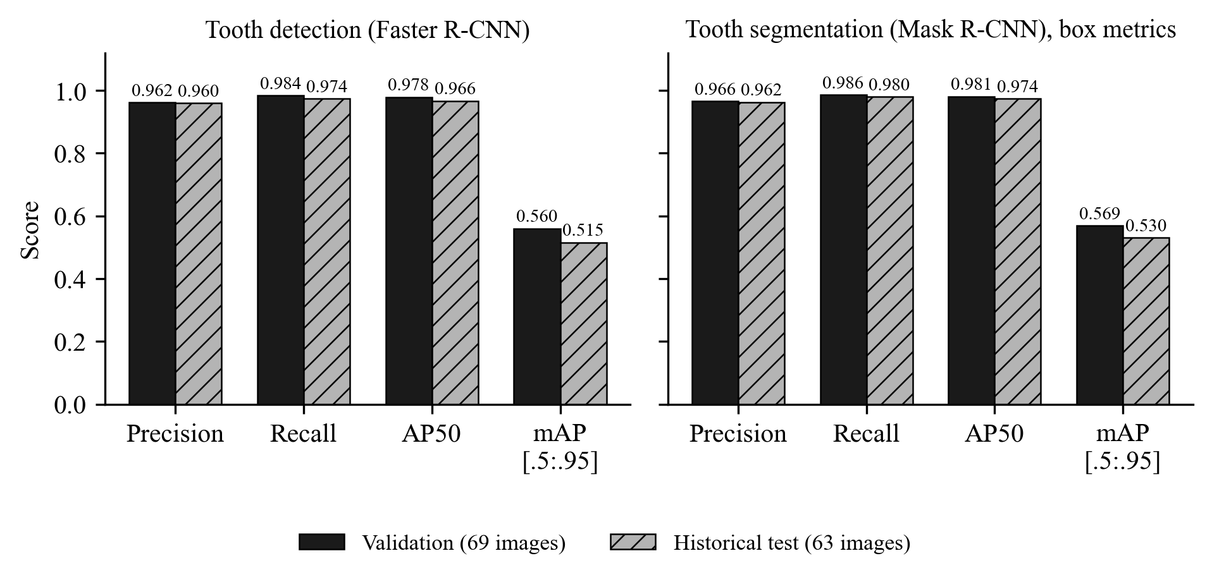
Fig. 7.1 Detection and segmentation on validation and historical test splits

7.2.2 FDI Tooth Numbering
Table 7.2 FDI tooth numbering
Split | GT teeth | Localised (coverage) | Exact FDI (of localised) | Correct quadrant | Strict (all GT)
Validation | 2,000 | 1,957 (0.979) | 0.936 | 0.997 | 0.915
Historical test | 1,790 | 1,734 (0.969) | 0.968 | 0.999 | 0.938

Among teeth that were localised, the numbering model assigns the exact FDI number in 93.6 % of validation cases and 96.8 % of historical test cases, and the quadrant is almost always right (99.7 % and 99.9 %). Fig. 7.2 shows the per-tooth accuracy on the validation split: the lowest value is for tooth 36 (0.82), and other molars such as 18, 37 and 47 lie between 0.86 and 0.87, while the incisors are numbered almost perfectly. The strict accuracy, which counts every unlocalised tooth as wrong, is 0.915 and 0.938.
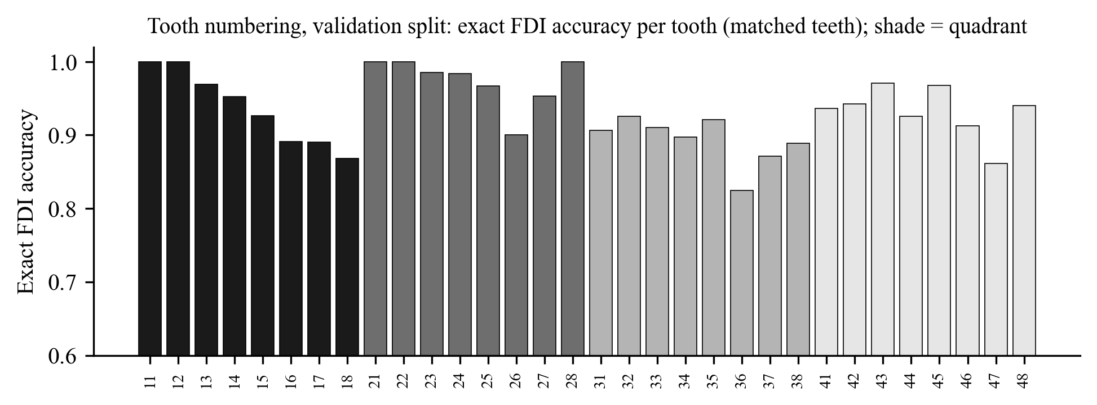
Fig. 7.2 Exact FDI numbering accuracy per tooth on the validation split

7.2.3 Finding Classification on Ground-Truth Tooth Boxes
Table 7.3 Finding classification with ground-truth boxes: summary
Split | Crops | Accuracy | Macro precision | Macro recall | Macro F1
Validation | 331 | 0.825 | 0.693 | 0.763 | 0.718
Historical test | 354 | 0.785 | 0.653 | 0.649 | 0.646
Historical test macro one-vs-rest ROC-AUC: 0.910. Specificity and ROC-AUC are computed among the four finding classes only, because there is no healthy class.
Table 7.4 Per-class results (validation / historical test)
Class | Support | Precision | Recall | F1 | Test ROC-AUC
Caries | 205 / 228 | 0.885 / 0.866 | 0.863 / 0.820 | 0.874 / 0.842 | 0.895
Deep Caries | 45 / 48 | 0.500 / 0.414 | 0.467 / 0.500 | 0.483 / 0.453 | 0.834
Impacted | 72 / 65 | 0.919 / 0.887 | 0.944 / 0.969 | 0.932 / 0.926 | 0.990
Periapical Lesion | 9 / 13 | 0.467 / 0.444 | 0.778 / 0.308 | 0.583 / 0.364 | 0.921

The classifier separates the four findings far better than chance (macro ROC-AUC 0.910), but its decisions are uneven across classes. Impacted teeth are recognised reliably (F1 0.93 on both splits), because impaction is a matter of position and shape that is visible at crop level. Caries is also good (F1 0.87 and 0.84). Deep Caries is weak (F1 0.48 and 0.45). The confusion matrix in Fig. 7.4 shows that 20 of the 45 validation Deep Caries crops are predicted as Caries and 18 Caries crops as Deep Caries. The two labels describe depth along a continuum, and the boundary is hard to see on a panoramic film. Periapical Lesion has only 9 validation and 13 test crops, so its results swing widely: recall is 0.78 on validation and 0.31 on test, and a single prediction changes the validation recall by 11 percentage points.
Accuracy is a misleading summary here. Caries makes up 62 % of the validation crops, so a model that is good at Caries and poor at the rare classes still reaches high accuracy. For this reason macro-F1 is the primary metric throughout the project.
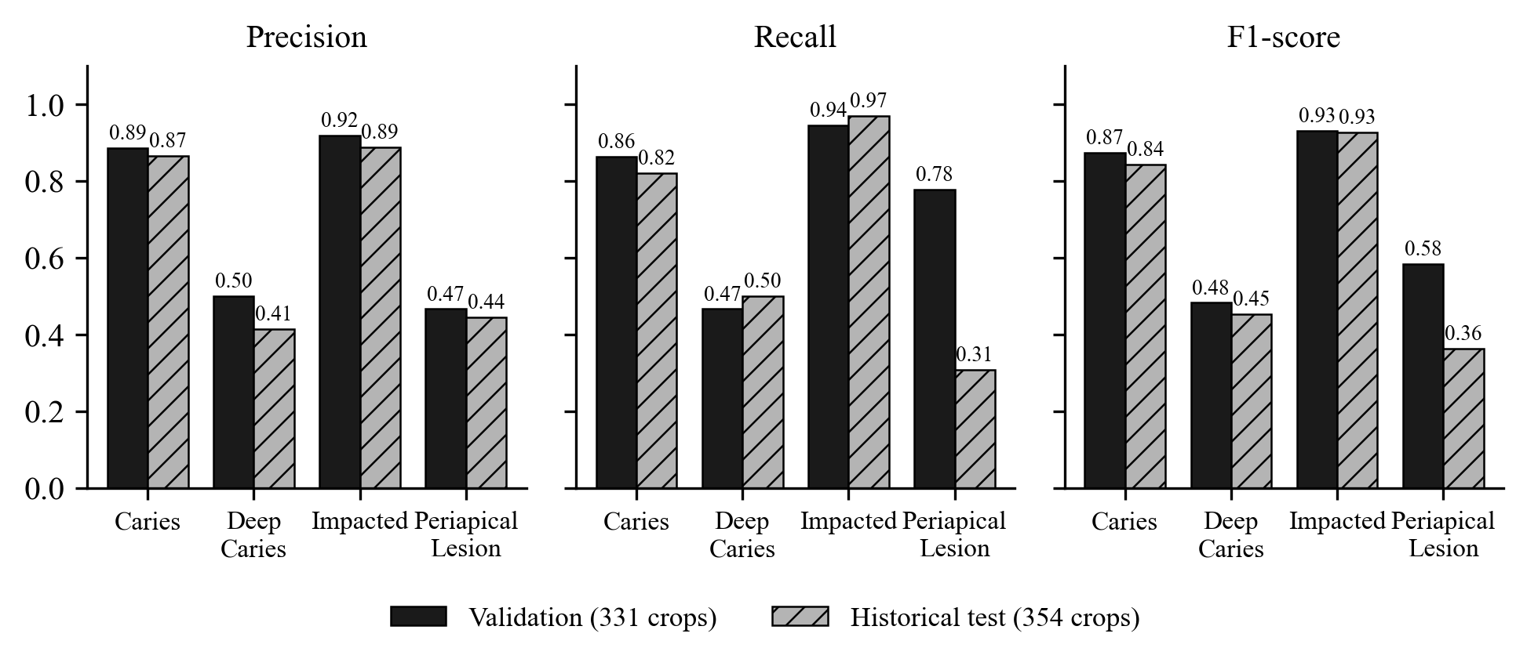
Fig. 7.3 Per-class precision, recall and F1 of the finding classifier
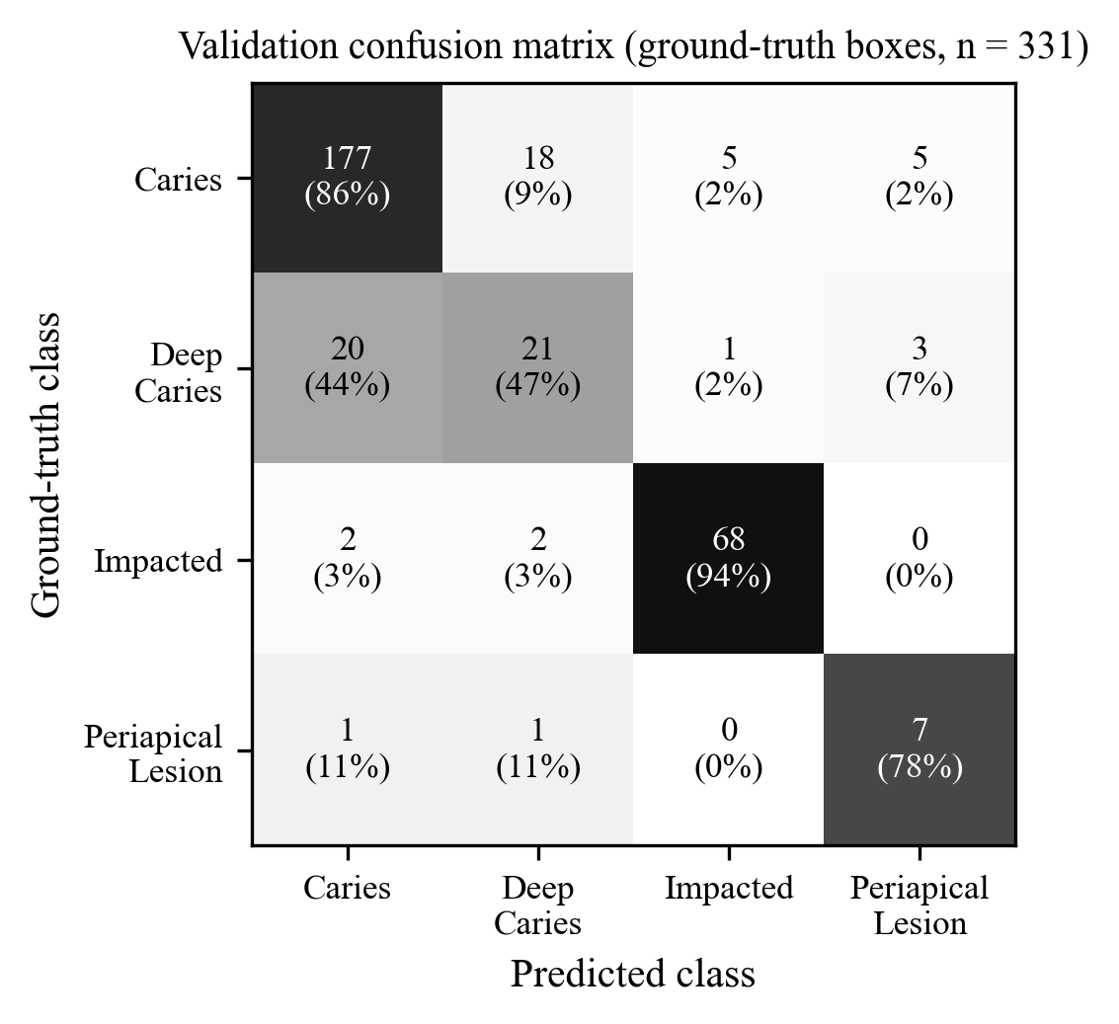
Fig. 7.4 Confusion matrix on the validation split (ground-truth boxes)

7.3 GENERATED OUTPUT ANALYSIS
Reports were generated for real analyses during testing. For the DENTEX test image val_0, the generated English summary reads, in part: “The detection model (dentex_teeth_detection_v1) located 27 tooth region(s). … The classification model (dentex_findings_classification_v1) gave each region its closest class among four trained findings. It has no healthy class, so a class name here is not a statement that the finding is present. Of these, 26 have a tooth number from the numbering model, 26 have a matched segmentation mask, and 20 are flagged for manual review.” The summary is followed by one line per finding with its identifier, tooth number, candidate class or abstention, raw score, uncertainty and review status, and by the fixed list of limitations (Fig. 7.12).
Three properties of the generated output were checked. Faithfulness: every number and tooth in the text comes from the evidence, because the validator rejects anything else. Consistency: the English, Hindi and Marathi versions contain identical findings and values, which the localisation tests confirm. Caution: the text uses the wording “closest class” and “flagged for manual review” and never names a diagnosis, and forbidden phrases are blocked automatically. The same example also shows the main weakness of the system: 18 of the 27 regions on val_0 abstained. The report is therefore honest, but it is less informative for a radiograph whose teeth are mostly healthy, which is exactly the situation the classifier was never trained on.

7.4 PERFORMANCE METRICS
Table 7.5 brings the main metrics of all four models together, with validation and historical test results kept separate.
Table 7.5 Summary of model performance
Model | Metric | Validation | Historical test
Tooth detection | Precision / recall / AP50 | 0.962 / 0.984 / 0.978 | 0.960 / 0.974 / 0.966
Tooth segmentation | Mask AP50 / box F1 | 0.980 / 0.976 | 0.974 / 0.971
Tooth segmentation | Mean Dice / mask IoU | not computed | 0.873 / 0.780
FDI numbering | Exact accuracy (of localised) | 0.936 | 0.968
Finding classifier (GT boxes) | Accuracy / macro-F1 | 0.825 / 0.718 | 0.785 / 0.646
Finding classifier (GT boxes) | Macro precision / recall | 0.693 / 0.763 | 0.653 / 0.649
Classifier on detector boxes | Accuracy / macro-F1 (323 teeth) | 0.811 / 0.649 | not evaluated
End-to-end (all 331 findings) | Accuracy / macro-F1 | 0.792 / 0.634 | not evaluated
Segmentation box F1 is derived from TP/FP/FN (1,972/70/28 and 1,754/69/36). The detector-box and end-to-end evaluations were run on the validation split only, so that the test split is not reused.

7.5 ACCURACY / RELEVANCE / QUALITY EVALUATION

7.5.1 Ground-Truth Boxes versus Detector Boxes
In the application the classifier never sees a ground-truth box; it classifies crops cut from the detector’s boxes. To measure what the user actually gets, the 331 validation findings were matched one-to-one to detector boxes at IoU ≥ 0.5. 323 findings were matched and 8 were not. On the same 323 teeth, ground-truth crops give accuracy 0.830 and macro-F1 0.717, while detector crops give 0.811 and 0.649. Counting the unmatched findings as errors, the end-to-end accuracy is 0.792 and the macro-F1 0.634 (Table 7.6 and Fig. 7.5).
The drop is concentrated in the rare classes. End to end, Deep Caries recall is 0.333 and only 4 of the 9 Periapical Lesion findings are recovered. The errors decompose as follows: 248 findings are correct with both box types and 41 are wrong with both. 20 are correct only with the ground-truth box and 14 only with the detector box, and 8 are unmatched. Of the unmatched findings, 4 are genuine detector misses and 4 sit on teeth that carry two findings, which a single box cannot represent. The detector itself is not the problem: on the 24 validation images with full tooth annotations it found 716 of 719 teeth with 17 false positives (precision 0.977, recall 0.996). The cause is crop sensitivity. About 10 % of predictions change even when the detector box overlaps the ground-truth box at IoU above 0.9, because the classifier was trained only on ground-truth crops.
Table 7.6 Classification with ground-truth and detector crops (validation)
Setting | Findings | Accuracy | Macro-F1 | Deep Caries recall | Periapical Lesion recall
Ground-truth boxes, all findings | 331 | 0.825 | 0.718 | 0.467 | 0.778
Ground-truth boxes, matched teeth | 323 | 0.830 | 0.717 | 0.439 | 0.857
Detector boxes, matched teeth | 323 | 0.811 | 0.649 | 0.366 | 0.571
End-to-end (misses count as wrong) | 331 | 0.792 | 0.634 | 0.333 | 0.444
Source: Data/reports/end_to_end_validation_evaluation.json (one-to-one greedy matching by IoU, detector score ≥ 0.3, classifier argmax).
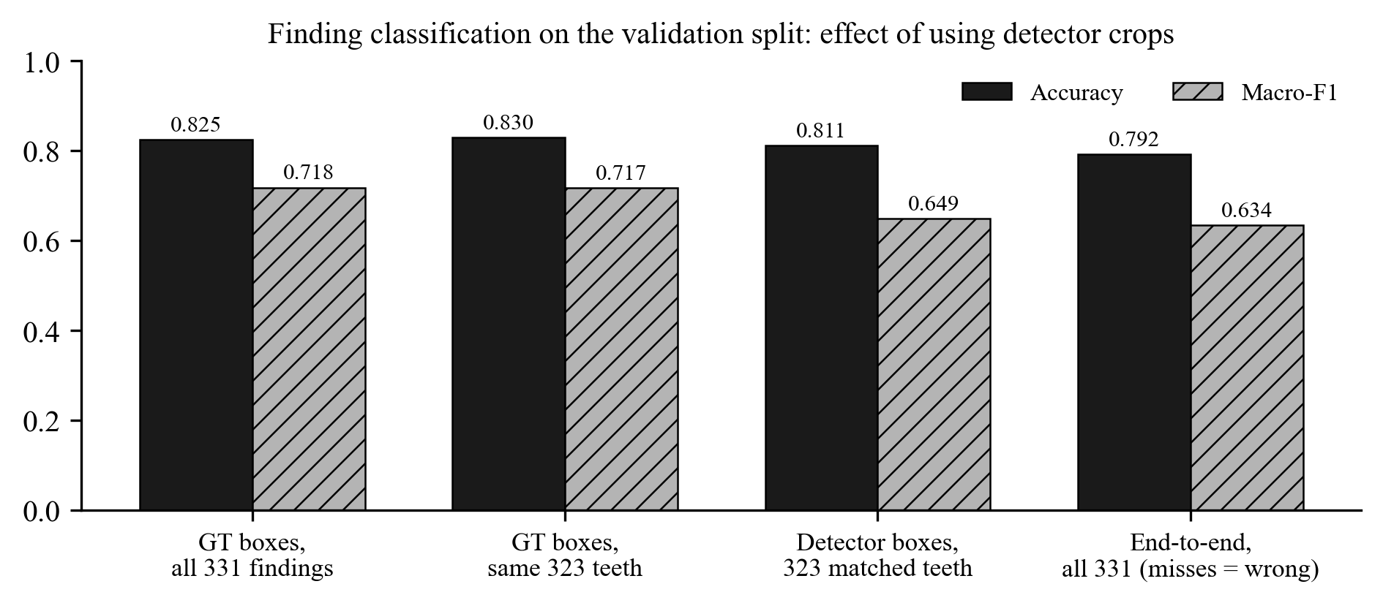
Fig. 7.5 Effect of detector crops on finding classification (validation split)
A related problem is the missing healthy class. Of the 1,903 detector boxes on the 65 validation images, 1,580 do not correspond to any labelled finding, yet the classifier still assigns each of them one of the four findings. Most of these teeth are probably healthy, but DENTEX does not label healthy teeth, so this cannot be measured. The abstention rule and the wording “closest class” exist because of this limitation.

7.5.2 Uncertainty and Abstention
The uncertainty thresholds were chosen on the calibration split (324 crops) and then measured once on the historical test split (354 crops). Normalised entropy ranks the classifier’s errors with an AUROC of 0.768, and flip disagreement with 0.745. At the chosen threshold, 54% of test crops are flagged, and these flagged crops contain 87% of all errors. The error rate is 34.4% among flagged crops and 6.2% among the rest (Table 7.7 and Fig. 7.6).
The raw scores are reasonably calibrated: the expected calibration error is 0.048 on the test split. Temperature scaling with T = 0.95, fitted on the calibration split [26], would reduce it to 0.036, but it increases the calibration-split ECE from 0.071 to 0.076. Because the evidence is mixed, the temperature is reported but not applied, and the interface labels scores as raw model scores. Flagging works as a triage signal, but flagging more than half of all crops is a heavy burden for a reviewer, and the thresholds remain provisional because they come from one seed and one dataset.
Table 7.7 Uncertainty evaluation of the finding classifier
Quantity | Calibration split | Historical test split
Crops / accuracy | 324 / 0.830 | 354 / 0.785
ECE before / after temperature scaling | 0.071 / 0.076 | 0.048 / 0.036
Brier score | 0.277 | 0.291
AUROC for errors: entropy / flip disagreement / 1 − max p | 0.721 / 0.709 / 0.713 | 0.768 / 0.745 / 0.790
Flagged fraction / errors caught | thresholds chosen here | 0.542 / 0.868
Error rate flagged / not flagged | – | 0.344 / 0.062
Error rate unstable / stable under flip | – | 0.485 / 0.187

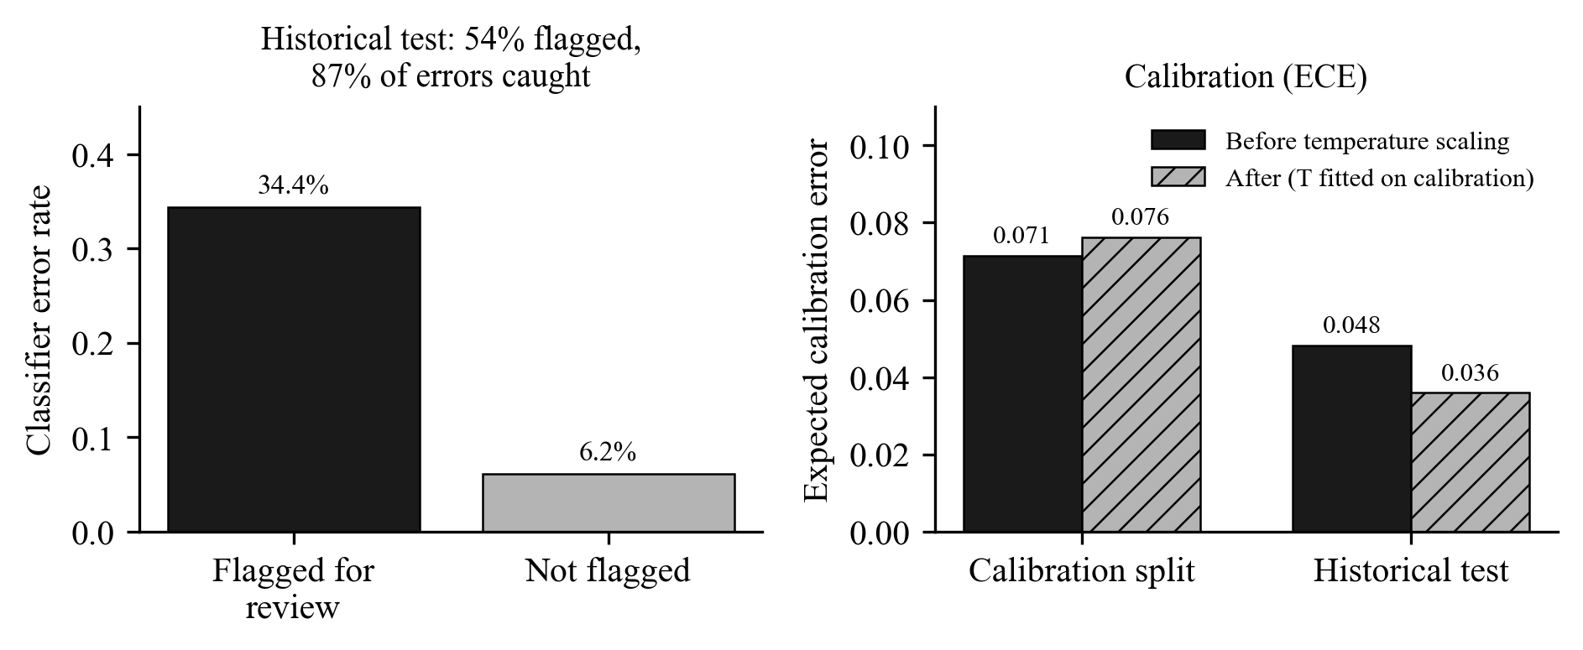
Fig. 7.6 Error rate of flagged and unflagged crops, and calibration error

7.6 VALIDATION OF RESULTS
This section reports the experiments that tried to improve the classifier, and the checks that support the integrity of all results. Every improvement had to pass a rule written before the experiment was run, and no experiment used the test split.

7.6.1 Class-Imbalance Experiments
Because the minority classes were the weak point, five standard remedies for class imbalance [25], [24] were compared with the baseline C0, a ResNet-50 trained with inverse-frequency class weights capped at 5. Each variant changed exactly one factor; everything else, including data, schedule and seeds 42 to 46, was identical. A re-run of the baseline (C0r) reproduced C0 bit for bit on all five seeds, so the comparison is deterministic and differences are caused by the change itself. The rule fixed in advance required a paired macro-F1 gain above 0.027, which is the seed-to-seed standard deviation of the baseline, in at least four of five seeds, without lowering minority-class recall. Validation was used for both epoch selection and reporting, which gives every method the same optimistic bias.
Table 7.8 Class-imbalance experiments on the validation split (5 seeds)
Variant | Macro-F1 (mean ± SD) | Paired Δ vs C0 (seeds better) | Deep Caries recall | Periapical Lesion recall | Accuracy
C0 baseline: inverse-frequency weights (cap 5) | 0.764 ± 0.027 | – | 0.587 | 0.711 | 0.850
A: weighted sampler, p ∝ n_{c}^{−0.5}, no weights | 0.766 ± 0.009 | +0.002 (2/5) | 0.489 | 0.600 | 0.868
B: oversampling of minority crops, weights kept | 0.774 ± 0.016 | +0.010 (3/5) | 0.516 | 0.689 | 0.869
C: focal loss, γ = 2, no weights | 0.750 ± 0.022 | −0.014 (0/5) | 0.476 | 0.600 | 0.852
D: square-root inverse-frequency weights | 0.742 ± 0.024 | −0.022 (1/5) | 0.533 | 0.622 | 0.852
E: extra geometric augmentation for minority classes | 0.751 ± 0.020 | −0.013 (1/5) | 0.462 | 0.756 | 0.850
Reference: plain cross-entropy | 0.751 ± 0.017 | – | 0.524 | 0.644 | 0.851
Source: docs/audit_evidence/ml_improvement/imbalance/results.json (sample SD across seeds). Validation supports: 205 / 45 / 72 / 9.
No variant passed, as Table 7.8 and Fig. 7.7 show. Oversampling (B) had the largest mean gain, +0.010, but it was better in only three of five seeds and the gain is well inside the noise. The sampler, oversampling and focal-loss variants raised precision on the minority classes but lowered their recall. For example, Deep Caries recall fell by 0.098 with the sampler and Periapical Lesion recall by 0.111 with focal loss. For a screening aid, missing a lesion is worse than flagging one too many, so this trade is the wrong direction. Square-root weights lowered macro-F1 and Periapical Lesion F1. Minority-only augmentation (E) lowered Deep Caries recall by 0.124 in all five seeds.
Post-hoc threshold tuning was also tested. Class-specific decision weights fitted on the validation split raised macro-F1 by 0.023 in-sample, but under cross-fitting, where weights are fitted on one half and scored on the other, the gain became −0.005, and the fitted weights changed erratically between seeds. The decision rule therefore stays at argmax. These remedies did not qualify for promotion because none produced an improvement larger than the variation between random seeds, and most of them made the clinically important minority classes worse. The deployed classifier was kept unchanged.
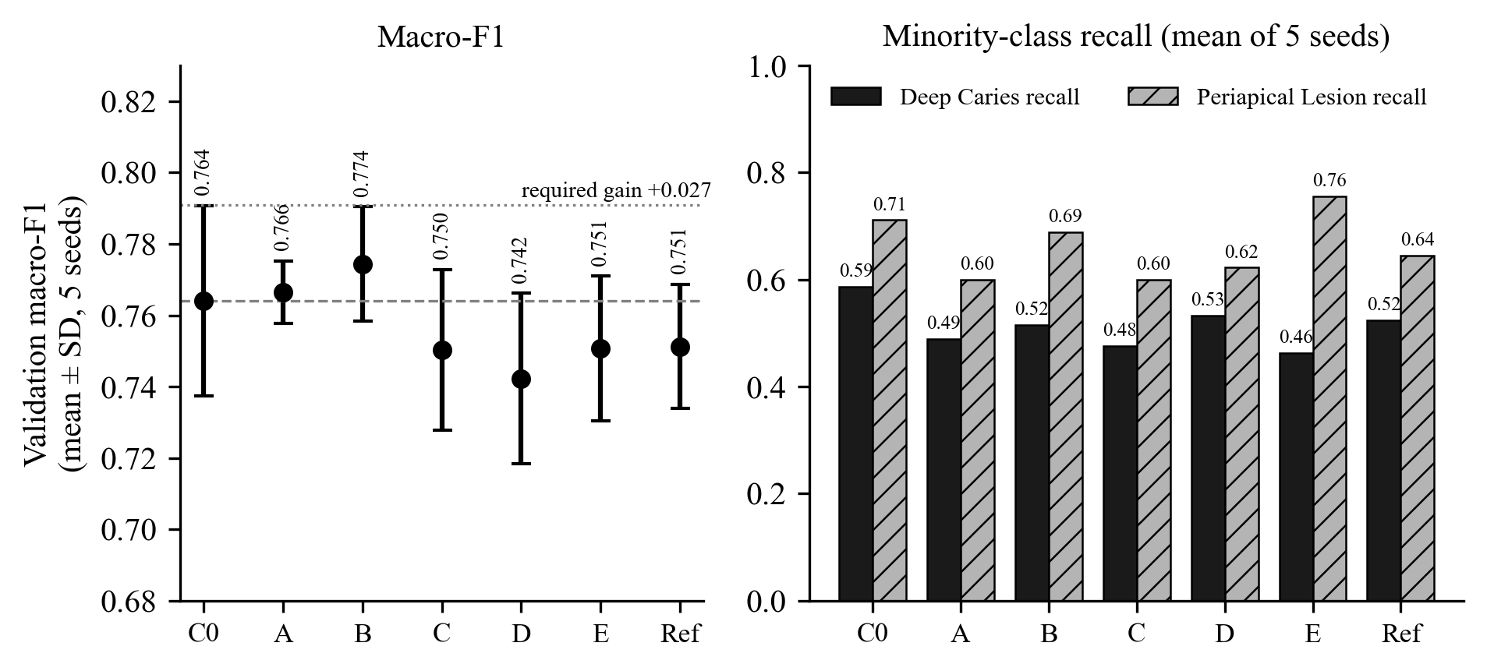
Fig. 7.7 Macro-F1 and minority-class recall of the imbalance variants (C0 baseline, A–E, reference)

7.6.2 Crop-Robustness Candidate
Because Section 7.5.1 identified crop sensitivity as a cause of errors, a second pre-registered experiment trained the classifier with box jitter sampled from the real offsets between detector and ground-truth boxes on the train split (Candidate B). Its detector-crop macro-F1 was 0.720 ± 0.038 against 0.723 ± 0.016 for the baseline (paired difference -0.003, better in 1 of 5 seeds), so it failed the primary criterion. It raised macro recall in all five seeds (+0.033) and Deep Caries recall by +0.117, but at the cost of precision (-0.028). It was not promoted.

7.6.3 Training-Recipe Comparison
The crop-robustness study revealed that the deployed classifier scored lower on detector crops than every baseline run of the experiment trainer. A third pre-registered study therefore compared the production training recipe (P) with the experiment recipe (E). The production trainer with seed 42 reproduced the deployed checkpoint bit for bit. Over five seeds, recipe P reached a detector-crop macro-F1 of 0.722 ± 0.045 and recipe E 0.724 ± 0.015. Recipe E was better in only 10 of 25 cross pairs and lowered Periapical Lesion recall, so it failed. The study did show that the deployed model is the weakest of the five production runs (0.651 against 0.718 to 0.776, Fig. 7.8). The spread between seeds of the same recipe is larger than any effect of the imbalance remedies. Choosing a different seed on the validation split would have been selection on noise, so the deployed model was kept. Single-seed results should not be trusted for this task.
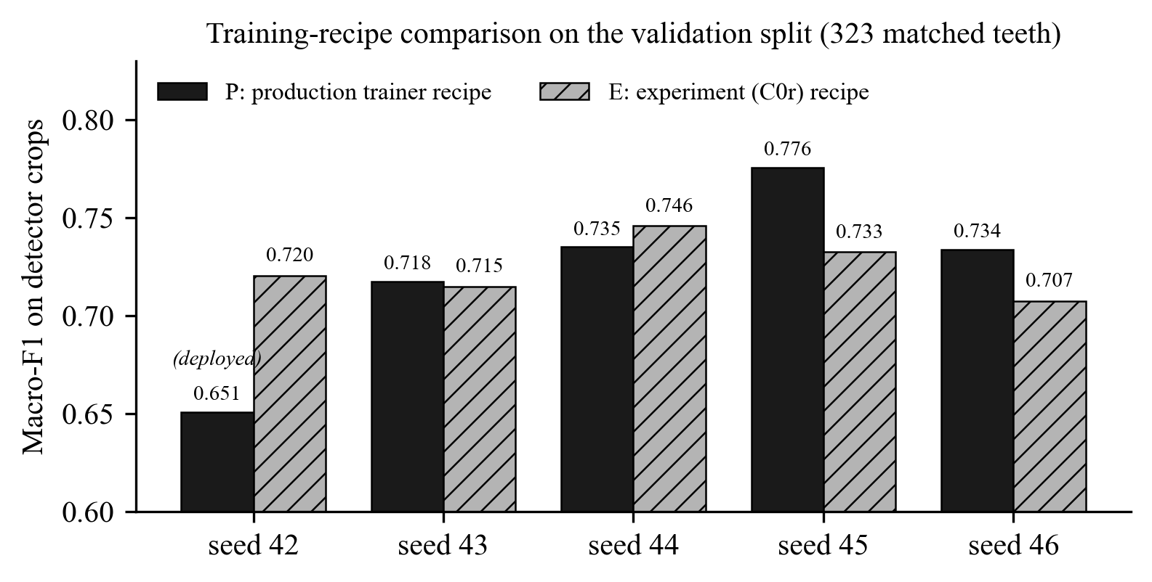
Fig. 7.8 Detector-crop macro-F1 of five seeds of each training recipe (validation)

7.6.4 Integrity and Reproducibility Checks
The leakage checker ran 18 checks: overlap between every pair of splits across all labelled sub-sets, the images actually used by each task for training and epoch selection against all test radiographs, the unlabelled pool, approved review items, the unlabelled demo files and near-duplicate films confirmed by pixel correlation. 17 checks passed and 1 produced the informational warning explained in Section 6.1. Every evaluation report records the dataset fingerprint, the split hash and the software versions, and the test-set ledger verifies its hash chain. Because the dataset contains no patient identifiers, separation at the patient level cannot be proven: two different radiographs of the same patient could still fall into different splits.
An active-learning experiment was also run (ResNet-18 at 160 px, 3 seeds, budgets of 60 to 300 training radiographs). Entropy-based and combined selection did not outperform random selection; at 300 radiographs the macro-F1 values were 0.706 (random), 0.706 (entropy) and 0.720 (combined), within one standard deviation of each other (Fig. 7.9). The active-learning module is therefore offered as a tool, without a claim that it saves annotation effort on this data [29].
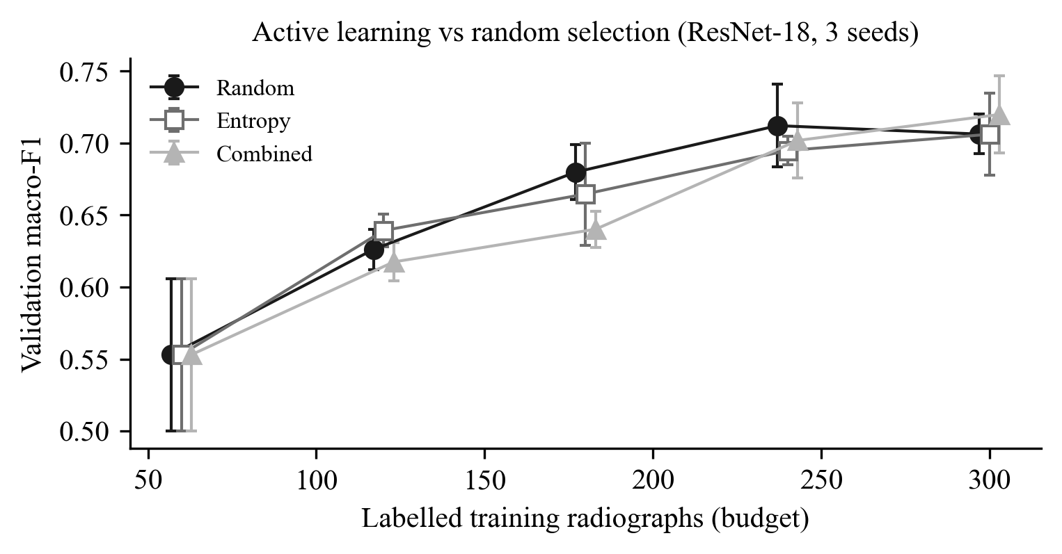
Fig. 7.9 Active learning versus random selection on the validation split

7.7 COMPARISON WITH EXISTING APPROACHES
A direct numerical comparison with published work is not meaningful, and we avoid one. The published studies use different images (periapical versus panoramic), different label sets, different splits and different metrics. Our classification metric is computed on tooth crops rather than on detected finding boxes, as in the DENTEX challenge. Table 7.9 therefore compares approaches qualitatively and quotes published numbers only where we verified them in the original paper.
Table 7.9 Qualitative comparison with existing approaches
Aspect | Typical published systems | DentaMind AI
Scope | One task: caries [14], numbering [15], [16], or lesions [17] | Detection, numbering, segmentation and four findings in one pipeline
Reported performance | Lee et al.: caries accuracy 82.0–89.0 % on periapical films [14] | Validation: detection recall 0.984, numbering 93.6 %, classifier macro-F1 0.718 (GT boxes) and 0.634 end to end
Uncertainty | Rarely reported | Entropy + flip-TTA, abstention, calibrated thresholds, ECE reported
Report generation | Free text, learned [5] or prompted [6] | Template generation from evidence + automatic validator; three languages
Evaluation hygiene | Often a single split; leakage rarely audited [13] | Duplicate-aware splits, 18 leakage checks, test ledger, pre-registered experiments
Human oversight | Usually outside the system | Built-in review queue, revisions and second-person approval
Clinical validation | Limited; reader studies in some works | None (research prototype)

The comparison shows where this project adds value. Its accuracy on the hard findings is not better than specialised systems. Its contribution is the integration of the tasks, the visible uncertainty, the grounded report generation and the evaluation discipline, which are the aspects the literature identifies as missing [10], [13].

7.8 SCREENSHOTS OF THE IMPLEMENTED SYSTEM
The following screenshots were captured from the running application on 15 October 2026, using the DENTEX test image val_0 from the unlabelled validation_data folder. They are reproduced in grayscale, as the report format requires; the application itself uses colour to separate the categories.
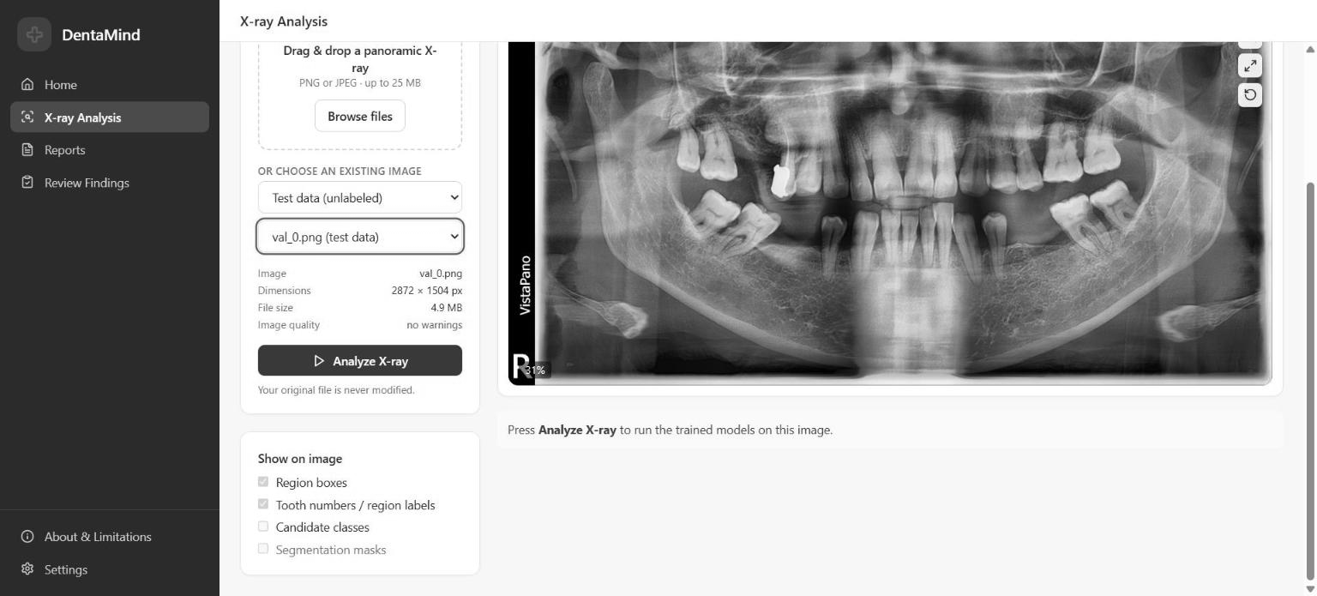
Fig. 7.10 X-ray Analysis page with a test image selected, before analysis
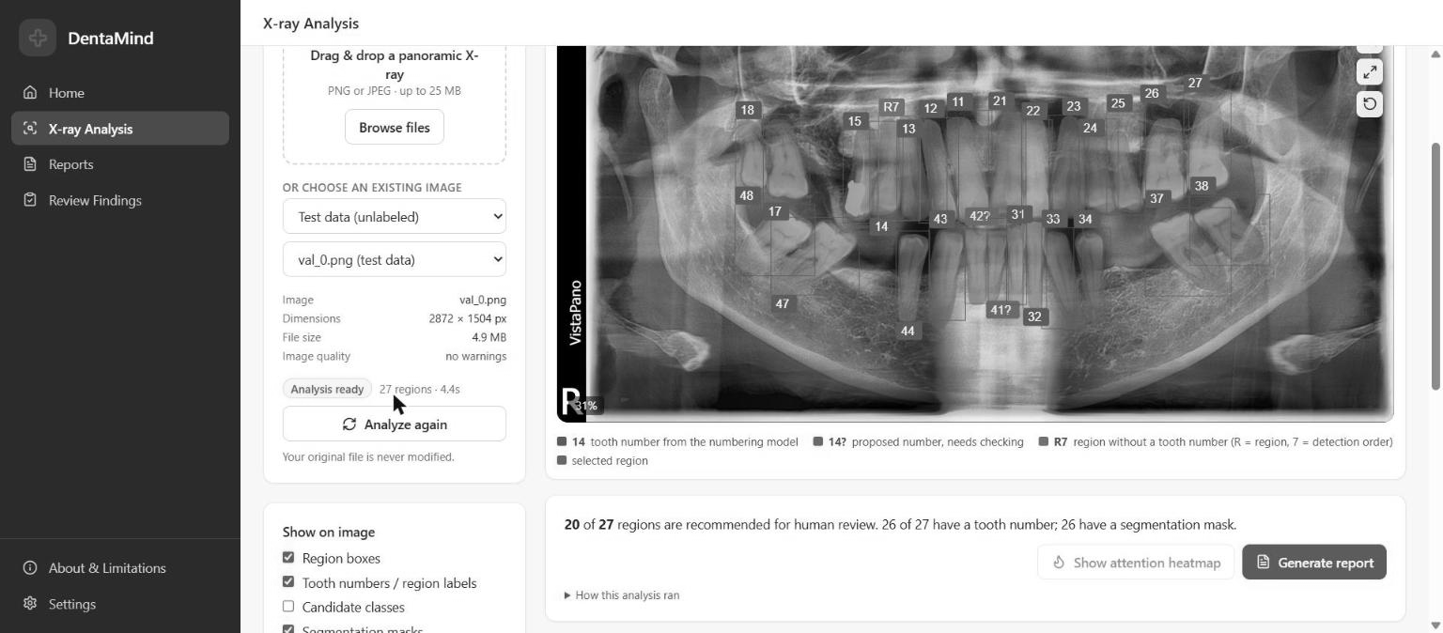
Fig. 7.11 Analysis result for val_0: 27 regions with FDI numbers, outlines and review markers
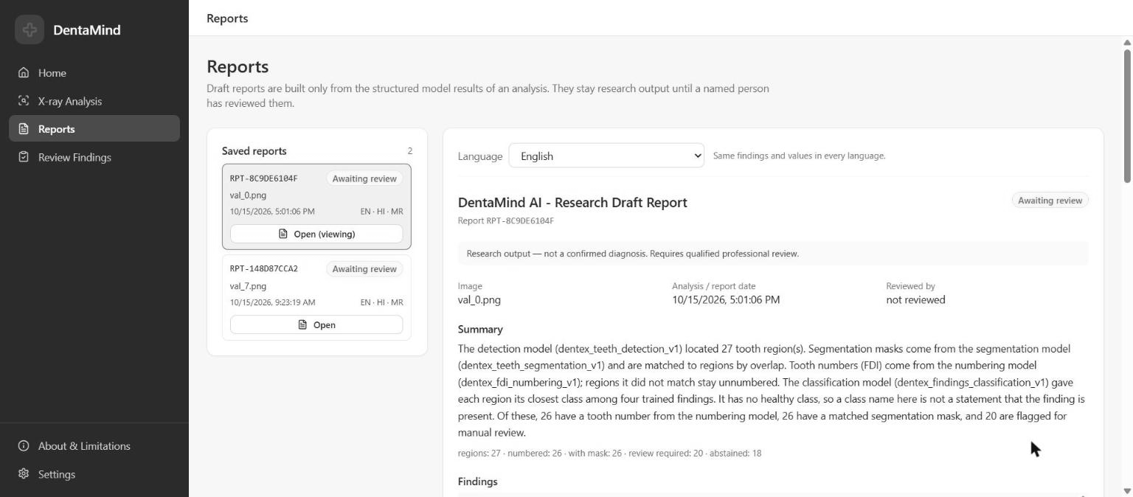
Fig. 7.12 Reports page with the validated draft report for val_0, awaiting review
CHAPTER 8

8. CONCLUSION AND FUTURE WORK

8.1 CONCLUSION
This project designed, implemented and evaluated DentaMind AI, an AI-assisted system for panoramic dental radiographs that combines tooth detection, FDI numbering, tooth segmentation and four-class finding classification with uncertainty-based abstention, evidence-grounded multilingual report generation and a human review workflow. The tooth-level tasks perform well. On the validation split, detection reached precision 0.962 and recall 0.984, and 93.6 % of localised teeth received the exact FDI number. On the historical test split, segmentation reached a mean Dice of 0.873.
Finding classification is the weak link. With ground-truth boxes the classifier reached a validation macro-F1 of 0.718 (historical test 0.646). On the detector’s own crops it fell to 0.649, and end to end to 0.634, with Deep Caries and Periapical Lesion as the main sources of error. Five class-imbalance remedies, a crop-robustness candidate and an alternative training recipe were evaluated under pre-registered rules, and none earned promotion. The variation between random seeds was as large as any of the effects.
The most important outcome is therefore not a single accuracy figure but a system that tells the user when it is unsure, cannot write a statement it has no evidence for, keeps humans responsible for every decision, and reports its own performance honestly. DentaMind AI is a research prototype; it has not been clinically validated and must not be used for diagnosis.

8.2 LIMITATIONS OF THE PROPOSED SYSTEM
No healthy class. DENTEX labels findings only on affected teeth, so the classifier has never seen a healthy tooth and assigns one of four findings to every detected tooth. Abstention reduces the damage but cannot replace a real healthy class; on the test image val_0, 18 of 27 regions abstained, and 1,580 of 1,903 detected validation teeth had no finding label at all.
Rare-class performance. Deep Caries (end-to-end recall 0.33 on validation) and Periapical Lesion (4 of 9 recovered) are weak, and with only 9 validation and 13 test examples of Periapical Lesion the estimates are very uncertain.
Crop sensitivity. Classification depends on the exact crop. About 10 % of predictions change even between almost identical boxes, and the classifier is weaker on detector crops than on ground-truth crops.
No independent external validation. All results come from one public dataset. There are no images from other clinics, machines or populations, and no patient identifiers, so patient-level separation between splits cannot be proven. The test split was used historically once per checkpoint, and the uncertainty thresholds are provisional.
Generative component. Reports come from deterministic templates; the optional LLM path was not configured or evaluated, and the Hindi and Marathi wording has not been reviewed by native-speaking dental professionals.
Deployment. The system runs on one machine without multi-user authentication or DICOM/PACS integration, and it is not a medical device.

8.3 FUTURE WORK
The first priority is data rather than algorithms. Adding healthy-tooth and “other finding” labels would turn the classifier into an open-set model that can say “no finding”. Collecting more Deep Caries and Periapical Lesion examples, ideally with a second annotator to measure agreement, would make the rare-class estimates meaningful.
On the modelling side, the classifier should be trained on detector-style crops or replaced by a detector that predicts findings directly, as in hierarchical DENTEX methods [8]. Ensembles or multiple seeds could be used both to reduce the seed sensitivity observed here and to provide a better uncertainty estimate, and calibration should be revisited with a larger calibration set. Grad-CAM-style explanations [28] could show which part of the crop drove each suggestion.
For validation, the next step is an external, multi-centre test set with patient-level splits, followed by a reader study in which dentists read radiographs with and without the system. Only after such a study could any claim about clinical usefulness be made. The language-model wording layer could then be enabled and evaluated with dental experts, keeping the validator as a hard gate, and the system could be integrated with DICOM and PACS workflows and proper user authentication.

8.4 APPLICATIONS
In its current form, DentaMind AI is suited to research and education: as a teaching aid that shows students tooth numbering and typical findings together with the model’s uncertainty, as a pre-annotation tool that proposes boxes, numbers and outlines for human annotators to correct, and as a platform for studying how AI suggestions and uncertainty displays affect human reviewers.
After the future work above and proper clinical validation, the same architecture could support screening programmes in which many panoramic radiographs must be triaged, structured report drafting that saves typing time for dentists, and quality-assurance checks that highlight teeth a reader may have missed. In every case the clinician would remain responsible for the diagnosis.

REFERENCES
[1] I. Goodfellow et al., “Generative adversarial nets,” in Advances in Neural Information Processing Systems (NeurIPS), vol. 27, 2014.
[2] J. Ho, A. Jain, and P. Abbeel, “Denoising diffusion probabilistic models,” in Advances in Neural Information Processing Systems (NeurIPS), vol. 33, 2020.
[3] A. Vaswani et al., “Attention is all you need,” in Advances in Neural Information Processing Systems (NeurIPS), vol. 30, 2017.
[4] T. B. Brown et al., “Language models are few-shot learners,” in Advances in Neural Information Processing Systems (NeurIPS), vol. 33, 2020.
[5] B. Jing, P. Xie, and E. Xing, “On the automatic generation of medical imaging reports,” in Proc. 56th Annual Meeting of the Association for Computational Linguistics (ACL), 2018, pp. 2577–2586, doi: 10.18653/v1/P18-1240.
[6] D. Stephan, A. Bertsch, M. Burwinkel, S. Vinayahalingam, B. Al-Nawas, P. W. Kämmerer, and D. G. E. Thiem, “AI in dental radiology—Improving the efficiency of reporting with ChatGPT: Comparative study,” Journal of Medical Internet Research, vol. 26, Art. no. e60684, 2024.
[7] P. Lewis et al., “Retrieval-augmented generation for knowledge-intensive NLP tasks,” in Advances in Neural Information Processing Systems (NeurIPS), vol. 33, 2020.
[8] I. E. Hamamci, S. Er, E. Simsar, A. Sekuboyina, M. Gundogar, B. Stadlinger, A. Mehl, and B. Menze, “Diffusion-based hierarchical multi-label object detection to analyze panoramic dental X-rays,” in Proc. Medical Image Computing and Computer Assisted Intervention (MICCAI), LNCS, vol. 14225. Cham, Switzerland: Springer, 2023, pp. 389–399, doi: 10.1007/978-3-031-43987-2_38.
[9] International Organization for Standardization, ISO 3950:2016, Dentistry — Designation system for teeth and areas of the oral cavity. Geneva, Switzerland: ISO, 2016.
[10] F. Schwendicke, T. Golla, M. Dreher, and J. Krois, “Convolutional neural networks for dental image diagnostics: A scoping review,” Journal of Dentistry, vol. 91, Art. no. 103226, 2019, doi: 10.1016/j.jdent.2019.103226.
[11] I. E. Hamamci et al., “DENTEX: An abnormal tooth detection with dental enumeration and diagnosis benchmark for panoramic X-rays,” arXiv preprint arXiv:2305.19112, 2023.
[12] S. Kaufman, S. Rosset, C. Perlich, and O. Stitelman, “Leakage in data mining: Formulation, detection, and avoidance,” ACM Transactions on Knowledge Discovery from Data, vol. 6, no. 4, Art. no. 15, 2012, doi: 10.1145/2382577.2382579.
[13] G. Varoquaux and V. Cheplygina, “Machine learning for medical imaging: Methodological failures and recommendations for the future,” npj Digital Medicine, vol. 5, Art. no. 48, 2022, doi: 10.1038/s41746-022-00592-y.
[14] J.-H. Lee, D.-H. Kim, S.-N. Jeong, and S.-H. Choi, “Detection and diagnosis of dental caries using a deep learning-based convolutional neural network algorithm,” Journal of Dentistry, vol. 77, pp. 106–111, 2018, doi: 10.1016/j.jdent.2018.07.015.
[15] D. V. Tuzoff et al., “Tooth detection and numbering in panoramic radiographs using convolutional neural networks,” Dentomaxillofacial Radiology, vol. 48, no. 4, Art. no. 20180051, 2019.
[16] H. Chen, K. Zhang, P. Lyu, H. Li, L. Zhang, J. Wu, and C.-H. Lee, “A deep learning approach to automatic teeth detection and numbering based on object detection in dental periapical films,” Scientific Reports, vol. 9, Art. no. 3840, 2019, doi: 10.1038/s41598-019-40414-y.
[17] T. Ekert, J. Krois, L. Meinhold, K. Elhennawy, R. Emara, T. Golla, and F. Schwendicke, “Deep learning for the radiographic detection of apical lesions,” Journal of Endodontics, vol. 45, no. 7, pp. 917–922, 2019.
[18] S. Ren, K. He, R. Girshick, and J. Sun, “Faster R-CNN: Towards real-time object detection with region proposal networks,” in Advances in Neural Information Processing Systems (NeurIPS), vol. 28, 2015.
[19] K. He, G. Gkioxari, P. Dollár, and R. Girshick, “Mask R-CNN,” in Proc. IEEE International Conference on Computer Vision (ICCV), 2017, pp. 2961–2969.
[20] K. He, X. Zhang, S. Ren, and J. Sun, “Deep residual learning for image recognition,” in Proc. IEEE Conference on Computer Vision and Pattern Recognition (CVPR), 2016, pp. 770–778.
[21] T.-Y. Lin, P. Dollár, R. Girshick, K. He, B. Hariharan, and S. Belongie, “Feature pyramid networks for object detection,” in Proc. IEEE Conference on Computer Vision and Pattern Recognition (CVPR), 2017, pp. 2117–2125.
[22] T.-Y. Lin et al., “Microsoft COCO: Common objects in context,” in Proc. European Conference on Computer Vision (ECCV), LNCS, vol. 8693, 2014, pp. 740–755.
[23] J. Deng, W. Dong, R. Socher, L.-J. Li, K. Li, and L. Fei-Fei, “ImageNet: A large-scale hierarchical image database,” in Proc. IEEE Conference on Computer Vision and Pattern Recognition (CVPR), 2009, pp. 248–255.
[24] T.-Y. Lin, P. Goyal, R. Girshick, K. He, and P. Dollár, “Focal loss for dense object detection,” in Proc. IEEE International Conference on Computer Vision (ICCV), 2017, pp. 2980–2988.
[25] M. Buda, A. Maki, and M. A. Mazurowski, “A systematic study of the class imbalance problem in convolutional neural networks,” Neural Networks, vol. 106, pp. 249–259, 2018, doi: 10.1016/j.neunet.2018.07.011.
[26] C. Guo, G. Pleiss, Y. Sun, and K. Q. Weinberger, “On calibration of modern neural networks,” in Proc. 34th International Conference on Machine Learning (ICML), PMLR, vol. 70, 2017, pp. 1321–1330.
[27] G. Wang, W. Li, M. Aertsen, J. Deprest, S. Ourselin, and T. Vercauteren, “Aleatoric uncertainty estimation with test-time augmentation for medical image segmentation with convolutional neural networks,” Neurocomputing, vol. 335, pp. 34–45, 2019, doi: 10.1016/j.neucom.2019.01.103.
[28] R. R. Selvaraju, M. Cogswell, A. Das, R. Vedantam, D. Parikh, and D. Batra, “Grad-CAM: Visual explanations from deep networks via gradient-based localization,” in Proc. IEEE International Conference on Computer Vision (ICCV), 2017.
[29] B. Settles, “Active learning literature survey,” Computer Sciences Technical Report 1648, University of Wisconsin–Madison, 2009.
[30] A. Paszke et al., “PyTorch: An imperative style, high-performance deep learning library,” in Advances in Neural Information Processing Systems (NeurIPS), vol. 32, 2019.
[31] W. J. Youden, “Index for rating diagnostic tests,” Cancer, vol. 3, no. 1, pp. 32–35, 1950.
[32] I. Loshchilov and F. Hutter, “Decoupled weight decay regularization,” in Proc. International Conference on Learning Representations (ICLR), 2019.

APPENDIX A: PAPER PUBLICATION DETAILS
No paper based on this project had been submitted or published when this report was prepared. If the group submits a paper, a patent application or receives event participation certificates, the conference or journal name, the reviewers’ comments, the certificate and the paper should be inserted here, as required by the report format.
Suggested scope for a future paper: the end-to-end evaluation of a closed-set dental finding classifier on detector crops versus ground-truth crops, together with the pre-registered negative result of the class-imbalance experiments.

APPENDIX B: PLAGIARISM REPORT
The plagiarism (similarity) report must be generated by the group with the institute-approved similarity-check tool, verified by the guide, and attached here. The format requires a similarity index below 15 %. This page is a placeholder: no similarity percentage is claimed in this document.

