Task_1
First
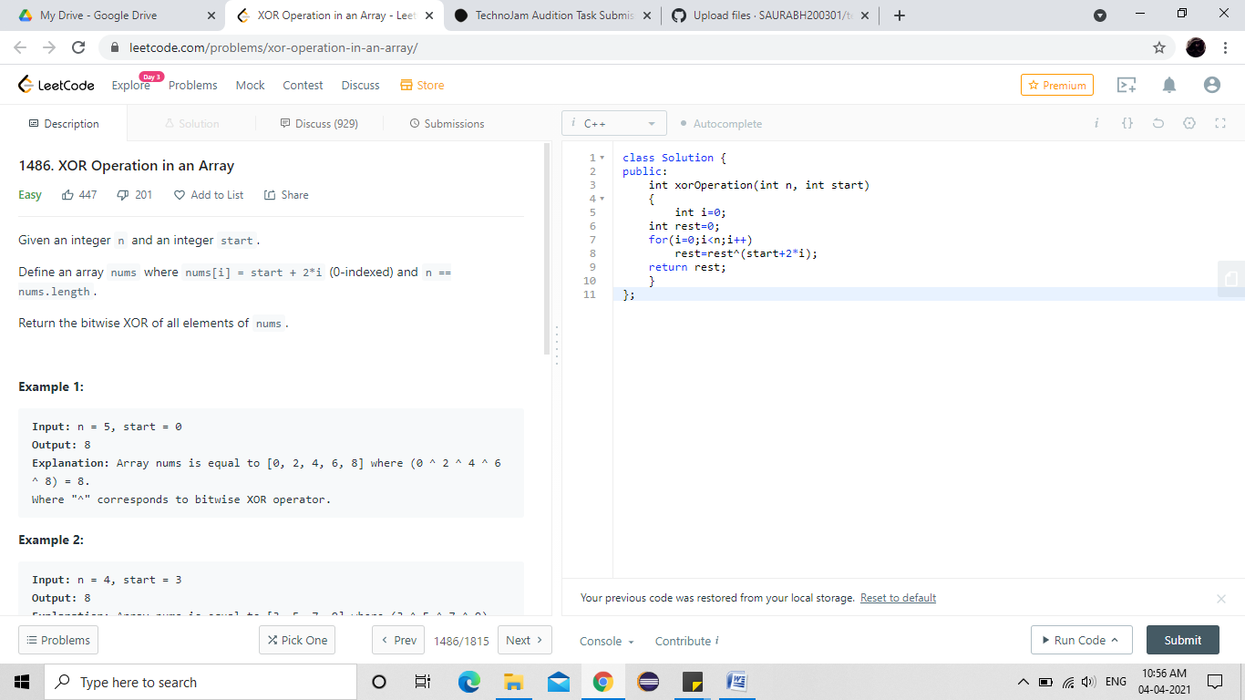
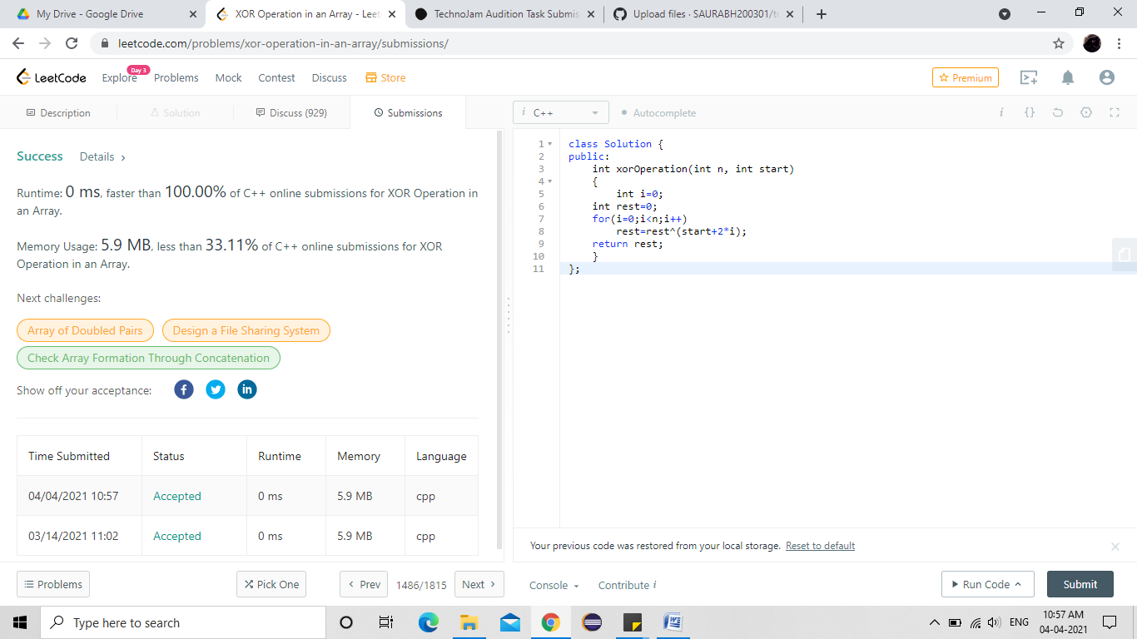
class Solution {
public:
int xorOperation(int n, int start)
{
int i=0;
int rest=0;
for(i=0;i<n;i++)
rest=rest^(start+2*i);
return rest;
}
};

