Third

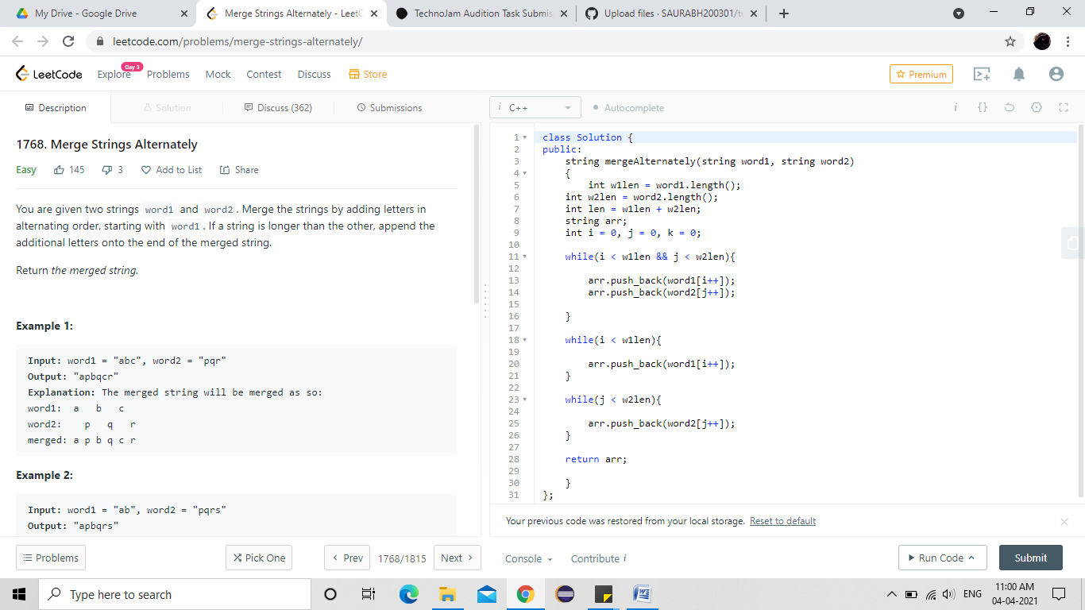
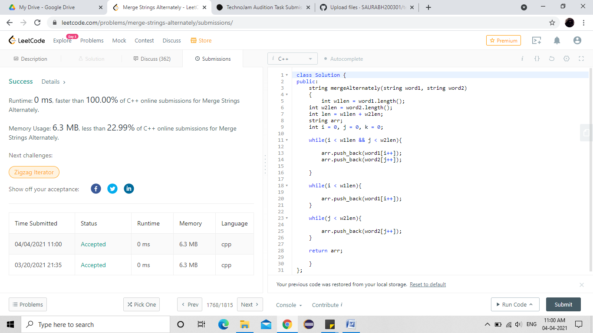
class Solution {
public:
string mergeAlternately(string word1, string word2)
{
int w1len = word1.length();
int w2len = word2.length();
int len = w1len + w2len;
string arr;
int i = 0, j = 0, k = 0;

while(i < w1len && j < w2len){

arr.push_back(word1[i++]);
arr.push_back(word2[j++]);

}

while(i < w1len){

arr.push_back(word1[i++]);
}

while(j < w2len){

arr.push_back(word2[j++]);
}

return arr;

}
};

