**Exp. No. Z-Transform and Inverse Z Transform**

**Name: Moharir Saurabh Bhanudas Roll No:36**

**Aim:** *Write a program to find ZT of given sequence and plot its pole zero plot and frequency response.*

--------------------------------------------------------------------------------------------------------------------------------------

**MATLAB CODE:**

clc;

close all;

clear all;

%%ZT 36

syms n a w;

xn=input('Enter sequence:');

y=ztrans(xn)

num=input('ENter num coeff:');

den=input('Enter the den coeff:');

figure;

zplane(num,den);

figure;

freqz(num,den);

***Example 1:***

**COMMAND WINDOW:**

Enter sequence:n^2

y =

(z^2 + z)/(z - 1)^3

ENter num coeff:[1 1 0]

Enter the den coeff:[1 -3 3 -1]

**Figures:**

Pole Zero Plot: 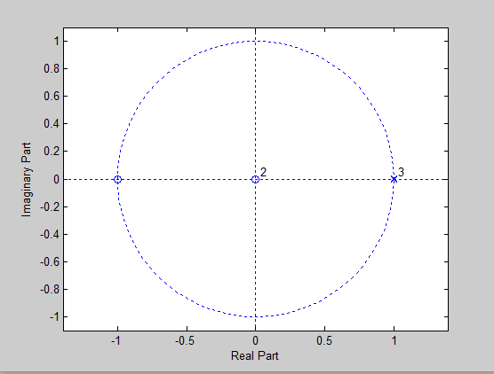

Frequency Response:

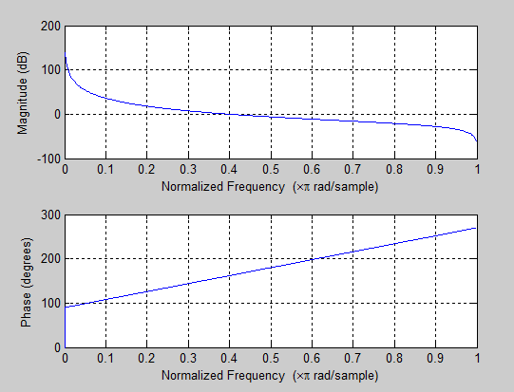

***Ex.2:***

Enter sequence:n*(-1)^n

y =

-z/(z + 1)^2

ENter num coeff:[-1 0]

Enter the den coeff:[1 2 1]

Figure:

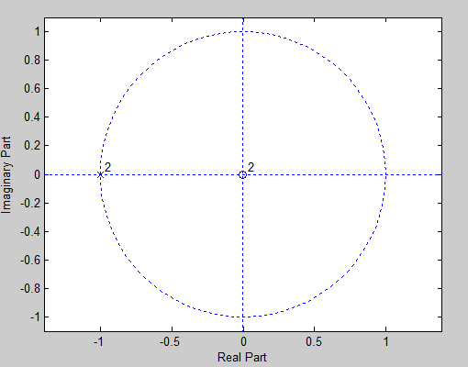

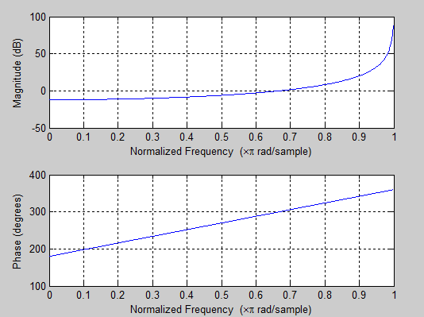

***Ex03:***

Enter sequence:(-1)^n*cos(pi/3*n)

y =

(z*(z + 1/2))/(z^2 + z + 1)

ENter num coeff:[2 1 0]

Enter the den coeff:[2 2 2]

>>

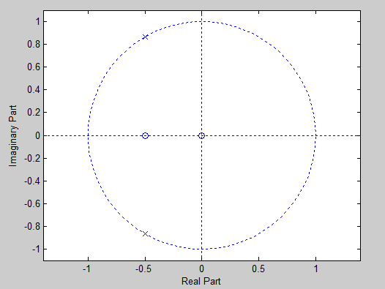

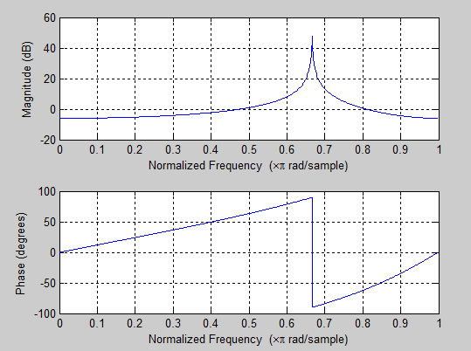

***Ex04:***

**Command Window:**

Enter sequence:(1/3)^(n-1)

y =

(3*z)/(z - 1/3)

ENter num coeff:[9 0]

Enter the den coeff:[3 -1]

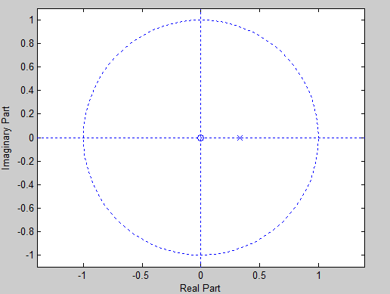

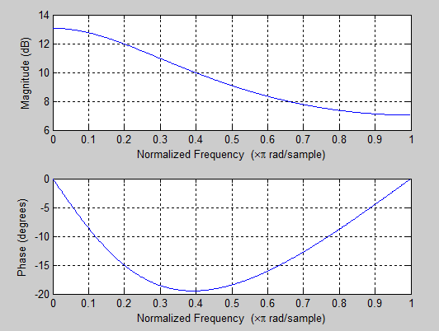

**Aim:Write a Program to find IZT of a given sequence.**

A]Long Division Method:

(1) Long Division

Matlab Code:

clc;

clear all;

close all;

%%Long division method ZT1

n=7;

num=input('Enter the numerator Coeff:');

den=input('Enter the denominator coefficent:');

num=[num zeros(1,n-1)];

[x r]=deconv(num,den)

zplane(num,den);

zk=roots(num)

pk=roots(den)

Command Window:

Enter the numerator Coeff:[1 3 7 10 10 7 2]

Enter the denominator coefficent:[1 2 3 2]

x =

1 1 2 1 0 0 0 0 0 0

r =

0 0 0 0 0 0 0 0 0 0 0 0 0

zk =

0

0

0

0

0

0

-0.5000 + 1.3229i

-0.5000 - 1.3229i

-0.2151 + 1.3071i

-0.2151 - 1.3071i

-1.0000

-0.5698

pk =

-0.5000 + 1.3229i

-0.5000 - 1.3229i

-1.0000

>>

Figures:

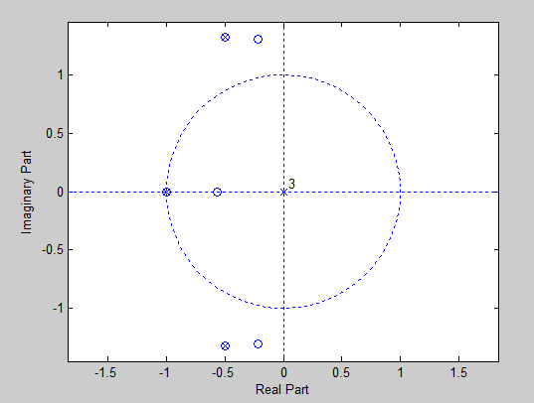

**(2) Long Division:**

MATLAB CODE:

clc;

close all;

clear all;

%%long div 2

num=input('Enter the numerator Coeff:');

den=input('Enter the denominator coefficent:');

n=6;

num=[num zeros(1,n-1)];

[x r]=deconv(num,den)

zplane(num,den);

zk=roots(num)

pk=roots(den)

Ex.01:

Command Window:

Enter the numerator Coeff:[1]

Enter the denominator coefficent:[0.5 -1.5 1]

x =

2 6 14 30

r =

0 0 0 0 31 -30

zk =

0

0

0

0

0

pk =

2

1

>>

Figures:

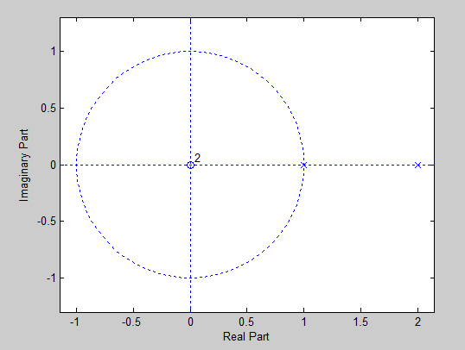

Ex.02:

Enter the numerator Coeff:[1 -0.5]

Enter the denominator coefficent:[1 0 -0.25]

x =

1.0000 -0.5000 0.2500 -0.1250 0.0625

r =

0 0 0 0 0 -0.0313 0.0156

zk =

0

0

0

0

0

0.5000

pk =

0.5000

-0.5000

>>

Figures:

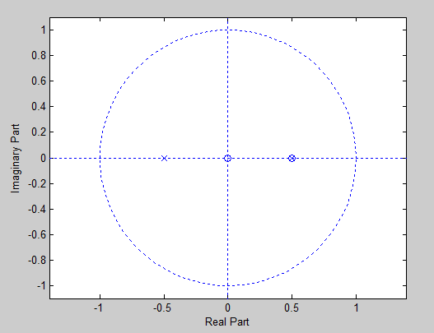

B] Residue Method:

MATLAB CODE:

clc;

close all;

clear all;

%%Residue method

n1=input('ENter the coefficient of n1');

d1=input('Enter the coefficent of d1');

[r p k]=residuez(n1,d1)

Ex.01:

Command Window:

ENter the coefficient of n1[1 0.25]

Enter the coefficent of d1[1 0 -1/9]

r =

0.8750

0.1250

p =

0.3333

-0.3333

k =[]

Ex.02:

ENter the coefficient of n1[1]

Enter the coefficent of d1[1 -6 6]

r =

1.3660

-0.3660

p =

4.7321

1.2679

k =

[]

>>

Aim: Write a program to find IZT of given sequence which is in form of:

X(n)=(N1(z) N2(z)……………………)/(D1(z) D2(z)………………)

1] By using SOS2 Function:

Matlab Code:

clc;

close all;

clear all;

%%Using SOS2 functn

n=6;

n1=input('Enter the coefficient of n1:');

n2=input('Enter the coefficient of n2:');

n3=input('Enter the coefficient of n3:');

d1=input('Enter the coefficent of d1:');

d2=input('Enter the coefficent of d2:');

d3=input('Enter the coefficent of d3:');

B=[n1;n2;n3]

A=[d1;d2;d3]

[b a]=sos2tf([B A])

b=[b zeros(1,n-1)]

[x r]=deconv(b,a)

[r p k]=residuez(b,a)

Command Window:

Enter the coefficient of n1:[1 0 0]

Enter the coefficient of n2:[0 1 1]

Enter the coefficient of n3:[1 1 0]

Enter the coefficent of d1:[3 -4 1]

Enter the coefficent of d2:[3 -4 1]

Enter the coefficent of d3:[1 -2 1]

B =

1 0 0

0 1 1

1 1 0

A =

3 -4 1

3 -4 1

1 -2 1

b =

0 1 2 1 0 0

a =

9 -42 79 -76 39 -10 1

b =

0 1 2 1 0 0 0 0 0 0 0

x =

0 0.1111 0.7407 2.5926 6.5350

r =

Columns 1 through 8

0 0 0 0 0 121.6173 -347.0041 402.8436

Columns 9 through 11

-229.6790 62.7572 -6.5350

r =

-3.5007 - 0.0007i

4.0023 + 0.0007i

-3.0022 - 0.0006i

1.0006 + 0.0006i

1.1667 + 0.0000i

0.3333 - 0.0000i

p =

1.0002 + 0.0002i

1.0002 - 0.0002i

0.9998 + 0.0002i

0.9998 - 0.0002i

0.3333 + 0.0000i

0.3333 - 0.0000i

k =

0 0 0 0 0

>>