JIRA ASSIGNMENT

(15,16,59,110,97,93)

1: creating issues as per our project(pizza management system)

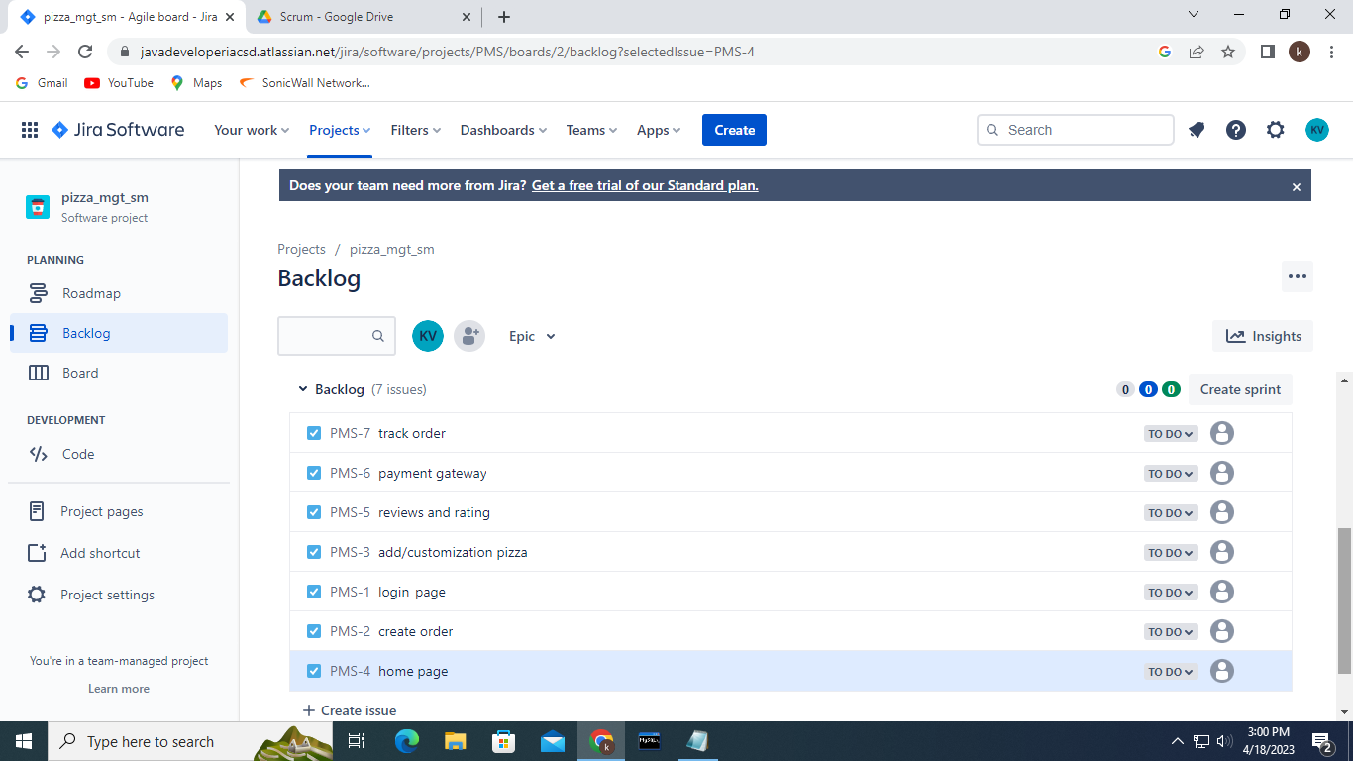

2: pushing names from backlog to the sprints

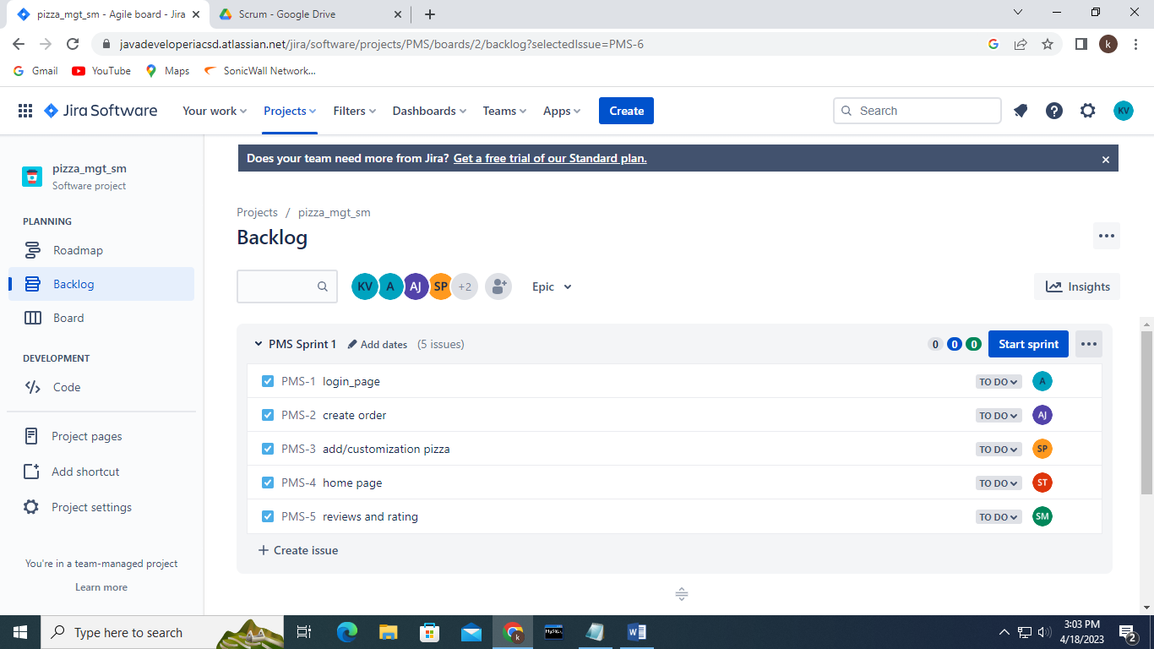

3: assigning tasks to the team members in the time frame of 2 weeks.

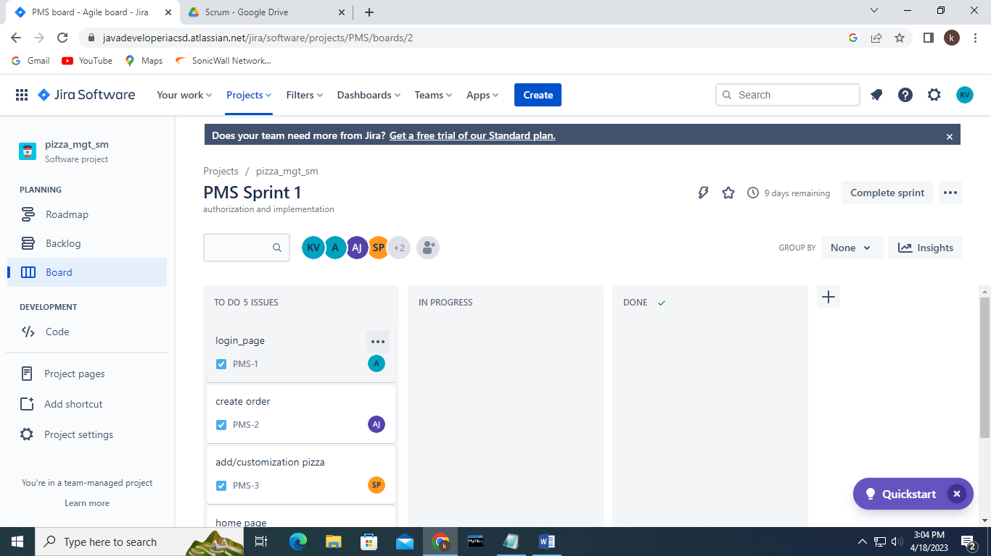

4: starting of the tasks

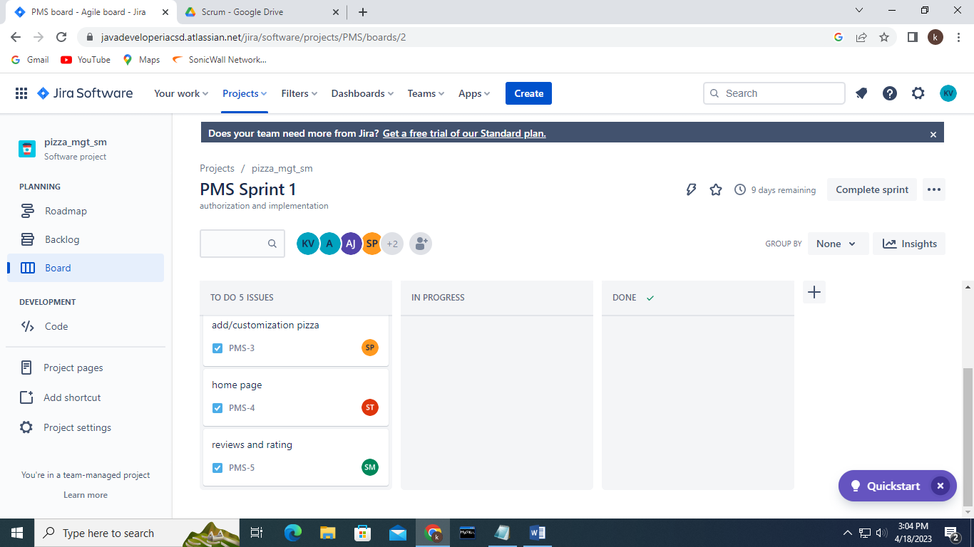

5: all members have started working on their assigned tasks.

