**1.Introduction**

**1.1 Purpose**

This document describes the Assignment and specification for a ROUNDROBIN scheduling algorithm and calculate the average turnaround time and waiting time.

Considering the arrival time and burst time requirement of the process the scheduler schedules the processes by interrupting the processor after every 6 units of time and does consider the completion of the process in this iteration. The scheduler than checks for the number of process waiting for the processor and allots the processor to the process but interrupting the processor every 10 unit of time and considers the completion of the processes in this iteration. The scheduler checks the number of processes waiting in the queue for the processor after the second iteration and gives the processor to the process which needs more time to complete than the other processes to go in the terminated state.

The inputs for the number of requirements, arrival time and burst time should be provided by the user.

Consider the following units for reference.

**Process    Arrival time    Burst time**

P1    0     20

P2    5     36

P3     13     19

P4     26     42

Such that, compute the scheduler performance by providing the waiting time for process, turnaround time for process and average waiting time and turnaround time.

**1.2 Document Conventions: font:** TNR 12

**1.3 Minimum Requirements and Reading Suggestions already stated**

**->A DESCENT LAPTOP OR PC**

Assignment project will be developed in Sublime IDE. We will make this project using Java language in above given IDE.

**2. Overall Description**

Round Robin is a [CPU scheduling algorithm](http://quiz.geeksforgeeks.org/gate-notes-operating-system-process-scheduling/) where each process is assigned a fixed time slot in a cyclic way.

* It is simple, easy to implement, and starvation-free as all processes get fair share of CPU.
* One of the most commonly used technique in CPU scheduling as a core.
* It is preemptive as processes are assigned CPU only for a fixed slice of time at most.
* The disadvantage of it is more overhead of context switching.

**2.1 Here are the working conditions:**

• User should be able to give the input (sitting at the computer).

• The board should be printed out every time given no of students with their IDs are proceeded.

• User should be able to get average turnaround time and waiting time.

**Algorithm –**

1- Create an array rem_bt[] to keep track of remaining

burst time of processes. This array is initially a

copy of bt[] (burst times array)

2- Create another array wt[] to store waiting times

of processes. Initialize this array as 0.

3- Initialize time : t = 0

4- Keep traversing the all processes while all processes

are not done. Do following for i'th process if it is

not done yet.

a- If rem_bt[i] > quantum

(i) t = t + quantum

(ii) bt_rem[i] -= quantum;

c- Else // Last cycle for this process

(i) t = t + bt_rem[i];

(ii) wt[i] = t - bt[i]

(ii) bt_rem[i] = 0; // This process is over.

**3.How to compute below times in Round Robin using a program?**

1. Completion Time: Time at which process completes its execution.
2. Turn Around Time: Time Difference between completion time and arrival time. Turn Around Time = Completion Time – Arrival Time
3. Waiting Time(W.T): Time Difference between turn around time and burst time.  
   Waiting Time = Turn Around Time – Burst Time

The tricky part is to compute waiting times. Once waiting times are computed, turn around times can be quickly computed.

**3.3 Gantt chart will be as following below,**

Taking an example

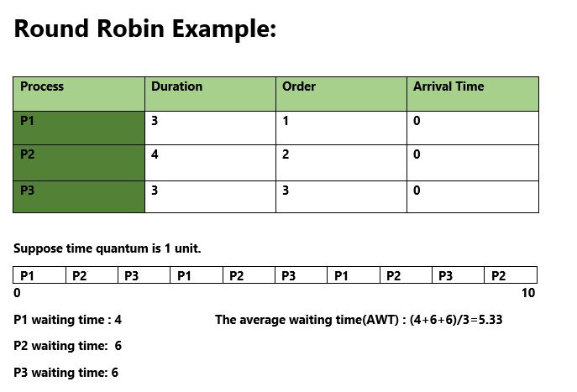

Since, completion time (CT) can be directly determined by Gantt chart, and

Therefore,

Once we have waiting times, we can compute turn around time tat[i] of a process as sum of waiting and burst times, i.e., wt[i] + bt[i]

**4. Methodology**

**4.1 Common terms for users:**

**Arrival Time:** Time at which the process arrives in the ready queue. Completion Time: Time at which process completes its execution. Burst Time: Time required by a process for CPU execution. Turn Around Time: Time Difference between completion time and arrival time. Turn Around Time = Completion Time - Arrival Time

**Waiting Time (W.T):** Time Difference between turnaround time and burst time. Waiting Time = Turn Around Time - Burst Time

**4.2 Formulas Used:**

Turn Around Time (TAT) = (Completion Time) - (Arrival Time)

Also, Waiting Time (WT) = (Turn Around Time) - (Burst Time)

5.SNAPSHOTS OF ROUND ROBIN WORKING CODE:

