Year: 2023  
Median: 35409.0  
Mean: 43656.25  
1st Quartile: 14625.75  
3rd Quartile: 77876.75  
Standard Deviation: 33825.971098403075  
Minimum: 2769.0  
Maximum: 94077.0

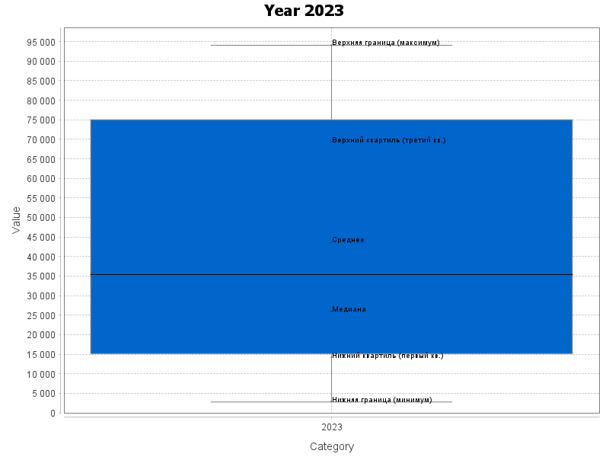

Year: 2024  
Median: 48031.5  
Mean: 55215.416666666664  
1st Quartile: 36565.0  
3rd Quartile: 84686.5  
Standard Deviation: 30181.197498558104  
Minimum: 63.0  
Maximum: 99636.0

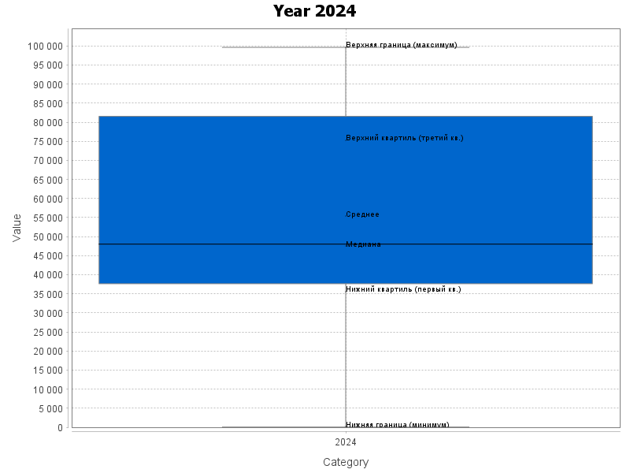

Year: 2025  
Median: 49459.0  
Mean: 52186.5  
1st Quartile: 37026.0  
3rd Quartile: 70910.5  
Standard Deviation: 24130.622101388104  
Minimum: 10938.0  
Maximum: 85441.0

