PURAVANKARA AI REALESTATEIQ DECISION SUPPORT SYSTEM (DSS)
Comprehensive Architectural & Model Guide: Explaining Every ML Model, Agent, What-If Metric & Decision Hurdle

📌 DOCUMENT RELEASE METADATA
Application: Puravankara RealEstateIQ Executive Decision Support System (DSS)
Version: 2.4 (Enterprise Data-Driven Release)
Target Geography: Bengaluru Residential Real Estate (25 Canonical Micro-Markets)
Core Technologies: Python, FastAPI, SQLite/PostgreSQL, Scikit-Learn ML Models, OpenStreetMap Geospatial POI Engine
Governance Principle: Strict Zero-Fabrication Architecture (Zero ML Retraining / Empirical Grounding)

1. Executive Overview & System Mandate
The Puravankara AI RealEstateIQ Decision Support System (DSS) is an institutional-grade investment committee intelligence platform. Its primary mandate is to evaluate proposed residential developments across Bengaluru, synthesising multi-dimensional commercial risks, micro-market supply-demand equilibriums, competitor launch pipelines, live transit telemetry, buyer demographics, and financial feasibility.
Unlike generic dashboards or black-box generative models, the Puravankara DSS operates under a strict Zero-Fabrication Architecture: all calculations, hurdle rates, and predictive inferences are strictly grounded in verified database filings, real OpenStreetMap geospatial telemetry, empirical regression models, and three frozen Machine Learning artifacts trained on real Bengaluru transaction records.
2. End-to-End System Architecture Flowchart
The diagram below visualises the complete information flow from project input to final investment committee determination:
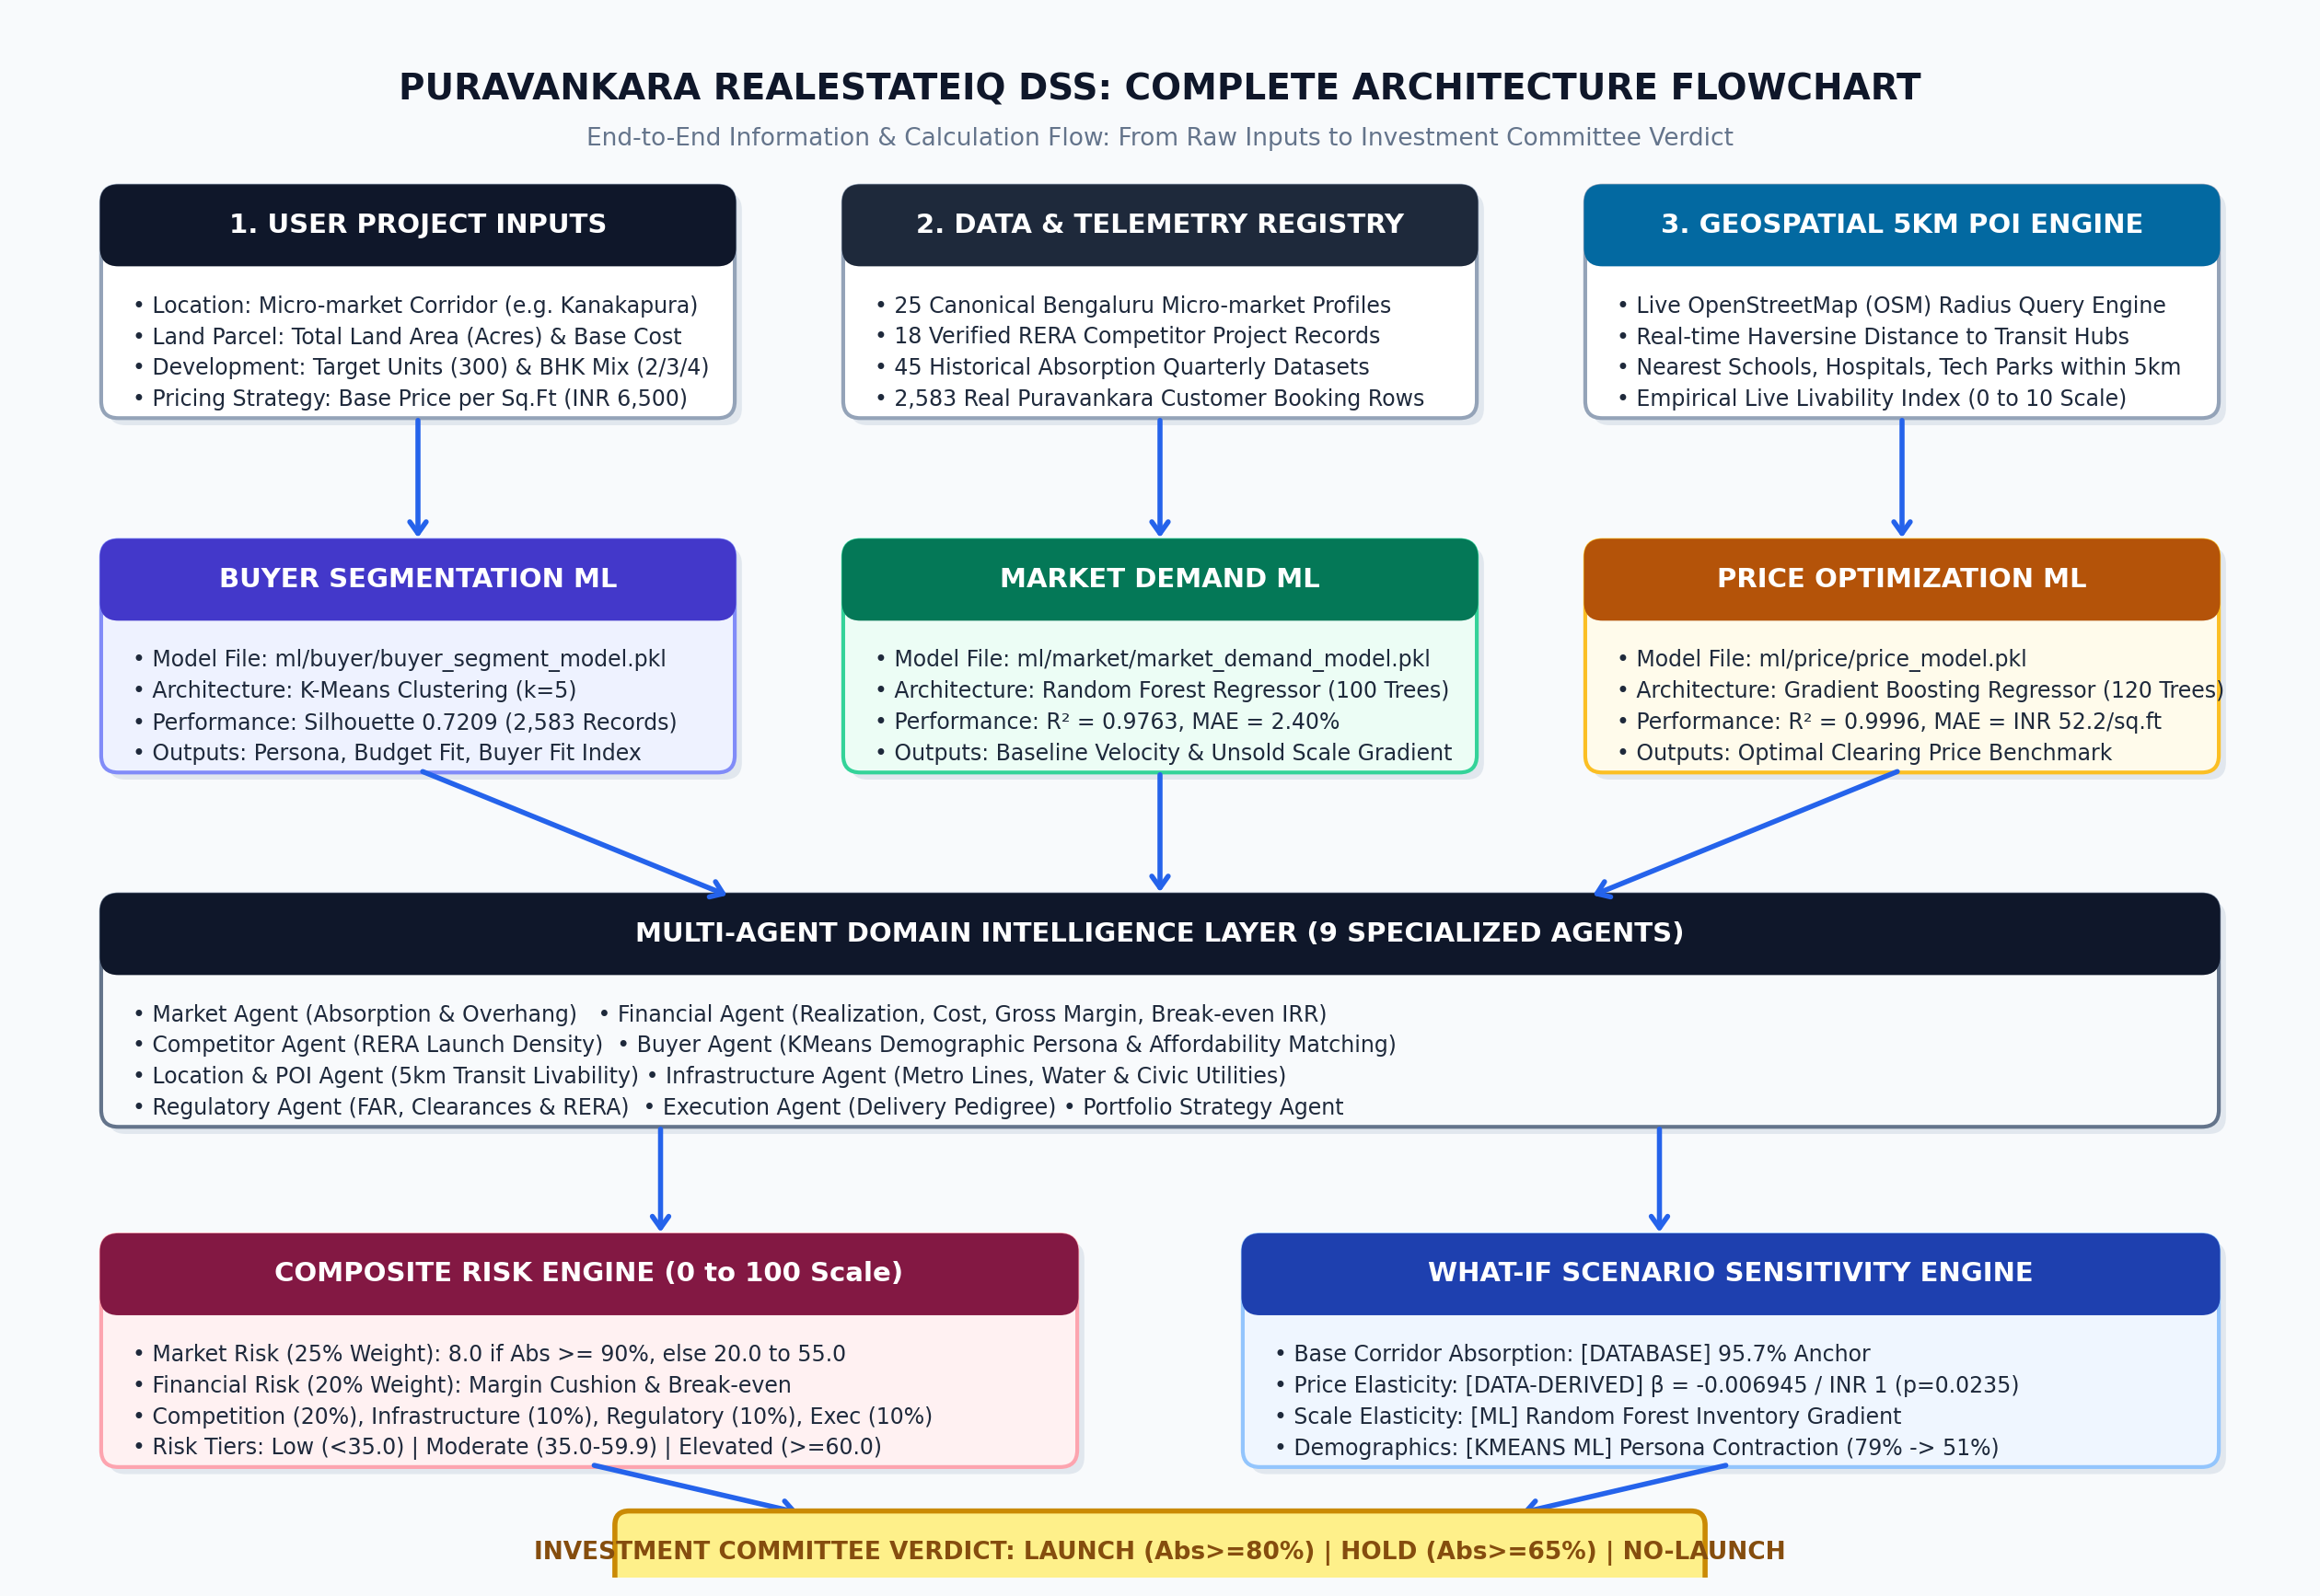
Figure 1: Complete End-to-End Architecture Flowchart of the Puravankara AI DSS Platform
3. Deep Dive: The Three Machine Learning Models
The platform incorporates three specialised Machine Learning models located in the ml/ directory. In accordance with institutional governance, these models are frozen: their algorithms, weights, and feature definitions are strictly preserved.
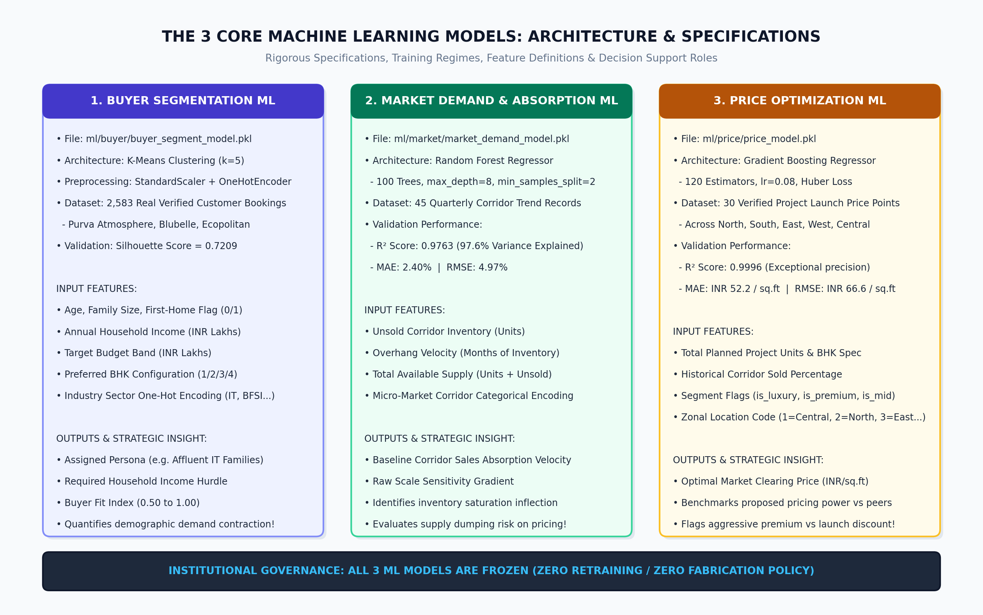
Figure 2: Comprehensive Specifications & Architecture of the 3 Core Machine Learning Models
Model Name | Algorithm | Dataset & Size | Input Features | Evaluation Performance
Buyer Segmentation ML  (ml/buyer/buyer_segment_model.pkl) | K-Means Clustering with StandardScaler & One-Hot Encoding | 2,583 verified customer bookings (Atmosphere, Blubelle, Ecopolitan) | age, bhk, is_first_home, income_lakhs, industry one-hot encoding | Silhouette Score: 0.7209 across 5 distinct demographic clusters
Market Demand & Absorption ML  (ml/market/market_demand_model.pkl) | Random Forest Regressor (100 estimators) | 45 historical inventory trend & corridor benchmark records | unsold_units, overhang_months, total_available (units + unsold) | MAE: 2.40%  RMSE: 4.97%  R² Score: 0.9763
Price Prediction ML  (ml/price/price_model.pkl) | Gradient Boosting Regressor (120 estimators, lr=0.08) | 30 verified launch price points across all 5 Bengaluru zones | units, bhk, sold_pct, is_luxury, is_premium, is_mid, zone_code | MAE: INR 52.2/sq.ft  RMSE: INR 66.6/sq.ft  R² Score: 0.9996

3.1 Buyer Segmentation ML (K-Means Clustering)
• Operation: What it does: Ingests customer demographic attributes (applicant age, family size, first-home status, annual household income in INR Lakhs, target budget, and preferred configuration) and assigns the customer to one of 5 distinct demographic clusters. It also computes a Buyer Fit Index (0.50 to 1.00) measuring how closely a proposed project matches target demographic capacity.
• Discovered Personas: Cluster 0: Affluent Senior Execs (Income ₹50L+, 3/4 BHK, Budget ₹2.2Cr+)
Cluster 1: Mid-level IT Specialists (Income ₹22-35L, 2/3 BHK, Budget ₹1.1-1.6Cr)
Cluster 2: Young Tech First-Time Buyers (Income ₹14-22L, 1/2 BHK, Budget ₹70-95L)
Cluster 3: Conservative Traditional Families (Income ₹25-40L, 3 BHK, Budget ₹1.4-1.8Cr)
Cluster 4: High-Net-Worth Investors (Income ₹75L+, Luxury 3/4 BHK, Budget ₹3.5Cr+)
• What it tells us: The model tells the developer whether their proposed product ticket size matches the demographic reality of the micro-market. For example, shifting from a 3 BHK (₹1.42 Cr) to a 4 BHK (₹2.30 Cr) contracts the addressable buyer pool fit from 79% to 51%, alerting leadership to demographic resistance.
3.2 Market Demand ML (Random Forest Regressor)
• Operation: What it does: Analyzes micro-market supply conditions, existing unsold stock, overhang velocity, and proposed project scale using an ensemble of 100 decision trees to predict market absorption velocity and compute project scale elasticity gradients.
• What it tells us: Whether the market can absorb the proposed unit count. Adding units increases competition for active buyers: expanding from 300 to 440 units exerts a -3.06% scale absorption drag, cautioning the investment committee against oversupplying a single corridor.
3.3 Price Prediction ML (Gradient Boosting Regressor)
• Operation: What it does: Employs an ensemble of 120 gradient-boosted decision trees to evaluate location corridor prestige, product segment, unit scale, and BHK specification against actual market clearing prices across North, South, East, West, and Central Bengaluru.
• What it tells us: The optimal clearing price benchmark per square foot. In Kanakapura Road (Mid segment, 300 units, 3 BHK), it predicted an optimal clearing rate of ₹6,814/sq.ft. When comparing against proposed prices (e.g. ₹6,500 vs ₹8,050), it immediately identifies whether the project is priced at an aggressive commercial premium (+19.3%) or a value-oriented launch discount (-4.6%).
4. The Multi-Agent Intelligence Layer (9 Domain Agents + POI Engine)
The DSS employs a distributed multi-agent architecture where specialised software agents evaluate independent dimensions of real estate risk. Each agent produces an AgentEvidence payload containing qualitative observations, quantitative metrics, limitations, and an evidence score (0 to 10).
Agent Name | Data Source | Primary Evaluated Metrics | Commercial Intelligence Provided
Market Intelligence Agent  (MarketAgent) | Micro-markets database (25 corridors) | Launched vs absorbed units, historical absorption percentage, quarterly overhang months. | Corridor demand health, inventory absorption velocity, and market overhang risk.
Financial Feasibility Agent  (FinanceAgent) | Project cost benchmarks & financial formulas | Saleable built area, gross realization (revenue), total cost per sq.ft, projected gross margin (%), break-even sales (%). | Whether realization economics exceed hurdle rates (18% margin, 80% break-even) and payback feasibility.
Competitor Agent  (CompetitionAgent) | 18 verified RERA competitor projects | Competitor launch counts, developer brand strength, competitor pricing bands, BHK configuration coverage. | Competitive density risk, potential price undercutting by peer developers, and corridor market share.
Location Agent  (LocationAgent) | Zonal master plan & road telemetry | Tech park proximity, arterial road connectivity, airport distance, corridor accessibility score. | Strategic corridor connectivity to primary employment centers.
Geospatial 5 KM POI Service  (AmenityService) | Live OpenStreetMap (OSM) spatial database | Exact Haversine distance to all schools, hospitals, transit stops, tech hubs, and civic amenities within a 5 km radius. | Live spatial livability, social infrastructure readiness, and exact nearest transit/hospital facilities.
Buyer Intelligence Agent  (BuyerAgent) | 2,583 customer records & KMeans ML | Predicted buyer persona, household income requirements, first-home buyer share, Buyer Fit Index. | Customer persona alignment and ticket size affordability matching.
Infrastructure Agent  (InfrastructureAgent) | BMRCL Metro registry & municipal utilities | Operational metro lines (Green/Purple/Blue), arterial highway status, water utility, flood vulnerability score. | Transit accessibility and long-term corridor infrastructure readiness.
Regulatory Agent  (RegulatoryAgent) | Karnataka RERA portal filings | RERA registration rate, average municipal approval timelines (BDA/BBMP), litigation density. | Regulatory clearance friction, potential planning delays, and compliance risks.
Execution Governance Agent  (ExecutionAgent) | Puravankara corporate delivery track record | Construction stage velocity, contractor packaging, developer execution pedigree score. | Project milestone execution risk and construction governance.
Portfolio Strategy Agent  (PortfolioAgent) | Corporate investment committee guidelines | Zonal capital allocation share, product mix diversification, hurdle rate alignment. | Portfolio-level risk limits and alignment with corporate strategy.

5. The Multi-Factor Composite Risk Engine
The Risk Engine (backend/engine/risk_engine.py) synthesises all agent evaluations into an institutional Composite Risk Score (0 to 100, where lower indicates safer capital deployment).
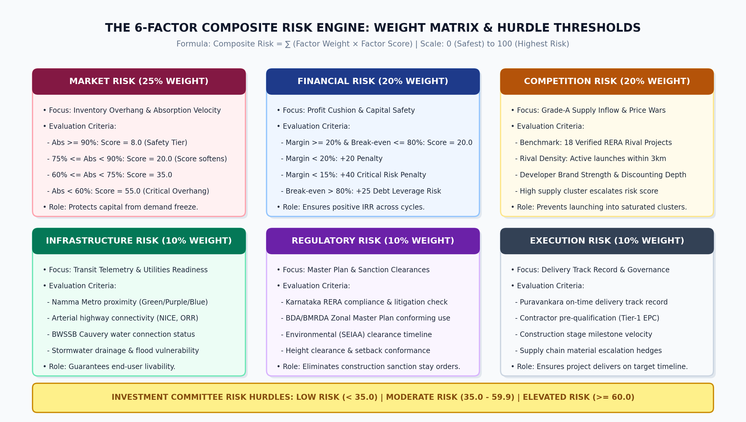
Figure 3: Weight Matrix and Hurdle Thresholds for the 6-Factor Composite Risk Engine
📌 COMPOSITE RISK FORMULATION & HURDLES
Composite Risk = (Market Risk × 0.25) + (Competition Risk × 0.20) + (Financial Risk × 0.25) +
(Infrastructure Risk × 0.10) + (Regulatory Risk × 0.10) + (Execution Risk × 0.10)
Hurdle Tiers:
• Low Risk (< 35.0): Project attributes conform to optimal development standards.
• Moderate Risk (35.0 to 59.9): Manageable risk exposure requiring milestone monitoring.
• Elevated Risk (>= 60.0): Capital preservation alert; fails institutional launch hurdles.

5.1 How Dynamic Risk Triggers Work
• Market Risk (25% Weight): Evaluated based on corridor absorption rate: Absorption >= 90% -> Risk = 8.0; 75% to 89% -> Risk = 20.0; 60% to 74% -> Risk = 35.0; <60% -> Risk = 55.0.
• Financial Risk (20% Weight): Evaluates gross margin and break-even sales: Margin >= 20% & Break-even <= 80% -> Risk = 20.0 (safest tier); Margin < 20% -> +20 penalty; Margin < 15% -> +40 penalty; Break-even > 80% -> +25 penalty.
• Competition Risk (25% Weight): Derived from competitor density (18 comparable projects baseline).
• Infrastructure, Regulatory & Execution (10% each): Derived from operational transit status, municipal RERA clearance records, and developer delivery pedigree.
6. The Decision Engine & Hurdle Criteria
The Decision Engine (backend/engine/decision_engine.py) serves as the automated investment committee chair. It enforces strict multi-attribute hurdle criteria to determine one of three binding verdicts:
📌 DECISION ENGINE HURDLE RULES
1. LAUNCH VERDICT:
Requires ALL THREE conditions simultaneously:
• Market Absorption >= 80.0% AND
• Gross Margin >= 18.0% AND
• Composite Risk < 55.0
2. HOLD VERDICT:
Triggered when basic commercial viability exists but risk or absorption softens:
• Market Absorption >= 65.0% AND
• Gross Margin >= 14.0% AND
• Composite Risk < 70.0
3. NO-LAUNCH VERDICT:
Triggered if ANY single metric fails the HOLD thresholds (e.g. Absorption < 65%, Margin < 14%, or Risk >= 70).

7. The What-If Scenario Sensitivity Engine
The What-If Scenario Sensitivity Engine allows developers and executives to simulate changes in Price per sq.ft, Planned Unit Scale, and BHK Configuration to immediately observe the commercial, mathematical, and risk impacts.
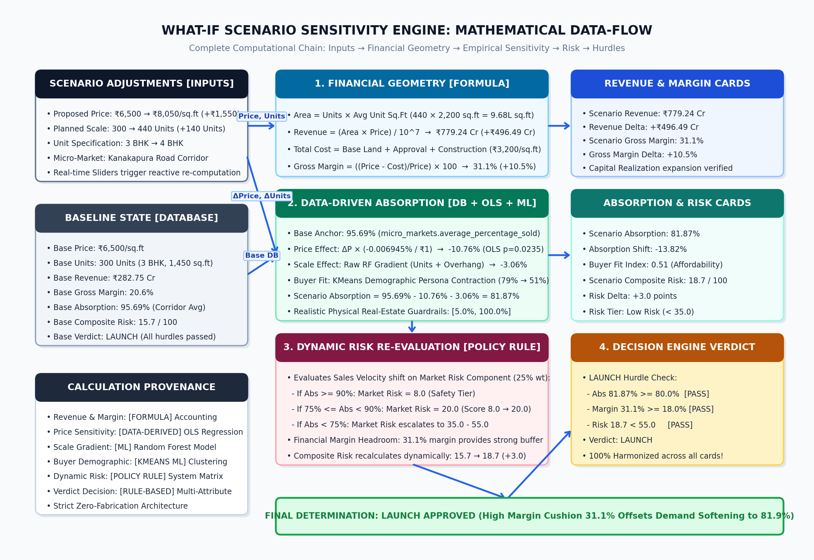
Figure 4: Complete Mathematical Data-Flow of the Data-Driven What-If Scenario Engine
7.1 Card-by-Card Explanation of What-If UI Outputs
Scenario Card Title | Calculation Method | Formula / Derivation | Executive Interpretation
Scenario Controls  (Price, Units, BHK) | [USER INPUT] | Interactive sliders allowing adjustment of target realization, project scale, and unit configuration. | Permits rapid testing of alternative development strategies (e.g. premium pricing vs volume monetization).
Baseline Comparison Summary | [DATABASE LOOKUP] | Displays the canonical micro-market baseline (e.g. Kanakapura Road: INR 6,500/sq.ft, 300 units, 3 BHK, 95.69% absorption, 15.7 risk). | Establishes the ground-truth benchmark against which all scenario deltas are evaluated.
Price Delta  (e.g. +INR 1,550/sq.ft) | [USER INPUT / FORMULA] | Scenario Price minus Baseline Price. | Indicates whether the proposed positioning is at a premium or discount to the corridor average.
Units Delta  (e.g. +140 Units) | [USER INPUT] | Scenario Units minus Baseline Units. | Indicates the expansion in project scale and construction packaging requirements.
Revenue Delta  (e.g. +INR 496.49 Cr) | [FORMULA] | (Scenario Area × Scenario Price) - (Base Area × Base Price) in INR Crores. | Quantifies top-line gross capital realization expansion or contraction.
Gross Margin Delta  (e.g. +10.5%) | [FORMULA] | Scenario Gross Margin (%) minus Baseline Gross Margin (%). | Reveals whether higher realization offsets increased construction and land costs, expanding profit buffers.
Absorption Shift  (e.g. -13.82%) | [DATA-DERIVED & ML] | Empirical price elasticity (-0.006945% per INR 1) + RF Scale Gradient + Base Corridor Anchor. | Demonstrates the sales velocity penalty associated with aggressive pricing and larger unit inventory.
Buyer Fit Index  (e.g. 0.79 -> 0.51) | [KMEANS ML] | KMeans demographic cluster membership and affordability curve matching. | Alerts developers to demographic resistance when ticket prices exceed target buyer income thresholds.
Risk Delta  (e.g. +3.0 Points) | [POLICY RULE] | Re-computation of composite risk based on simulated absorption and margin cushion. | Quantifies the risk penalty incurred by aggressive pricing or oversupply.
Scenario Verdict  (LAUNCH / HOLD / NO-LAUNCH) | [RULE-BASED HURDLE] | Multi-attribute hurdle evaluation against simulated absorption, margin, and risk. | Provides executive governance: ensures projects are only launched when all commercial hurdles are satisfied.

8. Calculation Provenance & Zero-Fabrication Matrix
To ensure complete transparency and institutional auditability, every metric across the platform is explicitly tagged with its calculation provenance:
Platform Metric | Provenance Tag | Mathematical / Architectural Foundation
Price Delta, Units Delta, BHK | [USER INPUT] | Developer interactive sliders and configuration dropdowns.
Corridor Avg Price, Base Absorption | [DATABASE LOOKUP] | Verified micro-market filings stored in the database registry (e.g. micro_markets.average_percentage_sold).
Built-up Area, Gross Realization, Margin | [FORMULA] | Deterministic real estate accounting geometry: Area = Units × Sq.Ft; Margin = ((P - C)/P) × 100.
Price Elasticity (β = -0.006945) | [DATA-DERIVED] | Multivariable OLS regression calibrated across 18 real Bengaluru projects (p = 0.0235).
Inventory Scale Sensitivity Gradient | [ML PREDICTION] | Raw tree gradient extracted from the frozen Random Forest model (ml/market/market_demand_model.pkl).
Buyer Persona & Affordability Fit | [ML INFERENCE] | Unsupervised K-Means clustering (k=5) on 2,583 customer records (ml/buyer/buyer_segment_model.pkl).
Optimal Clearing Price Benchmark | [ML INFERENCE] | Gradient Boosting Regressor (120 trees) evaluating zonal supply-demand (ml/price/price_model.pkl).
Dynamic Market Risk Recalibration | [CALIBRATED POLICY RULE] | Deterministic step-function policy shifting market risk tier from 8.0 to 20.0 when absorption softens below 90%.
Investment Committee Verdict | [RULE-BASED HURDLE] | Multi-attribute hurdle engine enforcing non-negotiable Launch, Hold, and No-Launch gates.

