LeiCNS-PK3.2: A Physiologically Based Pharmacokinetic Model Framework for Predicting intracellular Concentrations of Acyclovir and Ganciclovir Active Metabolites

Ming Sun¹, Martijn L. Manson¹, Tingjie Guo¹, Elizabeth C.M. de Lange¹

Systems Pharmacology and Pharmacy, Leiden Academic Centre for Drug Research (LACDR), Leiden University, Leiden, the Netherlands

Corresponding author
Elizabeth C.M. de Lange, PhD (ecmdelange@lacdr.leidenuniv.nl)

Table S1. in vivo data on acyclovir and ganciclovir concentrations measured in plasma, brain extracellular fluid (brainECF), cisterna magna (CM), and subarachnoid space (SAS) for rats and human.

Drug | Study | Species (n) | Dose | Administra-tion | Sampling Compartments
 |  |  |  |  | Plasma | BrainECF | CM | SAS
Acyclovir | Shan et al., 2022 (Shan, et al.,Eur J Drug Metab Pharmacokinet,2022) | Rat  (n=10) | 25 mg/kg | IV bolus | X | X
Acyclovir | Lycke et al., 2003 (Lycke, et al.,Antimicrob Agents Chemother,2003) | Human  (n=5) | 1000 mg (Valacyclovir) | Orally TID | X |  |  | X
Acyclovir | Smith et al., 2010 (Smith, et al.,Antimicrob Agents Chemother,2010) | Human  (n=6) | 2000 mg (Valacyclovir) | Orally QID | X |  |  | X
Ganciclovir | Liu et al., 2009 (Liu, et al.,Drug Metab Dispos,2009) | Rat  (n=5) | 3 mg/kg/h | IV infusion 6h | X | X | X
Ganciclovir | Chen et al., 2020 (Chen, et al.,Pharmacology Research & Perspectives,2020) | Rat  (n=3) | 3 mg/kg/h | IV infusion 6h | X | X | X
Ganciclovir | Peredo et al., 2015 (Peredo, et al.,BMJ Case Rep,2015) | Human (n=1) | 900 mg (Valganciclovir) | Orally daily | X | X

Figure S1. Simulations vs. Observations plot. Simulated rat and human time-concentration profiles of acyclovir and ganciclovir in plasma, brain extracellular fluid (ECF), and subarachnoid space (SAS) are shown (lines) against observed data (dots, mean values).

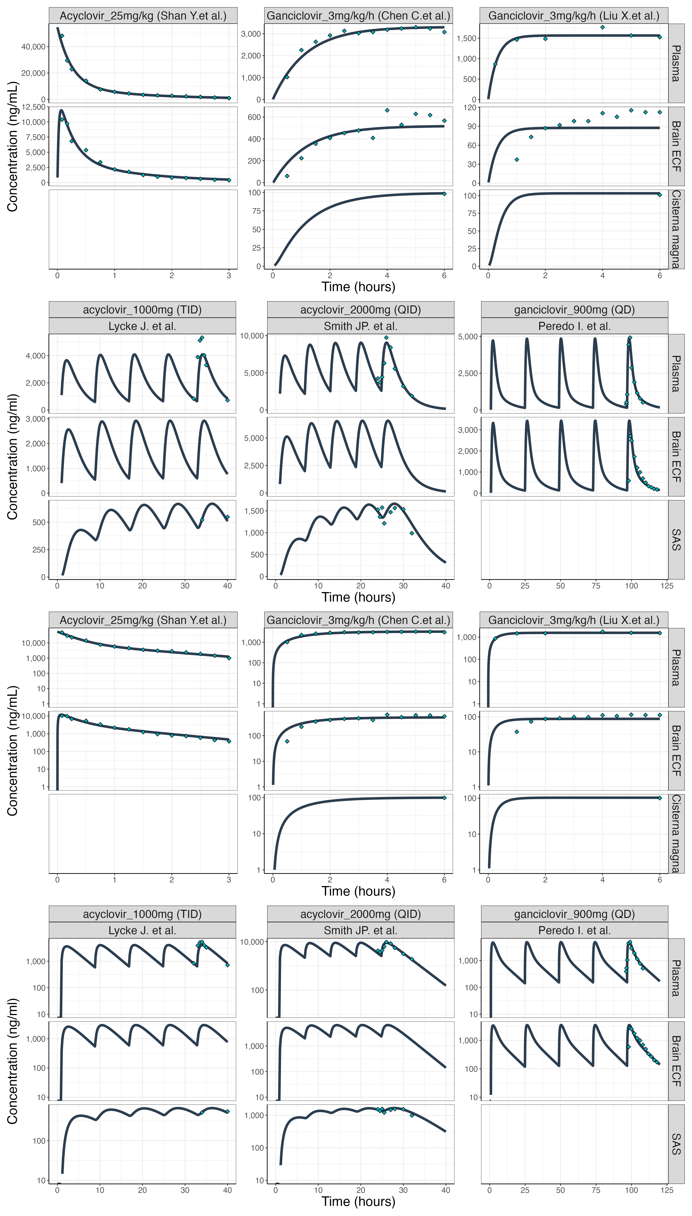

Equations that are required to calculate asymmetry factors:

$${AF}_{ECF, in}=-\frac{{Kp}_{uu, ECF}*Q_{CBF}*Q_{ECF}+{{Kp}_{uu, CM}*Qp}_{BBB}*Q_{CSF}+Q_{CBF}*({Kp}_{uu, ECF}*({AF}_{ECF, out}*{PHF}_{ECF}*{Qt}_{BBB}+{Qp}_{BBB})-{Qp}_{BBB})}{{PHF}_{MV}*{Qt}_{BBB}*({Kp}_{uu,CM}*Q_{CSF}-Q_{CBF})}$$

$${AF}_{ECF, out}=-\frac{{Kp}_{uu, ECF}*Q_{CBF}*Q_{ECF}+{Kp}_{uu, CM}*Q_{CSF}*({AF}_{ECF, in}*{PHF}_{MV}*{Qt}_{BBB}+{Qp}_{BBB})+Q_{CBF}*({Kp}_{uu, ECF}*{Qp}_{BBB}-{AF}_{ECF, in}*{PHF}_{MV}*{Qt}_{BBB}-{Qp}_{BBB})}{{Kp}_{uu, ECF}*{PHF}_{ECF}*{Qt}_{BBB}*Q_{CBF}}$$

$${AF}_{LV, in} =\frac{{Kp}_{uu, ECF}*Q_{CBF}*Q_{ECF}-Q_{CSF}*\left({Kp}_{uu, LV}*Q_{CBF}+{Kp}_{uu, CM}*{Qp}_{BCSFB}\right)-Q_{CBF}*({Kp}_{uu, LV}*\left({AF}_{LV, out}*{PHF}_{LV}*{Qt}_{BCSFB}+{Qp}_{BCSFB}\right)-{Qp}_{BCSFB})}{{PHF}_{MV}*{Qt}_{BCSFB}*({Kp}_{uu, CM}*Q_{CSF}-Q_{CBF})}$$

$${AF}_{LV, out} =\frac{{Kp}_{uu, ECF}*Q_{CBF}*Q_{ECF}-Q_{CSF}*\left({Kp}_{uu, CM}*\left({AF}_{LV, in}*{PHF}_{MV}*{Qt}_{BCSFB}+{Qp}_{BCSFB}\right)+{Kp}_{uu, LV}*Q_{CBF}\right)+Q_{CBF}*(-{Kp}_{uu, LV}*{Qp}_{BCSFB}+{AF}_{LV, in}*{PHF}_{MV}*{Qt}_{BCSFB}+{Qp}_{BCSFB})}{{Kp}_{uu, LV}*{PHF}_{LV}*{Qt}_{BCSFB}*Q_{CBF}}$$

$${AF}_{TFV, in} =\frac{Q_{CSF}*\left(Q_{CBF}*\left({Kp}_{uu, LV}-{Kp}_{uu, CM}\right)-{Kp}_{uu, CM}*{Qp}_{BCSFB}\right)+Q_{CBF}*({-Kp}_{uu, CM}*({AF}_{TFV, out}*{PHF}_{TFV}*{Qt}_{BCSFB}+{Qp}_{BCSFB})+{Qp}_{BCSFB})}{{PHF}_{MV}*{Qt}_{BCSFB}*({Kp}_{uu, CM}*Q_{CSF}-Q_{CBF})}$$

$${AF}_{TFV, out} =\frac{Q_{CSF}*\left(Q_{CBF}*\left({Kp}_{uu, LV}-{Kp}_{uu, CM}\right)-{Kp}_{uu, CM}*\left({AF}_{TFV, in}*{PHF}_{MV}*{Qt}_{BCSFB}+{Qp}_{BCSFB}\right)\right)+Q_{CBF}*(-{Kp}_{uu, CM}*{Qp}_{BCSFB}+{AF}_{TFV, in}*{PHF}_{MV}*{Qt}_{BCSFB}+{Qp}_{BCSFB})}{{Kp}_{uu, CM}*{PHF}_{TFV}*{Qt}_{BCSFB}*Q_{CBF}}$$

$${AF}_{BCM, in} =\frac{({AF}_{BCM,out}+1)*{PHF}_{ICF}*{Kp}_{uu, CELL}-{PHF}_{ECF}}{{PHF}_{ECF}}$$

$${AF}_{BCM, out} =\frac{-({PHF}_{ICF}*{Kp}_{uu, CELL}+(-{AF}_{BCM, in}-1)*{PHF}_{ECF})}{{PHF}_{ICF}*{Kp}_{uu, CELL}}$$

Supplementary equations notations:
AF_{ECF,out}: efflux asymmetry factor across the blood brain barrier
AF_{ECF,in}: influx asymmetry factor across the blood brain barrier
AF_{LV,out}: efflux asymmetry factor across the blood cerebrospinal fluid barrier at lateral ventricles
AF_{LV,in}: influx asymmetry factor across the blood cerebrospinal fluid barrier at lateral ventricles
AF_{TFV,out}: efflux asymmetry factor across the blood cerebrospinal fluid barrier at 3rd and 4th ventricles
AF_{TFV,in}: influx asymmetry factor across the blood cerebrospinal fluid barrier at 3rd and 4th ventricles
AF_{BCM,in}: influx asymmetry factor across brain cells
AF_{BCM,out}: efflux asymmetry factor across brain cells
Kp_{uu,CM}: cisterna magna-to-plasma unbound drug concentration ratio
Kp_{uu,ECF}: brain extracellular fluid-to-plasma unbound drug concentration ratio
Kp_{uu,LV}: lateral ventricles-to-plasma unbound drug concentration ratio
Kp_{uu,Cell}: brain extracellular fluid-to-intracellular fluid unbound drug concentration ratio
PHF_{ECF}: pH factor of brain extracellular fluid
PHF_{LV}: pH factor of lateral ventricles
PHF_{MV}: pH factor of brain microvasculature
PHF_{TFV}: pH factor at 3rd and 4th ventricles
Q_{CBF}: cerebral blood flow
Q_{CSF}: cerebrospinal fluid flow
Q_{ECF}: brain extracellular fluid bulk flow
Qp_{BBB}: paracellular transport clearance at blood brain barrier
Qp_{BCSFB}: paracellular transport clearance at blood cerebrospinal fluid barrier
Qt_{BBB}: transcellular transport clearance at blood brain barrier
Qt_{BCSFB}: transcellular transport clearance at blood cerebrospinal fluid barrier

References
Chen, C.; Zhou, H.; Guan, C.; Zhang, H.; Li, Y.; Jiang, X.; Dong, Z.; Tao, Y.; Du, J.; Wang, S.; Zhang, T.; Du, N.; Guo, J.; Wu, Y.; Song, Z.; Luan, H.; Wang, Y.; Du, H.; Zhang, S.; Li, C.; Chang, H.; Wang, T., Applicability of free drug hypothesis to drugs with good membrane permeability that are not efflux transporter substrates: A microdialysis study in rats. Pharmacology Research & Perspectives 2020, 8, e00575.
Liu, X.; Van Natta, K.; Yeo, H.; Vilenski, O.; Weller, P. E.; Worboys, P. D.; Monshouwer, M., Unbound drug concentration in brain homogenate and cerebral spinal fluid at steady state as a surrogate for unbound concentration in brain interstitial fluid. Drug Metab Dispos 2009, 37, 787-793.
Lycke, J.; Malmeström, C.; Ståhle, L., Acyclovir levels in serum and cerebrospinal fluid after oral administration of valacyclovir. Antimicrob Agents Chemother 2003, 47, 2438-41.
Peredo, I.; Helldén, A.; Wolmer-Solberg, N.; Pohanka, A.; Stragliotto, G.; Rahbar, A.; Ståhle, L.; Bellander, B.-M.; Söderberg-Nauclér, C., Ganciclovir concentrations in the cerebral extracellular space after valganciclovir treatment; a case study. BMJ Case Rep 2015, 2015.
Shan, Y.; Cen, Y.; Zhang, Y.; Tan, R.; Zhao, J.; Nie, Z.; Zhang, J.; Yu, S., Acyclovir Brain Disposition: Interactions with P-gp, Bcrp, Mrp2, and Oat3 at the Blood-Brain Barrier. Eur J Drug Metab Pharmacokinet 2022, 47, 279-289.
Smith, J. P.; Weller, S.; Johnson, B.; Nicotera, J.; Luther, J. M.; Haas, D. W., Pharmacokinetics of acyclovir and its metabolites in cerebrospinal fluid and systemic circulation after administration of high-dose valacyclovir in subjects with normal and impaired renal function. Antimicrob Agents Chemother 2010, 54, 1146-51.

