Table of Contents
OpenFOAM Tutorial 2
BASIC MODULE 2
M1-S1-P1: Introduction 2
Section 1, part 2: Description 7
Section 1, Part 3: Standard Solvers 11
Mesh Generation 19
Mesh Conversion 19
Mesh Manipulation 21
Turbulance Models 22

OpenFOAM Tutorial

BASIC MODULE

M1-S1-P1: Introduction

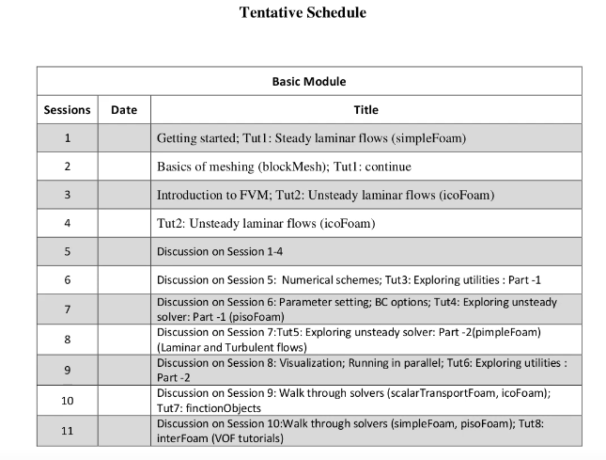
Grid generation by the blockmesh. Blockmesh comes with the openfoam.
Icofoam: Laminar folw solver.
Pisofoam and pimplefoam= Turbulent folw solver.
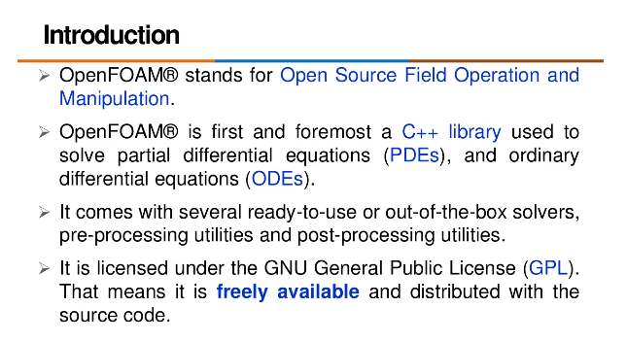
ANSYS, ComSOL these products are commercial which charges huge.
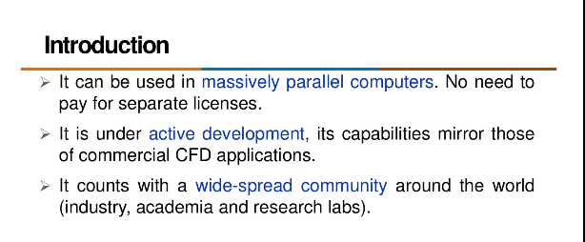
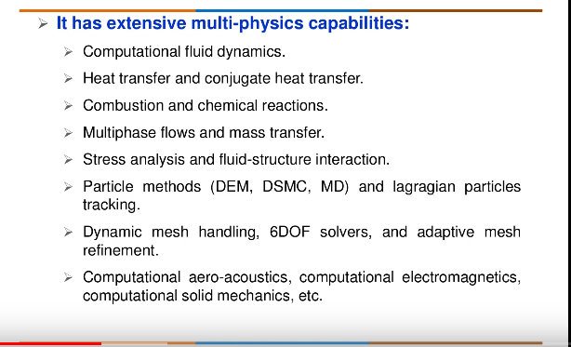
But, Dynamic mesh movement with heat transfer: This solver is not available. We have to merge both the solver and we will be ready to go. But, in commercial solver like COMSOL, everything is already available.
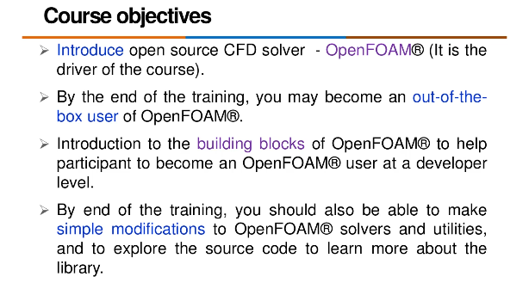
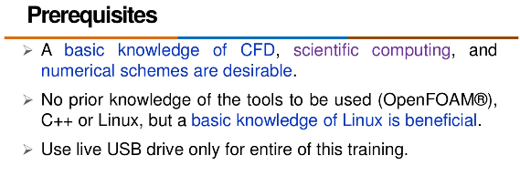
Use live USB, not present version of OpenFOAM for this course.
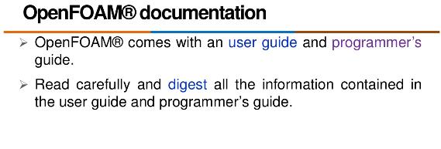
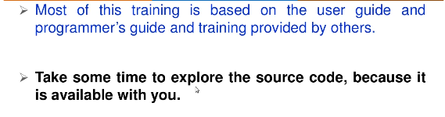
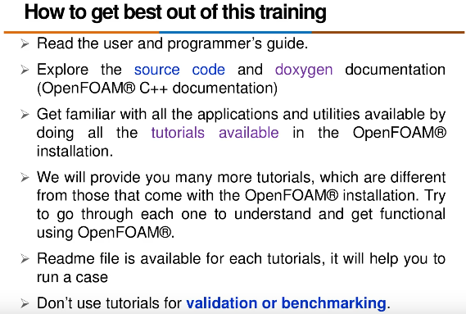
We should not use these tutorials for validation or benchmarking. Because, for that we need sophisticated grid generation.
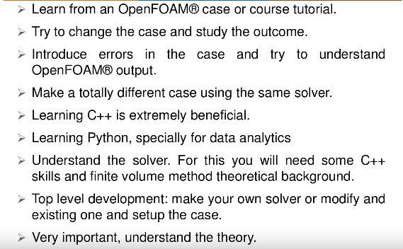
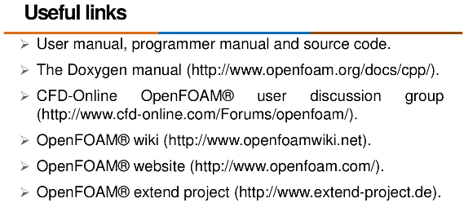

Section 1, part 2: Description
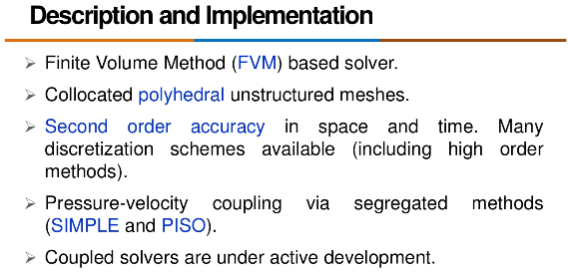
OpenFOAM can adapt all types of structured and unstructured meshing.
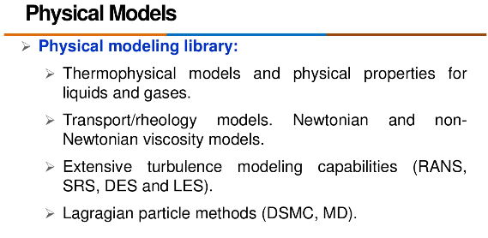
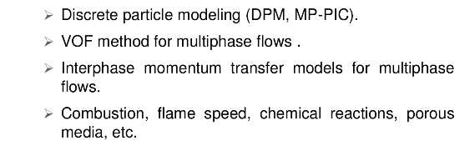
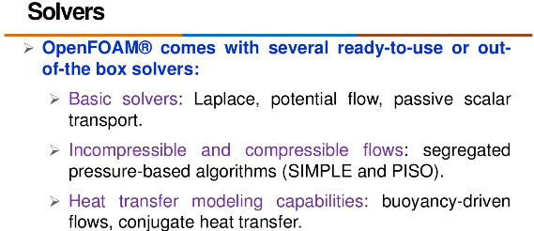
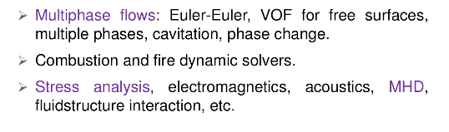
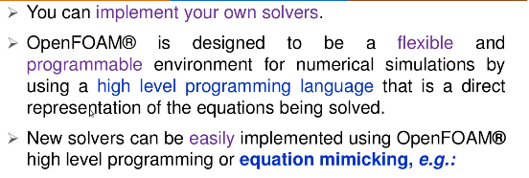
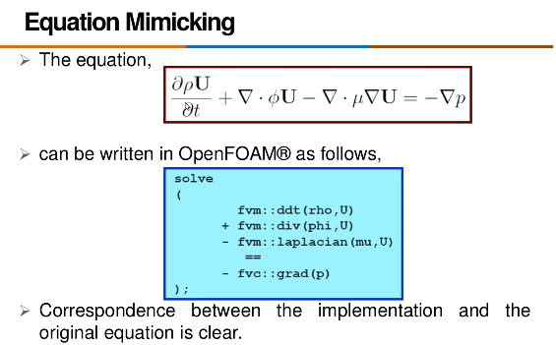
Any term you required in implicit way, you type ‘vm’. When explicit term is required, type ‘vc’.
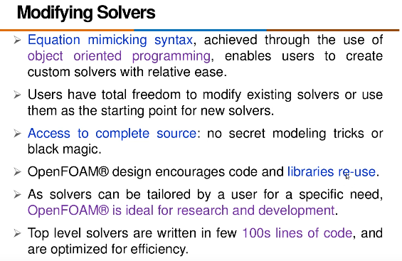
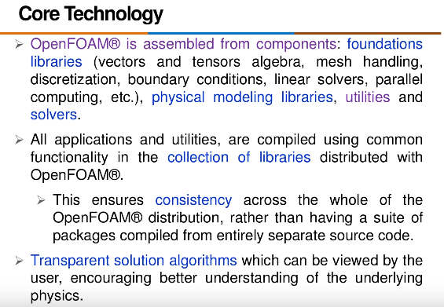

Section 1, Part 3: Standard Solvers
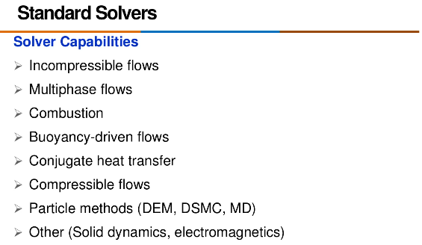
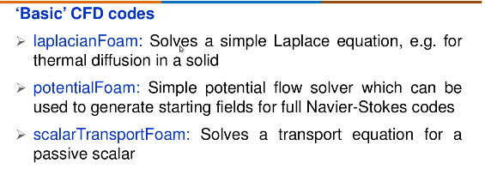

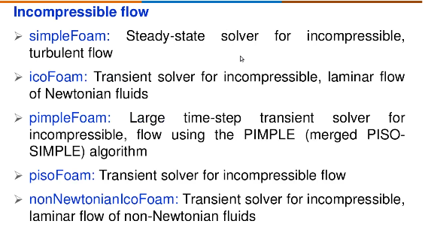
For highly complex physics then try to stick to the pimplefoam, not pisoFoam.
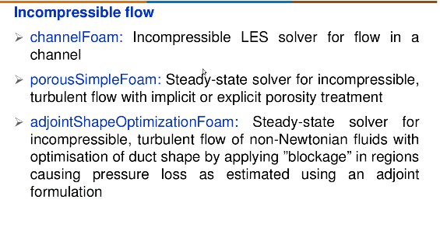
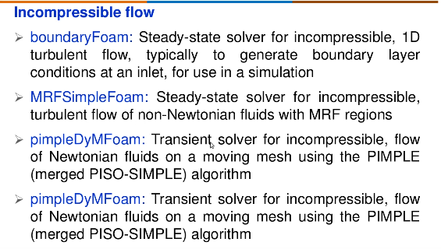
Many solver you can not find in the distributed version.But if you google it, you can get the source code.
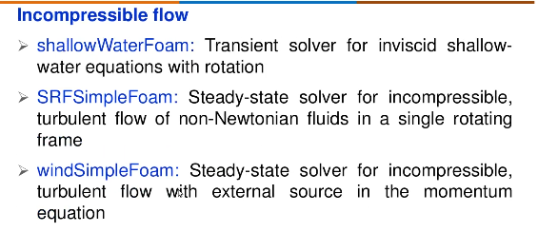
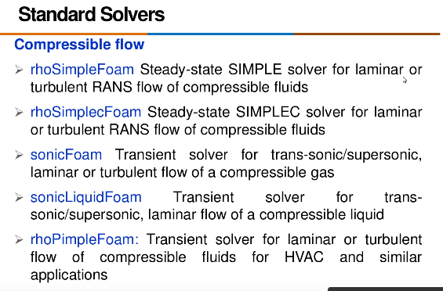
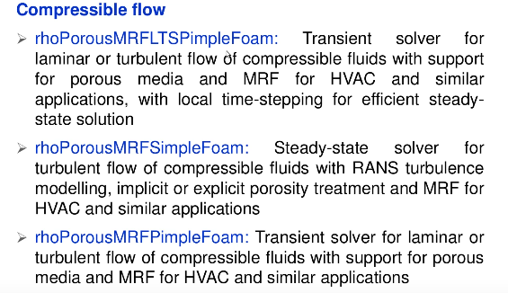
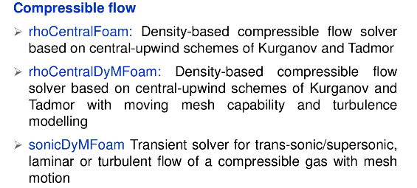
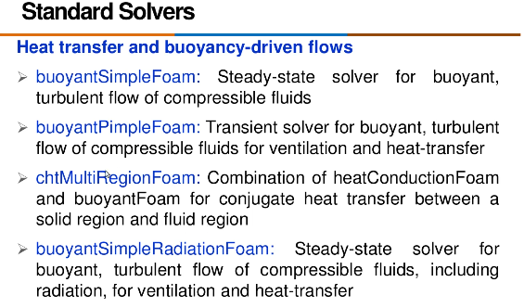
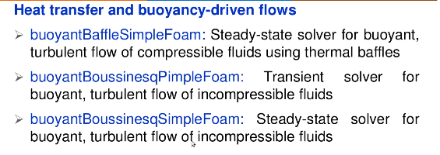
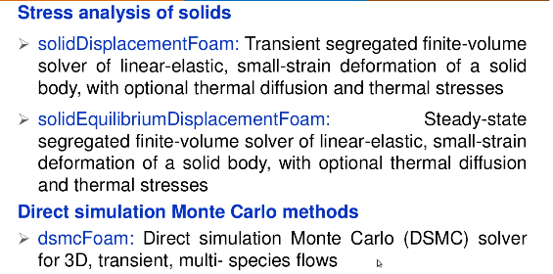
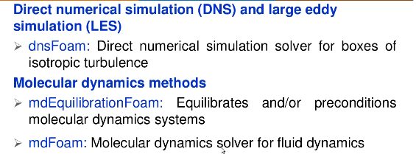

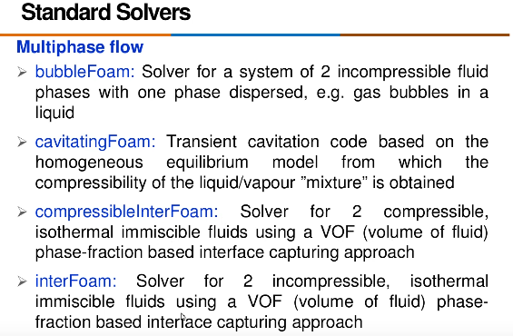
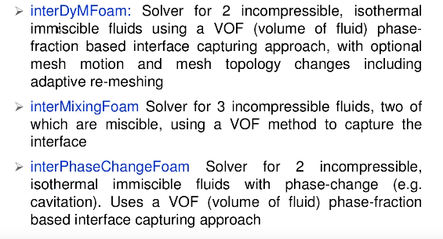
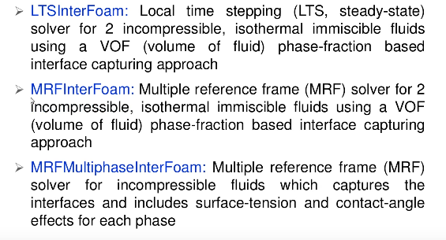
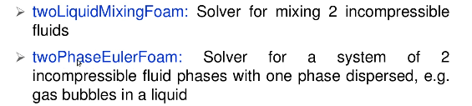
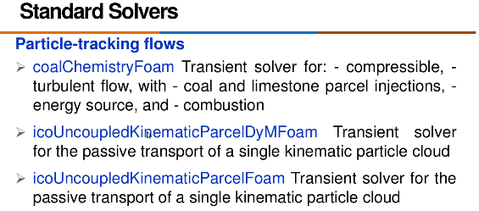

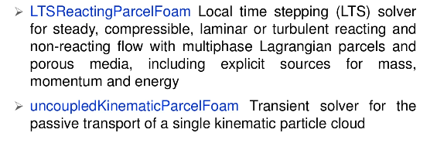

Mesh Generation
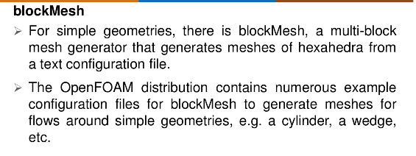
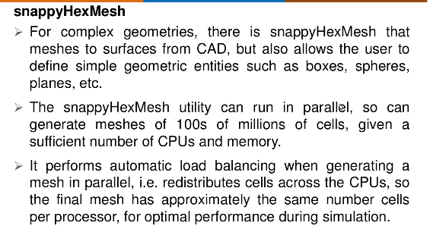

Mesh Conversion

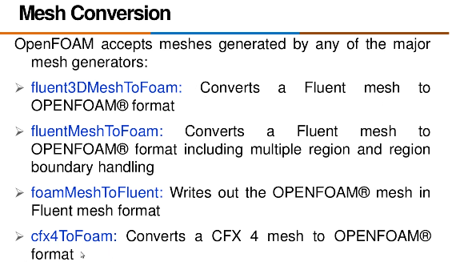
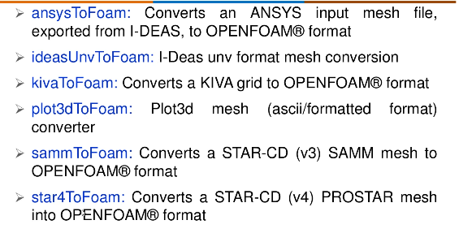

Mesh Manipulation
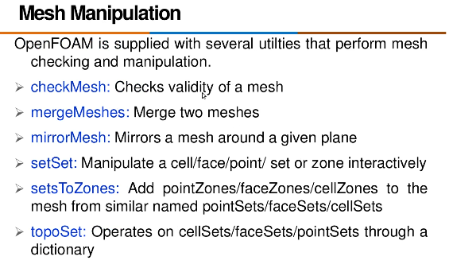
OpenFOAm gives the idea if a mesh is valid or not. Aspect ratio, skewness, voliume (either negative or positive) are checked. If not valid openFOAm throws the error.
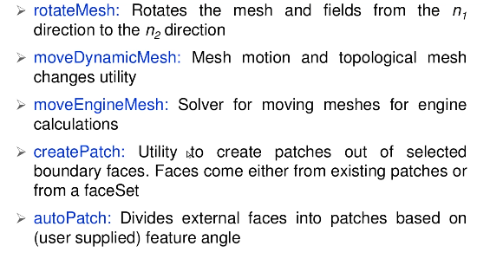

Turbulance Models
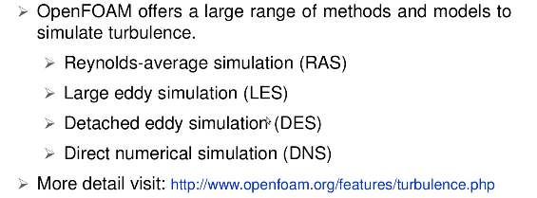
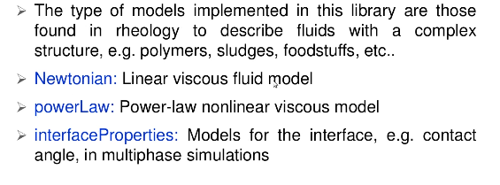

Transport Models
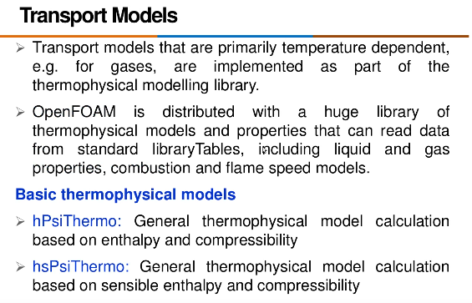

Thermophysical Models
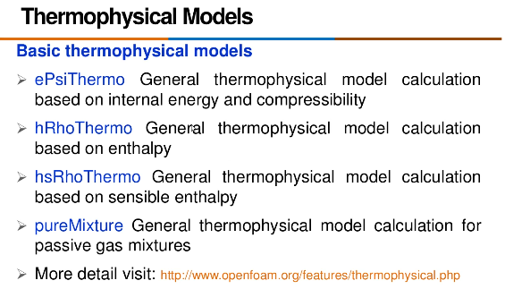

Lagrangian Particle Tracking
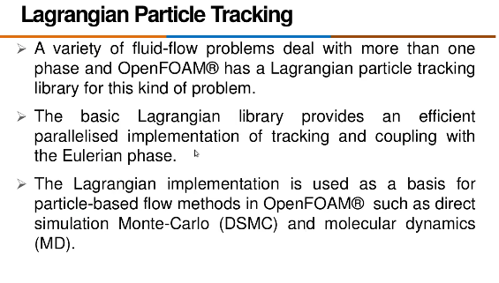
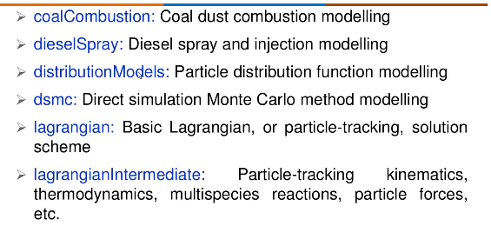

Post-processing

Paraview post processor

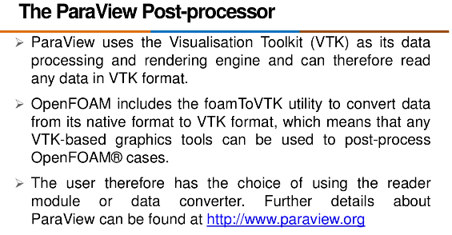

Run time post processing

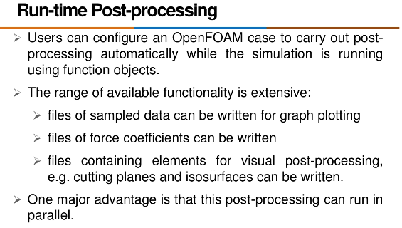
Run time post-processing is required to visulize how the simulation is going on while simulation is running on the background.
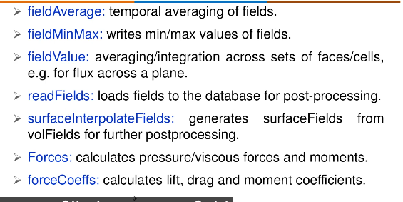
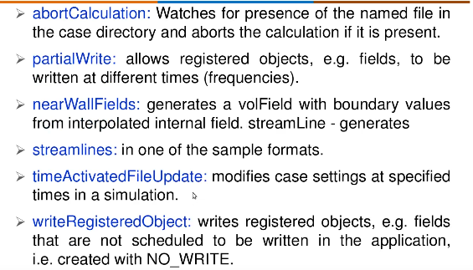

Third Party post processing
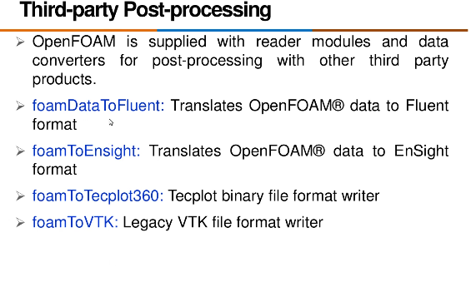

Session 2, Part 1: Understanding the directory structure of openFOAM

sayak@sayak-Precision-Tower-3620:~$ find / -type d -name "OpenFOAM*" 2>/dev/null
#If you are unsure about the installation location, you can search your system for OpenFOAM-related directories using this command.
/usr/lib/openfoam/openfoam2306/src/OpenFOAM
/home/sayak/OpenFOAM
sayak@sayak-Precision-Tower-3620:~$ source /usr/lib/openfoam/openfoam2306/etc/bashrc
#Sourcing the bashrc file is a common step in setting up and activating an environment for a specific software package. After running this command, your shell session should be configured to use OpenFOAM-2306.
sayak@sayak-Precision-Tower-3620:~$ cd /usr/lib/openfoam/openfoam2306
sayak@sayak-Precision-Tower-3620:/usr/lib/openfoam/openfoam2306$ ls
Allwmake bin META-INFO src tutorials
applications etc platforms ThirdParty wmake
sayak@sayak-Precision-Tower-3620:/usr/lib/openfoam/openfoam2306$ pwd
/usr/lib/openfoam/openfoam2306

All solvers of openfoam is in ‘applications’ directory.

sayak@sayak-Precision-Tower-3620:/usr/lib/openfoam/openfoam2306$ cd applications/
sayak@sayak-Precision-Tower-3620:/usr/lib/openfoam/openfoam2306/applications$ ls
Allwmake solvers test tools utilities

Allwmake: Contains scripts or files related to the compilation and building of OpenFOAM applications.
solvers: Houses solver applications for various numerical simulations, each subdirectory corresponding to a specific solver.
test: Contains test cases or examples to validate the correctness and performance of OpenFOAM solvers.
tools: Holds utility programs and tools for pre-processing, post-processing, and other tasks related to OpenFOAM simulations.
utilities: Contains various utility applications that complement the primary solvers, including mesh manipulation tools and data conversion programs.

sayak@sayak-Precision-Tower-3620:/usr/lib/openfoam/openfoam2306/applications$ cd solvers
sayak@sayak-Precision-Tower-3620:/usr/lib/openfoam/openfoam2306/applications/solvers$ ls
# lists the available solvers.
acoustic discreteMethods financial lagrangian
basic DNS finiteArea multiphase
combustion doc heatTransfer stressAnalysis
compressible electromagnetics incompressible

sayak@sayak-Precision-Tower-3620:/usr/lib/openfoam/openfoam2306/applications/solvers$ cd incompressible/
sayak@sayak-Precision-Tower-3620:/usr/lib/openfoam/openfoam2306/applications/solvers/incompressible$ ls
adjointOptimisationFoam nonNewtonianIcoFoam
adjointShapeOptimizationFoam pimpleFoam
boundaryFoam pisoFoam
icoFoam shallowWaterFoam
incompressibleSolversDoc.H simpleFoam
# Lists all incompressible flow solvers available. icoFoam, pisoFoam, simpleFoam, pimpleFoam will be used for basic tutorial.

sayak@sayak-Precision-Tower-3620:/usr/lib/openfoam/openfoam2306/applications/solvers/basic$ ls
#Shows contents in ‘basic’ folder.
basicSolversDoc.H laplacianFoam potentialFoam scalarTransportFoam

sayak@sayak-Precision-Tower-3620:/usr/lib/openfoam/openfoam2306/applications/utilities$ ls
#Contents of ‘utilities’ folder.
doc miscellaneous preProcessing
finiteArea parallelProcessing surface
mesh postProcessing thermophysical

sayak@sayak-Precision-Tower-3620:/usr/lib/openfoam/openfoam2306/applications/utilities/postProcessing$ ls
#Contents of ‘postProcessing’ folder.
dataConversion lumped noise postProcess
lagrangian miscellaneous optimisation

