1_1981_Determinationof Hydrogeological
ParametersUsingSinusoidalPressure
Tests:
A TheoreticalAppraisal
J. H.
BLACK
EnvironmentalProtectionUnit, Instituteof GeologicalSciences,
Harwell Laboratory,Harwell, England
K. L. KIPP, JR.'

The proposed method for determining hydrogeological parameters involves inducing sinusoidal pressure fluctuations in an excitation borehole. The derived equations describe how pressures and phase lags outside the borehole depend on distance, signal frequency, specific storage, hydraulic conductivity, and flow rates. Two distinct configurations are considered: one with a point source deep within a water-saturated elastic formation and another with a line source fully penetrating a confined aquifer. The applicability of these configurations is assessed using existing data on hydraulic diffusivities to estimate likely excitation and response pressures for various flow rates and signal frequencies. Both configurations require accurate measurements of phase shifts for the point source and amplitudes for the line source. It is concluded that while the method's ranges of application are useful, they are also limited.

2_1961_Responseof Well-Aquifer Systemsto Earth Tides
JOHN D. BREDEHOEFT
U.S. GeologicalSurvey, Washington,D. C: 20œ/•2

The water level in an artesian aquifer-connected well responds to pressure-head fluctuations from aquifer dilation. Hydrological findings indicate that most well-aquifer systems behave as if drilled into an infinite or partially bounded medium, challenging the representation of aquifers as finite cavities. Tidal water level fluctuations in well-aquifer systems depend on aquifer dilation and specific storage. Analysis of earth tide dilation assumes independence of near-surface aquifer elastic properties from the Earth as a whole. The tidal dilatation can be computed from equilibrium tide theory, with an amplitude around 1 X 10⁻⁸ for the large semidiurnal wave (M₂). Earth-tide fluctuations corresponding to M₂ with 1 to 2 cm amplitude are not uncommon, and variations are explained by specific storage dependence. Computation of specific storage and porosity from earth-tide fluctuations, based on known Poisson's ratio, shows promising results for three artesian wells.

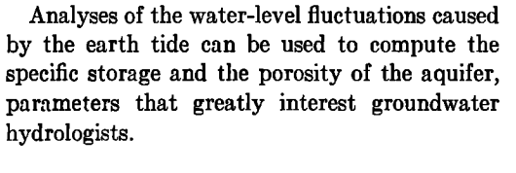

3_2015_Analytical and Semi-Analytical Tools
for the Design of Oscillatory Pumping Tests
by Michael Cardiff1 and Warren Barrash2

Oscillatory pumping tests, involving periodic variations in flow, offer a valuable method for understanding aquifer heterogeneity alongside traditional approaches like slug testing. Despite limited field applications, these tests extract robust metrics (signal amplitude and phase lag) from pressure data, providing insights into aquifer properties. To address the lack of design guidelines, we utilize existing analytical solutions to propose two key insights. First, we outline methods for selecting testing frequencies and flow rates to maximize signal amplitudes within practical constraints. Preliminary field data support these guidelines. Second, we introduce a semi-analytical approach to assess the sensitivity of oscillatory signals to spatial aquifer flow parameters, aiding in optimizing test design based on bulk parameter estimates.

In this paper, we have developed several analytical tools thatcan be used to design and analyze oscillatory pumping tests.

4_2013 Aquifer heterogeneity characterization with oscillatory pumping:
Sensitivity analysis and imaging potential
M. Cardiff,1,2 T. Bakhos,3 P. K. Kitanidis,3 and W. Barrash1

In this work,
we suggest a modiﬁed approach to periodic pumping test analysis in which one uses several
periodic pumping signals of different frequencies as stimulation, and responses are analyzed
through inverse modeling using a ‘‘steady-periodic’’ model formulation. We refer to this
strategy as multifrequency oscillatory hydraulic imaging.

5_2014 Oscillatory pumping wells in phreatic, compressible, and
homogeneous aquifers
G. Dagan1 and A. Rabinovich1
The paper presents an analytical solution for the head ﬁeld
in an unconﬁned aquifer of ﬁnite depth under the common assumptions of a linearized water table condi-
tion, different horizontal and vertical constant permeabilities, constant speciﬁc storativity and water table
drainable porosity, and small well radius to length ratio. The solution provides the expressions of the ampli-
tude and phase of the head as a function of coordinates, frequency, and the problem parameters. The solu-
tion simpliﬁes to one pertaining to an upper constant head condition and a rigid aquifer for a wide range of
the dimensionless frequency values.

6

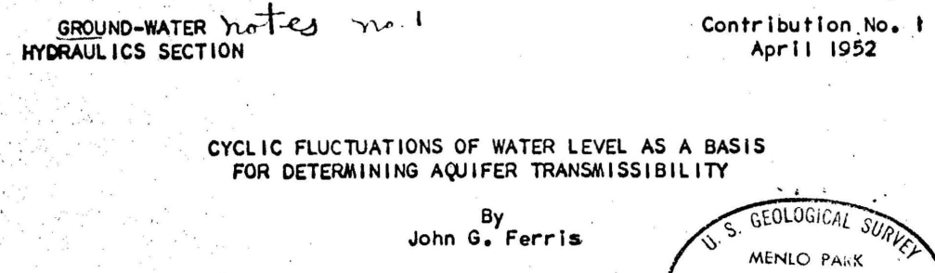
7_1955
NON-STEADY RADIAL F L O W IN A N INFINITE LEAKY AQUIFER
M . S. Hantush and C . E . Jacob

A b s t r a c t — T h e n o n - s t e a d y d r a w d o w n distribution n e a r a w e l l d i s c h a r g i n g f r o m an
infinite leaky aquifer i s p r e s e n t e d . V a r i a t i o n of d r a w d o w n with t i m e and distance c a u s e d
by a w e l l of constant d i s c h a r g e in confined s a n d of u n i f o r m thickness and u n i f o r m p e r m e
ability is obtained. T h e d i s c h a r g e i s s u p p l i e d by the reduction of s t o r a g e through e x p a n
sion of the w a t e r and the concomitant c o m p r e s s i o n of the s a n d , and a l s o by l e a k a g e through
the confining b e d . T h e l e a k a g e i s a s s u m e d to b e at a r a t e p r o p o r t i o n a l to the d r a w d o w n at
any point. S t o r a g e of w a t e r in the confining b e d is n e g l e c t e d . T w o f o r m s of the solution
are developed. One i s s u i t a b l e f o r computation f o r l a r g e v a l u e s of t i m e and the other s u i t
able f o r s m a l l v a l u e s of t i m e . T h i s solution i s c o m p a r e d with e a r l i e r solutions f o r slightly
different b o u n d a r y conditions.

9_2018_Analysis of Groundwater Response to Oscillatory Pumping Test in
2Unconfined Aquifers: Consider the Effects of Initial Condition and
3Wellbore Storage
4Ching-Sheng Huanga, Ya-Hsin Tsaib, Hund-Der Yehb* and Tao Yanga*
The combined effects of
wellbore storage and initial condition regarding the hydraulic head prior to OPT are commonly
neglected in the existing models. This study aims to develop a new model for describing the
hydraulic head fluctuation induced by OPT in an unconfined aquifer. The model contains a typical flow equation with an initial condition of static water table, inner boundary condition
specified at the rim of a finite-radius well for incorporating wellbore storage effect, and
linearized free surface equation describing water table movement. The analytical solution of
the model is derived by the Laplace transform and finite integral transform.

10_2019_A general analytical model for head response to
oscillatory pumping in unconfined aquifers: effects
of delayed gravity drainage and initial condition
Ching-Sheng Huang1 , Ya-Hsin Tsai2 , Hund-Der Yeh2 , and Tao Yang1
The combined effects of delayed
gravity drainage (DGD) and the initial condition regarding
the hydraulic head are commonly neglected in the existing
models. This study aims to develop a new model for de-
scribing the hydraulic head fluctuation induced by the OPT
in an unconfined aquifer. The model contains a groundwater
flow equation with the initial condition of a static water
table, Neumann boundary condition specified at the rim
of a partially screened well, and a free surface equation
describing water table motion with the DGD effect. The
solution is derived using the Laplace, finite-integral, and
Weber transforms.

12_1985 ANALYTICAL SOLUTIONS F O R PERIODIC WELL R E C H A R G E IN
R E C T A N G U L A R A Q U I F E R S WITH THIRD-KIND B O U N D A R Y
CONDITIONS
P. LATINOPOULOS

Analytical solutions for groundwater flow in rectangular aquifers are presented in the
case of single-well recharge. The problem concerns the impact of a seasonal (periodic)
recharge scheme of variable duration on aquifers with various boundary conditions of
which at least one is of the third kind. Results can be obtained for any combination of
boundary conditions and can be used in a preliminary assessment of the groundwater
response to artificial recharge schemes.

13_2017_
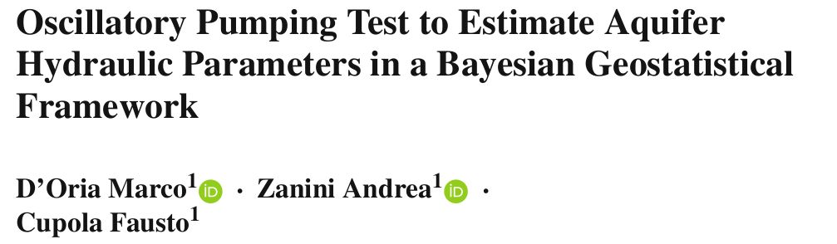
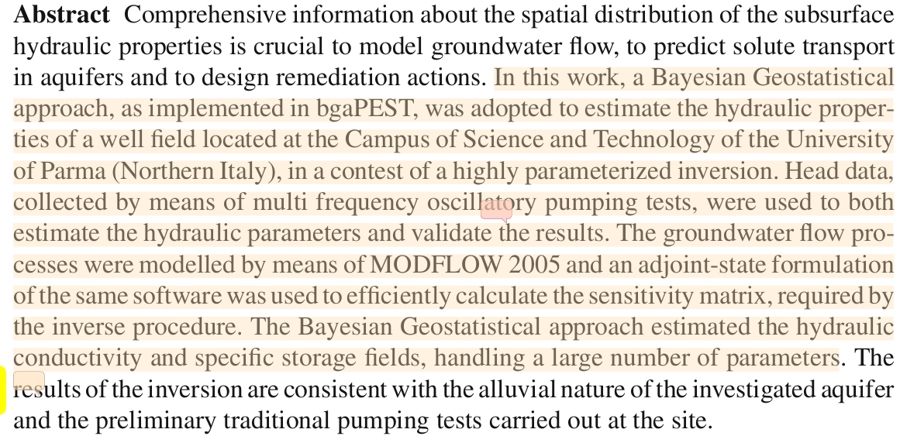
14_2015
Frequency dependent hydraulic properties estimated from oscillatory
pumping tests in an unconfined aquifer
Avinoam Rabinovich a,⇑, Warren Barrash b,c, Michael Cardiff d, David L. Hochstetler c, Tania Bakhos c,
Gedeon Dagan e, Peter K. Kitanidis c

Oscillatory pumping tests were conducted at the Boise Hydrogeophysical Research Site. A periodic pres-
sure signal is generated by pumping and injecting water into the aquifer consecutively and the pressure
response is recorded at many points around the source. We present and analyze the data from the field
test after applying Fourier analysis. We then match the data with a recently derived analytical solution
for homogeneous formations to estimate the equivalent aquifer properties: conductivity K, specific stor-
age Ss and specific yield Sy . The estimated values are shown to be in agreement with previous estimates
conducted at this site. We observe variations in the estimated parameters with different oscillation
periods of pumping.

15_2003 Estimating aquifer hydraulic properties using sinusoidal pumping
at the Savannah River site, South Carolina, USA
Todd C. Rasmussen · Kevin G. Haborak ·
Michael H. Young

A framework for estimating aquifer hydraulic
properties using sinusoidal pumping is presented that (1)
derives analytical solutions for confined, leaky, and
partially penetrating conditions; (2) compares the analyt-
ical solutions with a finite element model; (3) establishes
a field protocol for conducting sinusoidal aquifer tests;
and (4) estimates aquifer parameters using the analytical
solutions.

16_2013_Sinusoidal Hydraulic Testing of a Multi-Layer Aquifer
at the Waste Isolation Pilot Plant, Carlsbad, NM, USA
Todd C. Rasmussen∗, Nathanial J. Toll†, and Mark Bakker‡

This work presents the forward solution to sinusoidal flow in a multi-layer aquifer.
It stops short of providing a direct inverse analytical solution to determine aquifer parameters from observation data. Instead, an iterative least-squares optimization method is used to estimate
aquifer hydraulic properties.

Three sinusoidal aquifer
tests were performed by pumping at a periodic rate in the Culebra Dolomite Member of the Rustler
Formation, a hydrogeologic unit that overlies the repository and a hypothetical pathway for reposi-
tory releases.

An analytic solution was developed to obtain the hydraulic properties of the two dominant units
(Lower and Upper) within the vertically heterogeneous Culebra Dolomite using the sinusoidal data.
The problem is approached mathematically using a matrix formulation that vertically discretizes the
section into multiple layers and employs eigenvalues and eigenvectors to evaluate a Bessel function
with complex matrix arguments.

The solution for pumping from discrete intervals within an isotropic
aquifer is consistent with a partially penetrating solution.

16_2006_Periodic pumping tests
Jörg Renner and Mareike Messar

We performed pumping tests with a periodic succession of injection and production intervals
in a field of three shallow boreholes penetrating a jointed sandstone formation.

Two
types of analysis for the periodic pumping tests are presented. Injectivity analysis rests on the
determination of the amplitude ratio and phase shift between the periodic flow rate and pressure
records from the pumping well. Interference analysis is based on an evaluation of attenuation
and phase shift between the periodic pressure signals at the pumping and monitoring wells.
A periodic excitation permits to employ standard signal processing tools, such as fast Fourier
transformation, facilitating the evaluation of weak signals.

20_2017 Oscillatory hydraulic testing as a strategy for NAPL source zone
monitoring: Laboratory experiments
YaoQuan Zhou ⁎, Michael Cardiff

The research explores the use of oscillatory pumping tests, employing sinusoidal pumping variations to detect pressure changes, as a low-impact strategy for characterizing aquifer properties and monitoring NAPL movement. Experimental laboratory testing with dyed vegetable oil demonstrates that measurable changes in pressure signal amplitude and phase offer clear evidence of NAPL plume emplacement and migration, providing a promising method for ongoing NAPL monitoring in field remediation applications.

23_2016_
Aquifer imaging with pressure waves—Evaluation of
low-impact characterization through sandbox experiments
YaoQuan Zhou1, David Lim1, Fausto Cupola2, and Michael Cardiff1

An instrumented laboratory sandbox is ﬁlled with material of known hydraulic properties, and we
measure aquifer responses due to oscillatory pumping stimulations at periods of 2, 5, 10, and 20 s. Pressure
oscillation time series are processed through Fourier Transforms and inverted tomographically to obtain
estimates of aquifer heterogeneity, using a fast, steady-periodic groundwater ﬂow model. We show that
OHT is able to provide robust estimates of aquifer hydraulic conductivity even in cases where relatively few
pumping tests and observation locations are available. The use of multiple stimulation frequencies is also
shown to improve imaging results.
24_2019_Aquifer Imaging with Oscillatory Hydraulic
Tomography: Application at the Field Scale
by Michael Cardiff1,2 , YaoQuan Zhou1,3 , Warren Barrash4 , and Peter K. Kitanidis5

Modeling and laboratory experiments have demonstrated the ability of oscillatory hydraulic tomography (OHT) to characterize
heterogeneity in aquifer hydraulic properties. In OHT, a location is stressed via periodic pumping/injection at a set frequency,
and the resulting head signal is measured at a number of monitoring locations. The source of oscillations is repeatedly moved,
allowing tomographic imaging of aquifer properties. Changing the period of oscillation also results in observations with additional
information.

25_2023_Equivalent Hydraulic Conductivity of Heterogeneous Aquifers
Estimated by Multi-Frequency Oscillatory Pumping
Avinoam Rabinovich *
and David Guy

We investigate the
estimation of equivalent hydraulic conductivity (Keq ) in an oscillatory pumping test with a multi-
frequency excitation.
The result implies that oscillatory pumping field tests can be used for Keq estimation without
any corrections for frequency dependence.

26_2021_Stochastic analysis of oscillatory hydraulic tomography
Yu-Li Wang a, Tian-Chyi Jim Yeh a, b, *, Dong Xu c, Kuangjia Li d, Jet-Chau Wen e, f,
Shao-Yang Huang f, Wenke Wang g, Yonghong Hao b

This paper conducts a stochastic analysis to elucidate the effective
ness of delineating aquifer hydraulic heterogeneity using a periodic
pumping test or an oscillatory hydraulic tomography.

Results of Monte Carlo simulation confirm the analysis that the
multifrequency PPT or OHT does not increase the resolution of aquifer characterization.

Lastly, we do not discredit OHT or PPT. As noticed by many, the
oscillating signals can easily extract from background signals such as the sensor noise, sensor drift, and other hydraulic influences (e.g., another nearby pumping, river stage changes, etc.). However, constant-rate pumping tests could overcome these issues if the temporal sampling is
sufficiently dense and the signal-to-noise ratio is large enough (Mao et al., 2011, 2013b). Nevertheless, OHT is extremely useful in characterizing contaminated aquifers where contaminated groundwater and
discharge are prohibited. For this reason, OHT is highly desirable for
pump and treat remediation sites where groundwater is pumped out for
treatments and reinjected back to aquifers.

In contrast to constant rate pumping tests, oscillatory pumping tests employ sinusoidal pumping to estimate aquifer hydraulic properties. This involves injecting fluid during the first half of a sinusoidal cycle and extracting during the subsequent half.  Cooper et al. (1965) provided an analytical solution for sinusoidal pumping in confined aquifers with partially penetrating wells. Black and Kipp (1981) derived an analytical solution for sinusoidal pumping in a confined non-leaky aquifer, considering both point and line sources. Complex exponential functions were utilized to represent the sinusoidal pumping rate.  Rasmussen et al. (2003) derived analytical solutions for sinusoidal pumping in confined and leaky aquifers, as well as partially penetrating conditions in confined aquifers. They applied these solutions to estimate aquifer parameters at the Savannah River site in South Carolina, USA.  Dagan and Rabinovich (2014) developed an analytical solution for sinusoidal pumping by a partially penetrating well in a homogeneous and anisotropic unconfined aquifer.  Cardiff et al. (2013) utilized various sinusoidal signals with different frequencies to stimulate oscillatory pumping tests, aiming to estimate aquifer heterogeneity properties such as hydraulic conductivity (K) and storage coefficient (S).  Bakhos et al. (2014) focused on denoising oscillatory signals under different noise conditions. Cardiff and Barrash (2015) presented analytical methods for designing and analyzing oscillatory pumping tests, optimizing testing frequencies and flow rates to maximize signal amplitude within design constraints.  Rabinovich et al. (2015) conducted in situ oscillatory pumping tests at the Boise Hydrogeophysical Research Site, estimating aquifer properties using analytical solutions and field data. Zhou et al. (2016) performed oscillatory pumping tests in a laboratory-scale sand box model, employing a steady periodic groundwater flow model and geostatistical inversion method to determine heterogeneous aquifer properties.  Marco et al. (2017) conducted in situ oscillatory pumping tests at a well field in Northern Italy, simplifying the injection and extraction process using a square wave with constant flow rate. They used MODFLOW 2015 and Bayesian Geostatistical approaches to estimate hydraulic conductivity (K) and storage coefficient (S).  Aristodemo et al. (2018) conducted various slug tests in a laboratory model of a confined aquifer at the University of Calabria. They employed Savitzky-Golay filter, Fourier Transform, and two types of Wavelet Transform (Mexican hat and Morlet) to smooth noisy hydraulic head data for determining aquifer hydraulic conductivity.  Fallico et al. (2018) introduced a methodological approach to quantify the exponent of a power law for determining the spatial distribution of hydraulic conductivity. | Unlike constant rate pumping test, in oscillatory pumping test aquifer hydraulic properties are estimated  using sinusoidal pumping. During one cycle of sinusoidal pumping fluid is injected for first half a period  and extracted next half a period.  Cooper et al. (1965) derived an analytical solution of sinusoidal pumping for confined aquifer for  partially penetrating wells.  Black and Kipp (1981) derived an analytical solution for an aquifer borehole test for sinusoidal pumping  in a confined non-leaky aquifer. Solutions are provided for both a point source (i.e., a well screened over  a very small section relative to the entire thickness of an aquifer) and a line source (i.e., a well screened  over the entire thickness of the aquifer). Complex exponential function was used to represent the  sinusoidal pumping rate.  Rasmussen et al. (2003) derived analytical solutions of sinusoidal pumping for confined aquifer, leaky  aquifer and partially penetrating conditions in confined aquifer. Using sinusoidal pumping and derived  analytical solutions estimated aquifer parameters at the Savannah River site, South Carolina, USA.  Dagan and Rabinovich (2014) derived an analytical solution of the sinusoidal pumping by a partially  penetrating well in a homogeneous and anisotropic unconfined aquifer.  Cardiff et al. (2013) used several sinusoidal signals of different frequencies as stimulation for oscillatory  pumping test to estimate heterogeneity properties of aquifer (i.e., estimation of hydraulic conductivity K  and Storage coefficient S).  Bakhos et al. (2014) have done denoising of oscillatory signals under various types of noise.  Cardiff and Barrash (2015) presented analytical methods for design and analysis of oscillatory pumping  tests. The method was choosing testing frequencies and flow rates which maximize the signal amplitude  with given design constraints.  Rabinovich et al. (2015) conducted in situ oscillatory pumping tests at the Boise Hydrogeophysical  Research Site. They estimated aquifer properties (i.e., hydraulic conductivity K, specific storage Ss,  specific yield Sy) using the analytical solution given by Dagan and Rabinovich (2014) and field data.  Zhou et al. (2016) performed the oscillatory pumping tests of several frequencies in laboratory scale  sand box model. They used steady periodic ground water flow model and geostatistical inversion  method to determine heterogeneous aquifer properties.  2  File No. : CRG/2019/001210 | Page 5 of 32Marco et al. (2017) conducted in situ Oscillatory pumping test of a well field located at the campus of  Science and Technology of the University of Parma (Northern Italy). They simplified the injection and  extraction process using a square wave with constant flow rate. They used Ground water flow model  developed by means of MODFLOW 2015 and Bayesian Geostatistical approach to estimate hydraulic  conductivity K and Storage coefficient S of the field.  Aristodemo et al. (2018) conducted different slug tests in a laboratory model of confined aquifer at the  University of Calabria. Noisy hydraulic head data was smoothed using Savitzky-Golay filter, Fourier  Transform, and two types of Wavelet Transform Mexican hat and Morlet. The smoothed hydraulic heads  were used to determine the hydraulic conductivity of the aquifer.  Fallico et al. (2018) presented a methodological approach to quantify the exponent of a power law to  determine the spatial distribution of the hydraulic conductivity.

1_1981_Determinationof Hydrogeological
ParametersUsingSinusoidalPressure
Tests:
A TheoreticalAppraisal
J. H.
BLACK
EnvironmentalProtectionUnit, Instituteof GeologicalSciences,
Harwell Laboratory,Harwell, England
K. L. KIPP, JR.'

3_2015_Analytical and Semi-Analytical Tools
for the Design of Oscillatory Pumping Tests
by Michael Cardiff1 and Warren Barrash2

4_2013 Aquifer heterogeneity characterization with oscillatory pumping:
Sensitivity analysis and imaging potential
M. Cardiff,1,2 T. Bakhos,3 P. K. Kitanidis,3 and W. Barrash

5_2014 Oscillatory pumping wells in phreatic, compressible, and
homogeneous aquifers
G. Dagan1 and A. Rabinovich1

9_2018_Analysis of Groundwater Response to Oscillatory Pumping Test in
2Unconfined Aquifers: Consider the Effects of Initial Condition and
3Wellbore Storage
4Ching-Sheng Huanga, Ya-Hsin Tsaib, Hund-Der Yehb* and Tao Yanga*

10_2019_A general analytical model for head response to
oscillatory pumping in unconfined aquifers: effects
of delayed gravity drainage and initial condition
Ching-Sheng Huang1 , Ya-Hsin Tsai2 , Hund-Der Yeh2 , and Tao Yang1

15_2003 Estimating aquifer hydraulic properties using sinusoidal pumping
at the Savannah River site, South Carolina, USA
Todd C. Rasmussen · Kevin G. Haborak ·
Michael H. Young16_2006_Periodic pumping tests
Jörg Renner and Mareike Messar

20_2017 Oscillatory hydraulic testing as a strategy for NAPL source zone
monitoring: Laboratory experiments
YaoQuan Zhou ⁎, Michael Cardiff

23_2016_
Aquifer imaging with pressure waves—Evaluation of
low-impact characterization through sandbox experiments
YaoQuan Zhou1, David Lim1, Fausto Cupola2, and Michael Cardiff1

24_2019_Aquifer Imaging with Oscillatory Hydraulic
Tomography: Application at the Field Scale
by Michael Cardiff1,2 , YaoQuan Zhou1,3 , Warren Barrash4 , and Peter K. Kitanidis5

25_2023_Equivalent Hydraulic Conductivity of Heterogeneous Aquifers
Estimated by Multi-Frequency Oscillatory Pumping
Avinoam Rabinovich *
and David Guy26_2021_Stochastic analysis of oscillatory hydraulic tomography
Yu-Li Wang a, Tian-Chyi Jim Yeh a, b, *, Dong Xu c, Kuangjia Li d, Jet-Chau Wen e, f,
Shao-Yang Huang f, Wenke Wang g, Yonghong Hao b

Aristodemo, F., Ianchello, M., and Fallico, C. (2018). Smoothing analysis of slug tests data for aquifer
characterization at lab oratory scale. Journal of Hydrology, 562:125–139.
Bakhos, T., Cardiff, M., Barrash, W., and Kitanidis, P. K. (2014). Data processing for oscillatory pumping
tests. Journal of Hydrology, 511:310–319.
Black, J. and Kipp, K. (1981). Determination of hydrogeological parameters using sinusoidal pressure
tests: A theoretical appraisal. Water Resources Research, 17(3):686–692.
Cardiff, M., Bakhos, T., Kitanidis, P. K., and Barrash, W. (2013). Aquifer heterogeneity characterization
with oscillatory pumping: sensitivity analysis and imaging potential. Water Resources Research,
49(10):5395–5410.
Cardiff, M. and Barrash, W. (2015). Analytical and semi-analytical tools for the design of oscillatory
pumping tests. Groundwater, 53(6):896–907.
Cooper, H. H., Bredehoeft, J. D., Papadopulos, I. S., and Bennett, R. R. (1965). The response of well-
aquifer systems to seismic waves. Journal of Geophysical Research, 70(16).
Dagan, G. and Rabinovich, A. (2014). Oscillatory pumping wells in phreatic, compressible, and
homogeneous aquifers. Water Resources Research, 50(8):7058–7066.
12
File No. : CRG/2019/001210 | Page 15 of 32Fallico, C., Ianchello, M., Bartolo, S. D., and Severino, G. (2018). Spatial dependence of the hydraulic
conductivity in a well-type configuration at the mesoscale. Hydrological Processes, 32(4):590–595.
Marco, D., Andrea, Z., and Fausto, C. (2017). Oscillatory pumping test to estimate aquifer hydraulic
parameters in a bayesian geostatistical framework. Mathematical Geosciences.
Rabinovich, A., Barrash, W., Cardiff, M., Hochstetler, D. L., Bakhos, T., Dagan, G., and Kitanidis, P. (2015).
Frequency dependent hydraulic properties estimated from oscillatory pumping tests in an unconfined
aquifer. Journal of Hydrology, 531:2–16.
Rasmussen, T. C., Haborak, K. G., and Young, M. H. (2003). Estimating aquifer hydraulic properties using
sinusoidal pumping at the Savannah River site, South Carolina, USA. Hydrogeology Journal, 11(4):466–
482.
Zhou, Y., David, L., Fausto, C., and Cardiff, M. (2016). Aquifer imaging with pressure waves—evaluation
of low-impact characterization through sandbox experiments. Water Resources Research, 52:2141–

