Contents

1.Finite element methods 2

1.1 Can we take 1st degree polynomial for euler bernoulis beam's field variable? 2

2. Computational Hydraulics 4

2.1 What is shallow water equation? 4

Derivation 5

3.Transient Flow 9

4. Groundwater Engineering 10

4.1 Strainer type well 10

4.2 Why partial penetrating well has more drawdown? 11

4.3 Two types of data-based approaches: Descriptive and predictive. 12

4.4 Physical process-based approach: Lumped model approach and distributed approach. 14

5.Misc. 27

5.1 EXPLAIN WHILE LOOP AND ITS DIFFERENCE WITH FOR LOOP 27

5.2 what is the guess value for a steady state problem? 28

5.3 f = @(x) (x < 0) .* (-x) + (x >= 0) .* x; explain this. 29

5.4 what is the difference between IVP and IBVP? 30

5.5 depth integrated mass and Momentum conservation equation for surface water flow 31

5.6 flux of horizontal momentum 33

# 1.Finite element methods

## 1.1 Can we take 1st degree polynomial for euler bernoulis beam's field variable?

In Euler-Bernoulli beam theory, a first-degree polynomial can be used to represent the displacement field of the beam. However, a first-degree polynomial may not be able to accurately capture the curvature of the beam's deformation for many loading conditions and geometries.

A first-degree polynomial has only one term and represents a linear displacement field, which means that the deflection of the beam would vary linearly along its length. While this may be sufficient for some simple cases, it would not be able to represent the curvature of the beam's deformation for more complex loading conditions and geometries.

Therefore, a third-degree polynomial is commonly used in Euler-Bernoulli beam theory, as it provides a good balance between accuracy and simplicity. A third-degree polynomial can represent a more complex displacement field that includes both linear and quadratic terms, allowing it to more accurately capture the curvature of the beam's deformation for a wide range of loading conditions and geometries.

# 2. Computational Hydraulics

## 2.1 What is shallow water equation?

The shallow water equations (SWE) are a set of partial differential equations that describe the behavior of shallow water waves, such as those in oceans, seas, rivers, and lakes, where the depth of the water is much smaller than the horizontal length scale of the waves. These equations are a simplified version of the Navier-Stokes equations, which govern fluid motion, and they are commonly used in geophysical and environmental fluid dynamics for modelling and simulating the behavior of water in various natural settings.

The shallow water equations can be written in conservative form as follows:

1. Continuity Equation: ∂h/∂t + ∇ (h u) = 0
2. Momentum Equation (in vector form): ∂(hu)/∂t + ∇ (hu⃗⃗^2/2 + gh^2/2) = -∇(p) + τ⃗

Where:

* h represents the water depth.
* t is time.
* u is the horizontal velocity vector.
* g is the acceleration due to gravity.
* p is the pressure.
* τ⃗ is the stress vector, which can account for additional forces like friction and viscosity.

These equations describe the conservation of mass and momentum in a shallow water system. The first equation, the continuity equation, ensures that mass is conserved, while the second equation, the momentum equation, accounts for changes in velocity due to external forces and pressure gradients.

Solutions to the shallow water equations can provide insights into various phenomena, including the propagation of waves, the behavior of tides, storm surge modeling, and river flow simulations. Numerical methods are often employed to solve these equations in practical applications, as analytical solutions are generally limited to simplified cases.

### Derivation

detailed derivation of the shallow water equations from the Navier-Stokes equations. We will follow a step-by-step approach, making the necessary simplifications and assumptions along the way. The derivation begins with the full Navier-Stokes equations for incompressible flow:

**Continuity Equation**:

∂ρ/∂t + ∇·(ρu) = 0

For incompressible flow, density (ρ) is constant, so we have:

∇·u = 0

This is the incompressibility condition.

**Momentum Equation (x-direction)**:

ρ(∂u/∂t + u·∇u) = -∇p + μ∇²u + ρg

Assuming steady flow (no time variation) and neglecting viscosity (μ) for inviscid flow:

ρ(u·∇u) = -∇p + ρg

This equation describes the balance between pressure gradients, gravity, and the acceleration of the fluid.

**Momentum Equation (y-direction)**:

ρ(∂v/∂t + u·∇v) = -∇p + μ∇²v + ρg

Again, assuming steady flow and neglecting viscosity:

ρ(u·∇v) = -∇p + ρg

**Assuming Shallow Water Conditions**:

Shallow water conditions imply that the water depth (h) is much smaller than the characteristic horizontal length scale of the flow (L):

h << L

We also define the vertical coordinate z to be positive upward from the bottom of the water body.

**Depth-Averaging**:

We will perform depth-averaging over the vertical dimension z. Integrating the momentum equations over the depth, we obtain the depth-averaged velocity components ū and v̄:

ū = (1/h) ∫ u dz (from z = -h to z = 0) v̄ = (1/h) ∫ v dz (from z = -h to z = 0)

Here, h represents the water depth.

**Hydrostatic Pressure Approximation**:

For the pressure term, we use the hydrostatic pressure approximation. This approximation states that the vertical pressure variation is primarily due to the weight of the water column and is proportional to the depth:

∂p/∂z = -ρg

Integrating this equation yields:

p = p₀ - ρgz

Where p₀ is a constant reference pressure.

**Depth-Averaging the Hydrostatic Pressure**:

We depth-average the pressure term by integrating it over the depth:

P = (1/h) ∫ p dz (from z = -h to z = 0)

P = p₀ - ρg(h/2)

**Depth-Averaged Momentum Equations**:

Using the depth-averaged velocities and the depth-averaged pressure, we obtain the depth-averaged momentum equations for the x and y directions:

∂ū/∂t + ū·∇ū = -∇P - g∇η

∂v̄/∂t + ū·∇v̄ = -∇P - g∇η

Where η represents the free surface elevation (the height of the water above some reference level).

**Continuity Equation for Depth-Averaged Flow**:

We also obtain a depth-averaged continuity equation by integrating the continuity equation over depth:

∂η/∂t + ∇·(ūh) = 0

Where h = η + H is the total water depth (η is the free surface elevation, and H is the average depth).

**Nonlinear Shallow Water Equations**:

Defining the depth-averaged velocity vector 𝒖 = (ū, v̄) and the total water depth h = η + H, we arrive at the shallow water equations:

∂η/∂t + ∇·(𝒖h) = 0 (Continuity)

∂𝒖/∂t + 𝒖·∇𝒖 = -∇P - g∇η (Momentum)

These are the nonlinear shallow water equations, which describe the behavior of shallow water waves. They simplify the full Navier-Stokes equations by making assumptions appropriate for shallow water flows, such as the depth-averaging and hydrostatic pressure approximations.

# 3.Transient Flow

# 4. Groundwater Engineering

## 4.1 Strainer type well

The depth of an artesian well can vary greatly, so it is impossible to know the depth before digging. For the purposes of well drilling, the ground can be divided into two categories: the overburden* (sand and gravel) and the bedrock. We can find water in both land types.

If there is a sufficient quantity of water in the overburden (sand and gravel), it won’t be necessary to dig down to the bedrock.

Strainer type wells allow groundwater to be absorbed in the sand and gravel deposits. This technique is used when we obtain a sufficient volume of water without digging down to the bedrock. In this case, it is possible to harvest water with a strainer placed in the sand and gravel formation.

**What does the strainer do?**

The strainer is a stainless-steel filter tube inserted into the well at the lower end of the borehole, with openings chosen according to the sand and gravel grain size (the size of the grains), and is required to prevent the entry of particles in the water during pumping. This device lets the water filter through, but not the sand or gravel.

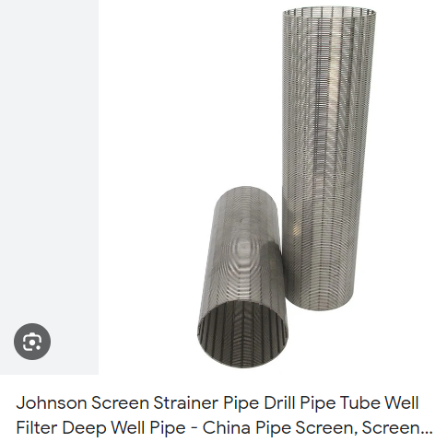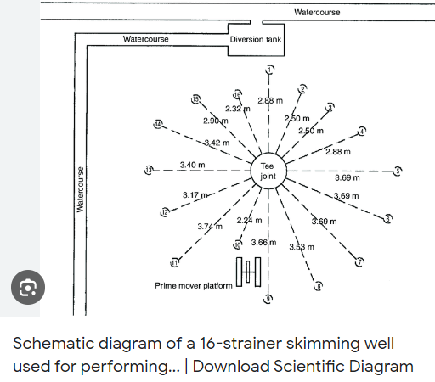

## 4.2 Why partial penetrating well has more drawdown?

A partial penetrating well typically experiences more drawdown than a fully penetrating well due to the way water is extracted from the aquifer. Here's an explanation of why this occurs:

**Limited Contact Area with Aquifer:** In a fully penetrating well, the screen or perforations that allow water to enter the wellbore extend throughout the entire depth of the aquifer. This means that water can flow into the well from a large portion of the aquifer's thickness. In contrast, a partial penetrating well only has screen or perforations in a limited depth range within the aquifer. As a result, it can only draw water from that specific section of the aquifer.

**Reduced Flow Path:** When a well has limited screen or perforated intervals, the flow path for water to enter the well is restricted to the section of the aquifer that intersects with the well's screened or perforated zone. Water from other parts of the aquifer cannot easily flow into the well. This restricted flow path leads to a localized drawdown effect.

**Cone of Depression:** When a well is pumping water, it creates a cone-shaped depression in the water table or potentiometric surface around the well. In the case of a partial penetrating well, this cone of depression is more pronounced because it affects only a specific depth range of the aquifer. Water from adjacent layers or sections of the aquifer cannot easily flow into the well, which leads to a greater drawdown in the screened or perforated zone.

**Limited Recharge:** In a fully penetrating well, water from a broad range of depths in the aquifer can recharge the well, which helps maintain a more stable water level. However, in a partial penetrating well, only water from the limited screened or perforated zone can contribute to well recharge. This limited recharge further exacerbates the drawdown effect.

In summary, a partial penetrating well has more drawdown because it can only access and draw water from a specific depth range within the aquifer, creating a localized cone of depression and limiting the overall flow of water into the well. This reduced flow and limited recharge result in a greater drawdown compared to a fully penetrating well, which can access water from a broader range of depths in the aquifer.

## 4.3 Two types of data-based approaches: Descriptive and predictive.

Data-based approaches are methods and techniques used in various fields to analyze, process, and make decisions based on data. There are many different types of data-based approaches, but two common categories are:

1. **Descriptive Data Analysis:**
   * Descriptive data analysis focuses on summarizing and presenting data in a meaningful way. It aims to provide insights into the past or current state of affairs. Common techniques and methods in this category include:
     + **Descriptive Statistics**: These statistics include measures like mean, median, mode, standard deviation, and percentiles. They help in summarizing and describing key characteristics of a dataset.
     + **Data Visualization**: Techniques such as bar charts, histograms, scatter plots, and heatmaps are used to represent data graphically, making it easier to understand patterns and trends.
     + **Summary Reports**: Creating reports that provide a concise and clear overview of data, often through tables, charts, and textual descriptions.
2. **Predictive Data Analysis:**
   * Predictive data analysis involves using historical data to make predictions about future events or trends. It's used in fields like machine learning and predictive analytics. Common methods and techniques in this category include:
     + **Machine Learning**: Algorithms and models are trained on historical data to make predictions or classifications. Common machine learning algorithms include linear regression, decision trees, support vector machines, and neural networks.
     + **Time Series Analysis**: This is used to analyze and predict data points that are collected over time, such as stock prices, weather data, or sales figures. Techniques like ARIMA (AutoRegressive Integrated Moving Average) and Exponential Smoothing are employed.
     + **Classification and Regression**: These are specific types of predictive modeling used to categorize or predict continuous values, respectively.
     + **Ensemble Methods**: Techniques that combine multiple models to improve predictive accuracy, such as Random Forests and Gradient Boosting.

These are just two broad categories of data-based approaches, and they can often overlap. For example, predictive data analysis often begins with descriptive data analysis to understand the dataset before building a predictive model. Additionally, there are other specialized data-based approaches, such as prescriptive analytics (which suggests actions to optimize outcomes) and diagnostic analytics (which aims to understand why something happened). The choice of approach depends on the specific problem and the goals of the analysis or decision-making process.

## 4.4 Physical process-based approach: Lumped model approach and distributed approach.

The lumped model approach and the distributed model approach are two different methods used in engineering and physics to analyze and describe physical systems. They are often applied to systems involving the transfer of mass, energy, or momentum. Each approach has its own set of assumptions and characteristics.

**Lumped Model Approach:**

The lumped model approach (also known as the lumped parameter model or lumped system analysis) is a simplified modelling technique that assumes a physical system can be represented as a single point or a small number of discrete components, often called lumped parameters or lumped elements. In this approach, the system is assumed to be spatially uniform, and variations within the system are negligible. Key characteristics of the lumped model approach include:

**Assumption of Uniformity:** The system is considered to be spatially homogeneous, meaning that the properties and conditions within the system do not vary significantly across its extent.

**Simplified Equations:** Differential equations describing the behavior of the system are often simplified to ordinary differential equations (ODEs). These equations describe how system parameters change with respect to time.

**Single-Point Representation:** The system is typically represented as a single point or a small number of discrete elements, such as electrical resistors or capacitors in an electrical circuit.

**Applicability:** Lumped models are suitable for systems where spatial variations and gradients are small and can be neglected. Examples include electrical circuits, simple thermal systems, and certain chemical reaction systems.

**Fast Computations:** Lumped models are computationally efficient and are often used for quick analysis and preliminary design.

**Distributed Model Approach:**

The distributed model approach (also known as the distributed parameter model or distributed system analysis) is a more complex modeling technique that considers the spatial distribution of properties and conditions within a system. In this approach, the system is divided into smaller, interconnected elements, and partial differential equations (PDEs) are used to describe the behavior of these elements. Key characteristics of the distributed model approach include:

**Spatial Variations:** This approach accounts for spatial variations in system properties, such as temperature, pressure, or concentration. Each element or region within the system is characterized by its own set of differential equations.

**Partial Differential Equations:** The governing equations are often partial differential equations (PDEs) that describe how system properties change with respect to both time and space.

**Complex Geometry:** Distributed models are suitable for systems with complex geometries and where spatial gradients are significant. Examples include heat conduction in solids, fluid flow in pipes, and wave propagation in continuous media.

**Detailed Analysis:** Distributed models provide a more detailed and accurate representation of the system's behavior but are computationally more intensive than lumped models.

**Fine-Grained Simulations:** These models are often used for detailed simulations, optimization, and understanding the behavior of complex systems.

In summary, the choice between lumped and distributed modeling approaches depends on the specific characteristics of the system being analyzed. Lumped models are suitable for systems with small spatial variations, while distributed models are necessary when spatial variations are significant and a higher level of detail is required for analysis.

## 4.5 stochastic and deterministic approach of determining permeability

Permeability is a measure of how easily a fluid can flow through a porous medium. It is a key property in many applications, such as oil and gas production, groundwater hydrology, and environmental engineering.

There are two main approaches to determining permeability: deterministic and stochastic.

Deterministic approaches assume that the pore structure of the medium is known and can be described by a set of equations. These equations can then be used to calculate the permeability. Deterministic approaches are often used for simple media with regular pore structures. However, they can be inaccurate for complex media with irregular pore structures.

Stochastic approaches do not assume that the pore structure is known. Instead, they use statistical methods to account for the uncertainty in the pore structure. This allows stochastic approaches to be more accurate for complex media. However, they are also more computationally expensive than deterministic approaches.

The following are some of the most common deterministic and stochastic approaches for determining permeability:

Deterministic approaches

* Darcy's law: This law states that the flow rate of a fluid through a porous medium is proportional to the pressure gradient and inversely proportional to the permeability.
* Kozeny-Carman equation: This equation relates the permeability to the pore size distribution and the porosity of the medium.
* Bundle-of-tubes model: This model treats the porous medium as a bundle of parallel tubes. The permeability is calculated based on the properties of the tubes.

Stochastic approaches

* Monte Carlo simulation: This method generates a large number of random pore structures and calculates the permeability for each structure. The average permeability of the generated structures is then used as an estimate of the true permeability.
* Finite element method: This method divides the porous medium into a mesh of small elements. The permeability is then calculated for each element and the results are combined to obtain an estimate of the overall permeability.

The choice of approach for determining permeability depends on the specific application and the available data. Deterministic approaches are often preferred for simple media with regular pore structures, while stochastic approaches are often preferred for complex media with irregular pore structures.

## 4.6 What will be the problem if sample size is much greater than representative elemental volume?

**Lack of Representative Data**: The whole concept of the REV is based on the assumption that properties or characteristics are homogenous within this volume. When the sample size is much larger than the REV, you are effectively averaging over a larger volume, which may contain variations that are not representative of the material as a whole. This can lead to inaccurate or misleading results.

**Loss of Microstructural Information: Materials often exhibit** microstructural variations at smaller length scales. When your sample size is much larger than the REV, you may miss important microstructural details, such as grain boundaries, inclusions, or defects, which could be critical for understanding material behavior.

**Increased Resource Requirements**: Collecting and testing a large sample size can be time-consuming and resource-intensive. If a smaller sample size is sufficient to obtain representative data, using a much larger sample size may be wasteful in terms of time, effort, and resources.

**Loss of Precision:** When dealing with large sample sizes, small variations in properties may become statistically significant but not practically meaningful. This can lead to an overemphasis on minor variations and detract from the overall understanding of the material's behavior.

## 4.7 Kriging interpolation method

Kriging, also known as Gaussian process regression or spatial interpolation, is a statistical interpolation method used in geostatistics and spatial analysis. It is particularly valuable for estimating values at unsampled locations based on observations made at sampled locations. Kriging is widely employed in various fields, including geology, environmental science, and engineering, to model spatial variability and make predictions at unobserved locations.

The key idea behind kriging is to estimate a spatial field of interest as a linear combination of the observed values within a neighborhood of the target location. The weights in this linear combination are determined through a statistical analysis of the spatial correlation or covariance between observations. Here's a basic overview of the kriging process:

1. **Data Collection:** You start with a set of observations (data points) at different locations in a spatial domain. These observations can be measurements of a variable such as soil contamination levels, temperature, or elevation.
2. **Variogram Analysis:** A variogram or semivariogram is a function that quantifies the spatial correlation or covariance between observations at different distances and directions. By analyzing the variogram, you can determine how closely data points are related as a function of distance.
3. **Variogram Modeling:** You fit a mathematical model to the variogram to describe the spatial correlation structure. Common models include exponential, spherical, and Gaussian variogram models.
4. **Kriging Estimation:** Kriging estimates the value at an unsampled location by considering a weighted average of nearby observed values. The weights are determined based on the variogram model and spatial relationships. This weighted average minimizes prediction errors and often provides an optimal estimate with minimum variance.

There are different types of kriging methods, including:

* **Ordinary Kriging (OK):** Assumes a constant mean for the variable being estimated and estimates both the mean and the spatial variability.
* **Simple Kriging:** Assumes a constant mean and estimates only the spatial variability.
* **Universal Kriging:** Accounts for a spatially varying mean, which can be modeled using a trend function.
* **Take into account categorical data:** Kriging can be extended to handle categorical variables or discrete data, not just continuous variables.

Kriging produces not only a prediction at unsampled locations but also an estimate of the prediction variance, which provides a measure of uncertainty associated with the prediction.

Kriging is a powerful tool for spatial interpolation, but it requires a good understanding of spatial statistics, especially variogram modeling, to be effectively applied. It's commonly used in fields like geology for mineral resource estimation, in environmental science for pollution mapping, and in many other applications where spatial predictions are required.

### Example:

let's go through a step-by-step example of Ordinary Kriging, which is one of the most common forms of kriging. In this example, we'll estimate groundwater contamination levels at an unsampled location within a contaminated site based on observed data.

**Step 1: Data Collection** Suppose we have collected groundwater contamination data at various monitoring wells within a contaminated site. The contamination levels are measured in parts per million (ppm). Here are the observed data points:

| **Well Location (x, y)** | **Contamination Level (ppm)** |
| --- | --- |
| (1, 2) | 30 |
| (3, 4) | 45 |
| (4, 1) | 20 |
| (2, 5) | 60 |

We want to estimate the contamination level at the location (3, 3), which is an unsampled location.

**Step 2: Variogram Analysis** To perform kriging, we need to calculate the variogram, which describes the spatial correlation between data points as a function of distance. For simplicity, let's assume we have already calculated the variogram model, and it follows an exponential model:

# 

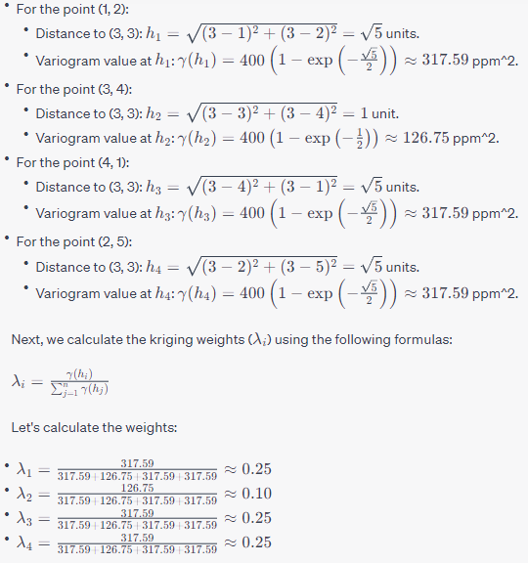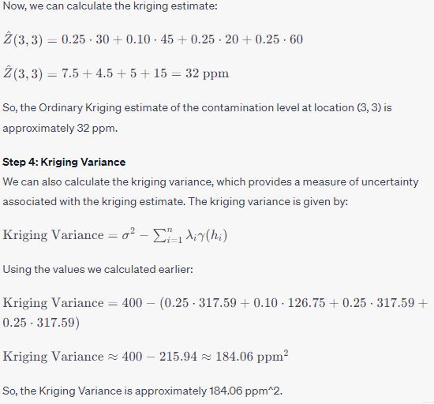

**Conclusion** In this example, we used Ordinary Kriging to estimate the groundwater contamination level at the unsampled location (3, 3) and calculated a Kriging Variance to assess the uncertainty of the estimate. Kriging is a powerful spatial interpolation method that takes into account both the spatial correlation structure of the data and the variability of the variable being estimated. It provides not only estimates but also measures of uncertainty, making it valuable for decision-making in various fields.

The unknown point should have close value to nearby known point. But, that’s not true here!!!!!!!!!!!!!!!!

## 4.8 Explain Dirac-Delta function.

5.Misc.

**5.1 EXPLAIN WHILE LOOP AND ITS DIFFERENCE WITH FOR LOOP**

In Matlab, a **while** loop is a control flow statement that allows a block of code to be executed repeatedly as long as a certain condition is true. The general syntax for a **while** loop is:

***while condition***

***% statements***

***End***

The **condition** is a logical expression that is evaluated at the beginning of each iteration of the loop. If it evaluates to **true**, the statements inside the loop are executed. This continues until the **condition** becomes **false**, at which point the loop terminates and program control moves to the next statement after the loop.

The main difference between a **while** loop and a **for** loop in Matlab is how they control the number of times a block of code is executed. In a **for** loop, a block of code is executed a fixed number of times based on a set of values that are specified beforehand. In contrast, a **while** loop allows a block of code to be executed as many times as needed until a certain condition is met.

Here is an example of a **while** loop that calculates the factorial of a given number:

*% Calculate the factorial of a number using a while loop*

*n = input('Enter a positive integer: ');*

*fact = 1;*

*i = 1;*

*while i <= n*

*fact = fact * i;*

*i = i + 1;*

*end*

*disp(['The factorial of ', num2str(n), ' is ', num2str(fact), '.']);*

n this example, the **while** loop iterates as long as **i** is less than or equal to the input **n**. Each time the loop executes, the value of **fact** is multiplied by the value of **i**, and the value of **i** is incremented by 1. This continues until **i** reaches the value of **n**, at which point the loop terminates.

**In summary, while both for and while loops can be used to repeat a block of code in Matlab, for loops are generally used when the number of iterations is known beforehand, while while loops are used when the number of iterations is not known and depends on some condition.**

**5.2 what is the guess value for a steady state problem?**

In a steady-state problem, the goal is to determine the distribution of hydraulic head (pressure) in the aquifer under a given set of conditions. Typically, this involves solving the groundwater flow equation using numerical methods, such as the finite difference or finite element method.

To start the numerical solution process, an initial guess value for the hydraulic head at each node in the computational grid is required. This guess value is used as a starting point for the numerical solution process, which iteratively adjusts the hydraulic head values until they converge to a solution that satisfies the governing equation.

The choice of initial guess value can affect the convergence rate and the quality of the solution obtained. In general, a reasonable guess value is one that is close to the expected or observed hydraulic head distribution based on the knowledge of the aquifer properties and boundary conditions. For example, if the aquifer is known to be sloping in a certain direction, the initial guess value should be higher in the upslope region and lower in the downslope region.

A common approach is to use a simple method such as the linear interpolation of known values or a constant value for the initial guess. However, in more complex problems, such as when the hydraulic conductivity varies spatially or there are significant heterogeneities in the aquifer properties, more sophisticated methods, such as the use of historical data or geostatistical techniques, may be needed to provide a reasonable initial guess value.

This portion is not required

**5.3 f = @(x) (x < 0) .* (-x) + (x >= 0) .* x; explain this.**

This is an anonymous function in MATLAB that takes a scalar or array input **x**, and returns a scalar or array output **y** that is the absolute value of **x**. The function achieves this by using logical indexing and the element-wise multiplication operation **.\***.

Specifically, the function is defined in two parts:

1. **(x < 0) .* (-x)** evaluates to **-x** for any element of **x** that is less than 0, and evaluates to 0 for any element of **x** that is greater than or equal to 0. This uses the less-than operator **<** to create a logical array that is 1 (true) where **x** is less than 0, and 0 (false) otherwise. The **.\*** operator then multiplies this logical array element-wise by **-x**, so that only the elements of **-x** corresponding to the true values in the logical array are non-zero.
2. **(x >= 0) .* x** evaluates to **x** for any element of **x** that is greater than or equal to 0, and evaluates to 0 for any element of **x** that is less than 0. This uses the greater-than-or-equal-to operator **>=** to create a logical array that is 1 (true) where **x** is greater than or equal to 0, and 0 (false) otherwise. The **.\*** operator then multiplies this logical array element-wise by **x**, so that only the elements of **x** corresponding to the true values in the logical array are non-zero.

The two parts are then added together, resulting in a function that returns the absolute value of **x** for any input.

**PLOT FOR discontinuous function (modulus function )**

% Define the function

f = (x < 0) .* (-x) + (x >= 0) .* x;

% Define the range of x values to plot

x = linspace(-5, 5, 1000)

% Plot the function

plot(x, f(x))

Top of Form

**5.4 what is the difference between IVP and IBVP?**

IVP and IBVP are types of initial value problems and boundary value problems, respectively, in the field of differential equations. The main difference between IVP and IBVP lies in the types of conditions that are imposed on the solution of the differential equation.

An Initial Value Problem (IVP) is a type of differential equation problem in which the value of the function and its derivative(s) are given at a specific initial point. In other words, an IVP provides a starting point for the solution of the differential equation. An example of an IVP is the following:

y' = 2y, y(0) = 1

where y' denotes the derivative of y with respect to x. Here, the value of y at x=0 is given, and the differential equation provides information about how y changes with respect to x.

On the other hand, a Boundary Value Problem (BVP) is a type of differential equation problem in which the solution is required to satisfy certain conditions at more than one point. An example of a BVP is the following:

y'' + y = 0, y(0) = 0, y(pi/2) = 1

Here, the solution of the differential equation must satisfy the conditions y(0) = 0 and y(pi/2) = 1. These are known as the boundary conditions.

An Initial Boundary Value Problem (IBVP) is a combination of IVP and BVP, where the differential equation is subject to both initial and boundary conditions. An example of an IBVP is the following:

y'' + y = 0, y(0) = 0, y'(pi) = 1

Here, the solution of the differential equation must satisfy both the initial condition y(0) = 0 and the boundary condition y'(pi) = 1.

In summary, the main difference between IVP and IBVP lies in the types of conditions that are imposed on the solution of the differential equation. IVPs have only initial conditions, while BVPs have only boundary conditions. IBVPs have both initial and boundary conditions.

**5.5 depth integrated mass and Momentum conservation equation for surface water flow**

The depth-integrated mass and momentum conservation equations for surface water flow are fundamental equations used in fluid mechanics to describe the behavior of shallow water flow over a flat bed. They are commonly used in the modeling and simulation of rivers, estuaries, and other open-channel flows.

The depth-averaged mass conservation equation for surface water flow can be expressed as follows:

∂(hu)/∂t + ∂(hu²)/∂x + ∂(huv)/∂y = 0

where h is the water depth, u and v are the horizontal and vertical velocities, respectively, and x and y are the horizontal and vertical coordinates, respectively. This equation states that the rate of change of the product of water depth and horizontal velocity with time is balanced by the horizontal and vertical fluxes of this product.

The depth-averaged momentum conservation equation for surface water flow can be expressed as follows:

∂(hu)/∂t + ∂(hu²+p)/∂x + ∂(huv)/∂y = gh∂h/∂x + Fx

∂(hv)/∂t + ∂(huv)/∂x + ∂(hv²+p)/∂y = gh∂h/∂y + Fy

where p is the hydrostatic pressure, g is the gravitational acceleration, and Fx and Fy are the external forces acting on the flow in the x and y directions, respectively. These equations describe the balance between the time rate of change of momentum and the sum of the external forces acting on the flow.

Overall, these equations form a system of partial differential equations that can be solved numerically using computational methods such as finite difference, finite volume, or finite element methods to simulate and analyze surface water flow.

∂(hu²)/∂x + ∂(huv)/∂y meaning of these two terms

The terms ∂(hu²)/∂x and ∂(huv)/∂y are components of the depth-averaged momentum conservation equation for surface water flow. They represent the fluxes of horizontal momentum in the x and y directions, respectively.

The term ∂(hu²)/∂x represents the flux of horizontal momentum in the x-direction due to the transport of the product of water depth h and the square of the horizontal velocity u. This term is commonly referred to as the advection term, as it describes the transport of momentum by the flow. The advection term is positive when the horizontal velocity u increases in the positive x-direction, and negative when u decreases in the positive x-direction.

The term ∂(huv)/∂y represents the flux of horizontal momentum in the y-direction due to the transport of the product of water depth h and the horizontal velocity v. This term is also an advection term, as it describes the transport of momentum by the flow. The advection term is positive when the horizontal velocity v increases in the positive y-direction, and negative when v decreases in the positive y-direction.

Overall, these two terms represent the horizontal transport of momentum by the flow, which is an important component of the momentum conservation equation for surface water flow.

**5.6 flux of horizontal momentum**

The flux of horizontal momentum refers to the transport of horizontal momentum by the flow in a given direction. In fluid mechanics, momentum is a physical quantity that describes the motion of an object, and it is defined as the product of mass and velocity. In the case of surface water flow, momentum is conserved in the horizontal direction, and the flux of momentum in a given direction is defined as the product of the momentum and the velocity in that direction.

The flux of horizontal momentum is a key component of the depth-averaged momentum conservation equation for surface water flow. This equation describes the balance between the time rate of change of momentum and the sum of the external forces acting on the flow, as well as the horizontal and vertical fluxes of momentum in the x and y directions. The horizontal flux of momentum is commonly referred to as the advection term, as it describes the transport of momentum by the flow.

In the case of the advection term ∂(hu²)/∂x, for example, the flux of horizontal momentum in the x-direction is given by the product of the water depth h and the square of the horizontal velocity u in that direction. This term describes the transport of momentum by the flow in the x-direction, and it can be positive or negative depending on the direction of the horizontal velocity.

Overall, the flux of horizontal momentum is an important concept in fluid mechanics and is essential for understanding the behavior of surface water flow and other types of open-channel flows.