Xmgrace

Lecture 1
Open xmgrace from command line by typing ‘xmgrace’ in terminal.

To open a file:
Data > import >Ascii
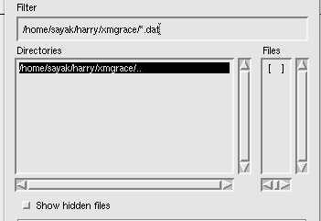

Delete this .dat to search for all kind of file.
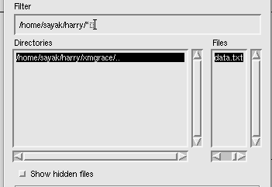

To open data directly with the command line,
xmgrace -nxy data.txt

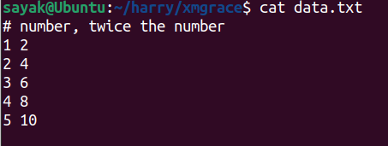

Reads data of 1st column as x axis, 2nd , 3rd, 4th etc columns as y axis.
Below is the first apparence.
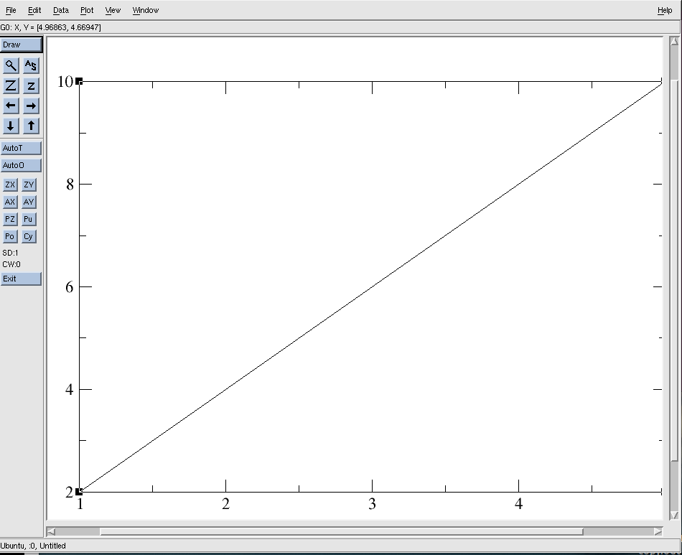

Plot > set apparence >main> symbol properties (circle) > apply > accept
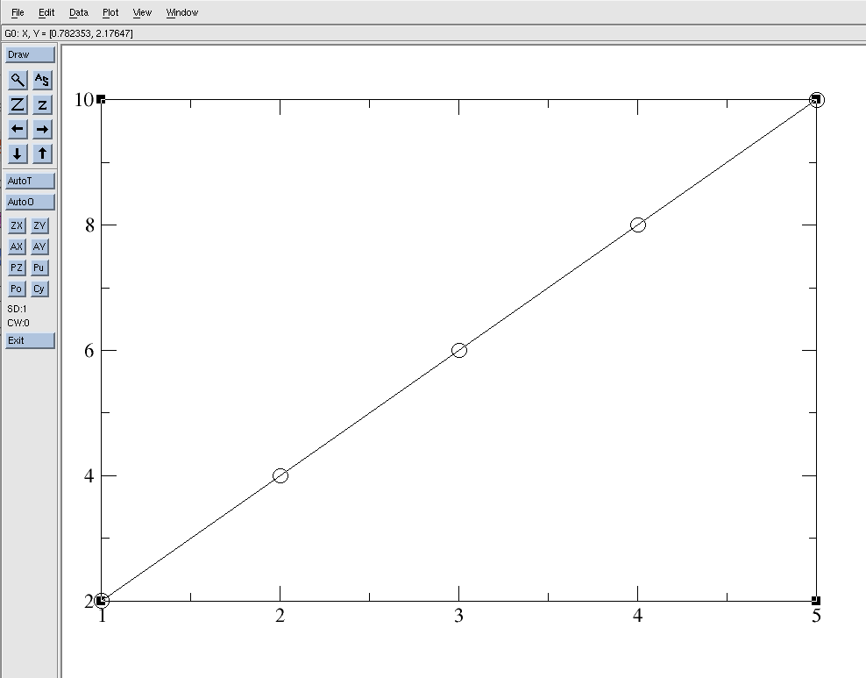

To change the range of the axes:
plot >axis properties
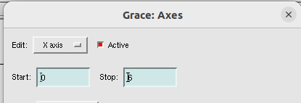

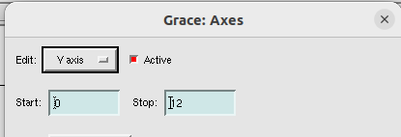

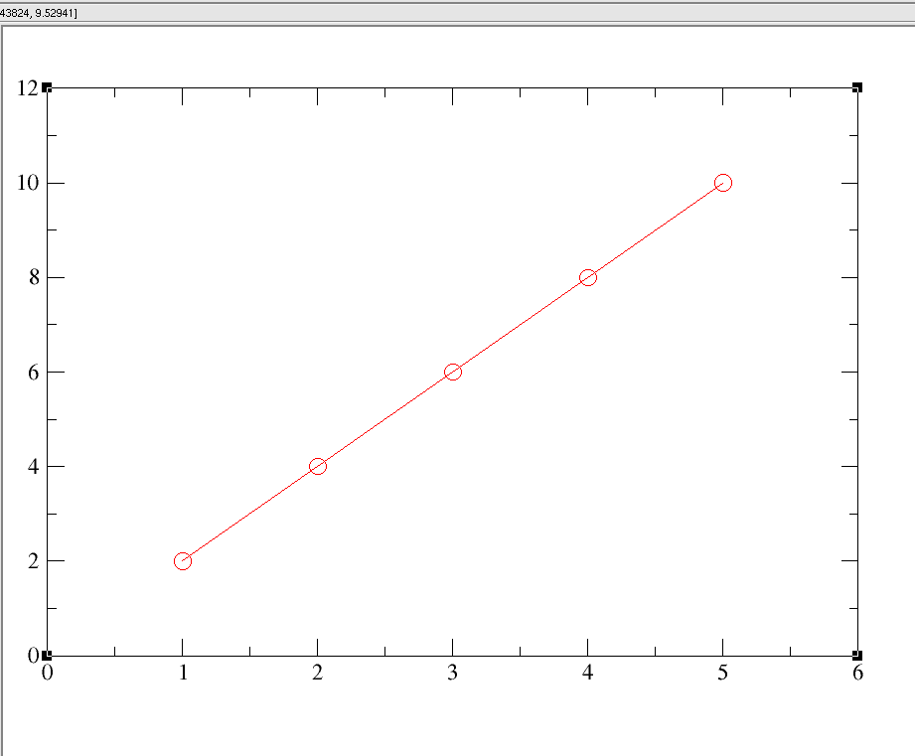

Label the axes:
plot >axis properties> main
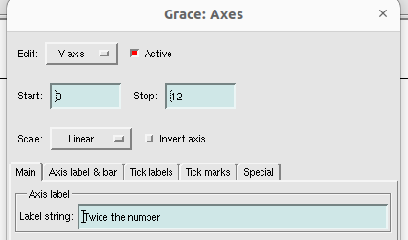

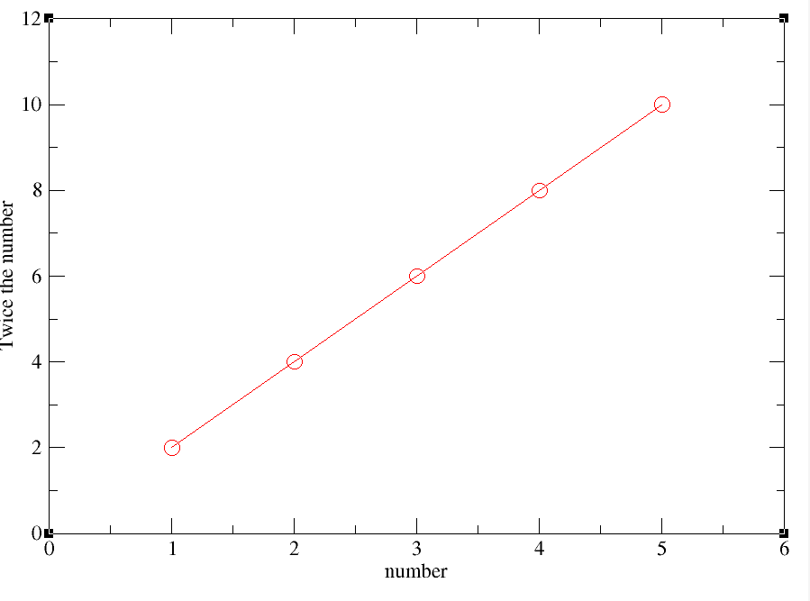

save the file:
File > save as
xmgrace files are stored as standard .agr file format , which we can edit in xmgrace software.
Under ‘selection’ option, you have the directory path from where you opened xmgrace in the terminal. Name the file( here, line_plot.agr). Click ok.
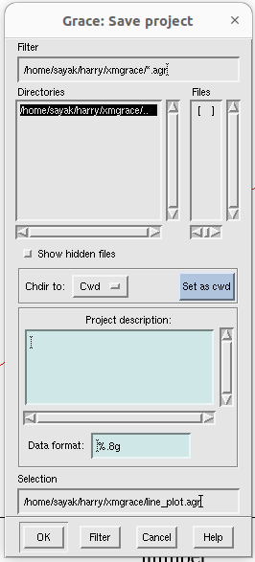

This agr file format is editable. If you want some common format, like png, jpg, pdf:
file > print setup> Device(pdf/png) , size (custom), set resolution(dpi) of the image. Then, again go to file> print. Now, saving is done.
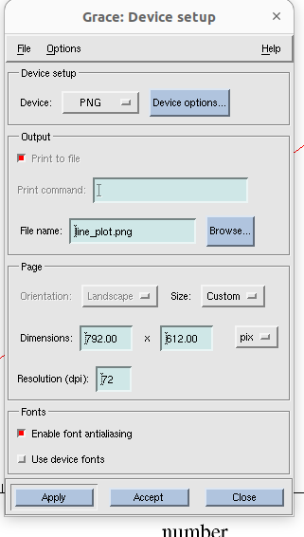

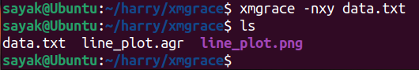

Lecture 2

Changing frame width
Open the previous file with xmgrace line_plot.agr command in terminal.
Plot> graph appearance > titles> fonts(Helvetica bold)
Plot> graph appearance >Frame> Frame type(closed), width(3)> apply> accept.

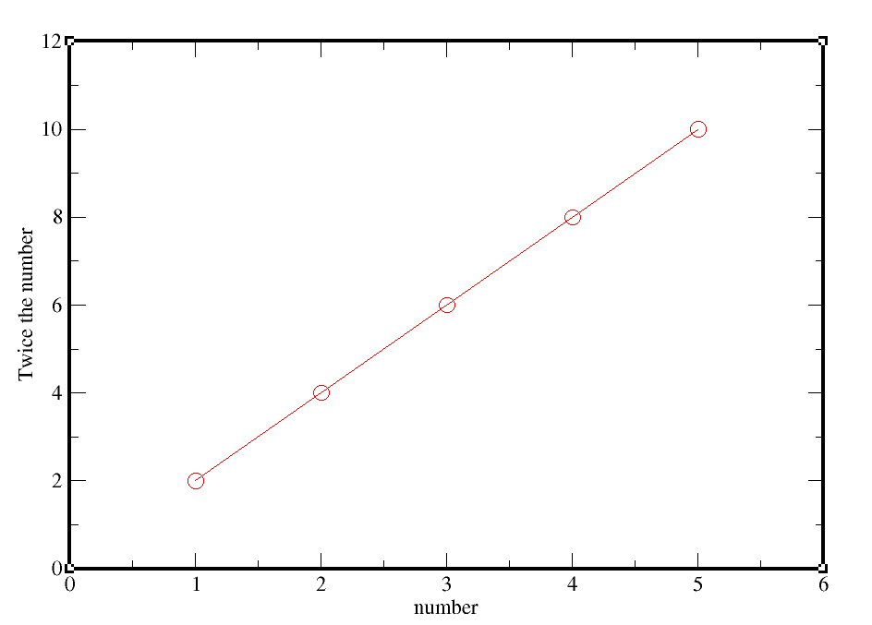
Now if you want to save the changes to that already saved file, go to file>save.

Changing tick properties:
Plot>axis properties >x axis > main> Tick properties(major spacing=0.5), Tick level properties(font: Helvetica-Bold)> apply
Plot>axis properties >x axis >tick labels> char size(100), Angle (30)> apply> accept.
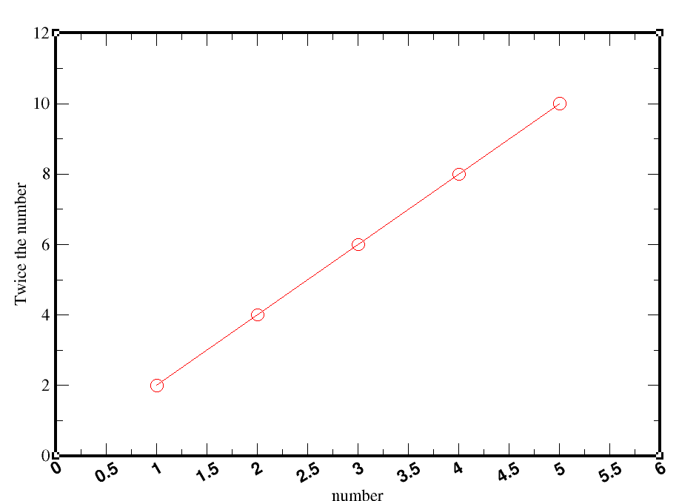

Changing axis label size:
Plot>axis properties >x axis / y axis >axis label and bar>

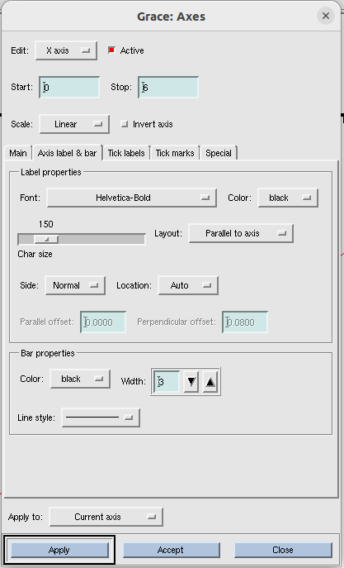

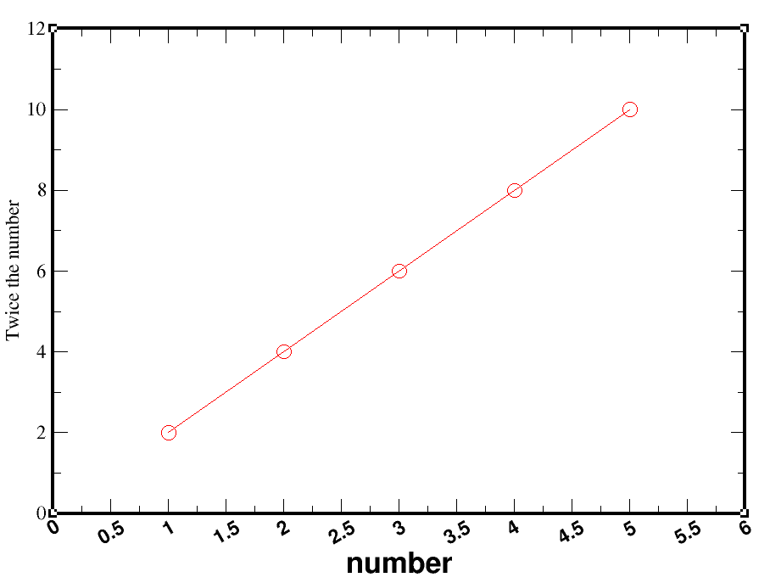

label of x axis (i.e ‘number’) has been changed to larger and bold. Tick labels also became larger and angled.

To move the axis ticks outside:
Plot>axis properties >x axis >tick marks
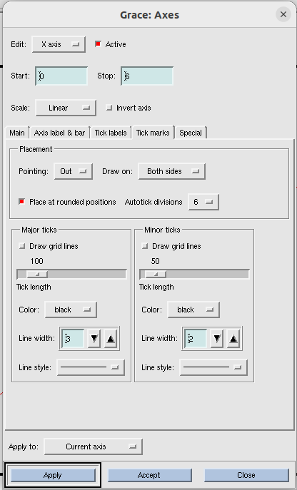
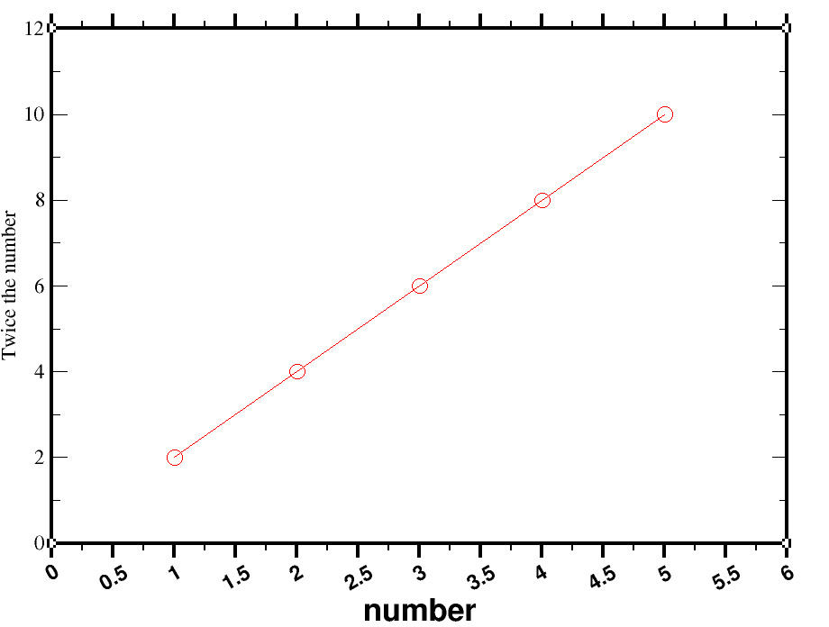

See tick marks of x axis went outside the box and it became bold. But it is not necessary to do.

Changing size of symbols ( i.e points on graph):
Enlarge size of the symbols(we choose circle):
Plot> set appearance > main > symbol properties> size(300)
Enlarge width
Plot> set appearance > symbols> symbol outline> width(3)
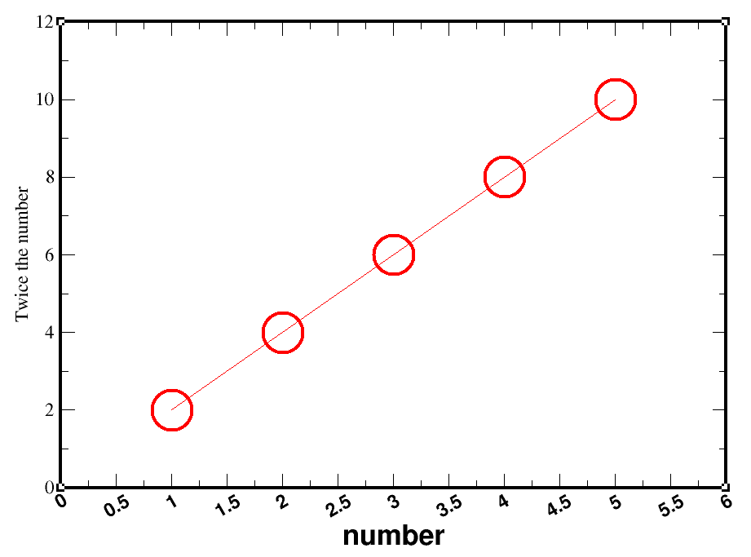

Changing line of graph:
Plot> set appearance >main> line properties> width(3), color(black)
Plot> set appearance >symbols > symbol fill> color(red), pattern(..)
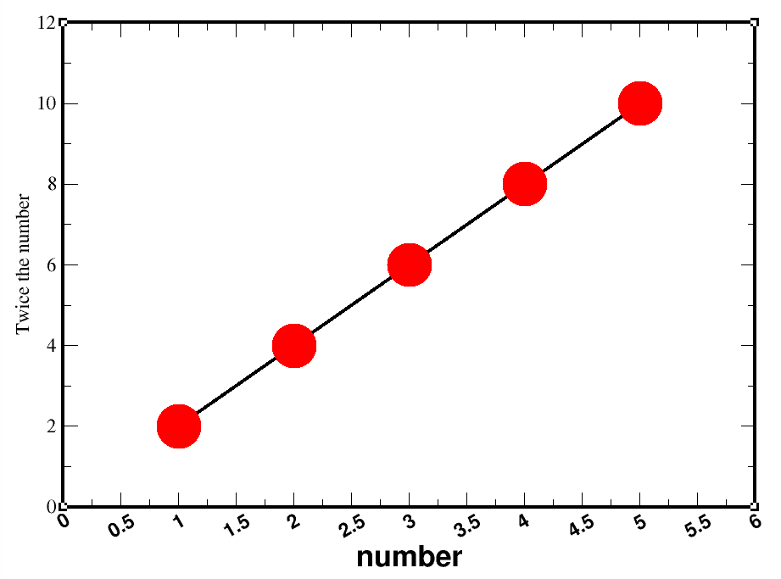

cleaning out white spaces
Edit > arrange graphs > page offsets (change the amount of whitespace in left, right, top and bottom).
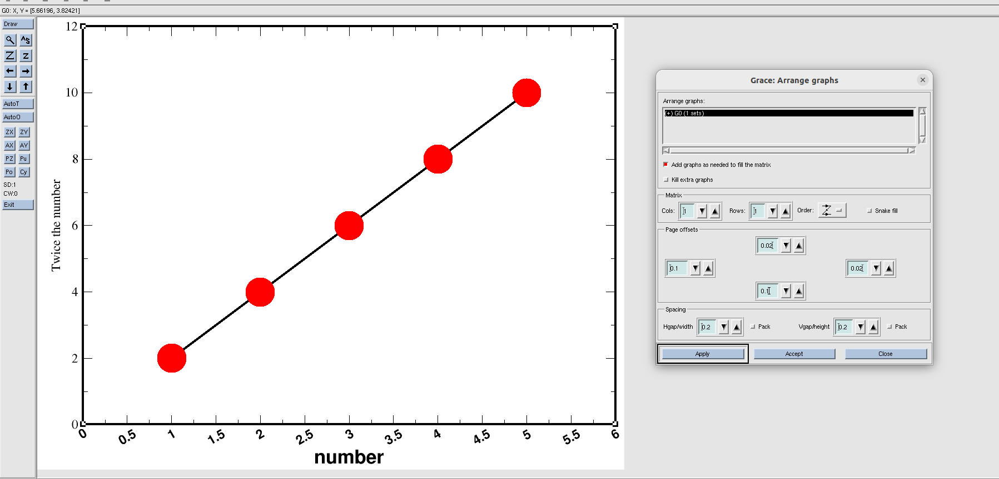

Lecture 3

How to make multiple plots in a single paper?
Type xmgrace -nxy data.txt in the terminal.
Now, one plot occupies entire window. But we want to accomodate 4 plots here.

Shifting 1st graph to top left:
Edit> arrange graph> page offsets(top=0.05, bottom=0.6, left=0.1, right =0.7)
Always note this page offsets values for future references. Because next time when you open the graphs, you cant see those again.

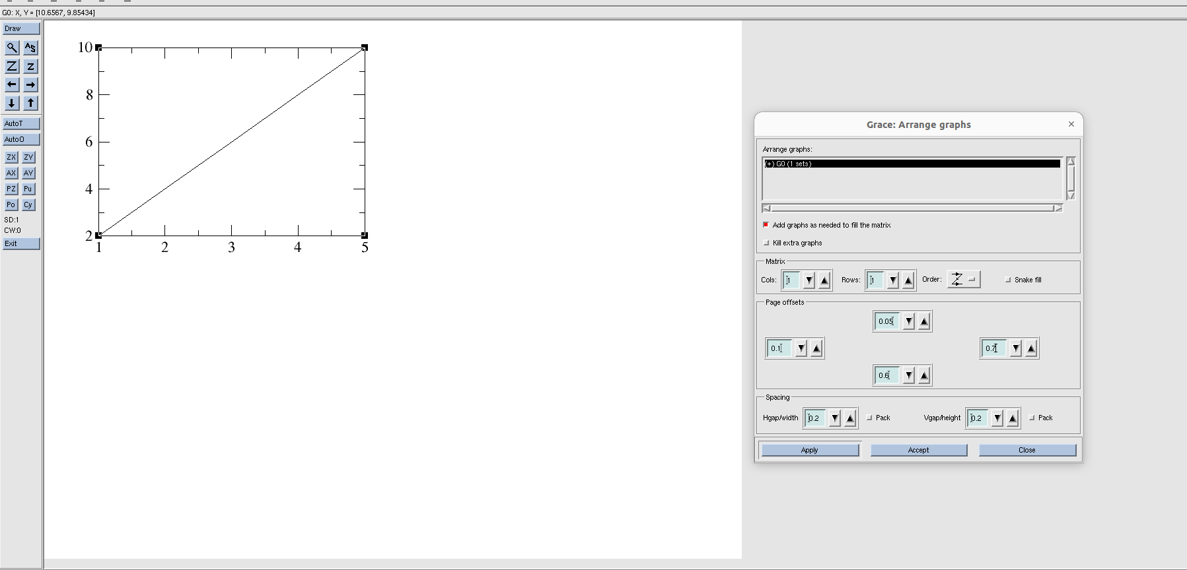
Plot 2nd graph:
Data> import >ascii> delete *.dat from filter and press enter> select 2_data.txt > right click on ‘read to graph’ > create new > click ‘ok’.(while clicking ‘ok’ 2_data.txt and (+)G1( 0 sets) both should be clicked ).
Make sure that 2_data.txt and (+)G1 (0 sets) are selected before clicking ‘ok’. Otherwise, line of the graph will not be visible. Now it looks like below:
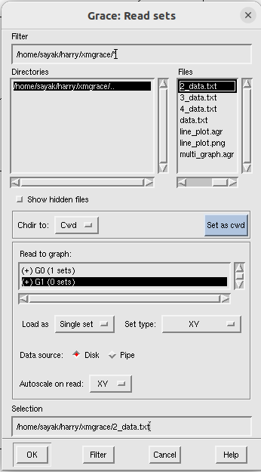

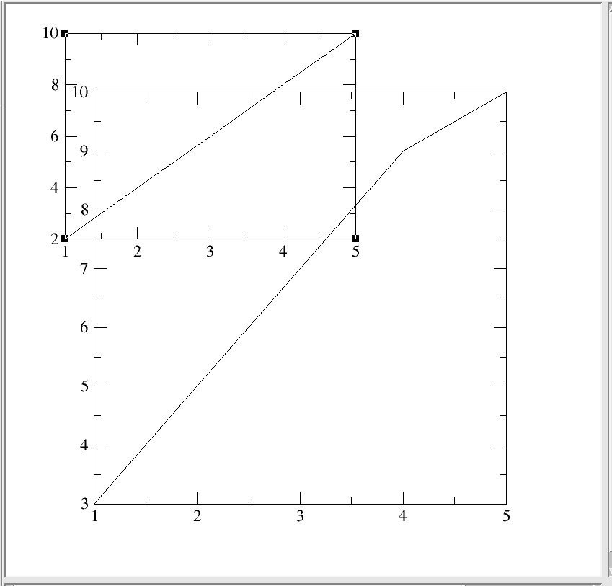

put the 2nd graph in bottom left corner.
Edit> arrange graph> page offsets(top=0.55, bottom=0.1, left=0.1, right =0.7)
Make sure (+) G1 (1 sets) is selected while changing page offsets.

Plot the 3rd graph at top right corner:
Data> import >ascii> delete *.dat from filter and press enter> select 3_data.txt > right click on ‘read to graph’ > create new > click ‘ok’(while clicking ‘ok’ 3_data.txt and (+)G2( 0 sets) both should be clicked ).
Edit> arrange graph> page offsets(top=0.05, bottom=0.6, left=0.76, right =0.04) > apply>accept.
Make sure (+) G2 (1 sets) is selected while changing page offsets.

Plot the 4th graph at top right corner:
Data> import >ascii> delete *.dat from filter and press enter> select 4_data.txt > right click on ‘read to graph’ > create new > click ‘ok’.(while clicking ‘ok’ 4_data.txt and (+)G3( 0 sets) both should be clicked ).
Edit> arrange graph> page offsets(top=0.55, bottom=0.1, left=0.76, right =0.04) > apply>accept.
Make sure (+) G3 (1 sets) is selected while changing page offsets.
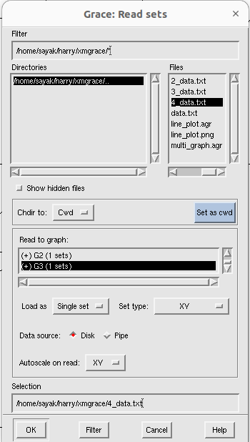

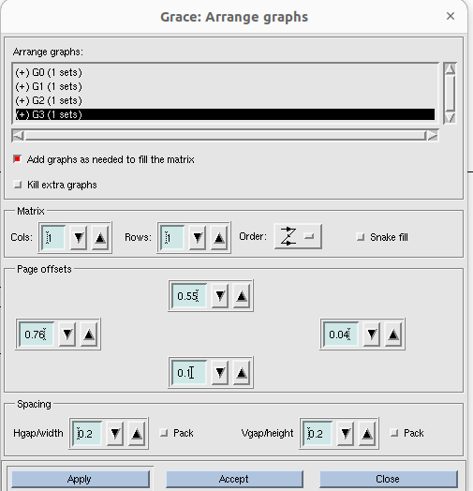
Now , finally it looks like below:
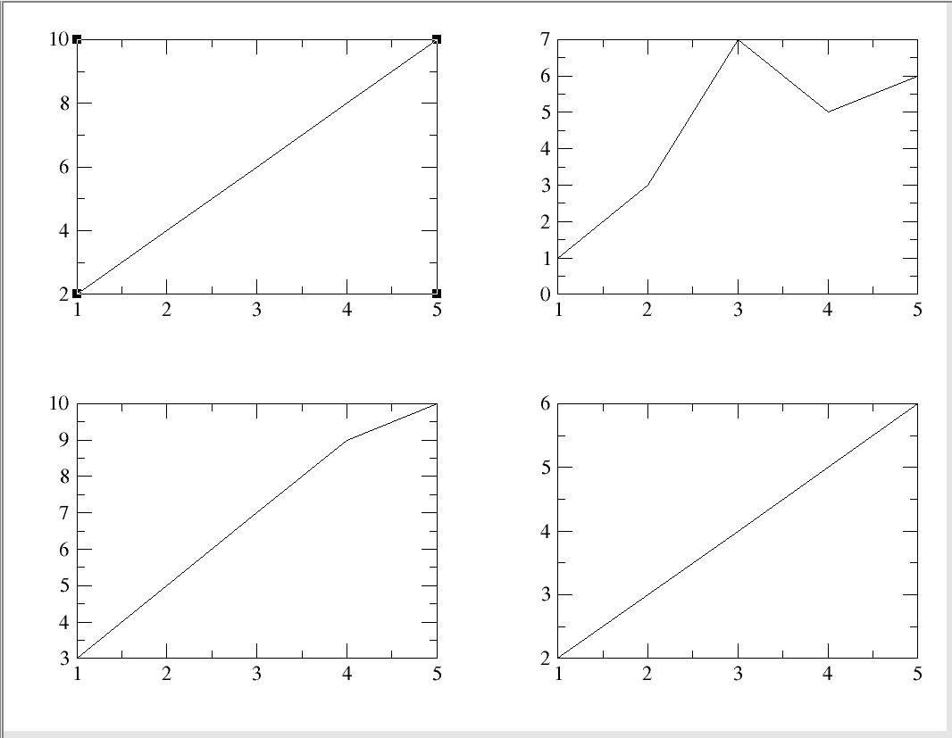
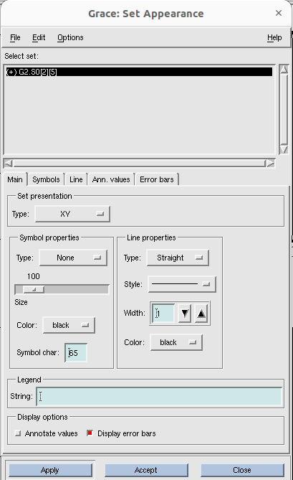
Now you can change the axis properties for each graph. To select the graph, whose axis property you want to change, go plot> graph apperaance and select the graph. Lets select 2nd graph (i.e G1):
Double click on the graph and the graph automatically got selected.

Now, go to plot > axis properties, and do all the changes that you want.
S now it looks like:
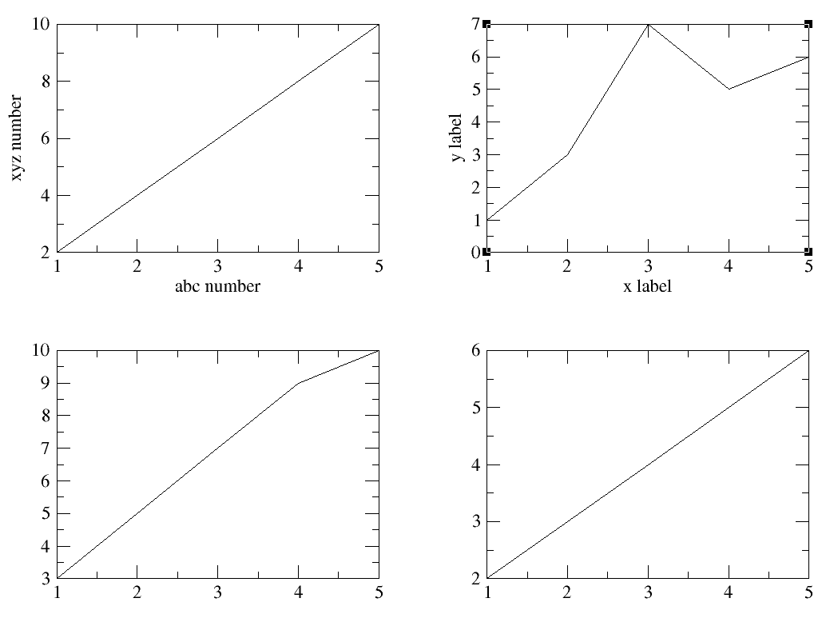

How to remove a particular tick level only:
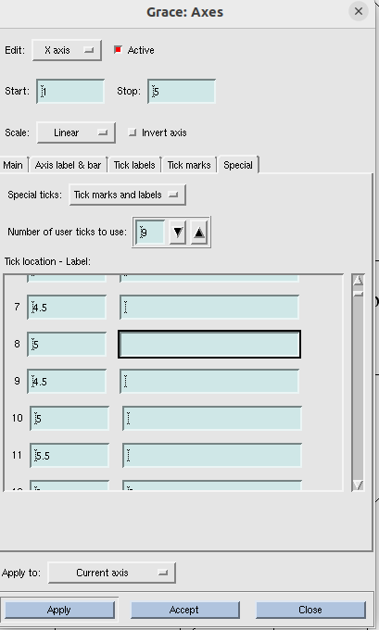
Plot > axis properties > special > special ticks (tick marks and labels), Tick location-label (make the box corresponding to that location blank)> apply> accept.

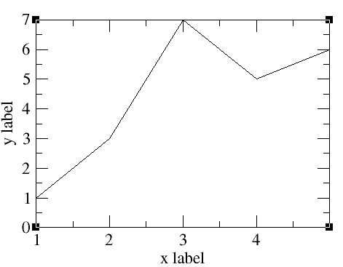

So, here we removed tick ‘5’ from the x axis.
To exit xmgrace, you can click file > exit and return to terminal.
Margins for multigraphs are sorted below:
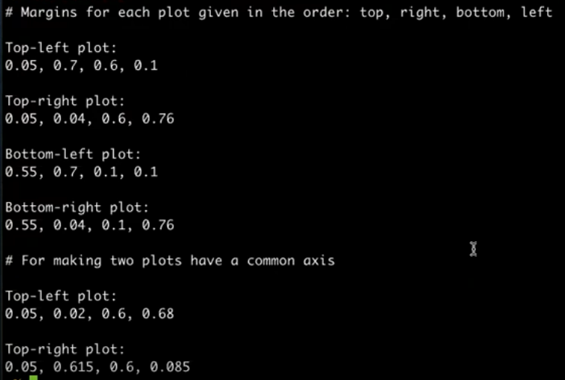

Lecture 4: Bar plots
Here is the text file that we need for the bar plots:
apple appricot, berries, melon, banana
Serial number of fruits, number of people who like them
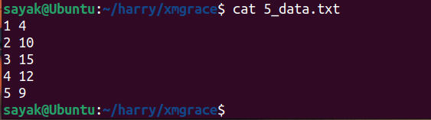
After writting xmgrace -nxy 5_data.txt in terminal, this is how it looks like:
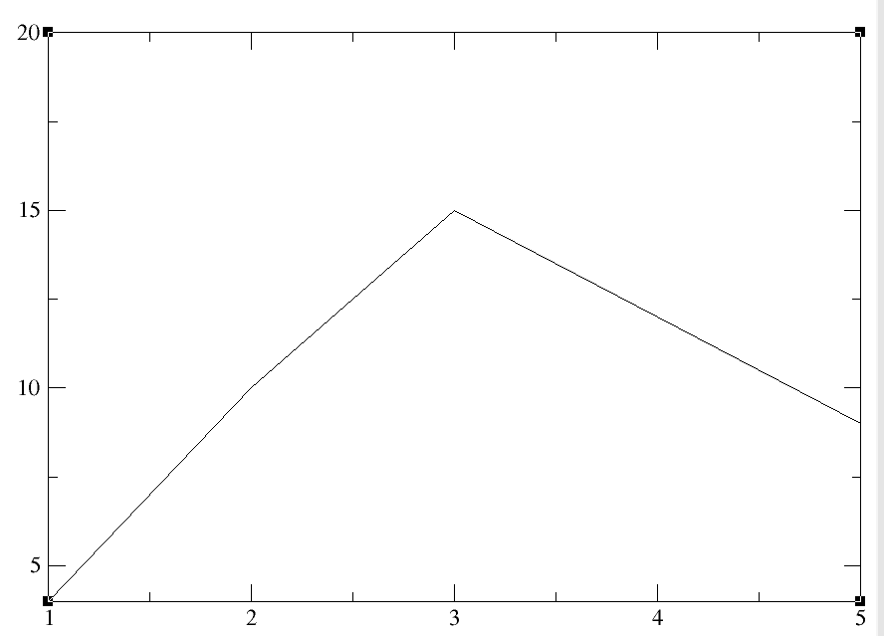

Here, y axis starts from 4 and x axis from 1. We should change it first. Go to plot > axis properties> x axis (Start 0, stop 6); yaxis (Start 0, stop 16).
Now:
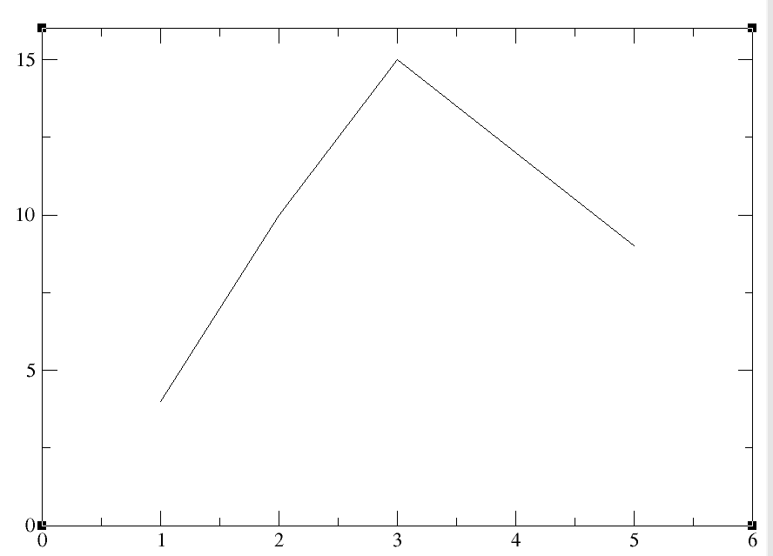

Now we will plot bar graph and delete line graph:
plot > set appearance >main> set presentation > type: BAR
plot > set appearance >main> line properties> None
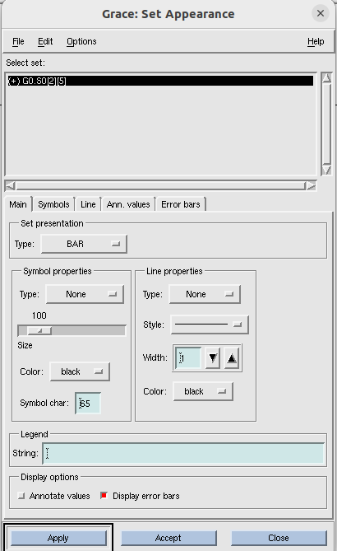
Now:
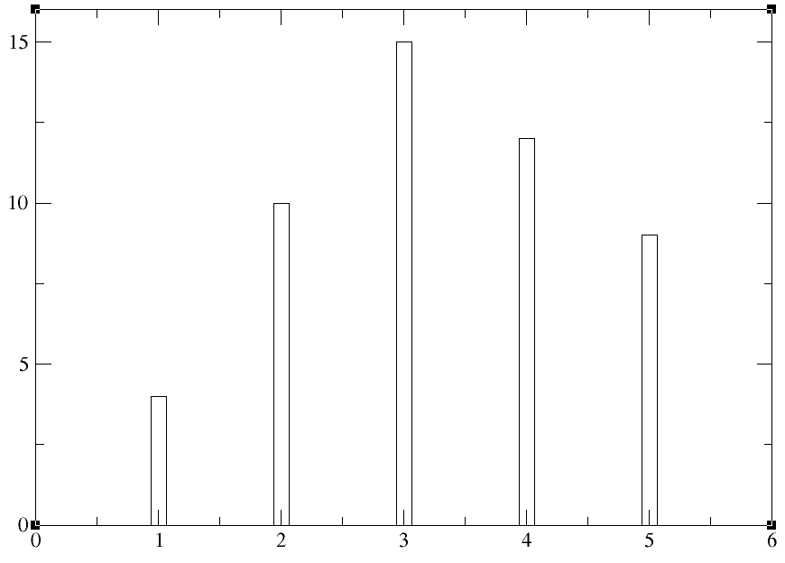

To change the bar width
plot > set appearance > main > symbol properties > size(300), type(none).
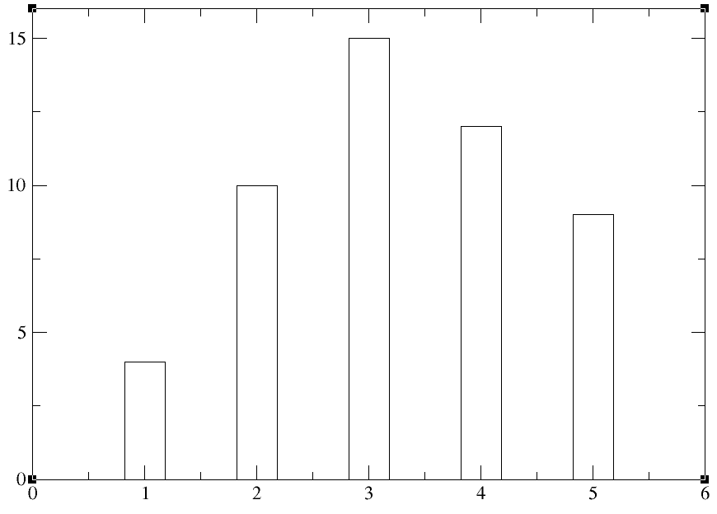

Here, we are representing data wrt some fruits name. So minor ticks do not make any sense. Lets delete them.
Plot > axis properties > x axis > special> special ticks (select: tick marks and labels), tick location-label ( do customize the tick locations and labels), number of ticks to use(5).
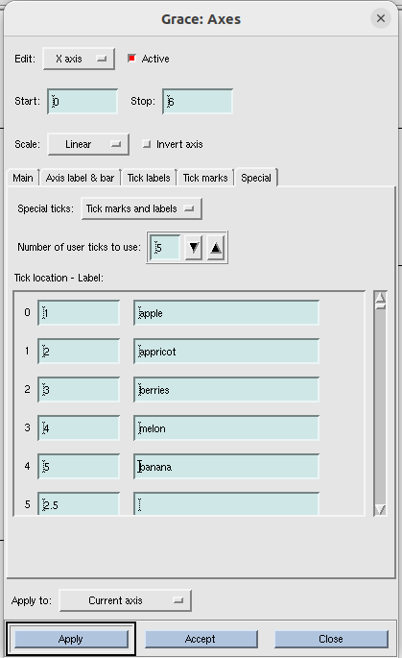

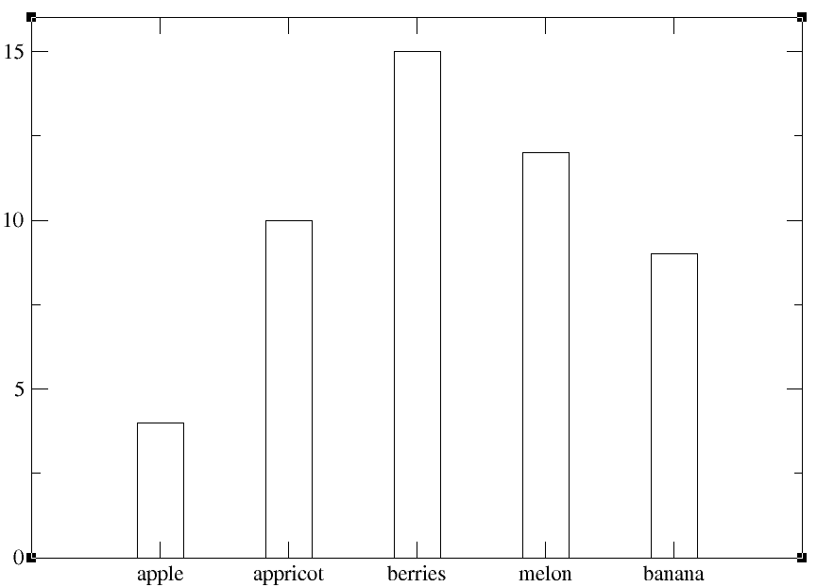

plot > axis properties > then do different things that you learnt previously.
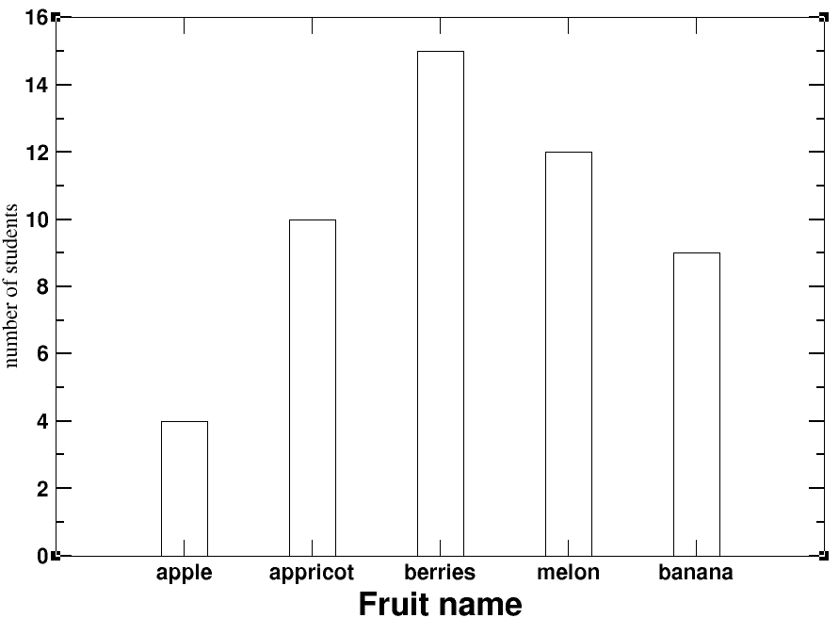
To make bars look beautiful,
plot> set appearance > symbols > symbol outline> width (3);
plot> set appearance > symbols > symbol fill> change color and pattern.

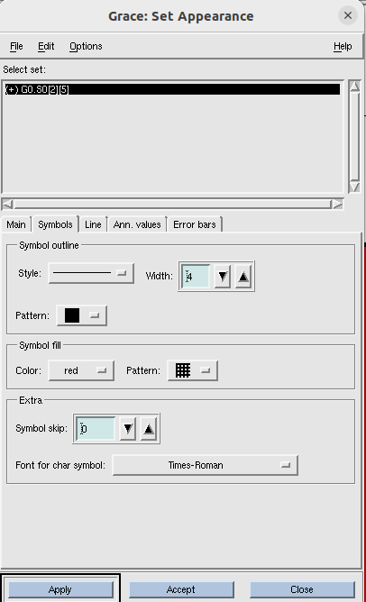

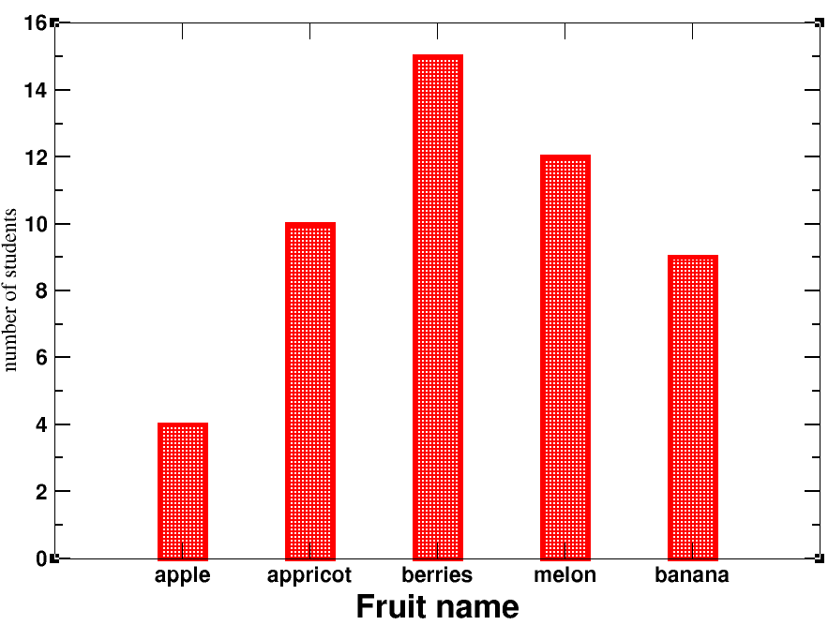
Save the file from file > save as in editable *.agr format.
Then from file > print setup, to save in pdf/ jpeg/ png format. Finally , file > print.

Lecture 5- Customize structure of each bar
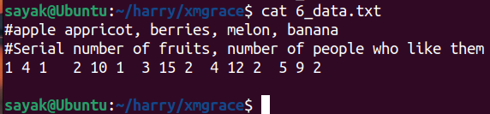
We want to import data column by column. So, we want to import blocks of data seperately. Here each bar will be a seperate graph. So we should have 5 different graphs. Then superimpose each other to get 1 graph.
For each block, first column denotes the index for fruits, 2nd column for no of students, third column represents error bar.
So this will be a bar graph with error bars on it. Lets start.

Write xmgrace in command line and open it.
Plot > graph appearance > main > presentation >type (xy chart) > accept
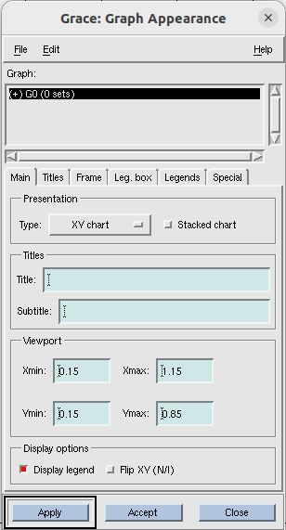
Now import data:
Data> import >ascii> delete *.dat from filter and press enter> select 6_data.txt ; Load as (block data) > click ok.
then another dialogue box comes named as ‘edit block data’.
Set type (BARDY) ; x from column(1); y from column(2); Y1 from column(3) > click accept.
#{ BARDY is used to load the error bars. Column 1 corresponds to apple, 2 for no of students, 3 for error}.

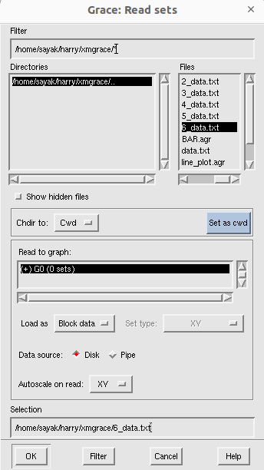
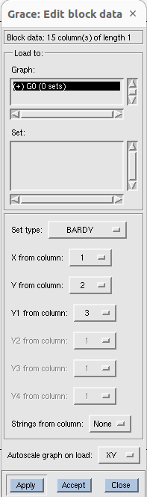

Now you have this:
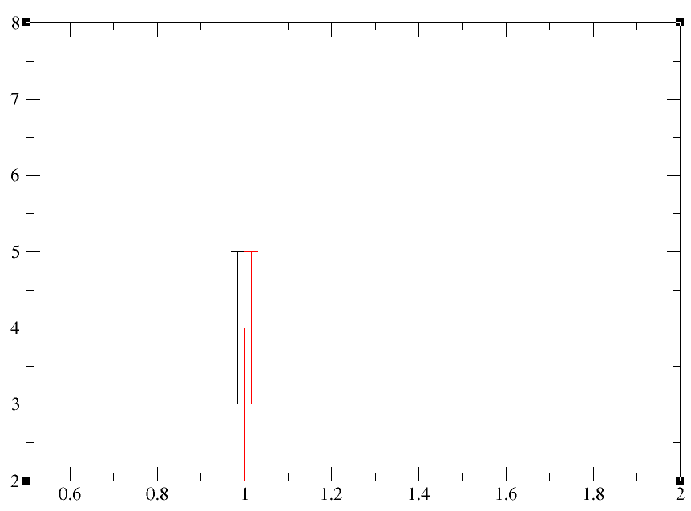

Now, we need to do this things for 4 different times. Before that, follow this below mentioned way:
edit > arrange graphs > matrix > cols(1); rows(5) > accept
#{ column1 and row 5 means five different graphs in one column.}
Now:
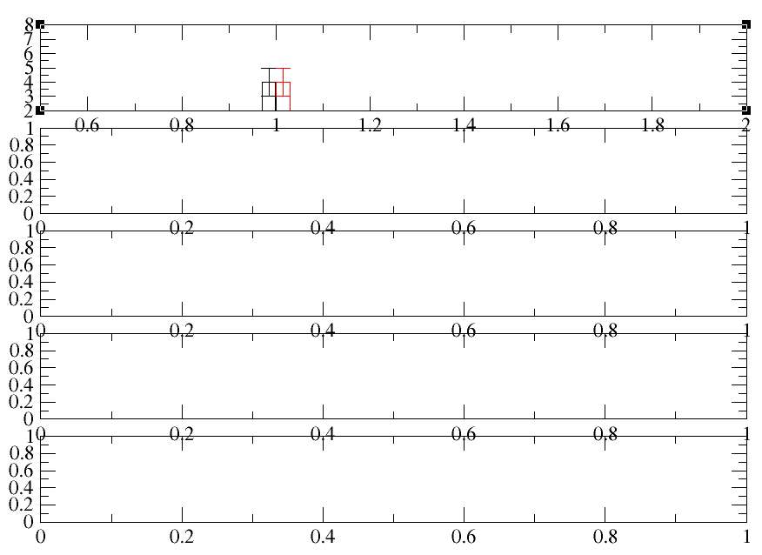

You can see 1st bar graph is the top one here. For the below 4 graphs, you can see default axis ranges. These are for empty graph actually. Now we will import 4 different blocks of data one in each of the graphs here.
Data > import > ascii > Files(6_data.txt); Read to graph(G1 0sets); load as (Block data) > click ok.
Now another dialogue box comes.
Set type (BARDY) ; x from column(4); y from column(5); Y1 from column(6) > click accept.
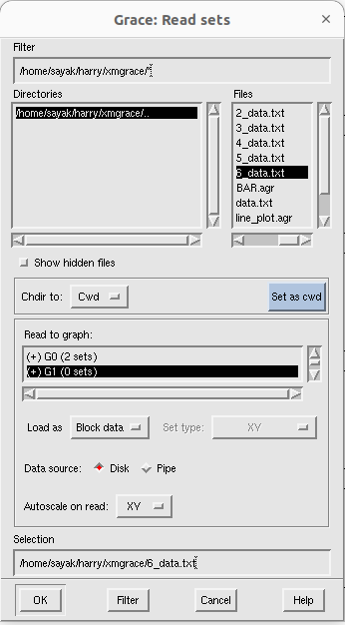
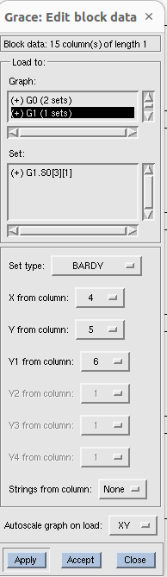
Now, it looks like below:

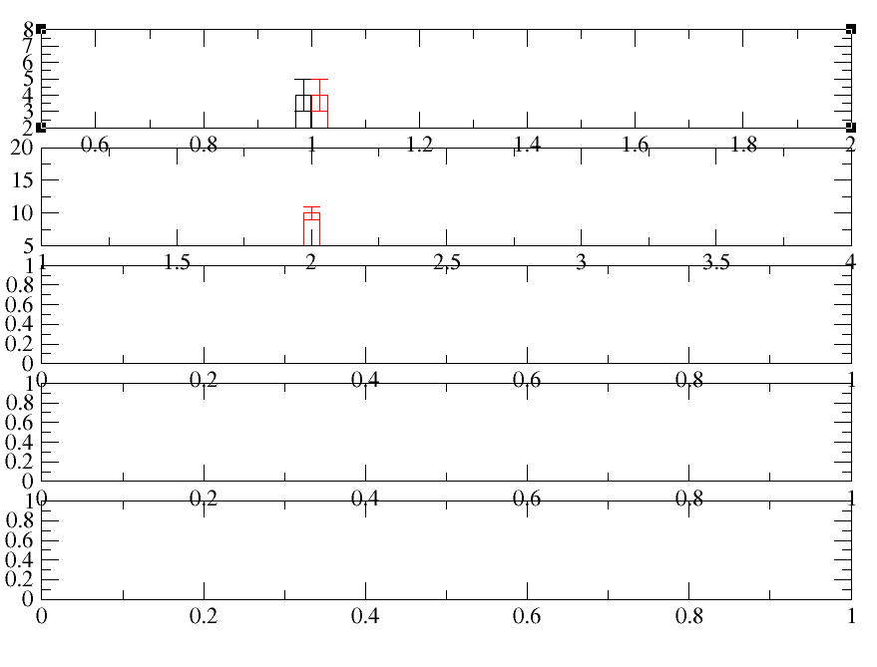
So, now we have 2 different bar plots.(I.T=> for 1st plot data got plotted for two times mistakenly).
# Now, do the similar process for plotting 3rd , 4th, 5th bars. Then:
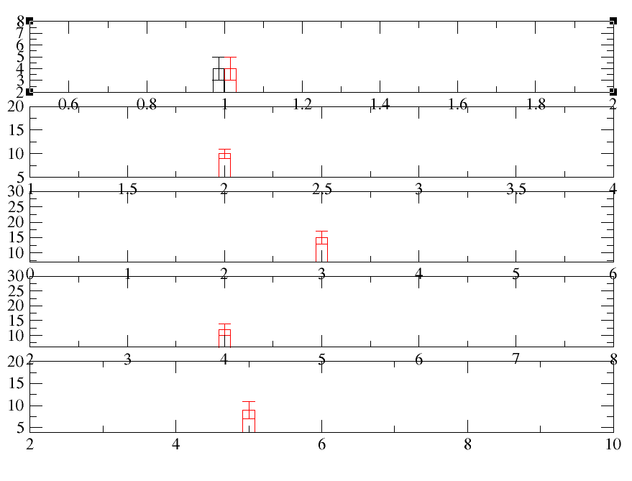
Now, before overlapping the graphs, we need to ensure that those have same axis ranges.

plot > axis properties >x axis > start(0.5); stop (5.5); major spacing (1); apply to(current axis, all graphs).
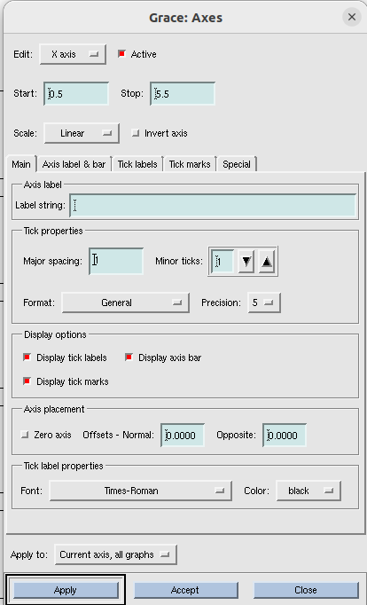

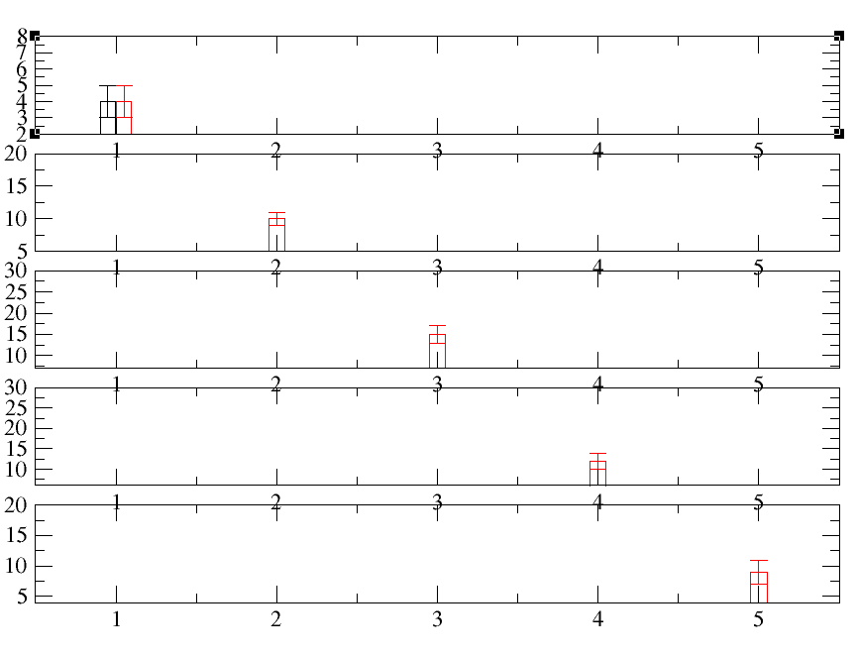

Now apply some changes in ticks, fonts and axes as per tutorial 2.
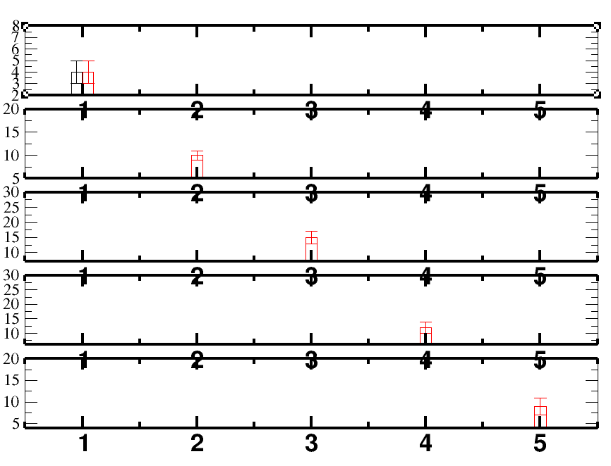

Showingtick labels in every bars is not necessary.
Go to x axis> Uncheck the display options > click apply.
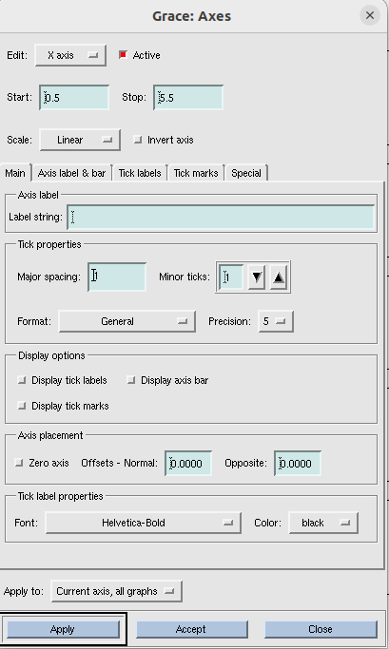

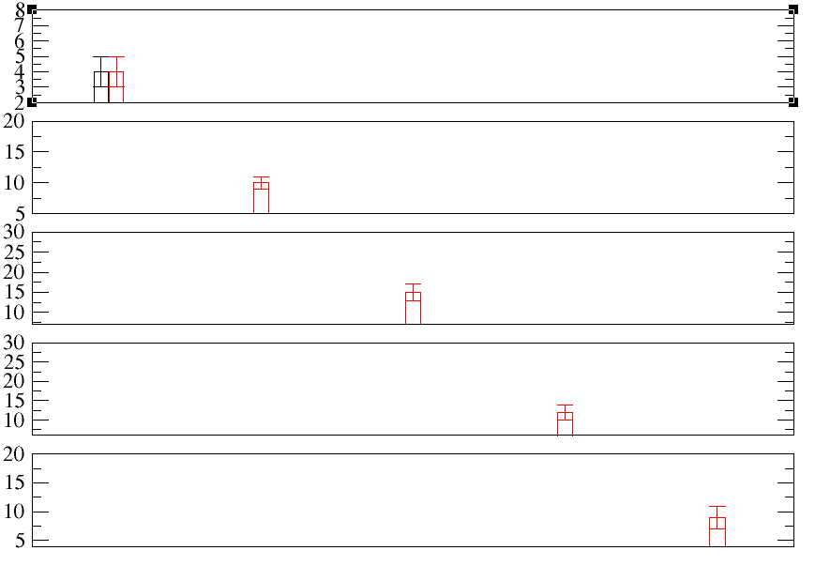
All tick marks gone because you did it for ‘ Apply to : current axis all graphs’. If you want to show tick marks for only one graph, re-check the display options and do “Apply to : Current axis”.
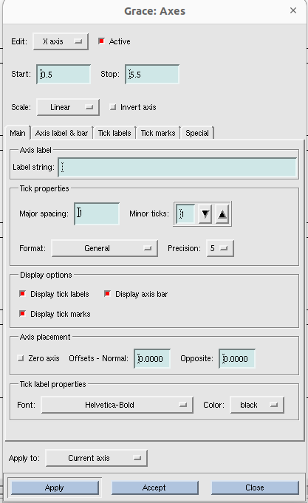
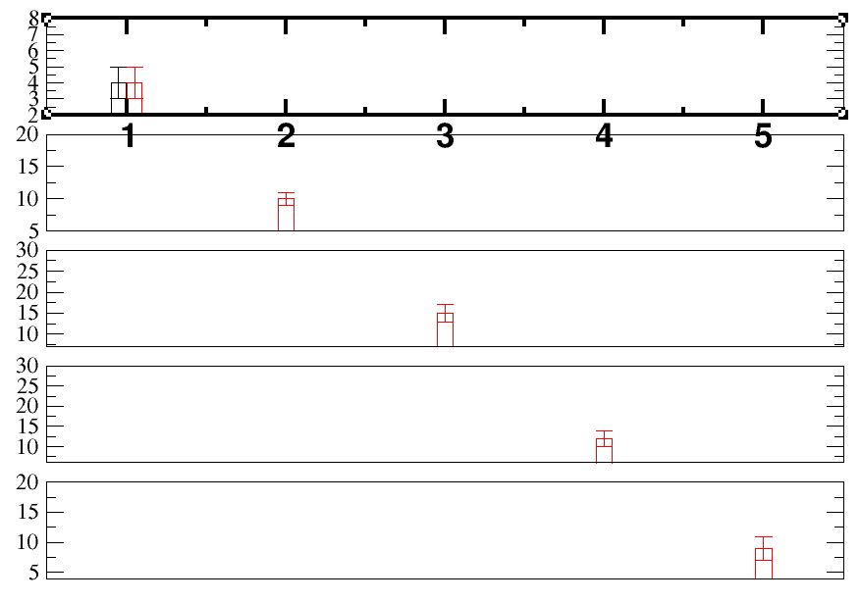

Now, go to : plot > axis properties >x axis > special and do the followings:
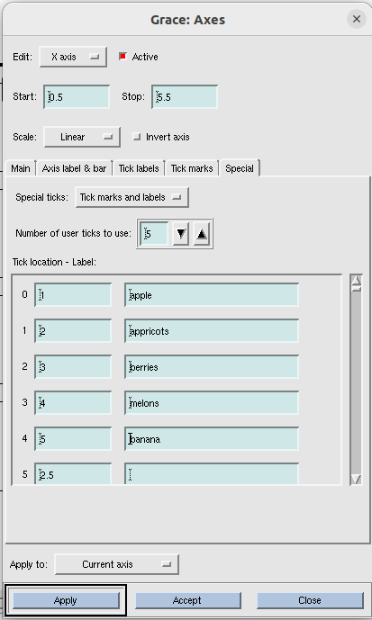
Now go to : plot > axis properties >y axis > start (0); stop (18);
plot > axis properties >y axis > main/ axis label and bars/ tick labels/tick marks > do different changes as your wish > apply to(current axis, all graphs).
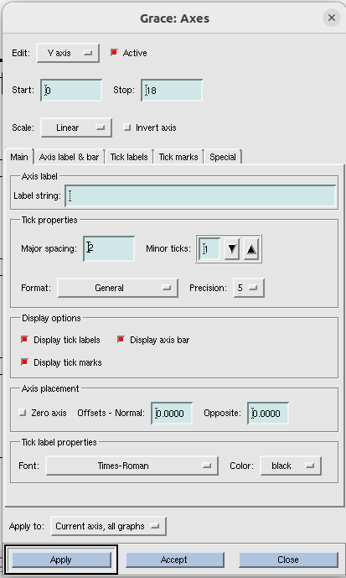

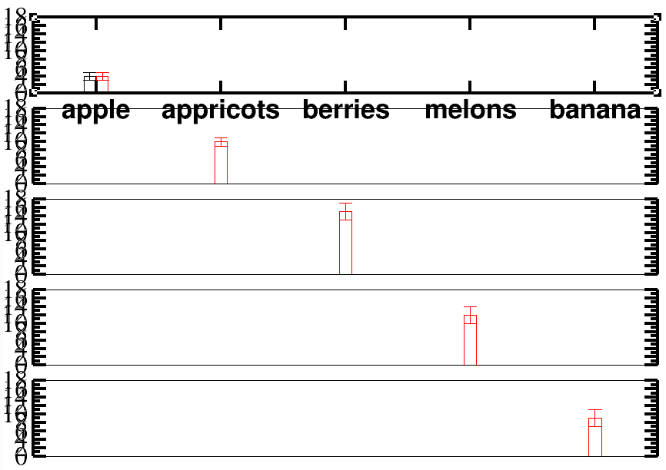
Now, Showing tick labels in every bars is not necessary.( Do same thing like x axis.)
Go to x axis> Uncheck the display options > click apply.
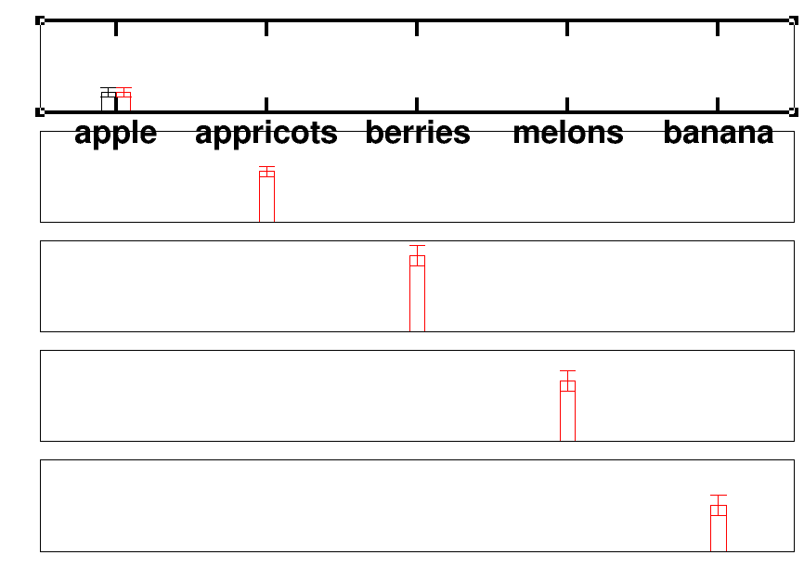

Now to restore ticks for at least one bar, re-tick the display options ( same as like what you have done in case of x axis) and “apply to( current axis)”.
Also give some axis label in this case.
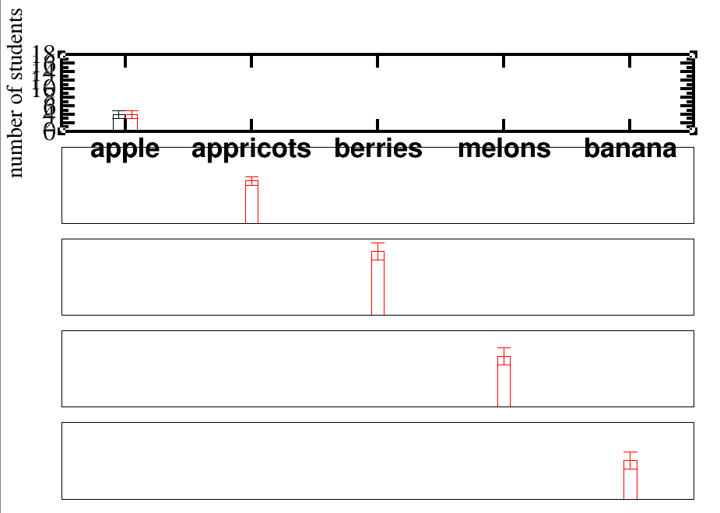

Process for superimposing:
Plot > graph appearance > select G0 > viewport (Xmin=0.1, Xmax=1.285, Ymin=0.05, Ymax =0.96)> apply
#{we need to change the viewport. Change Xmin, Xmax, Ymin, Ymax accordingly so that graph perfectly fits to the page. And do same Change for Xmin, Xmax, Ymin, Ymax for G1, G2, G3, G4 also and click accept}.
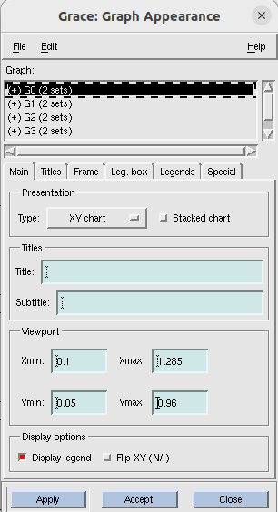

Now it looks like this:
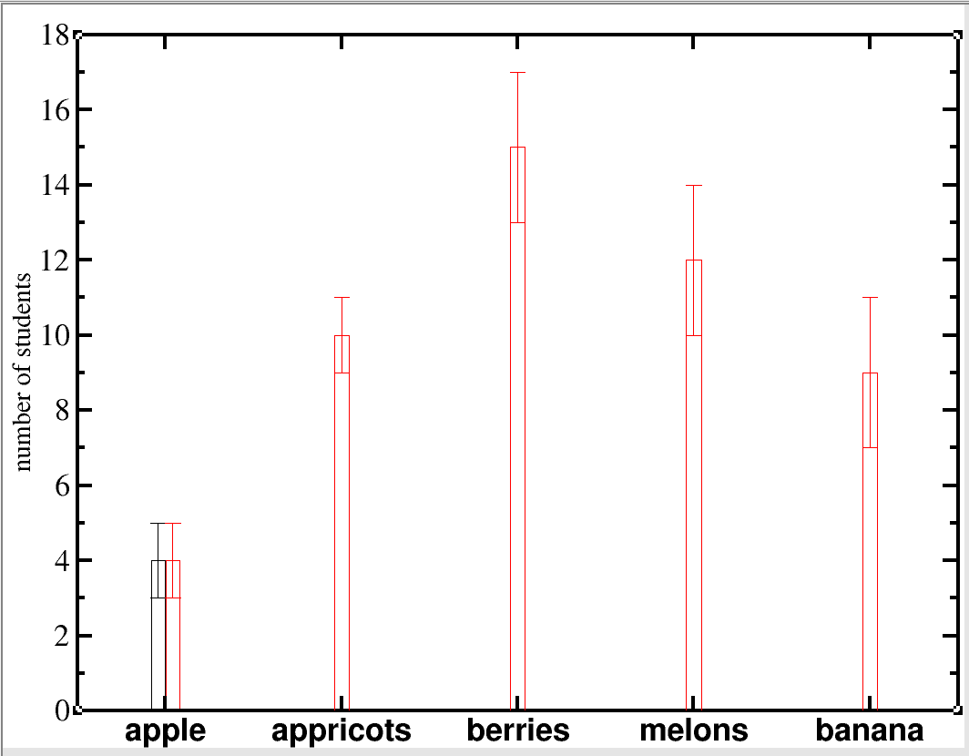

plot > graph appearance
plot > set appearance
open this two dialogue box simultaneously. Now, we want to customize each bar graph. While editing, make sure that, in both boxes same graph is selected ( e.g, G0).
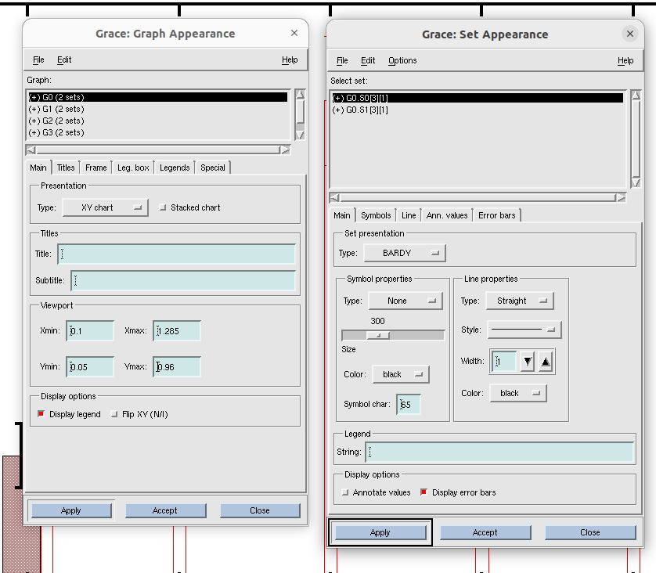
To change the appearance of error bars, go to plot > set appearance >error bars.

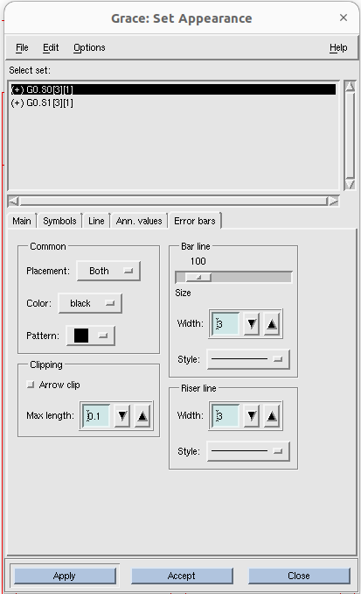

Now apply different settings for other bars also. To select other bars to edit , double click on G1 or G2 or G3 in graph apparance box. Then set apparance box will show set for that graph. Now, change properties for those as your wish.
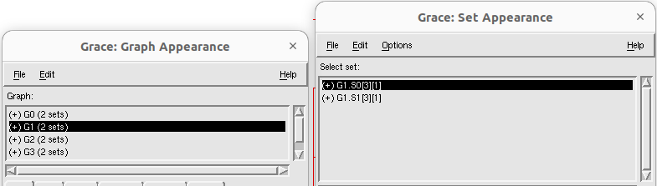
Now finally we get a bar graph which have different looks for different bars as shown below:

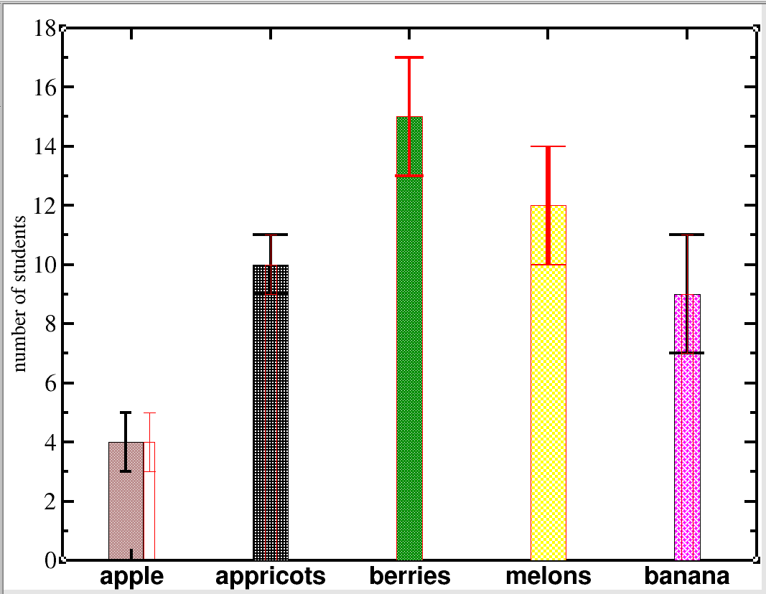

Lecture 6 – Histogram:
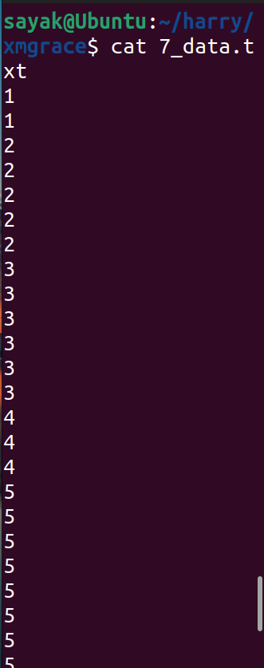

Open 7_data.txt using the command line xmgrace -block 7_data.txt -bxy 1:1
Now it looks like:
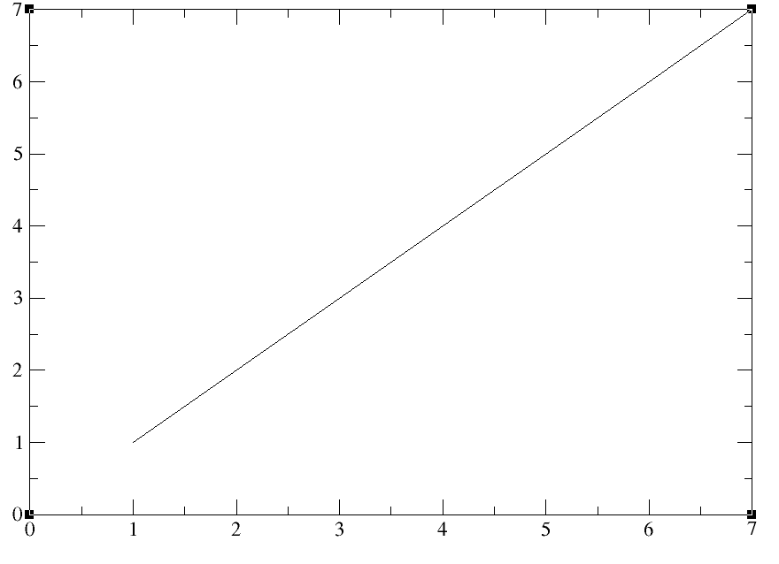

To transform this data to histogram,
Data > transformations > histograms
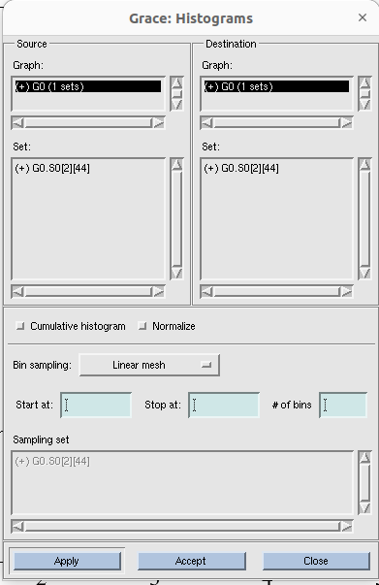
Right click on source set and click ‘duplicate’. We get:
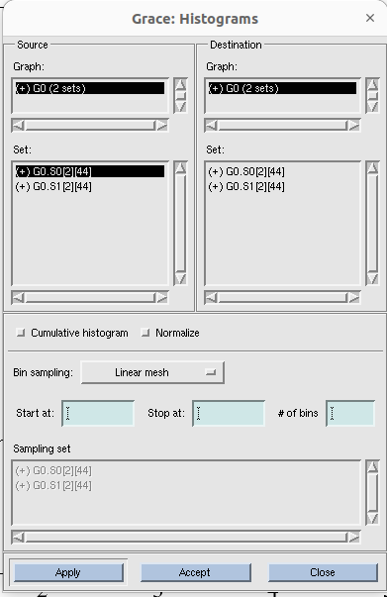

Again, right click on 1st source set ( here, G0.S0[2][44]) and click ‘hide’. See, here ‘+’ changed to ‘-’. ( IDK, why are we doing these?!may there be some reason,). Then provide start at(0), stop at (8); of beans(8).
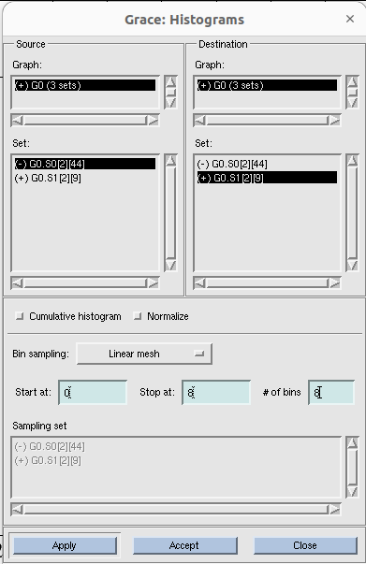
Note that, in source set (-)G0 is selected and in destination set, (+)G0 is selected (I.T=> this is because to hide the line graph and to show only the histogram). Then click apply. Histogram looks like:
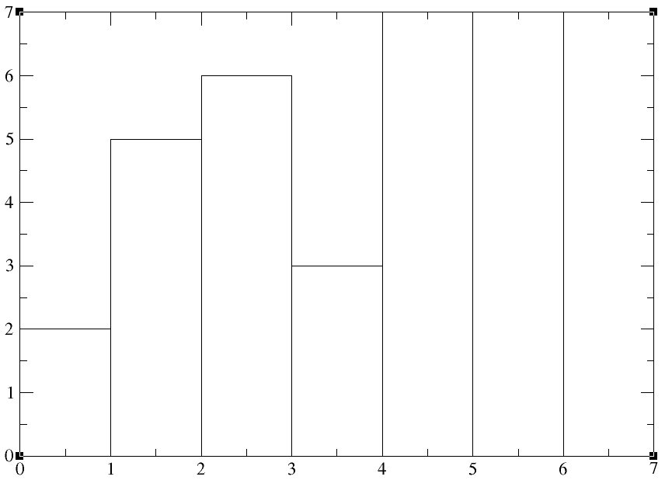

Now, plot > set apparence > edit (x axis) > start (0); stop (8)
plot > set apparence > edit (y axis) > start (0); stop (14)
Now it shows like:
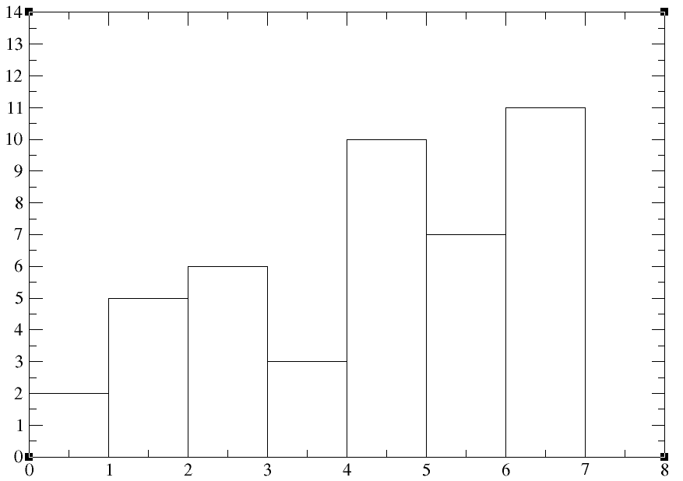
Now, to change the looks of the graph, go to
Plot > set appearance >
Remember, if you want to change the looks of the graph, make sure that, visible set is selected (i.e, (+)G0.S1[2][9]), not the hided one (i.e, (-)G0.S[2][44]). Otherwise, you can not see any change.
# See, in line properties > type (left stairs) has been there. Left stair means, no of 2’s in 7_data.txt file is represented by the bin from 1-2. So, if you select the ‘left stair’ option, make sure that you start your x axis 1 smaller than the smallest value. if you select the ‘right stair’ option, make sure that you stop your x axis at least 1 larger than the largest value.
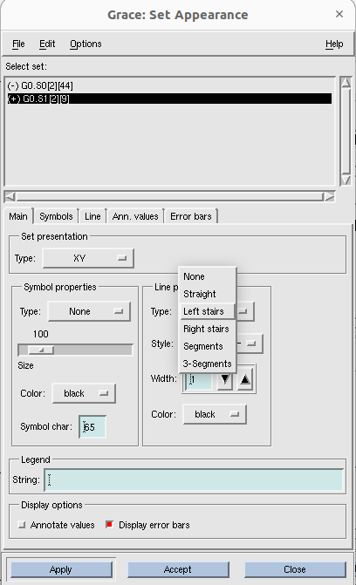

Now, go to ‘Histogram’ box and click ‘ normalize’ then click accept ( normalize means, sum of y vaules of all the bins will be 1).
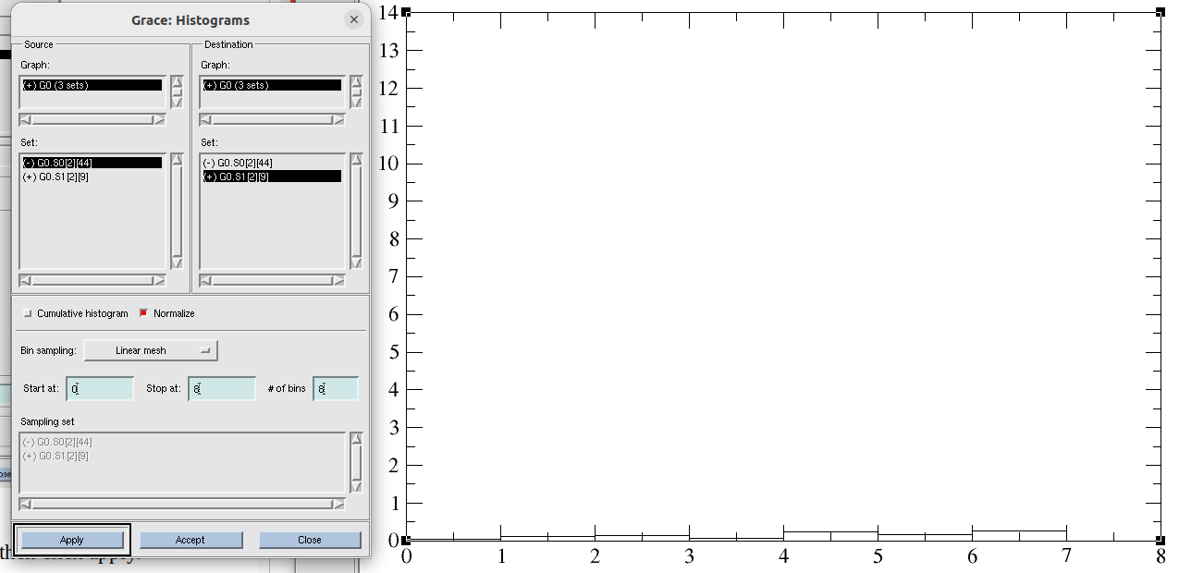
This looks y axis values went down! Go to :
plot >> axis properties >> start (0) ; stop (0.3); tick properties > major spacing(0.05)>> apply>>accept
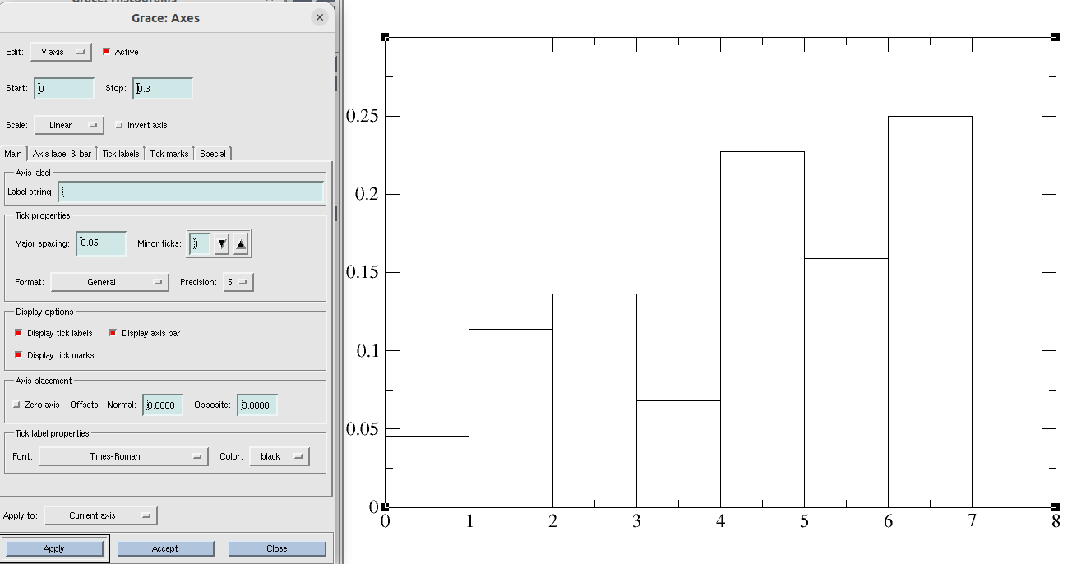
Go to Plot > set appearance > and change the look of the graph.
Plot > set appearance > line > uncheck ‘Draw drop lines’
# unchecking ‘Draw drop lines’ will remove the lines which seperates two bars.
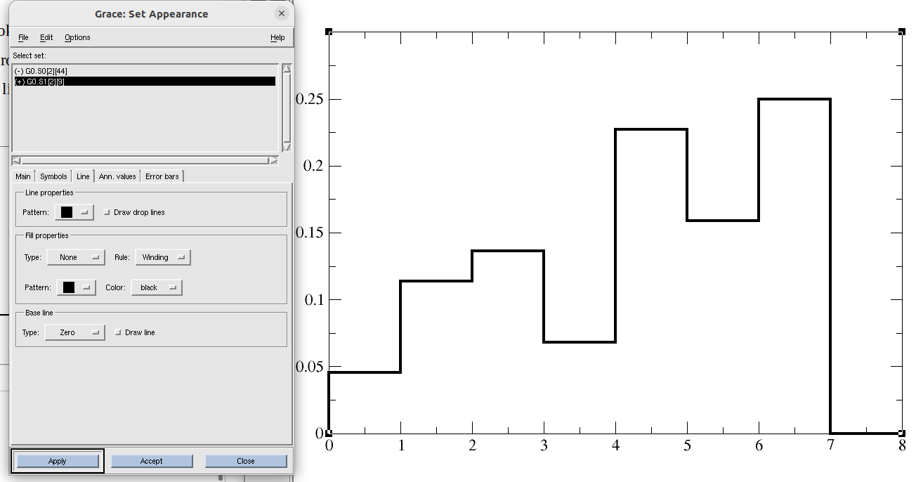
But, we will continue with drop lines here. Go and check that box.
If you color the bins , Plot >> set appearance >> line >> fill properties> type(to baseline) >> apply
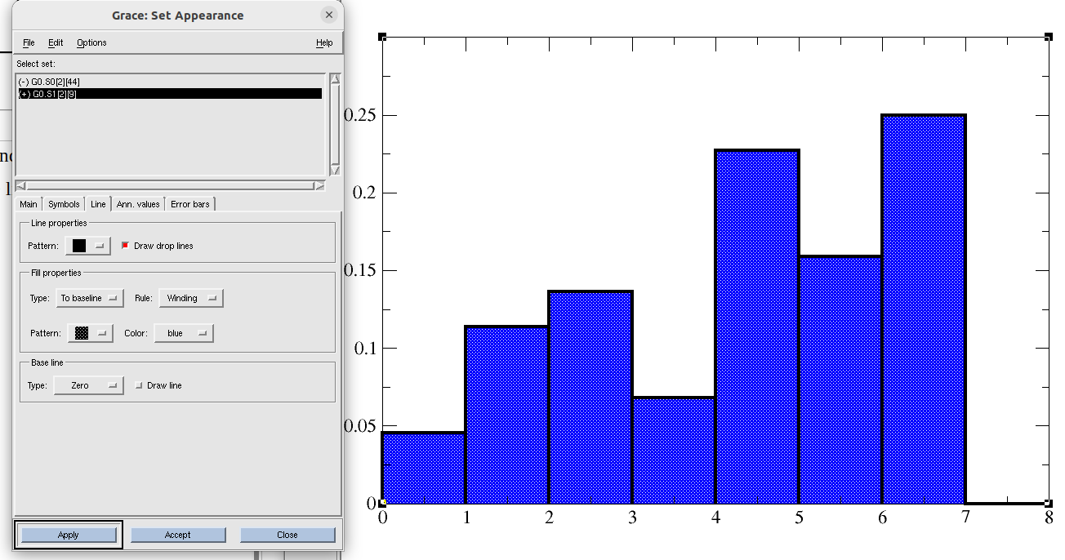
If you want to see y-axis tick values upto a particular decimal point,
plot >> axis properties >> edit (y axis) >> main>> tick properties > format (decimal); precision (2) >> apply
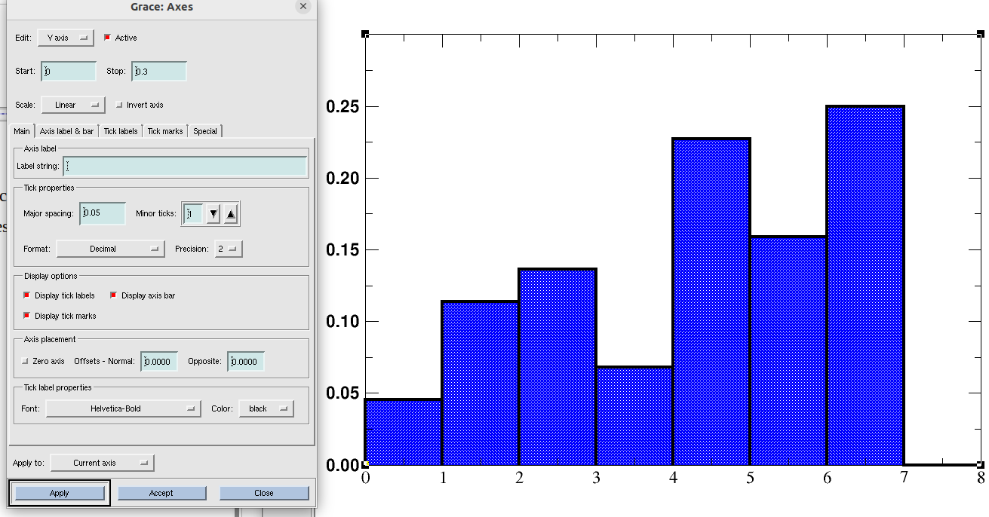
After modifications, final normalized histogram looks like:
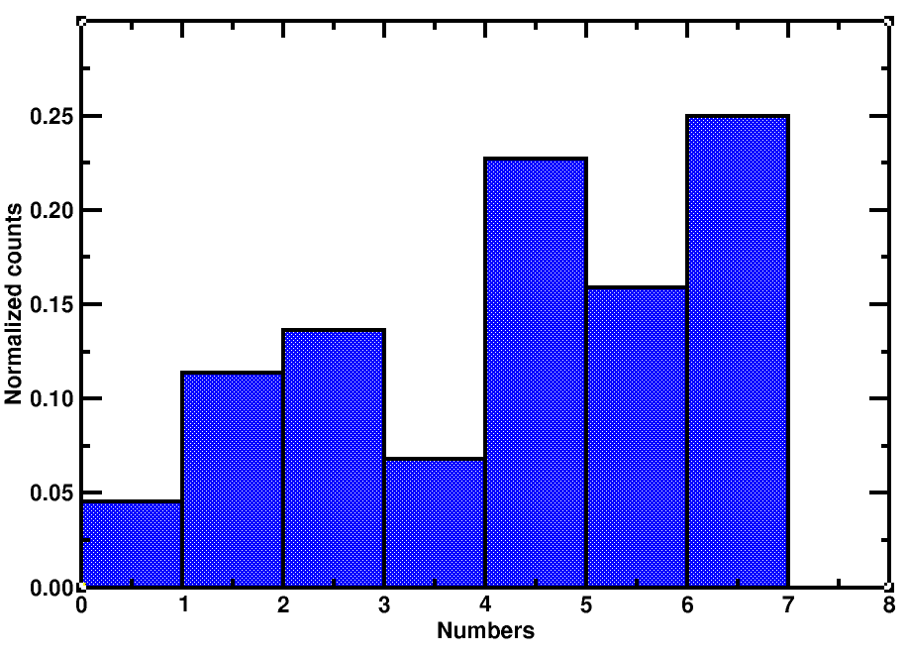

Tutorial 7: Making overlapping graphs using xmgrace:
We have two data files. One for the previous histogram (i.e, 7_data.txt), another is for parabola (parabola.txt). We will plot the histogram on the top of the parabolic curve.
Write xmgrace -nxy parabola.txt in the terminal and press enter.
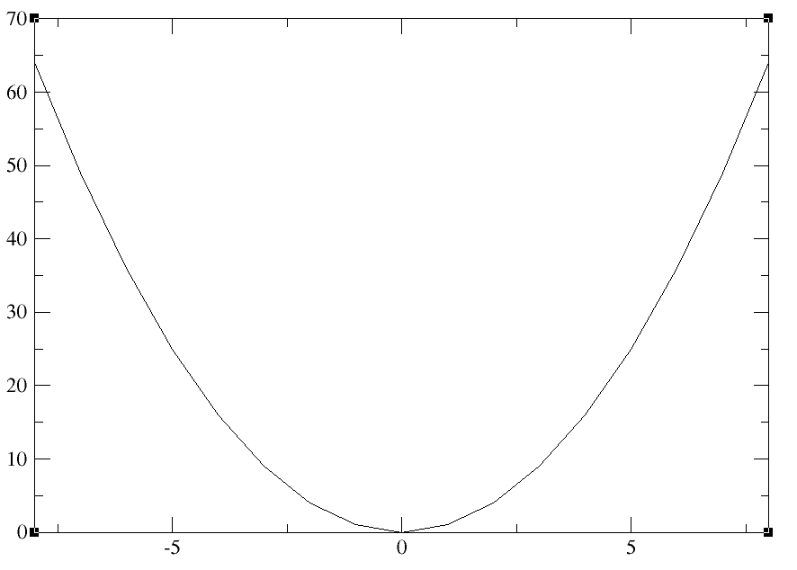

Data>> import >>ascii >> delete *.dat from filter and press enter> select 7_data.txt ; Right click on read to graph > create new > select G1(0 sets) ;Load as (block data) > click ok.
Now, another dialogue box comes. Nothing to change. Click accept.
#{because, 7_data.txt only has one column. So , x and y values will be taken from column 1 only.}
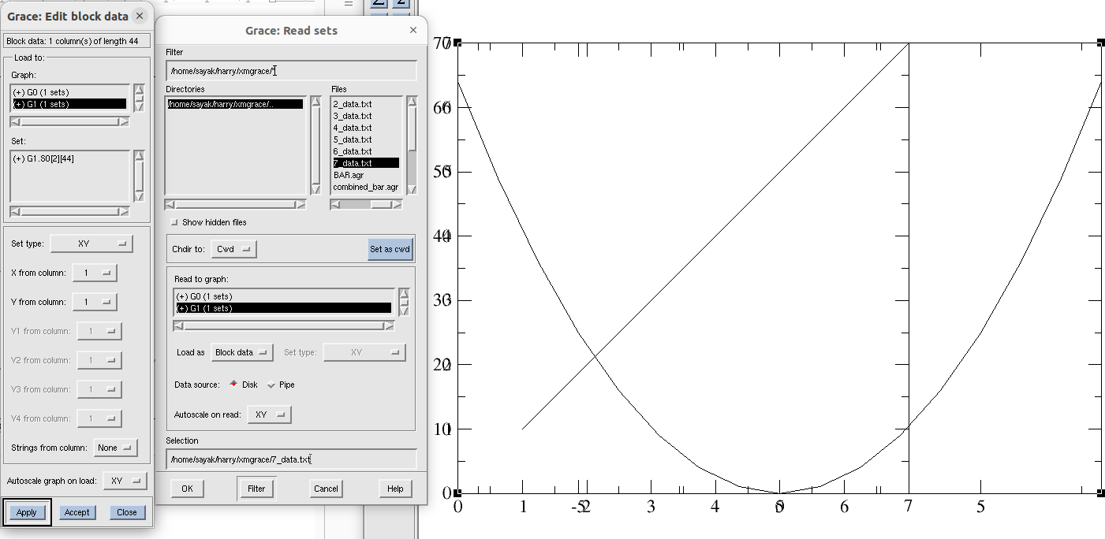
You can see, 1st and 2nd graphs have different width.
Go to edit >> Arrange graphs >> check whether page offsets of both the graphs (G0 and G1) are same. >> click accept.
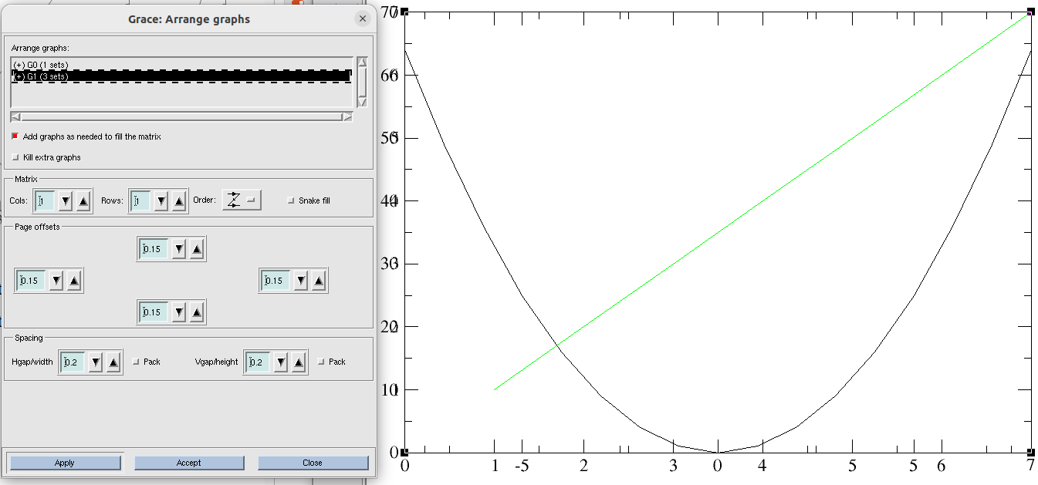
Now we need to make the 2nd plot as histogram.
Data >> transformations >> histogram >> From Source graph’ and ‘destination graph’ select ‘(+) G1(1 sets)’{#As that is our histogram data}; From ‘Source set’ right click on G1 and duplicate it. > Now, from the ‘source set’hide the first G1 ( # because we do not want to see the line graph anymore). Note that, data selection should be hided data of source graph (i.e, -G1.S0[2][44], line graph) and shown data of destination graph( i.e, -G1.S1[2][44], histogram graph). > In this case, lets try without normalizing histogram. Do uncheck ‘normalize’ box. > Start at(0); stop at (8); of bins(8) >> click accept.
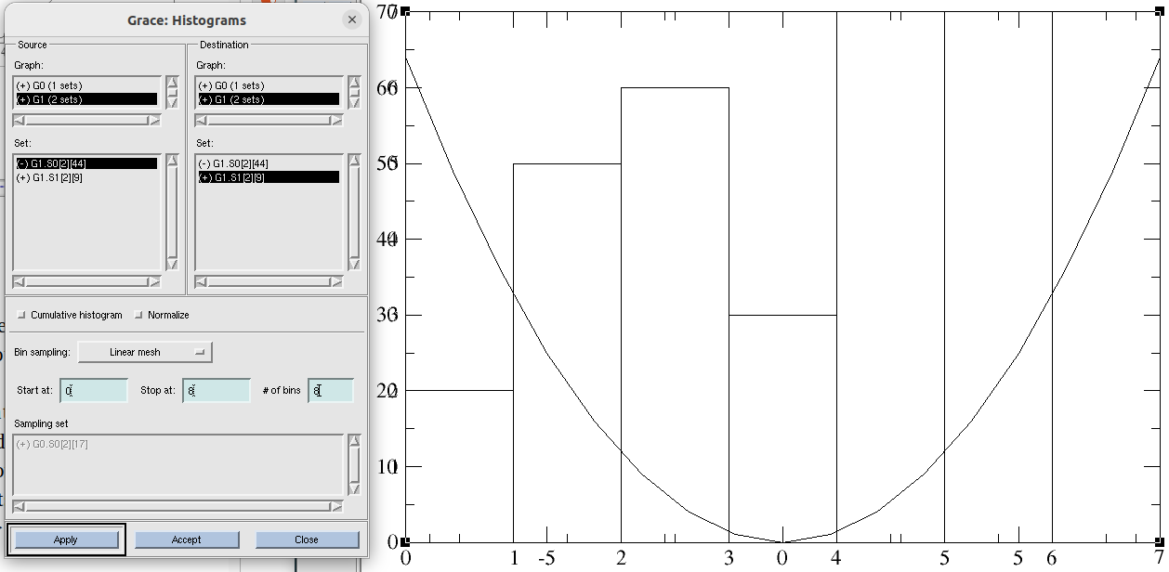
plot > graph appearance >
plot > axis properties >
# {Open this two dialogue box simultaneously. To change axis properties of any of this two graphs you should double click on G0 or G1 from ‘ Graph Appearance’. For details, see next page figure}.
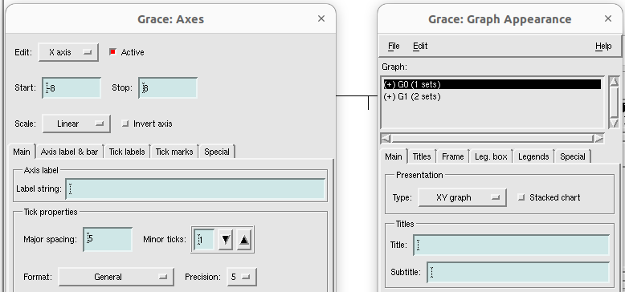
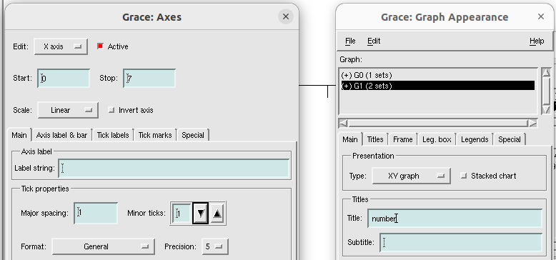
start and stop of x axis for parabola and histogram should have same value, so that they do not overlap. For histogram, change (start 0, stop 7) to (start -8, stop 8). Now:

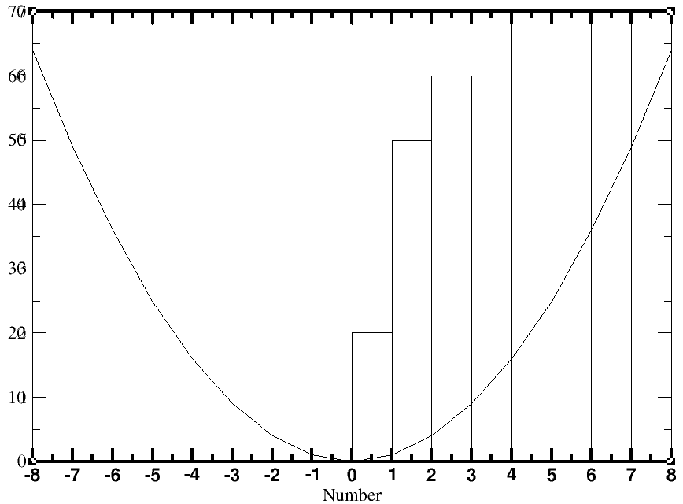

Now we need to resolve the issue of the y axis.
plot > graph appearance >
plot >> axis properties >> edit (y axis)
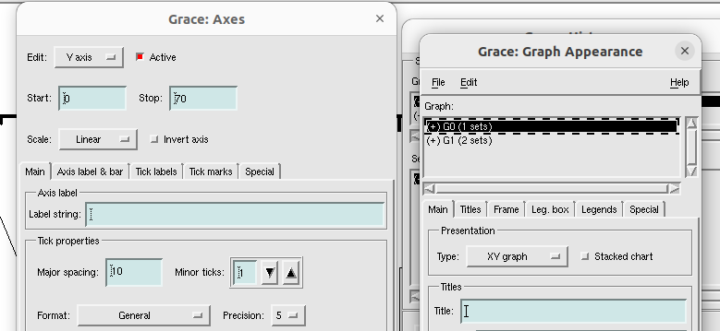
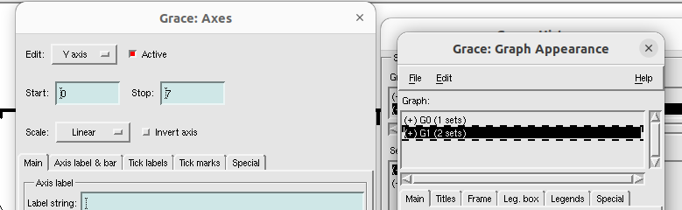
First see, y axis for the histogram is cut and incomplete one. Change the range to ‘start(0); stop(14)’
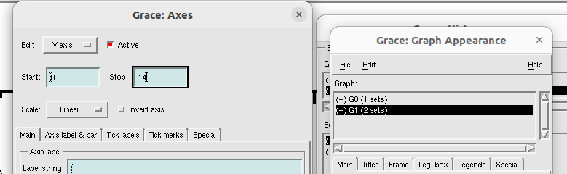
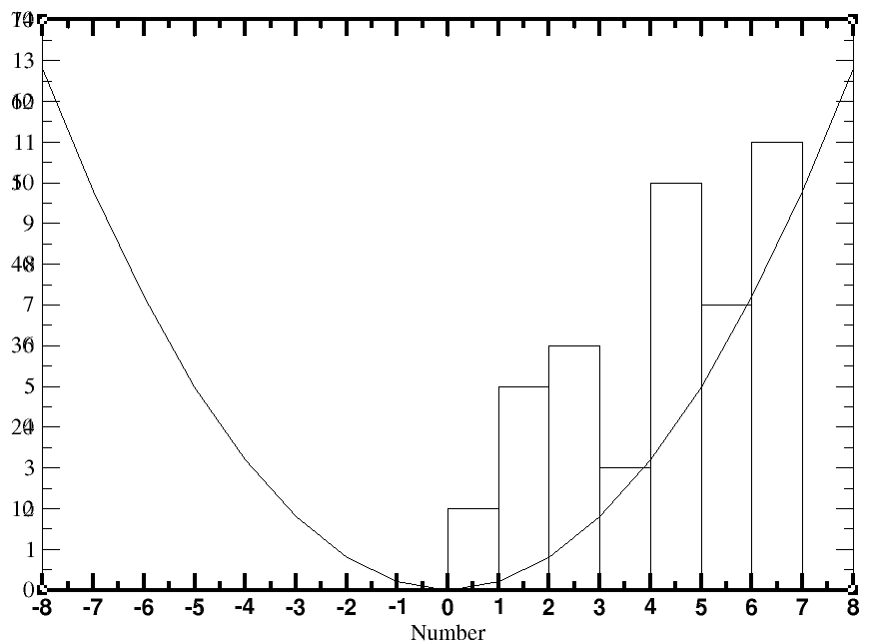

Now, bar graphs look better for histogram bins.
Now, we will use two y axis at left and right for two different graphs. Lets do histogram count at the right side.
From plot >> graph appreaance >> select and double click G1(#because G1 is for histogram data)
then, plot >> axis properties >> edit (y axis) >> axis label and bar > side (opposite) >> apply
then, plot >> axis properties >> edit (y axis) >> tick labels > side (opposite) >> apply
then, plot >> axis properties >> edit (y axis) >> tick marks > side (opposite) >> apply
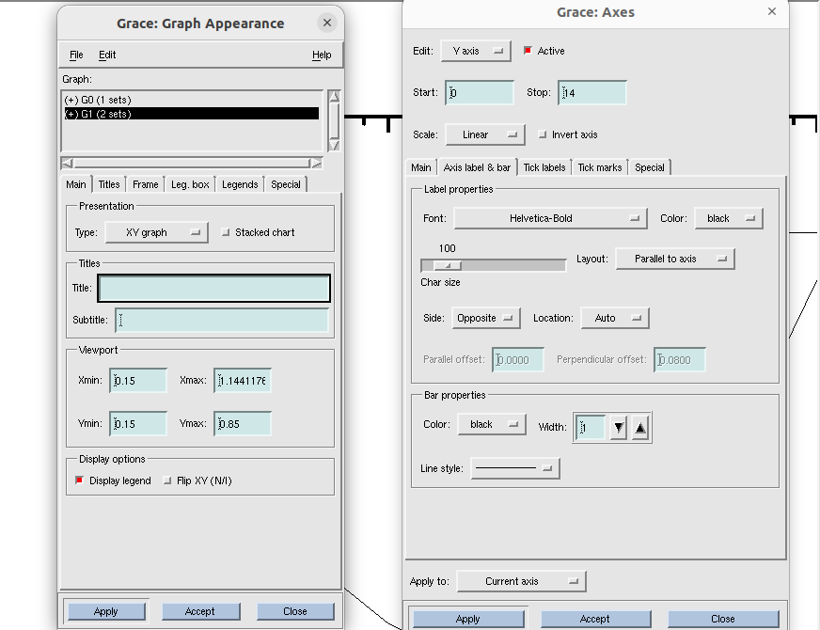
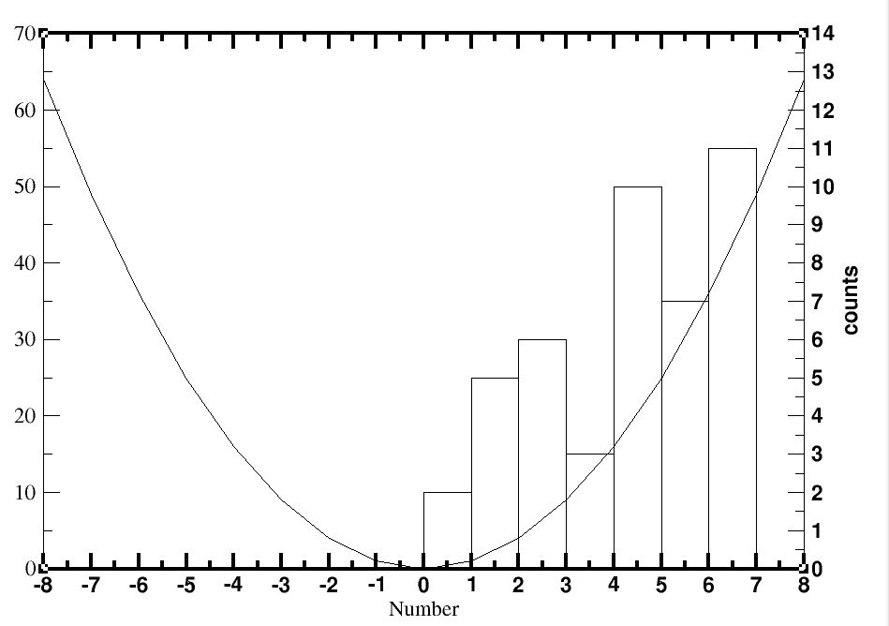
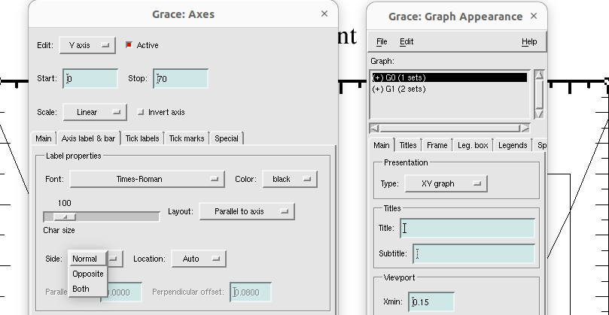
Also, make sure that axis mark and label, tick label, tick marks of parabola’s y axis are on the ‘normal side’.
Now, we should have distinguish particular graph for a particular y axis data between the two. In order to do that we use different color code for them.
From plot >> graph appreaance >> select and double click G0(# because G0 is our parabolic data)
Plot >> set appearance >> main >> line properties > color(red)
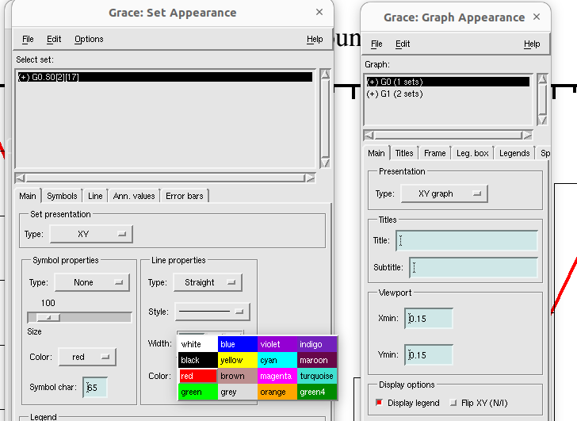
From plot >> graph appreaance >> select and double click +G1
Plot >> set appearance >>select +G1(# because +G1 is our shown histogram data, -G1 is the hidden one ) >> change line and fill properties from ‘main’ and ‘line’ options.
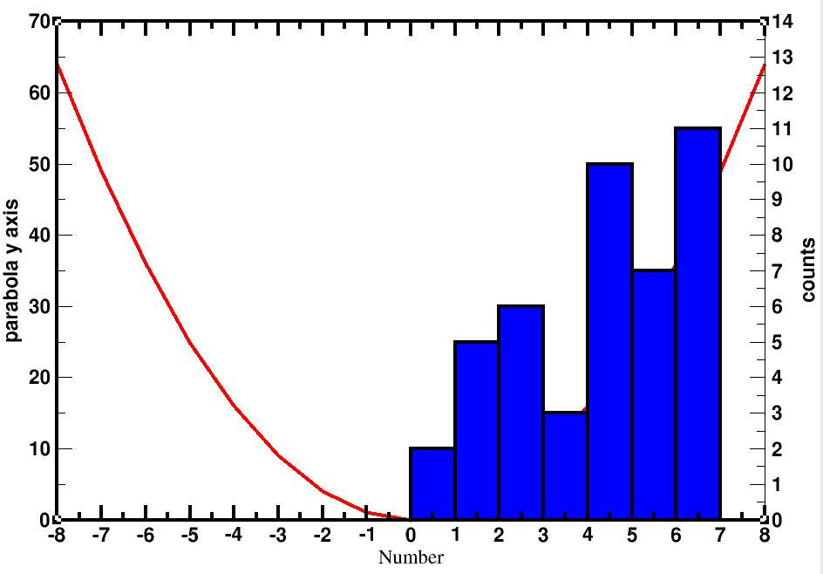

See, here parabola went behind the histogram and became invisible. Because, in graph appearance, G0(parabola) comes before G1(histogram).
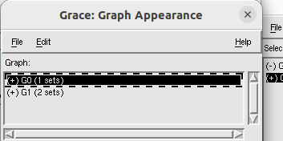

So, go to plot >> graph appearance>> right click on ‘(+)G0(1 sets)’ >>Duplicate >> ‘(+)G2 (1 sets)’ appears >> right click on ‘(+)G0(1 sets)’ and click “kill” >> accept.
Now:
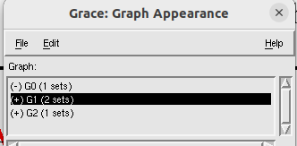

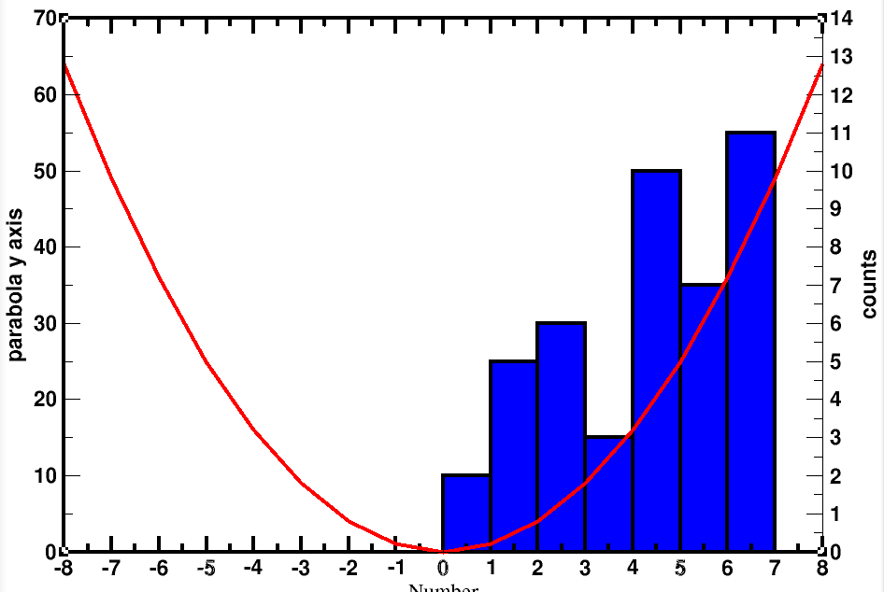
now G2 is our parabola which comes after the histogram (i.e, G1).
.......................................
Now, we need to colour two y axes accordingly.
From plot >> graph appreaance >> select and double click +G1
Plot>> axis properties >> edit (y axis) >> main >> tick label properties (color:blue)
Plot>> axis properties >> edit (y axis) >> Axis label and bar >> label properties (color:blue) >> apply
..........................................................................
From plot >> graph appreaance >> select and double click +G2
Plot>> axis properties >> edit (y axis) >> main >> tick label properties (color:red)
Plot>> axis properties >> edit (y axis) >> Axis label and bar >> label properties (color:red) >> apply.
Finally:
