**Machine Learning Model**

**RA1811030010023**

**Sayan Pramanick**

**Random Forests**

Random Forest is a popular machine learning algorithm that belongs to the supervised learning technique. It can be used for both Classification and Regression problems in ML. It is based on the concept of **ensemble learning,** which is a process of combining multiple classifiers to solve a complex problem and to improve the performance of the model.

As the name suggests, **"Random Forest is a classifier that contains a number of decision trees on various subsets of the given dataset and takes the average to improve the predictive accuracy of that dataset."** Instead of relying on one decision tree, the random forest takes the prediction from each tree and based on the majority votes of predictions, and it predicts the final output.

**The greater number of trees in the forest leads to higher accuracy and prevents the problem of overfitting.**

The below diagram explains the working of the Random Forest algorithm:

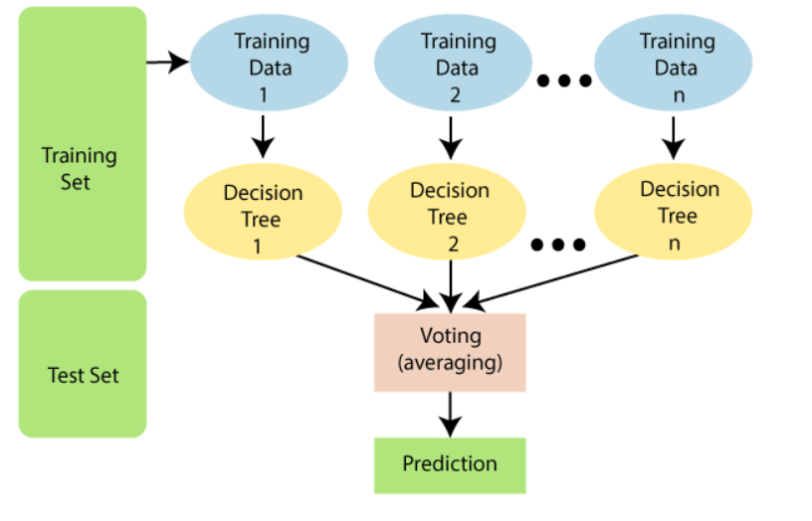

**Code:**

import pandas

from sklearn import model_selection

from sklearn.ensemble import RandomForestClassifier

url = "https://raw.githubusercontent.com/jbrownlee/Datasets/master/pima-indians-diabetes.data.csv"

names = ['preg', 'plas', 'pres', 'skin', 'test', 'mass', 'pedi', 'age', 'class']

dataframe = pandas.read_csv(url, names=names)

array = dataframe.values

X = array[:,0:8]

Y = array[:,8]

seed = 7

num_trees = 100

max_features = 3

kfold = model_selection.KFold(n_splits=10, random_state=seed)

model = RandomForestClassifier(n_estimators=num_trees, max_features=max_features)

results = model_selection.cross_val_score(model, X, Y, cv=kfold)

print(results.mean())

**Output:**

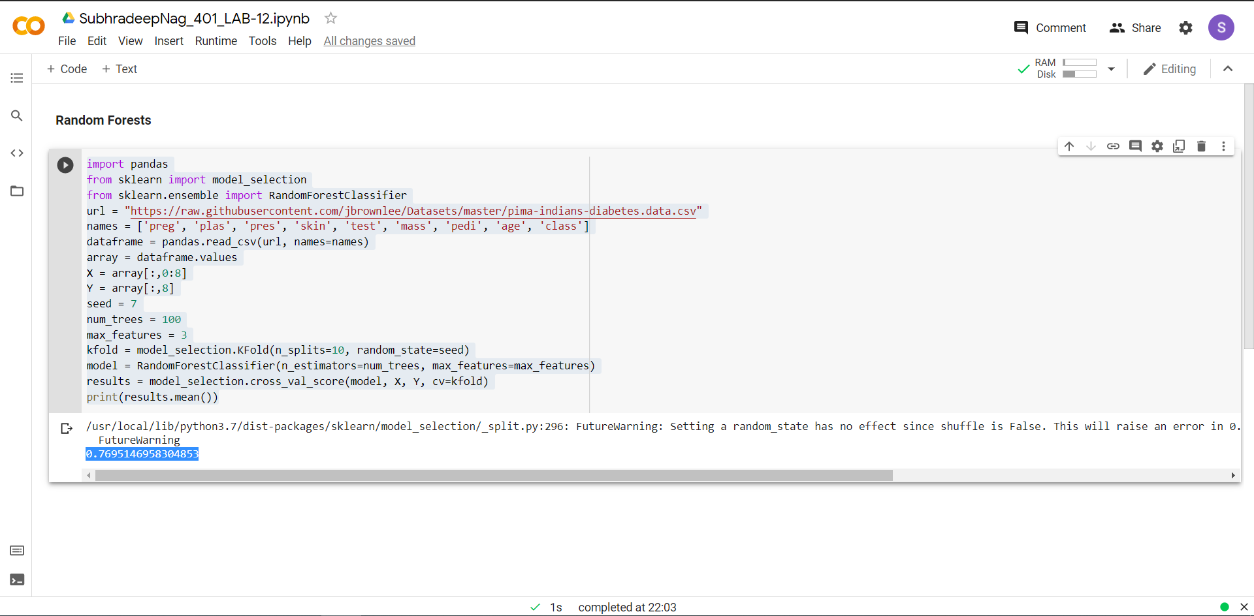

Ans - 0.7695146958304853