AI DRIVEN PLACEMENT INTELLIGENCE PLATFORM

1. Statement of the Problem
- In the context of career readiness and placement optimization, the modern academic and corporate recruitment landscape presents a range of systemic challenges to graduates and higher education institutions:
- Unstructured Resume Data Processing. Resumes are written in different unstructured formats (PDF, DOCX, TXT) with very diverse semantic phrasing. Traditional automated screening systems (Applicant Tracking Systems or ATS) work on exact keyword matching, making them fail miserably in finding appropriate candidates who use non-standard language or abbreviations (e.g., 'js' vs 'JavaScript', 'sklearn' vs 'scikit-learn').

- Obscure Skill Gap Analysis: Often, students do not have an objective, granular understanding of how their current skills align with specific industry roles (e.g., Frontend Developer, Backend Developer, DevOps, Data Science). There is no automated, weighted mechanism to distinguish between ‘Core’ skills (essential to a role) and ‘Peripheral’ skills leading to inefficient self-guided learning.

- Lack of Objective Metrics for Placement Readiness: Career placement cells and students lack predictive, data-backed tools to objectively quantify the probability of placement. Historically, placement readiness has been assessed by subjective human reviews or raw academic GPAs that do not capture the multi-dimensional synergy between GPA, total technical skill diversity, project counts, and prior internship experience.

- Administrative Overhead in Student Progress Tracking: Placement officers and student advisors have had to manually keep track of student progress through multiple versions of resumes without having one central and/or secure repository to keep track of all parts of the previous resume; to rate-limit abuse; or automatically create appropriate, dynamic academic improvement suggestions.

2. Proposed Solution

- The AI-Powered Placement Intelligence Platform is a unique, multi-layered software application intended to address these challenges by adding an automatically generated end-to-end layer of intelligence to the recruitment process. It contains an original set of new web technologies, Natural Language Processing (NLP), and Machine Learning pipelines, including:
- Intelligent Text Ingestion and Parsing: The Platform has many ways to receive resumes, regardless of the format (PDF, DOCX, TXT, etc.), utilizing an asynchronous text extraction engine to write text directly to the database. The use of advanced Natural Language Processing (NLP) libraries to parse the raw text streams allows for a fast and accurate execution of secure memory clean up processes in order to ensure the privacy of all candidate information.
- Fuzzy Skill Normalizer powered by Natural Language Processing: This tool was created to resolve keyword matching difficulties by providing an industry-standard skill catalog. It will compare the terms in raw resumes to the terms in the industry catalog based on similarities (threshold set at 80%). In doing so, many of the diverse student inputs can be grouped into single, consistent skill levels recognized as a part of that technical capability, regardless of how they are phrased stylistically.
- Dynamic Weighted Multi-Role Matching Engine: The custom-built multi-role scoring engine for the platform determines skill level not only by keyword counts but also by considering professional role classifications and creating a weighting for those professional roles (Core vs Peripheral). This will lead to calculating an exact match percentage for the user as well as their currently existing competencies and also provide a Skill Gap List identifying individually which specific technologies the user needs to develop.
- Predictive Machine Learning Engine: The platform uses a serialized Random Forest Classifier model with historical student placement data to collect user placement information based on user attributes. The model uses four-dimensions (cumulative GPA, sum of technical skills, total number of academic and industry-related projects, and length of work experience) to calculate the probability that the user will be placed in a job and assign them to their ordinal readiness rank (high, medium, low).
- Distributed and Secure Architecture: The Network uses a secure 3 tier design, which consists of a ReactJS 18 & Vite Frontend Application, FastAPI Middleware (using bcrypt hashing and Brevo OTP verification), and a Relational Database Layer (using SQLite and SQLAlchemy ORM, which supports analysis snapshots).
3. Software Workflow & Data Pipeline
The Software Workflow consists of a set of software processes that convert unstructured input files into highly structured and actionable predicting insights. The following describes the technical flow of the application:

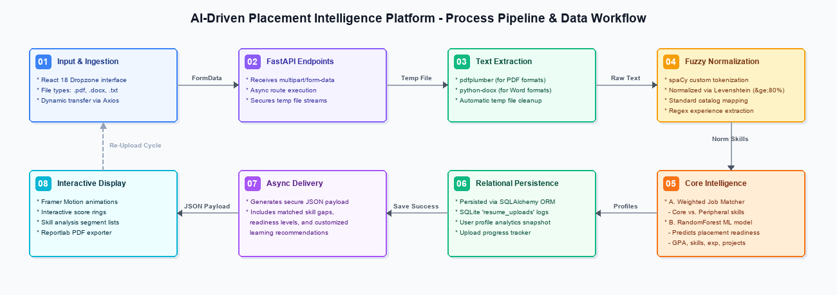
Figure 1: Architectural Data Pipeline and Processing Flowchart
2. Asynchronous Parsing: FastAPI receives the upload, creates a temporary file, detects the MIME type, extracts the raw text from the document buffer using pdfplumber or python-docx to convert the document buffer into raw text strings, and removes the temporary file immediately after extracting the text.
3. NLP Skill Normalization: The text extracted is cleaned up and matched against the pre-built SKILLS_DICTIONARY using the Fuzzy Skill Normalizer (skill_normalizer.py) and records are canonicalized to use standard terms when they have an 80% or greater Levenshtein similarity. Years of experience are extracted with the use of regular expressions.
4. Job Matching System Pipeline: The system will provide a double evaluation system that confirms the skills and abilities from the extracted data: (A) Weighted Job Matcher separates Core from Peripheral skill sets; and (B) Random Forest Readiness Classifier returns probability against the extracted features between 0% and 100% for placement probabilities.
5. Event Logging & Display Presentation: After the results have been processed, they are converted into JSON format and will be stored into the SQLite table resume_uploads. The backend returns a structured JSON payload to React that updates the state context of React and begins the animated dashboard that displays nurse scores with interactive score rings as well as dynamic learning suggestions. The end-user will be able to generate their own print-ready PDF summaries using Reportlab.
4. Conclusion & Claims of Originality
The AI Driven Placement Intelligence Platform is an integrated, proprietary, automated software system that methodically corrects structural friction in the modern career placement and student preparedness scoring process. High throughput asynchronous execution combined with specialization in natural language processing (NLP) and fuzzy mapping models and advanced Random Forest Classifiers resolves the shortcomings of traditional screening methods.
The software is the original literary and technical work of the authors, meaning that the custom designed components of the software are protected through copyright. These custom designed components, being the weighted core/peripheral skill gap matcher, the automated fuzzy skill normalizer, the dynamic predictive feature model, and the unified student analytics interface, constitute unique, functional works that warrant copyright protection. Federal copyright registration will protect the entire source code base, the database schema layouts, the custom integrated algorithm routines, and the dynamic website interfaces from unauthorized reproduction, replica, or deployment.

