COPYRIGHT REGISTRATION SPECIFICATION
Technical Document of Original Software Authorship
Title of the Work | AI-Driven Placement Intelligence Platform (v2.0.0)
Class of Work | Computer Software / Literary Work (Software Source Code)

1. Statement of the Problem
In the modern academic and corporate recruitment landscape, graduating students and higher education institutions face several systemic challenges regarding career readiness and placement optimization:
- Unstructured Resume Data Processing: Resumes are authored in varying, unstructured formats (PDF, DOCX, TXT) with highly diverse semantic phrasing. Traditional automated screening systems (Applicant Tracking Systems or ATS) rely on exact keyword matches, leading to high failure rates when identifying qualified candidates who use non-standard terminology or abbreviations (e.g., writing 'js' instead of 'JavaScript', or 'sklearn' instead of 'scikit-learn').
- Opaque Skill Gap Identification: Students frequently lack an objective, detailed understanding of how their current competencies align with specific industry roles (e.g., Frontend Developer, Backend Developer, DevOps, Data Science). There is no automated, weighted mechanism available to differentiate between 'Core' skills (indispensable for a role) and 'Peripheral' skills, leading to inefficient self-guided learning.
- Absence of Objective Placement Readiness Metrics: Career placement cells and students have no predictive, data-driven tools to objectively quantify placement probability. Placement readiness is historically evaluated through subjective human reviews or raw academic GPAs, which fail to capture the multi-dimensional synergy between GPA, total technical skill diversity, project counts, and prior internship experience.
- Administrative Overhead in Progress Tracking: Placement officers and student advisors are forced to manually track the progress of students over multiple resume iterations, lacking a centralized, secure repository that logs historical resume analyses, rate-limits abuse, and automatically generates actionable, dynamic study recommendations.
2. Proposed Solution
The AI-Driven Placement Intelligence Platform is a proprietary, multi-tiered software application designed to solve these challenges by introducing an automated, end-to-end intelligence layer. The software represents an original integration of modern web technologies, Natural Language Processing (NLP), and machine learning pipelines:
- Intelligent Text Ingestion & Parsing: The platform supports cross-format resume ingestion (PDF, DOCX, TXT) and features an asynchronous text extraction engine. It leverages advanced NLP libraries to parse raw text streams and immediately executes secure memory clean-ups to guarantee candidate data privacy.
- NLP-Powered Fuzzy Skill Normalization: To resolve the keyword-matching bottleneck, the platform implements a specialized Fuzzy Skill Normalizer. It compares raw resume terms against a standardized industry catalog using a similarity threshold (set at 80%). This normalizes highly diverse student inputs into canonical industry skills, ensuring that technical capability is recognized regardless of stylistic phrasing.
- Dynamic Weighted Multi-Role Matcher: The platform features a customized multi-role scoring engine. Instead of simple keyword counts, it evaluates skills across various professional roles, classifying them into a weighted hierarchy (Core vs. Peripheral). This yields an exact match percentage, present competencies, and an actionable Skill Gap list detailing the precise technologies a student needs to master.
- Predictive Machine Learning Engine: The software incorporates a serialized Random Forest Classifier model trained on historical student placement profiles. By creating a four-dimensional feature vector—comprising cumulative GPA, total technical skills, academic/industry projects, and years of work experience—the model outputs an objective, mathematical probability of placement and maps the user to an ordinal readiness tier (High, Medium, or Low).
- Secure, Distributed Architecture: The system employs a secure three-tier design. This consists of a React 18 & Vite Frontend Portal, FastAPI middleware featuring bcrypt hashing and Brevo OTP verifications, and a relational database layer backed by SQLite and SQLAlchemy ORM for detailed analytics snapshot persistence.
3. Software Workflow & Data Pipeline
The workflow of the software maps the transition of unstructured input files into highly structured, actionable prediction insights. Below is the technical flow of the application:
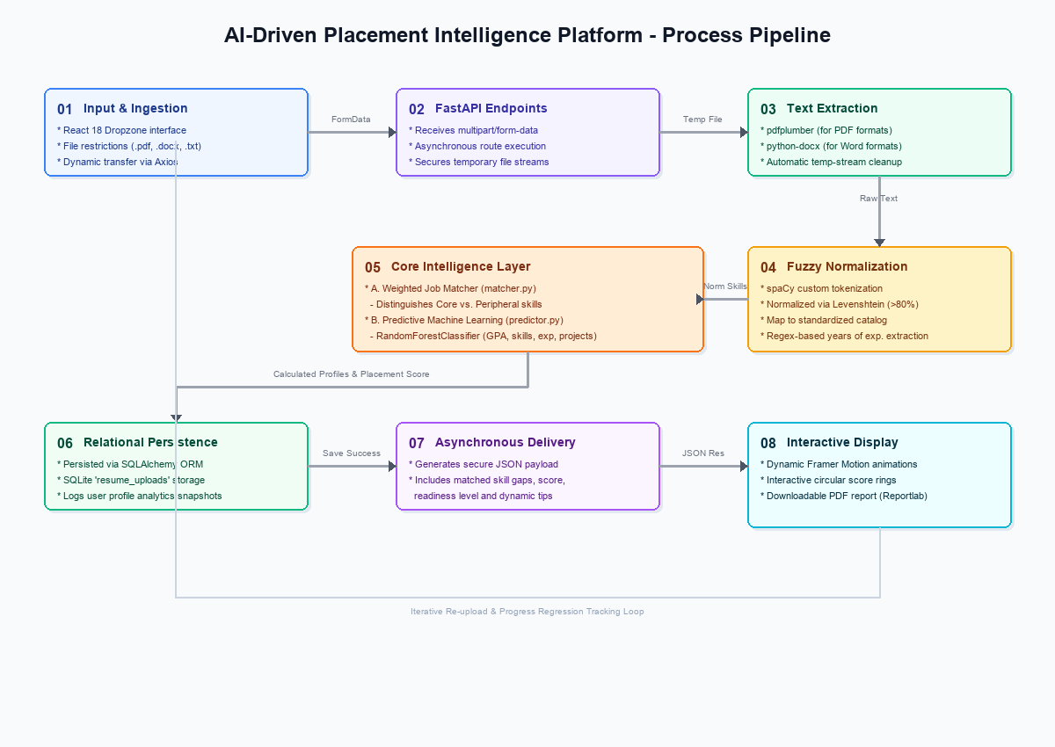
Figure 1: Architectural Data Pipeline and Processing Flowchart
1. Input & Ingestion: The frontend application validates file constraints and transmits the resume via Axios in multipart/form-data encoding to /upload_resume.
2. Asynchronous Parsing: FastAPI captures the upload, creates a temporary file, detects the MIME-type, and utilizes pdfplumber or python-docx to convert document buffers into raw text strings. The temp file is purged instantly upon text extraction.
3. NLP Skill Normalization: The text is cleaned and evaluated against a precompiled SKILLS_DICTIONARY using the Fuzzy Skill Normalizer (skill_normalizer.py). Matches having an 80% or greater Levenshtein similarity are canonicalized to standard terms. Regular expression matching extracts years of experience.
4. Joint Evaluation Pipeline: The extracted skills and attributes are parsed through a dual evaluation core: (A) Weighted Job Matcher distinguishes Core vs. Peripheral skills; (B) Random Forest Readiness Classifier predicts a probabilistic placement percentage from 0% to 100% based on feature inputs.
5. Relational Logging & Presentation: The results are serialized as JSON and logged inside the SQLite resume_uploads table. The backend returns a structured JSON payload to React which updates its state context and triggers an animated dashboard rendering with interactive score rings, and dynamic learning tips. Users can trigger custom print-ready Reportlab PDF summaries.
4. Conclusion & Claims of Originality
The AI-Driven Placement Intelligence Platform is a fully integrated, proprietary software solution that systematically addresses structural friction in modern career placement and student preparedness scoring. By coupling high-throughput asynchronous execution, specialized natural language processing (NLP) fuzzy-mapping models, and advanced random forest classifiers, the software resolves the limitations of standard screening procedures.
The software is an original literary and technical creation of the authors. Its custom-engineered components—specifically the weighted core/peripheral skill gap matcher, the automated fuzzy skill normalizer, the dynamic predictive feature model, and the unified student-focused analytics interface—are unique, functional creations worthy of copyright protection. Copyright registration will protect the entire source code base, database schema layouts, custom integrated algorithmic routines, and dynamic web interfaces from unauthorized replication, reproduction, or deployment.

