ABSTRACT  
The ability of the constitutive model to predict the complex direction-dependent mechanical behaviour of transversely isotropic rock and the failure modes observed in triaxial compression tests with different confining pressures and different inclination angles of the stratification planes with respect to the direction of axial loading is used to evaluate its performance. The ubiquitous joint concept, the introduction of scalar anisotropy parameters and the linear mapping into a fictitious isotropic configuration are three popular approaches for describing transversely isotropic material behaviour that are critically reviewed and examined. It is implemented into a FE-program by means of the return mapping algorithm and it is regularized by an over-nonlocal implicit gradient enhancement for ensuring mesh-insensitive results.

Introduction

In engineering practise, tunnel advancement is a difficult task. In numerical tunnelling simulations, isotropic, linear-elastic perfectly-plastic material equations are typically utilised to describe the material behaviour of the surrounding rock mass. These material laws are based on the failure hypothesis according to **Hoek et al**. In the latter, discontinuities in a rock mass are simplified by using an empirical approach generated from a rock mass classification system to reduce the strength characteristics of intact rock. However, when compared to the true mechanical behaviour of rock mass, the respective simplifications overlook certain important impacts of discontinuities. For example, Plastic deformation in the pre-peak region of the stress-strain curves is neglected, as is strain softening in the post-peak domain, which is accompanied by material stiffness deterioration. Furthermore, linear-elastic behaviour is mistakenly predicted for stress paths with dominant hydrostatic compression, despite the fact that the material behaviour in this situation is widely known to be dependent on the hydrostatic pressure. These Shortcomings significantly influence the prediction of the deformation and stress state in numerical simulation of tunnel advance. In order to overcome the mentioned shortcomings, an isotropic damage plasticity model for rock and rock mass, denoted as rock damage plasticity (RDP) model, was developed by **Unteregger** et al.

In addition to the inherent anisotropic behaviour, directional dependencies can also occur due to load-induced micro cracking commonly known as induced anisotropy. Since the focus of the present publication is on the representation of inherent anisotropy, an overview on different approaches for considering the latter in constitutive models is provided in the following.

Objectives and Scope

This paper presented a three popular approaches for extending an existing isotropic elasto-plastic model to a transversely isotropic elasto-plastic model. Major objectives of three methods are

* A stable and durable formulation and implementation of the constitutive model is critical for assuring convergence when using damage plasticity models in large-scale finite element simulations. As a result, this research will offer a damage plasticity model for transversely isotropic materials that meets these conditions.
* In this paper we use three popular methods,the ubiquitous joint concept, the introduction of scalar anisotropy parameters and the linear mapping into a fictitious isotropic configuration.in this for approaching the stratified materials relies which is based on the **Single Plane of Weakness Theory by Jaeger**.In the original ubiquitous joint concept(OUJ) model,introduced by **Goodman ,** but in this model there is failure may occyr in the rock matrix,along the joints,or in the both rock matrix and the joints.since the OUJ model is only for strength anisotropy is considered.to overcome this shortcoming,the **Ismael and Konietzky** introduced Modified ubiquitous joint (MUJ) model. For considering strain hardening in the pre-peak regime of the stress-strain relation and softening in the post-peak regime in ubiquitous joint models, the so-called subiquitous joint (SUJ) models, were developed.
* A further possibility of modeling inherent anisotropic behavior was published by **Pietruszczak and Mroz** and Gao et.al. It relies on the generalization of isotropic yield functions by so-called scalar anisotropy parameters. These parameters are postulated by means of a microstructure tensor, which takes into account the influence of the inclination of the stratification planes on the material parameters.
* A different continuum-based approach for the extension of isotropic failure criteria to anisotropic behavior was presented by Boehler,wherein anisotropic behavior is described via a linear mapping tensor depending on the microstructure of the material.

Methodology

Methods

A CRITICAL REVIEW ON MODELING TRANSVERSELY ISOTROPIC MATERIAL BEHAVIOR WITHIN THE FRAMEWORK OF PLASTICITY THEORY

This section we discuss about the three popular approaches for extending an existing isotropic elasto-plastic model to transversely isotropic elasto-plastic model.

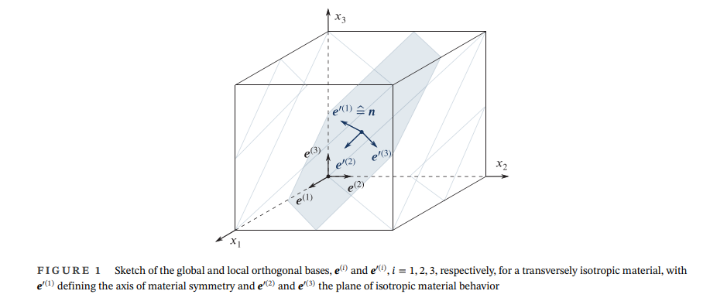

Preliminaries

The most practical approach to express the stress-strain relationship in the major material orientations.



and e where the superscript prime (∙)′ designates variables formulated in the local coordinate system aligned with the principal material directions.

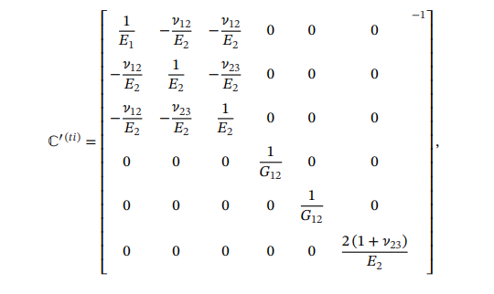

Where, The nominal Cauchy stress tensor is denoted by 𝝈′,

𝜺′ the total strain tensor,

𝜺′(e) the elastic strain tensor and 𝜺′(𝑝) the plastic strain tensor

ℂ′(𝑡𝑖) denotes the fourth-order transversely isotropic elastic stiffness tensor

Young’s modulus 𝐸1 in 𝑥′1-direction and the Poisson’s ratio 𝜈12 and the shear modulus 𝐺12 in planes containing the axis of material symmetry 𝒆′(1) and the Young’s modulus 𝐸2 and the Poisson’s ratio 𝜈23 both in the 𝑥′2 𝑥′3-plane of isotropic material behavior.

The stress and strain tensors, which are defined in the local coordinate system, are translated into the global coordinate system using the following formula

𝜀𝑘𝑙 = 𝑎𝑝𝑘 𝑎𝑞𝑙 𝜀′𝑝q  and 𝜎𝑖𝑗 = 𝑎𝑚𝑖 𝑎𝑛𝑗 𝜎′𝑚n  by rearranging this two terms we will get

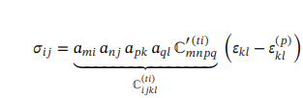

This equation referred to a global co-ordinate system, enters the equilibrium equation. Where as above two formulas applied in an analogous manner for the transformation of the elastic and plastic strain tensors.

**First model**

**Ubiquitous joint models**

in this model,we are using two different failure criteria that are combined,one is representing failure of rock matrix(”nonsliding mode”), denoted as 𝑓(𝑟), and the other one failure along the stratification planes (”sliding mode”), denoted as 𝑓(𝑠𝑝). The latter is defined in terms of the traction vector 𝑡i(𝑛) = 𝜎𝑖𝑗 𝑛𝑗 acting on an infinitesimal area of the stratification planes with the normal vector 𝒏, leading to the incorporation of direction-dependent behavior.

According to the latter,the set of admissible yield functions is defined as

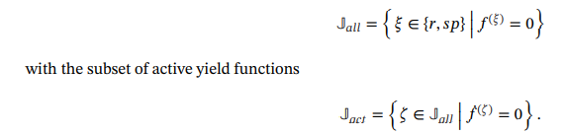

For the evolution of the plastic strain, the non-associated flow rule

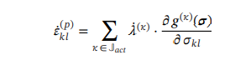

𝜅 the subset of active yield criteria, 𝑔(𝜅)(𝝈) the plastic potential function and 𝜆̇(𝜅) the corresponding consistency parameter.

In the following, the isotropic Drucker-prager yield is used for rock matrix with s and I1 denoting the deviatoric part and the first invariant of the Cauchy stress tensor,repectively

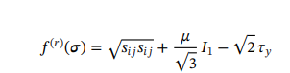

Where as 𝜏𝑦 and 𝜇 the cohesive and frictional material parameters.

A non associated plastic potential function is assumed for determining the plastic strain rate that we discussed in above formula

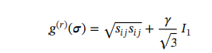

And the plastic potential function is defined for the stratification planes as



Where as 𝜓 denoting the dilatancy angle.

Transversely isotropic material behaviour is taken into consideration by an additional yield criterion for modelling failure owing to sliding along the stratification planes, according to the ubiquitous joint idea. The Mohr-Coulomb friction law is considered. The equation is

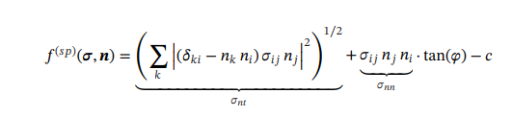

There in, 𝛿𝑘𝑙 denotes the Kronecker delta, 𝒏 the normal vector to the stratification planes, 𝜎𝑛𝑡 and 𝜎𝑛𝑛 the shear and the normal component of the stress vector (𝑛) acting on the latter, and 𝜑 and 𝑐 the friction angle and the cohesion, respectively.

Second method

Introduction of scalar anisotropy parameters

This method is commonly for capturing inherent anisotropy in plasticity models by the direction-dependent formulation of strength-related material parameters,the framework Pietruszczak and Mroz is selected for this review.

The layered fabric of a material is taken into account by a second-order microstructure tensor