**CSE405: Project Report**

|  |  |
| --- | --- |
| Student ID | 2019-1-60-063 |
| Student Name | Sazzad Hossen |
| Course Name | Computer Networks |
| Course Code | CSE405 |
| Section | 03 |

**Submitted to:**

Dr. Anisur Rahman

Associate Professor, Proctor

Department of Computer Science & Engineering

Date of submission: 11 May 2022

**Title: Design a full-fledged network for an organization with multiple subnets.**

**Abstract:**

The goal of this project was to have a thorough understanding of how a complex mesh of networks functions. This project also provided me with insight into how a sophisticated network architecture can be implemented in practice. Computer Network Is a collection of computers and other devices. When you're linked to the internet, you can communicate. sharing of information and equipment in a network This is a multi-dimensional network. The network design I presented should ideally meet all of the requirements and be as near to a real-world implementation as possible.

**Objective:**

The primary objective was to design a complete model of a complex network by discovering the interconnectivity of the systems and sub-networks, which will reflect the East West University structure and facilities.

The main objective of this project is to complete a model of a complex network by discovering the interconnectivity of the systems and subnetworks, which will reflect the East West University

University of Professionals structure and facilities, features.

A webpage for University of Professionals was also to be created, and it would be accessible at <http://www.professionals.edu>. To access the network, each Campus was also provided a wireless access point. The complicated network included all six of the university's campuses, as well as sub-nets within each campus.

Elements which are used to make this network:

* Routers
* Switches
* Connectors (Straight Through Cable and Serial DCE)
* Servers (DNS, DHCP, WEB)
* PCs
* Wireless Access points
* Laptop.

**Implementation of this network:**

Cisco Packet Tracer was used to implement the network design. A hexagonal shaped network of routers was deployed to cover all six campuses as well as connect them to a separate Server Room. Wi-Fi and wireless Access Points are also provided in each campus through which other devices can connect to the network wirelessly.

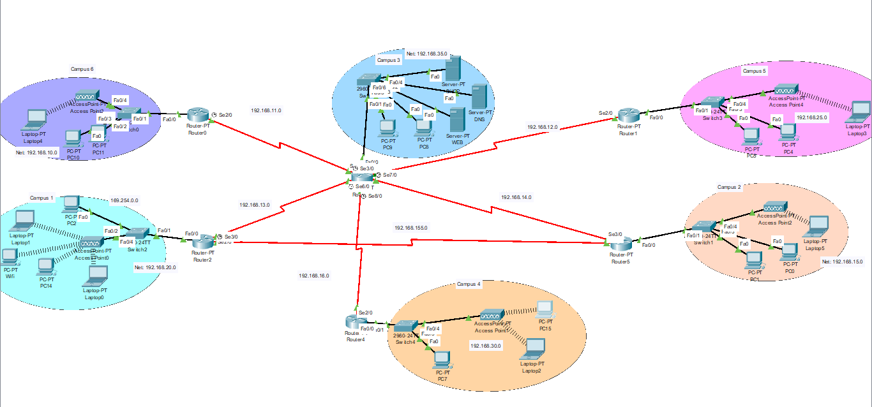

Figure: Design of the network

Each Router has complex routing capabilities, allowing it to connect to any of the other networks in the complex mesh. Six diagonals were connected, and routing paths were set up through those diagonals. This provided extra security and mesh endurance, as well as the capacity to route through different paths in the event that one or more routers went down.

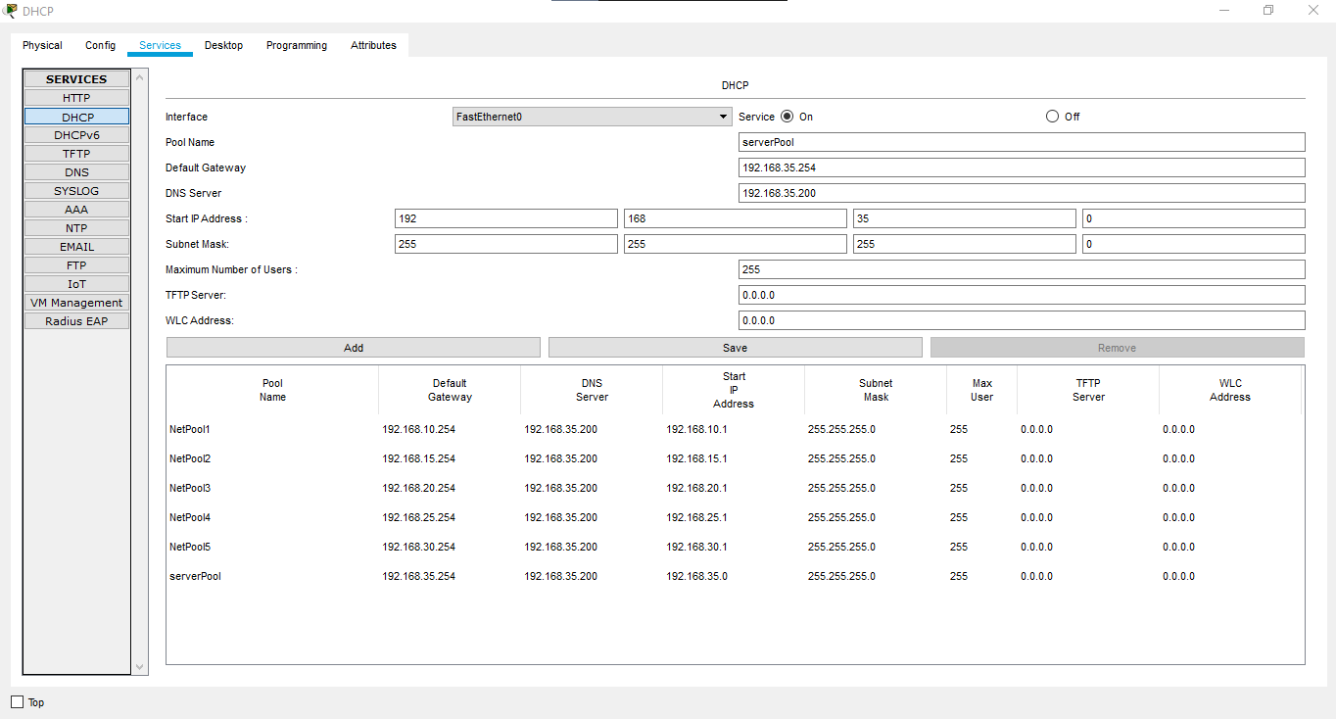

Here 5 server pools were used which is for DHCP, DNS and Web Server. All of these servers were stored in a separate Server Room from the rest of the Campus networks.

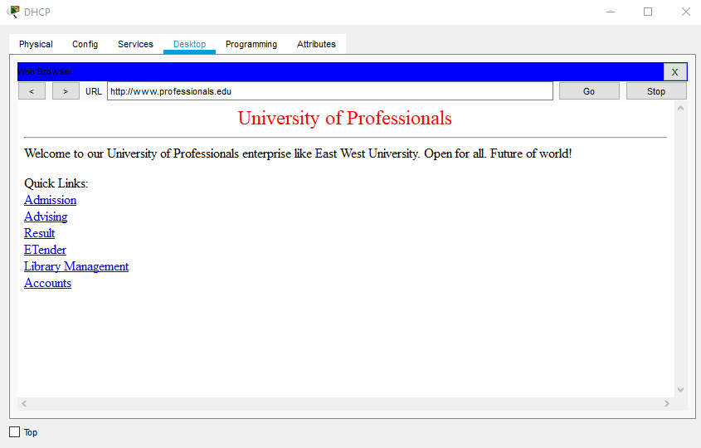

This is the allocated web page. The Web Server was used to host University of Professionals webpage, which may be accessed from any host in any network. The webpage included the necessary features to display information on Admissions, Advising, Results, and the library, among other things.

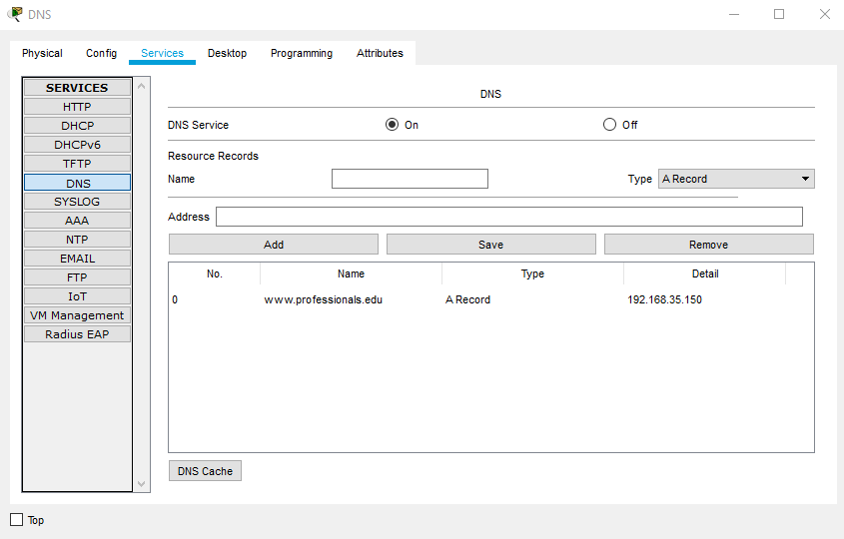

The DNS server was used so that all hosts may visit the Web Server's webpage using the required web address rather than the Web Server's IP address.

The host PCs on each campus obtained their IP addresses dynamically from a single DHCP server. It is also possible to add new hosts to the network without having to manually assign IP addresses using this setup. DHCP also sent information about the DNS server to the hosts.

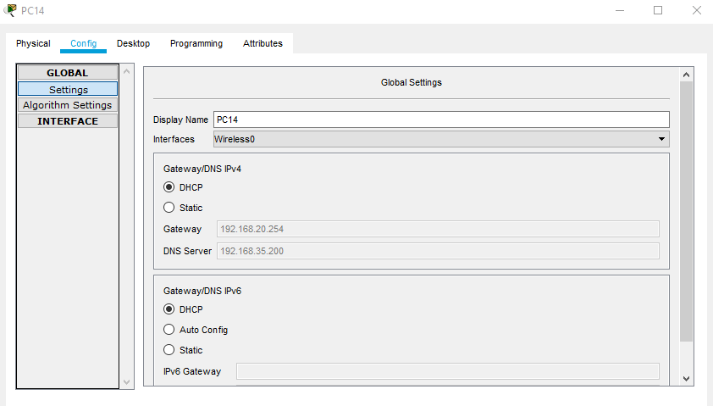

The DHCP server was used to dynamically assign IP addresses to all hosts on the six campuses, as well as the many Sub-Nets within each campus.

Wireless connections were made possible by the presence of wireless Access Points in each network. WEP encryption was used to secure the Access Points, and connecting devices required a password to connect to the wireless network.

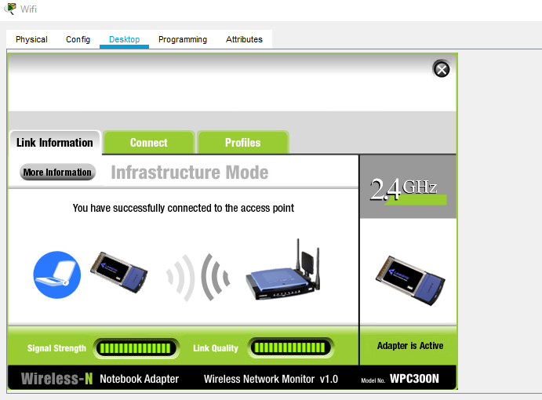

There are some other screenshots of the network functionality:

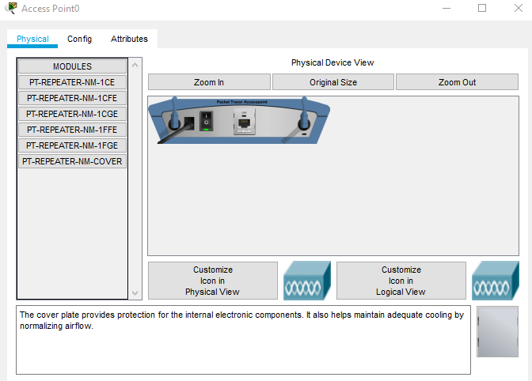

Figure: Physical view of access point

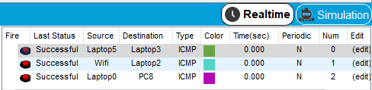

Figure: Realtime output after ping

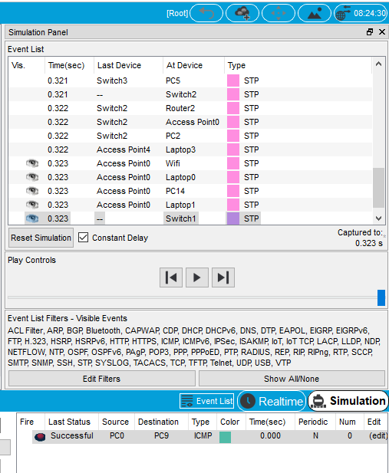

Figure: Output simulation after ping the networks

And that is how, the complete network was properly connected and communications between any of the complicated network's devices were established.

**Special Requirements:**

As per the special requirements for creating this network,

* Dynamically supply IP addresses to hosts belonging to all of the different networks, only one DHCP server was utilized.
* The servers were maintained in a server room, which was connected to a separate LAN.
* Each of the Campus Networks now includes Sub-Nets.
* The complex mesh was built with extra diagonal paths to ensure that other communications do not suffer if one or more routers fail.

**Conclusion:**

This project can be determined that the standards for University of Professionals complicated network were mostly met. A more effective routing strategy could not be adopted due to a lack of knowledge of sophisticated networking strategies and routing algorithms. A new network was developed as a result of the creation of a separate Server Room for the servers. As a result, maintaining the additional Server Room network may become costly, and extra steps must be made to ensure that the Router linking the Server Room does not go down.

The network design that was created was practical and capable of providing an effective means of communication amongst the various university campuses. Several more efforts were implemented to improve the network's reliability and robustness. During the course of this project, I learned effective networking approaches, which surely improved my networking skills.