

**Department of Computer Science & Engineering**

**CSE347 PROJECT PROPOSAL**

**BD-AGRO HELPER**

**Supervised By:**

Nishat Tasnim Niloy

Lecturer, Department of Computer Science & Engineering

East West University

**Submitted By:**

|  |  |
| --- | --- |
| **Name** | **ID** |
|  |  |
| Sazzad Hossen | 2019-1-60-063 |
|  |  |
|  |  |
|  |  |

**Date of Submission**

11 March 2023

**Introduction**

BD-AGRO HELPER is a service and information providing platform that makes life easy and saves time for the farmers who wants to acquire information regarding their crops especially, in terms of insecticides and which weather is suitable for creating a particular crop in a specific pH of land. Moreover, in case of emergency, clients can take advice from prominent experts and also Search for a specific item or list. Furthermore, they can also order fertilizers and insecticides at the cheapest price. This document contains the software requirements specification(SRS) for said app.

**Motivations**

* The main goal of our app is to give people the opportunity to get services by seeking information through an app. For example-if one needs to know which insecticides will assists them in growing a specific crop, then they’ll have to go to the website and ask experts or go through the saved information’s by using search option.
* Our app is targeted to make life easier for people by providing service. For example-In this pandemic, people are at remote areas cannot move freely so if they need to buy fertilizer they can’t go to market because of safety issues. So, in this situation they can order through website and get the required substance.
* Through this app clients can give review after taking service and recommend for future. All of that information available will be constantly available through the app’s intuitive UI.

**Challenges**

* Implementing certain features such as searching and ordering in a web-application.
* Since this project is entirely team driven, we lack any client or upper-management feedback. Lacking well-defined client-requirements will make the development process a little more difficult.
* Adding to the previous point, since we lack any client-defined deadlines, proper time management will also be an issue. To remedy this, the team as decided to use the Agile Scrum development method.
* Integrating several APIs into the application and ensuring they work properly together.
* Getting the team familiar with technologies they haven’t worked with before, namely, Django and Python.
* Making sure the UI isn’t too technical or cluttered and follows the latest design trends.
* Not being able to test the responsiveness of the app in certain devices/platforms the team doesn’t have access to, such as Safari browser (iOS), smart-televisions, etc.
* Internet Explorer probably won’t be able to support many of the app’s features. However, since IE isn’t very popular with the targeted audience, this should be considered a minor hindrance at best.
* Ensuring strict client security and protecting the client’s data.

**Non-functional Requirements**

For BD-AGRO HELPER types of non-functional requirement

1. Safety / security Requirement.
2. Environmental Requirement.
3. Usability Requirement.
4. Performance Requirement.
5. Development Requirement.

**Functional Requirements**

In BD-AGRO HELPER need a functional requirement

1. A user can easily access recommended option following the flow chart.
2. BD-AGRO HELPER is very user-friendly application. User can see all the current option in the menu bar.
3. While using BD-AGRO HELPER user can get First help, quick replies and solutions.
4. User can see he/her profile, Number, Address, Location Including log out, log in option.
5. User can Order Fertilizer and other agricultural tools from BD AGRO Application. The package will be delivered to the users in the correct location in 2/3 business day.
6. BD-AGRO HELPER also give you the suitable season and weather details for cultivating crops.
7. BD-AGRO HELPER gives the best advice to the user by our expert doctors online. Just click the photo of the crop disease then upload the picture and add your location, phone number, our expert doctor will advise the user in the description box what will be the solution or medicine for the disease.
8. There will be Agricultural news and Update in the Application so the user can get the updated news of the current situation.

**User authentication:** Since our app deal with sensitive information about the client’s information, a thorough authentication procedure should be followed.

**Research Feed:** If any fresher and user want to post something about there thesis, research paper or anything what related about agriculture they can post from this section.

**Technologies:** HTML, CSS, Bootstrap, Database, Python, Django.

**UML Use Case Diagram:**



**UML Class Diagram:**



**Activity Diagram:**



**Sequence Diagram:**

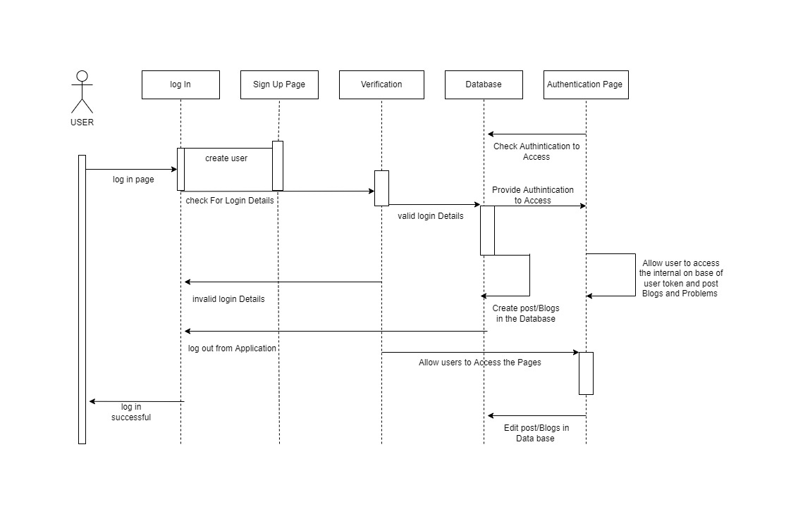

**ER diagram:**

