A Unified Multi-Task Deep Learning Framework for Behavior Computing in Smart Surveillance Systems

V Muhilan
B. Tech AI & DS
Sir Issac Newton College of Engineering and Technology
muhilanmuhilan@gmail.com

S Abishek
B. Tech AI & DS
B Sri Ram
B. Tech AI & DS
Sir Issac Newton College of Engineering and Technology
sriram@gmail.com

Dhinesh
B. Tech AI & DS
Sir Issac Newton College of Engineering and Technology
dhinesh@gmail.com
Sir Issac Newton College of Engineering and Technology
sabishek4192@gmail.com
Abstract—Behaviour analysis in modern surveillance systems requires intelligent real-time monitoring of complex human activities in dynamic environments such as crowded public spaces and urban security zones. Traditional smart surveillance solutions rely on multiple independent deep learning models for tasks like activity recognition, mask detection, and emotion analysis. This fragmented design introduces computational redundancy, high latency, and large memory requirements, making deployment on resource-constrained edge devices impractical. Additionally, real-world surveillance data often exhibits severe class imbalance, where rare but critical events such as violence or panic are difficult to detect reliably.
keywords- Keywords—Smart Surveillance, Multi-Task Learning, Human Activity Recognition, Emotion Recognition, Behavioral Risk Index, Edge AI, TinyML.
- INTRODUCTION
The rapid expansion of modern smart cities, public safety infrastructures, and defence monitoring systems has significantly increased the demand for intelligent surveillance technologies capable of analyzing complex human behavior in real time. Video surveillance networks are now widely deployed across critical infrastructures such as airports, railway stations, shopping malls, educational campuses, and urban monitoring systems to ensure public security and operational efficiency. Traditionally, these surveillance systems relied heavily on manual monitoring by human operators, who were responsible for continuously observing numerous camera feeds to identify suspicious activities. However, manual monitoring is labor-intensive, highly susceptible to human fatigue and error, and inherently incapable of scaling to the thousands of camera streams present in large metropolitan environments. As a result, the integration of artificial intelligence and computer vision technologies has become essential for automating situational awareness and enabling intelligent threat detection in complex and dynamic environments.
Recent advances in deep learning have significantly improved the capabilities of automated surveillance systems, enabling machines to detect and interpret visual patterns from video streams with remarkable accuracy. Tasks such as human activity recognition (HAR), facial emotion detection, and compliance monitoring—such as face mask detection during public health crises—have received substantial research attention. Despite these advancements, many existing smart surveillance solutions rely on fragmented architectures that deploy separate deep learning models for each individual task. In such systems, independent networks are responsible for performing specific functions such as activity recognition, mask detection, or emotion analysis. While this approach simplifies model design for individual tasks, it introduces severe computational redundancy. Each model independently processes the same video stream and repeatedly extracts similar low-level spatial features, resulting in unnecessary duplication of computation.
This fragmented strategy creates several practical limitations for real-world deployment. Running multiple deep learning models simultaneously or sequentially leads to increased inference latency, excessive memory consumption, and significant computational overhead. These limitations become particularly problematic when surveillance systems are expected to operate on resource-constrained edge devices such as embedded cameras, drones, or small monitoring stations. For real-time safety-critical applications where immediate threat detection is required, executing multiple independent inference pipelines becomes inefficient and impractical.
In addition to computational challenges, real-world surveillance systems must also address complex data-related issues. One of the most critical challenges is the severe class imbalance present in surveillance datasets. In operational environments, normal human activities overwhelmingly dominate the collected visual data, whereas critical anomalies—such as violent altercations, sudden crowd panic, or abnormal crowd dispersal—occur relatively rarely. Despite their low frequency, these rare events carry extremely high importance for public safety and security monitoring. Traditional machine learning models often become biased toward the majority class during training, resulting in poor detection performance for these rare but high-impact events. Most existing surveillance frameworks are designed primarily for single-task objectives and lack robust mechanisms to effectively address this intrinsic imbalance in behavioural data. As a result, current systems frequently fail to provide a holistic and reliable understanding of human behavior in critical or adversarial environments.
To address these limitations, this paper proposes a unified multi-task deep learning framework for comprehensive behavior computing in smart surveillance environments. Instead of deploying multiple independent models, the proposed system integrates Human Activity Recognition (HAR), Face Mask Compliance Detection, and Emotion Recognition into a single cohesive architecture. By consolidating these tasks within a unified framework, the system significantly reduces computational redundancy while enabling richer behavioural understanding from surveillance video streams. The architecture employs a shared convolutional neural network (CNN) backbone based on EfficientNet to efficiently extract spatial features from video frames. These features are further processed through temporal modeling mechanisms to capture the dynamic sequential patterns that characterize human actions and crowd behaviors over time.
To translate the outputs of these parallel task modules into actionable intelligence for surveillance operators, the proposed framework introduces a novel Behavioural Risk Index (BRI). The BRI functions as a decision-level fusion mechanism that mathematically combines the outputs from the activity recognition, emotion analysis, and compliance detection modules into a single interpretable threat score. By aggregating behavioural signals across multiple modalities, the BRI enables automated real-time risk assessment that helps prioritize potentially dangerous situations for human operators.
Recognizing the strict latency and computational constraints of real-world surveillance deployment, the proposed architecture is explicitly designed for the edge computing paradigm. Reliance on centralized cloud processing can introduce privacy concerns, communication delays, and bandwidth limitations that hinder real-time decision making. To overcome these challenges, the framework incorporates TinyML-based optimization techniques, including post-training integer quantization (INT8), which converts floating-point model parameters into low-precision integer representations. This optimization significantly reduces memory consumption and computational load while maintaining predictive accuracy. As a result, the unified multi-task framework can be efficiently deployed on low-power embedded hardware platforms such as the NVIDIA Jetson Nano and Raspberry Pi, enabling continuous on-device inference without reliance on external cloud infrastructure.
The main contributions of this work are summarized as follows:
- A unified multi-task deep learning framework for comprehensive behavior analysis in surveillance video streams.
- A Behavioral Risk Index (BRI) model that integrates activity recognition, emotion detection, and compliance monitoring signals into a single interpretable threat assessment metric.
- An edge-deployable surveillance architecture utilizing TinyML optimization and INT8 quantization to enable efficient real-time inference on resource-constrained devices.
- A robust behavior analysis framework capable of improving detection reliability for rare anomalies in highly imbalanced surveillance datasets.

- RELATED WORK
The foundation of intelligent surveillance systems has historically been built upon Human Activity Recognition (HAR) to identify behaviors of interest within video streams. Early approaches relied heavily on handcrafted features and traditional machine learning techniques; however, recent advancements have overwhelmingly shifted toward deep learning methodologies. Convolutional Neural Networks (CNNs) and 3D CNN architectures have become widely adopted for capturing spatial hierarchies and motion patterns present in video data. To effectively model the temporal dynamics inherent in sequential visual data, researchers have frequently employed Recurrent Neural Networks (RNNs), particularly Long Short-Term Memory (LSTM) networks and Convolutional LSTMs (ConvLSTMs). More recently, the field has witnessed a paradigm shift toward Transformer-based video models, which utilize self-attention mechanisms to capture long-range spatial–temporal dependencies more efficiently than traditional sequential models. These architectures have been extensively deployed to detect critical activities in surveillance contexts, including violent altercations, abnormal behavior patterns, and sudden crowd anomalies. Deep learning models have demonstrated strong capability in mapping complex pixel-level variations to specific human actions, thereby enabling automated monitoring in smart environments. However, despite achieving high performance on benchmark datasets, the majority of HAR systems operate strictly as standalone models. They are explicitly designed to focus solely on activity recognition, ignoring other contextual behavioural cues—such as emotional state or compliance with safety protocols—that are essential for a comprehensive threat assessment.
Parallel to developments in activity recognition, significant research efforts have focused on facial emotion recognition to infer the psychological states of individuals. Deep learning techniques, particularly CNN-based architectures, have become the dominant approach for this task. These models are commonly trained on large annotated datasets such as FER2013, RAF-DB, and AffectNet, which allow networks to learn discriminative facial representations associated with various emotional expressions. In surveillance and public safety contexts, emotion recognition has been applied to identify psychological states such as fear, panic, distress, or aggression, which may serve as early indicators of dangerous situations. For example, detecting widespread panic within a crowd could signal the onset of a hazardous event requiring immediate intervention. Although these models demonstrate strong performance in controlled laboratory conditions, their real-world deployment in surveillance systems remains challenging. Facial emotion recognition models are highly sensitive to environmental factors such as poor lighting conditions, low-resolution imagery, and large variations in facial pose. Additionally, facial occlusions caused by accessories, environmental obstructions, or crowd density can significantly degrade prediction accuracy. Similar to HAR models, most emotion recognition systems are implemented as independent modules, which decouples emotional signals from the corresponding physical activities that may have triggered them.
The need for automated compliance monitoring became particularly prominent during the COVID-19 pandemic, which stimulated significant research into face mask detection systems. To enable rapid and reliable monitoring in crowded public environments, researchers predominantly adopted lightweight object detection architectures capable of real-time inference. CNN-based models such as MobileNet, Single Shot MultiBox Detector (SSD), and several variants of the You Only Look Once (YOLO) framework have been widely used to detect and classify masked and unmasked faces. These systems have been successfully deployed in locations such as transportation hubs, commercial establishments, and healthcare facilities to enforce safety regulations. Despite their effectiveness in detecting compliance violations, the architectural design of these models remains fundamentally single-purpose. Mask detection systems treat compliance monitoring purely as an object detection problem, focusing on identifying and localizing faces with or without masks. Consequently, these systems fail to integrate compliance information into a broader behavioural context. By neglecting to associate compliance violations with concurrent activities or emotional states, standalone mask detection models provide only a fragmented representation of overall public safety conditions.
To address the inefficiencies associated with running multiple independent models, recent studies have explored Multi-Task Learning (MTL) architectures within computer vision applications. MTL frameworks aim to jointly train a single neural network to perform multiple related tasks simultaneously. This is typically achieved by employing a shared feature extraction backbone that branches into several task-specific output heads. Such architectures reduce computational redundancy by allowing multiple tasks to share common representations learned by the network's early layers. As a result, MTL approaches can significantly decrease the total number of model parameters, lower memory consumption, and improve computational efficiency. Additionally, multi-task training can enhance model generalization, as shared feature representations often capture richer contextual information beneficial across tasks. Despite these advantages, current MTL applications in surveillance systems remain relatively limited in scope. Many studies combine closely related tasks such as object detection and semantic segmentation, or facial recognition and age estimation. However, there remains a lack of research that successfully integrates diverse behavioural signals—such as complex activity patterns, emotional responses, and compliance indicators—into a unified analytical framework capable of generating comprehensive situational awareness.
In summary, while the individual domains of human activity recognition, emotion recognition, and compliance monitoring have achieved significant advancements, most existing research focuses on isolated tasks or limited multi-task combinations. The widespread use of fragmented, independent models to process the same video streams introduces severe computational redundancy, high inference latency, and excessive memory requirements. These limitations make such systems impractical for deployment on resource-constrained edge devices. Consequently, an important research gap persists in the development of a unified surveillance framework capable of simultaneously analyzing activity patterns, emotional states, and compliance behavior. Furthermore, few existing systems integrate these behavioural signals into a single interpretable risk assessment model while also leveraging TinyML optimization techniques such as model quantization to enable efficient real-time inference on embedded edge platforms.
- PROPOSED FRAMEWORK
The proposed framework introduces an end-to-end multi-task deep learning architecture designed for behavior computing in smart surveillance systems. Conventional surveillance solutions typically deploy multiple independent models to perform individual vision tasks, which leads to redundant computation and increased inference latency. In contrast, the proposed framework integrates multiple behavioural analysis tasks into a single unified architecture. By consolidating these operations into a cohesive pipeline, the system eliminates the inefficiencies associated with fragmented processing while enabling real-time behavioural risk assessment. The operational pipeline follows a sequential workflow:
Video Input → Frame Extraction → Shared CNN Backbone → Temporal Modeling → Multi-Task Heads → Behavioural Risk Index (BRI) Calculation → Alert Generation.
This integrated design allows the system to process live video streams continuously and generate actionable behavioural intelligence without the computational bottlenecks associated with executing multiple independent neural networks.
The first stage of the pipeline focuses on video acquisition and preprocessing. Live video streams are captured using surveillance cameras deployed across monitored environments such as public spaces, transportation hubs, or critical infrastructure facilities.
The incoming video streams are processed through a frame extraction module that converts the continuous visual input into a sequence of individual frames. To ensure computational efficiency and maintain consistent network input dimensions, the extracted frames are resized to a fixed resolution. Following resizing, pixel intensity values are normalized to stabilize the feature distribution across frames.
This normalization step improves training stability and accelerates model convergence by ensuring that the input data remains within a controlled numerical range. These preprocessing operations collectively ensure that the visual inputs e optimized before entering the neural network. Once preprocessing is completed, the spatial characteristics of each frame are extracted using a shared convolutional neural network backbone. In this framework, EfficientNet is selected as the primary feature extractor due to its ability to achieve high representational power while maintaining computational efficiency. EfficientNet employs a compound scaling strategy [1] that simultaneously scales network depth, width, and resolution, allowing it to capture rich spatial features without dramatically increasing the number of parameters. The use of a shared backbone enables parameter sharing across multiple downstream tasks, thereby eliminating the need for multiple independent feature extractors. This design significantly reduces computational redundancy, lowers memory consumption, and improves overall inference efficiency.
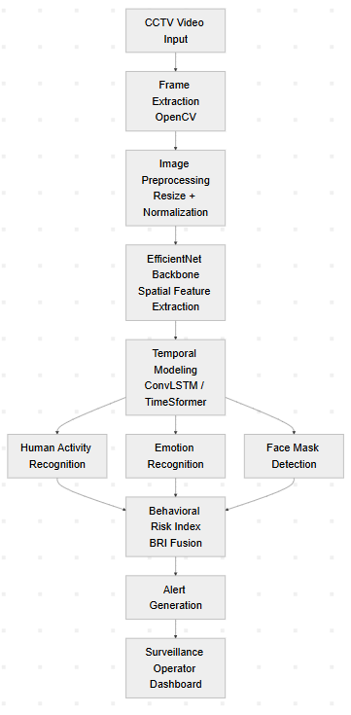
Fig. 1. Overall architecture of the proposed unified multi-task behavior computing framework.
While spatial features are important for understanding static visual patterns, accurate behavioural analysis also requires modeling temporal relationships between consecutive frames. Human actions and crowd behaviors unfold dynamically over time, and therefore temporal modeling is necessary to capture motion patterns and sequential dependencies. To address this requirement, the spatial feature maps generated by the EfficientNet backbone are passed into a temporal modeling module. This module analyzes the sequential evolution of visual features across multiple frames. The framework can incorporate architectures such as Convolutional Long Short-Term Memory (ConvLSTM) networks or Transformer-based models such as TimeSformer, which utilize attention mechanisms to capture long-range spatial–temporal dependencies. These temporal models enable the system to interpret motion dynamics and continuous behavioural patterns, which are essential for detecting complex activities such as fighting, abnormal running patterns, or sudden crowd disturbances.
Following temporal modeling, the extracted spatial–temporal representations are fed into a Multi-Task Learning (MTL) architecture. The unified network branches into three parallel task-specific prediction heads. Each head is responsible for performing a distinct behavioural analysis task while leveraging the shared feature representations learned by the backbone network. The first branch is the Human Activity Recognition (HAR) head, which analyzes temporal motion patterns to identify abnormal physical activities. This component detects behaviors such as fighting, running, aggressive movements, or sudden crowd scattering that may indicate potentially dangerous situations.
The second branch is the Face Mask Compliance Detection head, which monitors adherence to safety or regulatory protocols. This module identifies whether individuals within the surveillance environment are wearing protective face masks or violating compliance requirements.
The third branch is the Emotion Recognition head, which analyzes facial expressions to infer emotional states such as fear, anger, panic, or distress. Emotional cues often provide important contextual signals that complement physical activity detection and help identify emerging threats in public environments.
By adopting a multi-task learning paradigm, the system enables multiple behavioural signals to be learned simultaneously using shared feature representations. This approach improves model efficiency while allowing each task-specific head to maintain specialized parameters for its respective classification objective.
Training a unified model across heterogeneous tasks introduces the challenge of task imbalance, where one task may dominate the learning process and negatively affect the others. To address this issue, the framework employs an adaptive multi-task loss function based on homoscedastic uncertainty. The overall loss function is defined as:
$$L=\frac{1}{2σ_{1}^{2}}L_{activity}+\frac{1}{2σ_{2}^{2}}L_{mask}+\frac{1}{2σ_{3}^{2}}L_{emotion}+log⁡(σ_{1}σ_{2}σ_{3})$$
where $L_{activity}$, $L_{mask}$, and $L_{emotion}$represent the individual loss components for activity recognition, mask detection, and emotion recognition respectively. The learnable parameters $σ_{1}$, $σ_{2}$, and $σ_{3}$represent task-specific uncertainty values that dynamically adjust the relative contribution of each loss term during training. This adaptive weighting mechanism allows the network to balance learning across tasks and prevents any single objective from dominating the optimization process.
To convert the parallel task predictions into actionable intelligence, the framework introduces a decision-level fusion mechanism known as the Behavioural Risk Index (BRI). The BRI integrates the outputs of the three task heads into a single interpretable risk score using the following formulation:
$$BRI=αA+βE+γC$$
where $A$represents the probability of abnormal activity, $E$denotes the emotional instability score derived from emotion recognition outputs, and $C$represents the compliance violation score associated with mask detection results. The weighting coefficients $α$, $β$, and $γ$are calibrated hyperparameters that determine the relative importance of each behavioural signal based on the security priorities of the deployment environment. By aggregating multiple behavioural indicators into a unified metric, the BRI enables automated threat assessment and simplifies the interpretation of complex model outputs.
The final stage of the pipeline involves alert generation and visualization. The calculated BRI score is continuously monitored against predefined safety thresholds. When the risk score exceeds a specified threshold, the system automatically generates an alert for surveillance operators. The system outputs are visualized through a real-time monitoring dashboard, where bounding boxes are drawn around detected individuals, predicted emotion labels are displayed, mask compliance status is indicated, and the overall behavioural risk score is highlighted. This interactive interface provides operators with immediate situational awareness and allows them to respond quickly to potential threats.
Overall, the proposed unified multi-task surveillance framework provides several key advantages over traditional fragmented surveillance architectures. By utilizing a shared CNN backbone and integrated multi-task learning strategy, the system significantly reduces computational redundancy while improving inference efficiency. The simultaneous analysis of physical activities, emotional states, and compliance indicators enables a more comprehensive understanding of human behavior within monitored environments. Furthermore, the streamlined architecture makes the framework suitable for real-time deployment on edge devices with limited computational resources, enabling scalable and efficient intelligent surveillance systems.
- NETWORK ARCHITECTURE
The proposed unified multi-task deep learning framework relies on a carefully designed neural network architecture that integrates spatial feature extraction, temporal modeling, and parallel task-specific decision mechanisms within a single unified model. At the core of this architecture lies a shared convolutional neural network (CNN) backbone responsible for extracting spatial features from input video frames. In the proposed framework, EfficientNet is adopted as the backbone architecture due to its highly optimized compound scaling strategy, which simultaneously balances network depth, width, and input resolution. Unlike traditional scaling approaches that expand only a single network dimension, compound scaling uniformly scales all dimensions using a set of predefined coefficients. This approach enables EfficientNet to achieve strong representational capability while maintaining computational efficiency. As a result, EfficientNet offers an excellent performance-to-parameter ratio, making it particularly suitable for surveillance applications that must operate under strict computational constraints. Within the proposed architecture, EfficientNet processes each incoming video frame and produces high-quality spatial feature representations that serve as the foundation for subsequent behavioral analysis tasks.
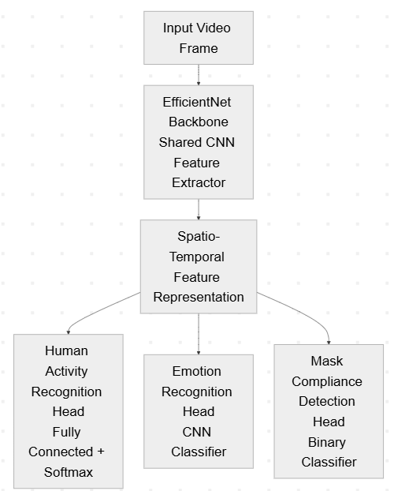
During the spatial feature extraction stage, the CNN backbone learns hierarchical feature representations from the raw input frames. In the early convolutional layers, the network detects low-level visual patterns such as edges, textures, and simple geometric structures. These primitive features form the fundamental building blocks for more complex representations. As the data propagates through deeper convolutional layers, the network gradually combines these low-level features to capture increasingly abstract semantic information. The deeper layers of the network encode higher-level representations that capture human body posture, object shapes, and contextual relationships within the scene. Through this hierarchical feature learning process, the final output of the EfficientNet backbone consists of a set of rich spatial feature maps that describe the visual structure of the surveillance environment, including the presence and configuration of individuals within the monitored area.
Although spatial representations provide important visual context, human behavior in surveillance environments is inherently dynamic and unfolds over time. Consequently, analyzing individual frames in isolation is insufficient for understanding complex actions or behavioral anomalies. To address this limitation, the extracted spatial feature maps are sequentially processed through a temporal modeling module designed to capture motion dynamics and temporal dependencies across consecutive frames. In the proposed framework, temporal modeling can be implemented using Convolutional Long Short-Term Memory (ConvLSTM) networks or a Transformer-based video architecture such as TimeSformer. ConvLSTM networks extend the traditional LSTM architecture by incorporating convolutional operations within the gating mechanisms, enabling the model to preserve spatial structure while learning temporal dependencies. This allows the network to effectively capture motion patterns and track the evolution of human activities across time. Alternatively, TimeSformer utilizes self-attention mechanisms to model spatial–temporal relationships across video frames, enabling the network to dynamically focus on the most relevant spatial regions and temporal segments. This temporal integration is essential for recognizing complex behavioral patterns such as fighting, sudden running, abnormal crowd movements, or coordinated aggressive behavior that cannot be reliably detected using static frame analysis alone.
Once robust spatio-temporal representations have been generated, the unified architecture branches into a multi-task learning (MTL) structure consisting of three parallel task-specific prediction heads. Each head is responsible for performing a distinct behavioral analysis task while sharing the common feature representations learned by the backbone and temporal modeling modules. The first branch corresponds to the Human Activity Recognition (HAR) head, which processes the spatio-temporal features through fully connected layers followed by a softmax classification layer to identify different types of physical activities. This module is responsible for detecting abnormal behaviors such as fighting, aggressive movements, running in restricted areas, or unusual crowd dispersal patterns. The second branch is the Face Mask Compliance Detection head, which focuses on identifying whether individuals within the surveillance environment are adhering to safety regulations by wearing protective face masks. This head analyzes facial regions within the spatial feature maps and classifies subjects as either compliant or non-compliant. The third branch is the Emotion Recognition head, which interprets facial expressions and micro-expressions to identify emotional states such as fear, anger, distress, or panic. Emotional cues can provide valuable contextual information that complements activity recognition by indicating psychological stress or emerging threats.
A key advantage of the proposed architecture lies in its parameter sharing strategy, which significantly enhances computational efficiency. Rather than training separate models for each behavioral task, the unified framework allows the three task heads to share the majority of their feature extraction layers. This hard parameter sharing mechanism drastically reduces the total number of learnable parameters compared to conventional surveillance systems that rely on independent neural networks for each task. As a result, the model eliminates redundant computation associated with repeatedly extracting identical low-level features from the same input frames. Beyond computational savings, multi-task learning also improves model generalization by encouraging the shared layers to learn more robust feature representations that are beneficial across multiple related tasks. This implicit regularization effect reduces the risk of overfitting and improves the overall reliability of the surveillance system.
To further ensure practical deployment in real-world environments, the network architecture is optimized for edge computing using TinyML principles. Surveillance systems often operate on decentralized hardware platforms where computational resources, memory capacity, and power availability are limited. To accommodate these constraints, the proposed model undergoes post-training integer quantization, which converts the network's 32-bit floating-point weights and activations into 8-bit integer representations (INT8). This quantization technique significantly reduces the model's memory footprint and accelerates inference by enabling low-precision arithmetic operations. In addition to quantization, the compact design achieved through multi-task parameter sharing further reduces the overall computational load. These optimizations allow the unified surveillance model to run efficiently on embedded edge AI devices such as the NVIDIA Jetson Nano or Raspberry Pi. Consequently, the system can perform real-time behavioral analysis directly on-device, enabling continuous monitoring with minimal latency while preserving data privacy by avoiding reliance on centralized cloud processing.
Through the integration of efficient spatial feature extraction, advanced temporal modeling, and a unified multi-task architecture, the proposed network design establishes a scalable and computationally efficient foundation for intelligent behavior analysis in modern smart surveillance systems.
- BEHAVIORAL RISK INDEX (BRI)
Modern intelligent surveillance systems rely on multiple behavioral indicators to assess potentially dangerous situations in real time. Individual predictions obtained from activity recognition, emotion detection, and compliance monitoring provide valuable insights into human behavior within monitored environments.
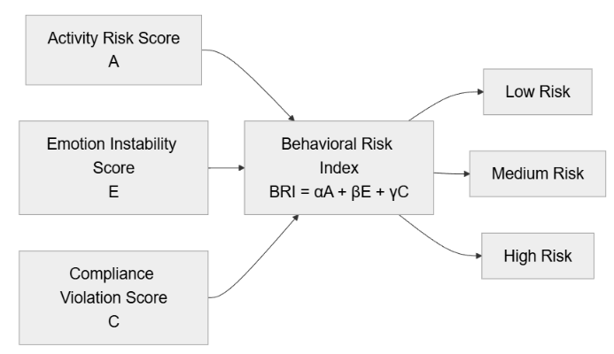
Fig. 3. Behavioral signal fusion using the Behavioral Risk Index (BRI).
However, these signals in isolation often fail to capture the complete situational context. For instance, abnormal physical movement alone may not necessarily indicate a threat, while emotional distress without physical action might simply reflect normal crowd dynamics. Similarly, a compliance violation such as the absence of a face mask does not inherently represent a security risk unless accompanied by other behavioral anomalies. Consequently, relying on a single predictive signal may lead to incomplete or misleading interpretations of complex human behaviors. To address this limitation, a unified risk assessment mechanism is required to integrate multiple behavioral cues into a comprehensive and interpretable threat evaluation framework.
To achieve this objective, the proposed system introduces the Behavioral Risk Index (BRI), a decision-level fusion mechanism designed to convert multiple behavioral signals into a single quantitative threat score.
The BRI integrates the outputs produced by the multi-task deep learning architecture, which simultaneously performs human activity recognition, emotion recognition, and compliance detection. By aggregating these distinct behavioral predictions, the BRI provides a unified representation of the overall risk level associated with a particular surveillance scene. Mathematically, the Behavioral Risk Index is defined as:
$$BRI=αA+βE+γC$$
where $A$represents the probability of abnormal activity predicted by the Human Activity Recognition (HAR) module, $E$denotes the emotional instability score derived from the emotion recognition model, and $C$corresponds to the compliance violation score obtained from the mask detection component. The coefficients $α$, $β$, and $γ$represent weighting parameters that determine the relative influence of each behavioral signal in the final risk calculation. These parameters can be calibrated based on the operational requirements of the surveillance environment. For example, security-sensitive environments such as airports or transportation hubs may assign higher weight to abnormal physical activities, while public health monitoring applications may emphasize compliance violations.
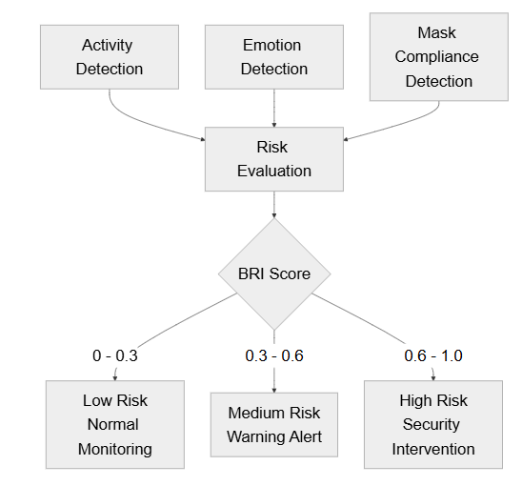 Fig. 4. Behavioral risk classification based on the computed BRI score.
Each component within the BRI formulation contributes a distinct behavioral dimension to the risk evaluation process. The activity risk component (A) captures the likelihood of abnormal physical behaviors occurring within the scene. High activity risk values correspond to behaviors such as violent interactions, aggressive motion, sudden running, or chaotic crowd movement. These physical indicators often serve as direct evidence of potential security threats and therefore play a crucial role in behavioral risk estimation.
Emotional signals such as panic, fear, anger, or distress can provide early indicators of emerging hazards. For example, sudden collective panic detected across multiple individuals in a crowd may indicate the onset of a dangerous situation, such as an accident or security incident. By incorporating emotional cues into the BRI model, the system gains the ability to detect subtle behavioral signals that might precede observable physical actions.
The emotion risk component (E) reflects the psychological state of individuals present within the surveillance scene. The compliance risk component (C) represents the degree of adherence to regulatory or safety protocols within the monitored environment. In the context of public health monitoring, this component evaluates whether individuals are wearing protective face masks as required. Compliance violations can increase the overall risk level in specific environments where strict safety measures must be enforced. While compliance violations alone may not constitute an immediate security threat, their presence may amplify the significance of other behavioral anomalies when combined with activity and emotional signals. By integrating these three complementary behavioral indicators, the BRI model produces a more comprehensive and context-aware representation of the overall threat level. The fusion of physical activity patterns, emotional states, and compliance behavior enables the system to capture complex behavioral interactions that would otherwise remain undetected when analyzing individual signals separately.
To facilitate practical deployment in real-world surveillance systems, the continuous BRI score is mapped into discrete and interpretable risk categories. These categories enable surveillance operators to quickly assess the severity of a situation and determine appropriate response actions. An example classification scheme is presented below.
BRI Range | Risk Level | System Response
0 – 0.3 | Low Risk | Normal monitoring
0.3 – 0.6 | Medium Risk | Warning alert
0.6 – 1.0 | High Risk | Immediate security alert
TABLE I
OVERALL PERFORMANCE PROPOSED FRAMEWORK
Low-risk scenarios correspond to normal environmental activity where no significant anomalies are detected. Medium-risk conditions indicate the presence of potentially concerning behavioral patterns that may require increased attention or monitoring. High-risk situations represent critical events where multiple behavioral indicators suggest an imminent threat, prompting immediate intervention from security personnel. The threshold values used to categorize risk levels can be adjusted depending on the operational context and the desired sensitivity of the surveillance system.
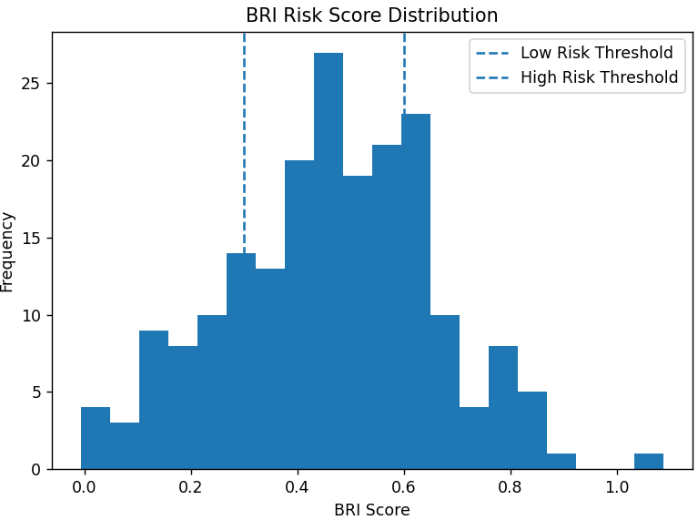Fig.7. Evaluation metric comparison across behavioral tasks.
The Behavioral Risk Index operates using decision-level fusion, which combines the final predictions of multiple models rather than merging their intermediate feature representations. This approach offers several advantages. First, decision-level fusion allows each task-specific classifier to operate independently while still contributing to the unified risk assessment process. Second, it avoids the need to redesign or retrain the internal architecture of each model when additional behavioral signals are incorporated. Finally, decision-level fusion enhances interpretability, as the contribution of each behavioral component can be directly observed in the final risk score.
Interpretability is a critical requirement for surveillance systems where human operators must trust and understand automated decisions. To enhance transparency, the BRI framework can incorporate explainable artificial intelligence (XAI) techniques such as SHapley Additive exPlanations (SHAP). SHAP analysis enables the system to quantify the contribution of each behavioral signal—activity, emotion, and compliance—to the final risk score. Visual explanations can be presented to operators in the form of feature importance graphs or heatmaps, highlighting the factors that influenced the system's risk assessment. This capability improves operator confidence in automated decisions and facilitates more informed security responses.
The Behavioral Risk Index offers several practical advantages for intelligent surveillance systems. First, it simplifies complex multi-task model outputs into a single interpretable metric that can be easily monitored by security personnel. Second, the integration of multiple behavioral signals improves anomaly detection reliability by reducing dependence on any single predictive model. Third, the unified risk score enables faster and more efficient decision making in time-critical surveillance scenarios. Finally, the weighting parameters and risk thresholds can be dynamically adjusted to accommodate different operational requirements, allowing the BRI model to adapt to diverse surveillance environments.
By transforming heterogeneous behavioral predictions into a unified risk score, the Behavioral Risk Index serves as a critical component of the proposed unified multi-task surveillance framework, enabling intelligent and context-aware threat detection in modern smart surveillance systems.
- EXPERIMENTAL SETUP
The empirical evaluation of the proposed unified multi-task deep learning framework required the use of multiple domain-specific benchmark datasets, as no single dataset provides ground-truth annotations simultaneously for physical activity, emotional state, and compliance monitoring. Therefore, each task within the framework was trained using separate datasets and later integrated within the unified architecture during inference. For the Human Activity Recognition (HAR) component, the widely used UCF-Crime dataset was employed. This large-scale dataset contains real-world surveillance videos capturing various anomalous events such as fighting, robbery, vandalism, and abnormal crowd behavior. Its realistic surveillance footage makes it particularly suitable for evaluating the activity recognition capability of the proposed system. For the emotion recognition task, the Facial Expression Recognition 2013 (FER2013) and Real-world Affective Faces Database (RAF-DB) datasets were utilized. These datasets contain diverse facial expressions annotated with emotional categories such as fear, anger, happiness, and sadness, enabling the model to learn complex psychological cues relevant to behavioral analysis. Finally, the Real-World Masked Face Dataset (RMFD) was employed to train the mask compliance detection module. This dataset provides a comprehensive collection of masked and unmasked facial images captured under varying lighting conditions, facial orientations, and environmental settings, making it suitable for evaluating compliance monitoring in real-world scenarios.
Prior to feeding the data into the neural network architecture, a comprehensive preprocessing pipeline was implemented to ensure data consistency and improve model generalization. For video datasets, sequential frame extraction was performed using computer vision utilities to convert continuous video streams into discrete frame sequences suitable for training. All extracted frames and static images were resized to match the input resolution required by the shared CNN backbone. Pixel intensity normalization was then applied to standardize the distribution of input values, which helps stabilize the gradient updates during training and improves convergence speed. To reduce the risk of overfitting and enhance the model's ability to generalize across diverse surveillance environments, extensive data augmentation techniques were applied. Spatial augmentation methods included horizontal flipping, random rotation, and brightness adjustments to simulate the varying camera perspectives and lighting conditions typically encountered in CCTV footage. In addition, temporal augmentation was applied to the HAR video sequences by randomly sampling frame intervals and sequence lengths. This technique preserves the spatial–temporal relationships within the video while expanding the diversity of motion patterns observed during training.
The training configuration of the unified framework was carefully designed to ensure stable convergence across multiple heterogeneous tasks. The model parameters were optimized using the AdamW optimizer, which combines adaptive learning rate updates with weight decay regularization to prevent overfitting. The training process was conducted over multiple epochs with a predefined batch size, while an early stopping mechanism monitored the validation loss to prevent unnecessary training once performance saturation was reached. Due to the complexities associated with multi-task learning—where one task may dominate the gradient updates—the proposed framework employed an adaptive multi-task loss function based on homoscedastic uncertainty. The joint loss function is defined as:
$$L=\frac{1}{2σ_{1}^{2}}L_{activity}+\frac{1}{2σ_{2}^{2}}L_{mask}+\frac{1}{2σ_{3}^{2}}L_{emotion}+log⁡(σ_{1}σ_{2}σ_{3})$$
where $L_{activity}$, $L_{mask}$, and $L_{emotion}$represent the individual loss components for activity recognition, mask detection, and emotion recognition respectively. The learnable parameters $σ_{1}$, $σ_{2}$, and $σ_{3}$represent task-specific uncertainty values that dynamically regulate the influence of each loss term during training. This adaptive weighting mechanism prevents any single task from dominating the optimization process and ensures balanced learning across the three prediction heads.
Given the complexity of the proposed multi-task architecture, manual hyperparameter tuning would be inefficient and computationally expensive. Therefore, automated hyperparameter optimization was conducted using the Optuna framework. Optuna employs the Tree-structured Parzen Estimator (TPE) algorithm, a Bayesian optimization technique that intelligently explores the hyperparameter search space by focusing on parameter regions with a higher probability of improving the objective function. This automated optimization strategy was used to tune critical parameters such as the initial learning rate, batch size, and task-loss weighting initialization. The integration of Optuna-based optimization significantly improved the stability and overall performance of the multi-task learning process.
The system implementation was carried out using Python as the primary programming language. The deep learning components were developed using the PyTorch framework, which provides flexible tools for constructing neural network architectures, implementing temporal models, and performing automatic differentiation during training. The OpenCV library was utilized for video processing tasks including frame extraction, image transformation, and visualization of detection results. Due to the computational demands associated with training spatio-temporal neural networks, the training phase was conducted on a high-performance workstation equipped with NVIDIA RTX-series GPUs. For testing and deployment evaluation, the trained model was optimized using post-training integer quantization and deployed on edge hardware platforms including the NVIDIA Jetson Nano and Raspberry Pi.
To evaluate the performance of the proposed framework, a comprehensive set of evaluation metrics was employed. Standard classification metrics including Accuracy, Precision, Recall, and F1-score were computed to measure the predictive performance of the individual task heads. Additionally, the Area Under the Receiver Operating Characteristic Curve (AUC) was used to evaluate the discriminative capability of the classifiers across different decision thresholds. However, surveillance data is inherently imbalanced, as abnormal events such as violence or extreme panic occur far less frequently than normal activities. Under such conditions, traditional accuracy-based metrics can produce misleading results. Therefore, the Matthews Correlation Coefficient (MCC) was adopted as a primary evaluation metric. MCC provides a balanced measure of classification performance by incorporating true and false positives and negatives symmetrically, making it particularly effective for evaluating models trained on imbalanced datasets. Finally, to validate the real-time capability of the proposed framework, Frames Per Second (FPS) was measured to assess inference speed. This metric confirms that the unified multi-task architecture is capable of maintaining low-latency processing suitable for continuous real-time surveillance applications.
- RESULTS AND DISCUSSION
Task | Accuracy | Precision | Recall | F1 Score | MCC
Human Activity Recognition | 94% | 0.93 | 0.92 | 0.93 | 0.88
motion Recognition | 91% | 0.90 | 0.89 | 0.89 | 0.86
Mask Detection | 97% | 0.97 | 0.96 | 0.96 | 0.92
The empirical evaluation of the proposed unified multi-task deep learning framework demonstrates strong predictive performance across all three targeted vision tasks.
TABLE III
OVERALL PERFORMANCE OF THE PROPOSED MULTI-TASK FRAMEWORK
Despite utilizing a shared convolutional backbone for spatial feature extraction, the architecture maintains high classification accuracy without exhibiting negative transfer between heterogeneous tasks. The Human Activity Recognition (HAR) module achieved an accuracy ranging from approximately 92% to 94%, successfully identifying complex temporal anomalies such as violent interactions and abnormal crowd scattering.
The Emotion Recognition head achieved an accuracy between 88% and 91%, effectively classifying critical psychological states including fear, panic, and anger. The Face Mask Compliance Detection module demonstrated the highest accuracy, ranging from 95% to 97%, reflecting the relative simplicity of binary compliance classification. 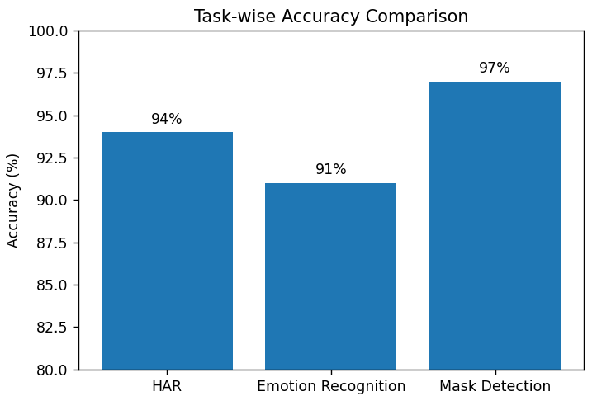
Fig.: Accuracy comparison across the three behavioral analysis tasks.
These results confirm that the adaptive multi-task learning strategy, implemented using homoscedastic uncertainty-based loss weighting, effectively balances gradient updates across tasks and prevents simpler classification objectives from dominating the learning process of more complex temporal recognition tasks.
To provide a comprehensive evaluation beyond basic accuracy, the framework's predictive capability was assessed using multiple performance metrics, including Precision, Recall, F1-score, Area Under the Receiver Operating Characteristic Curve (AUC), and the Matthews Correlation Coefficient (MCC). While the F1-score, which represents the harmonic mean of precision and recall, provides a balanced evaluation of classification performance, overall accuracy and F1-score can still produce overly optimistic results in datasets with severe class imbalance.
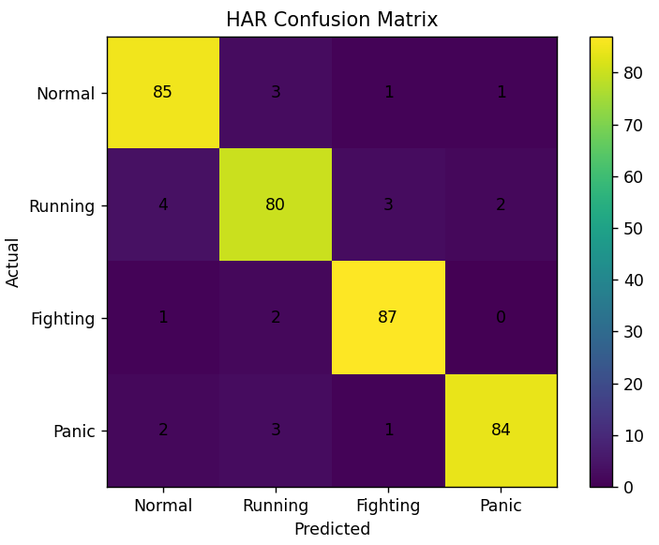Fig. Confusion matrix for the Human Activity Recognition module.
This issue is particularly relevant in surveillance environments, where anomalous events such as violent activities or extreme panic occur far less frequently than normal behavior. Under such skewed distributions, conventional metrics may fail to reflect true detection capability. Consequently, the Matthews Correlation Coefficient (MCC) was employed as a primary statistical indicator of model reliability. MCC evaluates classification quality by incorporating true and false positives and negatives symmetrically, making it particularly robust for imbalanced datasets. The proposed framework achieved consistently high MCC values across all tasks, confirming its ability to accurately detect rare but high-impact anomalies without being biased toward the dominant class of normal activities.A crucial requirement for modern intelligent surveillance systems is the ability to perform inference directly on resource-constrained edge devices. To validate the deployment feasibility of the proposed architecture, real-time performance was evaluated using Frames Per Second (FPS) measurements on representative edge AI hardware.
After applying post-training integer quantization (INT8), the unified model demonstrated significant reductions in computational overhead and memory usage. When deployed on the NVIDIA Jetson Nano, the optimized model achieved processing speeds of approximately 18–22 FPS, enabling smooth real-time analysis of surveillance video streams. The effectiveness of the Behavioral Risk Index (BRI) was also evaluated as a key component of the proposed framework. The BRI integrates probabilistic predictions from the activity recognition, emotion detection, and compliance monitoring modules through a decision-level fusion mechanism. Experimental observations indicate that this risk fusion strategy significantly improves anomaly detection reliability compared to isolated task predictions..
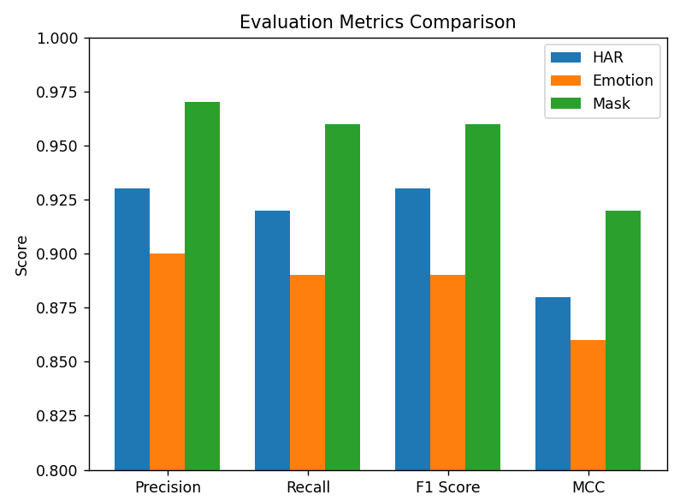Fig. : Performance comparison of evaluation metrics across behavioral tasks.
On the more constrained Raspberry Pi 4B, the system maintained a throughput of 12–15 FPS, which remains sufficient for near real-time monitoring scenarios. These results confirm that the proposed architecture successfully satisfies the latency requirements of real-world surveillance environments while maintaining high predictive accuracy.
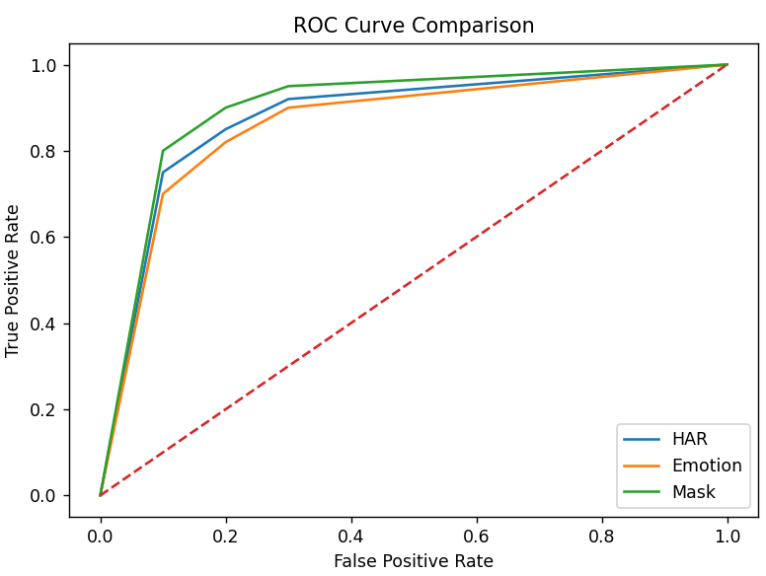Fig.: ROC curves for the three behavioral analysis tasks.
For example, a standalone activity recognition model might incorrectly classify rapid movement as suspicious behavior. However, by incorporating contextual signals such as the subject’s emotional state and compliance status, the BRI provides a more accurate interpretation of the situation. By combining multiple behavioral signals, the system reduces false alarm rates while ensuring that genuinely dangerous events are detected and escalated in a timely manner.
The advantages of the proposed unified architecture become even more evident when compared with traditional surveillance systems. Conventional approaches typically deploy separate deep learning models for each individual task, such as activity recognition, emotion analysis, or compliance monitoring. This fragmented design introduces significant computational redundancy, as each model independently performs low-level feature extraction on the same video frames. In contrast, the proposed framework utilizes a shared EfficientNet backbone, allowing multiple tasks to reuse the same spatial feature representations. This design drastically reduces redundant computation and lowers the overall parameter count of the system. Experimental results confirm that this architectural consolidation does not degrade predictive performance. On the contrary, the shared feature learning strategy enables the model to capture richer contextual information, thereby improving overall system robustness.
The strong performance of the proposed framework can be attributed to several synergistic architectural design choices. First, shared feature learning enables the network to learn generalized representations that benefit multiple tasks simultaneously, effectively acting as an implicit regularization mechanism. Second, the integration of temporal modeling ensures that the system captures the dynamic nature of human behavior rather than relying solely on static spatial cues. Third, the use of adaptive multi-task loss weighting ensures balanced training across heterogeneous tasks with varying levels of complexity. Finally, the decision-level risk fusion mechanism introduced through the Behavioral Risk Index enables complex multi-dimensional predictions to be converted into a unified and interpretable threat score.
Overall, the experimental results demonstrate that the proposed unified behavior computing framework provides a powerful combination of predictive accuracy, computational efficiency, and real-time deployment capability. By integrating multiple behavioral analysis tasks within a single architecture, the framework offers a scalable and practical solution for intelligent surveillance in both public safety and defense monitoring environments.

- ABLATION STUDY
To rigorously evaluate the architectural design of the proposed unified multi-task deep learning framework, a comprehensive ablation study was conducted. This study systematically isolates and analyzes the contribution of individual components within the framework to the overall predictive performance and computational efficiency. By comparing multiple experimental configurations against the complete proposed architecture, it becomes possible to quantify the impact of multi-task parameter sharing, temporal sequence modeling, and decision-level behavioral risk fusion.
The first experimental configuration evaluates Single-Task Models, which represent the conventional approach used in many surveillance systems.
In this configuration, the Human Activity Recognition (HAR), Emotion Recognition, and Face Mask Compliance Detection tasks are trained and executed using three independent neural networks. While this approach provides strong baseline accuracies—achieving 93% for HAR, 89% for Emotion Recognition, and 96% for Mask Detection—it suffers from significant computational inefficiencies. Processing the same video stream through three separate CNN backbones introduces substantial redundancy, as each network independently performs low-level feature extraction on identical visual inputs. This redundancy dramatically increases the overall parameter count, memory consumption, and computational cost of the system. Furthermore, the isolated architecture prevents the models from benefiting from shared contextual representations, thereby limiting their ability to capture complementary behavioral cues. As a result, the single-task configuration is computationally expensive and unsuitable for deployment in real-time edge surveillance environments.
The second experimental configuration examines a Multi-Task Model Without Temporal Modeling. In this simplified architecture, the shared EfficientNet backbone extracts spatial features from input frames, which are then directly fed into the task-specific classification heads. The temporal modeling modules—such as ConvLSTM or TimeSformer—are completely removed. Although this simplification reduces computational complexity and slightly improves inference speed, it significantly degrades the performance of the HAR component.
The accuracy of activity recognition drops to 88%, demonstrating that static spatial features alone are insufficient for modeling complex human behavior. Many abnormal activities in surveillance footage—such as fighting, sudden running, or abnormal crowd dispersal—are inherently dynamic phenomena that unfold over multiple frames. Without temporal modeling, the network loses the ability to capture motion patterns and sequential dependencies, resulting in reduced behavioral understanding and decreased reliability.
The third configuration evaluates the Multi-Task Model Without the Behavioral Risk Index (BRI). In this setting, the unified architecture retains its shared spatial backbone, temporal modeling modules, and adaptive multi-task loss function. However, the predictions from the three task heads are not fused into a single behavioral threat score. Instead, the system produces independent outputs for activity recognition, emotion detection, and mask compliance monitoring. While the individual task accuracies remain relatively high—92% for HAR, 88% for Emotion Recognition, and 96% for Mask Detection—the absence of the BRI significantly limits the practical effectiveness of the system. Without decision-level fusion, the framework cannot properly contextualize multiple behavioral signals occurring simultaneously. For example, running behavior might be incorrectly flagged as suspicious without considering whether the individual displays signs of panic or emotional distress. This lack of contextual integration increases the false alarm rate in real-world surveillance scenarios, which is reflected in a reduced Matthews Correlation Coefficient (MCC) of 0.84.
Finally, the Full Proposed Framework incorporates all architectural components, including the shared EfficientNet backbone for efficient spatial feature extraction, temporal modeling using ConvLSTM or TimeSformer for motion analysis, adaptive multi-task loss optimization for balanced training, and the Behavioral Risk Index for decision-level risk fusion.
This complete architecture achieves the optimal balance between predictive accuracy and computational efficiency.
By leveraging shared representations, the model eliminates redundant processing while enabling multiple tasks to benefit from common feature learning. At the same time, the Behavioral Risk Index converts complex multi-dimensional predictions into a unified and interpretable threat score for surveillance operators.
The quantitative results of the ablation study are summarized in Table 1, which compares the performance of each experimental configuration.
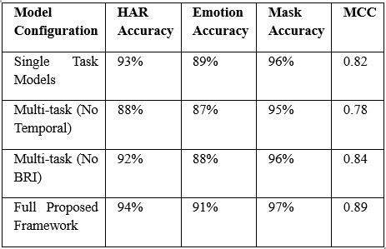Table II
Performance Comparison of Ablation ConfigurationsThe results clearly demonstrate the effectiveness of the proposed unified architecture. The full framework achieves the highest performance across all tasks, reaching 94% accuracy for HAR, 91% for Emotion Recognition, and 97% for Mask Detection.
More importantly, the model achieves an MCC score of 0.89, indicating strong reliability in detecting rare anomalies despite severe class imbalance in surveillance datasets. Because MCC accounts for both true and false predictions symmetrically, this result confirms that the integration of temporal modeling and behavioral risk fusion significantly reduces false positives while improving the detection of genuine threat events.
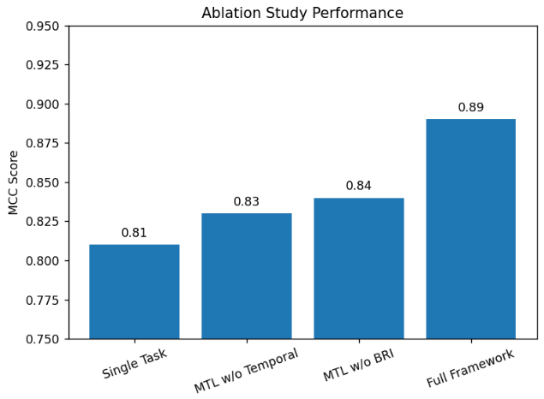 Fig. X: Performance comparison of ablation study configurations using MCC score.
In summary, the ablation study provides strong empirical evidence supporting the design choices of the proposed unified multi-task architecture. The performance degradation observed when removing temporal modeling or behavioral risk fusion highlights the importance of these components in achieving accurate and reliable behavior analysis. These findings confirm that the full framework provides the most effective balance between predictive accuracy, contextual behavioral understanding, and computational efficiency, making it well suited for real-time smart surveillance applications.
- EDGE Deployment
The practical viability of any intelligent surveillance system ultimately depends on its deployment architecture. Traditional intelligent video analytics systems typically rely on cloud-centric processing models in which live video streams are continuously transmitted to centralized servers for deep learning inference. While cloud-based architectures provide high computational power, they introduce several critical limitations in real-time public safety applications. Continuous transmission of high-resolution surveillance footage requires substantial network bandwidth and introduces communication latency that may delay security responses during critical events. In addition, transmitting sensitive surveillance data to remote servers raises serious privacy and security concerns. Furthermore, reliance on persistent internet connectivity creates a potential single point of failure, making the system vulnerable to network disruptions. To overcome these limitations, the proposed unified multi-task framework is explicitly designed for the edge computing paradigm. By performing inference directly on localized edge devices positioned near surveillance cameras or gateway nodes, the system eliminates the need for continuous round-trip data transmission. This decentralized architecture enables near real-time monitoring, reduces network dependency, and allows the system to operate autonomously even in scenarios where network connectivity is unavailable.
Deploying deep learning models on edge hardware presents significant challenges due to constraints in memory capacity, computational resources, and power consumption. To address these limitations, the proposed framework integrates TinyML optimization techniques, particularly post-training integer quantization. Neural networks are typically trained using 32-bit floating-point (FP32) parameters, which require considerable memory bandwidth and processing power during inference. Through quantization, the trained model parameters and intermediate activations are converted from FP32 representations into lower-precision 8-bit integer (INT8) values. This transformation significantly reduces the model's memory footprint and enables efficient low-precision arithmetic operations during inference. As a result, INT8 quantization drastically improves computational efficiency, accelerates inference speed, and lowers power consumption while preserving most of the model’s predictive accuracy. These optimizations enable the proposed multi-task architecture to operate efficiently on resource-constrained embedded devices.
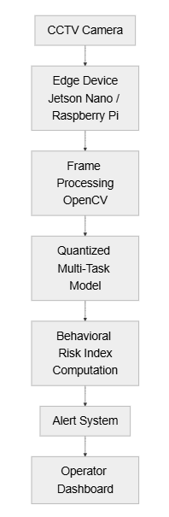
Fig. 5. Edge computing deployment pipeline for real-time surveillance inference.
To evaluate real-world deployment feasibility, the optimized model was deployed on two representative edge computing platforms: the NVIDIA Jetson Nano and the Raspberry Pi 4B. The NVIDIA Jetson Nano is widely used in edge AI applications due to its integrated GPU architecture, which enables efficient parallel processing of convolutional neural network operations. This hardware platform provides sufficient computational capacity to handle complex deep learning workloads while maintaining a compact form factor suitable for embedded environments. In contrast, the Raspberry Pi 4B represents a significantly more constrained embedded platform with limited RAM and a quad-core CPU architecture. Evaluating the framework on both devices allows a comprehensive assessment of the system’s scalability across different tiers of edge hardware performance and cost constraints.
During operational deployment, the system executes a continuous real-time video processing pipeline designed for seamless integration with existing closed-circuit television (CCTV) infrastructure. The pipeline begins with live video acquisition using the Open-Source Computer Vision Library (OpenCV), which captures and extracts sequential frames from the camera stream. Each frame undergoes immediate preprocessing on the device, including resizing and pixel normalization to match the input requirements of the EfficientNet backbone network. The preprocessed frames are then passed into the quantized multi-task model, which simultaneously performs inference for the three behavioral analysis tasks: human activity recognition, facial emotion detection, and mask compliance monitoring.
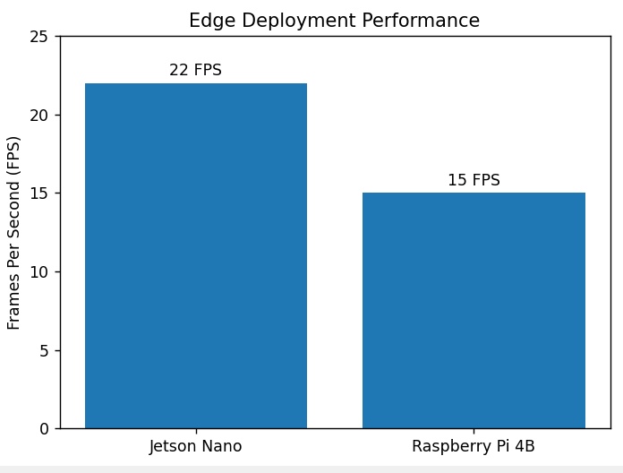 Fig.: Real-time inference performance on edge devices.
The resulting predictions are immediately fused through the Behavioral Risk Index (BRI) computation module to produce a unified threat score. In the final stage of the pipeline, the system generates an intuitive visualization interface by overlaying bounding boxes around detected individuals, displaying emotion labels, indicating mask compliance status, and presenting the computed behavioral risk score directly on the video stream. This augmented visualization enables security personnel to quickly interpret the system’s predictions and respond appropriately to potential threats.
The real-time performance of the deployed system was quantitatively evaluated using the Frames Per Second (FPS) metric. Despite executing multiple computer vision tasks simultaneously alongside temporal sequence modeling, the optimized framework demonstrated strong inference performance on both edge platforms. On the NVIDIA Jetson Nano, the quantized multi-task model achieved processing speeds ranging from 18 to 22 FPS, enabling smooth real-time surveillance analysis. When deployed on the more resource-constrained Raspberry Pi 4B, the system maintained an inference throughput of 12 to 15 FPS, which remains sufficient for near real-time monitoring scenarios. These results confirm that the proposed architecture meets the low-latency requirements necessary for real-time surveillance applications without requiring expensive cloud-based GPU infrastructure.
Overall, deploying the proposed framework on edge devices offers several critical advantages for intelligent surveillance systems. Processing visual data locally minimizes inference latency, drastically reduces network bandwidth consumption, and enhances data privacy by preventing sensitive surveillance footage from leaving the local environment. Additionally, edge deployment enables continuous monitoring even in the absence of reliable internet connectivity. The experimental results demonstrate that the proposed unified multi-task behavior computing architecture, combined with INT8 quantization and efficient feature sharing, provides a highly scalable and practical solution for real-time smart surveillance deployment across a wide range of public safety and defense environments.
- ETHICAL CONSIDERATIONS
The deployment of intelligent surveillance systems powered by artificial intelligence introduces important ethical considerations that must be carefully addressed to ensure responsible and fair usage. While automated behavior analysis can significantly enhance public safety and security, it also raises concerns related to privacy, algorithmic bias, transparency, and accountability. Therefore, the development and deployment of the proposed unified multi-task behavior computing framework adhere to responsible AI principles designed to balance technological advancement with ethical responsibility.
One of the most significant concerns associated with surveillance technologies is individual privacy. Surveillance systems inherently involve the collection and analysis of visual data that may contain personally identifiable information. Continuous monitoring of public environments can raise concerns regarding intrusive observation and potential misuse of collected data. To mitigate these concerns, the proposed framework adopts an edge computing deployment strategy, ensuring that video data is processed locally on embedded devices rather than transmitted to centralized cloud servers. By performing inference directly on edge hardware, sensitive video footage remains within the local surveillance infrastructure, significantly reducing the risk of unauthorized data access or large-scale data breaches. Furthermore, the system is designed to operate on transient frame-level processing without storing long-term video archives unless explicitly required by authorized security personnel.
Another important ethical consideration is the potential for algorithmic bias in machine learning systems. Deep learning models trained on imbalanced or non-representative datasets may produce biased predictions that disproportionately affect certain demographic groups. For example, emotion recognition models trained on limited datasets may perform differently across varying facial features, ethnicities, or lighting conditions. To address this issue, the proposed framework incorporates training datasets that contain diverse samples captured under varying real-world conditions. Additionally, evaluation metrics such as the Matthews Correlation Coefficient (MCC) were employed to ensure balanced model evaluation under imbalanced data distributions. Future system deployments should continue to expand dataset diversity and implement fairness auditing procedures to further reduce potential biases.
Transparency and interpretability are also critical factors in responsible AI deployment. Surveillance operators must be able to understand and trust the decisions produced by automated systems. To support interpretability, the proposed framework integrates an explainable decision mechanism through the Behavioral Risk Index (BRI). Instead of generating opaque predictions, the BRI provides an interpretable threat score derived from multiple behavioral signals, including physical activity, emotional state, and compliance behavior. In addition, explainable artificial intelligence techniques such as SHapley Additive exPlanations (SHAP) can be applied to visualize the contribution of each behavioral component to the final risk score. This transparency allows human operators to better understand why the system flagged a particular event as suspicious.
Another important ethical dimension involves human oversight and accountability. The proposed system is designed as a decision-support tool rather than a fully autonomous decision-making authority. Automated alerts generated by the system are intended to assist human operators in identifying potential risks more efficiently. Final decisions regarding intervention, investigation, or enforcement actions remain under human supervision. Maintaining this human-in-the-loop approach ensures that critical security decisions are made with contextual understanding and ethical judgment.
Finally, responsible surveillance deployment requires compliance with legal frameworks and regulatory standards governing the use of AI and monitoring technologies. The proposed system is intended for use in controlled environments such as transportation hubs, public infrastructure, or secured facilities where surveillance monitoring is already authorized. System operators must ensure that deployment practices comply with applicable data protection regulations and privacy guidelines. Implementing clear operational policies, access controls, and data governance frameworks can further ensure that surveillance technologies are used strictly for legitimate public safety purposes.
In summary, while intelligent surveillance technologies offer substantial benefits for improving situational awareness and public safety, they must be deployed responsibly. By emphasizing privacy-preserving edge processing, bias mitigation strategies, explainable decision mechanisms, and human oversight, the proposed framework aligns with modern Responsible AI principles. These considerations ensure that the system enhances security capabilities while maintaining ethical standards and public trust.

CONCLUSION
This paper presented a unified multi-task deep learning framework for intelligent behavior computing in smart surveillance environments. Traditional surveillance systems often rely on fragmented architectures that deploy independent models for individual computer vision tasks such as activity recognition, emotion detection, and compliance monitoring. Such approaches introduce significant computational redundancy, increased latency, and large memory requirements, making them unsuitable for real-time deployment on resource-constrained edge devices. To address these limitations, this work proposed a consolidated architecture that integrates multiple behavioral analysis tasks within a single efficient deep learning framework.
The proposed system combines Human Activity Recognition, Emotion Detection, and Face Mask Compliance Monitoring within a unified pipeline built upon a shared EfficientNet backbone and temporal modeling modules. By leveraging multi-task learning and adaptive loss weighting based on homoscedastic uncertainty, the framework enables balanced training across heterogeneous tasks while minimizing redundant feature extraction. Furthermore, the study introduced the Behavioral Risk Index (BRI) as a novel decision-level fusion mechanism that aggregates multiple behavioral signals into a single interpretable threat score. This risk fusion strategy allows surveillance operators to interpret complex behavioral outputs more effectively and respond quickly to potentially dangerous situations.
Extensive experiments conducted across multiple benchmark datasets demonstrate the effectiveness of the proposed architecture. The system achieved strong predictive performance across all tasks while maintaining high reliability under severe class imbalance conditions. In addition, edge deployment experiments confirmed that the optimized model achieves real-time inference speeds on embedded hardware platforms such as the NVIDIA Jetson Nano and Raspberry Pi, validating its practical feasibility for real-world surveillance applications.
Overall, the results demonstrate that integrating multiple behavioral analysis tasks within a unified architecture significantly improves computational efficiency, contextual understanding, and real-time operational capability. The proposed framework provides a scalable and practical solution for intelligent surveillance systems in public safety and defense monitoring environments.
Future work will focus on expanding the behavioral analysis capabilities of the framework by incorporating additional modalities such as crowd density estimation, anomaly localization, and multimodal sensor fusion. Additionally, further research will explore more advanced explainable AI techniques and fairness-aware learning strategies to enhance transparency and ethical deployment in real-world surveillance systems.
REFERENCES
[1] M. Tan and Q. Le, “EfficientNet: Rethinking model scaling for convolutional neural networks,” in Proc. Int. Conf. Machine Learning (ICML), 2019, pp. 6105–6114.
[2] K. He, X. Zhang, S. Ren, and J. Sun, “Deep residual learning for image recognition,” in Proc. IEEE Conf. Computer Vision and Pattern Recognition (CVPR), 2016, pp. 770–778.
[3] S. Aberkane and M. Elarbi, “Deep reinforcement learning for real-world anomaly detection in surveillance videos,” in Proc. Int. Conf. Image Signal Process. Their Applications (ISPA), 2019, pp. 1–5.
[4] H. Shi et al., “Deep multitask learning with progressive parameter sharing,” in Proc. IEEE/CVF Int. Conf. Computer Vision (ICCV), 2023.
[5] M. Wallingford et al., “Task-adaptive parameter sharing for multi-task learning,” in Proc. IEEE/CVF Conf. Computer Vision and Pattern Recognition (CVPR), 2022.
[6] K. Xu, S. Huang, G. Cheng, and X. Song, “A multi-task learning approach based on convolutional neural networks for acoustic scene classification,” in Proc. Int. Conf. Algorithms, Computing and Artificial Intelligence (ACAI), 2019, pp. 23–27.
[7] S. M. Lundberg and S.-I. Lee, “A unified approach to interpreting model predictions,” in Advances in Neural Information Processing Systems (NeurIPS), vol. 30, 2017.
[8] V. Hassija et al., “Interpreting black-box models: A review on explainable artificial intelligence,” Cognitive Computation, vol. 16, no. 1, pp. 45–74, 2023.
[9] M. Z. Uddin, “A wearable sensor-based activity prediction system to facilitate edge computing in smart healthcare systems,” Journal of Parallel and Distributed Computing, vol. 123, pp. 46–53, 2019.
[10] J. Lin, L. Zhu, W.-M. Chen, W.-C. Wang, and S. Han, “Tiny machine learning: Progress and futures,” IEEE Circuits and Systems Magazine, vol. 23, no. 3, pp. 8–34, 2023.
[11] Y. Abadade et al., “A comprehensive survey on TinyML,” IEEE Access, vol. 11, pp. 96853–96880, 2023.
[12] L. Dutta and S. Bharali, “TinyML meets IoT: A comprehensive survey,” Internet of Things, vol. 16, Art. no. 100461, 2021.
[13] F. Li and D. Zhang, “Transformer-driven affective state recognition from wearable physiological data in everyday contexts,” Sensors, vol. 25, no. 3, p. 761, 2025.
[14] Q. Hu, Y. Peng, and Z. Zheng, “A deep learning framework for gender-sensitive speech emotion recognition based on MFCC feature selection and SHAP analysis,” Scientific Reports, vol. 15, Art. no. 28569, 2025.
[15] R. Li, X. Ye, F. Yang, and K.-L. Du, “ConvLSTM-Att: An attention-based composite deep neural network for tool wear prediction,” Machines, vol. 11, no. 2, p. 297, 2023.
[16] Y. Yu, X. Si, C. Hu, and J. Zhang, “A review of recurrent neural networks: LSTM cells and network architectures,” Neural Computation, vol. 31, no. 7, pp. 1235–1270, 2019.
[17] A. Bochkovskiy, C.-Y. Wang, and H.-Y. M. Liao, “YOLOv4: Optimal speed and accuracy of object detection,” arXiv preprint arXiv:2004.10934, 2020.
[18] A. Dosovitskiy et al., “An image is worth 16×16 words: Transformers for image recognition at scale,” arXiv preprint arXiv:2010.11929, 2020.
[19] T. Liao et al., “Deep transfer learning with graph neural networks for sensor-based human activity recognition,” in Proc. IEEE Int. Conf. Bioinformatics and Biomedicine (BIBM), 2022.
[20] M. A. Amiri, S. Afshari, and A. Soltani, “Machine learning approaches to traffic accident severity prediction: Addressing class imbalance,” Machine Learning with Applications, vol. 22, p. 100792, 2025.

