
(B.TECH) Trimester-XI AY 2020-21
PPL Lab Assignment No. 03

Faculty: Prof. Jayshree Aher

Problem Statement: To study/ implement Naïve Bayes & Random Forest.

Name: Vishwa Mohan Singh
ERP No.: 1032170273
Panel: AML2 (Panel A)
Date: 28/12/2020

Objectives:
- To understand the basics of Classifiers such as NB, RF, Regression.
- To analyze the performance of the classifiers.

Theory:

- Naïve Bayes: Naïve Bayes is a probabilistic model that is based on the Bayes Theorem.
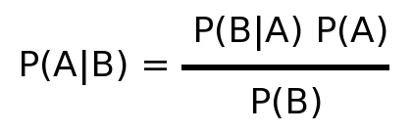
If B is to be replaced by the attributes and A with the class, the prior probabilities will be the probability of a set of attributes belonging to a particular class. To calculate P(B|A), we need to employ the chain rule, which makes the assumptions that the attributes are independent of each other, which is not true for most cases. Therefore, the algorithm is called “Naïve”.
- Regression: Regression is a method in machine learning which is used in prediction of a dependent variable which is continuous in nature. The goal of regression model is to build a mathematical equation that defines a continuous variable Y as a function of the X variables.
- Random Forest: A decision tree model is very susceptible to overfitting due to the hard boundary splits. Therefore, to reduce the variance, we use an ensemble technique called bagging on the decision tree algorithm. Here, we create multiple decision tree models and train them on small segments of the data. The results of all these trees are aggregated to get the final results.

- Support Vector Classifier: In machine learning, support-vector machines are supervised learning models with associated learning algorithms that analyze data for classification and regression analysis. Here, we find points on the edges of the data which are used to find the regression line/classification split.

Compare the performance of the classifiers

Operations to be performed on dataset:

Steps in Preprocessing of Data (Consider any binary classification dataset)
- Read the .csv file of dataset
- Display few observations
- Perform data preprocessing(handling missing data, etc)
- Create the independent and dependent variables
- Standardization of data
- Plot few graphs to understand/explore the data.
- Perform feature importance and find the most significant features.
- Split the data into training and test sets.
- Create the objects of classifiers.
- Fit the data in model to train it.
- Analyze the performance of the various classifiers.
- Try to plot the ROC curve.
Program code:
import pandas as pd
import numpy as np
from sklearn.impute import SimpleImputer
from sklearn.preprocessing import LabelEncoder,OneHotEncoder,StandardScaler
from sklearn.compose import ColumnTransformer
from sklearn.model_selection import train_test_split
import matplotlib.pyplot as plt
from sklearn.metrics import roc_curve
from sklearn.metrics import roc_auc_score

## Importing the data
dataset = pd.read_csv("train.csv")

## Array Transformation
arr = dataset.iloc[:,[2,5,6,7,9,11,1]]

## Handeling NaN
impu = SimpleImputer(missing_values=np.nan, strategy = "mean")
arr = arr.values
arr[:,[0,1,2,3,4]] = impu.fit_transform(arr[:,[0,1,2,3,4]])

#Remvoing the entries from categorical columns

arr = pd.DataFrame(arr)
arr = arr.dropna()
arr = arr.values

#OneHot and LableEncoding

lb = LabelEncoder()
arr[:,-1] = lb.fit_transform(arr[:,-1])
transformer = ColumnTransformer(
transformers=[("OneHot", OneHotEncoder(),[5])],
remainder='passthrough'
)
arr = transformer.fit_transform(arr.tolist())

##X-Y Split
X = arr[:,:-1]
Y = arr[:,-1].astype('int')

#Scaling
scaler = StandardScaler()
X = scaler.fit_transform(X)

#Train Test Split
X_train,X_test,Y_train,Y_test = train_test_split(X,Y,test_size=0.2, random_state=10)

##Importing the libraries for creating the models
from sklearn.svm import SVC # For support vector machines
from sklearn.ensemble import RandomForestClassifier #For random forest
from sklearn.naive_bayes import GaussianNB # For Naive Bayes
from sklearn.linear_model import LogisticRegression
from sklearn.neighbors import KNeighborsClassifier

#No Skill Line
ns_probs = [0 for _ in range(len(Y_test))]
ns_fpr, ns_tpr, _ = roc_curve(Y_test, ns_probs)

model_svm = SVC(probability=True)
model_rf = RandomForestClassifier(n_estimators=5)
model_nv = GaussianNB()
model_lr = LogisticRegression()
model_knn = KNeighborsClassifier()

print("Training Support Vector Machine")
model_svm.fit(X_train,Y_train)
print("Accuracy: ", model_svm.score(X_test,Y_test))

#Printing Roc-Auc Score
print("Roc-Auc Score: ", roc_auc_score(Y_test, model_svm.predict_proba(X_test)[:,1]))

#Making the Roc-Auc Plot
fpr, tpr, _ = roc_curve(Y_test, model_svm.predict_proba(X_test)[:,1])
plt.plot(ns_fpr, ns_tpr, linestyle='--', label='No Skill')
plt.plot(fpr, tpr, marker='.', label='SVM')
plt.legend()
plt.show()

#Breaking
print()

print("Training Random Forest Classifier")
model_rf.fit(X_train,Y_train)
print("Accuracy: ", model_rf.score(X_test,Y_test))

#Printing Roc-Auc Score
print("Roc-Auc Score: ", roc_auc_score(Y_test, model_rf.predict_proba(X_test)[:,1]))

#Making the Roc-Auc Plot
fpr, tpr, _ = roc_curve(Y_test, model_rf.predict_proba(X_test)[:,1])
plt.plot(ns_fpr, ns_tpr, linestyle='--', label='No Skill')
plt.plot(fpr, tpr, marker='.', label='Random Forest')
plt.legend()
plt.show()

#Breaking
print()

print("Training Naive Bayes")
model_nv.fit(X_train,Y_train)
print("Accuracy: ", model_nv.score(X_test,Y_test))

#Printing Roc-Auc Score
print("Roc-Auc Score: ", roc_auc_score(Y_test, model_nv.predict_proba(X_test)[:,1]))

#Making the Roc-Auc Plot
fpr, tpr, _ = roc_curve(Y_test, model_nv.predict_proba(X_test)[:,1])
plt.plot(ns_fpr, ns_tpr, linestyle='--', label='No Skill')
plt.plot(fpr, tpr, marker='.', label='Naive Bayes')
plt.legend()
plt.show()

#Breaking
print()

print("Training Logistic Regression")
model_lr.fit(X_train,Y_train)
print("Accuracy: ", model_lr.score(X_test,Y_test))

#Printing Roc-Auc Score
print("Roc-Auc Score: ", roc_auc_score(Y_test, model_lr.predict_proba(X_test)[:,1]))

#Making the Roc-Auc Plot
fpr, tpr, _ = roc_curve(Y_test, model_lr.predict_proba(X_test)[:,1])
plt.plot(ns_fpr, ns_tpr, linestyle='--', label='No Skill')
plt.plot(fpr, tpr, marker='.', label='Logistic Regression')
plt.legend()
plt.show()

#Breaking
print()

print("Training KNN")
model_knn.fit(X_train,Y_train)
print("Accuracy: ", model_knn.score(X_test,Y_test))

#Printing Roc-Auc Score
print("Roc-Auc Score: ", roc_auc_score(Y_test, model_knn.predict_proba(X_test)[:,1]))

#Making the Roc-Auc Plot
fpr, tpr, _ = roc_curve(Y_test, model_knn.predict_proba(X_test)[:,1])
plt.plot(ns_fpr, ns_tpr, linestyle='--', label='No Skill')
plt.plot(fpr, tpr, marker='.', label='KNN Classifier')
plt.legend()
plt.show()

#Breaking
print()

Dataset used:
Titanic: A Kaggle competition dataset that is used for a machine learning competition aimed at predicting who might have survived the sinking. It includes passenger information like class, embarkment port, fare, cabin etc.
Link: https://www.kaggle.com/c/titanic/data

Output:
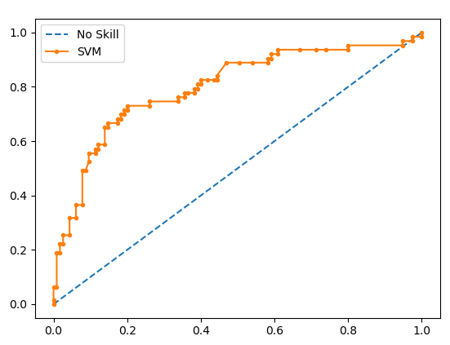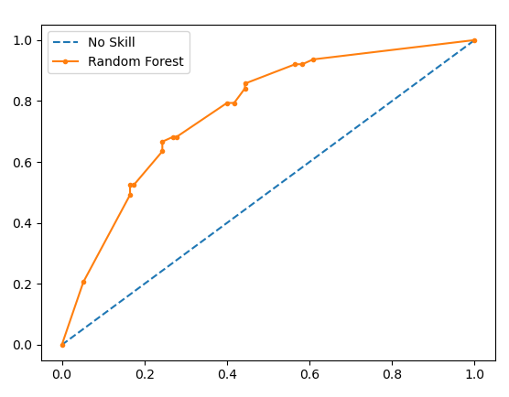
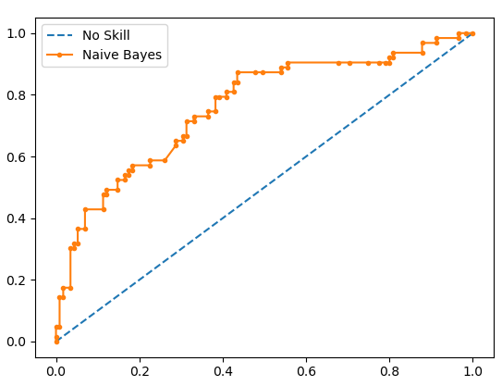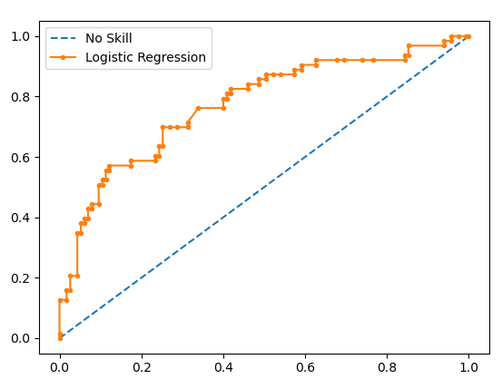
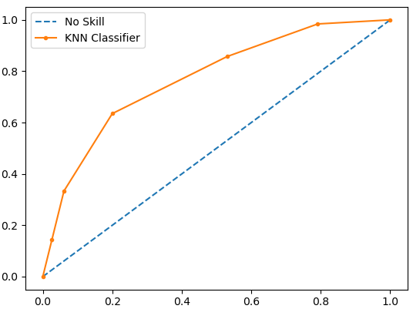

Training Support Vector Machine
Accuracy: 0.7808988764044944
Roc-Auc Score: 0.7993788819875776

Training Random Forest Classifier
Accuracy: 0.6573033707865169
Roc-Auc Score: 0.7301587301587302

Training Naive Bayes
Accuracy: 0.7303370786516854
Roc-Auc Score: 0.7616977225672878

Training Logistic Regression
Accuracy: 0.7640449438202247
Roc-Auc Score: 0.774120082815735

Training KNN
Accuracy: 0.7415730337078652
Roc-Auc Score: 0.7712215320910972

FAQs:
- Describe the terms: Sensitivity, F1_Score and Precision.
- Sensitivity: It is calculated as the number of correct positive predictions divided by the total number of positives.
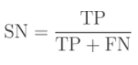
F1 Score: It is the combination of precision and recall and is defined as 2 times of product of precision and recall divided by the sum of precision and recall.
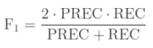
Precision: It is calculated as the number of correct positive predictions divided by the total number of positive predictions.
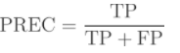

- Compare RF and NB.
Random Forest | Naïve Bayes
It is a tree-based algorithm. | It is a probabilistic algorithm
A random forest model can be used for regression and classification | Naïve Bayes can only be used for classification
It tries to minimize the entropy to create the model. | Model uses Bayes theorem to find the probability of belonging to a class.

- What is Decision Tree classifier?
- Decision tree is a model where the root and intermediate nodes represent test and based on the conditions, we create the branches. The leaves represent the output. A decision tree can be used for both regression and classification. In classification, we create splits on the nodes in order to minimize the entropy and in the end, each leaf represents a class.

- Describe various types of NB.
- Gaussian: It is used in classification and it assumes that features follow a normal distribution.
- Multinomial: It is used for discrete counts. For example, let’s say, we have a text classification problem. Here we can consider Bernoulli trials which is one step further and instead of “word occurring in the document”, we have “count how often word occurs in the document”, you can think of it as “number of times outcome number x_i is observed over the n trials”.
- Bernoulli: The binomial model is useful if your feature vectors are binary (i.e. zeros and ones).

- Give the importance of Logistic Regression.
- Although OLS seems deceptively simple, in some cases they can outperform other models. They can also be morphed into a polynomial model to improve its flexibility and reduce the bias.
- Logistic regression/OLS models is used for feature selection process like forward selection and backward elimination since it is easy to get statistics like p-values and adjusted R-squared.
- It can be used to eliminate multi-collinearity by enabling the calculation of Variance Inflation Factor.
- State the significance of ROC_AUC curve.
- AUC - ROC curve is a performance measurement for classification problem at various thresholds settings. ROC is a probability curve and AUC represents degree or measure of separability. It tells how much model is capable of distinguishing between classes. Higher the AUC, better the model is at predicting 0s as 0s and 1s as 1s.

Conclusion:
Different classifiers such as NB, RF, Regression, etc. were studied and their performance analysis was done.

