Scott Anderwald

Project Number 2

Introduction:

For the project two stocks and a ETF were selected and analyzed by varies models to compare the AIC and BIC outputs. ARIMA, SARIMA, and GARCH were the models utilized for the analysis. For a graphical representation comparison of both stock assets and the two ET will be plotted for the exploratory data analysis.

Similar to the first project, the stocks and ETF are energy industry specific. Both XOM and WPX are operators in the oil and gas market. XOM(Exxon) is considered a major player in the oil and gas market. Exxon, has assets in both the international and domestic markets. Along with these assets Exxon’s operational areas include both upstream (exploration and drilling) and downstream(refinement)operations. WPX is a domestic small capital producer focusing on midcontinent domestic assets. These assets include the Williston, San Juan, and Permian Basin. Unlike Exxon, WPX is primarily an upstream based company. Their main focus will be the exploration and drilling of assets. The belief would be with WPX major swings of the market this could have a greater impact on the stock price. Exxon having a broader focus in the market their stock prices should be able to handle market swing better.

The SPY consists of common stock of the S&P 500. This does include a holding of Exxon (XOM) of 1.39%. XLE is an energy sector SPDR ETF. Similar to SPY the XLE ETF has holding of Exxon the amount of course is larger at 23.69%(source yahoo finance).

Data:

Data for the project was retrieved from yahoo. CSV. Files were downloaded and imported for the tableau section. For the remaining portion of the project involving R an URL request was made for the following XOM, WPX, SPY, and XLE.

Exploratory Data Analysis.

From the histograms, the SPY has a mean of 213 and is right skewed. XLE ETF is left skewed with an adjusted close mean of 66.13. The two stocks prices of XOM and WPX are both left-skewed distribution with a mean of 79.19 and 10.43 respectively.

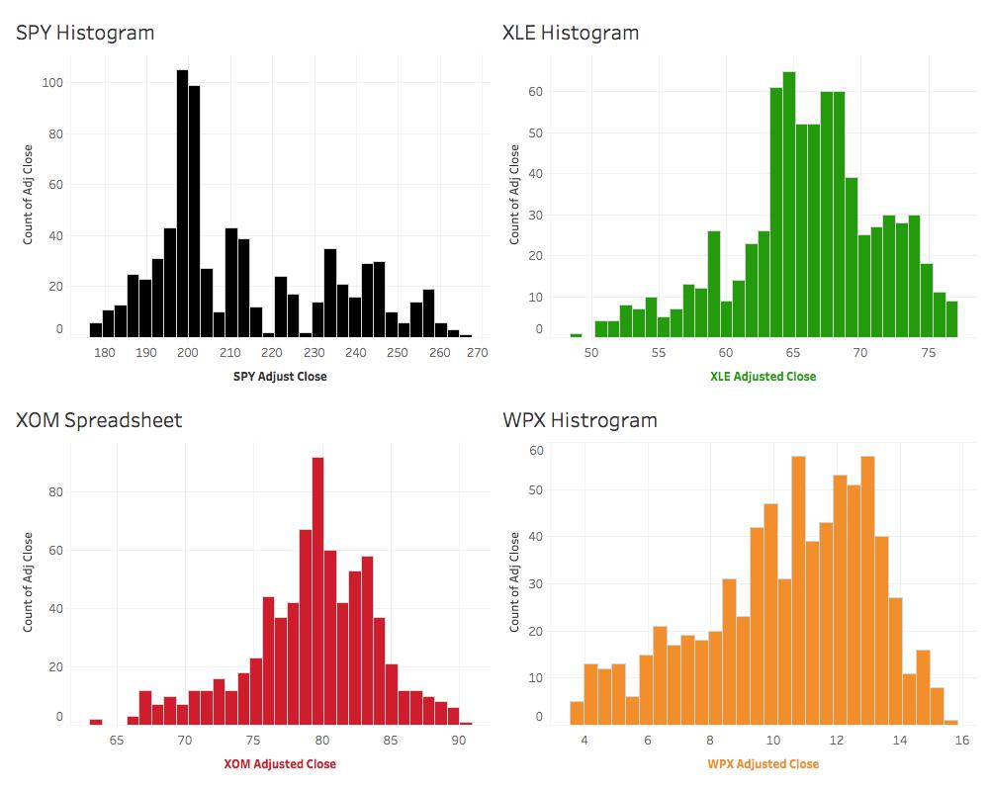

From the line the graph, it appears that the adjusted close for the SPY ETF is gradually increasing over time. While XLE, XOM and WPX has seen a slight increase since the summer of 2017. A note that since the XLE ETF has a 26% holding of Exxon within its portfolio is a slight correlation between the trends.

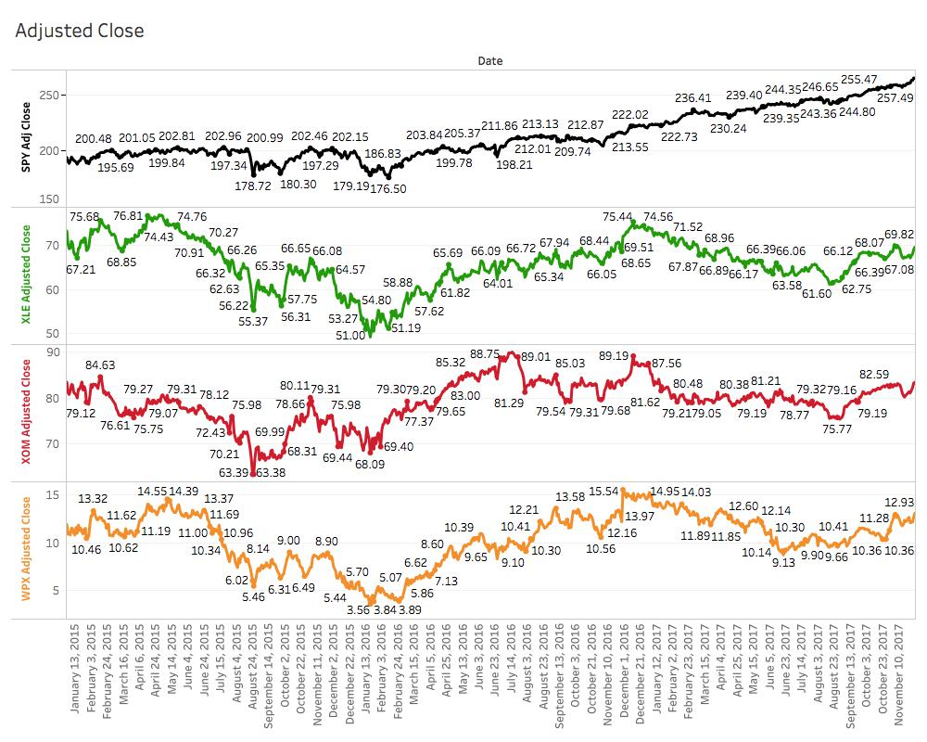

Stock Analysis.

For the analysis three models were used which would be ARIMA, SARIMA, and GARCH. For the comparison the outputs of AIC, BIC will be used for the best fit of the model. In the GARCH model no AICc is outputted. Exxon (XOM) was the asset to be analyzed. With ARIMA model set to automatic the following outputs were noted. AIC = 2230.88 and BIC= 2249.11.

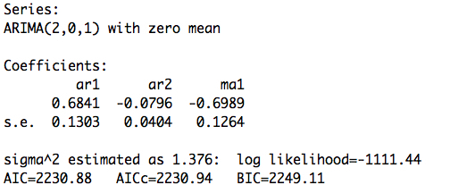

The seasonal ARIMA model was used with the outputs of AIC = -7.86, and BIC = -8.30. While smaller in numerical value than the ARIMA model the output is now negative in nature.

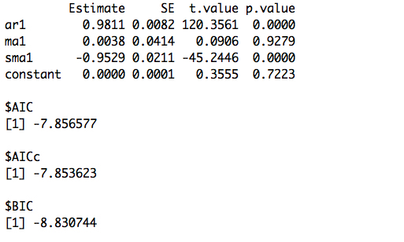

The GARCH model was then used for the XOM stocks. Similar to the SARIMA model the outputs were negative in nature. With AIC = -6.30, BIC = -6.30.

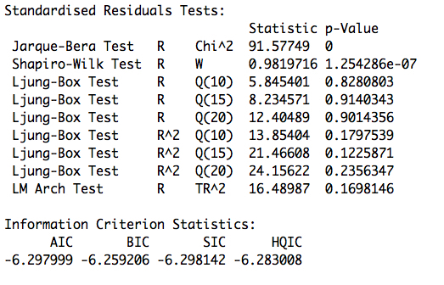

For WPX the automatic ARIMA had different output for the model with a pdq of 3,0,3. With a AIC = 4064.26 and BIC = 4096.17

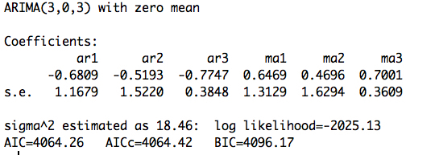

SARIMA model was run similar to XOM stock with an input of 1,0,1 0,1,1 with an output of

AIC = -5.26 and BIC = -6.23.

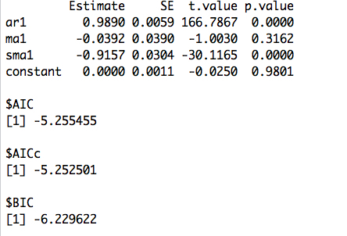

GARCH model was AIC -3.68, and BIC = -3.64

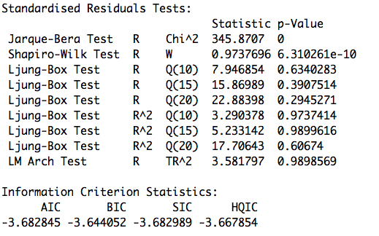

The last asset to be evaluated was the XLE ETF. Once again please remember that XLE has a 23.69% holding of XOM. Inputs for the SARIMA were similar to both XOM and WPX of 1,0,1 0,1,1. Output for the ARIMA were AIC = 2473.15 and BIC = 2482.27.

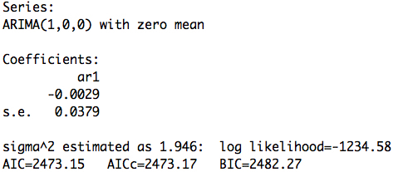

SARIMA model’s outputs were AIC = -7.51 and BIC -8.49

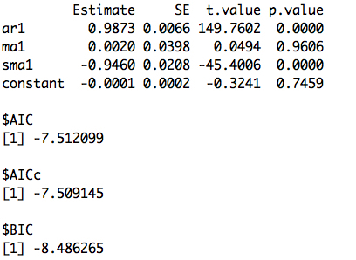

For the GARCH model the outputs were AIC -5.91, BIC = -5.87.

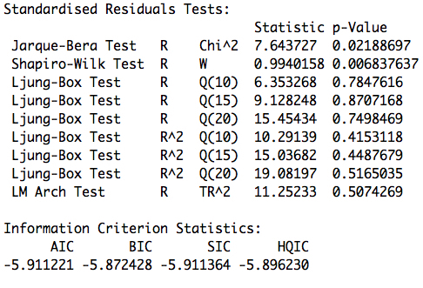

Conclusion

Post analysis of the three models reveal that by running the GARCH model the result is a lower AIC and BIC number. For time series analysis in particular financial data the GARCH model needs to be applied to better understand the volatility of the assets.

Appendix

R Code

library(tseries)

library(forecast)

library(quantmod)

library(astsa)

library(xts)

library(fGarch)

sp500 <- new.env()

stocks <- getSymbols(c("XOM"), env = sp500,

from = as.Date("2015-01-01"),

to = as.Date("2017-10-20"))

XOM <- sp500$XOM

XOM <- get("XOM",envir = sp500)

XOM <- with(sp500, XOM)

XOM <- as.data.frame(XOM)

XOM <- XOM$XOM.Adjusted

plot(XOM, type = "l" , col = "red")

acf(XOM); pacf(XOM)

ts_XOM <- 100 * diff(log(XOM))

#plot diff of acf and pacf

acf(ts_XOM); pacf(ts_XOM)

XOM.auto <- auto.arima(x=ts_XOM)

print(XOM.auto)

print(forecast(XOM.auto, h = 5))

#SARIMA

lXOM = log(XOM); dlXOM = diff(lXOM); ddlXOM = diff(dlXOM, 12)

plot.ts(cbind(XOM,lXOM,dlXOM,ddlXOM), yax.flip=TRUE, main="")

# below of interest for showing seasonal RW (not shown here):

par(mfrow=c(2,1))

monthplot(dlXOM); monthplot(ddlXOM)

sarima(lXOM, 1,0,1, ,1,1,12)

sarima.for(lXOM, 12, 1,0,1, 0,1,1,12)

dXOM =diff(log(XOM))

acf2(dXOM) # exhibits some autocorrelation (not shown)

acf2(dXOM^2) # oozes autocorrelation (not shown)

library(fGarch)

summary(Ddxom.g <- garchFit(~arma(1,0)+garch(1,1), data=dXOM,

cond.dist='std'))

#plot(Ddxom.g)

##For WPX

sp500 <- new.env()

stocks <- getSymbols(c("WPX"), env = sp500,

from = as.Date("2015-01-01"),

to = as.Date("2017-10-20"))

WPX <- sp500$WPX

WPX <- get("WPX",envir = sp500)

WPX <- with(sp500, WPX)

WPX <- as.data.frame(WPX)

WPX <- WPX$WPX.Adjusted

plot(WPX, type = "l" , col = "red")

acf(WPX); pacf(WPX)

ts_WPX <- 100 * diff(log(WPX))

#plot diff of acf and pacf

acf(ts_WPX); pacf(ts_WPX)

WPX.auto <- auto.arima(x=ts_WPX)

print(WPX.auto)

print(forecast(WPX.auto, h = 5))

lWPX = log(WPX); dlWPX = diff(lWPX); ddlWPX = diff(dlWPX, 12)

plot.ts(cbind(WPX,lWPX,dlWPX,ddlWPX), yax.flip=TRUE, main="")

# below of interest for showing seasonal RW (not shown here):

par(mfrow=c(2,1))

monthplot(dlWPX); monthplot(ddlWPX)

sarima(lWPX, 1,0,1, ,1,1,12)

sarima.for(lWPX, 12, 1,0,1, 0,1,1,12)

dWPX =diff(log(WPX))

acf2(dWPX) # exhibits some autocorrelation (not shown)

acf2(dWPX^2) # oozes autocorrelation (not shown)

library(fGarch)

summary(DdWPX.g <- garchFit(~arma(1,0)+garch(1,1), data=dWPX,

cond.dist='std'))

#plot(DdWPX.g)

##For XLE

sp500 <- new.env()

stocks <- getSymbols(c("XLE"), env = sp500,

from = as.Date("2015-01-01"),

to = as.Date("2017-10-20"))

XLE <- sp500$XLE

XLE <- get("XLE",envir = sp500)

XLE <- with(sp500, XLE)

XLE <- as.data.frame(XLE)

XLE <- XLE$XLE.Adjusted

plot(XLE, type = "l" , col = "red")

acf(XLE); pacf(XLE)

ts_XLE <- 100 * diff(log(XLE))

#plot diff of acf and pacf

acf(ts_XLE); pacf(ts_XLE)

XLE.auto <- auto.arima(x=ts_XLE)

print(XLE.auto)

print(forecast(XLE.auto, h = 5))

lXLE = log(XLE); dlXLE = diff(lXLE); ddlXLE = diff(dlXLE, 12)

plot.ts(cbind(XLE,lXLE,dlXLE,ddlXLE), yax.flip=TRUE, main="")

# below of interest for showing seasonal RW (not shown here):

par(mfrow=c(2,1))

monthplot(dlXLE); monthplot(ddlXLE)

sarima(lXLE, 1,0,1, 0,1,1,12)

sarima.for(lXLE, 12, 1,0,1, 0,1,1,12)

dXLE =diff(log(XLE))

acf2(dXLE) # exhibits some autocorrelation (not shown)

acf2(dXLE^2) # oozes autocorrelation (not shown)

library(fGarch)

summary(DdXLE.g <- garchFit(~arma(1,0)+garch(1,1), data=dXLE,

cond.dist='std'))

#plot(DdXLE.g)