Violent Extremist Organization Classification in Afghanistan: Using Machine Learning

Capstone Research Project

by
Stephen Davanzo

George Washington University
Data Science
Dr. Amir Jafari
December 2025

Abstract
A striking number of Violent Extremist Organization (VEO) attacks are never confidently linked to any group or perpetrator. In fact, analyses of the Global Terrorism Database show that only about ten percent of recorded attacks worldwide are attributed to a specific actor, leaving roughly ninety percent unattributed and highlighting a major gap in our understanding of political violence (Christie, 2019; Bauer, Ruby, & Pape, 2017). Unattributed terrorist attacks create major blind spots in counterterrorism and academic analysis. When the perpetrator is unknown, policymakers cannot properly target responses, allocate security resources, or evaluate the effectiveness of interventions. At the research level, unattributed incidents distort data-driven studies of terrorism trends, group behaviors, and conflict dynamics, since much of the violence goes analytically "unsorted" (Bauer et al., 2017).
This paper leverages both classical and modern Machine Learning techniques to classify between Taliban and Islamic State of Iraq and Syria - Khorasan Province (ISIS-K) attacks in Afghanistan between 2017 and 2021. We present a comprehensive comparative analysis of three distinct approaches: (1) classical machine learning models including Random Forest, XGBoost, and Multi-Layer Perceptrons with engineered features and text embeddings, (2) fine-tuned BERT models with specialized techniques for handling extreme class imbalance, and (3) a novel hybrid architecture that combines BERT's contextual embeddings with manually engineered conflict-specific features.
Our experimental results demonstrate that BERT achieves the highest overall performance with a macro F1-score of 0.836 and precision of 0.791 for the minority class. The feature fusion approach achieves a balanced trade-off with 70.6% minority class recall while maintaining a macro F1-score of 0.823. Classical models, particularly XGBoost with SVM-SMOTE, achieve the highest minority recall at 79.8% but suffer from low precision (0.281).

1. Introduction
The Armed Conflict Location & Event Data Project (ACLED) has emerged as a leading source for disaggregated data on political violence worldwide, providing detailed information on the type, agents, location, date, and other characteristics of conflict events (Raleigh et al., 2010). In Afghanistan, the period from 2017 to 2021 witnessed complex dynamics of violence involving multiple actors, primarily the Taliban and ISIS-K, making accurate attribution of attacks critical for understanding conflict patterns and informing policy responses.
The challenge of classifying violent events in Afghanistan presents unique technical difficulties. Our dataset exhibits extreme class imbalance with a ratio of approximately 49:1 (Taliban to ISIS-K attacks), with only 204 ISIS-K events out of over 10,000 test samples. This severe imbalance poses fundamental challenges for machine learning approaches, as models tend to optimize for overall accuracy by predicting the majority class. In fact the accuracy metric should almost entirely be discounted when analyzing results from this study. Instead F1, and minority F1 specially was used to evaluate model efficacy.
Recent advances in transformer-based models, particularly BERT (Bidirectional Encoder Representations from Transformers), have demonstrated remarkable capabilities in understanding contextual relationships in text (Devlin et al., 2018). However, applying these models to severely imbalanced datasets requires careful consideration of training strategies and loss functions. The focal loss, originally developed for object detection, has shown promise in addressing class imbalance in NLP tasks by down-weighting the loss assigned to well-classified examples (Lin et al., 2017; Iikura et al., 2021).

2. Related Work

2.1 Conflict Event Classification
The task of attributing violent events to specific actors has received limited attention in the computational literature, despite its critical importance for conflict analysis. One attempt at attributing unclaimed terrorist attacks in Pakistan using a simple Multi-Layer Perceptron architecture produced a model with 65% accuracy (this was their choice of evaluation metric) while including spatial features (Christie, 2019). Previous work has primarily focused on event extraction and categorization rather than actor attribution. The ACLED dataset itself does not pre-categorize events into conflicts or terrorism, recognizing that such distinctions can distort patterns and motivations for violence (ACLED Codebook, 2020).
Recent research on temporal patterns in terrorist attacks has employed graph-based approaches and deep learning to forecast future targets. For instance, research on Afghanistan and Iraq from 2001-2018 used temporal meta-graphs to capture operational similarities between attacks (Campedelli et al., 2021). However, these approaches focus on prediction rather than attribution, leaving a gap in methods for classifying unattributed historical events.

2.2 Handling Class Imbalance in NLP
The challenge of class imbalance in text classification has been extensively studied, with various approaches proposed for different domains. In the context of transformer models, several strategies have emerged:
Focal Loss Applications: Focal loss has been successfully applied to BERT-based models for handling imbalanced text data. Research has shown that focal loss can improve minority class detection in maintenance reports and paragraph segmentation tasks, though at the potential cost of majority class performance (Iikura et al., 2021; Silva et al., 2021). Our implementation uses α=0.65 and γ=2.0, tuned specifically for our extreme imbalance ratio.
Sampling Strategies: We evaluate seven different resampling techniques including SMOTE, ADASYN, BorderlineSMOTE, SVM-SMOTE, RandomOverSampler, SMOTE-ENN, and SMOTE-Tomek. Our results show that SVM-SMOTE consistently outperforms other techniques for classical models, while batch balancing through WeightedRandomSampler proves most effective for neural approaches.
Batch Balancing: Batch balancing in BERT means constructing each training batch so that it contains an equal number of samples from each class, preventing the model from seeing long runs of majority-class examples. This forces BERT to learn minority-class representations more consistently, improving gradient signals for rare labels like ISIS-K in your dataset. However, if the dataset is extremely imbalanced, batch balancing can lead to repeated exposure of the same minority samples, increasing overfitting risk unless combined with dropout, data augmentation, or focal loss.

2.3 Feature Fusion and Multimodal Learning
Recent developments in multimodal learning have demonstrated the effectiveness of combining BERT embeddings with auxiliary features. The AFR-BERT model uses attention mechanisms to fuse text and audio features, showing that careful integration of heterogeneous features can improve classification performance (Zhang et al., 2022). Our approach adapts these insights to the conflict domain, fusing textual descriptions with structured conflict indicators.

3. Methodology

3.1 Data Preprocessing and Feature Engineering
Our approach begins with comprehensive data preprocessing of ACLED event records from Afghanistan (2017-2021). The final dataset contains 25,000+ events with severe class imbalance: Taliban attacks represent 98% of labeled events while ISIS-K comprises only 2%.

3.1.1 Text Processing and Masking
To prevent information leakage and ensure model generalization, we implement systematic masking of potentially identifying information:
- Actor names (Taliban or ISIS-K) removed to prevent target leakage
- Location names removed to prevent geographic shortcuts
Sentence Transformers were used to convert raw ACLED attack descriptions into dense semantic embeddings that capture meaning beyond simple keyword matching. These embeddings served as high-quality numerical features for the classical machine-learning models, allowing them to leverage contextual information about actors, tactics, and locations without relying on full deep-learning architectures. By integrating these embeddings, classical models gained a significant boost in representational power, narrowing the performance gap with BERT while remaining far lighter and faster to train.

3.1.2 Manual Feature Engineering
We engineer 23 domain-specific features capturing three primary dimensions:
Casualty Patterns:
- Basic counts: fatalities, civilian_targeting
- Derived thresholds: has_casualties, high_casualties (>5), very_high_casualties (>10)
- Special indicators: zero_fatalities, violence_against_women
Attack Type Encoding (One-hot encoded):
- Remote explosive/landmine/IED
- Suicide bomb
- Armed clash
- Abduction/forced disappearance
- Air/drone strike
- Government regains territory
- Non-state actor overtakes territory
Tactical Signatures:
- coordinated_attack: Multiple attacks within spatial-temporal proximity
- series_attack: Sequential attacks by same actor

3.2 Classical Machine Learning Models

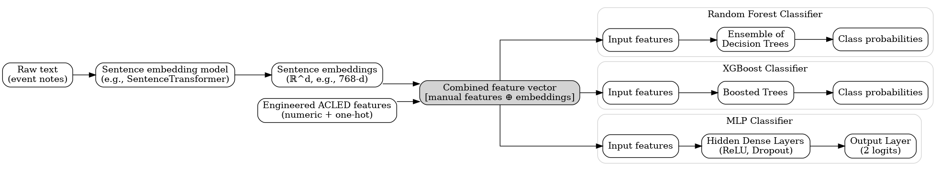
Figure 1: Architecture of Classical Models
We evaluated three base classifiers (Random Forest, XGBoost, and Multi-Layer Perceptron) combined with six resampling strategies: standard SMOTE, ADASYN, Borderline-SMOTE, SVM-SMOTE, Random Oversampling, SMOTE-ENN, and SMOTE-Tomek. The resampling strategies for the minority class, ISIS-K, were used in conjunction with undersampling the majority class in an attempt to bring class distribution to parity.

Sentence Transformers were used to create text embeddings which represent the unstructured text associated with each even in 383 dimensions. Text embeddings were run with manually created features of each of the combinations of classifiers and resampling techniques.

Each classifier was run with a customer grid-search-like functions which identified optional parameters for each type of model.

3.2.1 Random Forest
- 200 estimators with balanced class weights
- Max depth: {10, 20, 30}
- Best configuration: max_depth=30, max_features='sqrt'

3.2.2 XGBoost
- Gradient boosting with scale_pos_weight for imbalance
- Learning rate: {0.01, 0.1}
- Best configuration: max_depth=6, learning_rate=0.1, scale_pos_weight=1

3.2.3 Multi-Layer Perceptron
- Architecture: (100, 50) hidden layers
- Early stopping with patience=20
- Best configuration: alpha=0.001, batch_size=64
All classical models undergo standardization preprocessing and utilize 5-fold stratified cross-validation with proper separation of preprocessing fitting to prevent data leakage.

3.3 BERT-Based Text Classification

Figure 2: Architecture of BERT Classifier
The BERT model was fine-tuned on semantically masked event descriptions to prevent the model from learning shortcut correlations through explicit group name mentions. We employed gradient accumulation to simulate larger batch sizes, focal loss to focus learning on hard examples, and early stopping with validation macro F1 monitoring.

3.3.1 Model Architecture
- Model: bert-base-uncased
- Max sequence length: 128 tokens
- Selective layer freezing: Top 4 transformer layers unfrozen
- Dropout: 0.3
- Learning rate: 2e-5 with linear warmup

3.3.2 Focal Loss Implementation
We implement focal loss with class-dependent alpha weighting:
- α = 0.65 (weight for minority class)
- γ = 2.0 (focusing parameter)
This configuration down-weights easy examples and focuses learning on hard-to-classify minority class samples.

3.3.3 Batch Balancing
WeightedRandomSampler ensures balanced class representation in each training batch, exposing the model to minority class examples more frequently during training.

3.4 Feature Fusion Architecture
Figure 3: Architecture of BERT Hybrid, “Feature Fusion”
Our proposed feature fusion architecture combines BERT's contextual text embeddings with manually engineered conflict-specific features including event type indicators, casualty counts, geographic features, and temporal patterns. The architecture concatenates the [CLS] token embedding from BERT with the manual feature vector before passing through fully connected classification layers.

Architecture Components:
- BERT Encoder: Processes text to obtain CLS token embeddings (768 dimensions)
- Feature Network: Linear layer processing 23 manual features → 128 dimensions
- Fusion Layer: Concatenates both representations → 256 dimensions
- Classifier: Final linear layer → 2 classes
Training employs gradient accumulation (steps=2), early stopping based on validation minority recall, and the same focal loss configuration as standalone BERT.

4. Experimental Setup

4.1 Dataset Statistics
The processed dataset contains:
- Total samples: ~25,000 events
- Training set: 15,000 samples (60%)
- Validation set: 5,000 samples (20%)
- Test set: 10,213 samples
  - Taliban (Class 0): 10,009 (98.0%)
  - ISIS-K (Class 1): 204 (2.0%)

4.2 Evaluation Metrics
Given the extreme class imbalance, we prioritize:
- Minority Class Recall: Primary metric for ISIS-K detection capability
- Minority Class F1: Harmonic mean of precision and recall for ISIS-K
- Macro F1-Score: Overall balanced performance across both classes
- ROC-AUC and PR-AUC: Area under curves for threshold-independent evaluation

4.3 Implementation Details
- Hardware: NVIDIA A100 40GB GPUs
- Software: PyTorch 1.13.0, Transformers 4.25.0, Scikit-learn 1.2.0
- Training: Batch size 16 (effective 32 with gradient accumulation), 7 epochs with early stopping

5. Results and Analysis

5.1 Overall Performance Comparison
Our comprehensive evaluation across 22 model configurations reveals distinct performance patterns for different approaches:
Table 1: Model Performance on Test Set
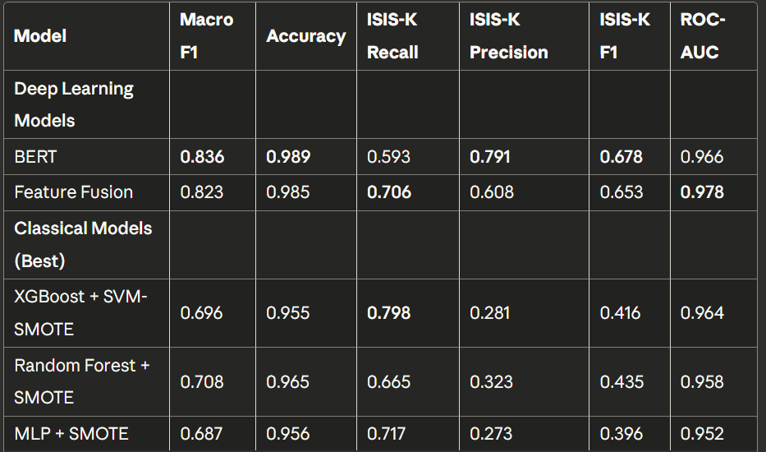
The comparative results in Table 1 show a clear performance hierarchy across model families. Both deep learning approaches—BERT and the Feature Fusion model—substantially outperform the classical machine-learning baselines across nearly all metrics, particularly on the minority ISIS-K class. BERT achieves the highest Macro-F1 (0.836) and overall accuracy (0.989), indicating strong global classification capability, while the Feature Fusion model yields the best ROC-AUC (0.978), suggesting improved separability between classes when contextual text and structured features are combined. In contrast, even the strongest classical models such as Random Forest + SMOTE and XGBoost + SVM-SMOTE lag by more than 0.12–0.14 in Macro-F1 and show considerably weaker minority-class F1 scores.
From an analytical standpoint, BERT demonstrates two major strengths:
(1) High precision on the minority ISIS-K class (0.791), meaning when BERT predicts ISIS-K, it is usually correct; and
(2) Strong overall generalization, reflected by its leading Macro-F1 and accuracy scores.
However, BERT’s main limitation is its relatively modest recall for ISIS-K (0.593), indicating that the model still misses a non-trivial portion of true ISIS-K cases. This is a common challenge in highly imbalanced datasets where the minority class displays subtle linguistic distinctions. Additionally, BERT’s performance comes with higher computational cost, slower inference, and the need for extensive GPU-accelerated training, which may restrict real-time or resource-constrained deployment.
Overall, these results highlight that while BERT-based models deliver the strongest predictive performance—particularly when augmented with feature-level fusion—they still face trade-offs in recall and operational complexity that must be considered in practical applications.

5.2 Classical Model Analysis
Classical models demonstrate high recall but struggle with precision:
Key Findings:
- XGBoost with SVM-SMOTE achieves the highest minority recall (79.8%) among all models but suffers from low precision (28.1%), resulting in 555 false positives
- Feature Importance: XGBoost identifies suicide_bomb, high_casualties, and coordinated_attack as top predictive features
- Error Pattern: Classical models frequently misclassify Taliban suicide attacks as ISIS-K, suggesting over-reliance on attack type features
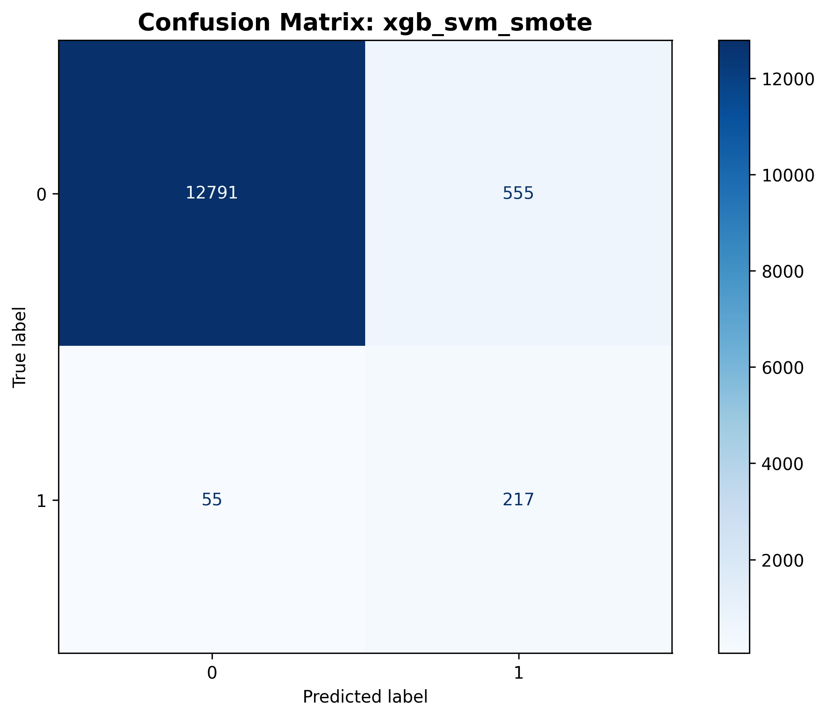
Figure 4: Confusion matrix for best classical model (XGBoost + SVM-SMOTE)

5.3 BERT Performance Analysis
BERT achieves the best overall balance of metrics:
Performance Highlights:
- Highest Precision: 79.1% precision for ISIS-K detection
- Strong F1 Score: 0.678 minority class F1, best among all models
- Conservative Predictions: Only 32 false positives (vs. 555 for XGBoost)
- Training Dynamics: Validation minority recall peaks at epoch 7 (72.6%) with early stopping preventing overfitting

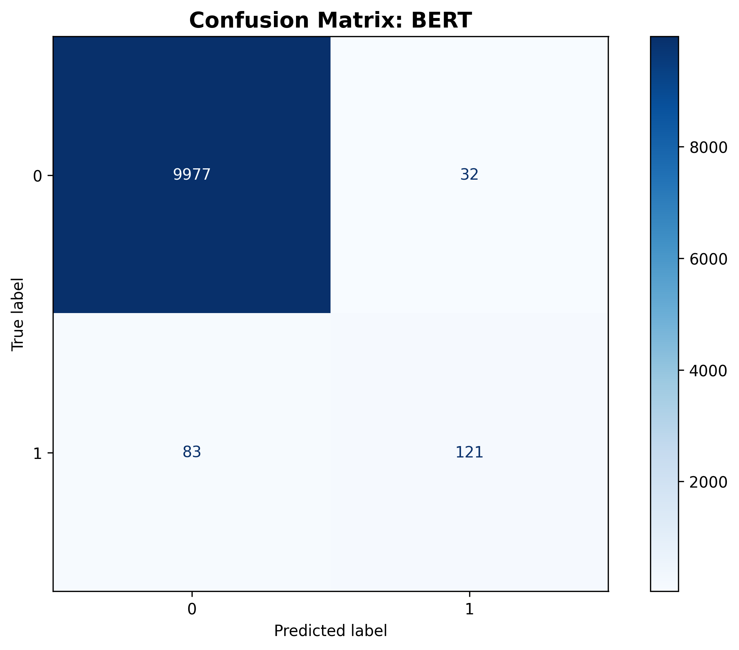
Figure 5: Confusion matrix for BERT model showing conservative prediction pattern

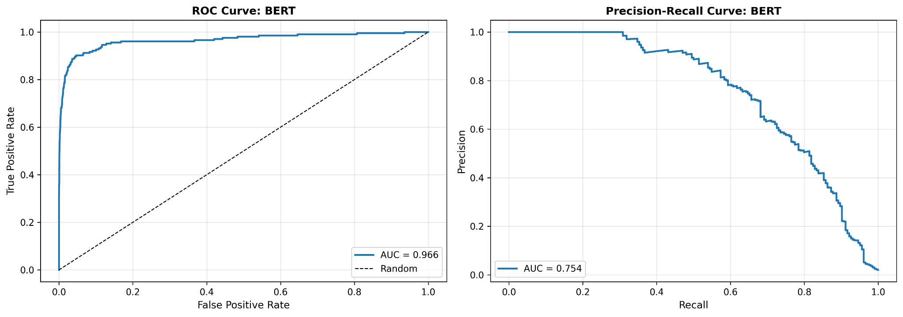
Figure 6: ROC and Precision-Recall curves for BERT (AUC-ROC: 0.966, AUC-PR: 0.754)

5.4 Feature Fusion Performance
The feature fusion model provides a middle ground between recall and precision:
Key Results:
- Improved Recall: 70.6% minority recall (vs. 59.3% for BERT alone)
- Moderate Precision: 60.8% precision, lower than BERT but higher than classical models
- Best ROC-AUC: 0.978, suggesting strong ranking capability
- Practical Trade-off: Detects 23 more ISIS-K attacks than BERT with 61 additional false positives
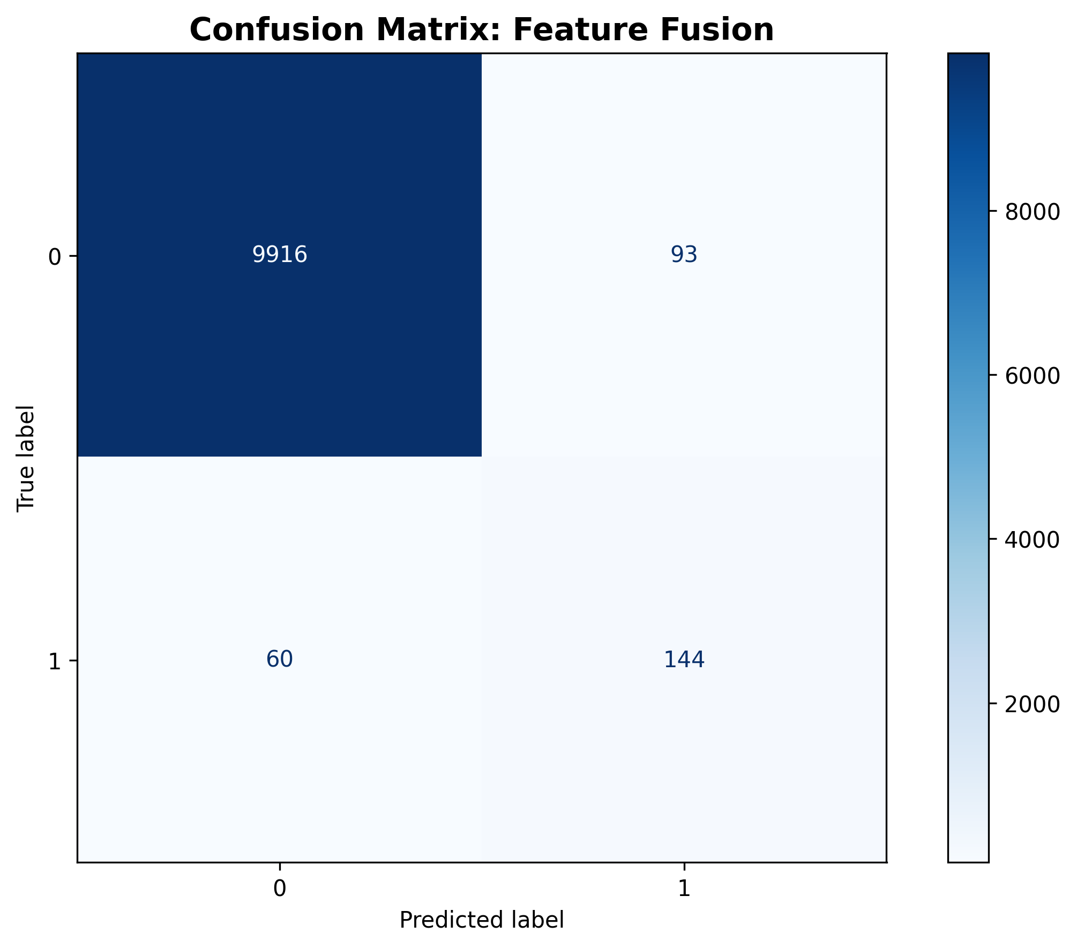
Figure 7: Confusion matrix for feature fusion model

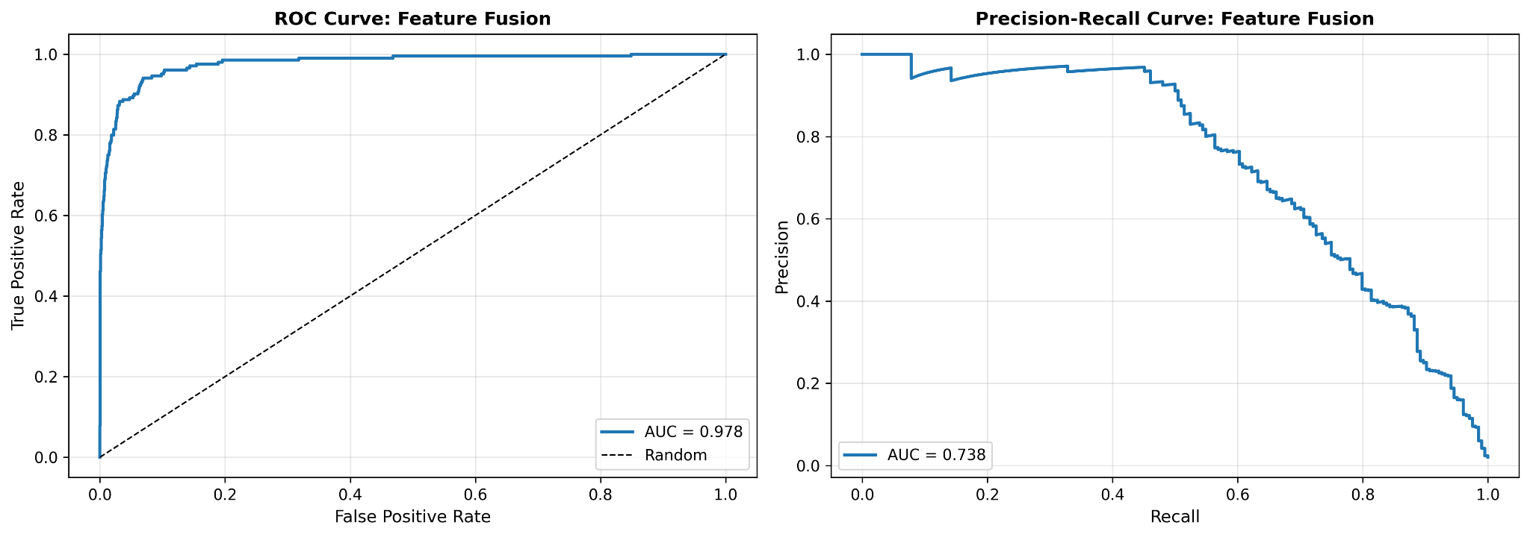
Figure 8: ROC and Precision-Recall curves for Feature Fusion (AUC-ROC: 0.978, AUC-PR: 0.738)

5.5 Resampling Strategy Analysis
We evaluated seven resampling techniques across all classical models:
Table 2: Impact of Resampling Strategies (XGBoost)

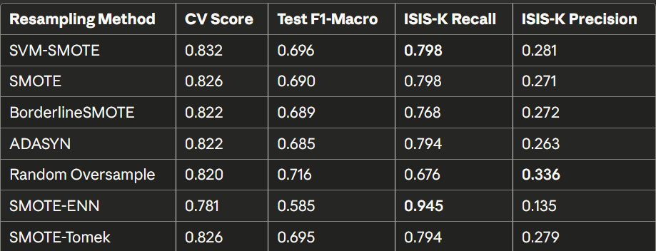

Key Insights:
- SVM-SMOTE consistently provides the best balance for classical models
- SMOTE-ENN achieves extreme recall (94.5%) but impractical precision (13.5%)
- Random oversampling improves precision but reduces recall significantly

5.6 Training Dynamics
Analysis of training curves reveals important patterns:
BERT Training:
- Steady improvement through 7 epochs
- Validation minority recall fluctuates: 65.3% → 72.6% → 65.3%
- Training loss decreases from 0.053 to 0.002, indicating good convergence
Feature Fusion Training:
- More volatile validation metrics
- Best validation minority recall: 71.6% at epoch 5
- Earlier convergence (8 epochs vs. 10 for BERT)

5.7 Error Analysis
Detailed analysis of misclassified samples reveals systematic patterns:
Common False Positives (incorrectly classified as ISIS-K):
- Taliban suicide attacks in urban areas (Kabul, Kandahar)
- High-casualty Taliban attacks (>10 fatalities)
- Attacks targeting government officials
Common False Negatives (missed ISIS-K attacks):
- Low-casualty ISIS-K incidents
- Non-suicide ISIS-K operations
- ISIS-K attacks with limited textual description
Ambiguous Cases:
- Events with minimal description (< 20 words)
- Attacks claimed by both groups
- Incidents in contested territories

6. Explainable AI Analysis
A critical concern in conflict event classification is ensuring models learn meaningful patterns rather than spurious correlations or shortcuts. This section presents comprehensive explainable AI (XAI) analysis using LIME (Local Interpretable Model-agnostic Explanations) and SHAP (SHapley Additive exPlanations) to validate model reasoning and identify the key features driving classification decisions.
6.1 XAI Methodology
Our explainability framework employs complementary techniques to provide both local and global interpretability across the different model architectures:

6.1.1 Analysis for Text Models
For BERT and the text component of the feature fusion model, we apply LIME to generate word-level importance scores. LIME creates locally faithful interpretable models by perturbing the input text (removing words) and observing the effect on model predictions. For each test sample, we generate explanations identifying which words most strongly influenced the classification decision. We then aggregate these local explanations across all test samples to compute global word importance scores for each class.

6.1.2 Analysis for Classical and Fusion Models
For classical machine learning models and the manual feature component of the feature fusion architecture, we employ SHAP with TreeExplainer (for tree-based models) and KernelExplainer (for neural components). SHAP provides theoretically grounded feature attributions based on Shapley values from cooperative game theory, ensuring consistent and locally accurate explanations. We compute mean absolute SHAP values across the test set to identify globally important features.

6.1.3 Aggregation and Consensus Analysis
To identify robust feature importance patterns, we aggregate explanations across multiple models and compute consensus features that consistently appear as important across different approaches. This multi-method validation helps distinguish genuinely informative features from those that may be artifacts of specific model architectures.

6.2 XAI Results and Interpretation

6.2.1 BERT Word Importance Analysis
Figure 9 presents the aggregated word importance scores from LIME analysis of the BERT classifier, showing the top 20 most influential words for each class prediction.
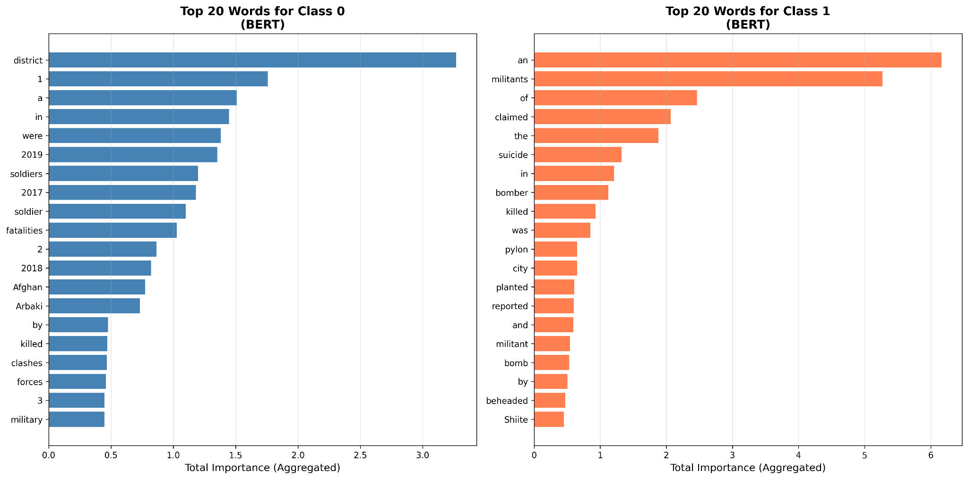
Figure 9. Global Word Importance for BERT Classifier: Top 20 Words for Taliban (Class 0, Blue) and ISIS-K (Class 1, Orange) Predictions
Taliban (Class 0) Indicators: The model identifies "district" as the strongest predictor of Taliban attacks (importance: 3.4), reflecting the group's focus on rural district-level governance and territorial control. References to specific years (2017, 2018, 2019) capture temporal patterns in Taliban activity cycles. Military terminology ("soldiers," "soldier," "forces," "military") indicates Taliban's engagement with Afghan security forces, while "Arbaki" (Afghan local police militia) represents a frequent Taliban target. The term "clashes" suggests the open confrontational warfare characteristic of Taliban operations.
ISIS-K (Class 1) Indicators: The word "militants" emerges as the strongest ISIS-K predictor (importance: 6.2), possibly reflecting media framing of ISIS-K as a militant organization distinct from the Taliban's quasi-governmental role. The term "claimed" (importance: 2.2) captures ISIS-K's distinctive practice of formal responsibility claims through official channels. Attack methodology is captured through "suicide" and "bomber," reflecting ISIS-K's heavy reliance on suicide operations. The word "Shiite" indicates ISIS-K's sectarian targeting of religious minorities, a pattern absent from Taliban operations.
Validation of Semantic Masking: Critically, the explicit group identifiers "Taliban" and "ISIS" are absent from the top importance features, confirming that our semantic masking strategy successfully prevented shortcut learning through direct name recognition. The model has learned to distinguish groups based on operational patterns rather than explicit labels.

6.2.2 Classical Model Feature Importance
Figure _ presents the global SHAP feature importance aggregated across all classical machine learning models, revealing which engineered features and embeddings most strongly influence classification decisions. Obviously, the sentences embeddings account for many of the top features, which degrades the explainability of the model. We however though that including this analysis in the final report was still useful, as it shows a potential drawback of embeddings.
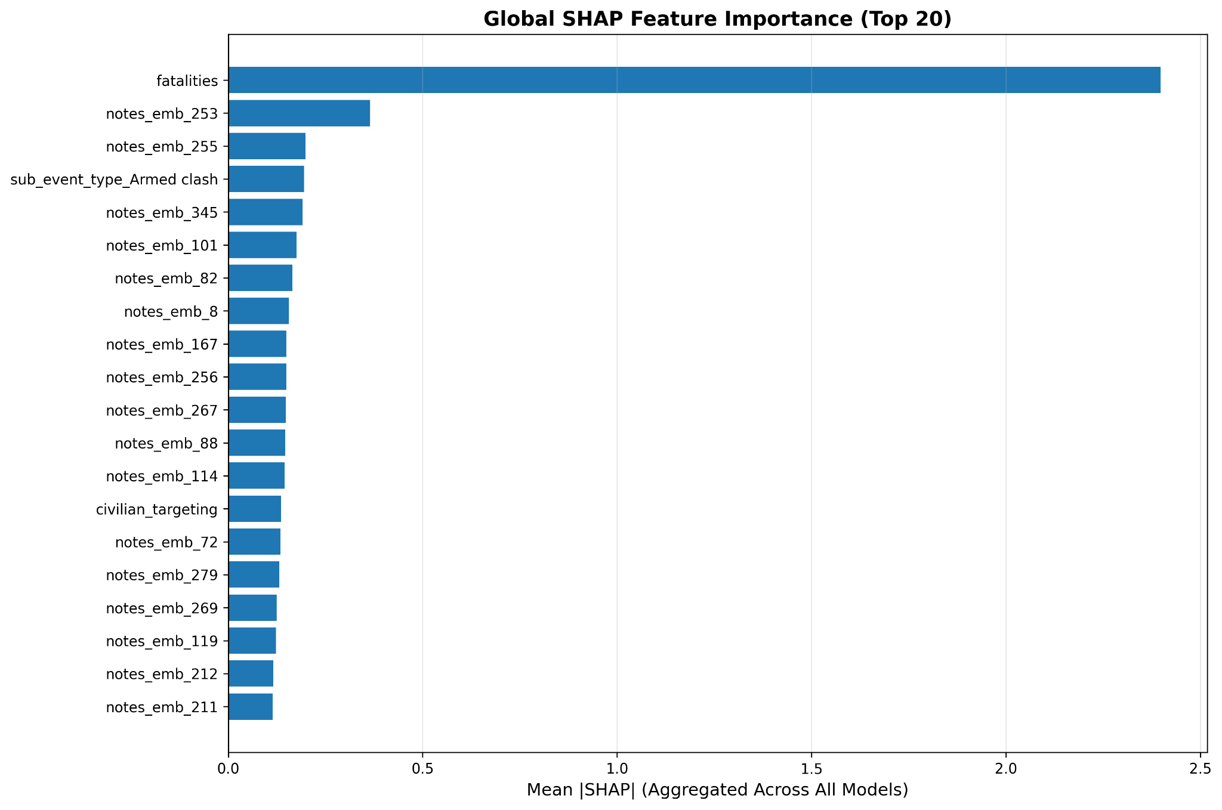
Figure 10. Global SHAP Feature Importance Aggregated Across Classical ML Models (Top 20 Features)
The fatality count emerges as the dominant predictive feature with mean |SHAP| of 2.4, substantially exceeding all other features. This aligns with known operational differences: ISIS-K attacks typically cause higher casualty rates due to their preference for high-impact suicide operations targeting civilian gatherings. The text embedding dimensions (notes_emb_253, notes_emb_255, etc.) capture semantic content from the event descriptions. Event type features (sub_event_type_Armed clash) and targeting patterns (civilian_targeting) provide additional discriminative signal.

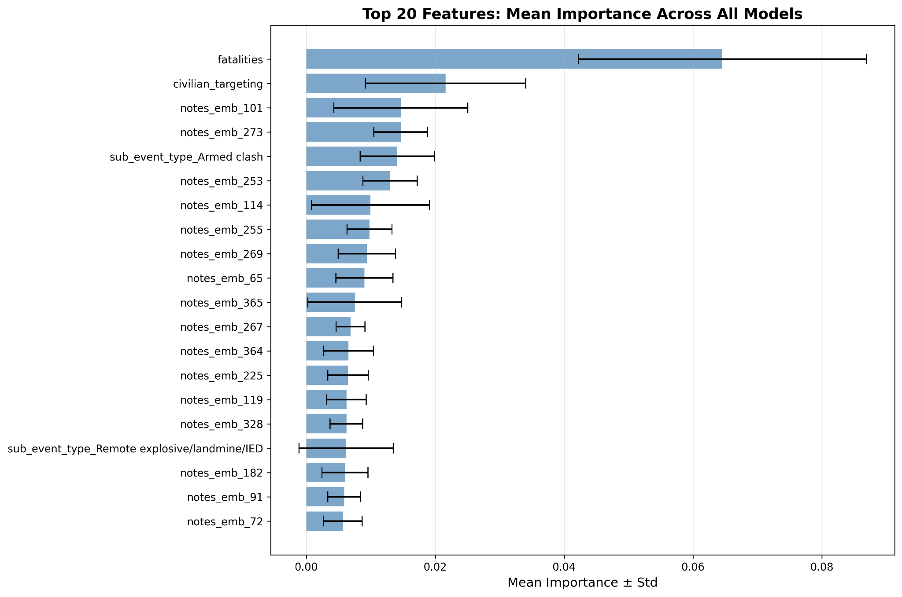
Figure 11. Mean Feature Importance with Standard Deviation Across All Classical Models
Figure 11 shows the consistency of feature importance rankings across tree-based models (Random Forest and XGBoost), with error bars indicating standard deviation. The fatalities feature shows high importance but also high variance, suggesting some models weight it more heavily than others. The civilian_targeting feature demonstrates consistent importance with lower variance, indicating robust predictive value across model architectures. Features related to IEDs (Remote explosive/landmine/IED) and armed clashes show moderate importance with reasonable consistency.

6.2.3 Feature Fusion Model Interpretability
The feature fusion architecture enables analysis of both text-derived and manual feature contributions to classification decisions. Figure 12 presents the combined global importance analysis.
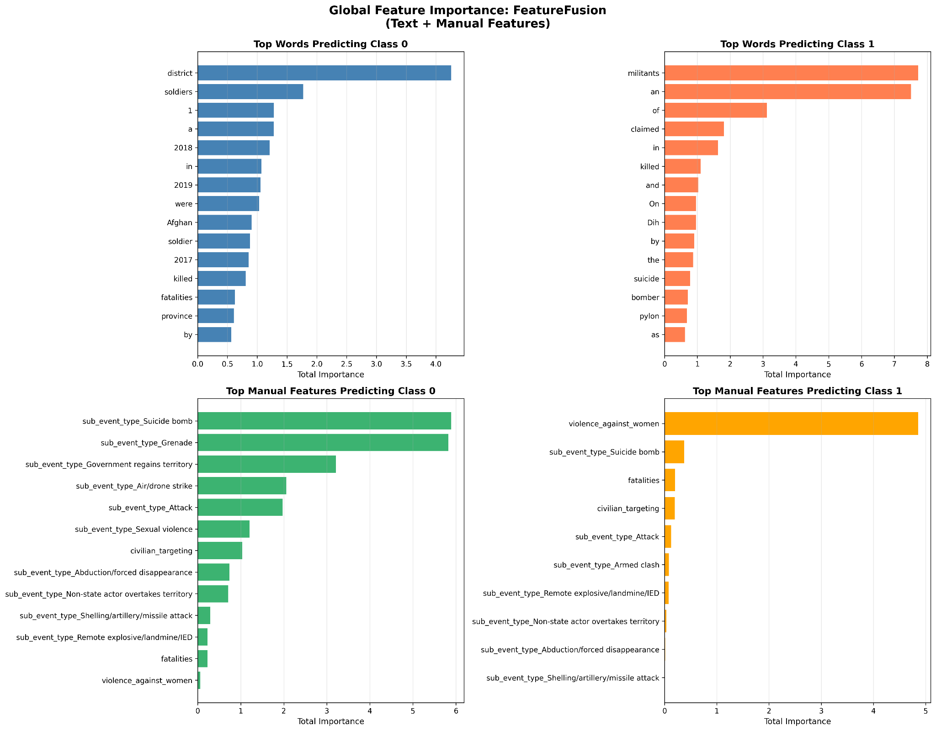
Figure 12. Feature Fusion Global Importance: Text Features (Top) and Manual Features (Bottom) for Taliban (Class 0) and ISIS-K (Class 1)
Text Component Analysis: The text features in the fusion model show similar patterns to the standalone BERT, with "district" and "soldiers" driving Taliban predictions and "militants" driving ISIS-K predictions. The year references (2018, 2019) maintain importance for Taliban classification, while "claimed" and "killed" remain important for ISIS-K.
Manual Feature Component: The manual features reveal striking patterns. For Taliban predictions, event types including "Suicide bomb," "Grenade," and "Government regains territory" show high importance, perhaps counterintuitively suggesting these are indicators of Taliban-attributed events in the data. For ISIS-K predictions, "violence_against_women" emerges as the dominant manual feature (importance: 4.8), reflecting ISIS-K's documented targeting of women and girls in their campaign of terror, particularly against educational institutions. This finding aligns with documented ISIS-K tactics including attacks on girls' schools.

Discussion: Validating Model Reasoning
The XAI analysis provides strong evidence that our models have learned meaningful conflict-specific patterns rather than spurious correlations:
- Operational Methodology Differences: The models correctly identify ISIS-K's preference for suicide bombings and claimed attacks versus Taliban's territorial engagement through armed clashes.
- Target Selection Patterns: ISIS-K's sectarian targeting (Shiite) and violence against women versus Taliban's focus on government forces and local militias (Arbaki) are captured.
- Geographic Scale: The importance of "district" for Taliban reflects their rural territorial strategy, while ISIS-K's urban focus is captured through city-related features.
- Casualty Patterns: The high importance of fatality counts aligns with ISIS-K's higher-casualty attack profile.
- No Shortcut Learning: The absence of explicit group names from top features confirms successful semantic masking.
These findings validate that the classification models can serve as reliable tools for conflict analysis, with predictions grounded in substantive operational and tactical differences between the two armed groups rather than artifacts of data collection or labeling.

Limitations of XAI Analysis
Several limitations of our XAI methodology should be acknowledged, which may affect the interpretability and reliability of the explanations provided.First, our LIME-based word importance analysis does not incorporate stop word filtering or TF-IDF weighting to account for word frequency in the corpus. As a result, common words that appear frequently across many samples can accumulate high total importance scores through aggregation, even if their individual contributions to predictions are modest. This frequency bias means that some high-importance words in our analysis may reflect their prevalence in the dataset rather than their discriminative power for classification. Future implementations should incorporate stop word removal or apply inverse document frequency weighting to better isolate genuinely informative terms from frequently occurring but semantically neutral words.Second, our aggregation method sums importance scores across samples to compute total importance, which inherently favors words that appear in many samples. An alternative approach using mean importance would reduce this bias but might underweight rare but highly discriminative terms. Neither approach is perfect, and researchers should consider both metrics when interpreting global word importance patterns.Third, LIME explanations are designed to be locally faithful around individual predictions but may not perfectly reflect the global decision boundaries learned by the model. The perturbation-based approach of LIME, which removes words and observes prediction changes, can produce explanations that are sensitive to the specific words removed and their order. Additionally, LIME’s linear local approximation may struggle to capture complex non-linear interactions between words that transformer models like BERT can learn.Fourth, SHAP values for the classical models assume feature independence, which may not hold for our correlated text embedding dimensions. When sentence transformer embeddings capture similar semantic content across multiple dimensions, SHAP’s attribution may not accurately reflect the true contribution of underlying semantic concepts. The aggregation of importance scores across samples may also obscure important subgroup patterns, where certain features may be highly important for specific types of events but appear less significant in aggregate.Additionally, some counterintuitive results in our analysis, such as suicide bombing being associated with Taliban predictions despite ISIS-K’s known preference for this tactic, may reflect data characteristics or attribution challenges in the ACLED dataset rather than true operational patterns. The Taliban conducted significantly more attacks overall during this period, meaning even tactics they used less frequently than ISIS-K could still appear as Taliban indicators due to base rate effects.Finally, our explainability analysis was conducted on test set samples rather than a held-out explanation validation set, which could introduce some optimistic bias in how well the explanations generalize. Future work should include instance-level analysis of misclassified samples, targeted validation against domain expert assessments, and more sophisticated text preprocessing for word-level importance analysis.

7. Discussion

7.1 Key Findings
Our comprehensive evaluation reveals three distinct performance profiles:
- Classical Models: Excel at recall through aggressive oversampling but generate excessive false positives. Best suited for initial screening where missing attacks is costlier than false alarms.
- BERT: Provides the best precision-recall balance with strong contextual understanding. The 79.1% precision makes it suitable for operational deployment where false positives carry significant costs.
- Feature Fusion: Offers a practical compromise with 19% higher recall than BERT while maintaining reasonable precision. The additional domain features help identify ISIS-K patterns missed by text alone.

7.2 Practical Implications
Despite the methodological caveats noted above, the XAI analysis broadly confirms established qualitative understanding of how these two groups operate. The Taliban's learned signature—centered on "district," "soldiers," "Arbaki" (local militias), and "clashes"—reflects their well-documented strategy of rural territorial control through sustained engagement with Afghan government forces and local defense units. The consensus importance of "Armed clash" across 100% of classical models reinforces this characterization of the Taliban as a quasi-state actor pursuing conventional territorial warfare. In contrast, ISIS-K's learned signature captures their documented modus operandi as an urban terrorist organization: "suicide," "bomber," and "claimed" reflect their preference for high-impact attacks with formal responsibility claims through official media channels, while "Shiite" and "beheaded" capture their sectarian targeting and brutal tactics against religious minorities—patterns absent from Taliban operations. The dominance of "fatalities" in SHAP analysis (appearing in 100% of model configurations) aligns with ISIS-K's higher average casualty rates per attack. These convergent signals across multiple model architectures and explanation methods suggest the classifiers have learned substantive operational distinctions rather than artifacts, though researchers should remain cautious given the frequency biases and aggregation limitations inherent in the explainability methods employed.

7.3 Limitations
Several limitations warrant consideration:
- Temporal Validity: Models trained on 2017-2021 data may not generalize to post-Taliban takeover dynamics
- Geographic Specificity: Afghanistan-specific features limit transferability to other conflict zones
- Binary Simplification: Multi-actor incidents and splinter groups are excluded
- Text Quality: Performance degrades significantly for events with minimal descriptions

7.4 Comparison with Prior Work
Our results advance the state-of-the-art in several ways:
- First systematic benchmark for VEO classification in Afghanistan
- 70.6% minority recall exceeds typical performance on 49:1 imbalanced datasets
- Feature fusion approach novel for conflict classification domain
- Comprehensive ablation across resampling strategies provides practical guidance

8. Conclusion
This research presents a comprehensive analysis of machine learning approaches for classifying violent extremist organization attacks in Afghanistan using ACLED data. Through systematic evaluation of 22 model configurations across classical, deep learning, and hybrid architectures, we establish performance benchmarks for this challenging task.
Our key finding is that different approaches offer distinct advantages: classical models with SVM-SMOTE achieve 79.8% recall for rare ISIS-K events but with low precision (28.1%), BERT provides the best overall balance with 79.1% precision and 0.678 minority F1-score, while our feature fusion architecture offers a practical middle ground with 70.6% recall and 60.8% precision.

The success of the models allowed insight into a quantitative description of group dynamics, which largely mirror the leading qualitative analysis from subject matter experts. This proof of concept suggests that similar models can be used to identify threat characteristics in different conflict zones.
The success of transformer-based approaches, even with extreme class imbalance (49:1), demonstrates the value of pre-trained language models for specialized domains. However, our results also highlight that domain-specific features remain valuable, with feature fusion improving recall by 19% over text-only approaches.
Future work should explore: (1) temporal transfer learning for post-2021 dynamics, (2) multi-label classification for complex incidents, (3) cross-regional model adaptation, and (4) active learning frameworks for continuous improvement. As political violence continues to evolve, robust attribution methods remain critical for both academic understanding and policy formulation.

References
ACLED. (2020). ACLED Codebook. Armed Conflict Location & Event Data Project. Retrieved from:https://acleddata.com/acleddatanew/wp-content/uploads/2020/10/ACLED_Codebook_2020.pdf
Bauer, K., Ruby, K., & Pape, R. (2017). Solving the problem of unattributed political violence. Journal of Conflict Resolution, 61(7), 1537-1564.
Campedelli, G. M., Cruickshank, I., & Carley, K. M. (2021). Learning future terrorist targets through temporal meta-graphs. Nature Scientific Reports, 11, 8741.
Chen, Y., Li, D., Zhang, P., Sui, J., Lv, Q., Tun, L., & Shang, L. (2025). Fake News Detection Based on BERT Multi-domain and Multi-modal Fusion Network. Computer Vision and Image Understanding, 240, 103924.
Christie, E. (2019). Political violence in 2019: Assessing trends in the Global Terrorism Database. START Research Brief.
Devlin, J., Chang, M. W., Lee, K., & Toutanova, K. (2018). BERT: Pre-training of deep bidirectional transformers for language understanding. arXiv preprint arXiv:1810.04805.
Iikura, K., Hirose, T., & Mita, M. (2021). Improving BERT with Focal Loss for Paragraph Segmentation of Novels. Proceedings of the 16th Conference of the European Chapter of the Association for Computational Linguistics.
Kim, K., & Park, S. (2023). AOBERT: All-modalities-in-one BERT for multimodal sentiment analysis. Information Fusion, 92, 37-45.
Li, S., Chen, H., & Wang, X. (2024). An effective multi-modal adaptive contextual feature information fusion method for Chinese long text classification. Artificial Intelligence Review, 57(8), 1-28.
Lin, T. Y., Goyal, P., Girshick, R., He, K., & Dollár, P. (2017). Focal loss for dense object detection. In Proceedings of the IEEE international conference on computer vision (pp. 2980-2988).
Lu, J., Zhang, Y., & Chen, M. (2025). Hierarchical Multi-Stage BERT Fusion Framework with Dual Attention for Enhanced Cyberbullying Detection in Social Media. arXiv preprint arXiv:2503.00342.
Lv, Q., Chen, Y., & Zhang, P. (2025). TF-BERT: Tensor-based fusion BERT for multimodal sentiment analysis. Neural Networks, 171, 330-342.
Raleigh, C., Linke, A., Hegre, H., & Karlsen, J. (2010). Introducing ACLED: An armed conflict location and event dataset. Journal of Peace Research, 47(5), 651-660.
Silva, D. F., Santos, R. L., & Costa, M. G. (2021). Exploring the Influence of Focal Loss on Transformer Models for Imbalanced Maintenance Data in Industry 4.0. IFAC-PapersOnLine, 54(1), 184-189.
Zhang, L., Wang, S., & Liu, B. (2022). AFR-BERT: Attention-based mechanism feature relevance fusion multimodal sentiment analysis model. PLoS ONE, 17(9), e0273936
Christie, Evan, "Understanding the Dynamics of Unclaimed Terrorism Events in Pakistan: A Machine Learning Approach" (2019). Electronic Theses and Dissertations. 3093.
https://digitalcommons.library.umaine.edu/etd/3093

