**1. Link to ABBYY help**

<https://help.abbyy.com/en-us/flexicapture/12/standalone_administrator/rule_bd>

The most important here

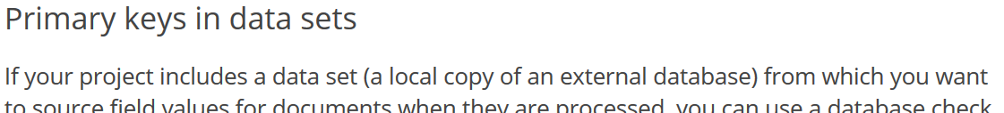

**2. Preparing data**

Executing two scripts

1. (Attached or link to GitHub)

2. (Attached or link to GitHub)

**IMPORTANT:**

Use “localhost” name and “Trust connection” (as standart enviroment) for the exchanging data in the developer group

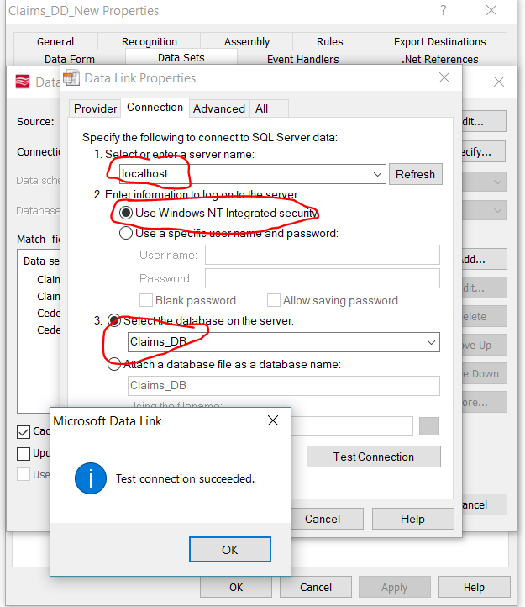

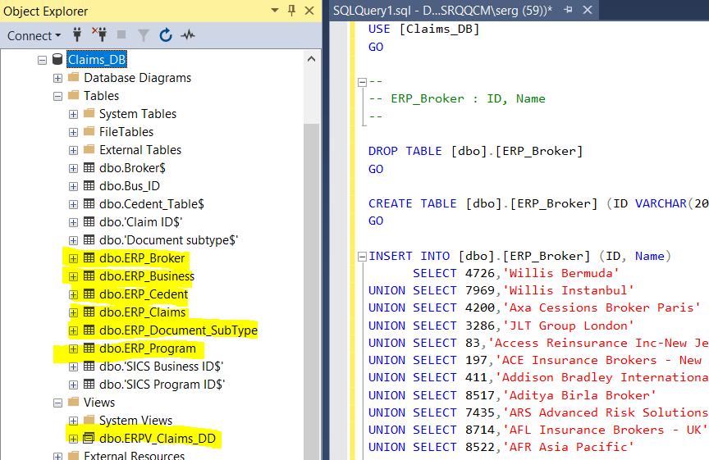

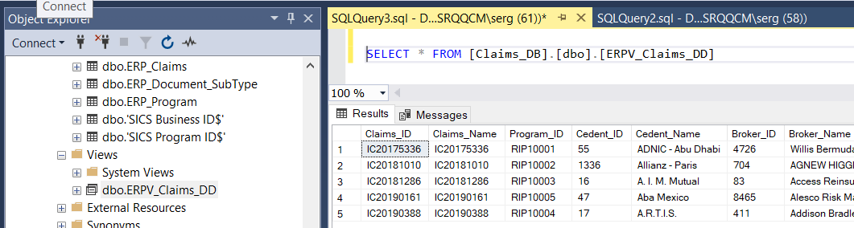

**3. Data Set**

Best way that DB names and FC names to be same

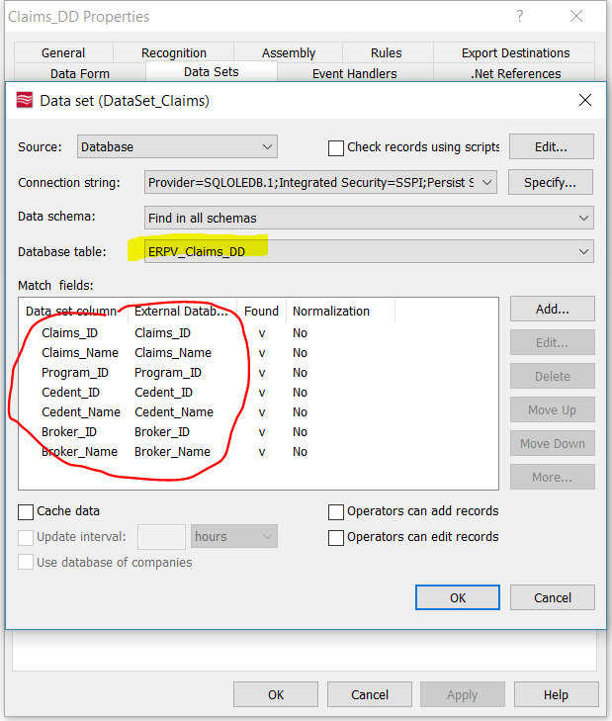

Set PK and Cache data

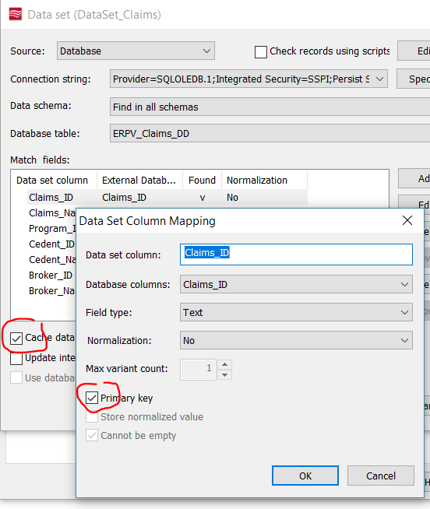

Update Data Set

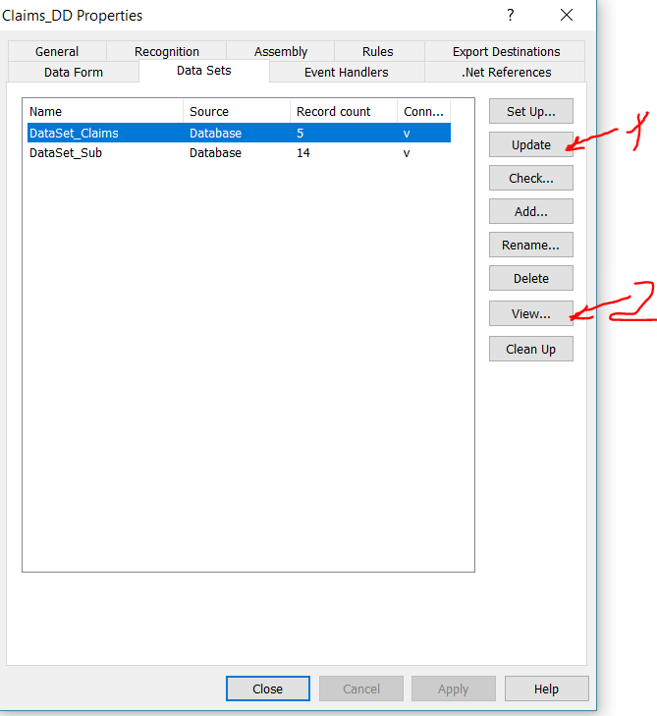

Look result

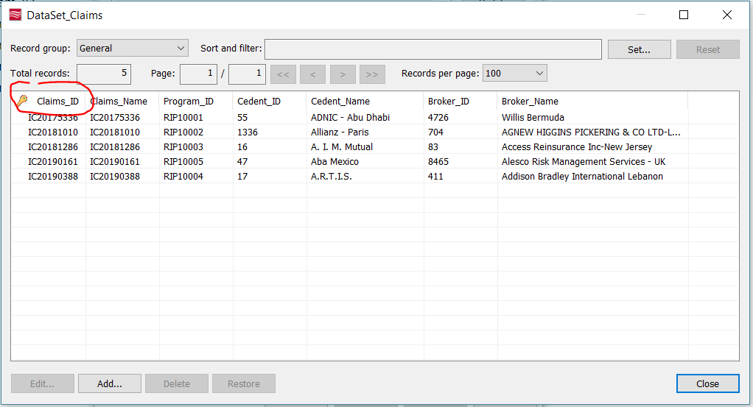

Set field properties (for PK)

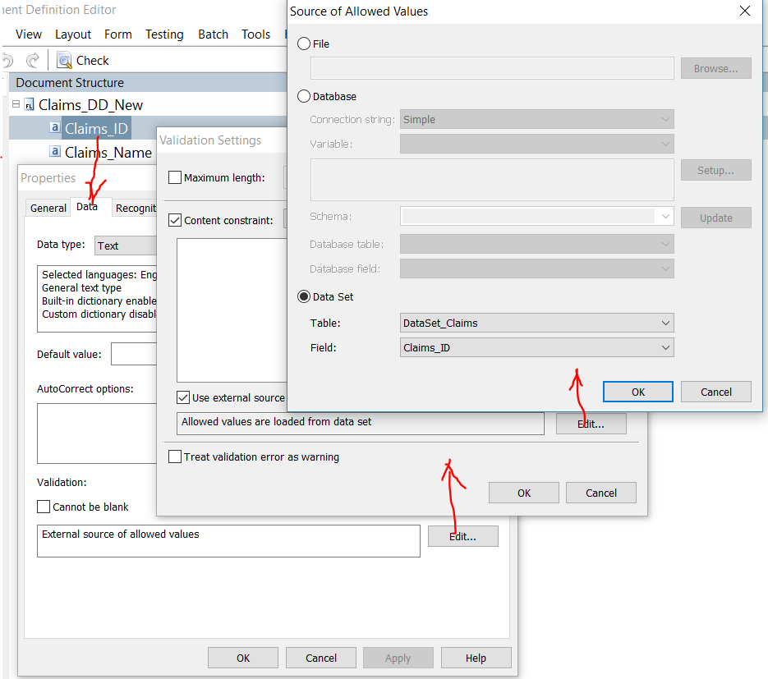

Set all fields you need properties (for non PK)

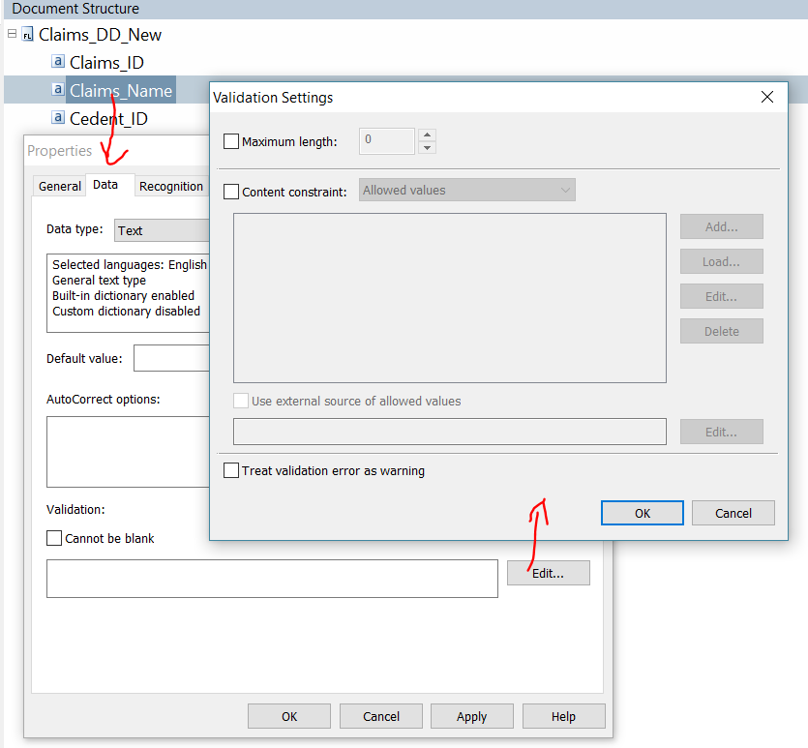

**4. Set rule**

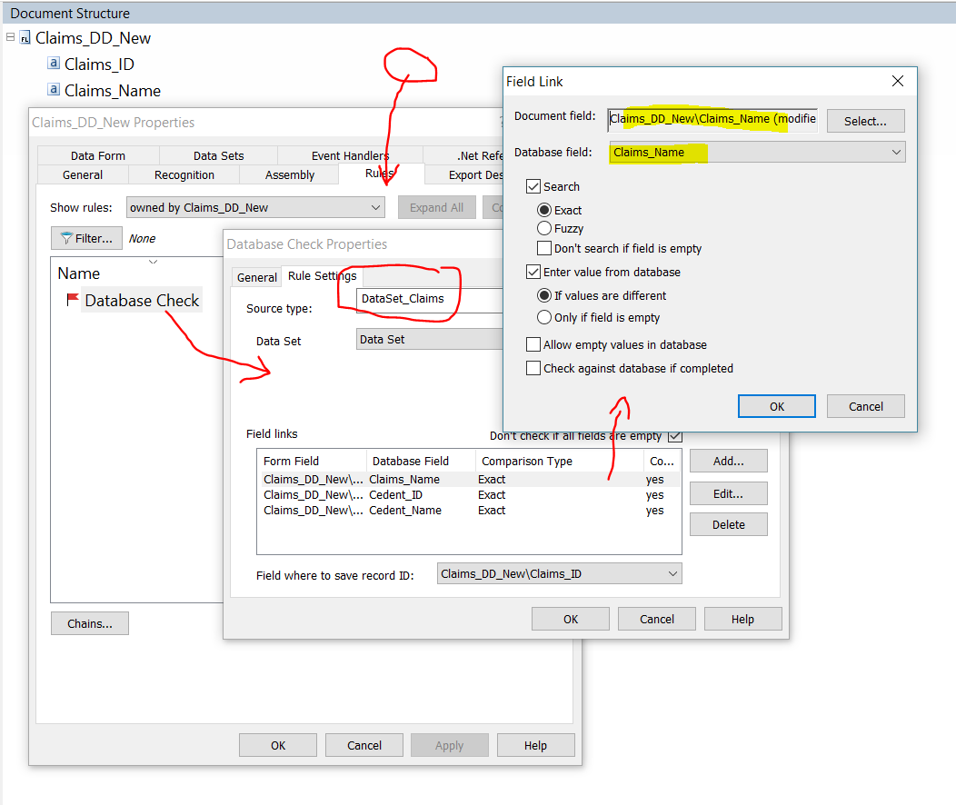

**5. Process**

Save and publish

Clear analysis results

Recognize

Verification – set record as batch

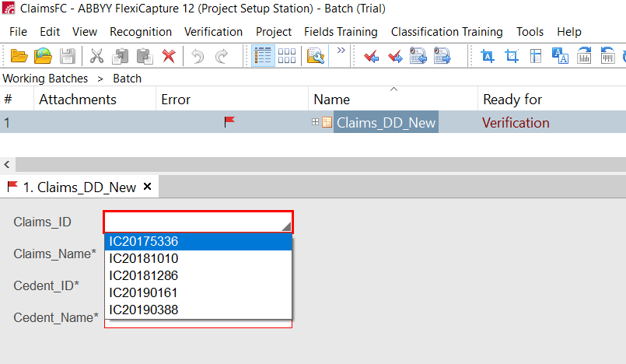

**6. Try to chane any field**

Appeared Popup lookup

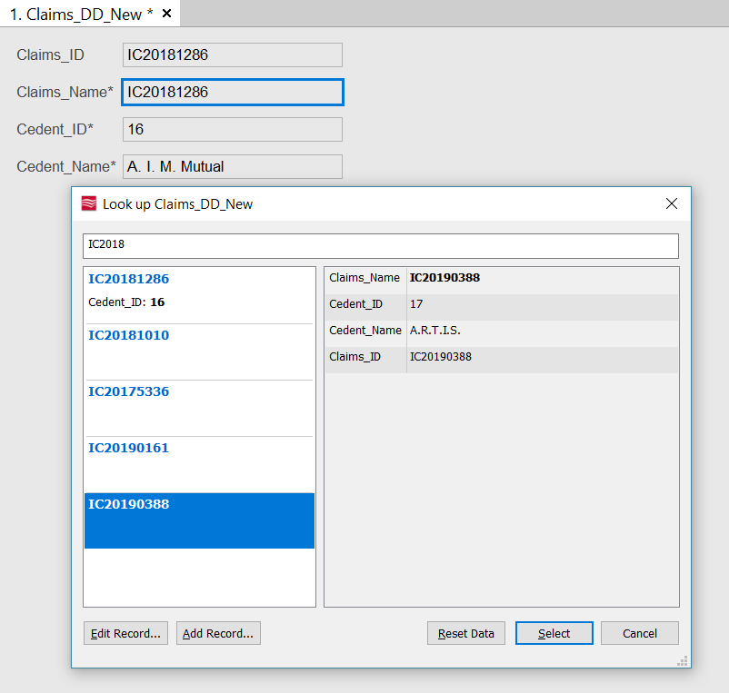

You can set new record only as batch

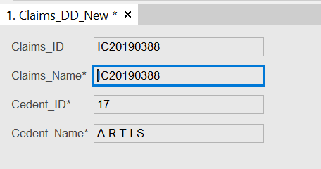

**END**