Working with LangChain and LCEL
Demo 1

Demo: Build a Resume Screening Application with LangChain
Overview
This is a Resume Screening Application developed using LangChain that assists HR professionals in efficiently screening candidate resumes against job requirements. The application leverages LangChain components and LangChain Expression Language (LCEL) to create an automated, AI-powered resume analyzer. The application compares uploaded resumes to specified job descriptions, generates structured analysis, assigns a suitability score, and stores the results using vector embeddings and ChromaDB.

Scenario
A company is looking for a Senior Python Developer post and receives hundreds of résumé applications. The HR team needs to rapidly filter these resumes to discover candidates whose abilities, experience, and qualifications best match the job criteria. Manually examining each CV is time-consuming and prone to human bias, leading to potential oversight of eligible individuals. The team requires an automated system to analyze applications against the job description, provide a complete compatibility assessment, and select the best prospects for further examination.

Problem Statement
Create a resume Screening Application using LangChain that lets HR managers enter job requirements, submit a candidate's résumé (in PDF, DOCX, or TXT format), and examine the resume to find fit for the post. The application should extract text from the resume, compare it against the job requirements using an artificial intelligence model, and offer a structured analysis including a match score, skills assessment, experience relevance, education evaluation, strengths, weaknesses, and general candidate recommendation. The answer has to be easy to use, handle several file types, and let users download the analysis report for keeping records.

Approach for the Solution
The Resume Screening Application leverages several LangChain components to provide an automated, AI-powered solution for screening resumes. The goal is to help HR professionals streamline the process of evaluating resumes against job requirements. Below is the approach for the solution:
- Data Ingestion: The app allows HR managers to upload resumes in various formats (PDF, DOCX, TXT). Once uploaded, the resume text is extracted using appropriate loaders (e.g., PyPDFLoader, Docx2txtLoader).
- Text Processing: The extracted resume text is processed for analysis using techniques such as Text Splitting. Text is split into manageable chunks to fit within token limits using RecursiveCharacterTextSplitter.
- Model Inference: The text is analyzed by a Generative AI model (ChatGoogleGenerativeAI) to understand how well the resume matches the job requirements. The model generates a structured response, including a Suitability Score.
- Embeddings and Semantic Search: The generated analysis is stored in a Vector Database (Chroma) with the help of Embeddings (GoogleGenerativeAIEmbeddings). This enables semantic search and easy retrieval of past analysis.
- User Interface: The app is deployed using Streamlit to provide an interactive front-end interface. HR professionals can input job requirements, upload resumes, view AI-generated analysis, and download the results.
- Pipeline Construction with LCEL: The entire process is modularized using LangChain's LCEL (LangChain Expression Language), allowing a smooth and flexible pipeline for data flow, processing, and model inference.

Structure of the Solution
The structure of the solution is designed to be modular, utilizing LangChain components for different tasks:
- Resume Upload & Job Requirements: Input by the user in the Streamlit interface.
- Text Extraction: Done using specific loaders depending on file type.
- Text Processing: Managed by the RecursiveCharacterTextSplitter.
- Model Inference & Analysis: Performed using the LLM (ChatGoogleGenerativeAI).
- Embedding and Storage: Analysis is converted into vector embeddings and stored in Chroma.
- User Interface: Streamlit is used for the front-end to display results.

Stepwise Solution

Step 1: Setting up the Environment
- Objective: Set up a virtual environment, install necessary dependencies, and load the environment variables.
- Topics Covered:
  - Components and Modules
  - Data Ingestion and Document Loaders
Code:
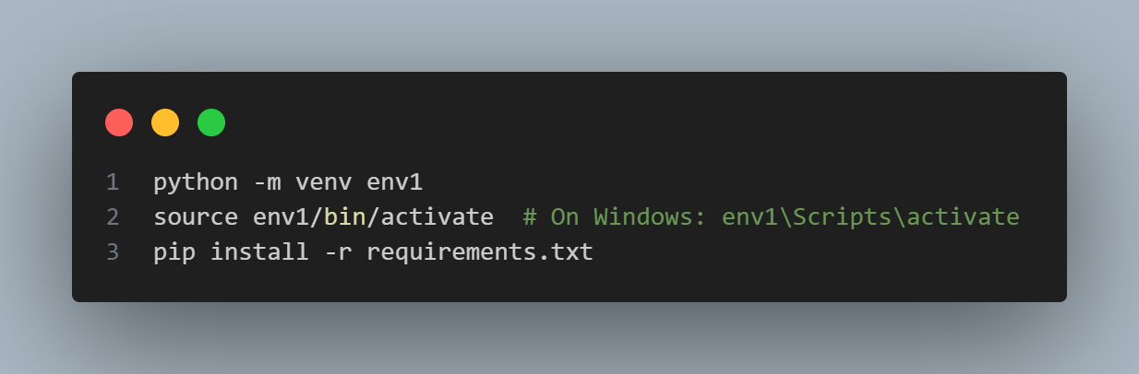
- Create a .env file to store API keys (like GOOGLE_API_KEY) for the AI model.

Step 2: Data Ingestion and Document Loaders
- Objective: Allow users to upload resumes and extract text using appropriate loaders for different file formats (PDF, DOCX, TXT).
- Topics Covered:
  - Data Ingestion and Document Loaders

Code:
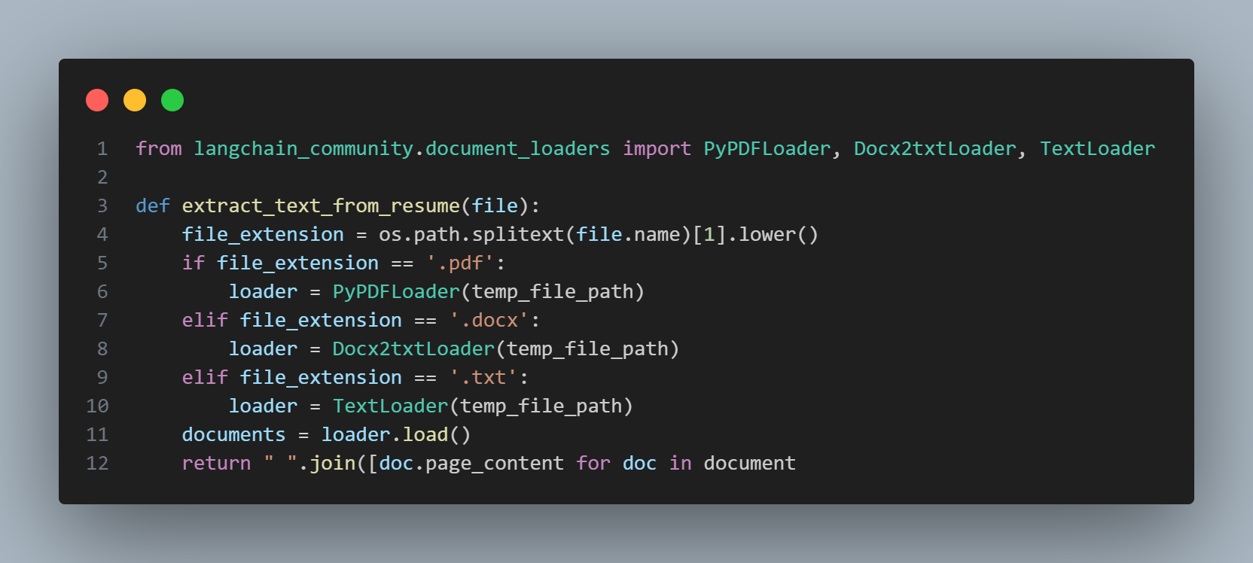

Step 3: Text Splitting
- Objective: Split long text into chunks that can be processed effectively.
- Topics Covered:
  - Text Splitting
Code:
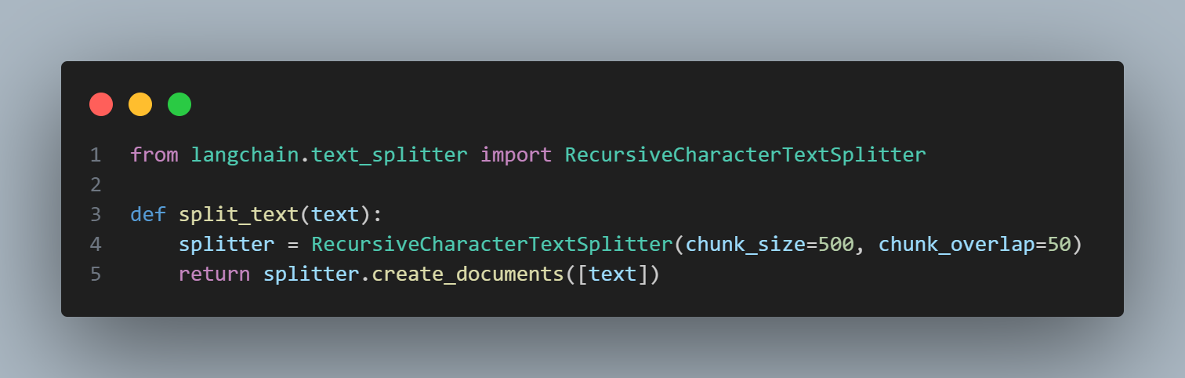

Step 4: Model Setup and Analysis Generation
- Objective: Use an AI model (Google Generative AI) to analyze the resume against job requirements and generate a Suitability Score.
- Topics Covered:
  - Embeddings
  - Chains
  - Runnables
Code:
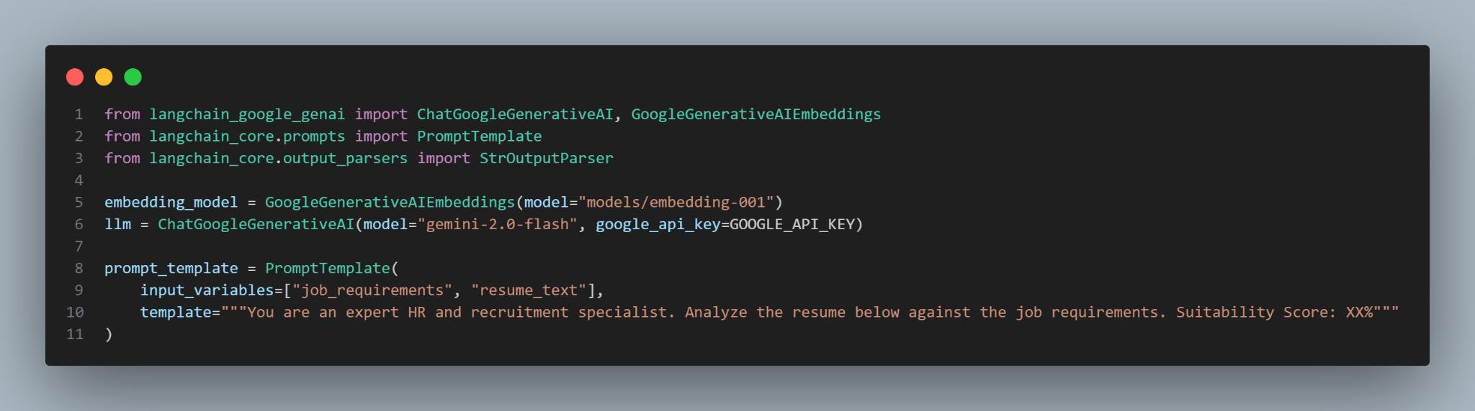

Step 5: Storing Results in Vector Store
- Objective: Store the analysis and resume data as embeddings in the Chroma vector database.
- Topics Covered:
  - Integration with Vector Databases
Code:
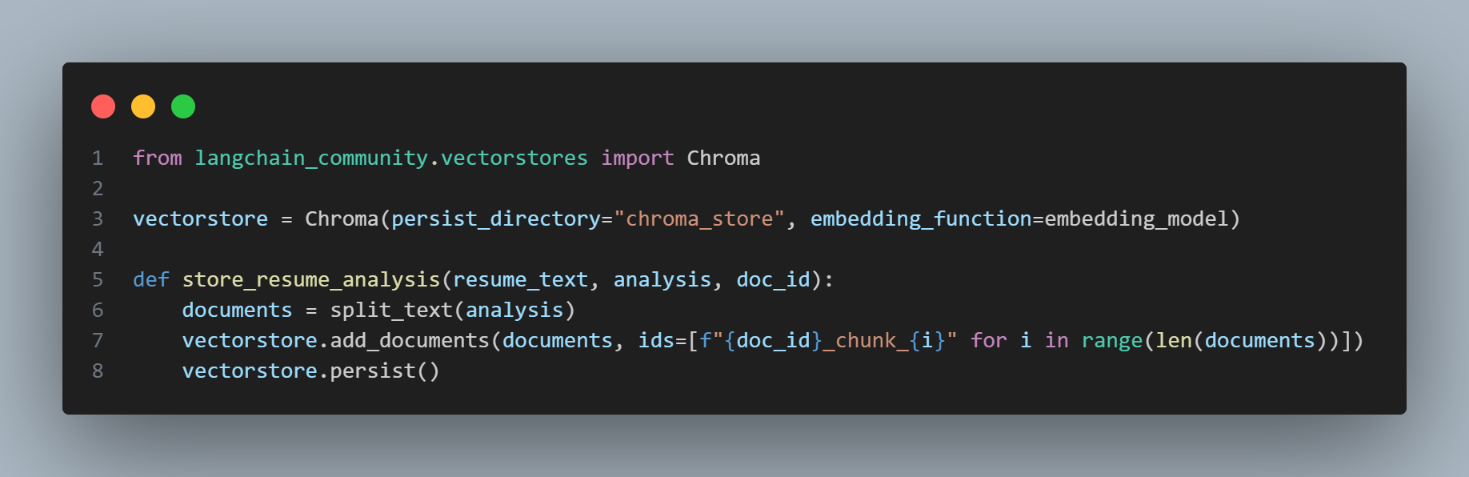

Step 6: Final Chain Construction using LCEL
- Objective: Use LangChain's LCEL to connect all components into a complete data pipeline.
- Topics Covered:
  - Introduction to Langchain Expression Language (LCEL)
  - Chains

Code:
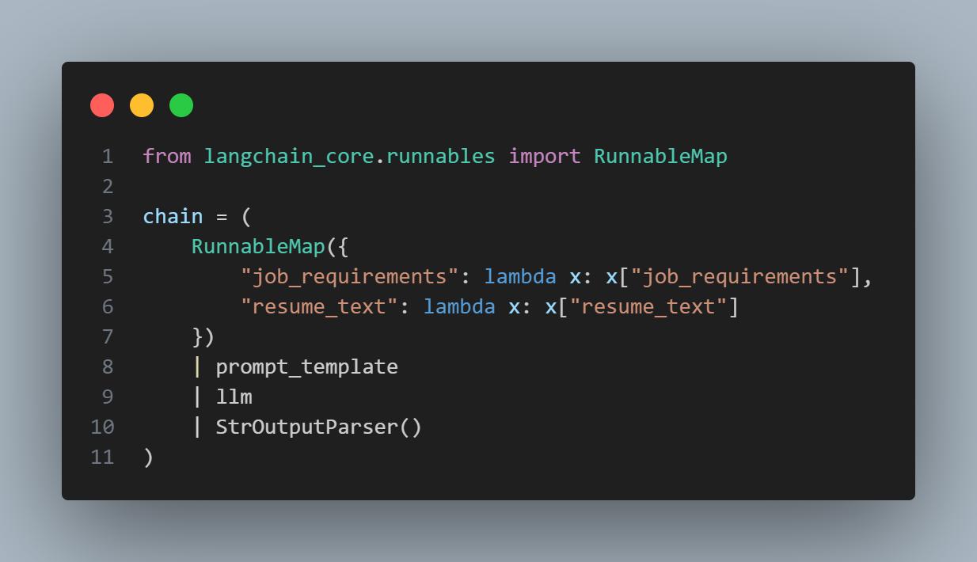

Step 7: Deployment with Streamlit
- Objective: Create a user-friendly web interface where users can upload resumes and input job requirements.
- Topics Covered:
  - Deployment with Streamlit
Code:
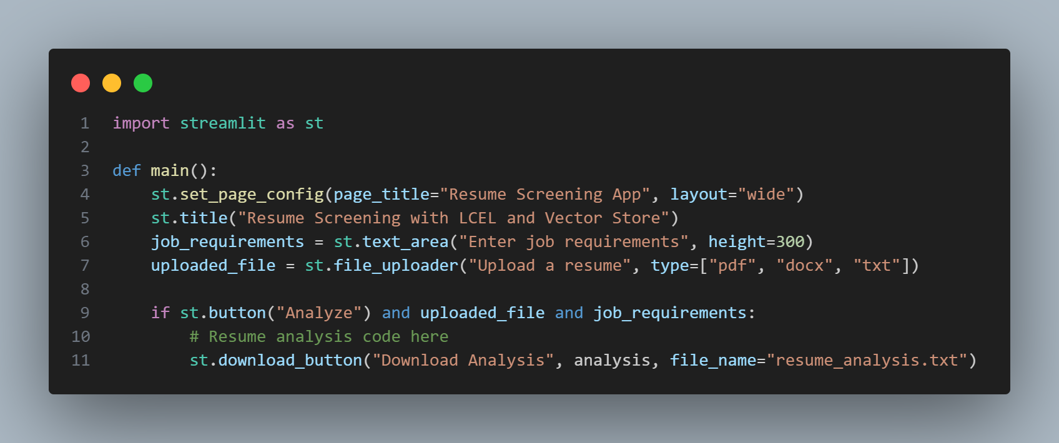

Conclusion
By following these steps, we’ve built a Resume Screening Application using LangChain, which automates the analysis of resumes against job requirements. The application integrates various LangChain components such as loaders, text splitting, embeddings, and chains to process documents, analyze them with AI models, store results in a vector database, and provide an intuitive user interface via Streamlit. This demonstrates how LangChain can be leveraged to build intelligent applications for real-world tasks like resume screening.

