Step-1 . User will enter shop name, Postcode and Address of the shop.

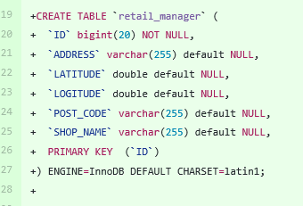

Step-2. Code will validate the user input parameters

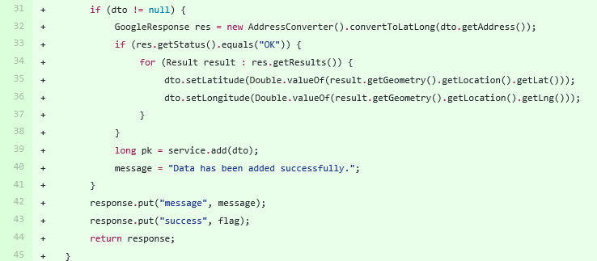

Step-3. If that particular shop is exist then controller will locate geographical position.

Step-4. If that particular shop does not exists then controller will not locate geographical position.

Step-5. The server side API then stores details of the shop to an in-memory array of shops. Details should contain:

1 shopName

2 ShopAddress.number

3 ShopAddress.postCode

4 shopLongitude

5 shopLatitude

Step-6. The server side API accepts two URL parameters for the request:

(a) Customer Longitude

(b) Customer Latitude

|  |  |
| --- | --- |
|  | |
|  |
|  |
| To add Record: |  |
|  | http://localhost:8080/RetailStore/rest/RetailManager/add |
|  |  |
|  | POST Input : |
|  |  |
|  | {"shopName":"ABC","address":"Mumbai,Maharashtra,India","postCode":"452015"} |
|  |  |
|  | Output : |
|  |  |
|  | { |
|  | "message": "Data has been added successfully.", |
|  | "success": false |
|  | } |
|  |  |
|  | ------------------------------------------------------- |
|  |  |
|  | To fetch record : |
|  |  |
|  | http://localhost:8080/RetailStore/rest/RetailManager/get |
|  |  |
|  | POST Input |
|  |  |
|  | {"latitude":19.0759837,"longitude":72.8776559} |
|  |  |
|  | Output : |
|  |  |
|  | { |
|  | "message": "Data has been fetched successfully.", |
|  | "dto": { |
|  | "id": 1, |
|  | "shopName": "ABC", |
|  | "address": "Mumbai,Maharashtra,India", |
|  | "postCode": "452015", |
|  | "latitude": 19.0759837, |
|  | "longitude": 72.8776559 |
|  | }, |
|  | "success": true |
|  | } |

0 comments on commit 898fca5

@SAsrani

Add header text

Add bold text <ctrl+b>

Add italic text <ctrl+i>

Insert a quote

Insert code

Directly mention a user or team

Reference an issue or pull request

Write Preview

Leave a comment

Attach files by dragging & dropping or selecting them.

Styling with Markdown is supported

Comment on this commit

Subscribe

You’re not receiving notifications from this thread.

Contact GitHub

API

Training

Shop

Blog

About

© 2017 GitHub, Inc.

Terms

Privacy

Security

Status

Help