**Seth Ayers**

**04/24/2018**

**IT 430**

**Lab 10**

**SAyers_lab10.docx**

**Lab 10: pfSEnse VLAN configuration**

|  |  |
| --- | --- |
| VM interface | IP Address |
| pfSense WAN interface | 192.168.43.178 |
| pfSense LAN interface | 192.168.64.1 |
| WIN7 LAN | 192.168.64.9 |
| WIN XP | 192.168.64.8 |
| WIN Server LAN | 192.168.64.10 |

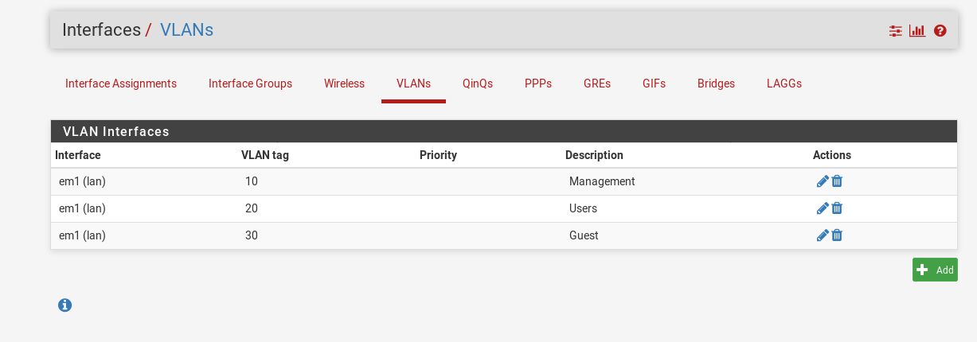

*Created VLANs for the various VM’s that will require access permissions.*

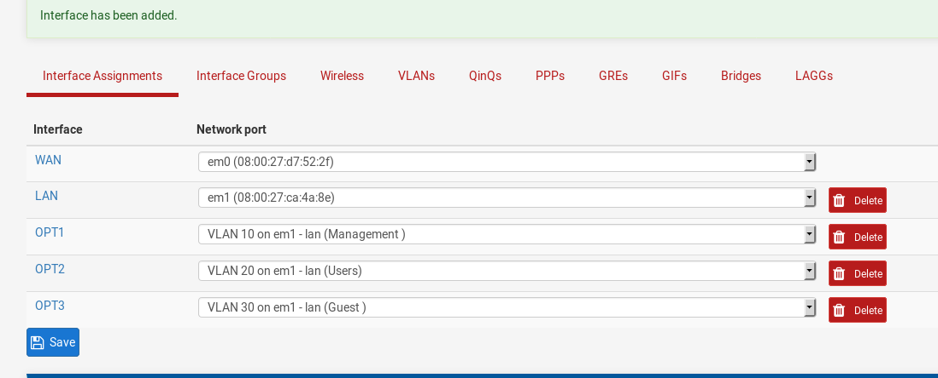

*Adding interfaces for each VLAN created.*

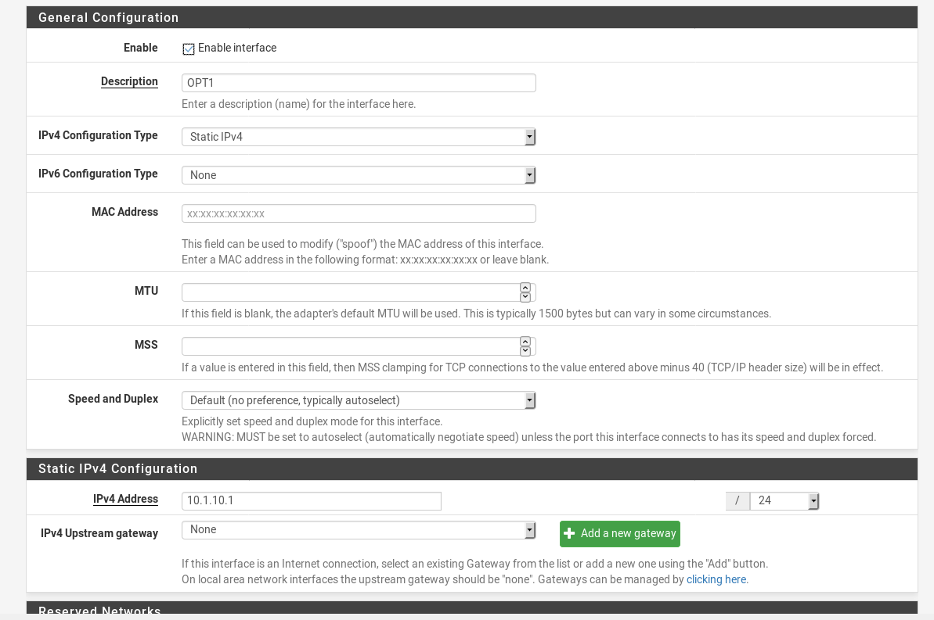

*OPT1 interface configuration settings.*

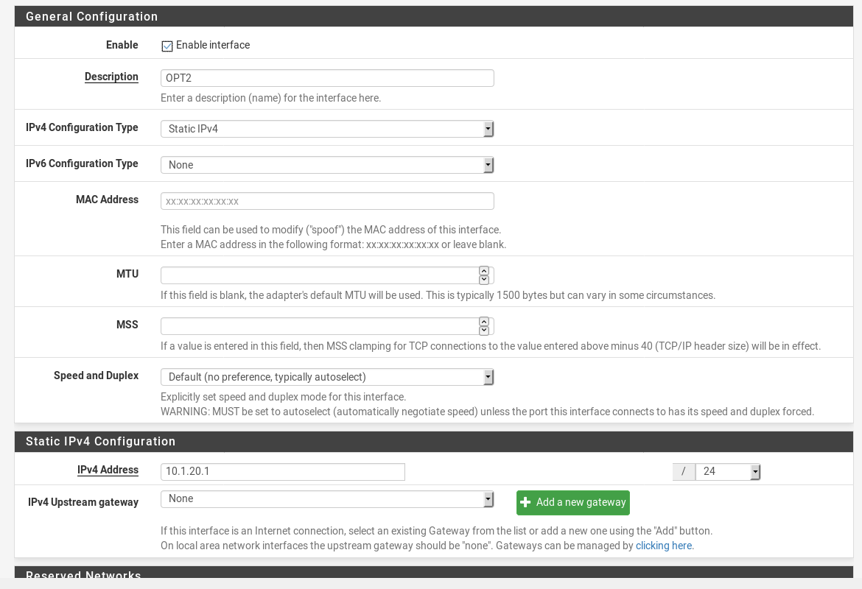

*OPT2 interface configuration settings.*

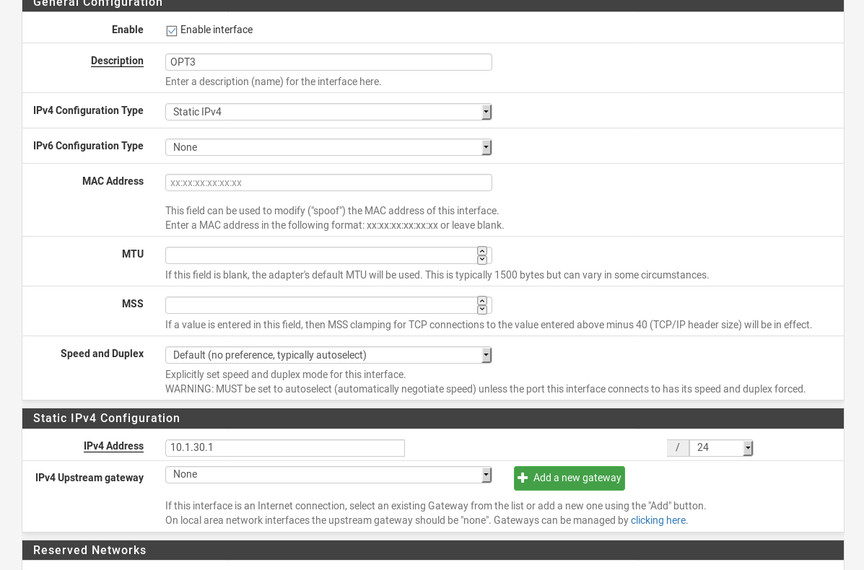

*OPT3 interface configuration settings.*

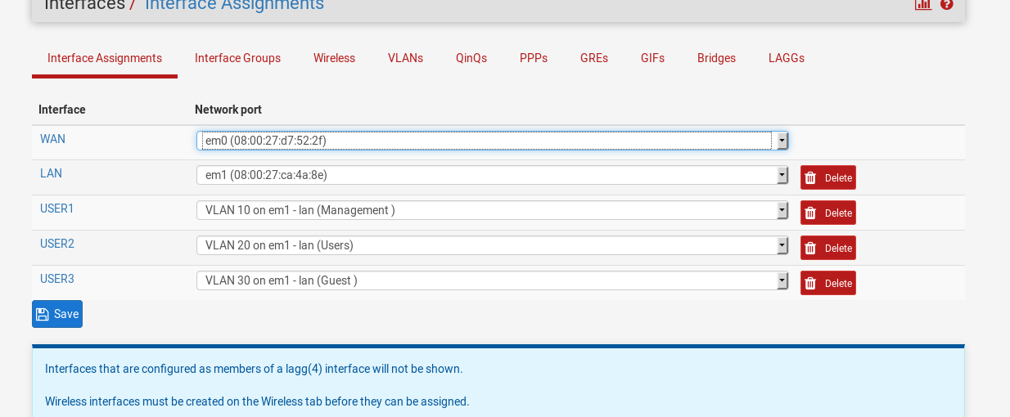

*Description name changes for all VLANS from the default settings.*

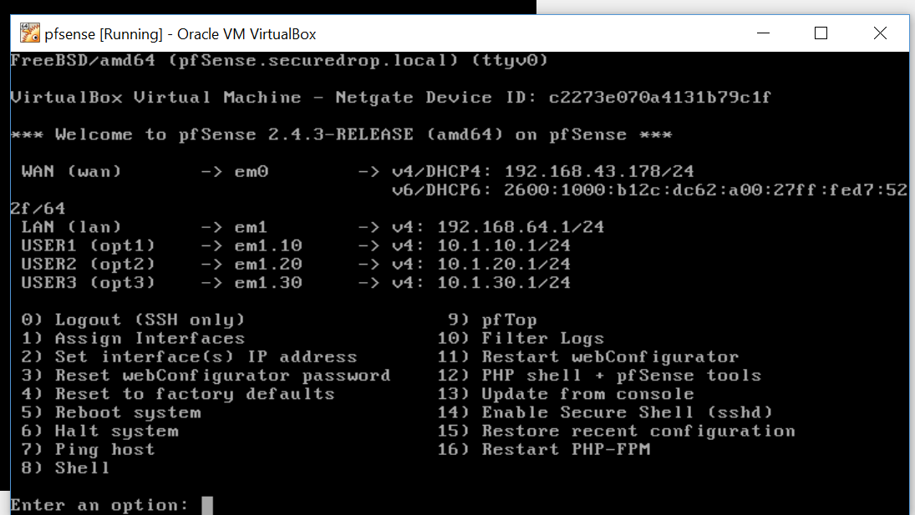*Confirmation that all VLANs were added to the pfSense firewall.*

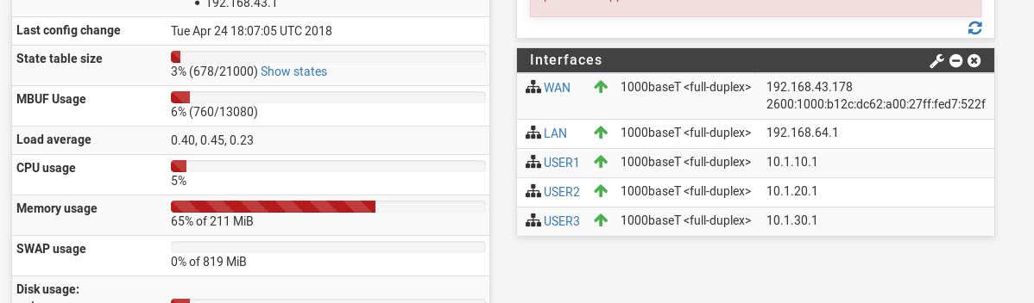

*Confirmation that all VLANs are added and visible on the GUI.*