**RESUME**

**NAME**  : NAVEENKUMAR.B,

**ADDRESS**  : 182, PILLIYAR KOVIL ST,

GOVINDHANGAL,

RANIPETT 632 505,

**CONTACT NO.** : 6374793361, 7826054979.

**MAIL ID.** : naveenkumar.b.9009@gmail.com.

**OBJECTIVE:**

To get an opportunity where I can make the best of my potential and contribute to the organization’s growth.

**EDUCATIONAL QUALIFICATION**

|  |  |  |  |  |  |
| --- | --- | --- | --- | --- | --- |
| **SLNO** | **COURSE** | **NAME OF THE INSTITUTION** | **YEAR OF PASSING** | **PERCENTAGE OF MARKS** | **GRADE** |
| **1** | **SSLC** | **GOVERNMENT HEGH SCHOOL, POLIPAKKAM** | **2020** | **85.00%** | **FIRST CLASS** |
| **2** | **HSC** | **GOVERNMENT BOYS HIR. SEC. SCHOOL, SHOLINGHUR** | **2022** | **80.00%** | **FIRST CLASS** |
| **3** | **DIPLOMA IN MECHATRONICS ENGINEERING AND SMART FACTORY** | **NETTUR TECHNICAL TRAINING CENTRE, BANGALORE** | **2025** | **96.00%** | **DISTRICTION** |

**TECHNICAL SKILLS**

* MS OFFICE AND ADVANCE EXCEL
* AUTOCAD
* CNC PROGRAMMING
* FUSION 360
* EMBEDD SYSTEM
* ROBOTIC PROGRAMING
* COMPUTER PROGRAMMING
* PLC PROGRAMMING

**SOFT SKILLS**

• Team work

• Leader ship

• Time management

• Critical thinking INTEREST

• Machine learning

• Volunteer Work

• Building simple circuits

• Travelling

• Sports

**HOBBIES**

* Swimming
* Painting
* Craft work
* Creative arts
* Cooking
* Watching movies
* Hearing songs
* Video editig

**LANGUAGE KNOWN**

* Tamil
* English.

**PERSONAL PROFILE**

FATHER’S NAME : BOOPATHY.K

DATE OF BIRTH : 17/10/2004

AGE : 21

GENDER : MALE

NATIONALITY : INDIAN

**DECLARATION:**

I hereby declare that the above mentioned particulars are true to the best of my knowledge and belief.

PLACE : POLIPAKKAM

DATE : 17/04/2023

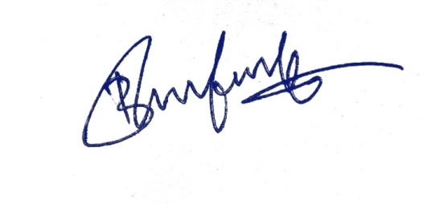

**SIGNATURE**