How to choose the best spot to open a food business in London by exploiting the potential of the location and minimizing the impact of competitors

**ABSTRACT**

***1. Introduction: business problem*** 1

*1.1 Background* 1

1.2 Project Goal 2

1.3 Interest 2

***2. Data Acquisition*** 2

2.1 Choose the best Area minimizing the impact of competitors 2

2.2 Battle of borough 4

2.2.1 Food business around the Top Pick (Aim: minimizing the impact of competitors) 4

2.2.2 Parking area availability (Aim: exploiting the potential of the location) 5

2.2.3 Underground station (Aim: exploiting the potential of the location) 5

2.2.4 Touristic sights (Aim: exploiting the potential of the location 6

***3. Methodology*** 6

***4. Analysis*** 7

4.1 Analysis on competitors (Aim: minimizing the impact of competitors) 7

4.2 Analysis on the profitability of the area (Aim: exploiting the potential of the location) 8

***5. Results and the winner*** 9

1. Introduction: business problem

## *1.1 Background*

London one of the most attractive cosmopolitan city in the world and invites many investors. Open a food business is not an easy task since the huge amount of restaurants, kiosks, confectionery and so on. To open a food business there are lots of analysis to do, like choose style, window, menu, design, looking at the financial aspects regarding for example the convenience or not on the rent or the purchase a slot; but one of the most important study to do is the investigation on competitors and on the area where to stablish the new opening. Therefore, it is advantageous for entrepreneurs to accurately analyse if an area is a profitable one or there are threats that must be avoided.

## 1.2 Project Goal

This project aim is to analyse in which part of the big city of London it will be convenient for entrepreneurs open a particular food business in such a way to minimize the impact of competitors and maximize the potential of a location.

## 1.3 Interest

This analysis will be done for a specific type of food business (Italian bakery) but it could be of interest to any type of investor in any city to achieve competitive advantage and business values.

2. Data Acquisition

Data has been extracted from Fourquare and Open Street Maps.

The project is divided in two phases:

## 2.1 Choose the best Area minimizing the impact of competitors

First of all is necessary to have the list of all the borough in London, that can be obtained by a web scraping. From the Wikipedia page: <https://en.wikipedia.org/wiki/List_of_places_in_London#mw-head>

I extract the list of the 32 London borough and then the Top Picks element in each borough are selected. That’s because the new opening must be near to an already famous place so that it can exploit the customers of a known place; also because the Top Picks represent the most visited place and that means a lot of foot traffic in that area. Obviously I have to exclude that borough where the first choice for people is already a food business, in this case, that zone has already a too strong competitor and must be excluded by the analysis (in the image below the borough excluded are marked with an ꓫ):



In the column “Remove?” I have insert bakerys, Ice cream shops and also restaurants because the stakeholders and I suppose that if a person go to eat in a restaurant probably after the dinner/launch he/she will take a sweet directly there, and don't go out to buy something else.

## 2.2 Battle of borough

Now that 25 possible boroughs have been highlighted, we can move on to the second phase. Once that a selection of areas are chosen, the business activity will be obviously located around the top pick that has been found. To choose the most profitable among the remaining neighbourhoods are compared many aspects, like:

* How many food business there are around The top Pick selected and how many of that are Italian (and for each of them the ratings)
* Parking area availability
* Underground station
* Touristic sights

Many of these feature can be easily taken from Foursquare, for those that are not provided (ex given underground station), I used the package osm (Open Street maps) to create Json API

### 2.2.1 Food business around the Top Pick (Aim: minimizing the impact of competitors)

First of all I with a statistic team have decided the radius within which Top Picks customers are willing to move to reach another point of interest (our business).

The distance did not have to be excessive to make people give up, so the concept is that the closer to the Top Picks the spot is, the better it is. However, the maximum limit was set at a range of 300 meters. Now that I have the distance, I start looking for our competitors that are “Bakery” and “Italian restaurants”).

Next I have analysed for each competitor in the rating to understand if that competitor is a treat to our business.

The idea is that, that restaurant/bakery is not a top pick now but if its rating is high it can became a top pick in the immediate future

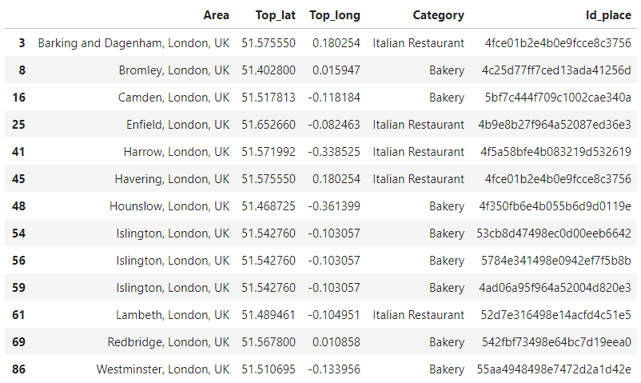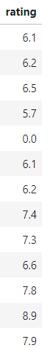

### 2.2.2 Parking area availability (Aim: exploiting the potential of the location)

Based on the distance found previously, I used the Foursquare API to evaluate the profitability of the remaining borough (the 25 candidates).

First of all I looked at parking availability.

The spot must be first of all conveniently located, we can also open the best business in the world but if the customers cannot reach us, the business will never take off.

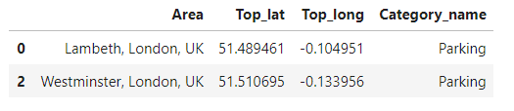The only parking area that are positioned at 300 mt from the relative Top Pick are:

### 2.2.3 Underground station (Aim: exploiting the potential of the location)

To search for the underground station in the proximity of the Top Picks, I have used **OSM API** (Open street maps) and the result is in the following dataframe:

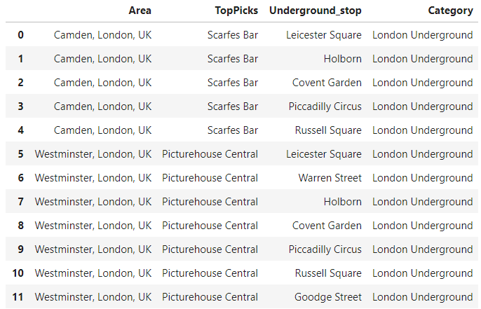

2.2.4 Touristic sights (Aim: exploiting the potential of the location*)*

The stakeholders and I have thought that in a city like London, full of historical monuments, the proximity to a touristic sight could give a considerable competitive advantage. I therefore have utilized Foursquare API, searching for this feature between the distance previously calculated and the result is the following dataframe:

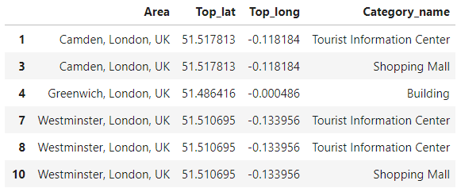

3. Methodology

In first step, according with the stakeholders, I have collected the required data:

* The list of all the borough of London;
* The most visited places in each borough;
* If the most visited place in the borough was a restaurant and bakery, that area was considered not suitable to establish our business (due to the presence of a competitor already acclaimed in the area)

With the remaining borough (25), I studied the presence of competitors based on characterizing factors such as:

* The presence of restaurants in a radius of 300mt and their rating;
* The presence of public transportation;
* The presence of parking availability;
* The presence of tourist sites

The methodology consists in creating a single table in which each area receives a positive or negative score and the sum of the scores will give an overall valuation of the area.



The weight given to the Analysis on competitor (the negative score) will be higher than the weight given to the Analysis on the profitability/potential of the area, the choice is due to the riskiness of the feature, in fact while opening a restaurant in a location without underground stops may have negative repercussions on the business but it does not make up the success of a store; the presence of competitors in the area puts the new business at serious risk of success.

4. Analysis

In this step the aim is to give a mark to each area

## 4.1 Analysis on competitors (Aim: minimizing the impact of competitors)

The negative score to give to that borough which have one or more competitors in an area of 300 meters from the Top Pick First is calculated in the following way:

The drivers to consider are two:

* Number of competitors;
* Rating

Thus if for example a borough has 3 competitors the mark is given by this rule:

|  |  |  |  |
| --- | --- | --- | --- |
| |  | | --- | |  | | If rating <7.0 | If rating >7.0 |
| 1° score= | rating | rating*2 |
| 2° score= | rating | rating*2 |
| 3° score= | rating | rating*2 |
| Total score= | max(score) | |

The result is the following dataframe:

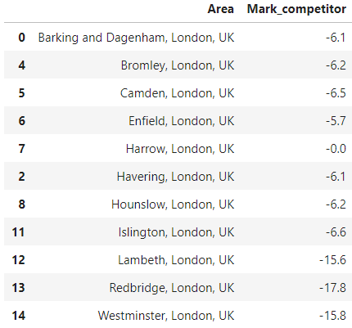

## 4.2 Analysis on the profitability of the area (Aim: exploiting the potential of the location)

The idea is that the negative mark given to that areas could be balanced by a positive mark given to the borough; in other words, if the location is full of competitors but there is a good foot traffic given by the presence of touristic sight, underground or parking; there can be enough client basin to give a good market share for our business. The positive score is calculated in the following way:

|  |  |
| --- | --- |
|  | Score |
| Area= | Volume of the positive characteristic found*1,5 |

The result of the analysis on competitors and on the profitability of the area is the following dataframe:



5. Results and the winner

In conclusion I have showed the results to the stakeholders; to make it easier I have represented the analysis starting point: the top picks of each borough, in other words the areas of greatest interest in each district.

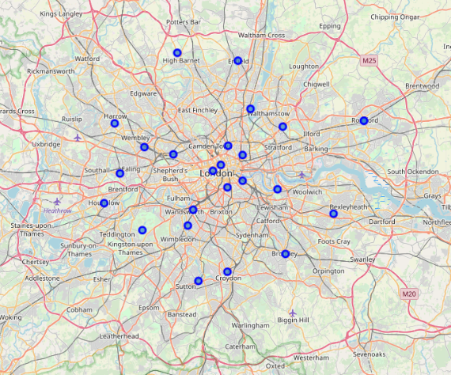

After that I have showed on a map the analysis end point: a choropleth maps that shows the final valuation on all the boroughs.

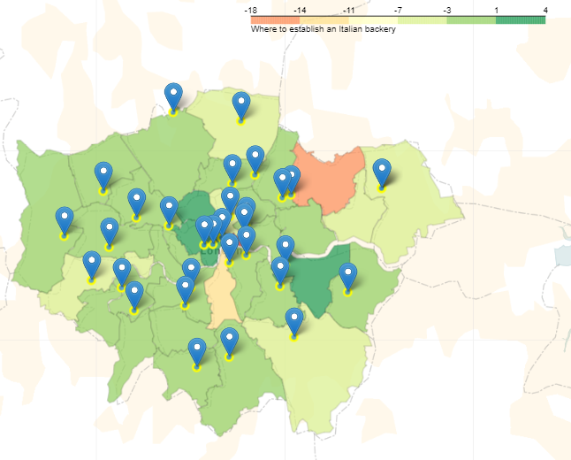

Clicking on the marker is possible to see the name of the area and the its final evaluation.

In conclusion the area with the highest assessment is **Camden** with a final mark of **4**, so the best location for our new opening business is in a radius of 300 metres maximum from the Camden Top Pick like is showed in the following figure:

