Mag M. NICOLA  Chief Deputy District Attorney | KELLY D. SCOTT  Chief Deputy District Attorney
CYNTHIA N. GRESSER  Chief Deputy District Attorney | JOHN T. SAVRNOCH  Chief Deputy District Attorney
megan rheinschild  Victim Assistance Director | Gregory Wilkins  Chief Investigator
kerry m. bierman
Chief Financial & Administrative Officer

OFFICE OF THE
DISTRICT ATTORNEY
COUNTY OF SANTA BARBARA
Joyce E. Dudley
District Attorney

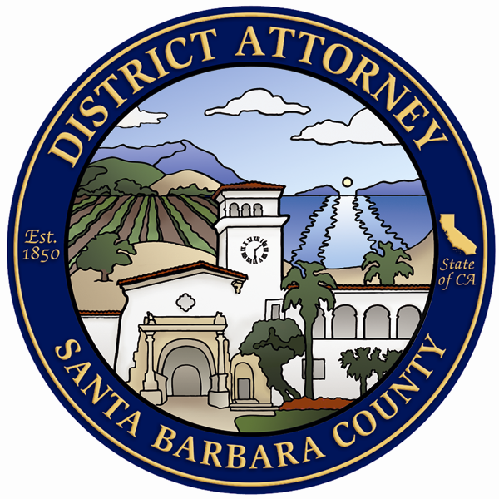
SANTA BARBARA OFFICE
1112 Santa Barbara Street
Santa Barbara, CA 93101
(805) 568-2300
Fax (805) 568-2453SANTA MARIA OFFICE
312-D East Cook Street
Santa Maria, CA 93454
(805) 346-7540
Fax (805) 346-7588LOMPOC OFFICE
115 Civic Center Plaza
Lompoc, CA 93436
(805) 737-7760
Fax (805) 737-7732

REAL ESTATE FRAUD COMPLAINT FORM
- You should know that the District Attorney has limited resources to review and catalog these complaints. All complaints will be reviewed by a Deputy District Attorney. Not all complaints are investigated.

- The legal staff of the Santa Barbara County District Attorney’s Office is not permitted to engage in the private practice of law or to furnish legal advice in private civil matters and does not have legal authority to assert your individual private rights.

- The Special Prosecutions Division does not conduct personal intake interviews or make appointments to accept the written complaint form.

PLEASE PRINT LEGIBLY

I. COMPLAINANT (Person Filing Complaint) (All information must be provided)
LAST NAME FIRST NAME INITIAL |  | DATE OF BIRTH | OCCUPATION
STREET ADDRESS OR P.O. BOX APT. NO. |  | DRIVERS LICENSE OR IDENTIFICATION NUMBER

CITY STATE ZIP CODE
FAX NO. | E-MAIL
DAY TELEPHONE NUMBER  ( ) | EVENING TELEPHONE NUMBER  ( )

II. BUSINESS/SUSPECT COMPLAINT IS AGAINST

NAME OF BUSINESS
STREET ADDRESS OR P.O. BOX |  |  |  | TELEPHONE NUMBER  ( )

CITY STATE ZIP CODE
INDIVIDUAL NAME | DOB (AGE) | RACE | MALE/FEMALE | HEIGHT | WEIGHT
STREET ADDRESS OR P.O. BOX APT. NO. |  |  |  | TELEPHONE NUMBER  ( )

CITY STATE ZIP CODE

III. TRANSACTION INFORMATION
DATE OF OCCURRENCE |  | ADDRESS OF PROPERTY INVOLVED IN THE TRANSACTION

IDENTIFY THE TYPE OF TRANSACTION PERTAINING TO YOUR COMPLAINT (refinance, mortgage, purchase or sale of property, etc.)

NATURE OF COMPLAINT
DATE OF PURCHASE | PURCHASE PRICE/AMOUNT OF LOSS |  |  | METHOD OF PAYMENT (check, cash, credit card, other - explain) | WAS A CONTRACT SIGNED? (If yes, please attach a copy)  YES NO

NAME ADDRESS AND PHONE NUMBER OF WITNESSES, IF ANY:

NAME, ADDRESS AND PHONE NUMBER OF OTHER VICTIMS, IF KNOWN:

HOW DID YOU HEAR ABOUT THE BUSINESS? (Newspaper, TV, telephone, etc.)
DID YOU CONTACT THE BUSINESS ABOUT YOUR COMPLAINT?  YES NO |  |  |  | NAME OF THE PERSON YOU CONTACTED

RESULT OF CONTACT

LIST OTHER AGENCIES YOU HAVE CONTACTED
HAVE YOU CONTACTED A PRIVATE ATTORNEY? IF YES, WHO?  YES NO |  |  | ANY CIVIL LAWSUITS PENDING, INCLUDING SMALL CLAIIMS?  YES NO |  |  | ANY JUDGMENTS?  YES NO

MAY WE PROVIDE A COPY OF YOUR COMPLAINT AND INFORMATION TO OTHER GOVERNMENTAL OR CONSUMER AGENCIES?
YES NO

IV. COMPLAINT
Briefly explain the facts upon which you are basing your complaint, including first contact with suspect, individual or business and anything said or represented which later proved to be untrue. Additional pages may be attached for further remarks.

Sign and Date below (Anonymous complaints are not accepted).
I declare that the forgoing is true and correct to the best of my knowledge and that this

declaration was executed at

__________________________________(city/state) on ____________________(date)

_____________________________________________________________________
(signature)
V. DECLARATION

VI. MAILING INSTRUCTIONS
To help explain the details of your complaint, YOU MUST SUPPLY PHOTOCOPIES OF THOSE DOCUMENTS RELATED TO YOUR COMPLAINT. (Include: real estate contracts, title documents, promissory notes, escrow documents, warranties, cancelled checks, repair orders, photographs, letters, etc.)

- DO NOT SEND ORIGINAL DOCUMENTS -

PHOTOCOPY THE COMPLETED COMPLAINT. KEEP A COPY FOR YOUR RECORDS.

Mail or deliver the complaint and copies of supporting documents to:

Santa Maria District Attorney
Real Estate Fraud Unit
312-D E. Cook St.
Santa Maria, CA 93454

FAILURE TO SEND SUPPORTING DOCUMENTS
MAY DELAY RESPONSE TO YOUR COMPLAINT.

