ICS1503- Web Application Development
Exercise 7
Online Food Ordering application using Vue JS Routing and State Management

Name : Balakumaran S
Class : MTech CSE (Integrated 5 years)
Reg No : 3122247001010 Date: 14/09/2026
Aim
To develop an online food ordering application using Vue.js, with Vue Router for page navigation, nested routing for the Order section, and Pinia for managing the shopping cart state.
Question
Develop a Vue.js Online Food Ordering application with Vue Router, nested routing, and Pinia for state management. The application should have a Home page, an Order section, and an About page. The Order section should use nested routing to provide separate pages for the Food Menu and Cart.
Requirements
1. Create the following routes:
/ → Home
/order → Order
/order/menu → Food Menu
/order/cart → Cart
/about → About
2. The Food Menu page should display the available food, each with its price and an Add to Cart button:
Pizza ₹250 [Add to Cart]
Burger ₹150 [Add to Cart]
Pasta ₹200 [Add to Cart]
Coke ₹80 [Add to Cart]
3. Use Pinia to maintain the cart state.
4. Define Pinia actions: addToCart(), increaseQuantity(), decreaseQuantity(), removeFromCart(), clearCart().
5. Use Pinia getters to calculate the total number of items and the total bill amount.
6. The Cart page should allow the user to increase/decrease quantity, remove items, and clear the cart.
Input
The user selects food items using Add to Cart and changes their quantities using + or −.
Expected Output
Cart (3 items)
Pizza [-] 2 [+] ₹500
Coke [-] 1 [+] ₹80
Total: ₹580
[ Clear Cart ]
Observation
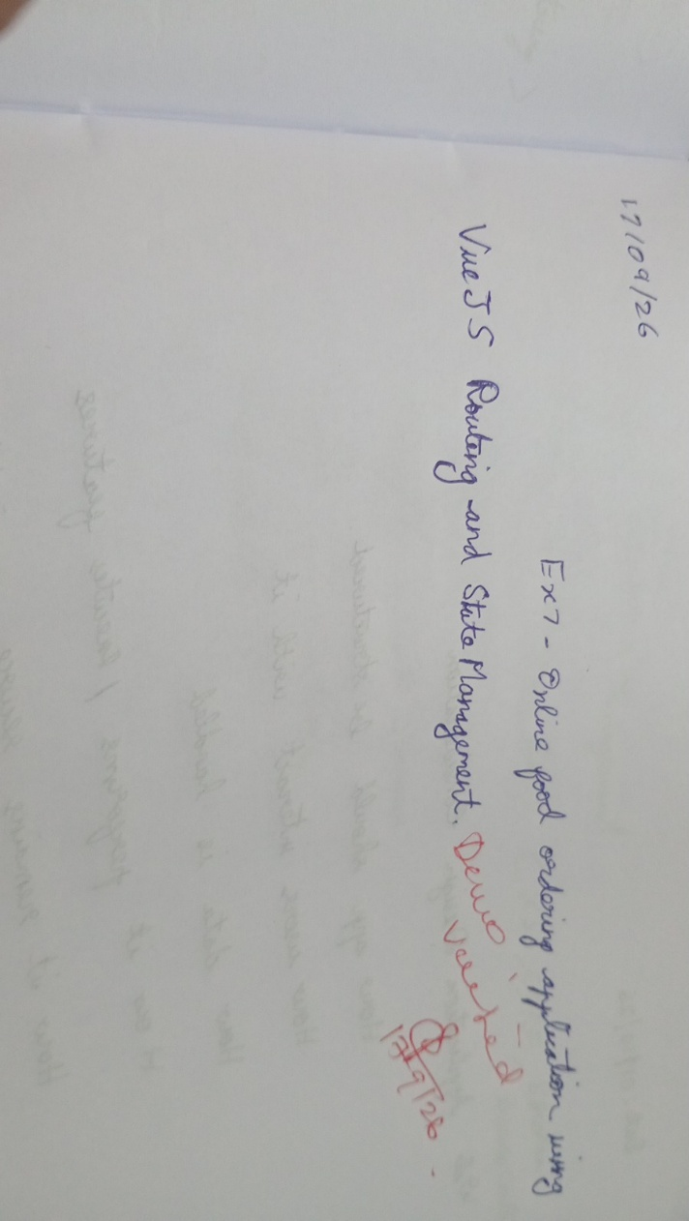

Code
main.js
import { createApp } from 'vue'
import { createPinia } from 'pinia'
import App from './App.vue'
import router from './router'

createApp(App)
.use(router)
.use(createPinia())
.mount('#app')
router/index.js
import { createRouter, createWebHistory } from 'vue-router'
import Home from '../views/Home.vue'
import Order from '../views/Order.vue'
import Menu from '../views/Menu.vue'
import Cart from '../views/Cart.vue'
import About from '../views/About.vue'

const routes = [
{ path: '/', component: Home },
{
path: '/order',
component: Order,
children: [
{ path: 'menu', component: Menu },
{ path: 'cart', component: Cart }
]
},
{ path: '/about', component: About }
]

const router = createRouter({
history: createWebHistory(),
routes
})

export default router
stores/cart.js (Pinia Store)
import { defineStore } from 'pinia'

export const useCartStore = defineStore('cart', {
state: () => ({
items: []
}),

getters: {
totalItems: (state) =>
state.items.reduce((sum, item) => sum + item.quantity, 0),

totalBill: (state) =>
state.items.reduce(
(sum, item) => sum + item.price * item.quantity,
0
)
},

actions: {
addToCart(food) {
const existing = this.items.find(item => item.id === food.id)

if (existing) {
existing.quantity++
} else {
this.items.push({ ...food, quantity: 1 })
}
},

increaseQuantity(id) {
const item = this.items.find(item => item.id === id)
if (item) item.quantity++
},

decreaseQuantity(id) {
const item = this.items.find(item => item.id === id)

if (item) {
item.quantity--

if (item.quantity <= 0) {
this.removeFromCart(id)
}
}
},

removeFromCart(id) {
this.items = this.items.filter(item => item.id !== id)
},

clearCart() {
this.items = []
}
}
})
App.vue
<template>
<div class="app">
<nav class="navbar">
<router-link to="/">Home</router-link>
<router-link to="/order">Order</router-link>
<router-link to="/about">About</router-link>
</nav>

<router-view />
</div>
</template>

<script setup>
</script>

<style scoped>
* {
box-sizing: border-box;
}

.app {
max-width: 700px;
margin: 0 auto;
padding: 15px;
min-height: 100vh;
font-family: Arial, sans-serif;
}

.navbar {
display: flex;
gap: 15px;
padding: 15px 35px;
margin-bottom: 15px;
border-bottom: 1px solid #ccc;
background-color: black;
color:white;

}

.navbar a {
text-decoration: none;
color: white;
font-weight: bold;
border-color:grey;
}

.navbar a :hover{
background-color: grey;
}
.navbar a.router-link-exact-active {
color: #e67e22;
}
</style>
views/Home.vue
<template>
<div>
<h1>Welcome to Food Order</h1>
<p>Order your favorite food easily.</p>
<router-link to="/order/menu">Browse Food Menu</router-link>
</div>
</template>

<script setup>
</script>

<style scoped>
h1 {
color: #2c3e50;
}
</style>
views/Order.vue
<template>
<div>
<h2>Order</h2>

<nav class="order-nav">
<router-link to="/order/menu">Food Menu</router-link>
<router-link to="/order/cart">Cart</router-link>
</nav>

<router-view />
</div>
</template>

<script setup>
</script>

<style scoped>
.order-nav {
display: flex;
gap: 15px;
margin-bottom: 15px;

}

.order-nav a {
text-decoration: none;
color: #2980b9;
}
</style>
views/Menu.vue
<template>
<div>
<h3>Food Menu</h3>

<div
class="food-item"
v-for="food in foods"
:key="food.id"
>
<span>{{ food.emoji }} {{ food.name }}</span>
<span>₹{{ food.price }}</span>

<button @click="addToCart(food)">
Add to Cart
</button>
</div>
</div>
</template>

<script setup>
import { useCartStore } from '../stores/cart'

const cart = useCartStore()

const foods = [
{ id: 1, name: 'Pizza', price: 250, emoji: '🍕' },
{ id: 2, name: 'Burger', price: 150, emoji: '🍔' },
{ id: 3, name: 'Pasta', price: 200, emoji: '🍝' },
{ id: 4, name: 'Coke', price: 80, emoji: '🥤' }
]

function addToCart(food) {
cart.addToCart(food)
alert(`${food.name} added to cart!`)
}
</script>

<style scoped>
.food-item {
display: flex;
align-items: center;
gap: 15px;
padding: 10px 0;
border-bottom: 1px solid #eee;
}

.food-item span:first-child {
flex: 1;
}

button {
padding: 6px 10px;
background-color: #27ae60;
color: white;
border: none;
border-radius: 4px;
cursor: pointer;
}

button:hover {
background-color: blue;
color: whitesmoke;
cursor:pointer;
}
</style>
views/Cart.vue
<template>
<div>
<h3> Cart ({{ cart.totalItems }} items)</h3>

<p v-if="cart.items.length === 0">
Your cart is empty.
</p>

<div v-else>
<div
class="cart-item"
v-for="item in cart.items"
:key="item.id"
>
<span>{{ item.emoji }} {{ item.name }}</span>

<button @click="cart.decreaseQuantity(item.id)">-</button>
<span>{{ item.quantity }}</span>
<button @click="cart.increaseQuantity(item.id)">+</button>

<span>₹{{ item.price * item.quantity }}</span>

<button @click="cart.removeFromCart(item.id)">
Remove
</button>
</div>

<hr />

<p>
<strong>Total: ₹{{ cart.totalBill }}</strong>
</p>

<button @click="cart.clearCart()">Clear Cart</button>
<button @click="placeOrder">Place Order</button>

<p v-if="orderMessage" class="success">
{{ orderMessage }}
</p>
</div>
</div>
</template>

<script setup>
import { ref } from 'vue'
import { useCartStore } from '../stores/cart'

const cart = useCartStore()
const orderMessage = ref('')

function placeOrder() {
if (cart.items.length === 0) {
orderMessage.value = 'Please add items before placing an order.'
return
}

orderMessage.value = 'Order placed successfully!'
cart.clearCart()
}
</script>

<style scoped>
.cart-item {
display: flex;
align-items: center;
gap: 10px;
padding: 8px 0;
border-bottom: 1px solid #eee;
}

.cart-item span:first-child {
flex: 1;
}

button {
padding: 4px 8px;
margin-right: 5px;
border: 1px solid #ccc;
background-color: #f5f5f5;
border-radius: 4px;
cursor: pointer;
}

.success {
margin-top: 15px;
font-weight: bold;
color: #27ae60;
}
</style>
views/About.vue
<template>
<div>
<h2>About</h2>

<p>
This application is a simple online food ordering system
developed using Vue.js, Vue Router and Pinia.
</p>
</div>
</template>

<script setup>
</script>

<style scoped>
p {
line-height: 1.6;
}
</style>
Output
Home Page (/)
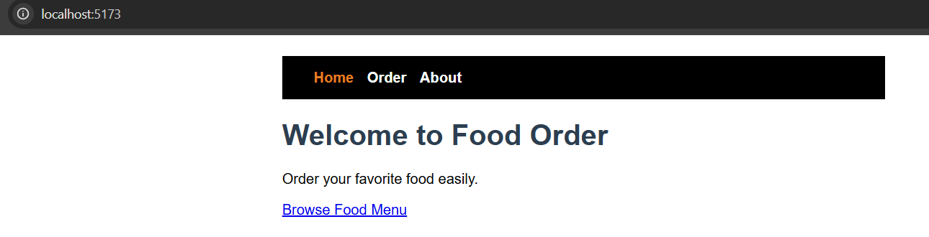
Fig 1: Home page with the navigation bar
Order Section (/order)
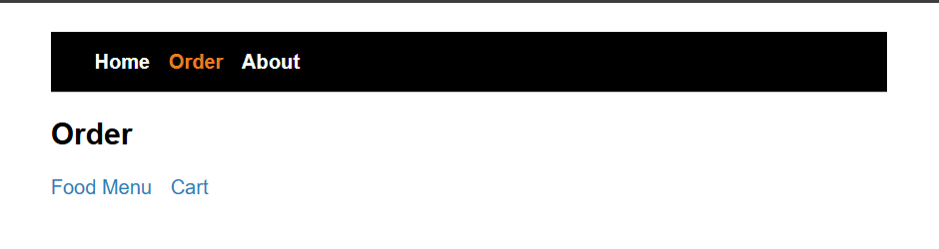
Fig 2: Order page showing the nested links for Food Menu and Cart
Food Menu (/order/menu)
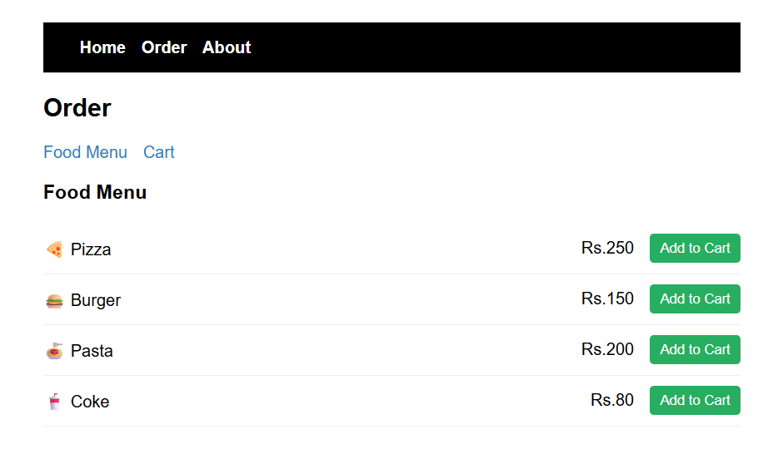
Fig 3: Food Menu page listing Pizza, Burger, Pasta and Coke with Add to Cart buttons
Cart with Items Added (/order/cart)
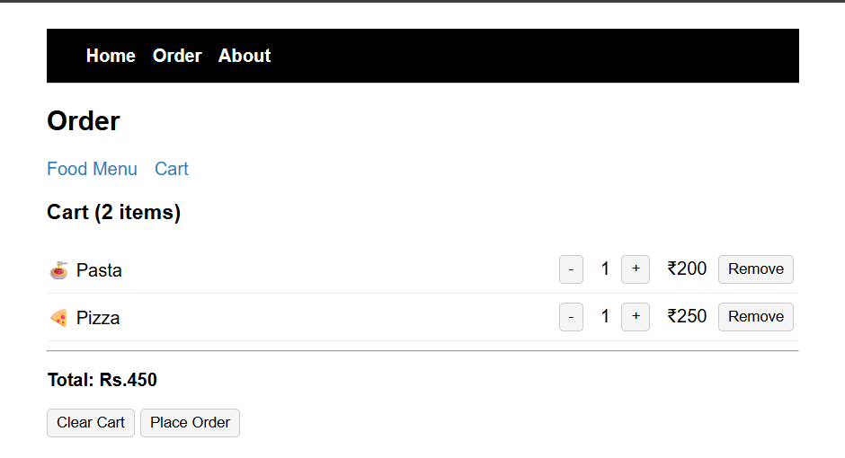
Fig 4: Cart page after adding Pasta and Pizza, showing item count and total bill
Increase Quantity
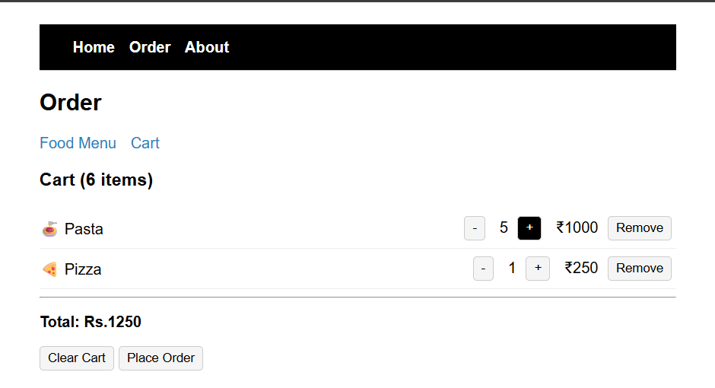
Fig 5: Quantity of Pasta increased using the + button, item count and total updated
Decrease Quantity
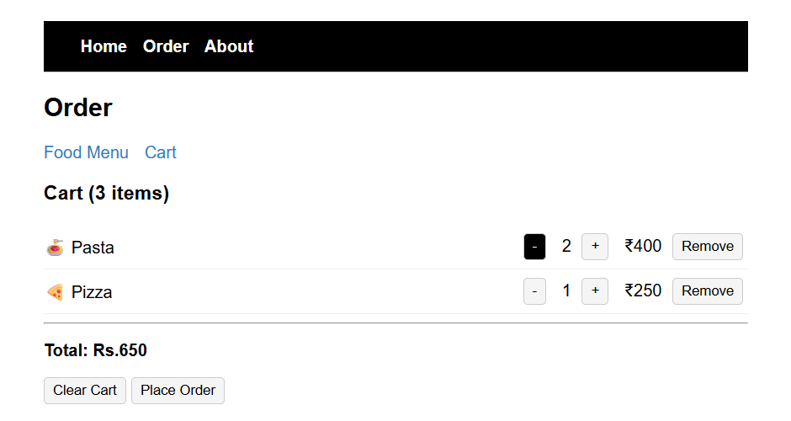
Fig 6: Quantity of Pasta decreased using the - button, item count and total updated
Remove Item
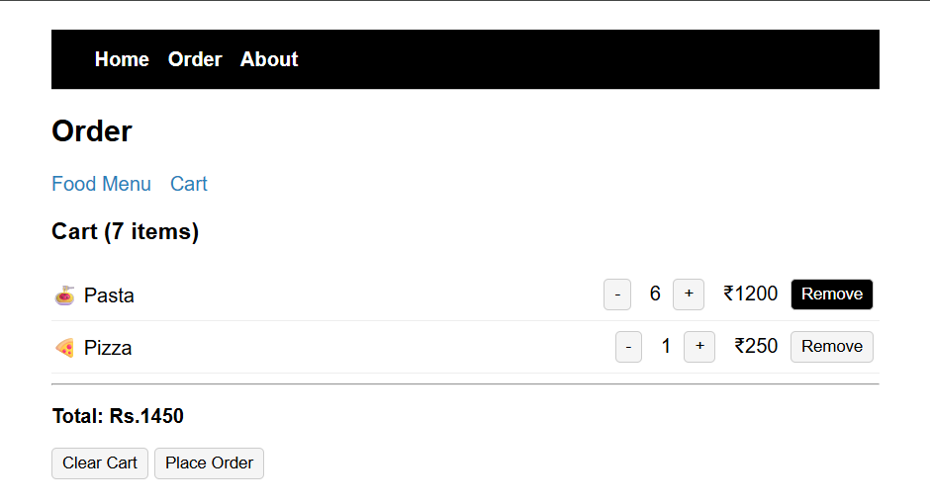
Fig 7: Cart before removing Pasta
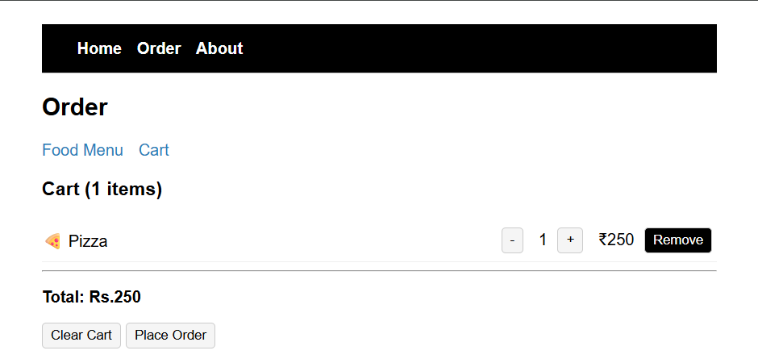
Fig 8: Cart after removing Pasta, only Pizza remains
Clear Cart
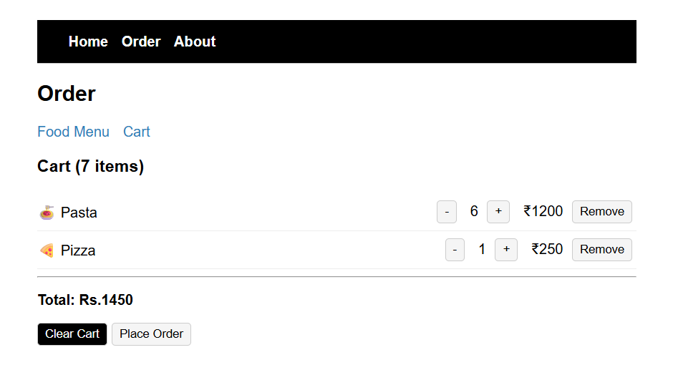
Fig 9: Cart before clicking Clear Cart
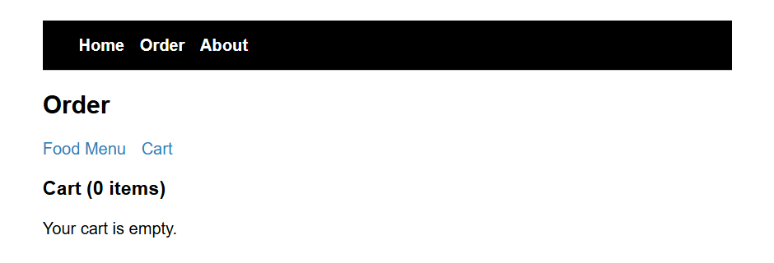
Fig 10: Cart empty after clearing, with 0 items
About Page (/about)
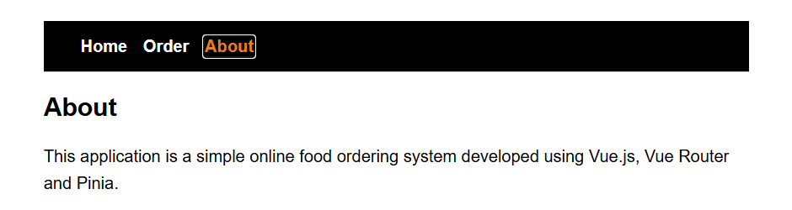
Fig 11: About page
Learning Outcomes
• Understood how to set up Vue Router and define routes for the Home, Order and About pages.
• Learned how to use nested routing, with the Menu and Cart pages rendered inside the Order page using a child router-view.
• Learned how to create a Pinia store to hold shared cart state that is available across different pages.
• Practiced writing Pinia actions (addToCart, increaseQuantity, decreaseQuantity, removeFromCart, clearCart) to update the cart.
• Used Pinia getters to calculate the total number of items and the total bill amount automatically.
• Understood how components read from and update a shared store, so the cart stays in sync between the Menu and Cart pages.

