**DET BYOD 19 August 2024**

Have added ability to customize shares and printers per site.

ALL stuff is at <https://intranet.egc.wa.edu.au/byod/>.

I am at peter.de.groot@education.wa.edu.au

Release notes

1. Upgraded so that the servers in the .drives and .printers file can either be just the server or the fqdn. i.e. E4182s01sv021 or e4182s01sv021.orange.schools.internal
2. Now checks if the print servers are on-line and the print spooler is running.
3. Now it does **not** do persistent drive mapping. So windows will not lock the user account when the user changes password, and windows tries to keep connecting with the old password.
4. Does all the good stuff when you hit the Go button. Drives and Printers.
5. Dumped the saved credentials tick box. Saves automagically. Seemed redundant.
6. Not sure if the printers are persistent.
7. In my situation. Even though printing works, it still appears in the queue window, unless you refresh the print queue window (F5).

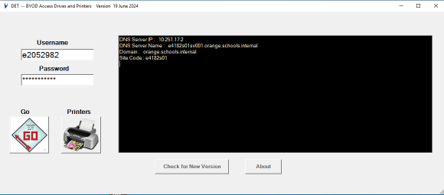

**Usage**.

1. Just copy/download the byod.exe program to your BYOD device (desktop?) and run it.
2. Feed in your credentials.
3. Hit the GO button. This should map your site wide drives and admin defined printers.
4. If you want other printers click the Printers button.

**Notes**

1. Microsoft defender does NOT like this program. You will have to exclude it. Check with google or ask your SBNA. Cost for a code signing cert is $1K ish ☹

Suggestion.

Go into Windows security – anti virus.

Disable real time scanning.

Download the exe. The browser may still complain here…

Move to desktop.

Exclude it in defender.

Anti Virus (Defender) real time scanning automatically restarts.

1. If you need to select a papercut cost centre at print time, you will have to install the papercut client. Use the local install version that does not require a constant network connection. For example we use \\e4182s01sv021\PCClient\win\client-local-install.exe. Check with your SBNA. It seems that a lot of sites use walk up printing, so this is not needed.
2. If you do not have the site wide setup configured, BYOD “should” default to the standard Home Directory and Staff Shared shares. Along with 006 as the print server. I have not tested this rigorously .. so get back to me.

-----------------------------------------------------------------------------------------------------------------------

The rest of this stuff is for your SBNA to do the site wide customisations.

4 Steps.

1. Create a site specific DNS entry called det-byod in SSS.

det-byod.E4182S01.schools.internal

Note: Has to be a CNAME (alias) entry.

Notice the E4182s01 ? That is the site specific part of it

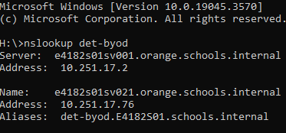

Here is the SSS dns entry, in small font ☹



1. On the referenced server, create a share called det-byod. As per this screenshot.

1. Within this share (if you desire) you will need 2 files. One for shared drives and the other for printers. Grab mine from <https://intranet.egc.wa.edu.au/byod>
2. The det-byod share HAS to be on a server on the domain. All to do with credentials.
3. The file format is self documented.. But anyway. A # at the start of the line makes the rest of it a comment. A space to delimit the variables. The order of the printer one is important. The default print server HAS to come first..

**Shares**

#

#

#

# This is the list of drives for mapping in the BYOD program

#

#

# WARNING ... need FQDN

#

# H drive is My Documents !! Gets mapped out of AD

#

#

#

# --format

#

# Drive name Share (FQDN)

#

j: \\e4182s01sv021.orange.schools.internal\Staff_Overflow\Users$\%username%

s: \\e4182s01sv001.orange.schools.internal\Shared

v: \\E4182S01SV021.orange.schools.internal\STUDENT_DATA

**Printers**

#

#

#

# This is the list of default printers for adding in the DET BYOD program

#

#

# Default Printer Server (either FQDN or just server.)

e4182s01sv021

# Printers

#

#

# Server Printer Name (either FQDN or just server.)

e4182s01sv021 715-SS_KonicaC659_x64

e4182s01sv021 712-213_KonicaC659_x64

e4182s01sv021.orange.schools.internal 712-216-Konica4000i_x64

1. Gotchas. Have noticed anti-virus complains. Need to add an exception. IT is a BYOD device.
2. If the byod files/share is not configured, it “should” default to the det standard ones. S and H drive and 006 for the print server.